# JavaScript OO Programming

## Overview

In this lab, you’ll refactor the “product manager” Web application from the previous lab so that it uses a fully object-oriented Product object.

The Product object will hold a description, email, price, projected sales, and timestamp. You will also define a method to format this information as a string. If time permits, you’ll implement another method to determine if a product’s description matches a regular expression.

## Source folders

* <LAB_HOME>/Labs/JsOop
* <LAB_HOME>/Solutions/JsOop

## Roadmap

There are 4 exercises in this lab, of which the last exercise is "if time permits". Here is a brief summary of the tasks you will perform in each exercise; more detailed instructions follow later:

1. Defining a Product object
2. Adding methods to the Product object
3. Refactoring the Web application to use the Product object
4. Supporting regular expressions

## Getting started with the Student project

Take a look at the following files.

* MainPage.html is the fully-complete Web page for this Web application.
* ProductSuggestionsFunctions.js contains all the initial JavaScript code for this Web application. At the moment, it uses a string to represent each product. In this lab, you’ll refactor this code to use a Product object instead.

Run the Web application and familiarize yourself with its capabilities.

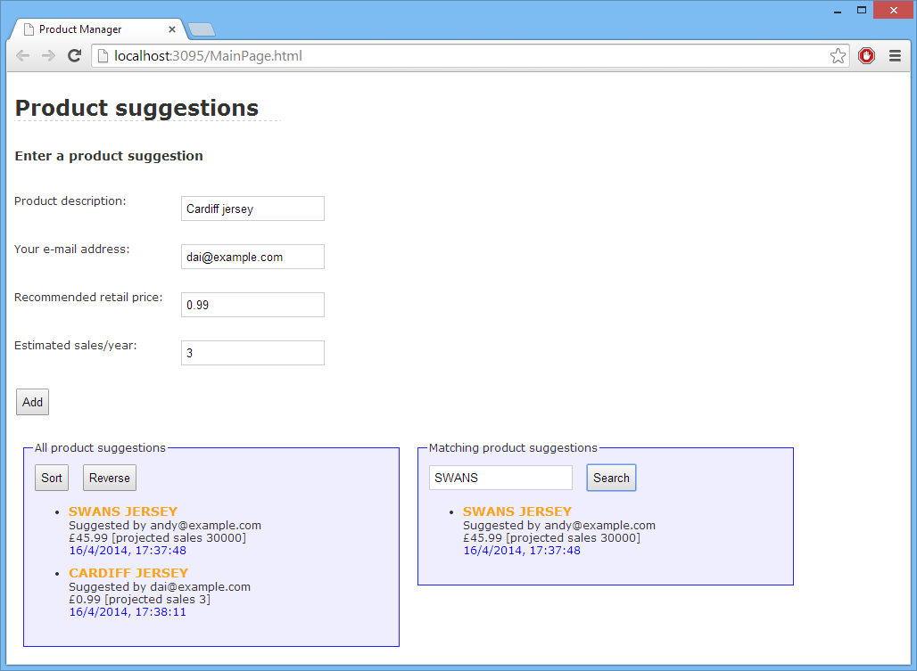

## Exercise 1: Defining a Product object

The best way to define a new object is by implementing a constructor function. Therefore, open ProductSuggestionsFunctions.js and define a constructor function as follows:

* Declare a global variable named Product.
* Assign the Product variable a constructor function. The constructor function should take 4 parameters representing the following product-related info:
  + description
  + user’s email
  + recommended retail price
  + estimated sales per year
* Inside the function body, assign the following properties to “this” object:
  + description
  + email
  + price
  + sales
  + ts (this is the timestamp of creation –assign the current date/time)

**Exercise 2: Adding methods to the Product object**

Now it’s time to add functionality to Product. To do this, set the Product.prototype property so that it includes a format function as follows:

* The function should create a formatted string that contains the product’s description, email, price, and sales (you can get most of this code from the existing doAdd() function – you might need to make some tweaks).
* The function should then append the formatted timestamp (again, you can get most of this code from the existing doAdd() function, with tweaks).
* The function should then return this concatenated text.

**Exercise 3: Refactoring the Web application to use the Product object**

In this exercise, you’ll refactor your code so that it uses the Product object.

* First, refactor doAdd() so that it creates a Product object to contain the information entered by the user, and then add the Product object (rather than a formatted string) in the global allProducts array. Why is it better for the array to hold Product objects rather than formatted strings?
* Next, refactor displayProducts() so that it makes use of the Product object’s format() method to return a formatted string representation of each product, ready to be displayed on the form.
* Finally, refactor doSort() so that it sorts the array of Product objects by description.

The default behavior of the array sort() function is to call toString() on each object in the array, to compare items lexicographically. Therefore, a simple solution would be for you to implement a toString() method in the Product prototype that just returned the product’s description. The array sort() function would then call toString() repeatedly to sort Product objects by description.

Another (more flexible approach) is to supply a function to the array sort() function, to tell it how to compare two Product objects explicitly. Here’s what we suggest for your doSort() function:

function doSort() {

allProducts.sort(**function (p1, p2) {**

**if (p1.description < p2.description)**

**return -1;**

**else if (p1.description > p2.description)**

**return +1;**

**else**

**return 0;**

**}**);

displayProducts(allProducts, "allProductsList");

}

Run the Web application. Add several product suggestions and verify the Web page displays them correctly. Also verify that the *Sort* and *Reverse* buttons still work correctly.

**Exercise 4 (If time permits): Supporting regular expressions**

Refactor your Web application so that it supports regular expression tests on Product objects. The recommended policy now is to just test the product’s description property (rather than testing entire formatted product suggestion strings as before, with the possibility of all the embedded HTML markup such as <font> and <bold> getting in the way).