AdvancedText2SpeechEditor
Sprint Report
2971_2973_3059
Στέλιος Ζαππίδης 2971, Αυγουστίνος Ζήγος 2973, Ζήσιμος Παράσχης 3059

Versions History
Date | Version | Description | Author
05/29/2021 | 1.0 | TextToSpeechEditor | Stelios Zappidhs,  Avgoustinos Zigos,  Zhsimos Parasxhs

Introduction
This document provides information concerning the <first> sprint of the project.

Purpose

Document Structure
The rest of this document is structured as follows. Section 2 describes out Scrum team and specifies the this Sprint's backlog. Section 3 specifies the main design concepts for this release of the project.

Scrum team and Sprint Backlog
US1 | OpenDocumentTest.java
US2 | EditDocumentTest.java
US3 | SaveDocumentTest.java
US4 | TransformContentTest.java
US5 | TransformSpecifiedContentTest.java
US6 | ConfigTransformerTest.java
US7 | EnableRecordingTest.java
US8 | PlayRecordingTest.java
US9 | DisableRecordingTest.java

Scrum team
Product Owner | Apostolos Zarras
Scrum Master | Stelios Zappidhs
Development Team | Stelios Zappidhs, Avgoustinos Zigos, Zhsimos Parasxhs

Sprints
<List below the sprints that you performed and the user stories that have been realized in each Sprint>
Sprint No | Begin Date | End Date | Number of weeks | User stories
1 | 3/8/2021 | 05/29/2021 | 11 | 9

Use Cases

< Open File>
Use case ID | UC1
Actors | Ordinary User
Pre conditions | None
Main flow of events | - The use case starts when the user presses the “Open File” button.  - The System opens an explorer window.  - The user defines which file to open  - The user defines which encryption has been used.  - The system opens the file.
Alternative flow | - If the file is encoded, the input subsystem decodes the contents of the file based on the info provided by the GUI.
Post conditions | The program must have opened the file that the user selected/

< Edit File>
Use case ID | UC2
Actors | Ordinary User
Pre conditions | A file must have been opened in a previous step.
Main flow of events | - The use case starts when the user presses the “Edit File” button.  - The system brings up the editor subsystem.  - The user edits the file.
Alternative flow | None
Post conditions | The file has been edited(but not saved).

< Save File>
Use case ID | UC3
Actors | Ordinary User
Pre conditions | A file must have been opened(and edited?).
Main flow of events | - The use case starts when the user presses the “Save File” button.  - The system opens an explorer window.  - The user selects the save location.  - The user selects the file’s encoding (Optional).  - The system saves the file based on the info provided by the main system.
Alternative flow | None
Post conditions | The file has been saved(as well as encoded, if requested by the user).

<Transform file to audio>
Use case ID | UC4
Actors | Ordinary User
Pre conditions | The file opened correctly.
Main flow of events | - The use case starts when the user presses the “Transform” button.  - The contents transform to audio.
Alternative flow | - If the recording button is pressed by the user save the action/command in the list.  - The use case continues from step 2 of the main flow.
Post conditions | The contents of the file can now be listened to instead of having to read them.

<Transform lines to audio>
Use case ID | UC5
Actors | Ordinary User
Pre conditions | The file opened correctly.
Main flow of events | - The use case starts when the user chooses a part of the contents and presses the “Transform” button.  - The chosen contents of the file transform to audio.
Alternative flow | - If the recording button is pressed by the user save the action/command in the list.  - The use case continues from step 2 of the main flow.
Post conditions | The specified contents of the file can now be listened to instead of having to read them.

<Tune audio parameters>
Use case ID | UC6
Actors | Ordinary User
Pre conditions | The contents of the file were transformed correctly.
Main flow of events | - The use case starts when the user presses the “Tune Parameters” button.  - The user changes the parameters.  - The parameters are now tuned.
Alternative flow 1 | - The application indicates the parameters specified are wrong.  - The application returns to the change parameters menu.  - The use case continues from step 2 of the main flow.
Post  conditions | The audio parameters are now customized to the user’s needs.

<Activate Recording>
Use case ID | UC7
Actors | Ordinary User
Pre conditions | None
Main flow of events | - The use case starts when the user presses the “Record” button.  - The system starts recording.
Alternative flow | None
Post  conditions | The system records every command until stopped.

<Replay Recorded Sequence>
Use case ID | UC8
Actors | Ordinary User
Pre conditions | None
Main flow of events | - The use case starts when the user presses the “replay” button.  - The application replays the recorded sequence .
Alternative flow | - The recording was not executed successfully.  - The system prints an error message.
Post  conditions | The recorded sequence was replayed successfully.

<Deactivate Recording>
Use case ID | UC9
Actors | Ordinary User
Pre conditions | The recording has already been activated.
Main flow of events | - The use case starts when the user wishes to stop the recording.  - The user presses the “Deactivate” button.  - The application stops the recording and deletes everything that has been recorded so far.
Alternative flow | - The deactivation of the recording was not executed successfully.  - The system prints an error message.
Post  conditions | The recording is now empty.

Design

Architecture
<Specify the overall architecture for this release in terms of a UML package diagram.>

Design
Commands Diagram:
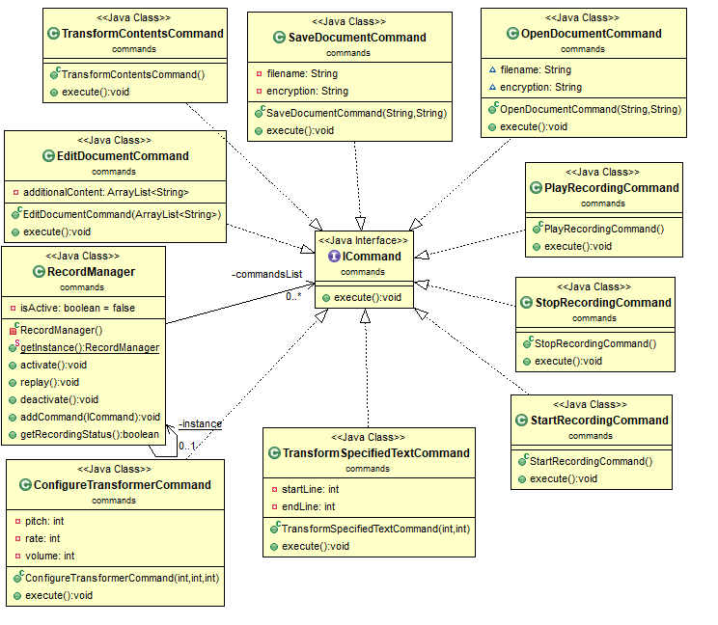
Input Diagram:
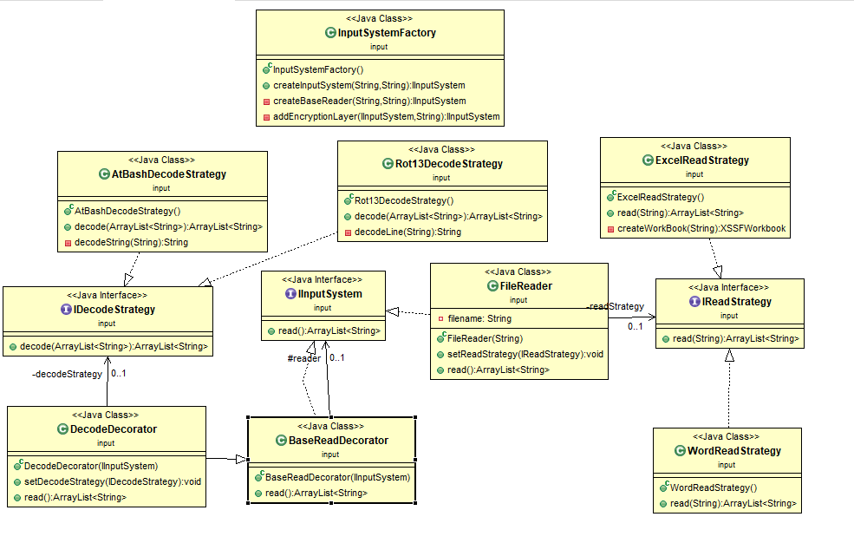

Model Diagram:
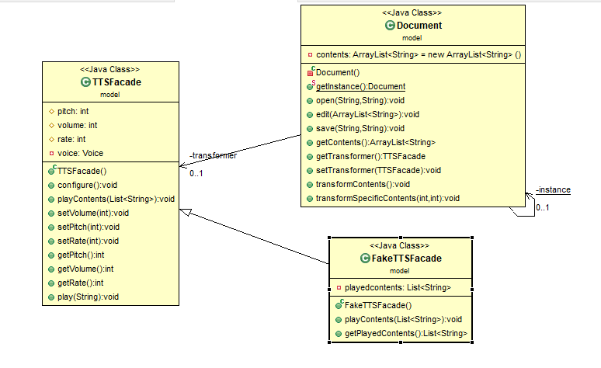
Output Diagram:
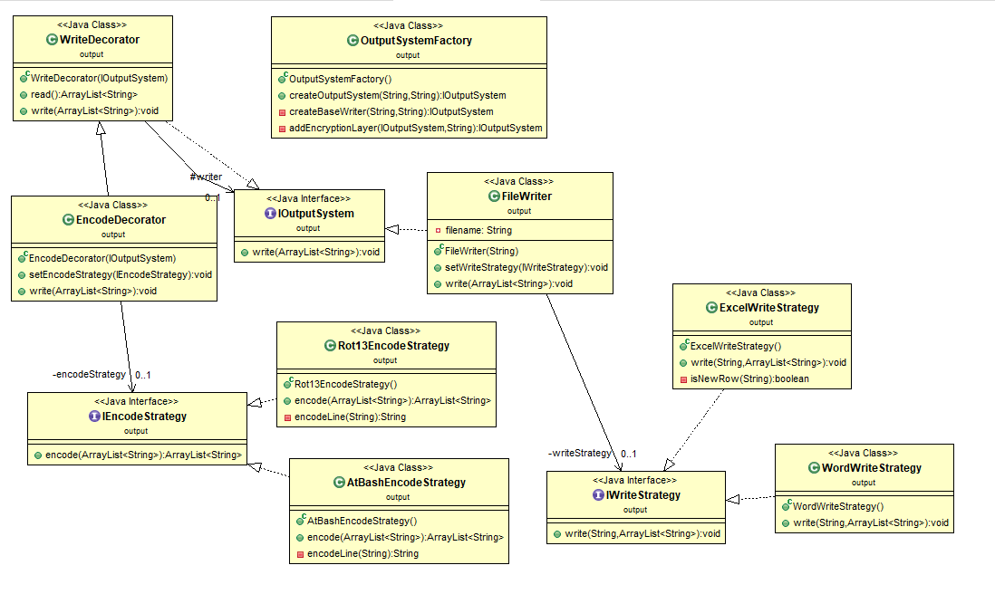
View Diagram:
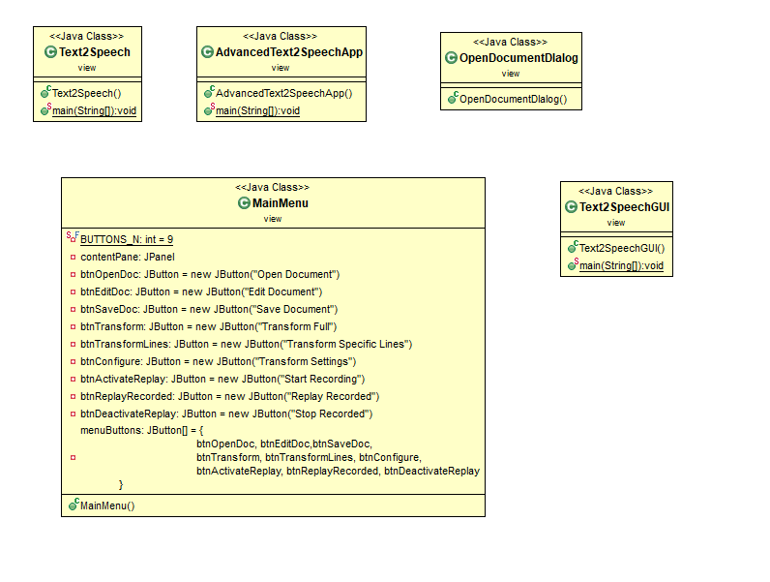

Class Name: ConfigureTransformerCmd.java
Responsibilities:  - Gives the user the ability to configure the pitch, rate and volume. | Collaborations:  - model.Document  - model.TTSFacade  - ICommand

Class Name: EditDocumentCmd.java
Responsibilities:  - Gives the user the ability to edit the contents of the file. | Collaborations:  - model.Document  - ICommand

Class Name: OpenDocumentCmd.java
Responsibilities:  - The user chooses the file he wants to open and the type of encryption. | Collaborations:  - model.Document  - ICommand

Class Name: PlayRecordingCmd.java
Responsibilities:  - Replays the recorded commands. | Collaborations:  - ICommand

Class Name: RecordManager.java
Responsibilities:  - Checks if the recording is activated or not. | Collaborations:

Class Name: SaveDocumentCmd.java
Responsibilities:  - Saves the contents of the file that the user opened. | Collaborations:  - model.Document  - ICommand

Class Name: StartRecordingCmd.java
Responsibilities:  - Uses the activate method of the RecordManager class so that the recording can begin. | Collaborations:  - ICommand

Class Name: StopRecordingCmd.java
Responsibilities:  - Uses the deactivate method of the RecordManager class to stop the recording. | Collaborations:  - ICommand

Class Name: TransformContentsCmd.java
Responsibilities:  - Transforms the contents of the file to audio. | Collaborations:  - ICommand  - Model.Document

Class Name: TransformSpecifiedTextCmd.java
Responsibilities:  - Transforms specific lines of the file to audio. | Collaborations:  - model.Document  - ICommand

Class Name: AtBashDecodeStrategy.java
Responsibilities:  - Implements the IDecodeStrategy and decodes the Atbash encoded file. | Collaborations:  - IDecodeStrategy

Class Name: BaseReadDecorator.java
Responsibilities: | Collaborations:  - IInputSystem

Class Name: DecodeDecorator.java
Responsibilities: | Collaborations:  - BaseReadDecorator

Class Name: ExcelReadStrategy.java
Responsibilities:  - Reads the Excel type files. | Collaborations:  - IReadStrategy

Class Name: FileReader.java
Responsibilities: | Collaborations:  - IInputSystem

Class Name: InputSystemFactory.java
Responsibilities: | Collaborations:

Class Name: Rot13DecodeStrategy.java
Responsibilities:  - Implements the IDecodeStrategy and decodes the Rot13 encoded file | Collaborations:  - IDecodeStrategy

Class Name: WordReadStrategy.java
Responsibilities: | Collaborations:  - IReadStrategy

Class Name: Document.java
Responsibilities:  - The document represents the contents of the file. | Collaborations:  - input.IInputSystem  - input.InputSystemFactory  - output.IOutputSystem  - output.OutputSystemFactory

Class Name: FakeTTSFacade.java
Responsibilities:  - The FakeTTSFacade class is a subclass of the TTSfacade and stores the text given to the play method inside the playedContents variable. | Collaborations:  - TTSFacade

Class Name: TTSFacade.java
Responsibilities:  - In the TTSFacade class is where we use the freetts jar files to transform to audio. | Collaborations:

Class Name: AtBashEncodeStrategy.java
Responsibilities:  - This class encodes the contents of the file back to AtBash. | Collaborations:  - IEncodeStrategy

Class Name: EncodeDecorator.java
Responsibilities: | Collaborations:  - WriteDecorator

Class Name: ExcelWriteStrategy.java
Responsibilities: | Collaborations:  - IWriteStrategy

Class Name: FileWriter.java
Responsibilities: | Collaborations:  - IOutputSystem

Class Name: OutputSystemFactory.java
Responsibilities: | Collaborations:

Class Name: Rot13EncodeStrategy.java
Responsibilities:  - Encodes the contents of the file back to Rot13. | Collaborations:  - IEncodeStrategy

Class Name: WordWriteStrategy.java
Responsibilities: | Collaborations:  - IWriteStrategy

Class Name: WriteDecorator.java
Responsibilities: | Collaborations:  - IOutputSystem

Class Name: AdvancedText2SpeechApp.java
Responsibilities: | Collaborations:

Class Name: MainMenu.java
Responsibilities: | Collaborations:  - JFrame

Class Name: OpenDocumentDialog.java
Responsibilities: | Collaborations:  - JDialog  - Commands.OpenDocumentCmd

Class Name: Text2Speech.java
Responsibilities: | Collaborations:

Class Name: Text2SpeechGUI.java
Responsibilities: | Collaborations:

Class Name: EditDocumentDialog.java
Responsibilities: | Collaborations:  - Model.Document  - Commands.EditDocumentCmd  - JDialog

Class Name: SaveDocumentDialog.java
Responsibilities: | Collaborations:  - JDialog

Class Name: SpecifyTransfContentsDialog.java
Responsibilities: | Collaborations:  - Jdialog

Class Name: Text2SpeechApp.java
Responsibilities: | Collaborations:  - Commands.PlayRecordingCmd  - Commands.StartRecordingCommand  - Commands.StopRecordingCmd  - Commands.TransformContentsCmd

