AdvancedText2SpeechEditor
Sprint Report
2971_2973_3059
Στυλιανός Ζαππίδης 2971, Αυγουστίνος Ζήγος 2973, Ζήσιμος Παράσχης 3059

Versions History
Date | Version | Description | Author
05/29/2021 | 1.0 | TextToSpeechEditor  Project for Software Engineering class 2020-2021. | Stylianos Zappidhs,  Avgoustinos Zigos,  Zhsimos Parasxhs

Introduction
This document provides information concerning the <first> sprint of the project.

Purpose

Document Structure
The rest of this document is structured as follows. Section 2 describes out Scrum team and specifies the this Sprint's backlog. Section 3 specifies the main design concepts for this release of the project.

Scrum team and Sprint Backlog
US1 | OpenDocumentTest.java
US2 | EditDocumentTest.java
US3 | SaveDocumentTest.java
US4 | TransformContentTest.java
US5 | TransformSpecifiedContentTest.java
US6 | ConfigTransformerTest.java
US7 | EnableRecordingTest.java
US8 | PlayRecordingTest.java
US9 | DisableRecordingTest.java

Scrum team
Product Owner | Apostolos Zarras
Scrum Master | Stylianos Zappidhs
Development Team | Stylianos Zappidhs, Avgoustinos Zigos, Zhsimos Parasxhs

Sprints
<List below the sprints that you performed and the user stories that have been realized in each Sprint>
Sprint No | Begin Date | End Date | Number of weeks | User stories
1 | 3/8/2021 | 05/29/2021 | 11 | 9

Use Cases

< Open File>
Use case ID | UC1
Actors | Ordinary User
Pre conditions | None
Main flow of events | - The use case starts when the user presses the “Open File” button.  - The System opens an explorer window.  - The user defines which file to open  - The user defines which encryption has been used.  - The system opens the file.
Alternative flow | - If the file is encoded, the input subsystem decodes the contents of the file based on the info provided by the GUI.
Post conditions | The program must have opened the file that the user selected/

< Edit File>
Use case ID | UC2
Actors | Ordinary User
Pre conditions | A file must have been opened in a previous step.
Main flow of events | - The use case starts when the user presses the “Edit File” button.  - The system brings up the editor subsystem.  - The user edits the file.
Alternative flow | None
Post conditions | The file has been edited(but not saved).

< Save File>
Use case ID | UC3
Actors | Ordinary User
Pre conditions | A file must have been opened(and edited?).
Main flow of events | - The use case starts when the user presses the “Save File” button.  - The system opens an explorer window.  - The user selects the save location.  - The user selects the file’s encoding (Optional).  - The system saves the file based on the info provided by the main system.
Alternative flow | None
Post conditions | The file has been saved(as well as encoded, if requested by the user).

<Transform file to audio>
Use case ID | UC4
Actors | Ordinary User
Pre conditions | The file opened correctly.
Main flow of events | - The use case starts when the user presses the “Transform” button.  - The contents transform to audio.
Alternative flow | - If the recording button is pressed by the user save the action/command in the list.  - The use case continues from step 2 of the main flow.
Post conditions | The contents of the file can now be listened to instead of having to read them.

<Transform lines to audio>
Use case ID | UC5
Actors | Ordinary User
Pre conditions | The file opened correctly.
Main flow of events | - The use case starts when the user chooses a part of the contents and presses the “Transform” button.  - The chosen contents of the file transform to audio.
Alternative flow | - If the recording button is pressed by the user save the action/command in the list.  - The use case continues from step 2 of the main flow.
Post conditions | The specified contents of the file can now be listened to instead of having to read them.

<Tune audio parameters>
Use case ID | UC6
Actors | Ordinary User
Pre conditions | The contents of the file were transformed correctly.
Main flow of events | - The use case starts when the user presses the “Tune Parameters” button.  - The user changes the parameters.  - The parameters are now tuned.
Alternative flow 1 | - The application indicates the parameters specified are wrong.  - The application returns to the change parameters menu.  - The use case continues from step 2 of the main flow.
Post  conditions | The audio parameters are now customized to the user’s needs.

<Activate Recording>
Use case ID | UC7
Actors | Ordinary User
Pre conditions | None
Main flow of events | - The use case starts when the user presses the “Record” button.  - The system starts recording.
Alternative flow | None
Post  conditions | The system records every command until stopped.

<Replay Recorded Sequence>
Use case ID | UC8
Actors | Ordinary User
Pre conditions | None
Main flow of events | - The use case starts when the user presses the “replay” button.  - The application replays the recorded sequence .
Alternative flow | - The recording was not executed successfully.  - The system prints an error message.
Post  conditions | The recorded sequence was replayed successfully.

<Deactivate Recording>
Use case ID | UC9
Actors | Ordinary User
Pre conditions | The recording has already been activated.
Main flow of events | - The use case starts when the user wishes to stop the recording.  - The user presses the “Deactivate” button.  - The application stops the recording and deletes everything that has been recorded so far.
Alternative flow | - The deactivation of the recording was not executed successfully.  - The system prints an error message.
Post  conditions | The recording is now empty.

Design

Architecture
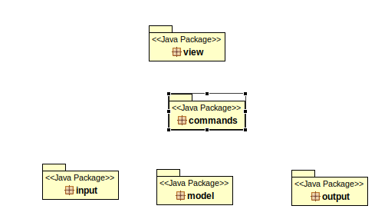

Design

Commands Diagram:
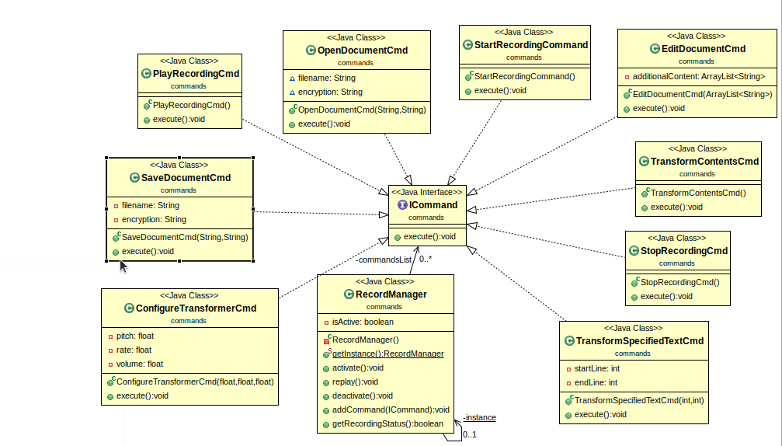

Input Diagram:
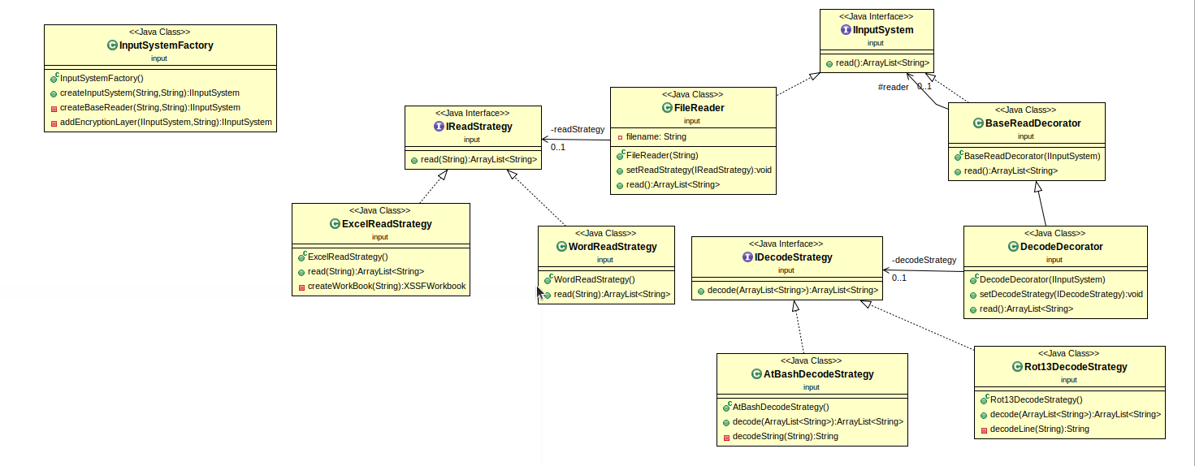

Model Diagram:
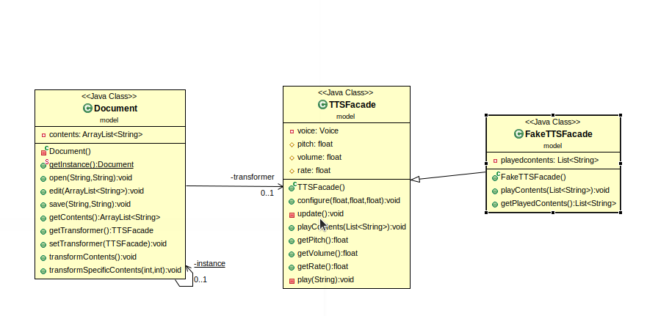

Output Diagram:
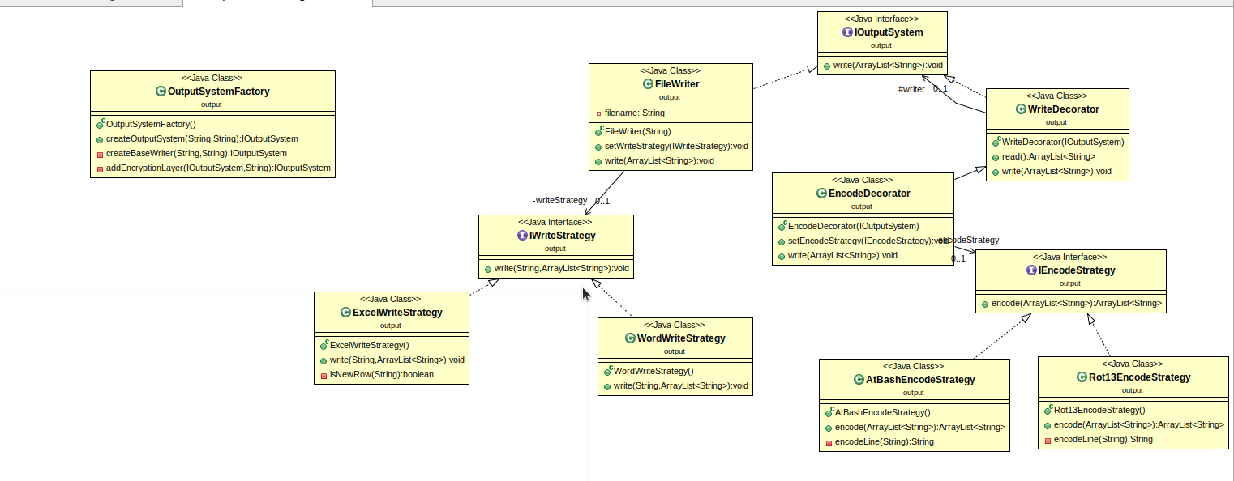

View Diagram:
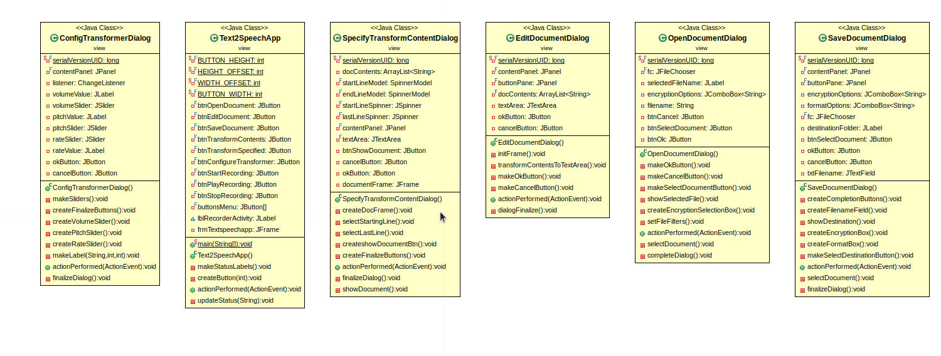

Class Name: ConfigureTransformerCmd.java
Responsibilities:  - Gives the user the ability to configure the pitch, rate and volume. | Collaborations:  - Document  - TTSFacade  - ICommand

Class Name: EditDocumentCmd.java
Responsibilities:  - Gives the user the ability to edit the contents of the file. | Collaborations:  - Document  - ICommand

Class Name: OpenDocumentCmd.java
Responsibilities:  - The user chooses the file he wants to open and the type of encryption. | Collaborations:  - Document  - ICommand

Class Name: PlayRecordingCmd.java
Responsibilities:  - Replays the recorded commands. | Collaborations:  - ICommand

Class Name: RecordManager.java
Responsibilities:  - Checks if the recording is activated or not. | Collaborations:

Class Name: SaveDocumentCmd.java
Responsibilities:  - Saves the contents of the file that the user opened. | Collaborations:  - Document  - ICommand

Class Name: StartRecordingCmd.java
Responsibilities:  - Uses the activate method of the RecordManager class so that the recording can begin. | Collaborations:  - ICommand

Class Name: StopRecordingCmd.java
Responsibilities:  - Uses the deactivate method of the RecordManager class to stop the recording. | Collaborations:  - ICommand

Class Name: TransformContentsCmd.java
Responsibilities:  - Transforms the contents of the file to audio. | Collaborations:  - ICommand  - Document

Class Name: TransformSpecifiedTextCmd.java
Responsibilities:  - Transforms specific lines of the file to audio. | Collaborations:  - Document  - ICommand

Class Name: AtBashDecodeStrategy.java
Responsibilities:  - Implements the IDecodeStrategy and decodes the Atbash encoded file. | Collaborations:  - IDecodeStrategy

Class Name: BaseReadDecorator.java
Responsibilities:  - For future extensions if additional decorators are needed. | Collaborations:  - IInputSystem

Class Name: DecodeDecorator.java
Responsibilities:  - Dynamically add decode function to reader. | Collaborations:  - BaseReadDecorator

Class Name: ExcelReadStrategy.java
Responsibilities:  - Reads the Excel type files. | Collaborations:  - IReadStrategy

Class Name: FileReader.java
Responsibilities:  - Main file reading class. | Collaborations:  - IInputSystem

Class Name: InputSystemFactory.java
Responsibilities:  - Constructs input system based on past parameters. | Collaborations:  - IInputSystem  - DecodeDecorator

Class Name: Rot13DecodeStrategy.java
Responsibilities:  - Implements the IDecodeStrategy and decodes the Rot13 encoded file | Collaborations:  - IDecodeStrategy

Class Name: WordReadStrategy.java
Responsibilities:  - Reads from Docx files. | Collaborations:  - IReadStrategy

Class Name: Document.java
Responsibilities:  - The document represents the contents of the file. | Collaborations:  - IInputSystem  - InputSystemFactory  - IOutputSystem  - OutputSystemFactory

Class Name: FakeTTSFacade.java
Responsibilities:  - The FakeTTSFacade class is a subclass of the TTSfacade and stores the text given to the play method inside the playedContents variable. | Collaborations:  - TTSFacade

Class Name: TTSFacade.java
Responsibilities:  - In the TTSFacade class is where we use the freetts jar files to transform to audio. | Collaborations:

Class Name: AtBashEncodeStrategy.java
Responsibilities:  - This class encodes the contents of the file back to AtBash. | Collaborations:  - IEncodeStrategy

Class Name: EncodeDecorator.java
Responsibilities:  - Dynamically add the encoding function to writer. | Collaborations:  - WriteDecorator

Class Name: ExcelWriteStrategy.java
Responsibilities:  - Write to xlsx files. | Collaborations:  - IWriteStrategy

Class Name: FileWriter.java
Responsibilities:  - Base class for writing to files. | Collaborations:  - IOutputSystem

Class Name: OutputSystemFactory.java
Responsibilities:  - Constructs the output system. | Collaborations:  - IOutputSystem  - EncodeDecorator

Class Name: Rot13EncodeStrategy.java
Responsibilities:  - Encodes the contents of the file back to Rot13. | Collaborations:  - IEncodeStrategy

Class Name: WordWriteStrategy.java
Responsibilities:  - Write to .docx files | Collaborations:  - IWriteStrategy

Class Name: WriteDecorator.java
Responsibilities:  - For future extensions if additional decorators are needed. | Collaborations:  - IOutputSystem

Class Name: Text2SpeechApp.java
Responsibilities:  - Main gui window. | Collaborations:  - OpenDocumentDialog  - EditDocumentDialog  - SaveDocumentDialog  - TransformContentsCmd  - SpecifyTransformContentDialog  - ConfigTransformerDialog  - StartRecordingCommand  - PlayRecordingCmd  - StopRecordingCmd

Class Name: OpenDocumentDialog.java
Responsibilities:  - Window for opening files. | Collaborations:  - OpenDocumentCmd

Class Name: EditDocumentDialog.java
Responsibilities:  - Window for adding content to document. | Collaborations:  - Document  - EditDocumentCmd

Class Name: SaveDocumentDialog.java
Responsibilities:  - Window for saving content to output file. | Collaborations:  - SaveDocumentCmd

Class Name: SpecifyTransfContentsDialog.java
Responsibilities:  - Window for specifying lines for speech transformation. | Collaborations:  - Document  - TransformSpecifiedTextCmd

Class Name: ConfigTransformerDialog.java
Responsibilities:  - Window for configuring transformer | Collaborations:  - ConfigureTransformerCmd

Σχόλια:
Όταν ο χρήστης χρησιμοποιεί την openDocument, τα contents του προηγούμενου αρχείου επικαλύπτονται από το νέο. Σε πραγματικό σενάριο, κατά το review του κώδικα θα έπρεπε να ρωτάμε αν αυτή είναι η επιθυμητή λειτουργία ή όχι.Αυτό ωφείλεται στο singleton pattern που χρησιμοποίησαμε για την κλάση Document.
Οι αλγόριθμοι AtBash και Rot13 κατά την κωδικοποίηση/αποκωδικοποίηση χρησιμοποιούν τον ίδιο ακριβώς αλγόριθμο. Ίσως θα ήταν καλύτερο να κρατάμε μέσα σε μία κλάση την συνολική τεχνική, αντί για μια κλάση κωδικοποίηση και μια κλάση αποκωδικοποίηση. Αυτό όμως δημιουργεί πρόβλημα με τα interfaces.
Δεν κατασκευάσαμε την κλάση CommandsFactory καθώς το κάθε command έπαιρνε διαφορετικό αριθμό, τύπο ή και καθόλου παραμέτρους.
Το TTSFacade είναι ολοκληρωμένο αλλά παίρνει πολύ ώρα να κάνει το transform αντί αυτού έχουμε βάλει ένα print για να εκτυπώνει τα περιεχόμενα του αρχείου που φτάνουν για μετατροπή.

