Assignment 2 (SSD)
Report

The pictures are the out put of the network trained for 100 with threshold of 0.7 and overlap of 0.3 epochs from training and testing sets (left to right).

- Visualization of the network output on an image with at least one cat object, before non maximum suppression.

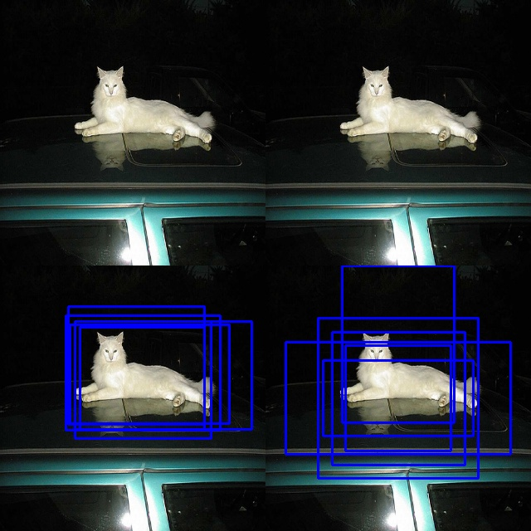
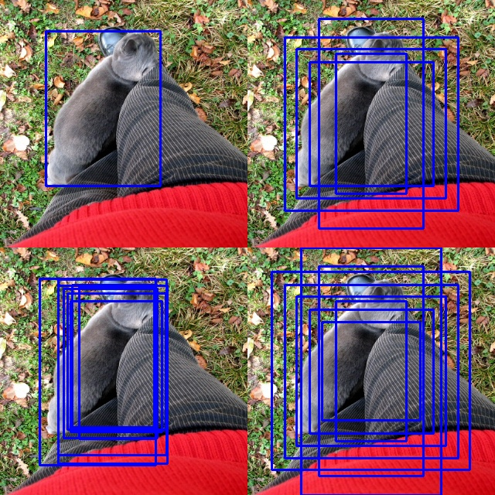

- Visualization of the network output on an image with at least one dog object, before non maximum suppression.
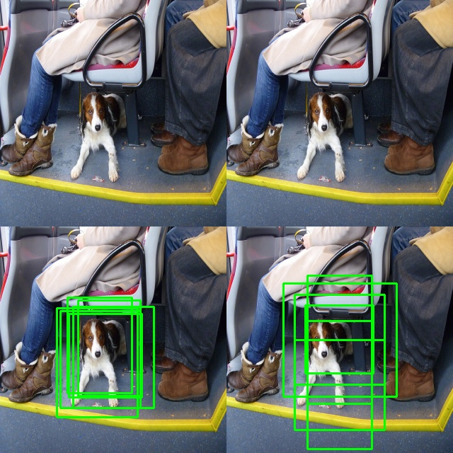
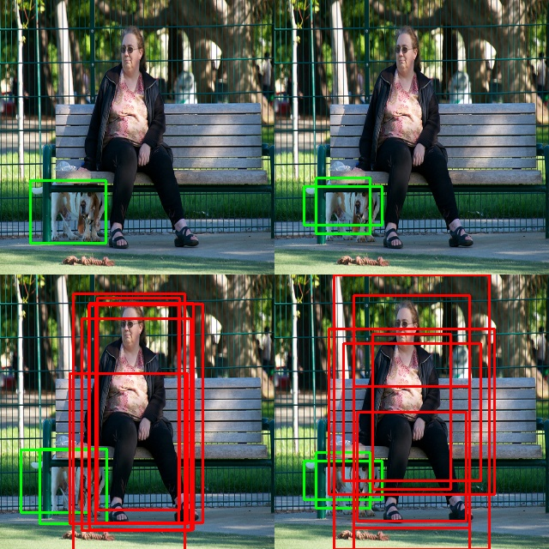

- visualization of the network output on an image with at least one person object, before non maximum suppression.
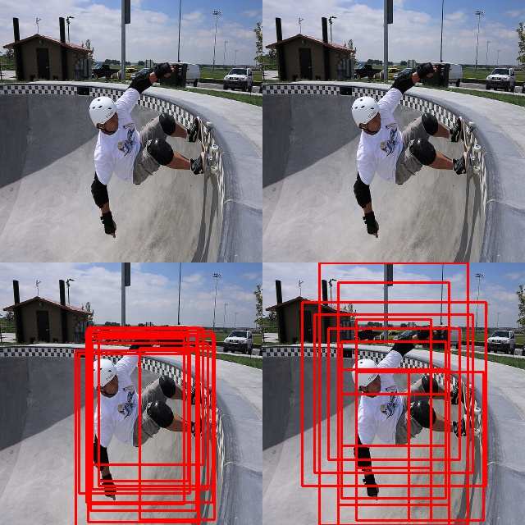
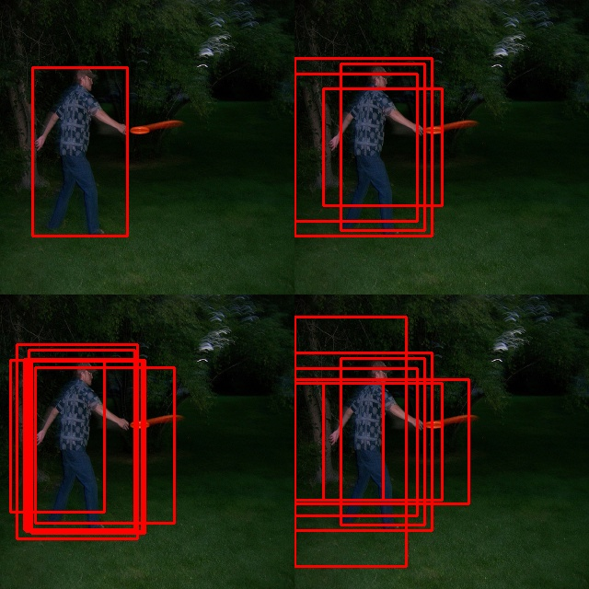

- visualization of the network output on an image with at least two person objects, before non maximum suppression.
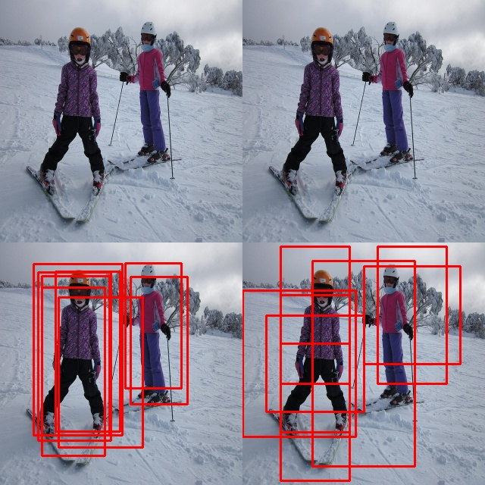
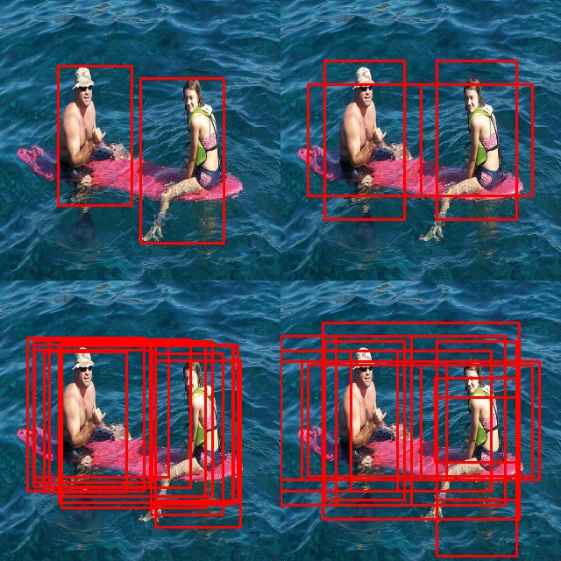

- visualization of the network output on an image with at least one cat object, after non maximum suppression.
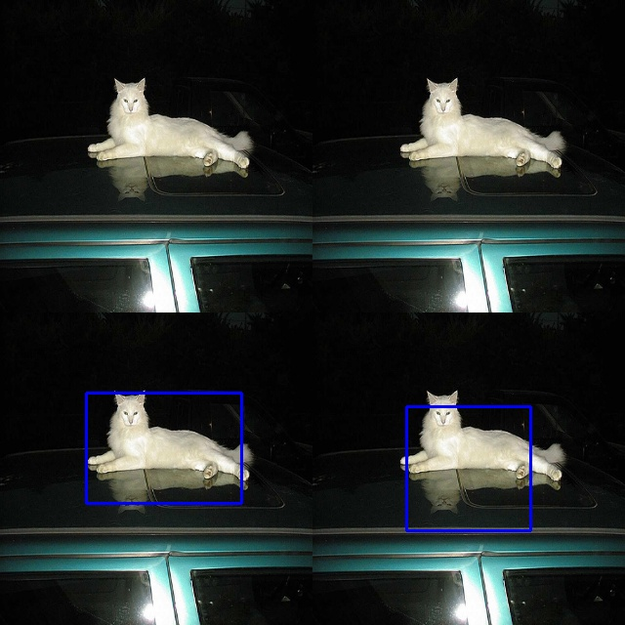
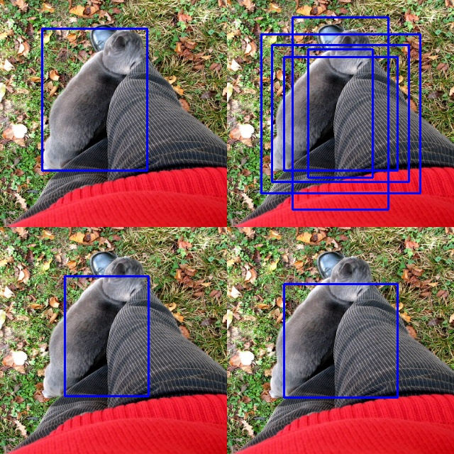

- visualization of the network output on an image with at least one dog object, after non maximum suppression.

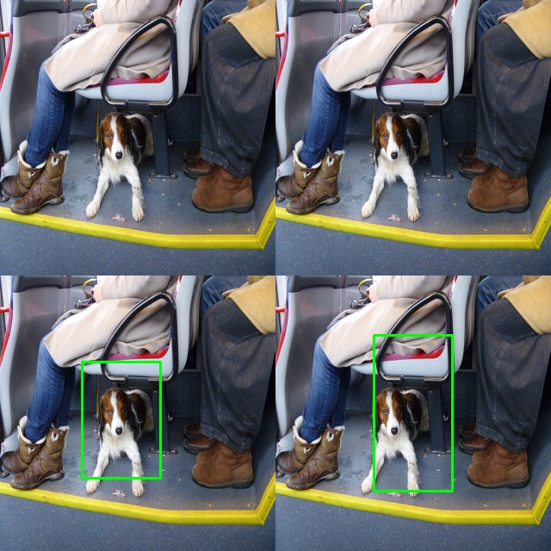
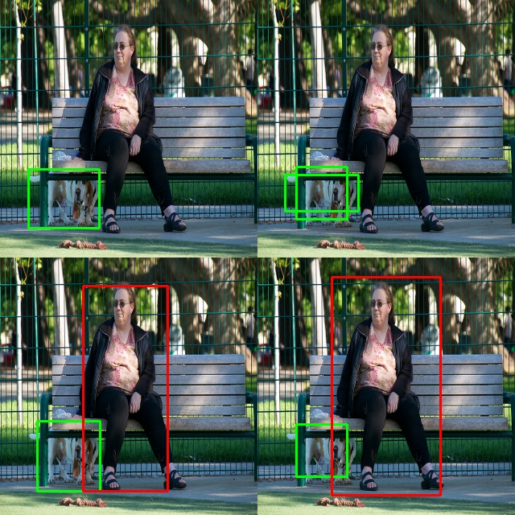

- visualization of the network output on an image with at least one person object, after non maximum suppression.
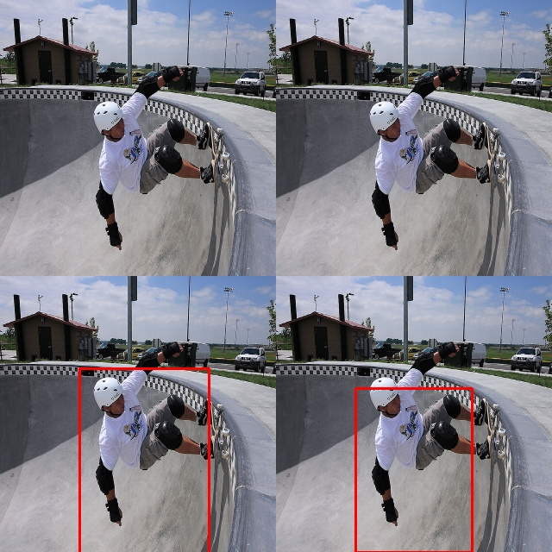
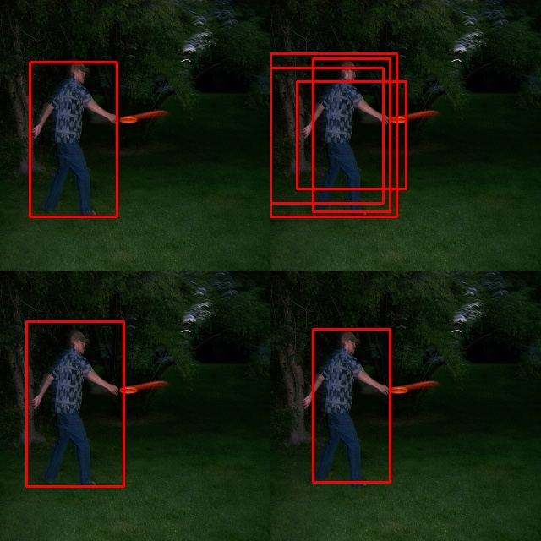

- visualization of the network output on an image with at least two person objects, after non maximum suppression.
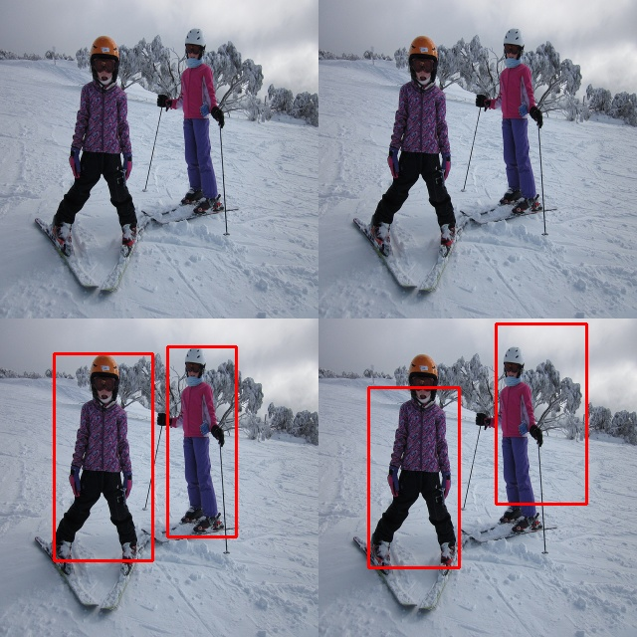
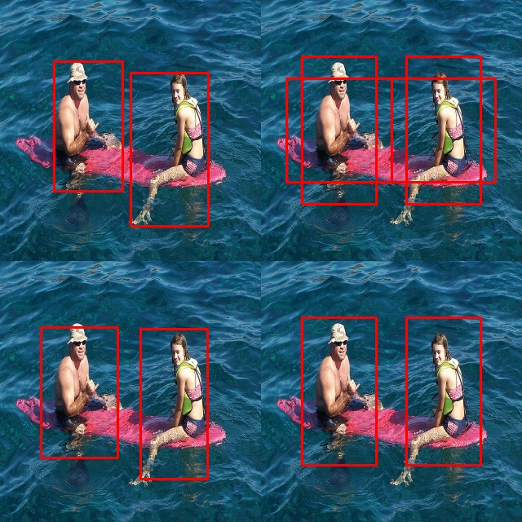

- The model training time was approximately 90 second per epoch. Therefore it took around 2 and half hours to train the model for 100 epochs on RTX 2080 GPU.

- I started implementing YOLO on March third. The SSD implementation was finished on March 12th. I worked average 6 hours per day on both YOLO and SSD combined.

- I think the assignment was 9 from 10 in terms of difficulty. Because it had lots of different logics that are not that hard theoriticaly but really tricky to implement correctly, such as NMS and updating the ground truth bounding boxes after applying data augmentation. The SSD model was also complicated and confiusing to implement.

