Product requirements document
PRD Forge Viewer
The author reads the whole PRD and its grades in one place, sees changes as they happen, and sends stakeholders a themed export marked with its version and draft status.

Version | 0.7.0
Status | draft
Owner | Richard Hightower
Domain | software product management
Created | 2026-10-26
Updated | 2026-10-31
Golden thread | J-001
Stakeholders | • Engineering lead (PER-003)  • Product sponsor (PER-004)  • Developers (PER-002, PER-005)

Executive summary
Problem | A PRD Forge set is 18 linked files. Authors cannot read it as one document or see all grades at once, and stakeholders without the authoring tools cannot read it, so feedback waits.
Users | PRD authors and developers who use the authoring tools, and the engineering lead, sponsor, and developers who read the exported PRD.
Why now | The authoring tools had their first release in October 2026, and teams adopt them only if stakeholders can review a PRD without them.
Bet | The author reads the whole PRD and its grades in one place, sees changes as they happen, and sends stakeholders a themed export marked with its version and draft status.
Measure | Median days from sending a PRD version to the first stakeholder feedback: target 2 days or less by 2027-03-31; baseline about 10 days (owner estimate).

Contents
§ | Section | Status | Grade | Blocking
1 | Problem and opportunity | final | 83/100 | —
2 | Target customer and market | final | 85/100 | —
3 | Objectives and success metrics | final | 83/100 | —
4 | Users and personas | final | 86/100 | —
5 | User journeys | final | 90/100 | —
5 | Scenarios | final | 81/100 | —
6 | Scope | final | 92/100 | —
7 | Functional requirements | final | 88/100 | —
7 | Wireframes | final | 97/100 | —
8 | Non-functional requirements | final | 82/100 | —
9 | Constraints | final | 85/100 | —
10 | Decision rights | final | 88/100 | —
11 | Assumptions, risks, and dependencies | review | 96/100 | —
12 | Open questions | draft | — | —
13 | Release plan | review | 96/100 | —
14 | Glossary | draft | — | —
15 | Change log | draft | — | —

About this document
PRD authors cannot read an 18-file PRD Forge set as one document or see every grade at once. Stakeholders without the authoring tools cannot read it at all, so feedback waits. The viewer shows the whole set and its grades in one place, shows changes as the authoring tools make them, searches, and makes themed export files marked with the version and draft status (formats in IN-006). Release 1 is due 2026-11-06 and delivers J-001, the golden thread. Success is feedback within 2 days of sending a version, by 2027-03-31.
Section | Document
1 | Problem and opportunity
2 | Target customer and market
3 | Objectives and success metrics
4 | Users and personas
5 | User journeys and Scenarios
6 | Scope
7 | Functional requirements
7 | Wireframes
8 | Non-functional requirements
9 | Constraints
10 | Decision rights
11 | Assumptions, risks, and dependencies
12 | Open questions
13 | Release plan
14 | Glossary
15 | Change log

Section 1

Problem and opportunity
final · 83/100 · no blocking defects
The authoring tools are new. They help teams write PRDs as a PRD set of 18 linked files. The authoring tools had 10 releases from 2026-10-26 to 2026-10-28, and 126 people cloned them in the 14 days to 2026-10-28. Both counts come from the public release and traffic pages of the repository of the authoring tools, read on 2026-10-28. Only the PRD owner has read this PRD, as the author and as the sponsor.
ID | Problem | Who
P-001 | To discuss one item, the author must first find which of 18 files holds it | PER-001, PER-002
P-002 | The author packages each version by hand before a stakeholder can read it | PER-001, PER-003, PER-004, PER-005
P-003 | To find the weak sections, the author opens each section and its grade note | PER-001

P-001. The author must find which file holds an item
To discuss one requirement or one scenario, the author or a developer must first find which of the 18 files holds it. The files give no picture of the whole PRD.
- Evidence. This set holds 25 functional requirements, 12 scenarios, and 10 non-functional requirements in 18 files, about 176 KB of text. In one review, the PRD owner searched for an item about 10 times, about 3 minutes each (owner estimate, 2026-10-28, Q-009).
- Status quo. The author and the developers open the files one at a time and search them for the id.
- Why now. 126 people cloned the authoring tools in 14 days. Each person who writes a PRD with them gets the same 18 files to search.
- Cost of inaction. About 30 minutes of searching in each review.
- Desired outcome. The author and the developers find any item without knowing which file holds it (O-001).

P-002. The author packages each version by hand
A stakeholder without the authoring tools sees raw text. Feedback waits until the author packages the PRD and sends it.
- Evidence. The only copy that the authoring tools make comes from a command line, holds the whole set, and has one fixed appearance. The historic PRDs took about 10 calendar days to the first stakeholder feedback. To package one version by hand takes 2 to 4 hours (owner estimate, 2026-10-28). This PRD does not count for review time, because it is for a new tool and only the PRD owner has read it. The number of stakeholders per PRD is not known (Q-002).
- Status quo. The author copies the sections into one document by hand, or sends the whole set from the command line. A reader gets every section, also the ones that the reader does not need.
- Why now. Versions 0.4.0 and 0.5.1 of this set followed releases of the authoring tools, and each version needs a new copy.
- Cost of inaction. About 3 hours of the author's time to package each version, and about 10 calendar days to the first feedback, as on the historic PRDs, against a 2-day target (O-001).
- Desired outcome. Stakeholders read each version without the authoring tools, and give feedback within 2 days (O-001).

P-003. To find the weak sections, the author opens each section
To find the weak sections, the author must open each graded section and its grade note, 14 of each in this set. No single place shows which sections have blocking defects.
- Evidence. The sponsor approved version 0.3.2 while the functional requirements had 1 blocking defect (ST-008 had no must requirement). The defect stayed open until version 0.4.0. Version 0.4.0 changed 11 sections, 9 of them graded.
- Status quo. The author opens each section and its grade note to find the weak sections.
- Why now. The authoring tools changed their checks on 2026-10-27 and 2026-10-28. The sponsor approved each of versions 0.3.0 to 0.5.0 within one day of the day it was written, so the author must know the weak sections within that day.
- Cost of inaction. 1 blocking defect stayed open in 3 versions over 2 days, and all 3 versions (0.3.2, 0.3.3, and 0.3.4) were approved with it. The adversarial grade found it.
- Desired outcome. The author knows which sections are weak without opening each one, and fixes blocking defects before stakeholders see a version (O-002).
P-001
Statement | To discuss one requirement or one scenario, the author or a developer must first find which of the 18 files holds it. The files give no picture of the whole PRD, so each discussion starts with a search through them.
Who | PRD author (PER-001), and a developer who uses the authoring tools (PER-002)
Persona | PER-001
Evidence | Claim: A PRD set has 18 files: one index and 17 section documents.  Source: The document layout of the authoring tools, version 1 (C-003)  Claim: This PRD set holds 25 functional requirements, 12 scenarios, and 10 non-functional requirements in 18 files, about 176 KB of text.  Source: Count of this PRD set by the PRD owner  As of: 2026-10-28  Claim: In one review of this PRD, the PRD owner searched the files for an item about 10 times, about 3 minutes each time.  Source: PRD owner estimate, answer to Q-009  As of: 2026-10-28
Status quo | The author and the developers open the files one at a time and search them for the id.
Why now | 126 people cloned the authoring tools in the 14 days to 2026-10-28 (public release and traffic pages of the repository of the authoring tools, read 2026-10-28). Each person who writes a PRD with them gets the same 18 files to search.
Cost of inaction | About 30 minutes of searching in each review of a PRD: about 10 searches, about 3 minutes each (PRD owner estimate, 2026-10-28, Q-009).
Desired outcome | The author and the developers find any item of a PRD set without knowing which file holds it (O-001).

P-002
Statement | The author must package each PRD version by hand before a stakeholder without the authoring tools can read it, and the stakeholder's feedback waits for that copy.
Who | PRD author (PER-001), and the readers of the copy (PER-003, PER-004, PER-005)
Persona | PER-001
Evidence | Claim: A PRD set is plain-text files with machine-readable headers. A reader without the authoring tools sees raw text.  Source: The document layout of the authoring tools, version 1 (C-003)  Claim: The only copy that the authoring tools make today comes from a command line inside them. It has one fixed appearance and holds the whole set.  Source: The authoring tools, current release  As of: 2026-10-28  Claim: The historic PRDs, written before the authoring tools, took about 10 calendar days to the first stakeholder feedback.  Source: PRD owner, from the historic PRDs, confirmed 2026-10-28  As of: 2026-10-28  Claim: To package one PRD version for stakeholders by hand takes the author 2 to 4 hours, about 3 hours.  Source: PRD owner estimate  As of: 2026-10-28  Claim: This PRD does not count for review time. It is for a new tool, and only the PRD owner has read it, as the author and as the sponsor.  Source: PRD owner  As of: 2026-10-28  Claim: The number of stakeholders for each PRD, and how many have the tools, is not known. See Q-002.  Source: PRD owner  As of: 2026-10-26
Status quo | The author copies the sections into one document by hand, or runs the command-line copy and sends the whole set. A reader then gets every section, also the ones that the reader does not need.
Why now | The authoring tools had 10 releases from 2026-10-26 to 2026-10-28 (public release and traffic pages of the repository of the authoring tools, read 2026-10-28). Versions 0.4.0 and 0.5.1 of this set followed two of those releases, and each new version needs a new copy for the stakeholders.
Cost of inaction | About 3 hours of the author's time to package each PRD version (owner estimate, 2026-10-28), and about 10 calendar days to the first stakeholder feedback, as on the historic PRDs, against a target of 2 days (O-001).
Desired outcome | Stakeholders read each PRD version without the authoring tools, and they give feedback within 2 days (O-001).

P-003
Statement | To find the weak sections, the author must open each graded section and its grade note, 14 of each in this set. No single place shows which sections have blocking defects.
Who | PRD author (PER-001)
Persona | PER-001
Evidence | Claim: This set keeps a score, a count of blocking defects, and a grade date in 14 of its 17 section documents, and the findings for each of them in a separate grade note, 14 notes in all.  Source: This PRD set  As of: 2026-10-28  Claim: The sponsor approved version 0.3.2 while the functional requirements had 1 blocking defect (ST-008 had no must requirement). The defect stayed open in versions 0.3.2, 0.3.3, and 0.3.4, until version 0.4.0 changed the release line.  Source: The change log of this PRD set (section 15), versions 0.3.2 to 0.4.0  As of: 2026-10-27  Claim: Version 0.4.0 of this set changed 11 sections. 9 of them are graded sections.  Source: The change log of this PRD set (section 15), version 0.4.0  As of: 2026-10-27
Status quo | The author opens each section and its grade note to find the weak sections.
Why now | The authoring tools changed their checks twice in two days: release 0.8.1 on 2026-10-27 and release 0.9.0 on 2026-10-28 (change log, versions 0.4.0 and 0.5.1). The sponsor approved each of versions 0.3.0 to 0.5.0 within one day of the day it was written, so the author must know the weak sections within that day.
Cost of inaction | 1 blocking defect stayed open in 3 versions over 2 days, 2026-10-26 to 2026-10-27, and all 3 versions (0.3.2, 0.3.3, and 0.3.4) were approved with it. The adversarial grade found it.
Desired outcome | The author knows which sections are weak without opening each section, and fixes blocking defects before stakeholders see a version (O-002).

Section 2

Target customer and market
final · 85/100 · no blocking defects
The viewer is free and open source for anyone who uses the authoring tools. The PRD owner decided this on 2026-10-26. Nobody buys it. The market is the people who use the authoring tools (S-001), 126 of whom cloned them in the 14 days to 2026-10-28, and the readers of their PRDs (S-002).
ID | Segment | Buyer | User | Size
S-001 | People who use the authoring tools | Nobody buys. The author decides to install (PER-001) | PER-001, PER-002 | 126 people cloned the tools in 14 days, to 2026-10-28
S-002 | Stakeholders who read PRDs made with the authoring tools | No buyer. Each reader decides | PER-003, PER-004, PER-005 | Not known (Q-002)

The S-001 count is of people who use the tools, not of authors only. It can be high, because one person can clone from more than one computer and automated clones count. It can also be low, because it leaves out people who got the tools earlier. Release 1 runs on macOS only (OUT-003), which limits adoption.
Substitute | Kind | Our edge
A copy that the author packages by hand | status quo | A stakeholder-ready copy in seconds (NFR-004, p95), not 2 to 4 hours (P-002)
A shared online document | direct | Each export shows its version, draft mark, and scores. No network transfer. No comments
A script that the team writes | build in house | Scores, version, and draft mark in each export, with no script to maintain
The command-line copy | indirect | A developer exports only the sections for the current work
The stepper pane | indirect | A reader without the authoring tools reads the export

Why we win, in the author's words: "Show me what is weak, then let me send it today." The viewer shows every grade in one view, and has a copy ready in seconds, not after 2 to 4 hours of packaging by hand.

Segments
S-001 People who use the authoring tools
Buyer | Nobody buys it. The viewer is free and open source. The PRD author decides to install it.
Buyer persona | PER-001
User | PER-001, PER-002
User personas | • PER-001  • PER-002
Size | 126 people cloned the authoring tools in the 14 days to 2026-10-28, in 294 clones. The count is of people who use the tools, authors and developers, not of authors only. The count can be high, because one person can clone from more than one computer and automated clones count. It can also be low, because it leaves out people who got the tools before that period. The number of teams is not known (R-002).
Size source | GitHub traffic page of the authoring tools, https://github.com/SpillwaveSolutions/prd-forge, read by the PRD owner
Size as of | 2026-10-28
Size method | bottom-up
Size unit | people
Willingness to pay | None needed. The viewer is free.
Adoption barriers | • Release 1 runs on macOS only (OUT-003).  • The author must install one more app beside the authoring tools.

S-002 Stakeholders who read PRDs made with the authoring tools
Buyer | No buyer. Nobody buys it, and no one decides for the readers. Each reader decides to install the free viewer, or reads only the copy that the author sends.
User | PER-003, PER-004, PER-005
User personas | • PER-003  • PER-004  • PER-005
Size | Not known. Q-002 asks the PRD owner to count the reviewers of each PRD, and how many of them have the authoring tools, by 2026-11-30.
Size as of | 2026-10-28
Size unit | people
Willingness to pay | None needed. The viewer is free.
Adoption barriers | • A reader who has the copy can read the PRD without the viewer (IN-006).

Competitors
The status quo, a copy that the author packages by hand
Kind | status-quo
Offer | The author copies the sections into one document by hand and sends the file. It takes 2 to 4 hours for each version (P-002).
Our edge | The author has a stakeholder-ready copy of a new version in seconds, 10 seconds at p95 for a set of up to 18 documents (NFR-004), not after 2 to 4 hours of packaging by hand (P-002).

A shared online document that the author pastes the PRD into
Kind | direct
Offer | Stakeholders read and comment on one document in a web browser.
Our edge | Each export shows the version and the draft mark (FR-014) and the score of every section (FR-019), so the sponsor and the engineering lead can check which graded version they read. The viewer makes no network transfer (NFR-005). The viewer does not offer comments, and the shared document does.

A script that the team writes to join the files
Kind | build-in-house
Offer | The team writes and maintains its own script that joins the 18 files into one document.
Our edge | The engineering lead sees the status and score of every section (FR-019), and the sponsor sees the version and the draft mark (FR-014). The team has no script to write or maintain.

The command-line copy of the authoring tools
Kind | indirect
Offer | One PDF and one Word file of the whole set, in one fixed appearance.
Our edge | A developer sends a file with only the sections for the current work (FR-012), and the team reads it without the authoring tools, not all 18 documents.

The stepper pane of the authoring tools
Kind | indirect
Offer | Steps through the sections one at a time, inside the authoring tools.
Our edge | The author exports the set (FR-010), and a reader without the authoring tools reads it. The stepper pane works only inside the authoring tools.

Section 3

Objectives and success metrics
final · 83/100 · no blocking defects
ID | Objective | Metric | Baseline | Target | By | Owner
O-001 | Stakeholders give feedback sooner | Median days from send to first written feedback | About 10 days (owner estimate) | 2 days or less | 2027-03-31 | Richard Hightower
O-002 | Blocking defects fixed before sending | Blocking defects in a version on the day it is sent | 1 (this PRD, 0.2.0) | 0 | 2027-03-31 | Richard Hightower

O-001. Stakeholders give feedback on a PRD version sooner
Metric: median calendar days from the day the author sends a PRD version to a stakeholder, to the day of the first written feedback from any stakeholder on that version. Serves P-001 and P-002.
Baseline: about 10 calendar days, from the historic PRDs written before the authoring tools (PRD owner, 2026-10-26, confirmed 2026-10-28). This PRD does not count for review time, because it is for a new tool (Q-001).
Target: 2 days or less by 2027-03-31. Owner: Richard Hightower, PRD owner.

O-002. Authors fix blocking defects before stakeholders see a version
Metric: the count of blocking defects in a PRD version on the day the author sends it. Serves P-003. Baseline: 1, in version 0.2.0 of this PRD. Target: 0 in every version sent, by 2027-03-31.

Objectives
O-001 Stakeholders give feedback on a PRD version sooner.
Problems | • P-001  • P-002
Metric | Median calendar days from the day the author sends a PRD version to a stakeholder, to the day of the first written feedback from any stakeholder on that version.
Baseline | About 10 calendar days, from the historic PRDs written before the authoring tools (PRD owner, 2026-10-26, confirmed 2026-10-28). This PRD does not count for review time, because it is for a new tool (Q-001).
Baseline question | Q-001
Target | 2 days or less
By | 2027-03-31
Owner | Richard Hightower, PRD owner

O-002 Authors fix blocking defects before stakeholders see a version.
Problems | • P-003
Metric | Count of blocking defects in a PRD version on the day the author sends it to a stakeholder, read from the grades in the export.
Baseline | 1 blocking defect in version 0.2.0 of this PRD, sent on or after 2026-10-26.
Target | 0 blocking defects in every version sent
By | 2027-03-31
Owner | Richard Hightower, PRD owner

Section 4

Users and personas
final · 86/100 · no blocking defects
PER-001 is the primary persona. Release 1 is designed around the PRD author. The personas work in a consulting engagement: the author's firm writes the PRD, and the client's executive approves it. PER-003, PER-004, and PER-005 usually read the exported PRD. They can also use the viewer, so it must be usable without training.
ID | Persona | Uses the authoring tools | Reads the PRD in | Authority
PER-001 | PRD author, senior consultant or product lead | Yes | The viewer | Owns the PRD
PER-002 | Developer with the authoring tools | Yes | The viewer | Chooses own items and exports
PER-003 | Engineering lead, client or delivery team | Usually no | The export | Reviews
PER-004 | Product sponsor, client executive | No | The export | Approves
PER-005 | Developer without the authoring tools | No | The export | None

PER-001. PRD author
"Show me what is weak, then let me send it today." Goals: see the whole PRD and go to one section, see which sections are weak, and send the PRD to stakeholders quickly. Pains: P-001, P-002, P-003. Authority: owns the PRD and cannot approve it.

PER-002. Developer who uses the authoring tools
Goals: find the requirements, stories, and scenarios for the current work, and export a part of the PRD. Pain: P-001. Authority: chooses own items and exports; cannot approve the PRD.

PER-003. Engineering lead
Goals: decide if the team can build from the PRD, and send back what is missing. Pain: P-002. Authority: reviews, does not approve.

PER-004. Product sponsor
"Two pages, then I decide." Goal: read a short summary and approve or reject the PRD. Journey: J-003. Pain: P-002. Authority: the only persona who approves.

PER-005. Developer who does not use the authoring tools
Goal: read the sections for the current work. Pain: P-002. Authority: none.
PER-001
Name | PRD author, a senior consultant or product lead at a consulting firm, who uses the authoring tools
Short name | Author
Primary | yes
Problems | • P-001  • P-002  • P-003
Goals | • Show me what is weak, then let me send it today.  • See the whole PRD and go directly to the section under discussion  • See which sections are weak and what to fix before anyone else reads them  • Send the PRD to stakeholders quickly, in a form they can read without the tools
Pains | • The PRD is 18 files, and finding one section or one item takes a search (P-001)  • Stakeholders cannot read the files without the tools (P-002)  • Grades and gaps are spread across 17 files (P-003)
Frequency | Opens the viewer several times a day while writing a PRD (Q-003). Exports once for each version sent to stakeholders, including draft versions.
Authority | Owns the PRD. Chooses which PRD set to open. Decides its content, which sections to fix, and the status of each section, which decides the draft mark. Chooses the format, theme, and sections of an export, and which version to send to whom. Cannot approve it.
Proficiency | Expert in the business domain. Uses the authoring tools. Often not an experienced product manager.

PER-002
Name | Developer on the consulting delivery team who uses the authoring tools but did not write the PRD
Short name | ToolsDeveloper
Problems | • P-001
Goals | • Give me the requirements for my story, nothing else.  • Find the requirements, stories, and scenarios for the current work without reading the whole PRD  • Export a part of the PRD to share with the team
Pains | • Finding one requirement or scenario across 18 files takes a search (P-001)
Frequency | Not known (Q-003).
Authority | Chooses which PRD set to open. Decides which items apply to own work, and the format, theme, and sections of an export to share. Cannot approve the PRD.
Proficiency | Expert in software and in the authoring tools. May not know the business domain.

PER-003 Engineering lead on the client or delivery team that builds the product
Short name | EngineeringLead
Problems | • P-002
Goals | • Can my team build this, yes or no?  • Decide if the team can build the product from this PRD  • Find what is missing or unclear, and send it back to the author
Pains | • Does not use the authoring tools, so cannot read the set without an export (P-002)
Frequency | Reads once for each version received, including drafts.
Authority | Reviews and comments. Decides if the team can build from the PRD. Does not approve it.
Proficiency | Expert in software. Usually does not use the authoring tools.

PER-004 Product sponsor, a client executive who approves the PRD
Short name | Sponsor
Problems | • P-002
Goals | • Two pages, then I decide.  • Read a short summary and decide to approve or reject the PRD
Pains | • Cannot read the set without the authoring tools, and will not read 18 files (P-002)
Frequency | Reads once for each version received, including drafts.
Authority | Approves or rejects the PRD. The only persona who approves.
Proficiency | Expert in the business. Does not use the authoring tools. Reads a few pages only.

PER-005 Developer on the client or delivery team who does not use the authoring tools
Short name | TeamDeveloper
Problems | • P-002
Goals | • Send me the part I need.  • Read the sections that apply to the current work
Pains | • Cannot read the set without an export (P-002)
Frequency | Reads once for each version received, including drafts.
Authority | None for the PRD.
Proficiency | Expert in software. Does not use the authoring tools.

Section 5

User journeys
final · 90/100 · no blocking defects
J-001 is the golden thread: the one journey that release 1 must deliver end to end.
ID | Persona | Goal | Stages | Golden thread
J-001 | PER-001 PRD author | Stakeholders read the PRD and the author has their feedback | ST-001 to ST-007 | Yes
J-003 | PER-004 Product sponsor | The sponsor approves or rejects a version | ST-011 to ST-012 | No
J-002 | PER-002 Developer with the authoring tools | The developer has the items for the current work and shares them | ST-008 to ST-010 | No

J-001. The author sends a reviewed PRD to stakeholders
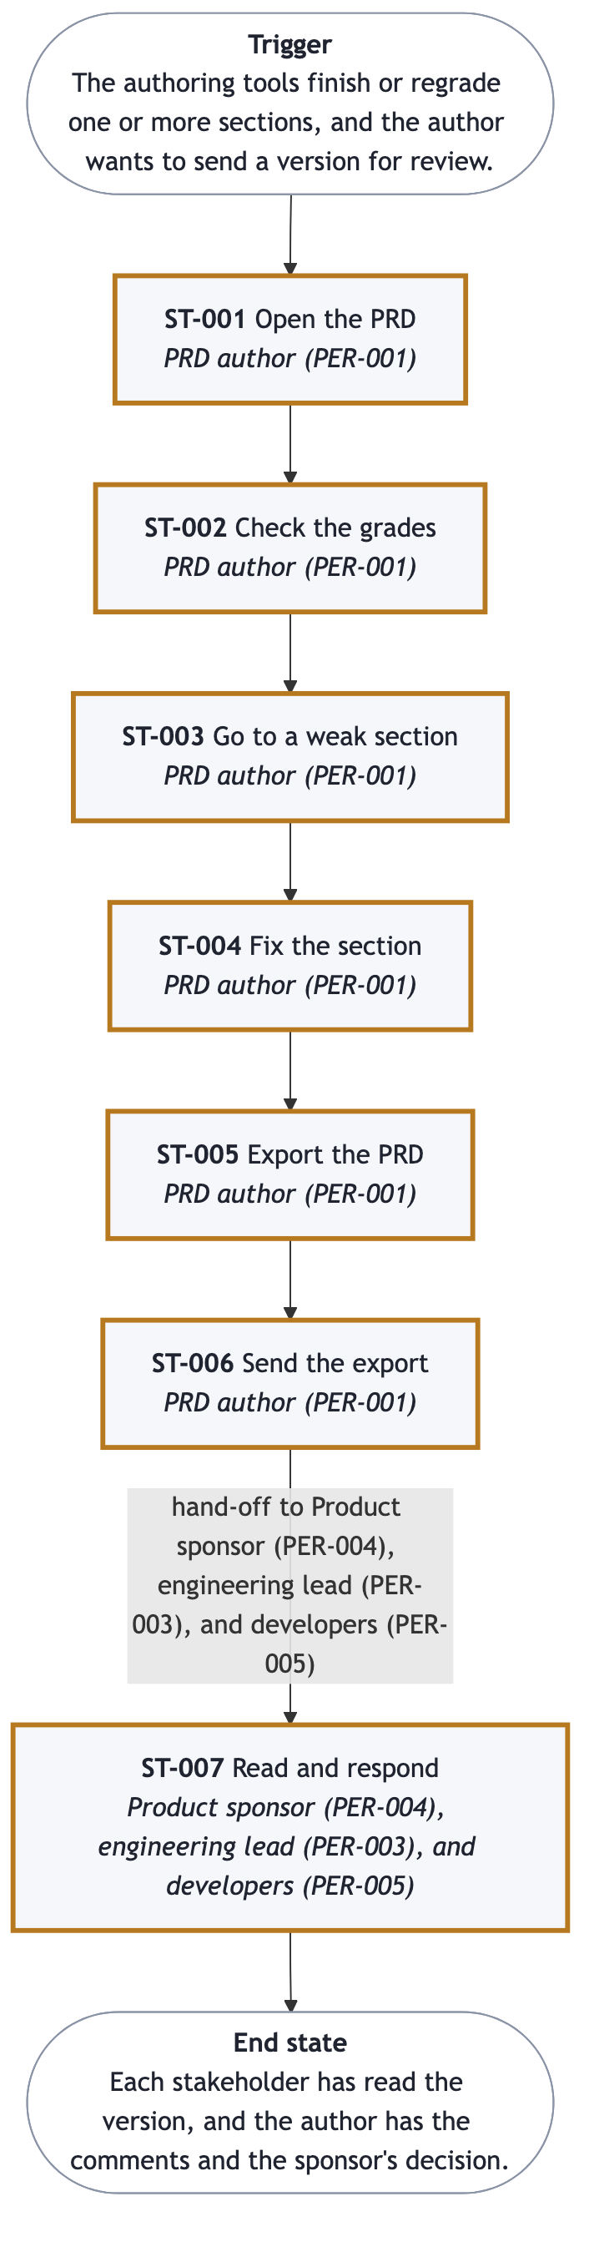
J-001 journey diagram
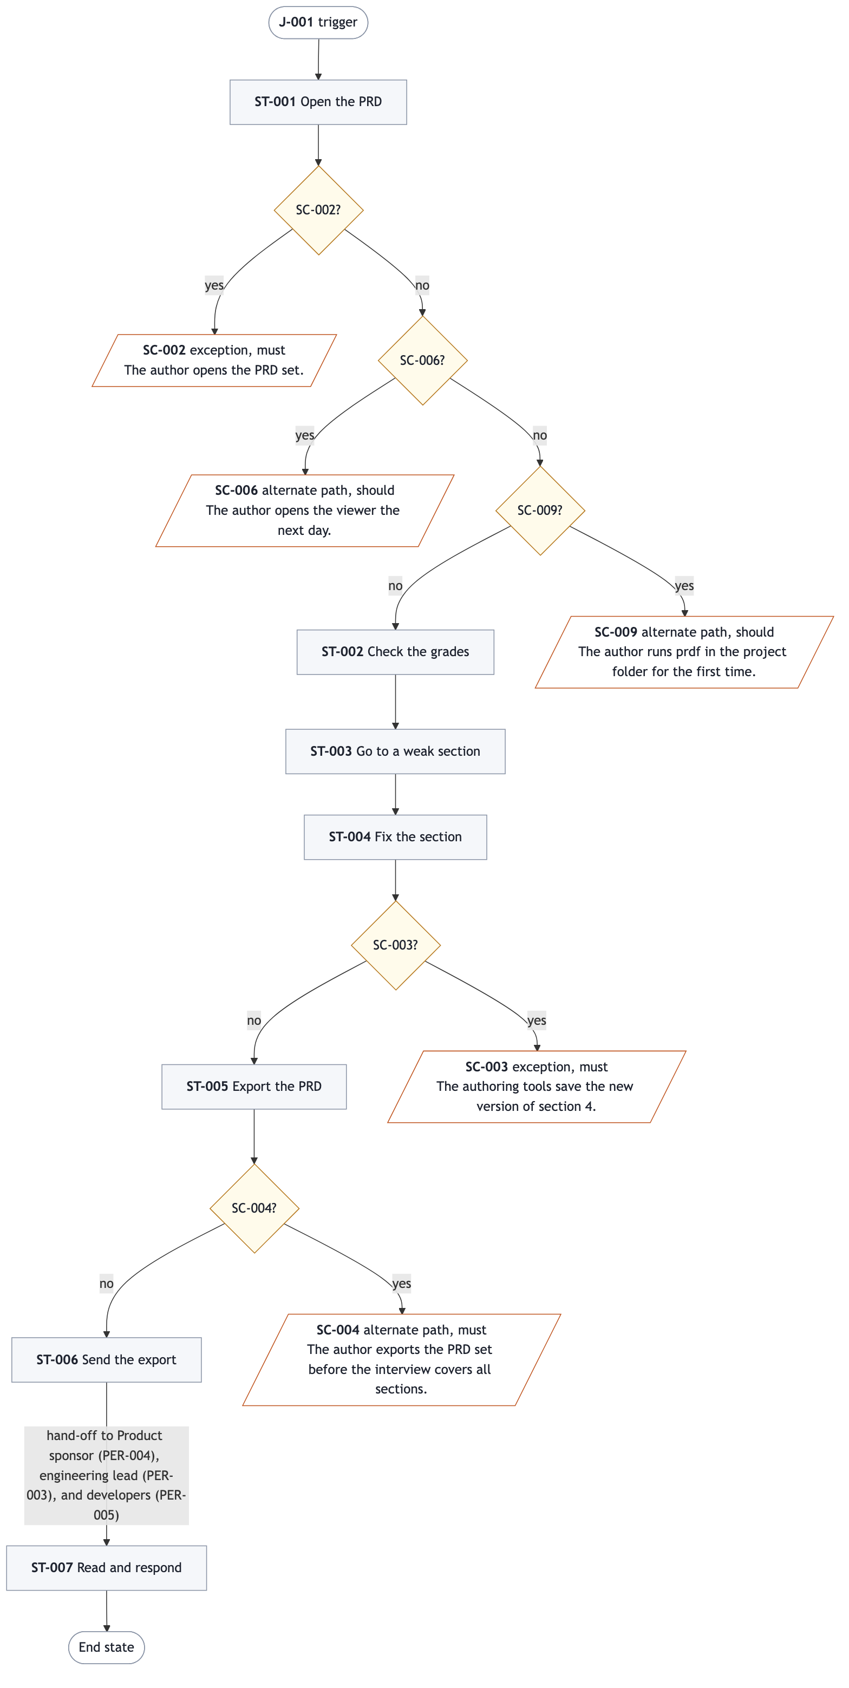
J-001 overview with its main alternate and exception paths
Trigger: the authoring tools finish or regrade sections, and the author wants to send a version for review.
Stage | Actor | Decision
ST-001. Open the PRD | PRD author | Is this the correct PRD and version?
ST-002. Check the grades | PRD author | Which sections must be fixed first?
ST-003. Go to a weak section | PRD author | Fix it now, or send it as a draft?
ST-004. Fix the section | PRD author, in the authoring tools | Is the section good enough to send?
ST-005. Export the PRD | PRD author | Which format, theme, and sections?
ST-006. Send the export | PRD author | Who receives this version?
ST-007. Read and respond | Sponsor, engineering lead, developers | Approve or reject, and comment

The author fixes sections in the authoring tools, not in the viewer. The viewer shows the change without any action from the author. ST-006 and ST-007 happen outside the viewer.
End state: each stakeholder has read the version, and the author has the comments and the sponsor's decision.

J-002. A developer finds and shares the items for the current work
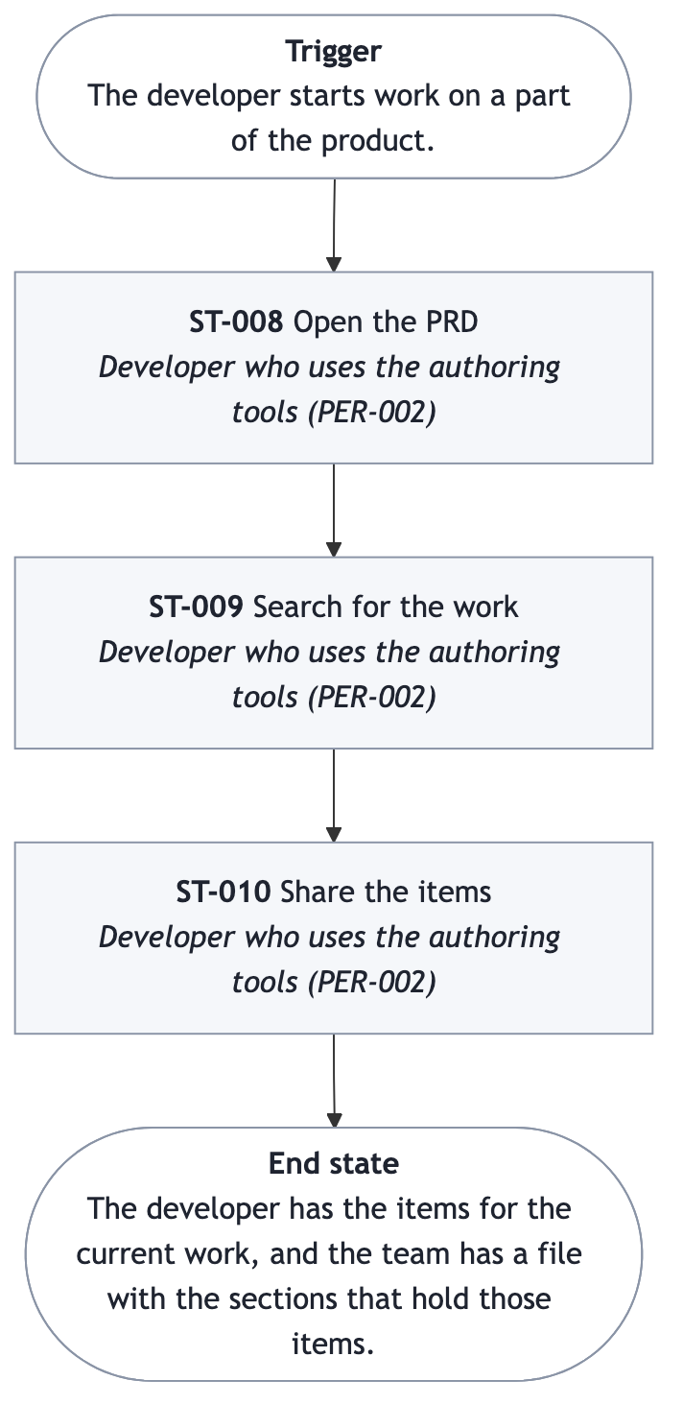
J-002 journey diagram
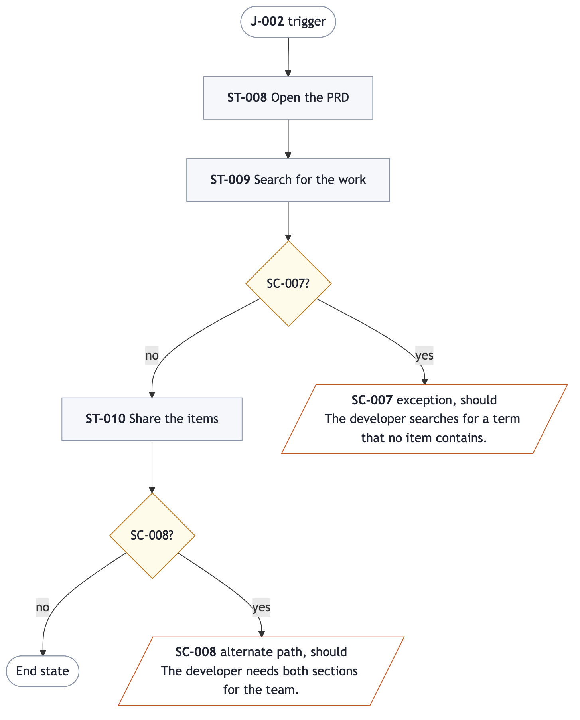
J-002 overview with its main alternate and exception paths
Trigger: the developer starts work on a part of the product.
Stage | Actor | Decision
ST-008. Open the PRD | Developer with the authoring tools | Is this the correct PRD and version?
ST-009. Search for the work | Developer with the authoring tools | Which items apply to the current work?
ST-010. Share the items | Developer with the authoring tools | Which sections does the team need?

End state: the developer has the items for the current work, and the team has a file with those items.

J-003. The sponsor approves or rejects a version
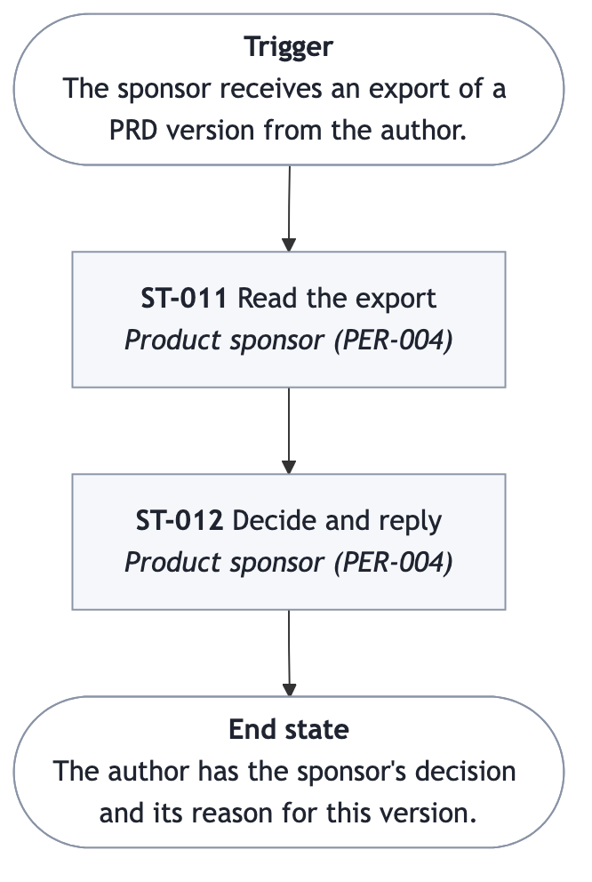
J-003 journey diagram
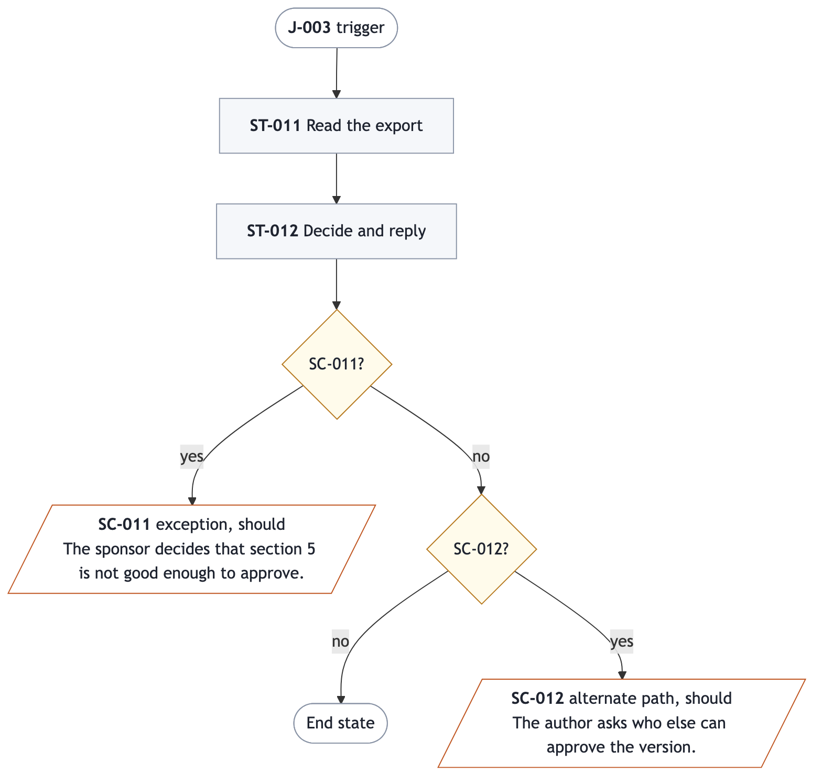
J-003 overview with its main alternate and exception paths
Trigger: the sponsor receives an export of a PRD version.
Stage | Actor | Decision
ST-011. Read the export | Product sponsor | Is there enough here to decide?
ST-012. Decide and reply | Product sponsor | Approve or reject this version

End state: the author has the sponsor's decision and its reason. Both stages happen outside the viewer. The export must carry what the sponsor needs (FR-014, FR-019).
J-001
Goal | Stakeholders have a version of the PRD they can read without the tools, and the author has their feedback.
Persona | PER-001
Trigger | The authoring tools finish or regrade one or more sections, and the author wants to send a version for review.
Golden thread | yes
Stages | Open the PRD  ID: ST-001  Actor: PRD author (PER-001)  Steps: The author opens the PRD set.; The author sees the product name, the version, the executive summary, and the status of every section.  Inputs: The PRD set  Outputs: The whole PRD, with the status of every section  Acceptance: Given a PRD set with 18 documents, when the author opens it, then the author sees the product name, the version, and the status of every document in order.  Decision: Is this the correct PRD and version?  Check the grades  ID: ST-002  Actor: PRD author (PER-001)  Steps: The author sees the score, the count of blocking defects, and the grade date for each section.; The author sees which sections are pending, draft, review, or final.  Inputs: The grades that the authoring tools recorded  Outputs: A list of the sections that are weak or not started  Acceptance: Given a set with graded and ungraded sections, when the author checks the grades, then the author sees the score, blocking count, and grade date of each graded section, and which sections are not graded.  Decision: Which sections must be fixed before anyone else reads the PRD?  Go to a weak section  ID: ST-003  Actor: PRD author (PER-001)  Steps: The author goes directly to a section, or searches for an item such as a requirement or a scenario.; The author reads the section and sees its status, score, and count of blocking defects.  Inputs: A section name, or a search term and a category  Outputs: The section or the item, with its status and grade  Acceptance: Given a weak section, when the author selects it or searches for one of its items, then the author reads it with its status, score, and blocking count.  Decision: Fix the section now, or send the PRD as a draft?  Fix the section  ID: ST-004  Actor: PRD author (PER-001)  Steps: The author fixes the section in the authoring tools, outside the viewer.; The author sees the changed section and its new grade in the viewer, without any action in the viewer.  Inputs: The author's answers to the wizard  Outputs: The changed section, with its new grade  Acceptance: Given the author reads a section in the viewer, when the authoring tools save a new version of it, then the author sees the new text and grade without any action.  Decision: Is the section good enough to send?  Export the PRD  ID: ST-005  Actor: PRD author (PER-001)  Steps: The author selects a document format that the readers open without the authoring tools.; The author selects an export theme.; The author selects the whole PRD or some sections.; The author saves or prints the export.  Inputs: The format, the theme, and the sections  Outputs: One file that a reader can open without the tools, or a printed copy  Acceptance: Given the author selects a format, a theme, and some sections, when the author exports, then the author has one file with only those sections, in that theme, that a reader opens without the authoring tools.  Decision: Which format, theme, and sections do these readers need?  Send the export  ID: ST-006  Actor: PRD author (PER-001)  Steps: The author sends the file to the stakeholders, outside the viewer.  Inputs: The exported file  Outputs: The stakeholders have the file  Acceptance: Given an exported file, when the author sends it, then each chosen stakeholder has the file.  Decision: Who receives this version?  Handoff: Product sponsor (PER-004), engineering lead (PER-003), and developers (PER-005)  Read and respond  ID: ST-007  Actor: Product sponsor (PER-004), engineering lead (PER-003), and developers (PER-005)  Steps: Each reader opens the file and sees the version, and sees if it is a draft.; The engineering lead and the developers reply with comments.; The sponsor approves or rejects the version.  Inputs: The exported file  Outputs: Comments, and the sponsor's approval or rejection  Acceptance: Given a stakeholder has the file, when the stakeholder opens it, then the stakeholder sees the version and if it is a draft, and can reply with comments or a decision.  Decision: The sponsor approves or rejects. The engineering lead decides if the team can build from it.  Handoff: PRD author (PER-001), who receives the feedback
Pain points | • The PRD is 18 files, so finding one section or item takes a search (P-001).  • The grades and gaps are in 17 separate files (P-003).  • Readers without the tools cannot read the files (P-002).  • While the authoring tools change a section, the author cannot be sure that the view is current.  • A reader of a draft cannot tell that it is a draft.
Needs | • One view of the whole PRD, with direct access to each section and a search for items.  • One view of the grades, blocking defects, and gaps of all sections.  • An export in a format that a reader opens without the tools, in a theme the author selects.  • The view shows each change to a section without any action from the author.  • The export shows the version and the status of the PRD and of each section.
End state | Each stakeholder has read the version, and the author has the comments and the sponsor's decision.

J-002
Goal | The developer has the sections and items for the current work, such as requirements, journeys, and scenarios, and can share those sections with the team.
Persona | PER-002
Trigger | The developer starts work on a part of the product.
Stages | Open the PRD  ID: ST-008  Actor: Developer who uses the authoring tools (PER-002)  Steps: The developer opens the PRD set and sees the list of sections.  Inputs: The PRD set  Outputs: The whole PRD  Acceptance: Given a PRD set, when the developer opens it, then the developer sees the version and the list of sections.  Decision: Is this the correct PRD and version?  Search for the work  ID: ST-009  Actor: Developer who uses the authoring tools (PER-002)  Steps: The developer enters a search term and selects a category, such as requirements, journeys, or scenarios, or all.; The developer sees the best matches first, each with its section and id.; The developer opens a match and follows its links to related items.  Inputs: A search term and a category  Outputs: The matching items, best match first  Acceptance: Given a search term and a category, when the developer searches, then the developer sees the matching items best first, each with its id and section, and opens one in one action.  Decision: Which items apply to the current work?  Share the items  ID: ST-010  Actor: Developer who uses the authoring tools (PER-002)  Steps: The developer exports the selected sections in a document format the team opens without the authoring tools, or prints them.; The developer sends the file to the team, outside the viewer.  Inputs: The selected sections, the format, and the theme  Outputs: One file with only those sections  Acceptance: Given the developer selects two sections, when the developer exports them, then the team has one file with only those two sections.  Decision: Which sections does the team need?  Handoff: Developers on the team (PER-005)
Pain points | • Finding one requirement or scenario in 18 files takes a search (P-001).  • The team needs only the sections for the current work, not the whole PRD.
Needs | • A search by term and category, with the best matches first.  • An export of selected sections only.
End state | The developer has the items for the current work, and the team has a file with the sections that hold those items.

J-003 The sponsor approves or rejects a version of the PRD, with a reason.
Persona | PER-004
Trigger | The sponsor receives an export of a PRD version from the author.
Stages | Read the export  ID: ST-011  Actor: Product sponsor (PER-004)  Steps: The sponsor opens the file without the authoring tools.; The sponsor sees the version and if it is a draft on the first page.; The sponsor reads the executive summary and the contents list with the status and score of each section.  Inputs: The exported file  Outputs: The sponsor knows what the PRD proposes and how complete it is  Acceptance: Given an export of a draft version, when the sponsor opens it, then the first page shows the version and the word Draft, then the summary and the status and score of every section.  Decision: Is there enough here to decide, or must the author answer questions first?  Decide and reply  ID: ST-012  Actor: Product sponsor (PER-004)  Steps: The sponsor approves or rejects the version, outside the viewer.; The sponsor sends the decision and the reason to the author.  Inputs: The sponsor's reading of the export  Outputs: An approval or a rejection, with a reason  Acceptance: Given the sponsor decided on a version, when the sponsor replies, then the author has the decision and its reason.  Decision: Approve or reject this version.  Handoff: PRD author (PER-001), who records the decision in the change log
Pain points | • The sponsor will not read 18 files to make a decision (P-002).
Needs | • One short file that starts with the version, the draft mark, the summary, and the status of every section.
End state | The author has the sponsor's decision and its reason for this version.

Section 5

Scenarios
final · 81/100 · no blocking defects
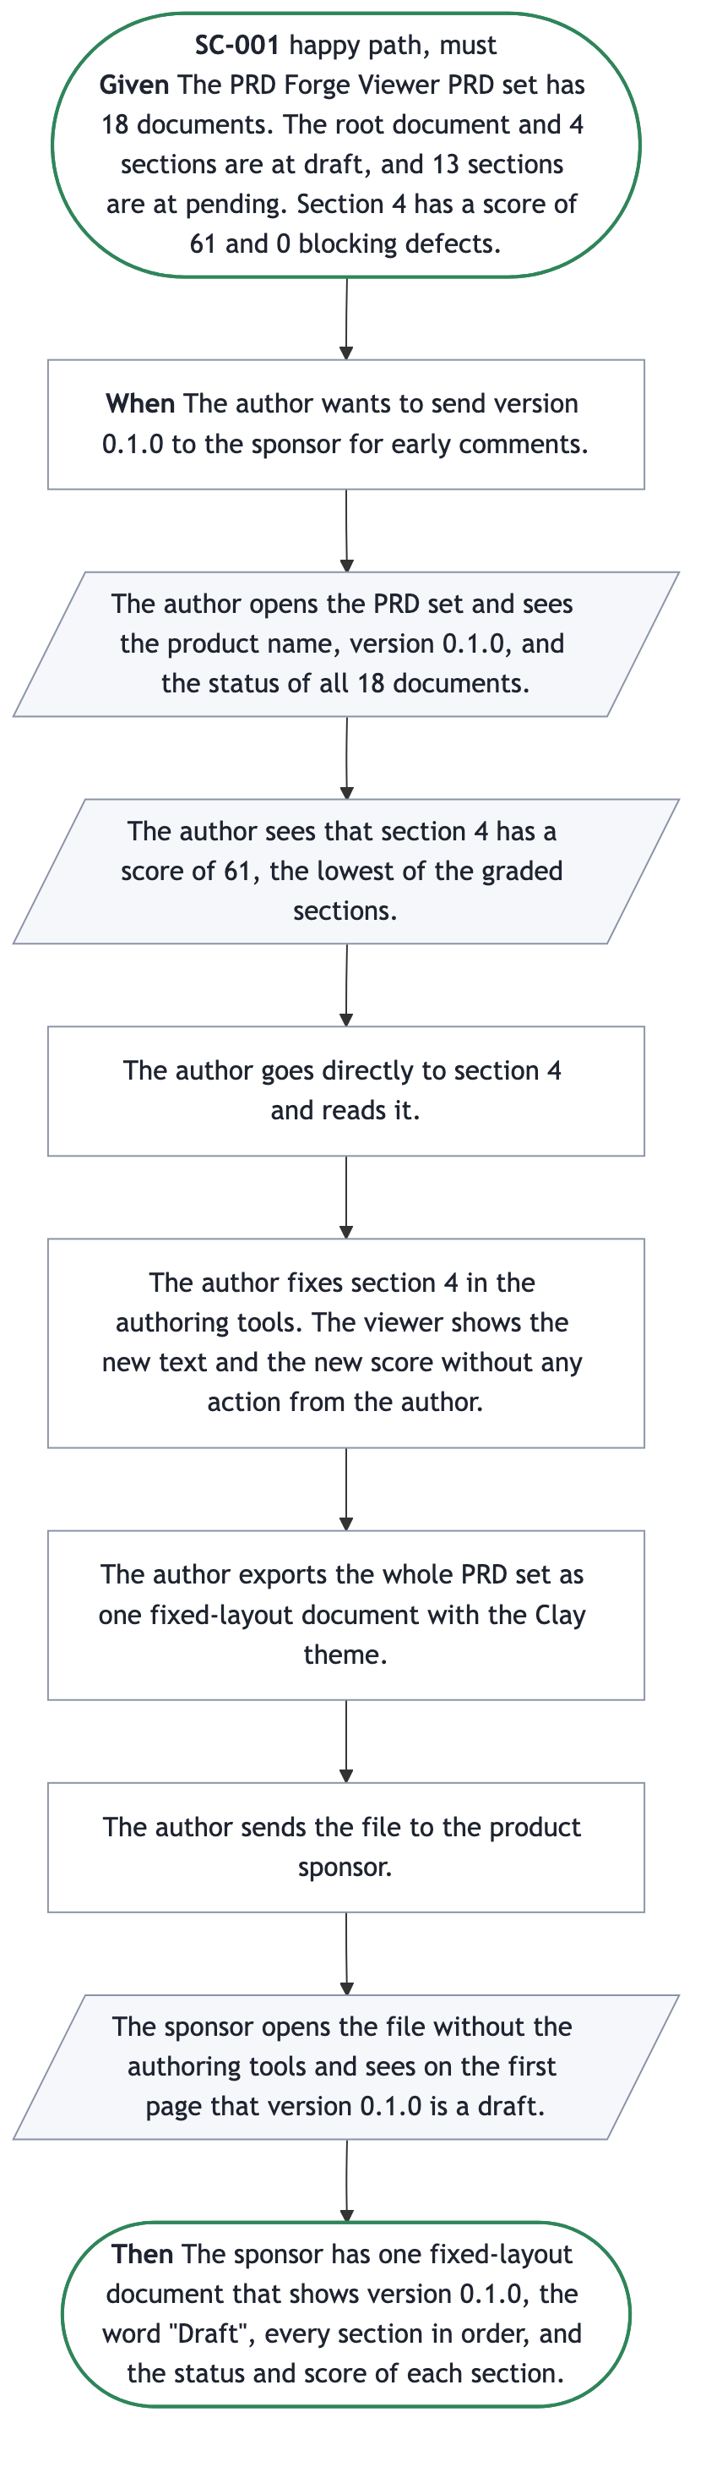
SC-001 scenario
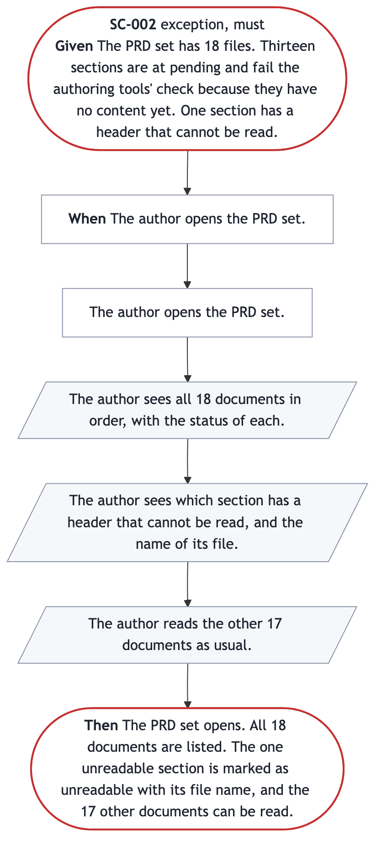
SC-002 scenario
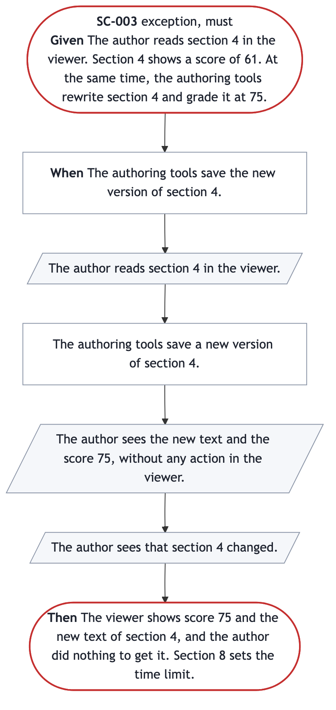
SC-003 scenario
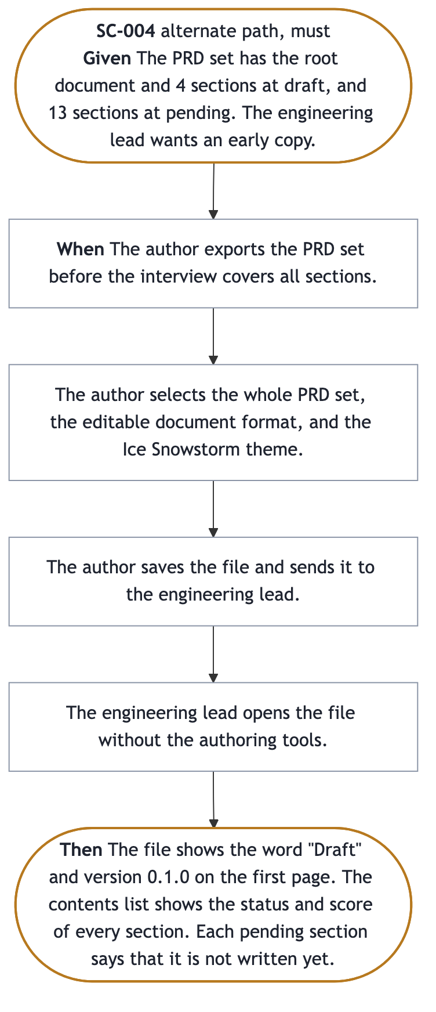
SC-004 scenario
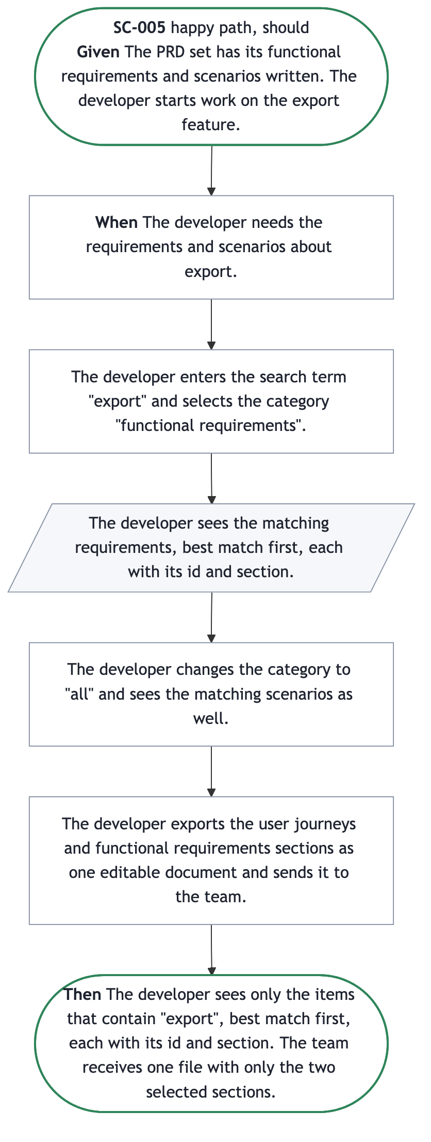
SC-005 scenario
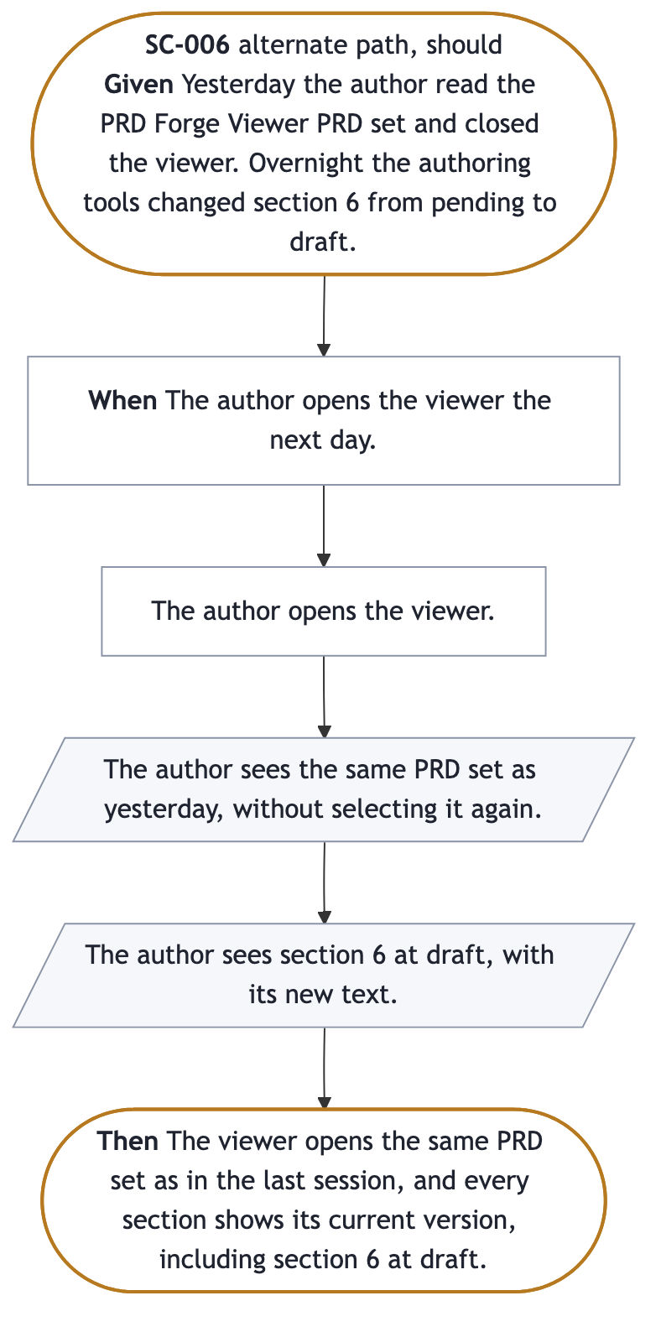
SC-006 scenario
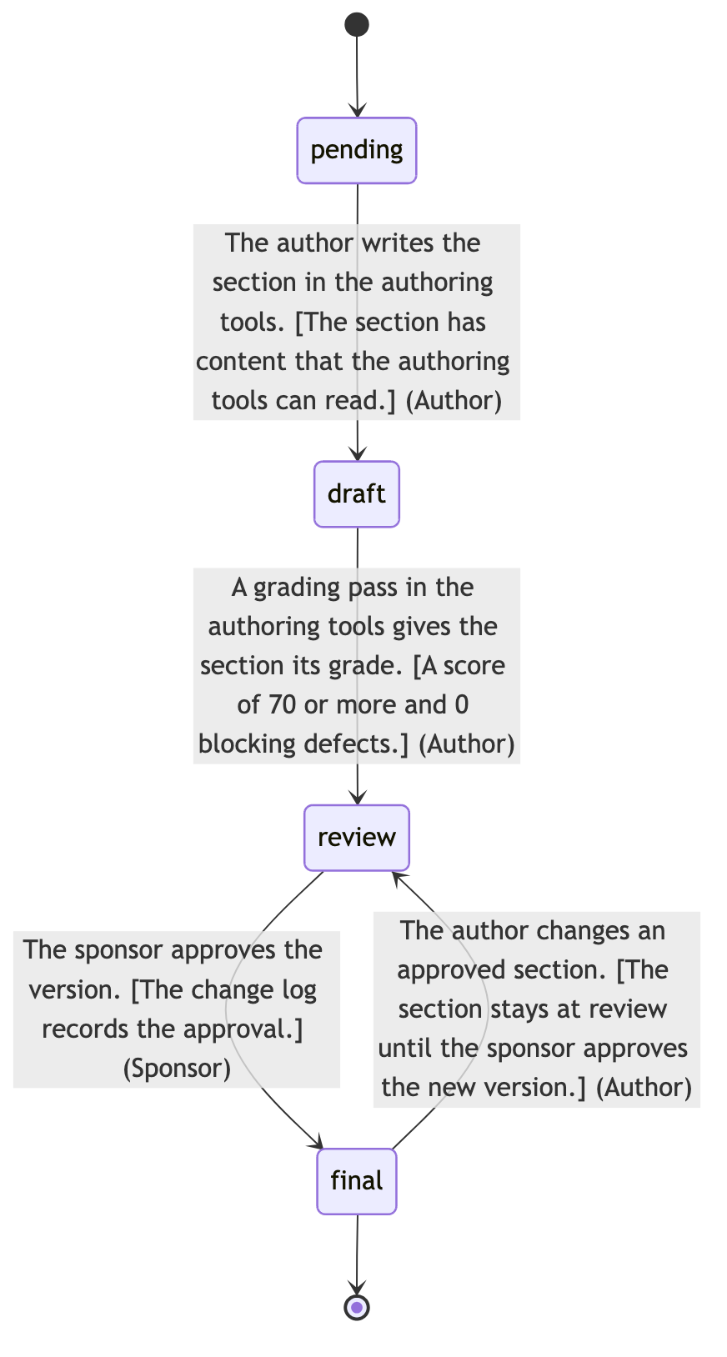
LC-001 lifecycle of A section of the PRD set
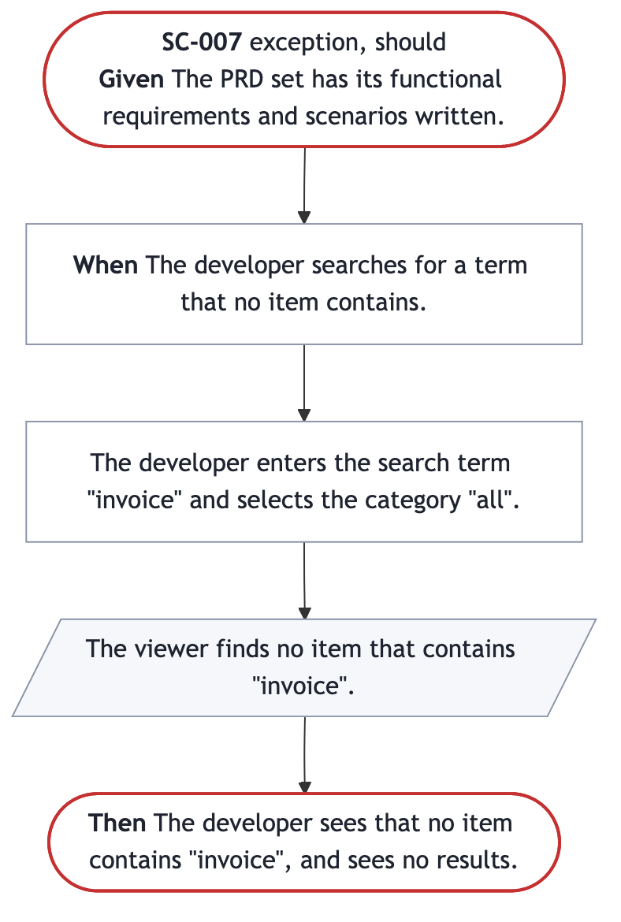
SC-007 scenario
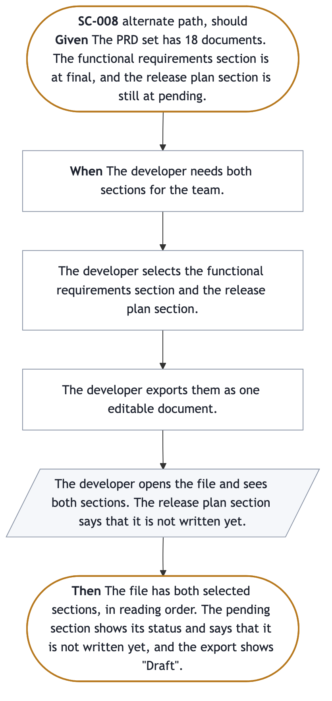
SC-008 scenario
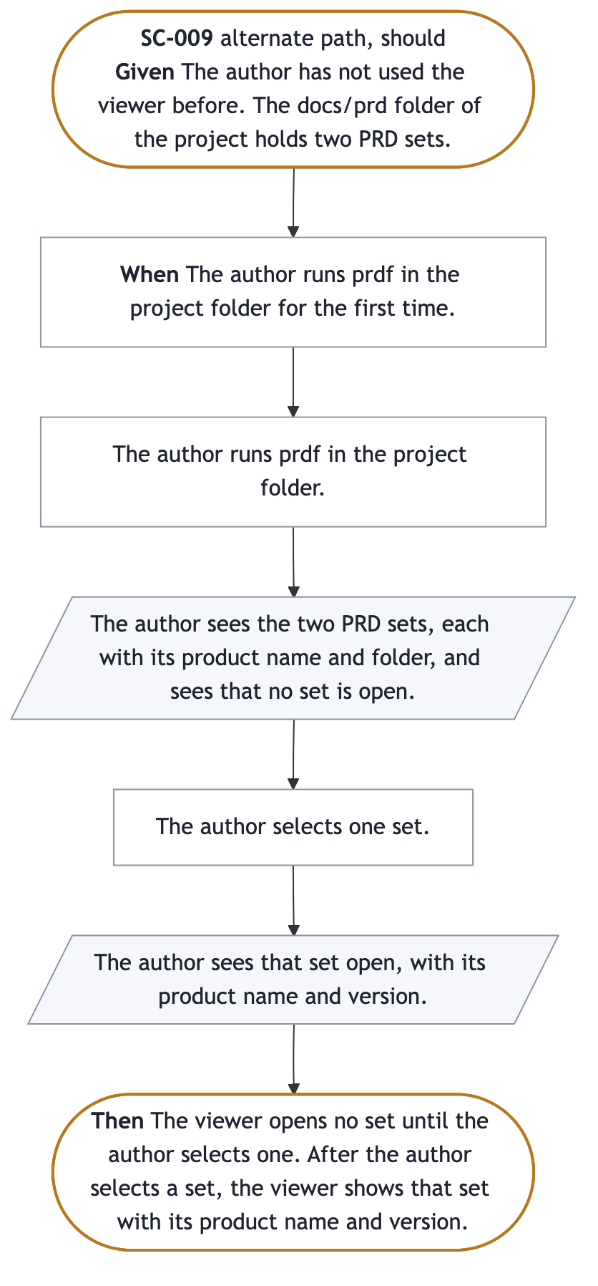
SC-009 scenario
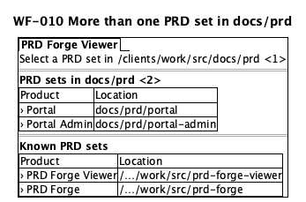
WF-010 drawing
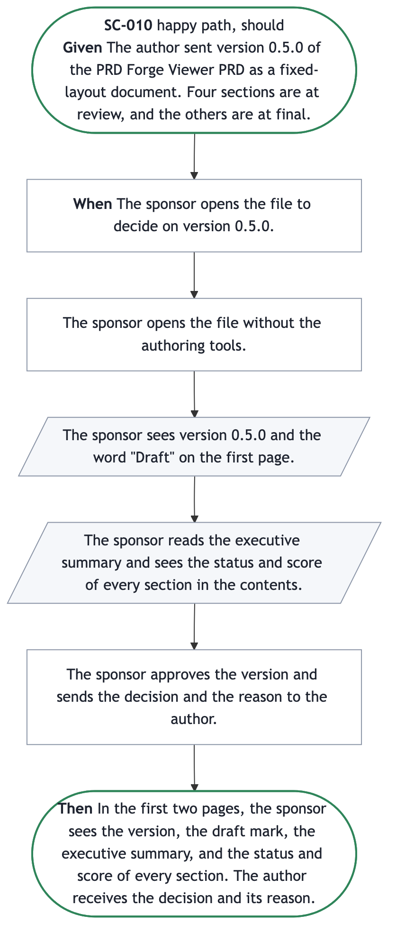
SC-010 scenario
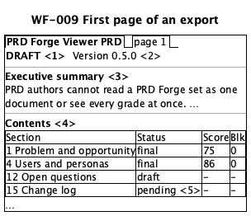
WF-009 drawing
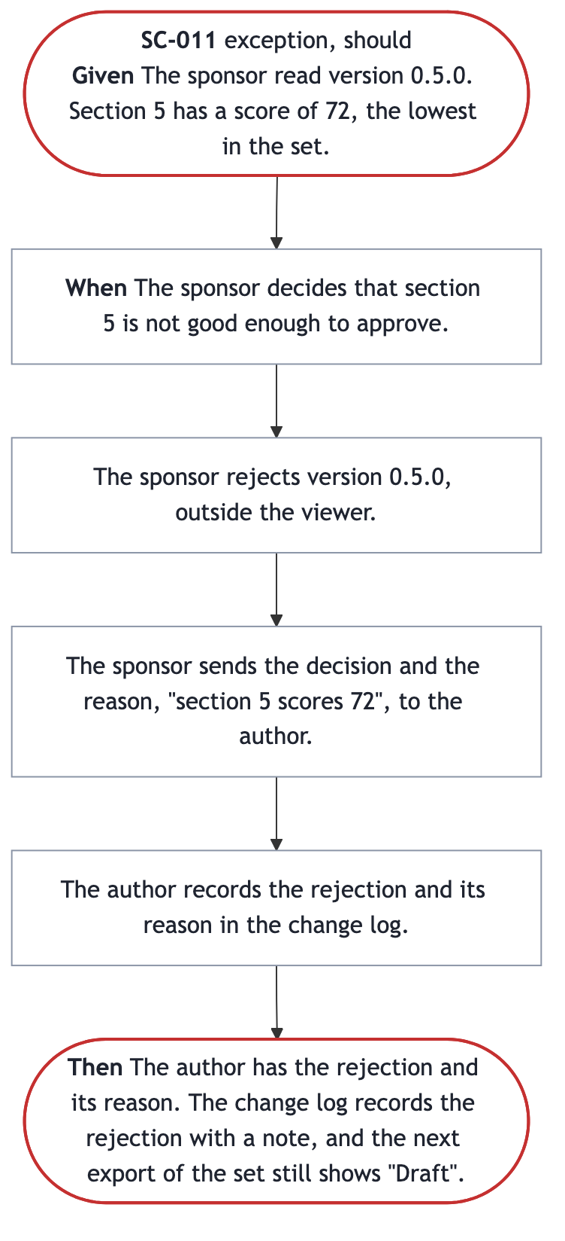
SC-011 scenario
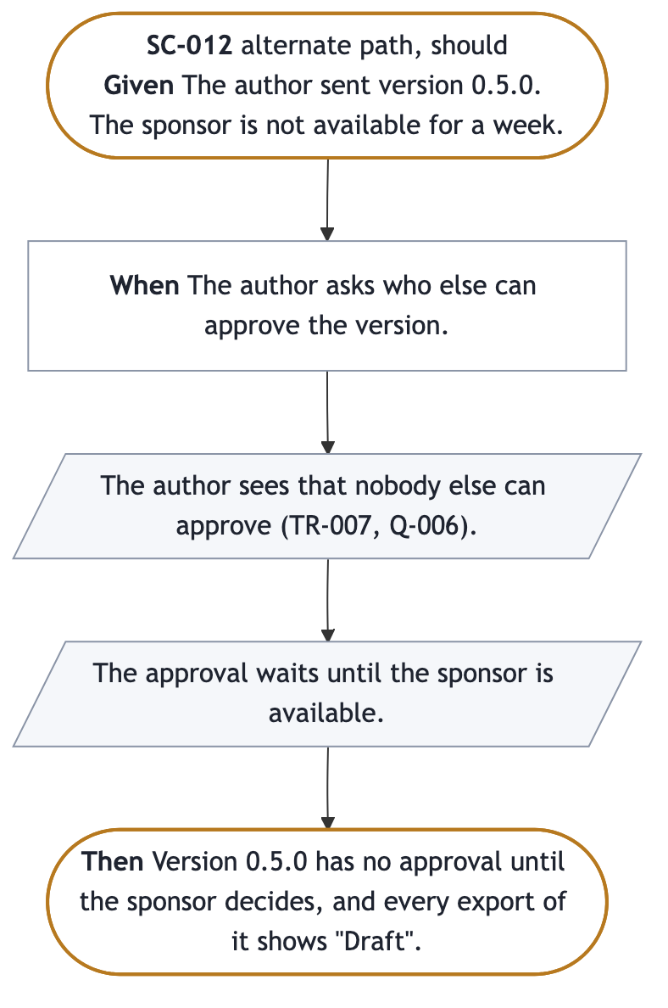
SC-012 scenario
SC-001 is the happy path of the golden thread. It is the end-to-end acceptance test for release 1.
SC-005, SC-007, and SC-008 are on J-002, and SC-010 to SC-012 are on J-003, so their priority is should. SC-006 and SC-009 are should because their requirements (FR-002 and FR-024) are should. A should scenario is still in release 1, but release 1 can ship without it.
ID | Journey | Stage | Variant | Summary
SC-001 | J-001 | ST-001 | happy | The author fixes a weak section and sends a draft fixed-layout document to the sponsor
SC-002 | J-001 | ST-001 | exception | The PRD set has pending sections and one unreadable section
SC-003 | J-001 | ST-004 | exception | The authoring tools change a section while the author reads it
SC-004 | J-001 | ST-005 | alternate | The author exports a set that is not complete
SC-005 | J-002 | ST-009 | happy | A developer searches by category and exports two sections
SC-006 | J-001 | ST-001 | alternate | The author reopens the viewer the next day
SC-007 | J-002 | ST-009 | exception | A search finds no match
SC-008 | J-002 | ST-010 | alternate | A developer exports a section that is still pending
SC-009 | J-001 | ST-001 | alternate | The author runs the viewer for the first time, with two sets in docs/prd
SC-010 | J-003 | ST-011 | happy | The sponsor reads the export and decides
SC-011 | J-003 | ST-012 | exception | The sponsor rejects a version with a reason
SC-012 | J-003 | ST-012 | alternate | The sponsor is not available, and the approval waits

SC-001. The author sends a draft fixed-layout document to the sponsor
The author opens the set, sees that section 4 has the lowest score (61), fixes it in the authoring tools, and sees the new score in the viewer. The author exports the whole set as a fixed-layout document with the Clay theme. Expected outcome: the sponsor's file shows version 0.1.0, the word "Draft", every section in order, and the status and score of each section.

SC-002. The set has pending sections and one unreadable section
Expected outcome: the set opens, all 18 documents are listed, the unreadable section is marked with its file name, and the other 17 can be read.

SC-003. A section changes while the author reads it
Expected outcome: the viewer shows score 75 and the new text without any action from the author. Section 8 sets the time limit.

SC-004. The author exports a set that is not complete
Expected outcome: the editable document shows "Draft" and the version on the first page, the status and score of every section in the contents list, and "not written yet" for each pending section.

SC-005. A developer searches by category and exports two sections
Expected outcome: the developer sees only the items that contain "export", best match first, and the team receives one file with only the two selected sections.

SC-006. The author reopens the viewer the next day
Expected outcome: the viewer opens the same PRD set as in the last session, and every section shows its current version, including changes made while the viewer was closed.

SC-007. A search finds no match
Expected outcome: the developer sees that no item contains "invoice", and sees no results (FR-008).

SC-008. A developer exports a section that is still pending
The developer exports two sections, and one is still pending. Expected outcome: the file has both sections, the pending one says that it is not written yet, and the export shows "Draft" (FR-012, FR-019, TR-005). This answers Q-008.

SC-009. The author runs the viewer for the first time
The author runs prdf for the first time where docs/prd holds two PRD sets. Expected outcome: the viewer lists both sets and opens neither until the author selects one (FR-024, WF-010).

SC-010. The sponsor reads the export and decides
The sponsor opens version 0.5.0 without the authoring tools. Expected outcome: the first two pages show the version, the draft mark, the summary, and every grade, and the author receives the decision and its reason (FR-014, FR-019, WF-009, TR-007).

SC-011. The sponsor rejects a version with a reason
The sponsor rejects version 0.5.0 because section 5 scores 72. Expected outcome: the author has the reason, and the change log records the rejection with a note (TR-007).

SC-012. The sponsor is not available
Nobody else approves. Expected outcome: the version waits for the sponsor, and every export shows "Draft" (TR-007, Q-006).

LC-001. The lifecycle of a section
A section moves from pending to draft when the author writes it, to review at a score of 70 or more with 0 blocking defects, and to final when the sponsor approves the version. A change to an approved section returns it to review. The author makes each move in the authoring tools, and the sponsor (PER-004) makes the move to final. The viewer only shows the state.

Scenarios
SC-001
Context | The PRD Forge Viewer PRD set has 18 documents. The root document and 4 sections are at draft, and 13 sections are at pending. Section 4 has a score of 61 and 0 blocking defects.
Journey | J-001
Stage | ST-001
Stages | • ST-001  • ST-002  • ST-003  • ST-004  • ST-005  • ST-006  • ST-007
Persona | PER-001
Variant | happy
Priority | must
Trigger | The author wants to send version 0.1.0 to the sponsor for early comments.
Course | • The author opens the PRD set and sees the product name, version 0.1.0, and the status of all 18 documents.  • The author sees that section 4 has a score of 61, the lowest of the graded sections.  • The author goes directly to section 4 and reads it.  • The author fixes section 4 in the authoring tools. The viewer shows the new text and the new score without any action from the author.  • The author exports the whole PRD set as one fixed-layout document with the Clay theme.  • The author sends the file to the product sponsor.  • The sponsor opens the file without the authoring tools and sees on the first page that version 0.1.0 is a draft.
Expected outcome | The sponsor has one fixed-layout document that shows version 0.1.0, the word "Draft", every section in order, and the status and score of each section.

SC-002
Context | The PRD set has 18 files. Thirteen sections are at pending and fail the authoring tools' check because they have no content yet. One section has a header that cannot be read.
Journey | J-001
Stage | ST-001
Persona | PER-001
Variant | exception
Priority | must
Trigger | The author opens the PRD set.
Course | • The author opens the PRD set.  • The author sees all 18 documents in order, with the status of each.  • The author sees which section has a header that cannot be read, and the name of its file.  • The author reads the other 17 documents as usual.
Expected outcome | The PRD set opens. All 18 documents are listed. The one unreadable section is marked as unreadable with its file name, and the 17 other documents can be read.

SC-003
Context | The author reads section 4 in the viewer. Section 4 shows a score of 61. At the same time, the authoring tools rewrite section 4 and grade it at 75.
Journey | J-001
Stage | ST-004
Persona | PER-001
Variant | exception
Priority | must
Situation | concurrent
Trigger | The authoring tools save the new version of section 4.
Course | • The author reads section 4 in the viewer.  • The authoring tools save a new version of section 4.  • The author sees the new text and the score 75, without any action in the viewer.  • The author sees that section 4 changed.
Expected outcome | The viewer shows score 75 and the new text of section 4, and the author did nothing to get it. Section 8 sets the time limit.

SC-004
Context | The PRD set has the root document and 4 sections at draft, and 13 sections at pending. The engineering lead wants an early copy.
Journey | J-001
Stage | ST-005
Persona | PER-001
Variant | alternate
Priority | must
Trigger | The author exports the PRD set before the interview covers all sections.
Course | • The author selects the whole PRD set, the editable document format, and the Ice Snowstorm theme.  • The author saves the file and sends it to the engineering lead.  • The engineering lead opens the file without the authoring tools.
Expected outcome | The file shows the word "Draft" and version 0.1.0 on the first page. The contents list shows the status and score of every section. Each pending section says that it is not written yet.

SC-005
Context | The PRD set has its functional requirements and scenarios written. The developer starts work on the export feature.
Journey | J-002
Stage | ST-009
Persona | PER-002
Variant | happy
Priority | should
Trigger | The developer needs the requirements and scenarios about export.
Course | • The developer enters the search term "export" and selects the category "functional requirements".  • The developer sees the matching requirements, best match first, each with its id and section.  • The developer changes the category to "all" and sees the matching scenarios as well.  • The developer exports the user journeys and functional requirements sections as one editable document and sends it to the team.
Expected outcome | The developer sees only the items that contain "export", best match first, each with its id and section. The team receives one file with only the two selected sections.

SC-006
Context | Yesterday the author read the PRD Forge Viewer PRD set and closed the viewer. Overnight the authoring tools changed section 6 from pending to draft.
Journey | J-001
Stage | ST-001
Persona | PER-001
Variant | alternate
Priority | should
Situation | return
Lifecycles | • LC-001
Trigger | The author opens the viewer the next day.
Course | • The author opens the viewer.  • The author sees the same PRD set as yesterday, without selecting it again.  • The author sees section 6 at draft, with its new text.
Expected outcome | The viewer opens the same PRD set as in the last session, and every section shows its current version, including section 6 at draft.

SC-007 The PRD set has its functional requirements and scenarios written.
Journey | J-002
Stage | ST-009
Persona | PER-002
Variant | exception
Priority | should
Trigger | The developer searches for a term that no item contains.
Course | • The developer enters the search term "invoice" and selects the category "all".  • The viewer finds no item that contains "invoice".
Expected outcome | The developer sees that no item contains "invoice", and sees no results.

SC-008
Context | The PRD set has 18 documents. The functional requirements section is at final, and the release plan section is still at pending.
Journey | J-002
Stage | ST-010
Persona | PER-002
Variant | alternate
Priority | should
Branches from | Scenario: SC-005  Step: 4
Trigger | The developer needs both sections for the team.
Course | • The developer selects the functional requirements section and the release plan section.  • The developer exports them as one editable document.  • The developer opens the file and sees both sections. The release plan section says that it is not written yet.
Expected outcome | The file has both selected sections, in reading order. The pending section shows its status and says that it is not written yet, and the export shows "Draft".

SC-009
Context | The author has not used the viewer before. The docs/prd folder of the project holds two PRD sets.
Journey | J-001
Stage | ST-001
Persona | PER-001
Variant | alternate
Priority | should
Situation | first-use
Branches from | Scenario: SC-001  Step: 1
Shown in | screen
Wireframes | • WF-010
Trigger | The author runs prdf in the project folder for the first time.
Course | • The author runs prdf in the project folder.  • The author sees the two PRD sets, each with its product name and folder, and sees that no set is open.  • The author selects one set.  • The author sees that set open, with its product name and version.
Expected outcome | The viewer opens no set until the author selects one. After the author selects a set, the viewer shows that set with its product name and version.

SC-010
Context | The author sent version 0.5.0 of the PRD Forge Viewer PRD as a fixed-layout document. Four sections are at review, and the others are at final.
Journey | J-003
Stage | ST-011
Stages | • ST-011  • ST-012
Persona | PER-004
Variant | happy
Priority | should
Shown in | report
Wireframes | • WF-009
Trigger | The sponsor opens the file to decide on version 0.5.0.
Course | • The sponsor opens the file without the authoring tools.  • The sponsor sees version 0.5.0 and the word "Draft" on the first page.  • The sponsor reads the executive summary and sees the status and score of every section in the contents.  • The sponsor approves the version and sends the decision and the reason to the author.
Expected outcome | In the first two pages, the sponsor sees the version, the draft mark, the executive summary, and the status and score of every section. The author receives the decision and its reason.

SC-011 The sponsor read version 0.5.0. Section 5 has a score of 72, the lowest in the set.
Journey | J-003
Stage | ST-012
Persona | PER-004
Variant | exception
Priority | should
Branches from | Scenario: SC-010  Step: 4
Trigger | The sponsor decides that section 5 is not good enough to approve.
Course | • The sponsor rejects version 0.5.0, outside the viewer.  • The sponsor sends the decision and the reason, "section 5 scores 72", to the author.  • The author records the rejection and its reason in the change log.
Expected outcome | The author has the rejection and its reason. The change log records the rejection with a note, and the next export of the set still shows "Draft".

SC-012 The author sent version 0.5.0. The sponsor is not available for a week.
Journey | J-003
Stage | ST-012
Persona | PER-004
Variant | alternate
Priority | should
Branches from | Scenario: SC-010  Step: 4
Trigger | The author asks who else can approve the version.
Course | • The author sees that nobody else can approve (TR-007, Q-006).  • The approval waits until the sponsor is available.
Expected outcome | Version 0.5.0 has no approval until the sponsor decides, and every export of it shows "Draft".

Lifecycles
LC-001 A section of the PRD set
States | pending  Meaning: The section is not written yet.  draft  Meaning: The section is written, and it is not graded high enough for review.  review  Meaning: The section has a score of 70 or more and no blocking defects.  final  Meaning: The sponsor approved the version that holds this section.
Initial | pending
Final | • final
Transitions | From: pending  To: draft  When: The author writes the section in the authoring tools.  Rule: The section has content that the authoring tools can read.  By: PER-001  From: draft  To: review  When: A grading pass in the authoring tools gives the section its grade.  Rule: A score of 70 or more and 0 blocking defects.  By: PER-001  From: review  To: final  When: The sponsor approves the version.  Rule: The change log records the approval.  By: PER-004  From: final  To: review  When: The author changes an approved section.  Rule: The section stays at review until the sponsor approves the new version.  By: PER-001

Section 6

Scope
final · 92/100 · no blocking defects
Release 1 delivers J-001, the golden thread, from ST-001 to ST-005 in the viewer. ST-006 and ST-007 happen outside the viewer, and the author and the stakeholders use the tools that they already use. Release 1 also lets a developer do the work of J-002: search is part of ST-003, and the export of selected sections is part of ST-005.
ID | In scope for release 1 | Stage
IN-001 | Open a PRD set and see every document's status; reopen the same set next time | ST-001
IN-002 | See status, score, blocking count, and grade date of every section | ST-002
IN-003 | Go directly to any section and read it | ST-003
IN-004 | Search by term and category, best matches first | ST-003
IN-005 | See changes from the authoring tools without any action | ST-004
IN-006 | Export the whole set or selected sections as a fixed-layout document (PDF) or an editable document (.docx), or print, with version and status | ST-005
IN-007 | Select a built-in theme, or make, change, and delete custom themes | ST-005
IN-008 | Export only the sections that a developer selects | ST-005

Out of scope for release 1
ID | Item | Revisit when
OUT-001 | Editing section text in the viewer | The PRD owner decides at the release 2 review, on 2026-11-06
OUT-002 | The findings behind each grade | Release 2, on 2026-11-06, with FR-025 (D-002 delivered).
OUT-003 | Operating systems other than macOS. The only test computer is an Apple silicon Mac with 16 GB of memory | The PRD owner decides at the release 2 review, on 2026-11-06

Non-goals
Non-goal | Reason
We are not building a tool that writes or grades a PRD. | The authoring tools do that, and the viewer only reads and exports their output.
We are not building a way to send files to stakeholders. | The author sends the export with the tools the author already uses.
We are not building comments inside the viewer. | Stakeholders reply outside the viewer, and the author records the result in the authoring tools.
We are not building a view of several PRD sets at once. | Every journey works on one PRD. No persona needs to compare two sets, and FR-022 already switches between sets.
We are not building accounts, cloud copies, or shared links. | Everything stays on the author's computer (NFR-005).
We are not building a viewer for PRDs in other formats. | The viewer reads only the PRD Forge format (C-003).

In scope
IN-001
Summary | Open a PRD set and see the product name, the version, the executive summary, and the status of every document. The next session opens the same PRD set.
Journey stage | ST-001
Requirements | • FR-001  • FR-002  • FR-003  • FR-021  • FR-022  • FR-024

IN-002
Summary | See the status, score, count of blocking defects, and grade date of every section in one view.
Journey stage | ST-002
Requirements | • FR-004

IN-003 Go directly to any section and read it.
Journey stage | ST-003
Requirements | • FR-005  • FR-023

IN-004 Search the PRD set by term, in one category or in all, and see the best matches first.
Journey stage | ST-003
Requirements | • FR-008  • FR-007

IN-005
Summary | See each change that the authoring tools make to a section, without any action from the author.
Journey stage | ST-004
Requirements | • FR-009

IN-006
Summary | Export the whole PRD set or selected sections as a fixed-layout document or an editable document, or print it. The fixed-layout document is PDF (ISO 32000). The editable document is a .docx file (ISO/IEC 29500). The readers already open these formats without installing anything (A-001). The export shows the version and the status of the PRD and of each section.
Journey stage | ST-005
Requirements | • FR-010  • FR-011  • FR-013  • FR-014  • FR-019

IN-007
Summary | Select an export theme. The viewer includes the built-in themes, and the author can make, change, and delete custom themes.
Journey stage | ST-005
Requirements | • FR-015  • FR-016  • FR-017  • FR-018  • FR-020

IN-008 Export only the sections that a developer selects.
Journey stage | ST-005
Requirements | • FR-012

Out of scope
OUT-001 Editing the text of a section in the viewer (Q-005).
Revisit | The PRD owner decides at the release 2 review, on 2026-11-06, if editing goes into a release.

OUT-002
Summary | Showing the findings behind each grade, such as what is missing and what to improve (Q-004).
Revisit | The authoring tools now record the findings (D-002 delivered). Release 2 shows them (FR-025), on 2026-11-06.

OUT-003
Summary | Operating systems other than macOS. Release 1 runs on macOS only, on the only test computer, an Apple silicon Mac with 16 GB of memory. The PRD owner decided this on item ADV-03 of the HLD review (change log, version 0.3.2).
Revisit | The PRD owner decides at the release 2 review, on 2026-11-06, if another operating system goes into a release.

Section 7

Functional requirements
final · 88/100 · no blocking defects
Each requirement uses MoSCoW priority: must, should, could, or won't.
ID | User | Capability | Priority | Stage
FR-001 | PER-001 | Open a PRD set and see its contents | must | ST-001
FR-002 | PER-001 | Return to the same PRD set in the next session | should | ST-001
FR-003 | PER-001 | Open a set with incomplete or unreadable documents | must | ST-001
FR-004 | PER-001 | See the grades of all sections together | must | ST-002
FR-005 | PER-001 | Go directly to any section | must | ST-003
FR-006 | PER-001 | Move to the previous or next section. Dropped: FR-005 and FR-023 cover it | wont | ST-003
FR-007 | PER-002 | Follow a reference to the item it names | should | ST-003
FR-008 | PER-002 | Search by term and category | must | ST-003
FR-009 | PER-001 | See changes from the authoring tools without any action | must | ST-004
FR-010 | PER-001 | Export as a fixed-layout document | must | ST-005
FR-011 | PER-001 | Export as an editable document | should | ST-005
FR-012 | PER-002 | Export only selected sections | must | ST-005
FR-013 | PER-001 | Print the set or selected sections | should | ST-005
FR-014 | PER-004 | See the version, and if it is a draft, in an export | must | ST-005
FR-015 | PER-001 | Select a built-in export theme | must | ST-005
FR-016 | PER-001 | Make a custom export theme | should | ST-005
FR-017 | PER-001 | Change a custom export theme | should | ST-005
FR-018 | PER-001 | Delete a custom export theme | should | ST-005
FR-019 | PER-003 | See the status of every section in an export, and the grades when included | should | ST-005
FR-020 | PER-001 | Keep custom themes from one session to the next | should | ST-005
FR-021 | PER-001 | Start the viewer from a terminal with prdf | must | ST-001
FR-022 | PER-001 | Choose a PRD set from remembered locations | should | ST-001
FR-023 | PER-001 | Select one item of a section and read it | must | ST-003
FR-024 | PER-001 | Choose one PRD set when docs/prd holds more than one | should | ST-001
FR-025 | PER-001 | See the findings behind the grade of a section, in release 2 | wont | ST-002
FR-026 | PER-001 | Make the text larger or smaller, in release 2 | should | ST-003
FR-027 | PER-002 | Keep search results in view while reading, in release 2 | should | ST-003
FR-028 | PER-002 | Move between a requirement and its backlog stories, in release 2 | should | ST-003

FR-001. Open a PRD set and see its contents
Given a PRD set with 18 documents, when the author opens it, then the author sees the product name, the version, the executive summary, and all 18 documents in order, each with its status.

FR-002. Return to the same PRD set in the next session
The same PRD set opens without any selection, and each section shows its current version.

FR-003. Open a set with incomplete or unreadable documents
All documents are listed. Pending sections show pending. An unreadable section is marked with its file name, and the other documents can be read.

FR-004. See the grades of all sections together
The author sees status, score, blocking count, and grade date for every section. A section with no grade shows that it is not graded.

FR-005. Go directly to any section
From any section, the author reaches any other section in one action.

FR-006. Move to the previous or next section
Dropped on 2026-10-26. FR-005 and FR-023 move the author to any section and item, so the viewer has no previous and next links. The ID stays, and nobody reuses it.

FR-007. Follow a reference to the item it names
From FR-004, the developer follows the reference to ST-002 in J-001.

FR-008. Search by term and category
Each result shows its id, title, section, and a relevance score from 0 to 100, highest first. Selecting a result opens the item. A search with no match says so.

FR-009. See changes from the authoring tools without any action
The author sees a new score and new text without any action, within the time limit in section 8.

FR-010. Export as a fixed-layout document
One fixed-layout document (IN-006) holds every document in order. A reader opens it without the authoring tools.

FR-011. Export as an editable document
One editable document (IN-006) holds every document in order. A reader opens it without the authoring tools.

FR-012. Export only selected sections
The file contains only the selected sections, in reading order.

FR-013. Print the set or selected sections
The printed copy matches the fixed-layout export in documents, order, and draft mark.

FR-014. See the version, and if it is a draft, in an export
The first page shows the version and "Draft".

FR-015. Select a built-in export theme
The built-in themes are Ice Snowstorm and Clay. The acceptance criteria give the colors and fonts of each.

FR-016. Make a custom export theme
The author selects a page color, a text color, a heading color, an accent color, and a text font and a heading font from serif, sans-serif, and monospace. Exports carry their fonts, so every reader sees the same fonts.

FR-017. Change a custom export theme
Later exports use the changed values. Built-in themes cannot change.

FR-018. Delete a custom export theme
The deleted theme is no longer available. Built-in themes cannot be deleted.

FR-019. See the status of every section in an export
The contents list shows the status of every section. Each pending section says that it is not written yet. An export leaves out the score and the blocking defects of each section, unless the author selects to include them.

FR-020. Keep custom themes from one session to the next
A custom theme is still available, with the same values, after the viewer restarts.

FR-021. Start the viewer from a terminal with prdf
The command prdf opens the viewer on the PRD set in the current directory, or on the path that the author gives.

FR-022. Choose a PRD set from remembered locations
The viewer remembers every PRD set location that it opened. In a folder with no PRD set, the author picks one from that list.

FR-023. Select one item of a section and read it
The author asks for the items of a section, sees them by id, and selects one item to read it with the status and grade of its section.

FR-024. Choose one of several PRD sets
When docs/prd holds more than one PRD set, prdf reopens the set that was open in the last session. If none of them was open before, the viewer shows a list of the sets it found, and the author selects one. The PRD owner decided this on 2026-10-26.

FR-025. See the findings behind the grade of a section
The author sees the blocking defects and the items to raise the grade of a section. The authoring tools record these findings (D-002). FR-025 is the only requirement of release 2 (REL-002). Its priority is wont, because the priority says what release 1 must handle, and release 1 does not have it.

FR-026. Make the text larger or smaller
The author changes the text size in steps and returns to the normal size in one action. The viewer keeps the size for the next session. The PRD owner added this on 2026-10-30.

FR-027. Keep search results in view while reading
Search is hidden until the developer asks for it. The developer can keep it in view beside the document, so that the results stay while the developer opens one result after another. The PRD owner added this on 2026-10-30.

FR-028. Move between a requirement and its backlog stories
When a backlog made from the PRD set is next to it, a requirement shows the stories that build it, and a story shows its requirements. Each link opens its item. The PRD owner added this on 2026-10-30 (GitHub issue 199).
FR-001 Open a PRD set and see its contents
Shown in | screen
User | PER-001
Outcome | The author sees the product name, the version, the executive summary, and every document of the set in order, each with its status.
Acceptance | • Given a PRD set with 18 documents, when the author opens it, then the author sees the product name, the version, the executive summary, and all 18 documents in order, each with its status.
Priority | must
Journey stage | ST-001
Objective | O-001
Source | Interview, 2026-10-26; SC-001

FR-002 Return to the same PRD set in the next session
Shown in | screen
User | PER-001
Outcome | The author continues with the same PRD set without selecting it again.
Acceptance | • Given the author closed the viewer while a PRD set was open, when the author opens the viewer again, then the same PRD set is open without any selection.  • Given a section changed while the viewer was closed, when the author opens the viewer again, then the author sees the current version of that section.
Priority | should
Journey stage | ST-001
Objective | O-001
Source | Interview, 2026-10-26; SC-006

FR-003 Open a PRD set that has incomplete or unreadable documents
Shown in | screen
User | PER-001
Outcome | The author reads every readable document and sees which documents cannot be read.
Acceptance | • Given a PRD set with 13 pending sections that have no content, when the author opens it, then all 18 documents are listed and each pending section shows its status as pending.  • Given one section that cannot be read, when the author opens the set, then the author sees that section marked as unreadable with its file name, and can read the other 17 documents.
Priority | must
Journey stage | ST-001
Objective | O-001
Source | SC-002

FR-004 See the grades of all sections together
Shown in | screen
User | PER-001
Outcome | The author sees the status, score, count of blocking defects, and grade date of every section at the same time.
Acceptance | • Given section 4 has score 61 and 0 blocking defects and section 3 has score 75 and 1 blocking defect, when the author views the grades, then the author sees both sections with those values and their grade dates.  • Given a section that has no grade, when the author views the grades, then that section shows that it is not graded.
Priority | must
Journey stage | ST-002
Objective | O-002
Source | Interview, 2026-10-26; P-003

FR-005 Go directly to any section
Shown in | screen
User | PER-001
Outcome | The author reads the selected section without opening other documents first.
Acceptance | • Given the author is reading the problem and opportunity section, when the author selects the functional requirements section, then the author sees it in one action.
Priority | must
Journey stage | ST-003
Objective | O-001
Source | Interview, 2026-10-26; P-001

FR-006 Move to the previous or the next section in reading order
User | PER-001
Outcome | The author reads the PRD set from start to end, one section after the other.
Acceptance | • Given the author is reading section 4, when the author moves to the next section, then the author sees section 5, user journeys.  • Given the author is reading section 4, when the author moves to the previous section, then the author sees section 3, objectives and success metrics.  • Given the author is reading the last section, when the author tries to move to the next section, then the author stays on the last section and sees that it is the last one.  • Given the author is reading the root document, when the author tries to move to the previous section, then the author stays on the root document and sees that it is the first one.
Priority | wont
Shown in | none
Journey stage | ST-003
Objective | O-001
Source | Interview, 2026-10-26. Dropped on 2026-10-26 by the PRD owner: FR-005 and FR-023 move the author to any section.

FR-007 Follow a reference from one item to the item it names
Shown in | screen
User | PER-002
Outcome | The developer reads the related item, such as the journey stage that a requirement serves.
Acceptance | • Given requirement FR-004 names stage ST-002, when the developer follows that reference, then the developer sees stage ST-002 in J-001.
Priority | should
Journey stage | ST-003
Objective | O-001
Source | J-002

FR-008 Search the PRD set by term, in one or more categories or in all categories
Shown in | screen
User | PER-002
Outcome | The developer sees the matching items, most relevant first, each with its id and section.
Acceptance | • Given the term "export" and the category functional requirements, when the developer searches, then the developer sees only the functional requirements that contain "export", each with its id and section.  • Given the term "export" and the categories functional requirements and scenarios, when the developer searches, then the developer sees only functional requirements and scenarios that contain "export".  • Given the same term and the category "all", when the developer searches, then the developer sees matching items from every section, including scenarios.  • Given item A has "export" in its title and item B has "export" only once in its text, when the developer searches for "export", then item A is above item B.  • Given a search with matches, when the developer views the results, then each result shows its id, its title, its section, and a relevance score from 0 to 100, highest first.  • Given a list of results, when the developer selects one result, then the developer sees that item in its section.  • Given a term that no item contains, when the developer searches, then the developer sees that there are no matches.
Priority | must
Journey stage | ST-003
Objective | O-001
Source | Interview, 2026-10-26; SC-005

FR-009 See changes that the authoring tools make, without any action
Shown in | screen
User | PER-001
Outcome | The author sees the current version of each section without any action.
Acceptance | • Given the author reads section 4 with score 61, when the authoring tools save section 4 with score 75, then the author sees score 75 and the new text without any action, within the time limit in NFR-002.  • Given the author reads section 4 when the authoring tools save it, when the new version shows, then the author sees that section 4 changed.  • Given the authoring tools change a section the author is not reading, when the author views the grades, then that section shows its new status and score.
Priority | must
Journey stage | ST-004
Objective | O-001
Source | Interview, 2026-10-26; SC-003

FR-010 Export the PRD set as a fixed-layout document (IN-006)
Shown in | report
User | PER-001
Outcome | The author has one fixed-layout document that a reader opens with software already on the computer, without the authoring tools.
Acceptance | • Given a PRD set with 18 documents, when the author exports the whole set as a fixed-layout document, then one file in the format that IN-006 names contains every document in order, and the sponsor opens it without the authoring tools.
Priority | must
Journey stage | ST-005
Objective | O-001
Source | Interview, 2026-10-26; SC-001

FR-011 Export the PRD set as an editable document (IN-006)
Shown in | report
User | PER-001
Outcome | The author has one editable document that a reader opens with software already on the computer, without the authoring tools.
Acceptance | • Given a PRD set with 18 documents, when the author exports the whole set as an editable document, then one file in the format that IN-006 names contains every document in order, and the engineering lead opens it in a word processor without the authoring tools.
Priority | should
Journey stage | ST-005
Objective | O-001
Source | Interview, 2026-10-26; SC-004

FR-012 Export only selected sections
Shown in | report
User | PER-002
Outcome | The developer has one file with only the selected sections.
Acceptance | • Given the user journeys section and the functional requirements section are the only sections selected, when the developer exports them, then the file contains only those two sections, in reading order.
Priority | must
Journey stage | ST-005
Objective | O-001
Source | Interview, 2026-10-26; SC-005

FR-013 Print the PRD set or selected sections
Shown in | report
User | PER-001
Outcome | The author has a printed copy with the same content as the export.
Acceptance | • Given the whole PRD set is selected, when the author prints it, then the printed copy has the same documents, order, and draft mark as the fixed-layout export.
Priority | should
Journey stage | ST-005
Objective | O-001
Source | Interview, 2026-10-26

FR-014 See the version of the PRD, and if it is a draft, in an export
Shown in | report
User | PER-004
Outcome | The sponsor knows which version is in the file, and if it is a draft.
Acceptance | • Given version 0.1.0 with sections at draft, when the sponsor opens the export, then the first page shows version 0.1.0 and the word "Draft".
Priority | must
Journey stage | ST-005
Objective | O-001
Source | Interview, 2026-10-26; SC-001, SC-004

FR-015 Select an export theme from the built-in themes
Shown in | screen
User | PER-001
Outcome | The export has the colors and fonts of the selected theme.
Acceptance | • Given the built-in theme Clay, when the author exports with Clay, then the file has page color FAF9F5, text color 3D3D3A, heading color 141413, accent color D97757, a serif font for headings, and a sans-serif font for text.  • Given the built-in theme Ice Snowstorm, when the author exports with it, then the file has page color F3F6FB, text color 111111, heading color 0B1F4B, accent color 1D4E89, and a sans-serif font for headings and text.
Priority | must
Journey stage | ST-005
Objective | O-001
Source | Interview, 2026-10-26

FR-016 Make a custom export theme
Shown in | screen
User | PER-001
Outcome | The author exports with colors and fonts that the author selected.
Acceptance | • Given the author makes a theme named "Acme" with a page color, a text color, a heading color, an accent color, a text font, and a heading font, each font chosen from serif, sans-serif, and monospace, when the author exports with "Acme", then the file uses those colors and fonts.  • Given an export with the theme "Acme", when a reader opens it on a computer that does not have those fonts installed, then the reader sees the same fonts as the author.
Priority | should
Journey stage | ST-005
Objective | O-001
Source | Interview, 2026-10-26

FR-017 Change a custom export theme
Shown in | screen
User | PER-001
Outcome | Later exports use the changed colors and fonts.
Acceptance | • Given the custom theme "Acme", when the author changes its accent color and exports, then the file uses the new accent color.  • Given a built-in theme, when the author tries to change it, then the built-in theme stays as it was.
Priority | should
Journey stage | ST-005
Objective | O-001
Source | Interview, 2026-10-26

FR-018 Delete a custom export theme
Shown in | screen
User | PER-001
Outcome | The deleted theme is no longer available for export.
Acceptance | • Given the custom theme "Acme", when the author deletes it, then "Acme" is no longer available to select.  • Given a built-in theme, when the author tries to delete it, then the built-in theme is still available.
Priority | should
Journey stage | ST-005
Objective | O-001
Source | Interview, 2026-10-26

FR-019 See the status of every section in an export, and the grades when the author includes them
Shown in | report
User | PER-003
Outcome | The engineering lead knows which sections are finished before reading them.
Acceptance | • Given 13 pending sections, when the engineering lead opens the export, then the contents list shows the status of every section.  • Given an export that the author made with no change to the options, when the engineering lead opens it, then it shows no score and no number of blocking defects.  • Given that the author selected to include the grades, when the engineering lead opens the export, then the contents list also shows the score and the number of blocking defects of every section.  • Given a pending section, when the engineering lead reaches it in the export, then the section says that it is not written yet.
Priority | should
Journey stage | ST-005
Objective | O-001
Source | SC-004

FR-020 Keep custom export themes from one session to the next
Shown in | screen
User | PER-001
Outcome | The author uses the same custom themes after the viewer restarts.
Acceptance | • Given the author made the custom theme "Acme", when the author closes and reopens the viewer, then "Acme" is available to select, with the same colors and fonts.
Priority | should
Journey stage | ST-005
Objective | O-001
Source | Interview, 2026-10-26

FR-021 Start the viewer from a terminal with the command prdf
Shown in | screen
User | PER-001
Outcome | The author sees the PRD set of the current directory in the viewer, with no other step.
Acceptance | • Given the current directory contains docs/prd with one PRD set, when the author runs prdf, then the viewer opens and shows that PRD set.  • Given the author runs prdf with the path of a PRD set, when the viewer opens, then it shows that PRD set.  • Given the current directory contains no PRD set, when the author runs prdf, then the author sees that no PRD set was found there, and sees the list of known PRD set locations (FR-022).
Priority | must
Journey stage | ST-001
Objective | O-001
Source | Interview, 2026-10-26. The PRD owner keeps the name docs/prd on 2026-10-27, because it is the folder that the authoring tools use and that the author sees.

FR-022 Choose a PRD set from the locations the viewer remembers
Shown in | screen
User | PER-001
Outcome | The author opens any PRD set opened before, without typing or finding its path.
Acceptance | • Given the author opened PRD sets in two different folders before, when the author opens a folder with no PRD set, then the author sees both locations, each with its product name.  • Given the list of known locations, when the author selects one, then the viewer opens that PRD set.  • Given a known location whose PRD set no longer exists, when the author sees the list, then that location is marked as not found.
Priority | should
Journey stage | ST-001
Objective | O-001
Source | Interview, 2026-10-26

FR-023 Select one item of a section and read it without the whole section
Shown in | screen
User | PER-001
Outcome | The author reads one item, such as a persona or a requirement, without reading the whole section first.
Acceptance | • Given the users and personas section with PER-001 to PER-005, when the author asks for the items of that section, then the author sees the five persona ids.  • Given the five persona ids of that section are in view, when the author selects PER-001, then the author sees PER-001 with the status and grade of its section.
Priority | must
Journey stage | ST-003
Objective | O-001
Source | Interview, 2026-10-26

FR-024 Choose one PRD set when the docs/prd folder holds more than one
Shown in | screen
User | PER-001
Outcome | The author opens the intended PRD set without typing its path.
Acceptance | • Given the current directory contains docs/prd with two PRD sets, and neither set was open in the last session, when the author runs prdf, then the author sees both sets, each with its product name and folder, and the viewer opens neither set.  • Given the current directory contains docs/prd with two PRD sets, and one of them was open in the last session, when the author runs prdf, then the viewer opens that set.  • Given that list, when the author selects one set, then the viewer opens that PRD set.
Priority | should
Journey stage | ST-001
Objective | O-001
Source | PRD owner decision, 2026-10-26 (HLD review ADV-02)

FR-025 See the findings behind the grade of a section
Shown in | screen
User | PER-001
Outcome | The author sees what is missing in a section and what to improve, without the authoring tools.
Acceptance | • Given section 7 has a grade with 1 blocking defect and 2 items to raise the grade, when the author views the findings of section 7, then the author sees the blocking defect and the 2 items.  • Given a section with no recorded findings, when the author views its findings, then the author sees that no findings are recorded.
Priority | wont
Journey stage | ST-002
Objective | O-002
Source | PRD owner decision, 2026-10-27; OUT-002, D-002

FR-026 Make the text larger or smaller
Shown in | screen
User | PER-001
Outcome | The author reads the PRD set at a text size that suits the author, and the viewer keeps that size for the next session.
Acceptance | • Given a section is open at the normal text size, when the author makes the text larger two times, then the text of the section is larger than before.  • Given a larger text size, when the author returns to the normal size, then the text is at the normal size again.  • Given the author made the text larger and closed the viewer, when the author opens the viewer again, then the text has the same larger size.
Priority | should
Journey stage | ST-003
Objective | O-001
Source | PRD owner decision, 2026-10-30

FR-027 Keep search results in view while reading the items they find
Shown in | screen
User | PER-002
Outcome | The developer opens one search result after another without searching again, and hides search when it is not needed.
Acceptance | • Given search is hidden, when the developer asks for search, then the developer sees the search box, ready for a term.  • Given search is kept in view and shows the results of "export", when the developer opens two results one after the other, then the results of "export" stay in view the whole time.  • Given search is not kept in view, when the developer opens a result, then search is hidden and the item is shown.
Priority | should
Journey stage | ST-003
Objective | O-001
Source | PRD owner decision, 2026-10-30

FR-028 Move between a requirement and the backlog stories that build it
Shown in | screen
User | PER-002
Outcome | The developer goes from a requirement to the stories that build it, and from a story back to its requirements, without losing context.
Acceptance | • Given a backlog next to the PRD set in which US-008 builds FR-005, when the developer views FR-005, then the developer sees US-008 and can open it.  • Given that backlog, when the developer views US-008, then the developer sees FR-005 and can open it.  • Given a PRD set with no backlog next to it, when the developer views FR-005, then the viewer shows the requirement with no backlog links.
Priority | should
Journey stage | ST-003
Objective | O-001
Source | PRD owner decision, 2026-10-30 (GitHub issue 199)

Section 7

Wireframes
final · 97/100 · no blocking defects
Each sketch shows what a person sees and what they can do there, with the set's own content. None of them decides how anything looks or how it is built. Every screen has a tree of the PRD set on the left. The person expands the PRD, then a section, then an item.
The PRD owner approved WF-001 to WF-009 on 2026-10-26. The sponsor approved the WF-006 change for FR-024 in version 0.3.2. Version 0.3.4 changes the example folder names in WF-006. Version 0.4.0 moves the list of PRD sets in docs/prd from WF-006 to WF-010, a state of WF-006. The sponsor approved both versions on 2026-10-27. Version 0.5.0 adds WF-011 for FR-025 (release 2), and the sketches show version 0.5.0. Version 0.7.0 adds WF-012 for FR-026 and FR-027, and WF-013 for FR-028, all in release 2.
The numbered marks in each sketch are explained, in order, by its shows list. Each sketch is also drawn in PlantUML Salt for the printed PRD.

WF-001 The PRD set, with the scores
Illustration, not a design. Illustrates FR-001, FR-002, FR-003, FR-004, FR-005, and FR-009. PER-001 sees it at ST-001.
The author opens the set and sees every section and its grade in one place. Each section in the root page is a link.
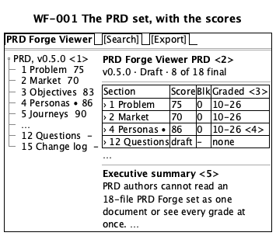
WF-001 drawing

WF-002 One item, selected in the tree
Illustration, not a design. Illustrates FR-005, FR-007, FR-009, and FR-023. PER-001 sees it at ST-003.
The author expands a section and reads one item. The authoring tools changed the section a moment ago.
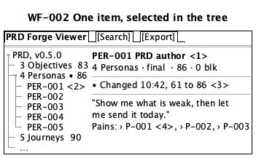
WF-002 drawing

WF-003 Search results
Illustration, not a design. Illustrates FR-008 and FR-023. PER-002 sees it at ST-009.
The developer searches the requirements for "export". The search computes the relevance scores, so the numbers here only show the order: highest first.
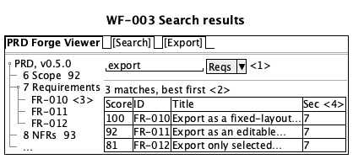
WF-003 drawing

WF-004 A search with no match
Illustration, not a design. Illustrates FR-008. PER-002 sees it at ST-009.
SC-007 names this state.
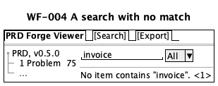
WF-004 drawing

WF-005 A document that cannot be read
Illustration, not a design. Illustrates FR-003. PER-001 sees it at ST-001.
SC-002 names this state.
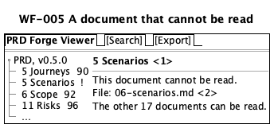
WF-005 drawing

WF-006 No PRD set in this folder
Illustration, not a design. Illustrates FR-021 and FR-022. PER-001 sees it at ST-001.
The author runs prdf in a folder with no PRD set. The first three locations are real PRD sets on the owner's computer. The fourth shows a location that no longer exists. When docs/prd holds more than one PRD set, the screen changes to WF-010.
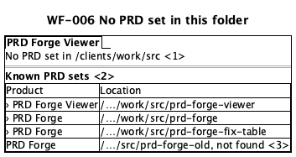
WF-006 drawing

WF-007 Export
Illustration, not a design. Illustrates FR-010, FR-011, FR-012, FR-013, and FR-015. PER-001 sees it at ST-005.
The author exports the whole set, or some sections, in a theme.
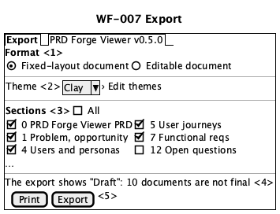
WF-007 drawing

WF-008 Themes
Illustration, not a design. Illustrates FR-015, FR-016, FR-017, FR-018, and FR-020. PER-001 sees it at ST-005.
The author makes and changes the custom theme "Acme", the same theme that the acceptance criteria of FR-016 to FR-018 use. Its colors are the values the author types.
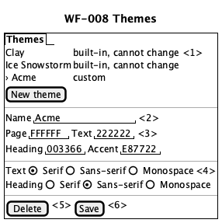
WF-008 drawing

WF-009 First page of an export
Illustration, not a design. Illustrates FR-014, FR-019, and FR-010. PER-004 sees it at ST-011.
The sponsor opens the file without the authoring tools and reads the first page. The contents rows are example values. No section of this set is pending today. The Change log row shows how a pending section looks (SC-004, FR-019).
WF-009 drawing

WF-010 More than one PRD set in docs/prd
Illustration, not a design. Illustrates FR-024 and FR-022. PER-001 sees it at ST-001. It is a state of WF-006.
The author runs prdf in a folder whose docs/prd holds two PRD sets, and neither set was open in the last session. The viewer lists the two sets above the known locations and opens neither until the author selects one. The product names and folders are examples.
WF-010 drawing

WF-011 The findings behind a grade
Illustration, not a design. Illustrates FR-025. PER-001 sees it at ST-002. FR-025 is in release 2.
The author reads the findings of section 5. The values come from the grade of section 5 on 2026-10-27.
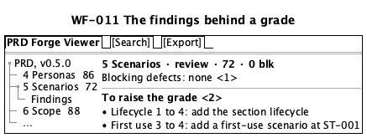
WF-011 drawing

WF-012 Search kept in view beside a section, at a larger text size
Illustration, not a design. Illustrates FR-008, FR-026, and FR-027. PER-002 sees it at ST-003. FR-026 and FR-027 are in release 2.
The developer searches two categories for "export", keeps search in view, and opens one result after another at a larger text size.
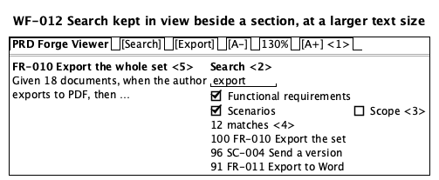
WF-012 drawing

WF-013 A requirement with the backlog stories that build it
Illustration, not a design. Illustrates FR-028. PER-002 sees it at ST-003. FR-028 is in release 2.
The developer opens FR-005 and sees the backlog story that builds it, then opens the story and goes back to the requirement.
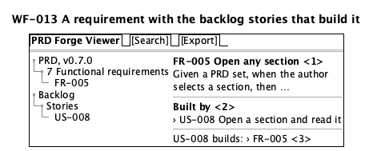
WF-013 drawing
WF-001 The PRD set, with the scores
Type | screen
Persona | PER-001
Journey stage | ST-001
Illustrates | • FR-001  • FR-002  • FR-003  • FR-004  • FR-005  • FR-009
Shows | • The tree: the PRD, and below it every section with its score  • The root page: the product name, the version, the draft mark, and the totals  • The grades: each section is a link, with its score and blocking defects  • The change mark on a section that changed  • The executive summary

WF-002 One item, selected in the tree
Type | screen
Persona | PER-001
Journey stage | ST-003
Illustrates | • FR-005  • FR-007  • FR-009  • FR-023
Shows | • The selected item, with the status and grade of its section  • The selected item in the expanded section  • The change notice  • A reference that opens the item it names

WF-003 Search results
Type | screen
Persona | PER-002
Journey stage | ST-009
Illustrates | • FR-008  • FR-023
Shows | • The search term and the category  • The number of matches  • The tree opens the section of the selected result  • Each result: relevance score, ID, title, and section

WF-004 A search with no match
Type | screen
Persona | PER-002
Journey stage | ST-009
Illustrates | • FR-008
Shows | • The no-match message

WF-005 A document that cannot be read
Type | screen
Persona | PER-001
Journey stage | ST-001
Illustrates | • FR-003
Shows | • The tree and the page both mark the document that cannot be read  • The file name of that document

WF-006 No PRD set in this folder
Type | screen
Persona | PER-001
Journey stage | ST-001
Illustrates | • FR-021  • FR-022
Shows | • The folder where prdf ran  • The known locations, each with its product name  • A location whose PRD set no longer exists

WF-007 Export
Type | screen
Persona | PER-001
Journey stage | ST-005
Illustrates | • FR-010  • FR-011  • FR-012  • FR-013  • FR-015
Shows | • The format, from IN-006  • The theme; Edit themes opens WF-008  • The sections to export, in reading order  • The reason that the export shows Draft (TR-005)  • The print and export buttons

WF-008 Themes
Type | screen
Persona | PER-001
Journey stage | ST-005
Illustrates | • FR-015  • FR-016  • FR-017  • FR-018  • FR-020
Shows | • The themes; the two built-in themes cannot change  • The name of the custom theme  • The four colors  • The text font and the heading font  • The delete button, for a custom theme only  • The save button; a saved theme is still there after a restart

WF-009 First page of an export
Type | report
Persona | PER-004
Journey stage | ST-011
Illustrates | • FR-014  • FR-019  • FR-010
Shows | • The draft mark  • The version  • The executive summary  • The contents, with the status, score, and blocking defects of each section  • A section that is not written yet, marked pending

WF-010 More than one PRD set in docs/prd
Type | screen
Persona | PER-001
Journey stage | ST-001
State of | WF-006
Illustrates | • FR-024  • FR-022
Shows | • The folder where prdf ran, and that the viewer opens no set until the author selects one  • The PRD sets found in docs/prd, each with its product name and folder, above the known locations

WF-011 The findings behind a grade
Type | screen
Persona | PER-001
Journey stage | ST-002
Illustrates | • FR-025
Shows | • The blocking defects of the section, or that it has none  • The items to raise the grade, each with its dimension

WF-012 Search kept in view beside a section, at a larger text size
Type | screen
Persona | PER-002
Journey stage | ST-003
Illustrates | • FR-008  • FR-026  • FR-027
Shows | • The text size, with a step down, the size, and a step up  • Search, kept in view beside the section  • The categories, two of them selected  • The results, which stay while the developer opens them  • The item that the developer opened from a result

WF-013 A requirement with the backlog stories that build it
Type | screen
Persona | PER-002
Journey stage | ST-003
Illustrates | • FR-028
Shows | • The requirement, with its fields  • The stories in the backlog that build it, each one a link  • A story, with a link back to its requirements

Section 8

Non-functional requirements
final · 82/100 · no blocking defects
The PRD owner accepted these targets on 2026-10-26, and extended NFR-008 on 2026-10-28. The test computer is the one in OUT-003. Each speed target holds for a PRD set of at most 18 documents and 176 KB of text, the size of this set on 2026-10-28.
The speed targets follow the response time limits of Jakob Nielsen. 1.0 second is the limit for an uninterrupted flow of thought, so search (NFR-003) has 0.5 seconds. 10 seconds is the limit of attention, so the export (NFR-004) has 10 seconds. The author opens the viewer several times a day while writing a PRD (Q-003), so the open and update targets are 2 seconds.
ID | Category | Requirement | Target
NFR-001 | performance | Open a PRD set, also with prdf and from the list of sets | p95 at most 2 s
NFR-002 | performance | Show a change from the authoring tools | p95 at most 2 s
NFR-003 | performance | Show search results | p95 at most 0.5 s
NFR-004 | performance | Make an export of the whole set | p95 at most 10 s
NFR-005 | privacy | No PRD content leaves the computer | zero network transfers
NFR-006 | availability | Every feature works offline | 100% of FR-001 to FR-024, except FR-006
NFR-007 | accessibility | Keyboard-only use, WCAG 2.2 AA through WCAG2ICT | 100%, zero failures
NFR-008 | durability | Custom themes, known locations, and the last set survive a restart | zero lost
NFR-009 | accessibility | Exports work with a screen reader | zero checker errors
NFR-010 | security | Only local content shows. No script runs, nothing remote loads | zero scripts, zero requests

NFR-002. Show a change from the authoring tools
This sets the time limit that FR-009 and SC-003 refer to.

NFR-005. No PRD content leaves the computer
The viewer never sends PRD content over a network. The test counts every transfer, because a search of encrypted traffic cannot find PRD text.

NFR-007. Keyboard use and WCAG
WCAG 2.2 is written for web content. WCAG2ICT, a W3C Group Note, says how each success criterion applies to non-web software such as the viewer.

NFR-010. Only local content shows
A PRD set can hold a script or a link to a remote image. The viewer shows the text and the local files only. Each test script changes its section text to SCRIPT RAN if it runs, so a tester can see it.

Categories that do not apply
Category | Reason
Scale | One person opens one local PRD set of at most 18 documents at a time. NFR-001 to NFR-004 give the largest set size.
Retention | The viewer does not change a PRD set in release 1 (OUT-001). The PRD set stays where the authoring tools keep it. The viewer keeps only what it needs to search a set, and the author's settings.
Observability | The viewer runs on the person's own computer and loads nothing remote (NFR-010). Failures show to that person, as in FR-003.

Requirements
NFR-001 The author sees a PRD set within 2 seconds of opening it.
Category | performance
Metric | Time from the open action to the moment the author sees the product name, the version, the executive summary, and the status of every document.
Target | p95 at most 2 seconds, for a PRD set of at most 18 documents and 176 KB of text, the size of this set on 2026-10-28
Measurement | On one day, open this PRD set 20 times on the test computer (OUT-003): 10 times from the viewer, 5 times with prdf, and 5 times from the list of sets. Time each open from a screen recording, and take the 19th fastest time.
Priority | must
Applies to | • FR-001  • FR-002  • FR-003  • FR-021  • FR-024
Source | PRD owner decision, Richard Hightower, 2026-10-26. The author opens the viewer several times a day while writing a PRD (Q-003). 2 seconds is within the 10-second limit of attention in "Response Times: The 3 Important Limits", Jakob Nielsen, Nielsen Norman Group, 1993, updated 2014, https://www.nngroup.com/articles/response-times-3-important-limits/

NFR-002 The author sees a change from the authoring tools within 2 seconds of the save.
Category | performance
Metric | Time from the moment the authoring tools save a section to the moment the author sees the new text and score in the viewer.
Target | p95 at most 2 seconds, for a PRD set of at most 18 documents and 176 KB of text, the size of this set on 2026-10-28
Measurement | On one day, change and save one section 20 times while the viewer shows it, on the test computer. Time each update from a screen recording, and take the 19th fastest time.
Priority | must
Applies to | • FR-009
Source | PRD owner decision, Richard Hightower, 2026-10-26. The author checks each change while writing (Q-003, SC-003).

NFR-003 The developer sees search results within 0.5 seconds of searching.
Category | performance
Metric | Time from the search action to the moment the developer sees the results.
Target | p95 at most 0.5 seconds, for a PRD set of at most 18 documents and 176 KB of text, the size of this set on 2026-10-28
Measurement | On one day, run 20 searches with different terms and categories on this PRD set, on the test computer. Time each from a screen recording, and take the 19th fastest time.
Priority | must
Applies to | • FR-008
Source | PRD owner decision, Richard Hightower, 2026-10-26. A search must not break the developer's flow of thought. Nielsen gives 1.0 second as the limit for an uninterrupted flow of thought, and 0.5 seconds keeps half of that as a margin. "Response Times: The 3 Important Limits", Jakob Nielsen, Nielsen Norman Group, 1993, updated 2014, https://www.nngroup.com/articles/response-times-3-important-limits/

NFR-004 The author has the export file within 10 seconds of starting the export.
Category | performance
Metric | Time from the export action to the moment the file is ready to open.
Target | p95 at most 10 seconds, for the whole PRD set, at most 18 documents and 176 KB of text, the size of this set on 2026-10-28
Measurement | On one day, export this PRD set 20 times, 10 times in each format of IN-006, on the test computer. Time each export, and take the 19th fastest time.
Priority | must
Applies to | • FR-010  • FR-011  • FR-012
Source | PRD owner decision, Richard Hightower, 2026-10-26. The author waits for the export and does not change to another task. Nielsen gives 10 seconds as the limit for keeping the user's attention. "Response Times: The 3 Important Limits", Jakob Nielsen, Nielsen Norman Group, 1993, updated 2014, https://www.nngroup.com/articles/response-times-3-important-limits/

NFR-005 No content of a PRD set leaves the author's computer.
Category | privacy
Metric | Number of network transfers that the viewer makes during a session. A transfer counts even if its content is encrypted.
Target | Zero
Measurement | On one day, record all network connections that the viewer opens on the test computer during a session that opens, searches, and exports this PRD set. Count every connection to a host other than the computer itself. The count is zero.
Priority | must
Source | PRD owner decision, Richard Hightower, 2026-10-26. A PRD set can hold client information, because the sponsor (PER-004) is a client executive. No feature needs to send it (NFR-010).

NFR-006 Every release 1 feature works without a network connection.
Category | availability
Metric | Share of the release 1 functional requirements that pass with the network off.
Target | 100% of the 23 functional requirements
Measurement | On one day, turn off all network connections on the test computer and run the acceptance criteria of FR-001 to FR-024, except FR-006.
Priority | must
Source | PRD owner decision, Richard Hightower, 2026-10-26. The viewer shows only local content (NFR-010), so no feature needs a network.

NFR-007 A person who uses only a keyboard can do every task in the viewer.
Category | accessibility
Metric | Share of the release 1 acceptance criteria that a tester completes with a keyboard only, and the count of failures of the WCAG 2.2 level AA success criteria, as WCAG2ICT applies them to non-web software.
Target | 100% of the acceptance criteria, and zero level AA failures
Measurement | In one week, a tester runs the acceptance criteria of FR-001 to FR-024, except FR-006, with a keyboard only. The tester then checks the viewer against each WCAG 2.2 level AA success criterion that WCAG2ICT applies to non-web software.
Priority | must
Source | PRD owner decision, Richard Hightower, 2026-10-26. The success criteria come from WCAG 2.2, applied to a desktop app by "Guidance on Applying WCAG 2 to Non-Web Information and Communications Technologies (WCAG2ICT)", W3C Group Note, 11 December 2025, https://www.w3.org/TR/wcag2ict-22/

NFR-008
Statement | Custom export themes, the known locations, and the last open PRD set are not lost when the viewer restarts.
Category | durability
Metric | Number of custom themes, theme values, known locations, or last-set records lost after a restart.
Target | Zero
Measurement | On one day, make 5 custom themes, open PRD sets from 3 locations, and leave one set open. Close the viewer, restart the computer, and open the viewer. Compare every theme value and every known location, and check that the same set is open.
Priority | must
Applies to | • FR-002  • FR-016  • FR-020  • FR-022
Source | PRD owner decision, Richard Hightower, 2026-10-26, extended on 2026-10-28 to the known locations and the last set. The author makes these once and expects to find them again.

NFR-009 A reader who uses a screen reader can read every export.
Category | accessibility
Metric | Number of errors that the accessibility checker of a reader for each format of IN-006 reports on an export.
Target | Zero errors, for each format of IN-006
Measurement | On one day, export this PRD set in each format of IN-006. Run the accessibility checker of a reader for that format on each file.
Priority | should
Applies to | • FR-010  • FR-011  • FR-012
Source | PRD owner decision, Richard Hightower, 2026-10-26. Every reader of the export (PER-003, PER-004, PER-005) must be able to read it, also a reader who uses a screen reader.

NFR-010
Statement | The viewer shows content only from files on the computer. No script in a PRD set runs, and no remote image or link loads.
Category | security
Metric | Number of scripts that run, and number of network requests that the viewer makes, while it shows a test PRD set that holds a script in a section, a script in a diagram, a remote image, and a remote link.
Target | Zero scripts run and zero network requests
Measurement | On one day, on the test computer, start a network monitor and open the test PRD set. Each test script, if it runs, changes the visible text of its section to SCRIPT RAN. Read every section, select the remote link, and count the sections that show SCRIPT RAN and the network requests.
Priority | must
Applies to | • FR-001  • FR-005  • FR-007  • FR-008  • FR-009  • FR-010  • FR-011  • FR-012  • FR-013  • FR-023
Source | PRD owner decision, Richard Hightower, 2026-10-26. A PRD set can come from another person, and its content must not act on the author's computer.

Not applicable
scale
Reason | One person opens one local PRD set at a time, and a set has at most 18 documents. NFR-001 to NFR-004 give the largest set size. The viewer has no shared data and no other users.

retention
Reason | The viewer does not change a PRD set in release 1 (OUT-001). The PRD set stays where the authoring tools keep it. The viewer keeps only what it needs to search a set, and the author's settings.

observability
Reason | The viewer runs on the person's own computer and loads nothing remote (NFR-010). Failures show to that person, as in FR-003. No service exists to monitor.

Section 9

Constraints
final · 85/100 · no blocking defects
Constraints are rules that the product team cannot change by agreement. C-003 comes from the published PRD Forge format. The viewer must read the PRD sets that the authoring tools already write, so the team cannot change the format.
ID | Category | Rule | Authority
C-003 | standard | The viewer reads the PRD Forge document format, version 1 | The prd-forge/*@1 schemas

C-003. The PRD Forge document format
The viewer reads PRD sets that follow the PRD Forge version 1 layout and headers.

Retired constraints
C-001 (the export formats), C-002 (the viewer is read-only), and C-004 (release 1 runs on macOS only) were retired in version 0.6.0. Each is a release 1 decision that the PRD owner can change, not an outside rule. Section 6 records them: IN-006 names the export formats, OUT-001 records the read-only rule, and OUT-003 records macOS only. The PRD owner revisits OUT-001 and OUT-003 at the release 2 review on 2026-11-06. The ids C-001, C-002, and C-004 are not used again.
C-003
Statement | The viewer reads PRD sets in the document layout of the authoring tools, version 1: one root document and the section documents, with the headers and links that the prd-forge/*@1 schemas define.
Category | standard
Authority | The PRD Forge document format, version 1: the prd-forge/*@1 schemas in the schemas folder of https://github.com/SpillwaveSolutions/prd-forge. Release 0.9.0 of the authoring tools, read on 2026-10-28, uses them for 18 documents.
Applies to | • FR-001  • FR-002  • FR-003  • FR-004  • FR-005  • FR-007  • FR-008  • FR-009  • FR-023  • FR-024
Verification | Open a PRD set that passes the validator of the authoring tools, release 0.9.0. Every document and every grade shows in the viewer. Then change one section header so that it fails the schema, and open the set again. That section shows as unreadable, as FR-003 says.

Section 10

Decision rights
final · 88/100 · no blocking defects
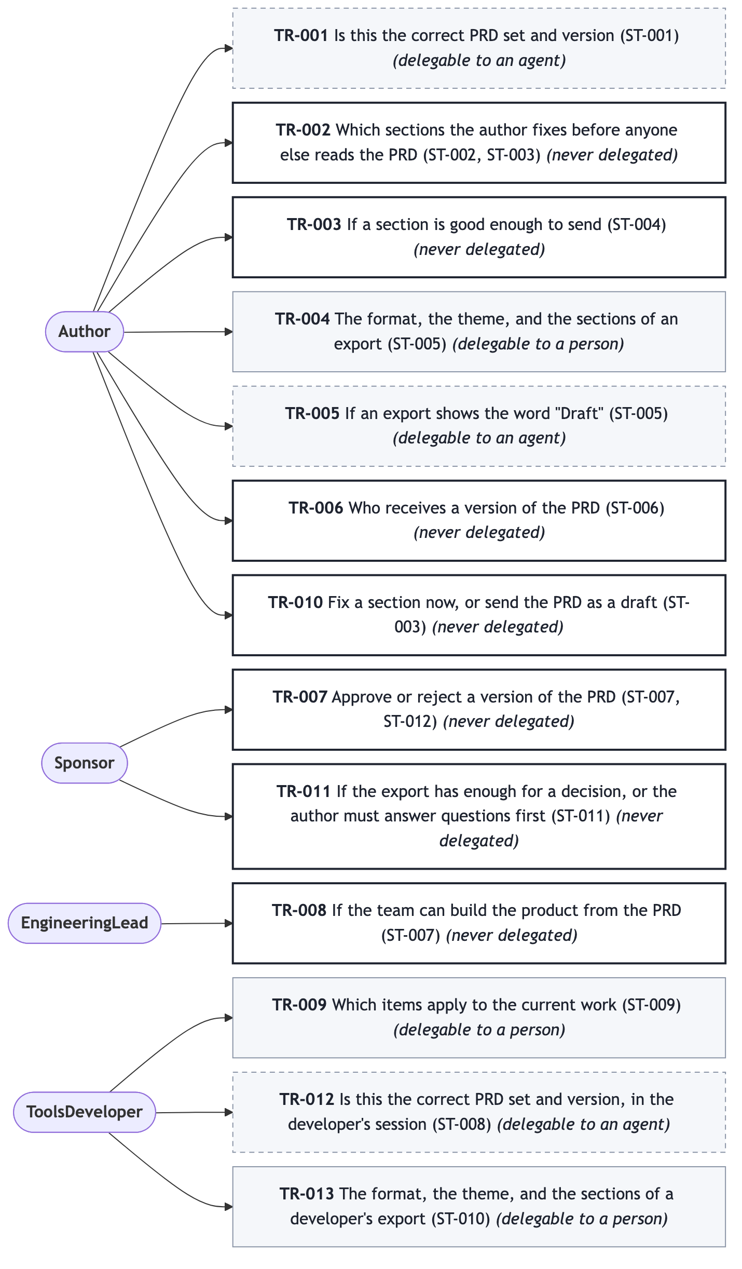
Who decides what
A person makes every decision in the journeys, with two exceptions. The viewer proposes the PRD set from the last session (TR-001, TR-012), and the viewer decides if an export shows "Draft" by a fixed rule (TR-005).
"Software may decide: No" and "Always a person: No" together mean that a person decides, but the viewer can offer a default, such as the last theme used.
- PER-004 approves a version. PER-001, PER-002, PER-003, and PER-005 may not.
- PER-001 decides what goes to whom. The viewer may not send anything.
- No person may remove the "Draft" mark in the viewer.
ID | Decision | Approver | Software may decide | Always a person
TR-001 | Is this the correct PRD set and version | PER-001 | Yes, it proposes the last set | No
TR-002 | Which sections to fix first | PER-001 | No | Yes
TR-003 | If a section is good enough to send | PER-001 | No | Yes
TR-004 | Format, theme, and sections of an export | PER-001 | No | No
TR-005 | If an export shows "Draft" | PER-001, through section status | Yes | No
TR-006 | Who receives a version | PER-001 | No | Yes
TR-007 | Approve or reject a version | PER-004 | No | Yes
TR-008 | If the team can build from the PRD | PER-003 | No | Yes
TR-009 | Which items apply to the current work | PER-002 | No | No
TR-010 | Fix a section now, or send as a draft | PER-001 | No | Yes
TR-011 | Enough to decide, or ask the author first | PER-004 | No | Yes
TR-012 | Is this the correct PRD set, in the developer's session | PER-002 | Yes, it proposes the last set | No
TR-013 | Format, theme, and sections of a developer's export | PER-002 | No | No

TR-005. The "Draft" rule
An export shows "Draft" when any document in the PRD set is not at final. The author cannot remove the mark in the viewer. To remove it, the author takes every section to final in the authoring tools. The PRD owner decided this rule on 2026-10-26.

TR-007. approval
Only the sponsor approves a version. The export never says that a PRD is approved. The author records the approval in section 15. The escalation when the sponsor is not available: the approval waits, and nobody else approves (Q-006). When the sponsor rejects a version, the author records the rejection and its reason in section 15, fixes the PRD, and sends a new version.
TR-001 Is this the correct PRD set and version (ST-001)
Stages | • ST-001
Approver | PER-001
Delegable to an agent | yes
Never delegated | no
Agent role | proposes
Evidence required | The product name and version of the PRD set that is open.
Escalation | The viewer proposes the PRD set from the last session. Nobody else decides. The author opens a different PRD set at any time.
Acceptance | • Given the author closed the viewer with a PRD set open, when the author opens the viewer again, then the same PRD set is open and the author sees its product name and version.  • Given the same PRD set reopened, when the author opens a different PRD set, then the different PRD set is open.

TR-002 Which sections the author fixes before anyone else reads the PRD (ST-002, ST-003)
Stages | • ST-002  • ST-003
Approver | PER-001
Delegable to an agent | no
Never delegated | yes
Evidence required | The status, score, count of blocking defects, and grade date of every section, in one view.
Escalation | The decision waits for the author. Nobody else decides.
Acceptance | • Given sections with different scores, when the author views the grades, then the viewer shows every section and does not mark any section as "to fix" on its own.

TR-003 If a section is good enough to send (ST-004)
Stages | • ST-004
Approver | PER-001
Delegable to an agent | no
Never delegated | yes
Evidence required | The new score, count of blocking defects, and status of the changed section.
Escalation | The decision waits for the author. Nobody else decides.
Acceptance | • Given a section that the authoring tools changed, when the author views it, then the author sees its new score, count of blocking defects, and status before choosing to export.

TR-004 The format, the theme, and the sections of an export (ST-005)
Stages | • ST-005
Approver | PER-001
Delegable to an agent | no
Never delegated | no
Evidence required | The selected format, theme, and sections before the export starts.
Escalation | The export waits for the author. Nobody else decides.
Acceptance | • Given the author starts an export, when the author has not selected a format, then the author has no file.  • Given the author starts an export, when the author has not selected any section, then the author has no file.  • Given the author selects a format, a theme, and sections, when the export finishes, then the author sees the selected format, theme, and sections in the file.

TR-005 If an export shows the word "Draft" (ST-005)
Stages | • ST-005
Approver | PER-001
Delegable to an agent | yes
Never delegated | no
Agent role | acts
Evidence required | The status of every section in the PRD set at the time of export.
Escalation | PER-001 decides through the status of each section in the authoring tools. The viewer applies the rule, and no person can change the mark in the viewer. If the author thinks that the mark is wrong, the author changes the status of the sections in the authoring tools and exports again.
Acceptance | • Given the root document and 15 sections at final and 1 section at review, when the author exports, then the first page shows "Draft".  • Given all 17 section documents and the root document at final, when the author exports, then the export does not show "Draft".  • Given an export that shows "Draft", when the author tries to remove the mark in the viewer, then the mark stays.

TR-006 Who receives a version of the PRD (ST-006)
Stages | • ST-006
Approver | PER-001
Delegable to an agent | no
Never delegated | yes
Evidence required | The version and the draft mark of the export.
Escalation | The decision waits for the author. Nobody else decides.
Acceptance | • Given the author makes an export, when the export finishes, then the viewer has sent the file to nobody.

TR-007 Approve or reject a version of the PRD (ST-007, ST-012)
Stages | • ST-007  • ST-012
Approver | PER-004
Delegable to an agent | no
Never delegated | yes
Evidence required | The export, with the version, the draft mark, and the status and score of every section.
Escalation | When the sponsor is not available, the approval waits. Nobody else approves (Q-006). When the sponsor rejects a version, the author records the rejection and its reason in the change log in section 15, fixes the PRD, and sends a new version.
Acceptance | • Given any export, when the sponsor opens it, then the export does not say that the PRD is approved. The author records the approval in the change log in section 15.

TR-008 If the team can build the product from the PRD (ST-007)
Stages | • ST-007
Approver | PER-003
Delegable to an agent | no
Never delegated | yes
Evidence required | The export, with every section and the status and score of each.
Escalation | The engineering lead sends comments to the author, who fixes the PRD in the authoring tools. If the engineering lead is not available, the decision waits.
Acceptance | • Given an export of the whole PRD set, when the engineering lead opens it, then every section is in the file, with its status and score.

TR-009 Which items apply to the current work (ST-009)
Stages | • ST-009
Approver | PER-002
Delegable to an agent | no
Never delegated | no
Evidence required | The matching items, each with its id and section.
Escalation | The decision waits for the developer. Nobody else decides.
Acceptance | • Given a search with matches, when the developer views the results, then the viewer selects no item on its own.

TR-010 Fix a section now, or send the PRD as a draft (ST-003)
Stages | • ST-003
Approver | PER-001
Delegable to an agent | no
Never delegated | yes
Evidence required | The status, score, and count of blocking defects of the section.
Escalation | The decision waits for the author. Nobody else decides.
Acceptance | • Given a section with 1 blocking defect, when the author exports, then the viewer makes the export and shows "Draft", and does not stop the export.

TR-011
Decision | If the export has enough for a decision, or the author must answer questions first (ST-011)
Stages | • ST-011
Approver | PER-004
Delegable to an agent | no
Never delegated | yes
Evidence required | The version, the draft mark, the executive summary, and the status and score of every section.
Escalation | The sponsor asks the author. The approval waits (Q-006).
Acceptance | • Given an export of the whole PRD set, when the sponsor opens it, then the first two pages show the version, the draft mark, the executive summary, and the contents list with the status and score of every section.

TR-012 Is this the correct PRD set and version, in the developer's session (ST-008)
Stages | • ST-008
Approver | PER-002
Delegable to an agent | yes
Never delegated | no
Agent role | proposes
Evidence required | The product name and version of the PRD set that is open.
Escalation | The viewer proposes the PRD set from the last session. Nobody else decides. The developer opens a different PRD set at any time.
Acceptance | • Given the developer closed the viewer with a PRD set open, when the developer opens the viewer again, then the same PRD set is open and the developer sees its product name and version.  • Given the same PRD set reopened, when the developer opens a different PRD set, then the different PRD set is open.

TR-013 The format, the theme, and the sections of a developer's export (ST-010)
Stages | • ST-010
Approver | PER-002
Delegable to an agent | no
Never delegated | no
Evidence required | The selected format, theme, and sections before the export starts.
Escalation | The export waits for the developer. Nobody else decides.
Acceptance | • Given the developer starts an export, when the developer has not selected any section, then the developer has no file.  • Given the developer selects a format and two sections, when the export finishes, then the developer sees the selected format and only those two sections in the file.

Section 11

Assumptions, risks, and dependencies
review · 96/100 · no blocking defects
Release 1 target date: 2026-11-06, set by the PRD owner on 2026-10-28. Release 2 target date: 2026-11-06, set on 2026-10-26.
ID | Assumption | If it is false
A-001 | Stakeholders open PDF and Word without installing anything | IN-006, FR-010, and FR-011 change
A-002 | The PRD set is on the same computer as the viewer | FR-001, FR-002, NFR-005, and NFR-006 change
A-003 | The PRD Forge version 1 format is stable until release 1 | C-003, FR-001, FR-003, and FR-004 can fail
A-004 | Authors want a viewer, not only the command-line export | O-001 does not move

ID | Risk | Likelihood | Impact | Owner
R-001 | A PRD Forge format change breaks the viewer | medium | high | Richard Hightower
R-002 | Few teams use PRD Forge | medium | medium | Richard Hightower
R-003 | Nobody measures the O-001 baseline | medium | medium | Richard Hightower

ID | Need | From | By | Status | Blocks
D-001 | Stable PRD Forge version 1 format | PRD Forge | 2026-10-26 | committed | C-003, FR-001, FR-003, FR-004
D-002 | PRD Forge records grade findings | PRD Forge | 2026-10-26 | delivered | OUT-002

D-002 was delivered in PRD Forge 0.2.0, which writes the reasons for each grade beside each section.

Assumptions
A-001 Stakeholders open PDF and Word files without installing anything.
If false | IN-006 changes, and FR-010 and FR-011 need other formats.
Validated by | Send the first export of this PRD to PER-003 and PER-004 and ask.
Owner | Richard Hightower

A-002 The PRD set is on the same computer as the viewer.
If false | FR-001 and FR-002 change, and NFR-005 and NFR-006 need new targets.
Validated by | Ask the first three authors where they keep their PRD sets.
Owner | Richard Hightower

A-003 The PRD Forge version 1 format stays the same until release 1 ships.
If false | C-003 changes, and FR-001, FR-003, and FR-004 can fail on new files (R-001).
Validated by | D-001.
Owner | Richard Hightower

A-004 Authors want a viewer, and the current command-line export is not enough for them.
If false | O-001 does not move because of the viewer, and P-001 and P-002 need a different answer.
Validated by | Measure O-001 on this PRD with and without the viewer (Q-001).
Owner | Richard Hightower

Risks
R-001 A change to the PRD Forge document format breaks the viewer.
Likelihood | medium
Impact | high
Mitigation | C-003 fixes the format at version 1. FR-003 shows each unreadable document by name. D-001 keeps the format stable for release 1.
Owner | Richard Hightower

R-002 Few teams use PRD Forge, so the viewer has few users.
Likelihood | medium
Impact | medium
Mitigation | Measure O-001 on this PRD first, and report it by 2027-03-31.
Owner | Richard Hightower

R-003 Nobody measures the baseline for O-001, so nobody can show success.
Likelihood | medium
Impact | medium
Mitigation | Q-001, due 2026-11-30.
Owner | Richard Hightower

Dependencies
D-001 PRD Forge keeps the version 1 document format stable until release 1 ships.
From | PRD Forge maintainers, owned by Richard Hightower
By | 2026-10-26
Status | committed
Blocks | • C-003  • FR-001  • FR-003  • FR-004

D-002 PRD Forge records the findings behind each grade in the PRD set.
From | PRD Forge maintainers, owned by Richard Hightower
By | 2026-10-26
Status | delivered
Blocks | • OUT-002

Section 12

Open questions
draft
Questions are collected during the interview and consolidated later.
ID | Question | Decider | By
Q-001 | How long from a finished PRD to stakeholder feedback today? Answered: about 10 days on the historic PRDs. | Richard Hightower | 2026-11-30
Q-002 | How many stakeholders review a PRD, and how many have the tools? | Richard Hightower | 2026-11-30
Q-003 | How often do PER-001 and PER-002 open a PRD in the viewer? Answered: the author, several times a day. | Richard Hightower | 2026-11-30
Q-004 | Must release 1 show the findings behind each grade? Answered: no, later, after a change to the authoring tools. | Richard Hightower | 2026-11-30
Q-005 | Is editing text in the viewer in release 1? Answered: no, it is a later feature. | Richard Hightower | 2026-10-26
Q-006 | Who approves when the sponsor is not available? Answered: nobody, the approval waits. | Richard Hightower | 2026-11-30
Q-007 | When must PRD Forge record grade findings? Answered: PRD Forge 0.2.0 does it now. | Richard Hightower | 2026-10-26
Q-008 | What other unhappy path does J-002 need? Answered: an export with a pending section (SC-008). | Richard Hightower | 2026-11-30
Q-009 | How often, and for how long, does a review start with a search for an item? Answered: about 10 searches of about 3 minutes. | Richard Hightower | 2026-11-30

Q-001. Time from a finished PRD to stakeholder feedback
Measure it on this PRD as the baseline. Blocks the cost of inaction for P-001 and P-002.
Answered on 2026-10-28: the historic PRDs took about 10 calendar days. This PRD does not count for review time, because it is for a new tool.

Q-002. Stakeholders per PRD, and how many have the tools
Blocks the evidence for P-002.

Q-003. How often PER-001 and PER-002 open a PRD in the viewer
Answered on 2026-10-26: the author opens the viewer several times a day.

Q-004. The findings behind each grade
Answered on 2026-10-26: the findings are a later feature. The feature depends on a change to the authoring tools so that they record the findings in the PRD set. Release 1 shows the status, score, blocking count, and grade date.

Q-005. Editing text in the viewer
Answered on 2026-10-26: editing is a later feature, not in release 1. The author changes sections only in the authoring tools. Section 6 records it as a non-goal for release 1.

Q-006. Approval when the sponsor is not available
Answered on 2026-10-26: the approval waits until the sponsor is available.

Q-007. Date for the grade findings
Answered on 2026-10-26: PRD Forge 0.2.0 records the findings now (D-002 delivered).

Q-008. A second unhappy path for J-002
J-002 has one happy scenario (SC-005) and one exception (SC-007), a search with no match. The PRD owner decides by 2026-11-30 if release 1 needs another one.
Answered on 2026-10-27: a developer exports a section that is still pending (SC-008). Release 1 handles it as a should.

Q-009. Time to find an item
P-001 had no measured cost. The PRD owner counts the searches for an item in one review of this PRD, and the minutes of each, by 2026-11-30.
Answered on 2026-10-28: about 10 searches in one review, about 3 minutes each (owner estimate). P-001 records the cost, about 30 minutes for each review.
Q-001
Question | How long does it take today from a finished PRD to stakeholder feedback? The PRD owner estimates about 10 days. Measure it on this PRD to replace the estimate.
Decider | Richard Hightower
By | 2026-11-30
Answer | The historic PRDs took about 10 calendar days. This PRD does not count for review time, because it is for a new tool. The 10 days stay the baseline of O-001.
Answered | 2026-10-28
Blocks | • P-001  • P-002

Q-002
Question | How many stakeholders review a typical PRD, and how many of them have Claude Code and PRD Forge?
Decider | Richard Hightower
By | 2026-11-30
Blocks | • P-002

Q-003
Question | How often do the PRD author (PER-001) and the developer who uses PRD Forge (PER-002) open a PRD in the viewer?
Answered | 2026-10-26
Decider | Richard Hightower
By | 2026-11-30
Blocks | • PER-001  • PER-002
Answer | Answered on 2026-10-26. The author opens the viewer several times a day while writing a PRD. The frequency for PER-002 is not known.

Q-004
Question | The findings behind each grade (what is missing and what to improve) are not kept in the PRD set today. Must release 1 show them, and if so, who records them so that the author can see them later?
Answered | 2026-10-26
Decider | Richard Hightower
By | 2026-11-30
Blocks | • ST-002  • ST-003  • P-003
Answer | Answered on 2026-10-26. Release 1 does not show the findings behind each grade. That is a later feature, and it depends on a change to the authoring tools so that they record the findings in the PRD set. Release 1 shows the status, score, blocking count, and grade date that the authoring tools already record.

Q-005 Is editing text in the viewer in release 1?
Answered | 2026-10-26
Decider | Richard Hightower
By | 2026-10-26
Answer | No. Editing in the viewer is a later feature. In release 1 the author changes sections only in the authoring tools. Section 6 records this as a non-goal for release 1.

Q-006
Question | When the sponsor (PER-004) is not available to approve a version, who approves it, or does the approval wait?
Answered | 2026-10-26
Decider | Richard Hightower
By | 2026-11-30
Blocks | • TR-007
Answer | Answered on 2026-10-26. The approval waits until the sponsor is available. Nobody else approves.

Q-007
Question | By what date must PRD Forge record the findings behind each grade (D-002), and in which release does the viewer show them (OUT-002)?
Answered | 2026-10-26
Decider | Richard Hightower
By | 2026-10-26
Blocks | • D-002  • OUT-002
Answer | Answered on 2026-10-26. PRD Forge 0.2.0 already writes the reasons for each grade to a grades file beside each section, so D-002 is delivered. The PRD owner decides when the viewer shows them.

Q-008
Question | J-002 has one happy scenario (SC-005) and one exception (SC-007). What other way can a developer's search or export of selected sections go wrong, and must release 1 handle it?
Decider | Richard Hightower
By | 2026-11-30
Answer | A developer exports a section that is still pending. The export has every selected section, and the pending one says that it is not written yet (SC-008). Release 1 handles it as a should.
Answered | 2026-10-27
Blocks | • J-002

Q-009
Question | In one review of this PRD, how many times does the author or a developer search for an item before the discussion can start, and how many minutes does each search take? Measure it to give P-001 its evidence and cost.
Answered | 2026-10-28
Decider | Richard Hightower
By | 2026-11-30
Answer | About 10 searches in one review of this PRD, about 3 minutes each, so about 30 minutes for each review (PRD owner estimate, 2026-10-28). P-001 records it.

Section 13

Release plan
review · 96/100 · no blocking defects
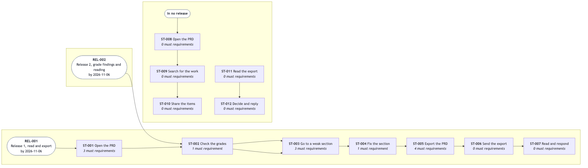
The release line
ID | Release | Target date | Stages | Requirements
REL-001 | Release 1, read and export | 2026-11-06, committed | ST-001 to ST-007 | FR-001 to FR-024, except FR-006
REL-002 | Release 2, grade findings and reading | 2026-11-06, indicative | ST-002, ST-003 | FR-025 to FR-028

REL-001. Release 1, read and export
The author reads the whole PRD set, sees the grades, and sends a themed PDF or Word export with a draft mark. A developer searches and exports selected sections, as part of ST-003 and ST-005. Release 1 comes first because it delivers the golden thread J-001. The PRD owner commits the date to the product sponsor (PER-004). ST-006 and ST-007 happen outside the viewer. Release 1 is done when SC-001 passes and every must requirement passes its acceptance criteria. The PRD owner moved the target date from 2026-10-26 to 2026-10-27 on 2026-10-26, and to 2026-11-06 on 2026-10-28. Release 1 runs on macOS only (OUT-003).

REL-002. Release 2, grade findings and reading
The author sees the findings behind each grade (FR-025). Release 2 comes second because release 1 is the golden thread J-001, and findings are useful only after the author sees all grades in one view (FR-004, release 1). Findings serve O-002. The authoring tools already record them (D-002). Editing in the viewer (OUT-001) has no release yet.
REL-001 Release 1, read and export
Outcomes | • The author opens a PRD set, sees the grade of every section in one view, goes to any section, and sees changes from the authoring tools without any action.  • The author sends stakeholders a PDF or Word export, in a theme the author selects, that shows the version and the draft mark.  • A developer searches the PRD set by term and category and exports selected sections.
Journey stages | • ST-001  • ST-002  • ST-003  • ST-004  • ST-005  • ST-006  • ST-007
Requirements | • FR-001  • FR-002  • FR-003  • FR-004  • FR-005  • FR-007  • FR-008  • FR-009  • FR-010  • FR-011  • FR-012  • FR-013  • FR-014  • FR-015  • FR-016  • FR-017  • FR-018  • FR-019  • FR-020  • FR-021  • FR-022  • FR-023  • FR-024
Objectives | • O-001
Target date | 2026-11-06
Date status | committed
Exit criteria | • SC-001, the end-to-end acceptance test for release 1, passes.  • Every must requirement in this release passes its acceptance criteria.

REL-002 Release 2, grade findings and reading
Outcomes | • The author sees, for each section, the findings behind its grade: what is missing and what to improve.  • The author and the developers read at a text size that suits them, keep search results in view, and move between requirements and the backlog stories that build them.
Journey stages | • ST-002  • ST-003
Requirements | • FR-025  • FR-026  • FR-027  • FR-028
Objectives | • O-001  • O-002
Target date | 2026-11-06
Date status | indicative
Depends on | • D-002
Exit criteria | • For each graded section, the author sees the findings behind its grade: what is missing and what to improve.

Section 14

Glossary
draft
Each term enters the glossary when it first appears in the interview.
Term | Meaning
PRD set | One PRD as 18 linked documents. The unit of work.
section | One of the 17 section documents in a PRD set.
authoring tools | The tools that write and grade the PRD set. Today: PRD Forge in Claude Code.
grade | A score from 0 to 100, a blocking-defect count, and a date.
blocking defect | A fault that stops a section from going to review or final.
status | pending, draft, review, or final.
golden thread | The one journey that release 1 must deliver end to end (J-001).
journey | The stages that one persona goes through to reach one goal.
stage | One large step of a journey.
persona | One role that uses the product or approves something about it.
export | A document file or printed copy that a reader opens without the authoring tools.
export theme | A named set of colors and fonts that controls how an export looks.
MoSCoW priority | must, should, could, or won't, for release 1. Source: Agile Business Consortium.
acceptance criterion | A Given, when, then test of one requirement. Source: Dan North, "Introducing BDD".
built-in theme | A theme that comes with the viewer: Ice Snowstorm or Clay.
fixed-layout document | An export whose pages look the same everywhere. Format in IN-006.
unreadable document | A document whose header the viewer cannot read. Pending is not unreadable.
contents list | The list of every document, in reading order, at the start of an export.
reading order | Root document first, then each section by its order number.
editable document | An export that a reader can change in a word processor. Format in IN-006.

PRD set
Meaning | One PRD as 18 linked documents: one root index with the executive summary, and 17 section documents. The unit of work for every persona.
See also | • section  • authoring tools

section
Meaning | One of the 17 section documents in a PRD set, such as problem and opportunity, user journeys, or functional requirements.

authoring tools
Meaning | The tools that interview the author, write the PRD set, and grade each section. Today these are PRD Forge, used inside Claude Code. The viewer reads their output and does not replace them.
Not | The viewer. The viewer reads and exports a PRD set; it does not write or grade it.

grade
Meaning | The result of checking one section against its rubric: a score from 0 to 100, a count of blocking defects, and the date of the check.
See also | • blocking defect

blocking defect
Meaning | A fault in a section that stops it from going to review or final, whatever its score.

status
Meaning | The stage of a section or of the PRD set: pending (not interviewed), draft (written), review (with reviewers), or final (approved).
Not | A review meeting. "Review" is a status.

golden thread
Meaning | The one journey that release 1 must deliver end to end. In this PRD it is J-001.

journey
Meaning | The stages that one persona goes through to reach one goal, from start to end, including steps outside the product.
See also | • stage

stage
Meaning | One large step of a journey, with an actor, inputs, outputs, and a decision.

persona
Meaning | One role that uses the product or approves something about it.

export
Meaning | A copy of the whole PRD set or of selected sections, as one document file or as a printed copy, that a reader opens without the authoring tools.
See also | • export theme

export theme
Meaning | A named set of colors and fonts that controls how an export looks. Some themes come with the viewer, and the author can make more.

MoSCoW priority
Meaning | The priority of a requirement: must (release 1 needs it), should (important, not essential for release 1), could (if time allows), or won't (not in this release).
Not | A won't requirement is not a non-goal. It is out of release 1 and comes back in a later release, as FR-025 does in release 2. The source defines the priorities for any timebox. This set ties them to release 1.
Source | "What is MoSCoW Prioritization?", Agile Business Consortium, https://www.agilebusiness.org/?p=1907

acceptance criterion
Meaning | One test that shows a requirement works, in the form Given a situation, when a person acts, then a result that a tester can see.
Source | "Introducing BDD", Dan North, 20 Sep 2006, https://dannorth.net/blog/introducing-bdd/

built-in theme
Meaning | An export theme that comes with the viewer and that the author cannot change or delete. Release 1 has two: Ice Snowstorm and Clay.
See also | • export theme

fixed-layout document
Meaning | An export file whose pages look the same on every computer and that the reader cannot easily change. IN-006 names the format.

editable document
Meaning | An export file that the reader can open and change in a word processor. IN-006 names the format.

unreadable document
Meaning | A document in a PRD set whose header the viewer cannot read, so its id, kind, title, or status is not known. A pending section with no content is not unreadable.

contents list
Meaning | The list of every document of the PRD set, in reading order, at the start of an export.

reading order
Meaning | The order of the documents in a PRD set: the root document first, then each section by its order number.

prdf
Meaning | The terminal command that starts the viewer, short for PRD Forge.

item
Meaning | Any entry in a PRD set that has an id, such as FR-008, SC-003, PER-002, or Q-004, and any glossary term. One search result is one item.

item title
Meaning | The first named field of an item: its name, capability, statement, question, or term.

category
Meaning | A filter for search: one category for each kind of section, such as functional requirements or scenarios. A search uses one or more categories, or all of them.

relevance score
Meaning | A number from 0 to 100 on each search result. Matches in the item title score higher than matches in the text, and more matches score higher.

known location
Meaning | A folder where the viewer opened a PRD set before. The viewer remembers it.

backlog
Meaning | The features, epics, stories, and spikes that the authoring tools derive from an approved PRD set. It is a separate set of documents next to the PRD set, and each story names the requirements that it builds.

text size
Meaning | The size of the text in the viewer, which the author can make larger or smaller.

Section 15

Change log
draft
Version | Date | Author | Summary | Approvals
0.1.0 | 2026-10-26 | Richard Hightower | First draft of all 15 sections | None yet
0.2.0 | 2026-10-26 | Richard Hightower | prdf, known locations, search scores, fonts; 10 sections to review | None yet
0.3.0 | 2026-10-26 | Richard Hightower | PRD Forge 0.5.1 fields, wireframes WF-001 to WF-009, FR-023 added, FR-006 dropped | Richard Hightower, sponsor, approved 2026-10-26
0.3.1 | 2026-10-26 | Richard Hightower | WF-009 shows a pending section | Richard Hightower, sponsor, approved 2026-10-26
0.3.2 | 2026-10-26 | Richard Hightower | HLD review decisions: date, macOS, FR-024, NFR-010 | Richard Hightower, sponsor, approved 2026-10-26
0.3.3 | 2026-10-26 | Richard Hightower | FR-024 reopens the last set | Richard Hightower, sponsor, approved 2026-10-27
0.3.4 | 2026-10-27 | Richard Hightower | Neutral folder names in WF-006 | Richard Hightower, sponsor, approved 2026-10-27
0.4.0 | 2026-10-27 | Richard Hightower | PRD Forge 0.8.1: release line ST-001 to ST-007, WF-010, new front matter fields | Richard Hightower, sponsor, approved 2026-10-27
0.5.0 | 2026-10-27 | Richard Hightower | Answers from the open questions: NFR categories, must share, FR-025, SC-008 to SC-012, TR-012, TR-013 | Richard Hightower, sponsor, approved 2026-10-27
0.5.1 | 2026-10-28 | Richard Hightower | Glossary sources for MoSCoW priority and acceptance criterion | None yet
0.6.0 | 2026-10-28 | Richard Hightower | Sections 1, 2, 8, and 9 above 80; C-001, C-002, and C-004 retired to IN-006, OUT-001, and OUT-003; Q-001 and Q-009 answered | Richard Hightower, sponsor, approved 2026-10-28
0.6.1 | 2026-10-28 | Richard Hightower | Release 1 target date moves to 2026-11-06 | None yet
0.6.2 | 2026-10-30 | Richard Hightower | Grades in an export are optional and off by default (FR-019) | Richard Hightower, sponsor, approved 2026-10-30
0.7.0 | 2026-10-31 | Richard Hightower | FR-008 in more than one category; FR-026 to FR-028 added to release 2 | Richard Hightower, sponsor, approved 2026-10-31

0.1.0. First draft
The interview wrote all 15 sections. The decisions recorded on 2026-10-26:
- Editing in the viewer is not in release 1 (Q-005, OUT-001).
- Grade findings wait for a later release and a PRD Forge change (Q-004, D-002).
- Search and custom export themes are in release 1.
- Every export shows "Draft" until every document is final (TR-005).
- PDF and Word are the export formats (C-001).
- When the sponsor is not available, the approval waits (Q-006).
- The release 1 target date is 2027-01-31.
- The viewer is free and open source for anyone who uses PRD Forge.
Versions 0.1.0 and 0.2.0 have no approval.

0.3.0. Approved by the sponsor
Richard Hightower approved version 0.3.0 as the sponsor (PER-004) on 2026-10-26. The 14 graded sections moved from review to final. The root, open questions, glossary, and change log stay at draft, so every export still shows "Draft" (TR-005).

0.3.1. A pending section in WF-009
WF-009 now shows how a pending section looks in the contents of an export. The wireframes section returned to review. Richard Hightower approved version 0.3.1 as the sponsor (PER-004) on 2026-10-26, and the wireframes moved to final.

0.3.2. Decisions from the HLD review
The PRD owner decided four items from the HLD review on 2026-10-26:
- REL-001 moves from 2026-10-26 to 2026-10-27 (ADV-07).
- Release 1 runs on macOS only. Other operating systems come later (C-004, ADV-03).
- When docs/prd holds more than one PRD set, the author picks one in the viewer (FR-024, ADV-02).
- The viewer shows only local content. No script runs, and nothing remote loads (NFR-010, ADV-01).
Scope, functional requirements, wireframes, non-functional requirements, constraints, and the release plan returned to review. Richard Hightower approved version 0.3.2 as the sponsor (PER-004) on 2026-10-26. Five of them moved to final. Functional requirements stay at draft: the adversarial grade found one blocking defect (ST-008 has no must requirement).

0.3.3. FR-024 reopens the last set
When docs/prd holds more than one PRD set, the viewer reopens the set that was open in the last session. The list of sets shows only when none of them was open before. This settles which rule wins between FR-002 and FR-024. Functional requirements stay at draft until ST-008 has a must requirement.

0.3.4. Neutral folder names in WF-006
The example folders in WF-006 no longer name a client. The wireframes returned to review until the sponsor approves this version.

0.4.0. Updated to PRD Forge 0.8.1
PRD Forge 0.8.1 checks that the release line is one run of J-001 stages, and that REL-001 lists exactly those stages. The PRD owner made these decisions on 2026-10-27:
- The release line is ST-001 to ST-007. ST-006 and ST-007 happen outside the viewer, and section 6 records the workaround for each.
- Search (IN-004) is part of ST-003, and the export of selected sections (IN-008) is part of ST-005. Release 1 still lets a developer do the work of J-002.
- SC-005 and SC-007 are should, because they are on J-002. FR-008 and FR-012 stay must in release 1, and FR-007 stays should.
- FR-007 and FR-008 move to ST-003, and FR-012 moves to ST-005, to agree with the scope.
- FR-023 says "Select one item of a section and read it without the whole section". It no longer names a control.
- The REL-001 date is committed. The REL-002 date is indicative.
- WF-010 shows the list of PRD sets in docs/prd. It is a state of WF-006, and WF-006 keeps marks 1 to 3.
The other changes copy facts that the PRD text already states into the new front matter fields. FR-012 and FR-013 state a situation in each Given. The root document and section 11 now give the correct release 1 date, 2026-10-27. The wireframes show version 0.4.0. The sponsor approved versions 0.3.3, 0.3.4, and 0.4.0 on 2026-10-27, and the changed sections returned to final.

0.5.0. Answers from the open questions
The PRD owner answered these questions on 2026-10-27:
- Scale, retention, and observability do not apply to the viewer. Section 8 gives the reason for each.
- Nine requirements move from must to should: FR-002, FR-011, FR-016, FR-017, FR-018, FR-019, FR-020, FR-022, and FR-024. They stay in release 1. Release 1 can ship without them.
- SC-008 adds a second unhappy path to J-002: an export with a pending section (Q-008).
- FR-025 shows the findings behind the grade of a section. It is the only requirement of release 2 (REL-002). Its priority is wont, because release 1 does not have it. WF-011 draws it.
- SC-009 is the first use of the viewer, with two PRD sets in docs/prd.
- SC-010 is the J-003 happy path. SC-011 (a rejection with a reason) and SC-012 (the sponsor is not available) come from TR-007 and Q-006.
- LC-001 records how a section moves from pending to final.
- SC-006 is should, because FR-002 is should.
- The PRD owner decides on OUT-001 (editing) at the release 2 review, on 2026-11-06.
- Each non-goal has a reason. The viewer shows one PRD set at a time, because every journey works on one PRD.
- FR-021 and FR-024 keep the folder name docs/prd, because the authoring tools use it and the author sees it. WF-010 keeps its example set names.
- TR-012 and TR-013 give the developer (PER-002) the decisions at ST-008 and ST-010. TR-001 and TR-004 keep only the author's stages.
- Release 1 comes first because it delivers the golden thread J-001. Release 2 comes second because findings are useful only after the author sees all grades in one view (FR-004).
The sponsor approved version 0.5.0 on 2026-10-27, and the changed sections moved to final.

0.5.1. Sources for standard terms
PRD Forge 0.9.0 asks the glossary to cite the published source of each standard term. The glossary entry for MoSCoW priority now cites the Agile Business Consortium. It states that this set ties the priorities to release 1, and that a won't requirement is not a non-goal. The new entry for acceptance criterion cites Dan North for the Given, when, then form that section 7 uses. The glossary is a draft, so this version needs no approval to keep the other sections final.

0.6.0. Sections 1, 2, 8, and 9 above 80
The PRD owner answered these questions on 2026-10-28:
- In one review of this PRD, the PRD owner searched the files for an item about 10 times, about 3 minutes each (Q-009). P-001 records the cost, about 30 minutes for each review.
- The historic PRDs took about 10 calendar days to the first feedback. This PRD does not count for review time, because it is for a new tool (Q-001). O-001 keeps the 10 days as its baseline.
- Packaging one version by hand takes 2 to 4 hours (P-002).
- The NFR speed targets follow the response time limits of Jakob Nielsen. NFR-008 also covers the known locations and the last set.
- C-001, C-002, and C-004 are retired, because the PRD owner can change them. IN-006 names the export formats, PDF and .docx. OUT-001 records the read-only rule, and the new OUT-003 records macOS only for release 1. The PRD owner revisits OUT-001 and OUT-003 on 2026-11-06. Section 9 keeps only C-003.
Section 2 now sizes S-001 from the 126 people who cloned the authoring tools in the 14 days to 2026-10-28, and names a shared online document and a team script as substitutes. Sections 3, 7, 11, 12, 13, and 14 changed only to match these answers.
The sponsor approved version 0.6.0 on 2026-10-28, and the changed sections moved to final.

0.6.1. Release 1 date
The PRD owner moved the release 1 target date (REL-001) from 2026-10-27 to 2026-11-06 on 2026-10-28. Sections 11 and 13 changed and returned to review.
First draft of all 15 sections from the PRD Forge interview. Decisions on 2026-10-26: editing is not in release 1 (Q-005); grade findings wait for a later release (Q-004); search and custom themes are in release 1; exports always show "Draft" until every section is final (TR-005); PDF and Word are a constraint (C-001); approval waits for the sponsor (Q-006); release 1 target date is 2027-01-31; the viewer is free and open source.
Version | 0.1.0
Date | 2026-10-26
Author | Richard Hightower
Sections | • 1  • 2  • 3  • 4  • 5  • 6  • 7  • 8  • 9  • 10  • 11  • 12  • 13  • 14  • 15
Resolves | • Q-004  • Q-005  • Q-006

Engineering review fixes and new decisions. Added FR-021 (the prdf command) and FR-022 (remembered PRD set locations). Search results show a relevance score from 0 to 100 and open the item when selected. Custom themes use serif, sans-serif, or monospace fonts, embedded in exports. The test computer is an Apple silicon Mac with 16 GB. The author opens the viewer several times a day (Q-003). PRD Forge 0.2.0 delivers the grade findings (D-002); the viewer shows them in release 2. Ten sections moved to review. Added O-002 and four non-goals. Release 1 is 2026-10-26 and release 2 is 2026-11-06.
Version | 0.2.0
Date | 2026-10-26
Author | Richard Hightower
Sections | • 2  • 4  • 5  • 6  • 7  • 8  • 9  • 11  • 12  • 13  • 14
Resolves | • Q-003  • Q-007

Updated to PRD Forge 0.5.1. Added persona short names, stage acceptance, scenario priorities, SC-007 (a search with no match), and Q-008. Added the wireframes section with WF-001 to WF-009, approved by the PRD owner, and shown_in on each requirement. Added FR-023 (expand a section in the tree and select an item). Dropped FR-006 (previous and next section) because the tree covers it.
Version | 0.3.0
Date | 2026-10-26
Author | Richard Hightower
Sections | • 4  • 5  • 7  • 12
Approvals | Richard Hightower  Role: Sponsor (PER-004)  Date: 2026-10-26  Decision: approved

WF-009 shows a pending section in the contents, and sections 1 and 4 as final. The wireframes section returns to review until the sponsor approves this version.
Version | 0.3.1
Date | 2026-10-26
Author | Richard Hightower
Sections | • 7
Approvals | Richard Hightower  Role: Sponsor (PER-004)  Date: 2026-10-26  Decision: approved

Decisions from the HLD review. Release 1 moves to 2026-10-27. Release 1 runs on macOS only (C-004). FR-024 adds a choice of PRD set when docs/prd holds more than one. NFR-010 shows only local content. Six sections return to review until the sponsor approves this version.
Version | 0.3.2
Date | 2026-10-26
Author | Richard Hightower
Sections | • 6  • 7  • 8  • 9  • 13
Approvals | Richard Hightower  Role: Sponsor (PER-004)  Date: 2026-10-26  Decision: approved

FR-024 reopens the set that was open in the last session. The list of sets shows only when none of them was open before.
Version | 0.3.3
Date | 2026-10-26
Author | Richard Hightower
Sections | • 7
Approvals | Richard Hightower  Role: Sponsor (PER-004)  Date: 2026-10-27  Decision: approved

WF-006 uses neutral example folder names. The wireframes return to review until the sponsor approves this version.
Version | 0.3.4
Date | 2026-10-27
Author | Richard Hightower
Sections | • 7
Approvals | Richard Hightower  Role: Sponsor (PER-004)  Date: 2026-10-27  Decision: approved

Updated to PRD Forge 0.8.1. The release line is ST-001 to ST-007 of J-001. ST-006 and ST-007 are recorded as stages outside the viewer, with their workarounds. Search (IN-004) is part of ST-003, and the export of selected sections (IN-008) is part of ST-005. REL-001 lists ST-001 to ST-007, its date is committed, and it has exit criteria. REL-002 is indicative and depends on D-002. SC-005 and SC-007 are should. FR-008 and FR-012 stay must in release 1, and FR-007 stays should. FR-007 and FR-008 move to ST-003, and FR-012 moves to ST-005. FR-023 states the user need and no longer names a control. WF-010 is the state of WF-006 when docs/prd holds more than one PRD set. The front matter now records competitor kinds, the primary persona, the approver, the problems that each objective and persona serves, a persona id for each decision approver, and the questions that each change answers. The wireframes show version 0.4.0, and section 11 gives the correct release 1 date, 2026-10-27.
Version | 0.4.0
Date | 2026-10-27
Author | Richard Hightower
Sections | • 2  • 3  • 4  • 5  • 6  • 7  • 10  • 11  • 12  • 13  • 15
Approvals | Richard Hightower  Role: Sponsor (PER-004)  Date: 2026-10-27  Decision: approved

Answers from the open questions. Section 8 records scale, retention, and observability as not applicable, with reasons. Nine requirements move from must to should: FR-002, FR-011, FR-016, FR-017, FR-018, FR-019, FR-020, FR-022, and FR-024. They stay in release 1. SC-008 adds an export with a pending section to J-002 (Q-008). FR-025 shows the findings behind a grade. It is the only requirement of REL-002, so its priority is wont for release 1. WF-011 draws it. The release plan says why REL-002 comes second, and that the REL-001 date is committed to the sponsor. TR-012 and TR-013 record the developer's decisions at ST-008 and ST-010. SC-009 adds first use, SC-010 to SC-012 add J-003, and LC-001 records the lifecycle of a section. SC-006 is should. OUT-001 is revisited at the release 2 review. Each non-goal has its reason. FR-021 records why docs/prd stays.
Version | 0.5.0
Date | 2026-10-27
Author | Richard Hightower
Sections | • 5  • 6  • 7  • 8  • 10  • 12  • 13  • 15
Resolves | • Q-008
Approvals | Richard Hightower  Role: Sponsor (PER-004)  Date: 2026-10-27  Decision: approved

PRD Forge 0.9.0 asks the glossary to cite the source of each standard term. MoSCoW priority cites the Agile Business Consortium and states how this set departs from it. The new term acceptance criterion cites Dan North for the Given, when, then form.
Version | 0.5.1
Date | 2026-10-28
Author | Richard Hightower
Sections | • 14

Raises sections 1, 2, 8, and 9 above a grade of 80 under PRD Forge 0.9.0. Section 1 gives P-001 a cost (about 10 searches of about 3 minutes in one review, Q-009) and states that this PRD does not count for review time, because it is for a new tool. The historic PRDs took about 10 days (Q-001). Section 2 sizes S-001 from the clone count of the authoring tools and adds two substitutes. Section 8 gives each NFR a source, cites the Nielsen response time limits and WCAG2ICT, and extends NFR-008 to the known locations and the last set. Section 9 keeps only C-003. C-001, C-002, and C-004 are retired, because the PRD owner can change them. Section 6 records them: IN-006 names the export formats, OUT-001 the read-only rule, and the new OUT-003 macOS only. Sections 7, 11, and 14 cite IN-006 in place of C-001.
Version | 0.6.0
Date | 2026-10-28
Author | Richard Hightower
Sections | • 1  • 2  • 3  • 6  • 7  • 8  • 9  • 11  • 12  • 13  • 14  • 15
Resolves | • Q-001  • Q-009
Approvals | Richard Hightower  Role: Sponsor (PER-004)  Date: 2026-10-28  Decision: approved

The PRD owner moved the release 1 target date (REL-001) from 2026-10-27 to 2026-11-06.
Version | 0.6.1
Date | 2026-10-28
Author | Richard Hightower
Sections | • 11  • 13

An export leaves out the grades by default. FR-019 keeps the status of every section in the contents list, and shows the score and the blocking defects only when the author selects to include them.
Version | 0.6.2
Date | 2026-10-30
Author | Richard Hightower
Sections | • 7
Approvals | Richard Hightower  Role: Sponsor (PER-004)  Date: 2026-10-30  Decision: approved

The PRD catches up with the viewer. FR-008 searches one or more categories. FR-026 adds the text size, FR-027 keeps search results in view, and FR-028 moves between a requirement and the backlog stories that build it (GitHub issue 199). The three new requirements join FR-025 in release 2 (REL-002). The glossary adds backlog and text size.
Version | 0.7.0
Date | 2026-10-31
Author | Richard Hightower
Sections | • 7  • 13  • 14
Approvals | Richard Hightower  Role: Sponsor (PER-004)  Date: 2026-10-31  Decision: approved

