Product requirements document
prd-forge
A domain expert, with no product management training, can reach a PRD that an engineering lead confirms is buildable, and can see for themselves where it is still weak before anyone starts work.

Version | 0.4.0
Status | draft
Owner | Richard Hightower
Domain | product management tooling
Created | 2026-10-23
Updated | 2026-10-26
Golden thread | J-001
Stakeholders | • Domain experts who must specify software for their own field  • Engineering leads who build from the resulting PRD  • Delivery leads who run story-mapping workshops

Executive summary
Problem | A domain expert knows exactly what their product must do, but what they can write down is a feature list with no named users, no pass-or-fail criteria and the technology already chosen, so the team that has to build it cannot.
Users | Domain experts specifying software for their own field, the engineering leads who build from what they write, and the sponsors who approve it.
Why now | Teams now expect to work from a written specification an assistant helped produce, and a specification that reads well but cannot be built from costs more than no specification at all, because it is believed.
Bet | A domain expert, with no product management training, can reach a PRD that an engineering lead confirms is buildable, and can see for themselves where it is still weak before anyone starts work.
Measure | Share of PRDs that pass an engineering buildability review on the first submission.

Contents
§ | Section | Status | Grade | Blocking
1 | Problem and opportunity | draft | — | —
2 | Target customer and market | draft | — | —
3 | Business objectives and success metrics | draft | — | —
4 | Users and personas | draft | — | —
5 | User journeys | draft | 88/100 | —
5 | Scenarios | draft | — | —
6 | Scope | draft | — | —
7 | Functional requirements | draft | 84/100 | —
7 | Wireframes | draft | 91/100 | —
8 | Non-functional requirements | draft | 82/100 | —
9 | Constraints | draft | — | —
10 | Decision rights and trust rules | draft | 86/100 | —
11 | Assumptions, risks and dependencies | draft | — | —
12 | Open questions | draft | — | —
13 | Release plan | draft | — | —
14 | Glossary | draft | — | —
15 | Change log and approvals | draft | — | —

About this document
A domain expert knows exactly what their product must do, but what they can write down is a feature list with no named users, no pass-or-fail criteria and the technology already chosen, so the team that has to build it cannot. The users are domain experts specifying software for their own field, the engineering leads who build from what they write, and the sponsors who approve it. Teams now expect to work from a written specification an assistant helped produce, and one that reads well but cannot be built from costs more than no specification at all, because it is believed. The bet is that a domain expert with no product management training can reach a PRD an engineering lead confirms is buildable, and can see for themselves where it is still weak before anyone starts work. We will know it worked from the share of PRDs that pass an engineering buildability review on the first submission.

Contents
Section | Document
1 | Problem and opportunity
2 | Target customer and market
3 | Business objectives and success metrics
4 | Users and personas
5 | User journeys
5 | Scenarios
6 | Scope
7 | Functional requirements
7 | Wireframes
8 | Non-functional requirements
9 | Constraints
10 | Decision rights and trust rules
11 | Assumptions, risks and dependencies
12 | Open questions
13 | Release plan
14 | Glossary
15 | Change log and approvals

How this document set is numbered
A PRD has fifteen numbered sections and this set has seventeen section documents, because section 5 holds two of them, journeys and scenarios, and section 7 holds two, functional requirements and wireframes. The two section 7 files share the prefix 08. So from section 5 onward the file prefix and the section number differ — 07-scope.md is section 6, 16-change-log.md is section 15. Every cross-reference in this set is by section number, never by file number. Three independent reviewers misread this, so it is stated here rather than left to be inferred.

A note on this PRD
This is prd-forge's PRD, written with prd-forge's own conventions. Writing it surfaced one real tension, recorded as C-001: the product is delivered inside an assistant the expert already uses, and naming that delivery mechanism in a requirement would fail test 5. The platform is therefore a constraint, and the requirements in section 7 describe only what a person does and sees.
Grading it with its own adversarial reviewers found twelve blocking defects across four sections, and a buildability review found four failed derivability checks. Version 0.2.0 fixes them: every graded section is now at zero blocking defects, and nine of the eleven derivability checks pass. What that grading found, and what it changed, is in section 15.
On the scores in this set. Each graded section carries the score from its last grading pass, with the date. Sections 5, 7 and 8 were graded before the second round of corrections, and section 10 before its last two, so each score is the last one measured and not a reading of the words as they now stand. Treat them as a floor. A score never rises without a change to the document, and never rises without a grading pass; the two gaps here are in the other direction.

Section 1

Problem and opportunity
draft
ID | Problem | Who
P-001 | What the expert writes is a feature list with no user and no testable outcome | Domain expert
P-002 | The steps between requirements are never written, so paths have gaps | Engineering lead
P-003 | Buildability is invisible until the team starts building | Sponsor or approver
P-004 | No source of PRD craft at the moment the expert needs it | Domain expert

The four compound. P-004 means the expert does not know what good looks like; P-001 is what they produce as a result; P-002 is the specific gap that costs the most; and P-003 is why none of it is caught before it is expensive.
Evidence note. The evidence above describes a pattern, not a measurement. No figure here is sourced, and three of the objectives in section 3 have no baseline for the same reason — see Q-001, Q-002 and Q-003. Measure your own intake before relying on any of it.
P-001
Statement | A domain expert can describe what their product must do out loud, but what they write down is a feature list: no named user, no outcome anyone could check, and a technology already chosen for reasons they cannot defend.
Who | Domain expert specifying software for their own field
Evidence | • Specifications arriving at delivery teams are commonly feature lists; teams report re-deriving the user and the acceptance criteria themselves before they can estimate. Quantify this from your own intake before you rely on it.  • Experts asked to write requirements reach for the words of the software they have used, because that is the only requirements language they have been exposed to.
Why now | Specifications are now commonly drafted with an assistant, which makes them fluent. Fluent and unbuildable is a worse failure than rough and unbuildable, because nobody queries it.
Cost of inaction | The gap is closed by an engineer guessing, during build, at what the expert meant, and the guess is discovered at review or in production.

P-002
Statement | Requirements are written one at a time, so the steps between them are never written at all, and nobody notices until the team tries to assemble a working path through the product.
Who | Engineering lead building from the specification
Evidence | • A specification with no user journey gives a story-mapping workshop no backbone, so features and epics cannot be derived from it at all.  • Gaps surface as mid-iteration questions about what happens between two requirements that both looked complete.
Why now | Teams are committing to outcomes per release, which needs a complete path through the product, not a complete list of features.
Cost of inaction | The release line is drawn across a feature list rather than a journey, so a release ships features and no user can complete anything with them.

P-003
Statement | Nobody can tell a buildable specification from a readable one until the team has already started building from it.
Who | Sponsor or approver signing the specification off
Evidence | • Approval is given on readability and completeness of headings, because those are the only properties an approver can assess unaided.  • The first real assessment of buildability happens when an engineer estimates, which is after approval and after the plan was made.
Why now | Where the document was drafted with an assistant, readability is no longer any evidence at all of buildability.
Cost of inaction | Plans and commitments are made on an approved document whose defects are found by the people asked to deliver against them.

P-004
Statement | An expert has nowhere to learn what a section of a PRD is for at the moment they are being asked to fill it in.
Who | Domain expert specifying software for their own field
Evidence | • Templates name the sections and not their purpose, so a heading like "non-functional requirements" is filled with adjectives.  • The craft exists in books and in experienced product managers, neither of which is available at the moment the expert is typing.
Why now | Organisations are asking domain experts to specify directly, without routing the work through a product manager first.
Cost of inaction | Each expert reinvents the form badly, and the organisation's specifications cannot be compared to one another or improved as a body of work.

Section 2

Target customer and market
draft
ID | Segment | Buyer | User
S-001 | Consultancies specifying from client domain knowledge | Principal or practice lead | The consultant
S-002 | Regulated-industry organisations where practitioners specify | Head of product or delivery | The practitioner
S-003 | Product teams entering an unfamiliar domain | Head of product | Product manager

S-003 is listed last deliberately. That segment already has the product skill and wants domain knowledge, which this product does not supply — it supplies product management to someone who already has the domain. Treat S-003 as a weak fit until Q-004 says otherwise.

Why we win
The expert can see, before anyone starts building, which parts of their own specification a development team will not be able to build from, and what to answer to fix it. No competitor above tells them that.
Honest weakness. Against a contracted product manager we have no quality edge, only availability and cost. A sceptical buyer is right to test that.

Segments
S-001 Consultancies and advisory firms turning client domain knowledge into specifications
Buyer | Principal or practice lead
User | The consultant with the domain knowledge
Size | <count> firms, per <a named register, with its year> — not yet measured; see Q-004.
Willingness to pay | Already pays for the consultant's time; the comparison is billable hours saved, not a software budget.

S-002 Regulated-industry organisations where practitioners specify their own internal software
Buyer | Head of product, delivery lead, or head of transformation
User | The practitioner, plus the delivery lead who reviews what they write
Size | Not yet measured; see Q-004.
Willingness to pay | Compared against contracting a product manager for the engagement.

S-003 Product teams entering a domain they do not know
Buyer | Head of product
User | Product manager, interviewing practitioners
Size | Not yet measured; see Q-004.
Willingness to pay | Lowest of the three: they already employ the product skill and want the domain, which this does not supply.

Competitors
A blank PRD template in the team's document tool
Offer | The section headings, immediately, free, in a tool everyone already has.
Our edge | A heading asks a question the expert cannot answer; this teaches the section first and then asks the questions that produce an answer.

A general-purpose assistant conversation with no structure
Offer | Fluent prose on any section, instantly, with no setup at all.
Our edge | Fluency is the failure mode in P-003. The difference here is the grading: the expert is told where the document is weak, against a stated rubric, by a reviewer that did not write it.

Contracting a product manager for the engagement
Offer | Genuine product judgement, and someone accountable for the outcome.
Our edge | None on quality. The edge is availability and cost at the moment the expert is typing, and that the expert keeps the understanding afterwards rather than renting it.

The status quo - a smart practitioner, a document, and a willing engineer
Offer | No tool, no cost, no adoption, and it does sometimes work.
Our edge | It works when the engineer is willing to re-derive the specification and is in the room. It fails on handover, on scale, and on anything the engineer cannot ask about.

Section 3

Business objectives and success metrics
draft
ID | Objective | Metric | Baseline | Target
O-001 | Buildable without re-derivation | Pass rate on first buildability review | unknown (Q-001) | 80%
O-002 | Days, not weeks, to an approved spec | Median working days, first question to approval | unknown (Q-002) | under 5
O-003 | Requirements testable as written | Share of must requirements an outside engineer can test | unknown (Q-003) | 95%

Why there are no baselines
All three baselines are unknown, and each has a matching open question with a decider and a date. That is deliberate and it is the honest state: this product has not run against a real engagement yet. The targets above are therefore intentions, not commitments, and section 15 should record the moment each baseline arrives and each target is either confirmed or changed.
A reviewer should push on this. An objective with an invented baseline is worse than one with an admitted gap, because the invented one gets planned against.

What would move these without this product
Worth asking, and recorded here because the answer is not nothing: a single experienced product manager embedded with the expert would move all three. The bet is on availability and cost, not on beating that person — see section 2.
O-001
Objective | A specification handed to a development team can be built from without the team re-deriving it first.
Metric | Share of PRDs that pass an engineering buildability review on first submission, where the review is the eleven derivability checks.
Baseline | unknown - not measured; see Q-001. Do not set a target against this until Q-001 is answered.
Target | 80% of PRDs pass on first submission.
By | 2027-09-30
Owner | Richard Hightower

O-002
Objective | A domain expert reaches an approved specification in days rather than the weeks a product manager's discovery cycle takes.
Metric | Median elapsed working days from the first interview question to an approval recorded in section 15.
Baseline | unknown - not measured; see Q-002.
Target | Under 5 working days for a single-journey product.
By | 2027-09-30
Owner | Richard Hightower

O-003
Objective | Requirements are testable as written, so a team can close them without asking the author what they meant.
Metric | Share of functional requirements whose acceptance criteria an engineer who was not in the interview judges sufficient to write a test.
Baseline | unknown - not measured; see Q-003.
Target | 95% of must requirements.
By | 2027-09-30
Owner | Richard Hightower

Section 4

Users and personas
draft
ID | Role | Frequency | May approve
PER-001 | Domain expert specifying their own field | Weeks per product, then rarely | Scope, terms, drafts, section states, facts, and offering the set; not the PRD itself
PER-002 | Engineering lead building from it | A handful of intensive reads | May reject as not buildable
PER-003 | Sponsor or approver | Once per version | The PRD for a release
PER-004 | Delivery lead running story mapping | Once per release | Backlog shape and order

PER-001 is the primary persona
Everything is designed around someone with deep domain knowledge, no product training, and a burst of intense use followed by months away. Two consequences run through the rest of this PRD: nothing may assume prior knowledge of product vocabulary, and the work must survive being put down for a week and picked back up — see FR-015 and NFR-004.

Who is deliberately not a persona
The assistant that delivers the teaching, the interview and the grading is not a user of this product. It is how the product reaches PER-001. Listing it here would put the delivery mechanism into the PRD, which section 9 keeps as a constraint instead. The same goes for the grading reviewers: a reviewer that grades a section is a mechanism, and what matters to this PRD is that PER-001 sees a grade they did not produce themselves.
PER-001 Domain expert specifying software for their own field
Goals | • Get what is in my head into a form the development team can build from  • Stop being asked the same question by four different engineers  • Not be the reason the project is late
Pains | • I know what it must do, and I cannot write it the way they need it  • I am told my requirements are not testable and I do not know what that means  • I reach for the names of software I have used, because that is the only requirements language I have
Frequency | Intensively for one to three weeks per product, then almost never until the next one.
Authority | Decides what the product must do and what is out of scope; decides the domain's own terms; decides when a section's interview is finished and when a section may be left at draft; accepts or corrects a drafted section; sets a section to final; accepts or refutes a grade; decides the set is ready to be offered for approval; and is the only one who may state a domain fact as true. May not approve the PRD for a release on their own where a sponsor exists.
Proficiency | Deep in their domain, often decades. No product management training. Assume no familiarity with MoSCoW, Given/When/Then, or the word "persona".

PER-002 Engineering lead who must build from the PRD
Goals | • Estimate without first interviewing the author  • Know which decisions are mine and which have been made for me  • Find out now, not in iteration three, what the document does not say
Pains | • Specifications that name a technology and so pre-empt my decision badly  • Requirements I cannot write a test for  • Gaps between two requirements that both looked complete
Frequency | Reads a given PRD a handful of times, intensively, at estimation and at each release planning.
Authority | Decides how it is built; may reject a PRD as not buildable.
Proficiency | Expert in delivery, usually knows nothing about the expert's domain.

PER-003 Sponsor or approver
Goals | • Be confident enough to commit budget and a date  • Know what is still undecided, and who is deciding it
Pains | • I can only judge whether it reads well  • I find out it was not buildable after I have committed to the plan
Frequency | Once per version, plus conditions.
Authority | Approves the PRD for a release; may approve with conditions; may reject.
Proficiency | Senior in the business, not in product or engineering.

PER-004 Delivery lead running the story-mapping workshop
Goals | • Walk into the workshop with a backbone already agreed  • Trace every story back to something the expert actually said
Pains | • No journey means no backbone, so the workshop invents one in the room  • Stories that trace to nothing, so nobody can say why they exist
Frequency | Once per release, plus refinement.
Authority | Decides the backlog's shape and order, and decides whether a backlog can be mapped from a set at all; does not decide scope.
Proficiency | Expert in agile delivery; depends entirely on the PRD for the domain.

Section 5

User journeys
draft · 88/100 · no blocking defects

J-001 - A domain expert reaches an approved PRD whose gaps are known (golden thread)
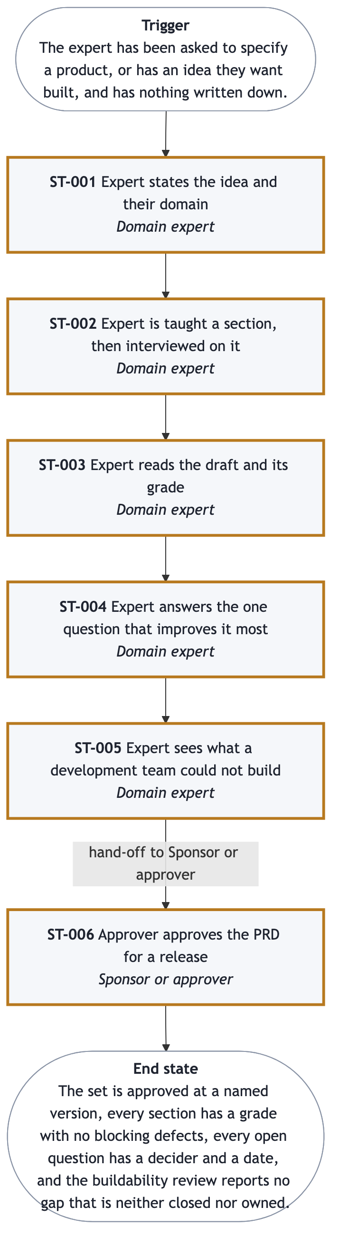
J-001 journey diagram
Persona PER-001. Trigger: they have been asked to specify a product and have nothing written. Stages ST-001 to ST-006.
Stage | Actor | Decision
ST-001 States the idea and the domain | Domain expert | What this is, and the domain's own words
ST-002 Taught a section, then interviewed | Domain expert | Have the questions reached the end of what they know
ST-003 Reads the draft and its grade | Domain expert | Accept, correct, or dispute the grade
ST-004 Answers the one question that matters most | Domain expert | Is this section done enough to leave
ST-005 Sees what a team could not build | Domain expert | Is it ready for someone who will commit
ST-006 Approver approves for a release | Sponsor or approver | Approve, approve with conditions, or reject

ST-002 to ST-004 are a loop, run once per section. That is the whole product: the expert is taught, asked, shown a draft, shown a grade, and asked one more thing.
End state: approved at a named version, every section graded with nothing blocking, every open question owned and dated, and no buildability gap left that is neither closed nor owned.
The goal deliberately does not claim an engineering lead's confirmation. No stage in ST-001 to ST-006 puts one in the actor seat, so claiming it would promise something the release line cannot deliver. A lead's own recorded confirmation is OUT-004, deferred to release 2 with J-002.

J-002 - A delivery lead derives a backlog (not the golden thread)
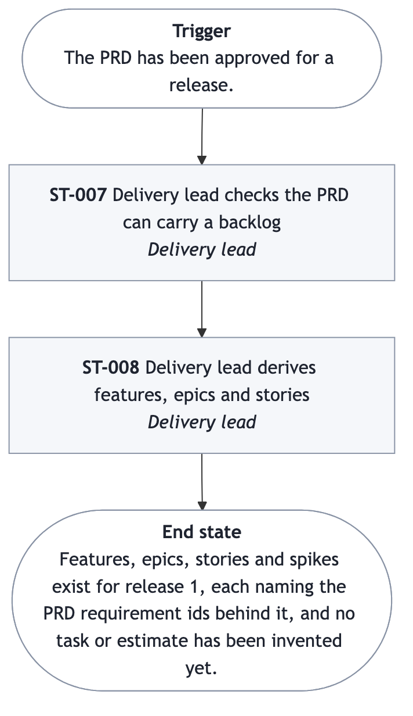
J-002 journey diagram
Persona PER-004, stages ST-007 and ST-008. Release 1 does not have to complete this journey — see section 6 — but the PRD must carry what it needs, which is what ST-007 checks.

What these journeys deliberately do not say
No stage says where the teaching text comes from, how a grade is computed, or what reviews the set in ST-005. Those are mechanisms. Every stage above names a person, what they do and see, and what they decide.
J-001
Goal | An approved PRD whose buildability gaps have been found and either closed or given an owner and a date, before anyone estimates it.
Persona | PER-001
Trigger | The expert has been asked to specify a product, or has an idea they want built, and has nothing written down.
Golden thread | yes
Stages | Expert states the idea and their domain  ID: ST-001  Actor: Domain expert  Acceptance: Given an expert with an idea and nothing written down, when they state the idea, the domain, and three words an outsider would misread, then they see a document set with every section listed and marked as not yet started.  Steps: Says what they want built, in their own words, however roughly; Is asked what the business domain is and what the unit of work is called - an engagement, a load, a claim, a case; Names three words their team uses that an outsider would misread; Sees that a set of documents now exists, every section listed and marked as not yet started  Inputs: The idea, the domain, and the vocabulary  Outputs: A document set with every section visible and honestly marked empty  Decision: What this product is, and what the domain's own words are  Expert is taught a section, then interviewed on it  ID: ST-002  Actor: Domain expert  Acceptance: Given a section not yet interviewed, when the expert reads what it is for and answers its questions one or two at a time, then the section has enough material to be drafted, or the expert has said they have nothing more to add.  Steps: Reads what the section is, why it matters, and what belongs in it, in under ten lines, with an example from their own domain; Is asked one or two questions at a time, in their own vocabulary; Is asked follow-ups where an answer was thin; Says when they have nothing more to add  Inputs: Their knowledge of the domain, in answer to each question  Outputs: Enough material for the section to be drafted  Decision: Whether the questions have reached the end of what they know  Expert reads the draft and its grade  ID: ST-003  Actor: Domain expert  Acceptance: Given a drafted and graded section, when the expert opens it, then they read it as prose and see its score, each blocking defect, and its weakest part.  Steps: Reads the drafted section as prose, not as a form; Sees a score, how many blocking defects there are, and what each one is; Sees which part of the section is weakest, and why; Decides whether the grade is fair  Inputs: Nothing; this is where they read  Outputs: A judgement on whether the draft says what they meant  Decision: Accept the draft, correct it, or dispute the grade  Expert answers the one question that improves it most  ID: ST-004  Actor: Domain expert  Acceptance: Given one question about the weakest part of a section, when the expert answers it, then they see the section re-graded against the same rubric.  Steps: Reads a single question, not a list of twelve; Answers it, or says why the premise is wrong; Sees the section re-graded against the same rubric; Moves to the next section, or goes back to an earlier one when this section showed it was incomplete  Inputs: One answer  Outputs: A section at a grade the expert accepts, and a set that is one section further on  Decision: Whether this section is done enough to leave  Handoff: Back into ST-002 for the next section, until every section has been through this loop.  Expert sees what a development team could not build  ID: ST-005  Actor: Domain expert  Acceptance: Given a set with every section written at least once, when the expert asks for a buildability review, then they see what a builder could not build and which release-line stages have no requirement behind them.  Steps: Asks for the whole set to be reviewed as a builder would read it; Sees what a builder could not build, and what they would have to guess; Sees which release-line stages have no requirement behind them; Fixes the holes, or records them as open questions with a decider  Inputs: Every section written at least once, so there is something to review  Outputs: A list of what is not buildable, and a set with those holes closed  Decision: Is this ready to be read by someone who will commit to it  Handoff: Sponsor or approver  Approver approves the PRD for a release  ID: ST-006  Actor: Sponsor or approver  Acceptance: Given a set offered for approval, when the approver approves, approves with conditions, or rejects it, then they see the decision recorded against the set's version.  Steps: Reads the summary, the scope, and what is still open; Sees each section's grade and whether anything is still blocking; Approves, approves with conditions naming what the condition is, or rejects; Sees the approval recorded against this version  Inputs: Their decision and any conditions  Outputs: An approved PRD at a named version, with the approval recorded  Decision: Approve, approve with conditions, or reject  Handoff: Delivery lead, for the story-mapping workshop
Pain points | • I do not know what the section is for, so I fill the heading with adjectives  • Nobody tells me my requirements are untestable until a team tries to build them  • I reach for the names of software I have used  • I put this down for a week and cannot remember where I was  • I cannot tell whether what I have written is good
Needs | • Teach me the section before you ask me about it, in my own domain  • Tell me where it is weak, against a stated standard, and ask me one thing  • Convert my technology talk into the need underneath it, without arguing  • Let me stop and resume without starting over  • Show me, before anyone builds, what a builder cannot build
End state | The set is approved at a named version, every section has a grade with no blocking defects, every open question has a decider and a date, and the buildability review reports no gap that is neither closed nor owned.

J-002 A backlog whose every story traces to a requirement the expert actually stated.
Persona | PER-004
Trigger | The PRD has been approved for a release.
Stages | Delivery lead checks the PRD can carry a backlog  ID: ST-007  Actor: Delivery lead  Acceptance: Given an approved set and the release it is mapped for, when the delivery lead checks it, then they see whether a golden-thread journey exists and what would block deriving a backlog.  Steps: Sees whether a journey exists and which one is the golden thread; Sees which release-line stages have requirements behind them; Sees what would block deriving a backlog, before the workshop  Inputs: An approved set, and the release it is being mapped for  Outputs: A go or no-go on holding the story-mapping workshop  Decision: Is there a backbone to map against  Delivery lead derives features, epics and stories  ID: ST-008  Actor: Delivery lead  Acceptance: Given an approved set, when the delivery lead derives a backlog from it, then they see one feature per journey stage, epics scoped by the release line, and a story per requirement, each naming the id it came from.  Steps: Sees one feature per journey stage, with the requirement ids it carries; Sees epics scoped by the release line; Sees a story per requirement, in the persona's own words, with the requirement's criteria as its acceptance criteria; Sees spikes for the open questions that block the release line  Inputs: The approved set, and the team's sizing of the stories  Outputs: A backlog whose every level names what it came from  Decision: Which epics come first, and why  Handoff: The engineering team, for iteration planning
Pain points | • The workshop invents a backbone in the room because the PRD has none  • Stories trace to nothing, so nobody can say why they exist  • Non-functional requirements and constraints are forgotten until late
Needs | • A journey to map against, agreed before the workshop  • Every story carrying the requirement id it came from  • Constraints arriving as definition-of-done items, not as surprises
End state | Features, epics, stories and spikes exist for release 1, each naming the PRD requirement ids behind it, and no task or estimate has been invented yet.

Section 5

Scenarios
draft
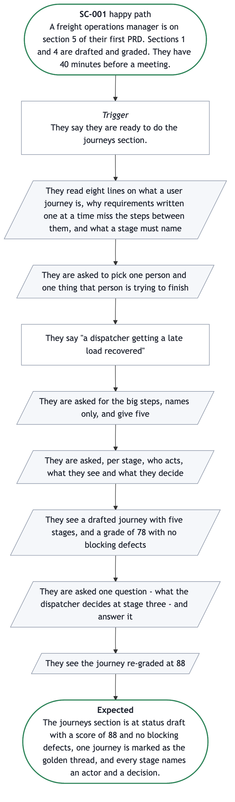
SC-001 scenario
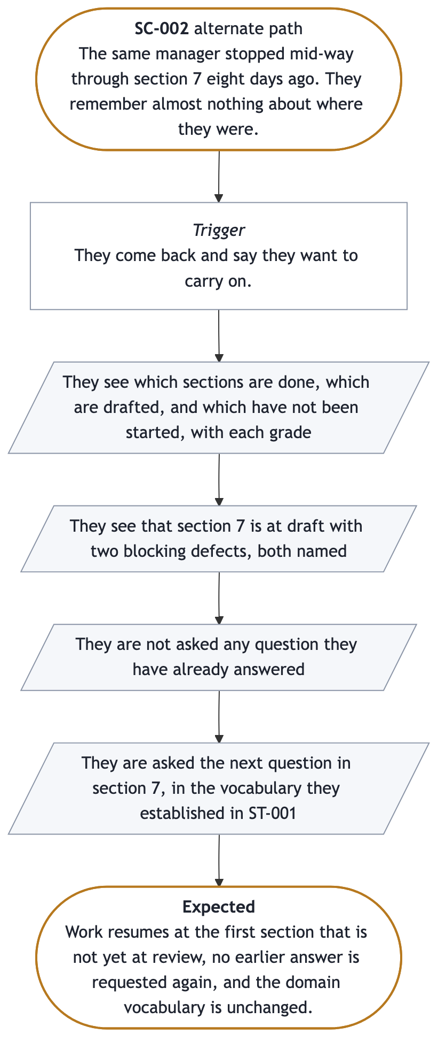
SC-002 scenario
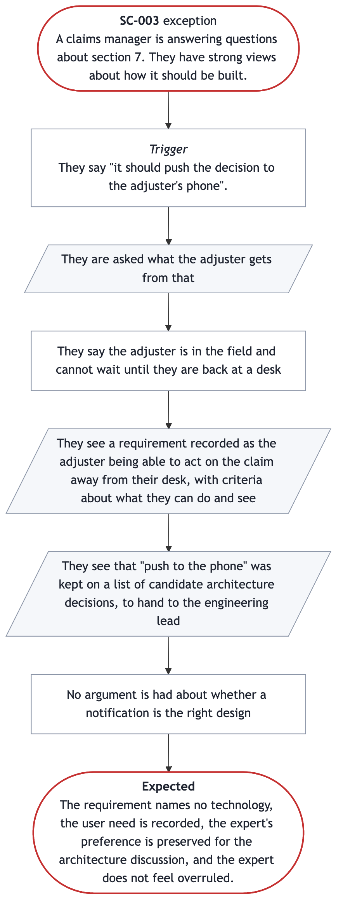
SC-003 scenario
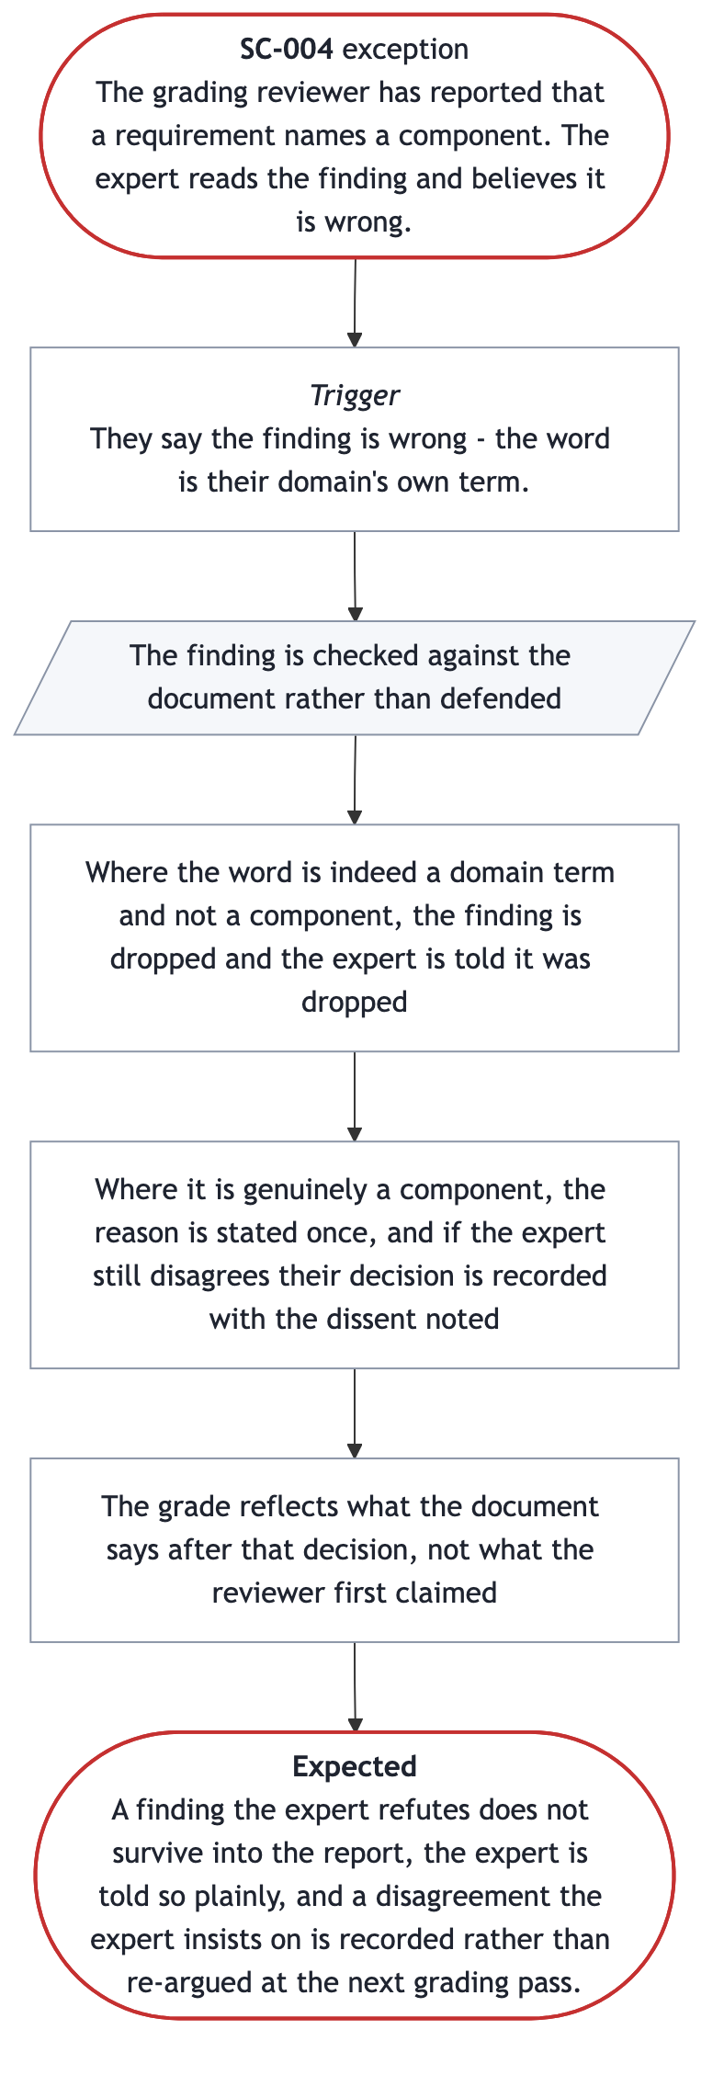
SC-004 scenario
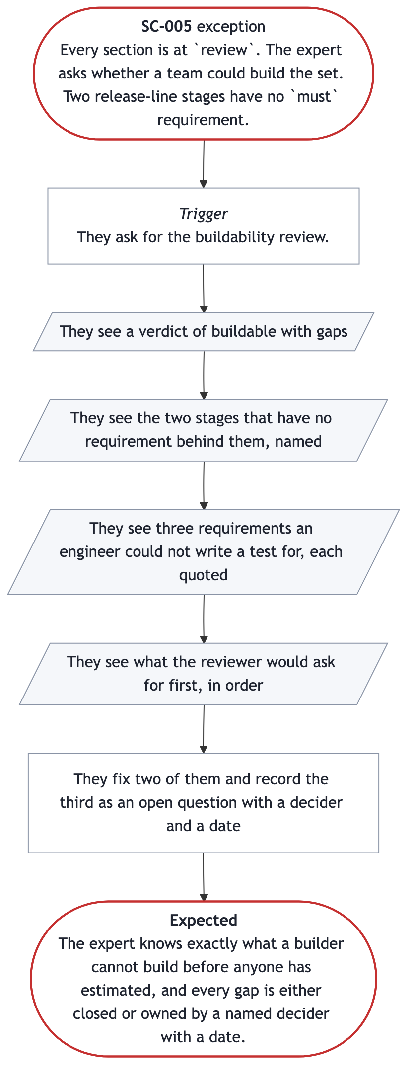
SC-005 scenario
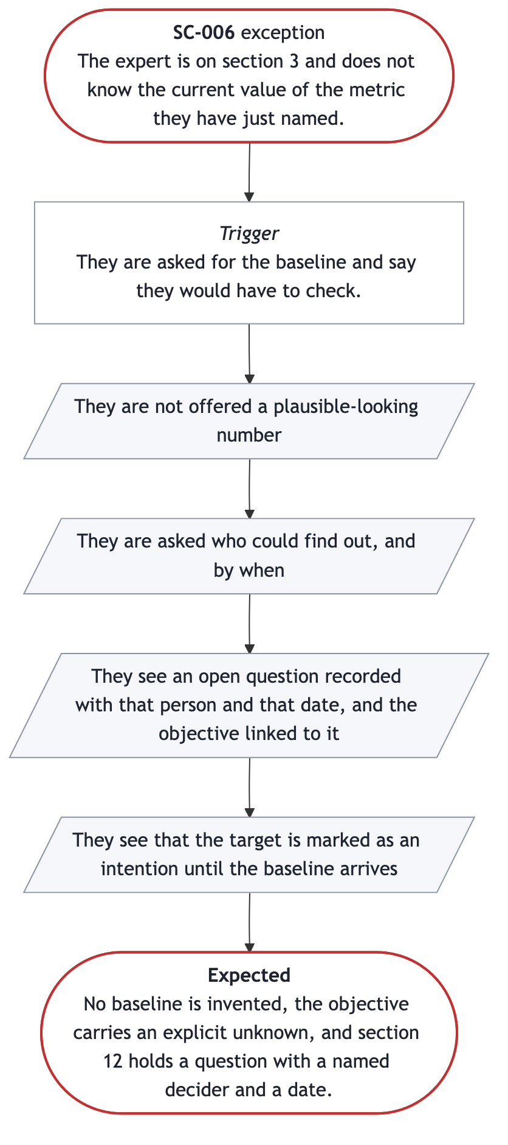
SC-006 scenario
ID | Stage | Variant | What it covers
SC-001 | ST-002 | happy | A section taught, interviewed, drafted, graded, improved
SC-002 | ST-004 | alternate | Resuming after eight days away
SC-003 | ST-002 | exception | The expert states a technology
SC-004 | ST-003 | exception | The expert refutes a grading finding
SC-005 | ST-005 | exception | Buildability review finds holes
SC-006 | ST-002 | exception | The expert has no baseline for a metric

SC-001 is the end-to-end acceptance test for release 1. SC-005 is the expert's own run of the buildability review, which is why its persona is PER-001 and not the engineering lead: no engineering lead is in release 1 at all, per OUT-004.
The four exceptions are the ones that decide whether this product is trustworthy. SC-003 and SC-006 are where a specification quietly acquires a technology choice or an invented fact. SC-004 is where the grading either earns the expert's trust or loses it: a reviewer that cannot be refuted is a reviewer nobody believes. SC-005 is the moment the product is supposed to pay for itself.
SC-001
Context | A freight operations manager is on section 5 of their first PRD. Sections 1 and 4 are drafted and graded. They have 40 minutes before a meeting.
Journey | J-001
Stage | ST-002
Persona | PER-001
Variant | happy
Trigger | They say they are ready to do the journeys section.
Course | • They read eight lines on what a user journey is, why requirements written one at a time miss the steps between them, and what a stage must name  • They are asked to pick one person and one thing that person is trying to finish  • They say "a dispatcher getting a late load recovered"  • They are asked for the big steps, names only, and give five  • They are asked, per stage, who acts, what they see and what they decide  • They see a drafted journey with five stages, and a grade of 78 with no blocking defects  • They are asked one question - what the dispatcher decides at stage three - and answer it  • They see the journey re-graded at 88
Expected outcome | The journeys section is at status draft with a score of 88 and no blocking defects, one journey is marked as the golden thread, and every stage names an actor and a decision.

SC-002
Context | The same manager stopped mid-way through section 7 eight days ago. They remember almost nothing about where they were.
Journey | J-001
Stage | ST-004
Persona | PER-001
Variant | alternate
Trigger | They come back and say they want to carry on.
Course | • They see which sections are done, which are drafted, and which have not been started, with each grade  • They see that section 7 is at draft with two blocking defects, both named  • They are not asked any question they have already answered  • They are asked the next question in section 7, in the vocabulary they established in ST-001
Expected outcome | Work resumes at the first section that is not yet at review, no earlier answer is requested again, and the domain vocabulary is unchanged.

SC-003
Context | A claims manager is answering questions about section 7. They have strong views about how it should be built.
Journey | J-001
Stage | ST-002
Persona | PER-001
Variant | exception
Trigger | They say "it should push the decision to the adjuster's phone".
Course | • They are asked what the adjuster gets from that  • They say the adjuster is in the field and cannot wait until they are back at a desk  • They see a requirement recorded as the adjuster being able to act on the claim away from their desk, with criteria about what they can do and see  • They see that "push to the phone" was kept on a list of candidate architecture decisions, to hand to the engineering lead  • No argument is had about whether a notification is the right design
Expected outcome | The requirement names no technology, the user need is recorded, the expert's preference is preserved for the architecture discussion, and the expert does not feel overruled.

SC-004
Context | The grading reviewer has reported that a requirement names a component. The expert reads the finding and believes it is wrong.
Journey | J-001
Stage | ST-003
Persona | PER-001
Variant | exception
Trigger | They say the finding is wrong - the word is their domain's own term.
Course | • The finding is checked against the document rather than defended  • Where the word is indeed a domain term and not a component, the finding is dropped and the expert is told it was dropped  • Where it is genuinely a component, the reason is stated once, and if the expert still disagrees their decision is recorded with the dissent noted  • The grade reflects what the document says after that decision, not what the reviewer first claimed
Expected outcome | A finding the expert refutes does not survive into the report, the expert is told so plainly, and a disagreement the expert insists on is recorded rather than re-argued at the next grading pass.

SC-005
Context | Every section is at review. The expert asks whether a team could build the set. Two release-line stages have no must requirement.
Journey | J-001
Stage | ST-005
Persona | PER-001
Variant | exception
Trigger | They ask for the buildability review.
Course | • They see a verdict of buildable with gaps  • They see the two stages that have no requirement behind them, named  • They see three requirements an engineer could not write a test for, each quoted  • They see what the reviewer would ask for first, in order  • They fix two of them and record the third as an open question with a decider and a date
Expected outcome | The expert knows exactly what a builder cannot build before anyone has estimated, and every gap is either closed or owned by a named decider with a date.

SC-006
Context | The expert is on section 3 and does not know the current value of the metric they have just named.
Journey | J-001
Stage | ST-002
Persona | PER-001
Variant | exception
Trigger | They are asked for the baseline and say they would have to check.
Course | • They are not offered a plausible-looking number  • They are asked who could find out, and by when  • They see an open question recorded with that person and that date, and the objective linked to it  • They see that the target is marked as an intention until the baseline arrives
Expected outcome | No baseline is invented, the objective carries an explicit unknown, and section 12 holds a question with a named decider and a date.

Section 6

Scope
draft

Release line
ST-001 through ST-006 for one expert, one PRD, one golden-thread journey.
ID | In scope | Stage | Requirements
IN-001 | Idea, domain, vocabulary, a visible empty set, and resumption | ST-001 | FR-001, FR-002, FR-015
IN-002 | Teach then interview, in their vocabulary | ST-002 | FR-003, FR-004, FR-005
IN-003 | No invented facts; convert technology talk | ST-002 | FR-006, FR-007
IN-004 | Draft as prose, with grade, blocking defects, and refutable findings, reached from any section | ST-003 | FR-008, FR-009, FR-016, FR-017, FR-018
IN-005 | One question, then re-grade | ST-004 | FR-010, FR-011
IN-006 | Buildability review of the whole set | ST-005 | FR-012
IN-007 | Approval recorded against a version | ST-006 | FR-013, FR-014

Out of scope for R1
ID | Out of scope | Revisit
OUT-001 | Deriving the backlog (J-002) | R2; the PRD already carries what it needs
OUT-002 | Two experts on one set at once | After three real engagements
OUT-003 | Any view beyond the documents and a stepper beside the conversation | When an approver asks
OUT-004 | An engineering lead's own recorded confirmation | R2, with J-002

Non-goals
The first is the one that defines the product: we do not supply domain knowledge. Someone without the domain is not served by this and should not buy it. The last is the one that protects its users: a grade is evidence, not a warrant. A high score on a PRD for the wrong product is still the wrong product.

In scope
IN-001
Summary | State the idea, establish the domain and vocabulary, and create a set with every section visible and honestly marked as not started
Journey stage | ST-001
Requirements | • FR-001  • FR-002  • FR-015

IN-002
Summary | Teach a section, then interview on it one or two questions at a time, in the expert's own vocabulary
Journey stage | ST-002
Requirements | • FR-003  • FR-004  • FR-005

IN-003
Summary | Never record an invented domain fact, and convert a stated technology into the need beneath it
Journey stage | ST-002
Requirements | • FR-006  • FR-007

IN-004 Show the draft as prose, with its grade and every blocking defect named
Journey stage | ST-003
Requirements | • FR-008  • FR-009  • FR-016  • FR-017  • FR-018

IN-005 Ask one question that most improves the section, and re-grade after it
Journey stage | ST-004
Requirements | • FR-010  • FR-011

IN-006 Review the whole set as a builder would, and report what cannot be built
Journey stage | ST-005
Requirements | • FR-012

IN-007 Record an approval, with conditions, against a named version
Journey stage | ST-006
Requirements | • FR-013  • FR-014

Out of scope
OUT-001 Deriving features, epics and stories from the approved PRD - journey J-002
Revisit | Release 2. The PRD must already carry what J-002 needs, which FR-012 checks, so nothing is lost by deferring the derivation itself.

OUT-002 More than one expert working on the same set at the same time
Revisit | Once a single expert's path is proven on three real engagements.

OUT-004
Summary | An engineering lead reading the set and recording their own confirmation that it can be built from
Revisit | Release 2, with J-002. Release 1 gives the expert the buildability report (FR-012) so the gaps are found before anyone estimates; a named lead's own confirmation is a second person's time, which R1 does not ask for.

OUT-003
Summary | Any view of the document set other than reading the documents themselves and stepping through them beside the conversation
Revisit | When an approver asks for one; PER-003 reads a handful of pages, which the documents already are.

Section 7

Functional requirements
draft · 84/100 · no blocking defects
ID | User | Capability | Priority | Stage
FR-001 | PER-001 | State the idea; establish the vocabulary once | must | ST-001
FR-002 | PER-001 | See the whole set's state at a glance | must | ST-001
FR-003 | PER-001 | Be taught the section before being asked | must | ST-002
FR-004 | PER-001 | Be asked one or two questions at a time | must | ST-002
FR-005 | PER-001 | End a section and see what was left behind | must | ST-002
FR-006 | PER-001 | Unknown facts become open questions, never inventions | must | ST-002
FR-007 | PER-001 | Technology talk converted; preference preserved | must | ST-002
FR-008 | PER-001 | Read the draft as prose | must | ST-003
FR-009 | PER-001 | See score, blocking defects, weakest part | must | ST-003
FR-010 | PER-001 | Be asked one question, not twelve | must | ST-004
FR-011 | PER-001 | See the re-grade against the same standard | must | ST-004
FR-012 | PER-001 | See what a team could not build from it | must | ST-005
FR-013 | PER-003 | See what is approved and what is open, on one page | must | ST-006
FR-014 | PER-003 | Approve, with conditions, against a version | must | ST-006
FR-015 | PER-001 | Stop and resume without being asked anything twice | must | ST-001
FR-016 | PER-001 | Refute a finding and have it withdrawn | must | ST-003
FR-017 | PER-001 | Move to any section without losing their place | must | ST-003
FR-018 | PER-001 | See the set as it now stands | must | ST-003

Every release-line stage has at least one must requirement. There are no should or could requirements in R1: the release line is already the smallest path, and anything that could be dropped has been dropped into section 6.
FR-015 and FR-016 were split out of FR-002 and FR-009 at version 0.2.0, because each has a failure mode of its own: a build could deliver perfect set-state visibility and still re-ask three answered questions, and could report a grade perfectly and still defend a finding the document does not support. Ids are never renumbered, so they sit at the end rather than in stage order.

A judgement call worth challenging
FR-002, FR-008 and FR-013 refer to "the set", "the section", "written English" and "the root document". A reviewer may read those as naming an output format and therefore failing test 5. The judgement taken here is that a written specification is the product's subject, not its delivery technology, so these words name the artifact rather than the mechanism. What is deliberately absent everywhere: the assistant the product runs inside, how grading is performed, who or what reviews the set, and what the documents are stored as. Those are in section 9 as constraints, or nowhere.
FR-001, FR-009, FR-013 and FR-014 each read as more than one capability, and a reviewer has called them out for it. They are left whole deliberately: each is one act with several parts, and a build delivering half of one would be visibly unfinished rather than arguably done. FR-015 and FR-016 were split precisely because they were not like that — each had a failure mode the other half could hide.
FR-001 State the idea in their own words and establish the domain's vocabulary once
User | PER-001
Outcome | Every question they are asked afterwards uses their unit of work and their terms, so they are never translating.
Acceptance | • Given an expert who says the unit of work is a "load", when any later question refers to that unit, then it says "load" and not "item", "record" or "entity".  • Given three words the expert says an outsider would misread, when the first section is drafted, then each of those words appears in the glossary with the expert's own meaning.  • Given an expert who has not stated a domain, when they ask to begin a section, then they are asked for the domain and the unit of work first.
Priority | must
Shown in | conversation
Journey stage | ST-001
Objective | O-003

FR-002 See every section of the set and what state each one is in, at any point
User | PER-001
Outcome | They can see at a glance what is done, what is weak and what has not been started, without opening any section.
Acceptance | • Given a set where four section documents are drafted and thirteen are untouched, when the expert asks where things stand, then they see all seventeen section documents with each one's state, and the untouched ones are shown as not started rather than omitted.  • Given a section that has been graded, when the expert sees the set's state, then that section shows its score and how many blocking defects it has.  • Given a set where no section has been started, when the expert asks where things stand, then every section is listed and shown as not started.
Priority | must
Shown in | screen
Journey stage | ST-001
Objective | O-002

FR-003
Capability | Be taught what a section is, why it matters and what belongs in it, before being asked anything about it
User | PER-001
Outcome | Before the first question of a section reaches them, what the section is for and what belongs in it is in front of them, in their own domain's terms.
Acceptance | • Given a section the expert has not done before, when they begin it, then they are first told what it is, why it matters and what belongs in it, in no more than ten lines.  • Given a stated domain, when a section is taught, then the example used is in that domain and not in another.  • Given an expert who says they already know the section, when they ask to skip the teaching, then the questions begin and the teaching is not forced.
Priority | must
Shown in | conversation
Journey stage | ST-002
Objective | O-003

FR-004 Be asked one or two questions at a time, never a questionnaire
User | PER-001
Outcome | No message puts more than two questions to them, so each answer they give addresses one thing.
Acceptance | • Given any section's interview, when the expert is asked for input, then at most two questions are put to them at once.  • Given an answer that leaves a field the section needs still unfillable, or that could be written into the section in two ways differing in meaning, when it is received, then a follow-up is asked about that answer before the next topic is opened.  • Given an expert whose answers would already score the section 70 or more with no blocking defects, when further questions remain unasked on the list, then the interview stops rather than continuing to the end of it.
Priority | must
Shown in | conversation
Journey stage | ST-002
Objective | O-003

FR-005 Say that they have nothing more to add, and have that end the section's interview
User | PER-001
Outcome | They are never trapped in an interview, and what they chose to leave incomplete is recorded rather than hidden.
Acceptance | • Given an expert who says they are done with a section, when the section does not yet pass its rubric, then it is written anyway at draft, and what is missing is recorded as an open question or named plainly to them.  • Given an expert who ends a section early, when they are told what was left behind, then the statement names the specific gap, not just a score.
Priority | must
Shown in | conversation
Journey stage | ST-002
Objective | O-002

FR-006
Capability | Have a fact they do not know recorded as an open question with a decider and a date, rather than filled in for them
User | PER-001
Outcome | Nothing in their PRD is a number or a citation that nobody can stand behind.
Acceptance | • Given an expert who says they would have to check a figure, when the section is drafted, then no figure is written in its place and an open question records who could find out and by when.  • Given an objective whose baseline is unknown, when the section is drafted, then the baseline says so explicitly and an open question exists for it.  • Given a regulation or standard the expert has not named, when a constraint is drafted, then no regulation number appears that the expert did not supply.
Priority | must
Shown in | conversation
Journey stage | ST-002
Objective | O-001

FR-007
Capability | State a technology they want and have the need beneath it recorded instead, with their preference preserved for the engineering lead
User | PER-001
Outcome | Their requirement names no technology, their reasoning is not lost, and they do not feel overruled.
Acceptance | • Given an expert who names a technology, when they are asked what the user gets from it and answer, then the recorded requirement states that outcome and names no technology, component, vendor or screen.  • Given a technology the expert stated, when the set is handed over, then that preference appears on a list of candidate architecture decisions for the engineering lead.  • Given an expert who insists the technology belongs in the requirement, when they have been told once why it does not, then their decision is recorded and is not argued again at the next grading pass.
Priority | must
Shown in | conversation
Journey stage | ST-002
Objective | O-001

FR-008 Read the drafted section as prose rather than as a filled-in form
User | PER-001
Outcome | They can judge whether it says what they meant, without reading a structured record they have no way to assess.
Acceptance | • Given a drafted section, when the expert reviews it, then what they are shown reads as written English, in sentences and short tables, and they are not asked to read the section's machine-readable form to judge it.  • Given a section whose readable form and machine-readable form disagree, when either is read, then the disagreement is reported to the expert rather than silently resolved.
Priority | must
Shown in | screen
Journey stage | ST-003
Objective | O-003

FR-009 See a score, every blocking defect by name, and which part of the section is weakest
User | PER-001
Outcome | They know how good the section is against a stated standard, and what specifically is wrong, rather than being told it looks good.
Acceptance | • Given a graded section, when the expert reads the grade, then they see a score, a count of blocking defects, and each blocking defect stated with where it is.  • Given a section scoring 70 or more with one blocking defect, when the grade is reported, then the section is not offered as ready, and the defect is named.  • Given a graded section, when the expert reads the grade, then the weakest part is named and why it is weak is stated in no more than three lines.
Priority | must
Shown in | screen
Journey stage | ST-003
Objective | O-001

FR-010
Capability | Be asked the single question that would most improve the section, not a list of everything wrong with it
User | PER-001
Outcome | They can act immediately, and the section improves one answer at a time instead of stalling under a list.
Acceptance | • Given a graded section scoring under 70, or carrying any blocking defect, when the expert is asked to improve it, then exactly one question is put to them.  • Given that one question, when it is asked, then it addresses the weakest part that was just named, and not a different part.
Priority | must
Shown in | conversation
Journey stage | ST-004
Objective | O-003

FR-011 See the section re-graded against the same standard after answering
User | PER-001
Outcome | They can see whether their answer actually improved the section, and by how much.
Acceptance | • Given an answered question, when the section is re-graded, then it is scored against the same rubric as before and both scores are visible.  • Given a re-grade, when the score has risen, then the document has changed; a score never rises without a change to the document.  • Given a section scoring 70 or more with no blocking defects, when it is re-graded, then the expert is offered the state `review`, and is told that `review` means the section is ready for someone else to read.
Priority | must
Shown in | screen
Journey stage | ST-004
Objective | O-003

FR-012
Capability | See what a development team would not be able to build from the set, before anyone has estimated it
User | PER-001
Outcome | They learn where their own specification fails while it is still cheap to fix, rather than at iteration three.
Acceptance | • Given a set in which every section has been written at least once, when the expert asks for a buildability review, then they see a verdict and, for each release-line stage, whether a requirement covers it or it is a gap.  • Given a requirement whose acceptance criteria an engineer who was not in the interview judges insufficient to write a test from, when the review reports it, then the requirement is named and the document is quoted.  • Given an open question that blocks a `must` requirement, when the review runs, then that dependency is reported.  • Given a review finding, when it is reported to the expert, then it has been checked against the document and anything not supported by the document has been dropped.
Priority | must
Shown in | report
Journey stage | ST-005
Objective | O-001

FR-013
Capability | See, in the set's own root document, what is being approved, what is still undecided and who owns each undecided thing
User | PER-003
Outcome | They can commit budget and a date knowing what they are committing to and what is still open.
Acceptance | • Given a set offered for approval, when the approver opens its root document, then that one document carries the summary, the scope, every section's state and grade, and every open question with its decider and date, without the approver opening any other document.  • Given a set with any blocking defect anywhere, when the approver opens it, then they see that, with the sections it is in.
Priority | must
Shown in | report
Journey stage | ST-006
Objective | O-001

FR-014
Capability | Approve, approve with conditions, or reject, and have that recorded against a named version
User | PER-003
Outcome | What was approved, when, by whom and on what conditions is answerable later without asking anyone.
Acceptance | • Given an approver who approves with conditions, when they state the conditions, then each condition names the open question or requirement it depends on and a date.  • Given a recorded approval, when the set is read later, then the version approved, the approver, their role, the date and the decision are all present.  • Given an approved set that is then changed, when the change is written, then a new version is recorded and the earlier approval is not represented as covering it.
Priority | must
Shown in | report
Journey stage | ST-006
Objective | O-001

FR-015 Stop in the middle of a set and resume days later without being asked anything twice
User | PER-001
Outcome | They pick up at the first unfinished section, and nothing they have already told the product is asked for again.
Acceptance | • Given an expert returning after eight days, when they say they want to carry on, then work resumes at the first section not yet at `review`.  • Given an expert who has already stated their domain and vocabulary, when they resume, then they are not asked for either again and the vocabulary in use is unchanged.  • Given an expert who answered a question in a section before stopping, when they resume that section, then that question is not put to them again.
Priority | must
Shown in | conversation
Journey stage | ST-001
Objective | O-002

FR-016 Refute a grading finding by pointing at the document, and have it withdrawn
User | PER-001
Outcome | They are told the finding was dropped, and it does not reappear at the next grading pass.
Acceptance | • Given a finding the expert refutes, when it is checked against the document and the document does not support it, then it is dropped and the expert is told it was dropped.  • Given a finding the document does support, when the expert disputes it, then the reason is stated once and their decision is recorded.  • Given a decision the expert reaffirmed after an objection, when the section is graded again, then the objection is not raised as a new finding.
Priority | must
Shown in | conversation
Journey stage | ST-003
Objective | O-001

FR-017
Capability | Move from the section in front of them to any other section of the set without losing their place
User | PER-001
Outcome | They reach the section they want in one step, and can always return to the view they were on before.
Acceptance | • Given a section in front of them, when they ask for the next or the previous section, then the section after or before it in reading order is shown, and at the first or the last section the view does not change.  • Given a section that cites an ID another section defines, such as Q-001, when they follow that ID, then the section that defines it is shown and the ID is named above it.  • Given they have moved through three views, a section, its grade, and its rubric, when they ask to go back three times, then they see the grade, then the section, then the view they started from.
Priority | must
Shown in | screen
Journey stage | ST-003
Objective | O-002

FR-018 See the set as it now stands after it was changed outside the view in front of them
User | PER-001
Outcome | What they read is never older than the last change written to the set.
Acceptance | • Given a section changed after they opened the set, when they ask to refresh, then that section shows its new text and its new state.  • Given a section that is graded again while the set is open, when the new grade is written, then the new grade is shown without them asking.  • Given no set existed when they looked, when a set is written and they ask to refresh, then every section of it is listed.
Priority | must
Shown in | screen
Journey stage | ST-003
Objective | O-002

Section 7

Wireframes
draft · 91/100 · no blocking defects
Every requirement in section 7 whose outcome a person meets on a screen or in a report is drawn here as a text sketch. Each sketch shows what the person sees and what they can do there, with the set's own content. None of them decides how anything looks or how it is built.
Five sketches follow the domain expert through the golden thread: a new set with nothing started, the set with a section open, why a section got its grade, the rubric behind it, and a re-grade. Two reports decide whether the set is buildable: the buildability review and the approval pack. Three smaller sketches draw the other states: no set at all, which FR-018's third criterion names; the review that finds gaps, which SC-005 names; and the return after a week away, which SC-002 names.
The numbered marks in each sketch are explained, in order, by its shows list. Each sketch is also drawn in PlantUML Salt for the printed PRD.

WF-001 The set with one section open
Illustration, not a design. Illustrates FR-002, FR-008, FR-017, and FR-018. PER-001 sees it at ST-003.
The expert reads a drafted section with the whole set beside it. Every graded section shows its score and its blocking count, so what is weak is visible without opening anything.
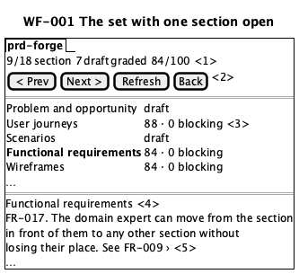
WF-001 drawing

WF-002 A new set, before the first interview
Illustration, not a design. Illustrates FR-002, FR-017, and FR-018. PER-001 sees it at ST-001.
At ST-001 the set exists and nothing in it is written. Every section is listed and marked not started, so the expert sees the whole shape of the work before the first question.
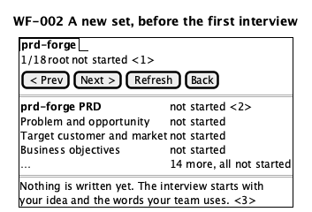
WF-002 drawing

WF-003 Why a section got its grade
Illustration, not a design. Illustrates FR-009 and FR-017. PER-001 sees it at ST-003.
A score alone does not tell the expert what to fix. This view names each blocking defect and where it is, and names the weakest part, quoting the section.
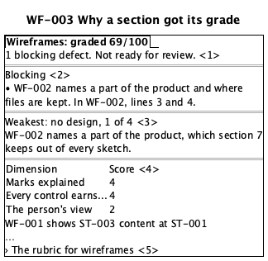
WF-003 drawing

WF-004 The standard a section is graded against
Illustration, not a design. Illustrates FR-009 and FR-017. PER-001 sees it at ST-003.
A grade against a stated standard is only fair if the expert can read the standard. This is the same rubric the graders used.
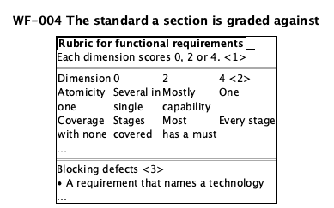
WF-004 drawing

WF-005 What a team could not build from this set
Illustration, not a design. Illustrates FR-012. PER-001 sees it at ST-005.
The expert reads this before anyone has estimated anything, while a fix is still a sentence. Every finding quotes the set, so the expert can check it rather than trust it.
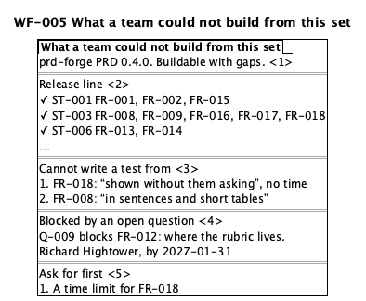
WF-005 drawing

WF-006 What the approver is asked to approve
Illustration, not a design. Illustrates FR-013 and FR-014. PER-003 sees it at ST-006.
The approver reads one document, not eighteen. It says what they are committing to, what is still open and who owns it, and where their decision is recorded.
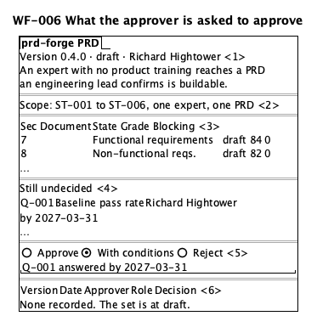
WF-006 drawing

WF-007 Before any set exists
Illustration, not a design. Illustrates FR-018. PER-001 sees it at ST-001.
Before the first interview there is no set to list. The view says so plainly, and a refresh lists every section once the set is written.
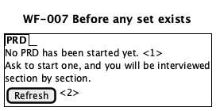
WF-007 drawing

WF-008 A section re-graded after one answer
Illustration, not a design. Illustrates FR-011. PER-001 sees it at ST-004.
After one answer the section is graded again against the same rubric. Both scores are visible, and at 70 or more with no blocking defects the expert is offered review. The values are SC-001's.
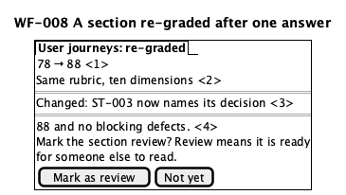
WF-008 drawing

WF-009 A buildability review that finds gaps
Illustration, not a design. Illustrates FR-012. PER-001 sees it at ST-005.
SC-005 is the review that finds work missing: two release-line stages have no must requirement behind them. The gaps are named first, before anything else in the review.
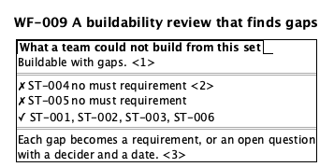
WF-009 drawing

WF-010 Resuming a set after a week away
Illustration, not a design. Illustrates FR-002 and FR-009. PER-001 sees it at ST-004.
SC-002 is the expert who returns after eight days and remembers nothing. The values are prd-forge's own at version 0.1.0, when section 7 scored 84 with two blocking defects: a grade of 70 or more that is still not offered as ready.
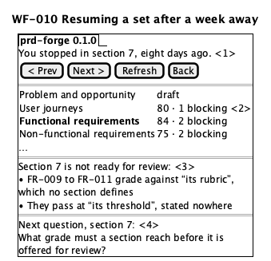
WF-010 drawing
WF-001 The set with one section open
Type | screen
Persona | PER-001
Journey stage | ST-003
Illustrates | • FR-002  • FR-008  • FR-017  • FR-018
Shows | • Where they are in the set, the section's state, and its grade  • Next, previous, refresh, and back to the view before  • Each section's grade and blocking count; opening it shows why  • The section itself, as prose  • An ID that another section defines opens that section

WF-002 A new set, before the first interview
Type | screen
Persona | PER-001
Journey stage | ST-001
Illustrates | • FR-002  • FR-017  • FR-018
Shows | • Where they are, and that nothing is started yet  • Every section listed, each marked not started  • What happens first

WF-003 Why a section got its grade
Type | screen
Persona | PER-001
Journey stage | ST-003
Illustrates | • FR-009  • FR-017
Shows | • The score, and that the section is not ready  • Each blocking defect, and where it is  • The weakest part, and why, in three lines or fewer  • Each dimension's score, with the evidence for it  • The standard the grade was given against

WF-004 The standard a section is graded against
Type | screen
Persona | PER-001
Journey stage | ST-003
Illustrates | • FR-009  • FR-017
Shows | • How a dimension becomes a grade  • What 0, 2 and 4 look like for each dimension  • What stops a section at any grade

WF-005 What a team could not build from this set
Type | report
Persona | PER-001
Journey stage | ST-005
Illustrates | • FR-012
Shows | • Which version of the set was reviewed, and the verdict  • Each release-line stage, covered or a gap  • Each requirement an engineer could not test, quoted  • An open question that blocks a must, its decider and date  • What the reviewer would ask for first

WF-006 What the approver is asked to approve
Type | report
Persona | PER-003
Journey stage | ST-006
Illustrates | • FR-013  • FR-014
Shows | • The version, its state, its owner, and what it is for  • What release 1 covers  • Every section with its state and grade, and what blocks  • What is still undecided, who decides it, and by when  • The decision, with any condition tied to a question  • Who decided what, in which role, on which version

WF-007 Before any set exists
Type | screen
Persona | PER-001
Journey stage | ST-001
Illustrates | • FR-018
Shows | • That nothing has been started  • Look again once a set exists

WF-008 A section re-graded after one answer
Type | screen
Persona | PER-001
Journey stage | ST-004
Illustrates | • FR-011
Shows | • The new score beside the old one  • The same standard both times  • What changed in the section  • The offer of review, and what review means

WF-009 A buildability review that finds gaps
Type | report
Persona | PER-001
Journey stage | ST-005
Illustrates | • FR-012
Shows | • The verdict  • The release-line stages with no requirement, named  • That each gap must become a requirement or a question

WF-010 Resuming a set after a week away
Type | screen
Persona | PER-001
Journey stage | ST-004
Illustrates | • FR-002  • FR-009
Shows | • Where they stopped  • Every section's grade and blocking count  • Each blocking defect in the section, named  • The next question, not one already answered

Section 8

Non-functional requirements
draft · 82/100 · no blocking defects
ID | Category | Target
NFR-001 | performance | Next question under 20s at p95
NFR-002 | performance | Section grade under 90s at p95
NFR-003 | scale | 120 requirements, 10 journeys x 10 stages, 200 terms
NFR-004 | durability | 100% of a set readable with no part of the product running
NFR-005 | usability | 90% of sections completed without asking what a term means
NFR-006 | accessibility | Zero WCAG 2.2 AA violations on the golden-thread path
NFR-007 | observability | 100% of grades reconstructable after the session
NFR-008 | privacy | Zero destinations beyond the session the expert already uses
NFR-009 | supportability | 100% of older sets readable within a major version
NFR-010 | retention | 100% retrievable from the organisation's own store, no expiry imposed by us
NFR-011 | availability | Zero answers lost per interruption; resume within 1 minute
NFR-012 | security | Zero read paths the organisation's own access rules do not govern

Where these came from
NFR-001 and NFR-002 come from PER-001's frequency: a burst of intense use. A 20-second wait is tolerable once; across 60 questions it is 20 minutes of dead time and the expert stops.
NFR-004 is the one that matters most and is cheapest to get wrong. PER-001 works in bursts weeks apart. If the set is only readable through this product, then a version change, a tool change or an expired session destroys weeks of an expert's thinking. The target is deliberately absolute.
NFR-005 is the only requirement here that needs people rather than instruments to measure, and it is the one most likely to be skipped. It is the direct test of whether P-004 was solved.
NFR-006 covers the approver too, not only the expert: PER-003 reads this once and must not need a mouse to do it.
There is no concurrency target, and that is a decision rather than an omission. Under C-001 the product reaches one expert inside a session they are already in, so simultaneous users are the host's load and not ours; NFR-003 therefore reads scale as the size of one set, which is the dimension we do control. If C-001 ever changes, concurrency comes back and this paragraph goes.
NFR-006 and NFR-012 set targets on things C-001 and C-002 say we do not own — what the host renders, and where the customer keeps its documents. They are kept as must because a target nobody owns is how accessibility and access control get lost; who owns them is Q-011.
NFR-010, NFR-011 and NFR-012 were added at version 0.2.0. Retention, availability and security had simply not been reached, and C-003 states a retention rule that no measurable requirement stood behind. NFR-010 is the one that answers C-003's second half: the product retains nothing of its own, so the only retention question is how long the organisation keeps the documents, and the answer must be that we impose no expiry on them.
NFR-001
Statement | An expert answering a question does not lose their train of thought waiting for the next one.
Category | performance
Metric | 95th percentile elapsed time from the expert submitting an answer to the next question or the drafted section appearing.
Target | under 20 seconds at p95, and under 60 seconds at p99
Measurement | At least 300 timed observations per release, taken across five scripted runs of all seventeen section documents on a set already holding 60 requirements, from the expert's own side of the conversation rather than from inside the product.
Priority | must
Applies to | • FR-004  • FR-010

NFR-002 A grading pass does not make the expert wait so long that they stop asking for one.
Category | performance
Metric | 95th percentile elapsed time for one section's grade to be reported, measured per grading pass on the section just drafted.
Target | under 90 seconds at p95 for a single section
Measurement | At least 200 grading passes per release, spread across all seventeen section documents and across sets of 20, 60 and 120 requirements.
Priority | must
Applies to | • FR-009  • FR-011

NFR-003 A set stays workable at the size real products reach.
Category | scale
Metric | The size of one set at which every requirement in section 7 still passes its acceptance criteria and every target in this section still holds.
Target | 120 functional requirements, 10 journeys of 10 stages, and 200 glossary terms
Measurement | A generated set at those sizes, run through every function in section 7, per release.
Priority | must

NFR-004 Work survives the expert stopping, and survives the tool they were using going away.
Category | durability
Metric | Share of a set's content recoverable after the authoring session ends, with no part of the product running.
Target | 100%, readable without this product
Measurement | End a session mid-section, then read the whole set with nothing but a text editor, once per release.
Priority | must
Applies to | • FR-015

NFR-005
Statement | An expert with no product management training can complete a section without asking anyone what a word means.
Category | usability
Metric | Share of sections a first-time expert completes without asking for the meaning of a product management term.
Target | 90% of sections, measured over 10 first-time experts
Measurement | Observed sessions with 10 first-time experts before release, questions to the observer counted and categorised.
Priority | must

NFR-006
Statement | Everything the expert and the approver read is usable with a screen reader and without a mouse.
Category | accessibility
Metric | Conformance to WCAG 2.2 AA of everything the product puts in front of the expert or the approver along the golden-thread journey.
Target | zero level-A or level-AA violations on the golden-thread path
Measurement | One manual screen-reader pass of the golden-thread journey per release, plus an automated check in the release pipeline of everything that journey shows.
Priority | must

NFR-007 An expert can tell why a section received the score it did, after the fact.
Category | observability
Metric | Share of grades for which the score per rubric dimension and the quotation behind each can be recovered after the session.
Target | 100% for any section at review or better
Measurement | Re-read a graded set a week later and reconstruct every score, once per release.
Priority | should
Applies to | • FR-009

NFR-008
Statement | What the expert says about their domain stays within whatever boundary their organisation already works in; this product adds no new place for it to go.
Category | privacy
Metric | Number of destinations set content reaches beyond the boundary C-001 names.
Target | zero
Measurement | Review of every outbound destination per release, recorded against C-003.
Priority | must

NFR-009 A set written by an earlier version is still readable and still gradable by a later one.
Category | supportability
Metric | Share of sets written by version N that version N+1 reads and grades without the expert rewriting anything.
Target | 100% within a major version
Measurement | Keep one set per released version and run the current version against all of them, per release.
Priority | should

NFR-010
Statement | A set remains readable and retrievable for as long as the organisation keeps the specifications it builds from, without this product being involved.
Category | retention
Metric | Share of a set retrievable and readable from the organisation's own document store, with no part of this product present.
Target | 100%, for as long as the organisation retains the set; no expiry imposed by us
Measurement | Retrieve a set written one release ago from the organisation's own store and read it with a text editor, once per release.
Priority | must
Applies to | • FR-014

NFR-011
Statement | An interview in progress survives the product being unavailable; no session loses an answer the expert has already given.
Category | availability
Metric | Answers lost per interruption, and time to resume after one.
Target | Zero answers lost, on every interruption; resume within 1 minute at p95 and within 3 minutes at p99
Measurement | Interrupt a session mid-section 100 times per release, spread across all seventeen section documents, and count answers lost and seconds to resume.
Priority | must
Applies to | • FR-015

NFR-012
Statement | Nobody but the people the organisation has already given access to its documents can read a set.
Category | security
Metric | Number of ways to read a set that the organisation's own document access rules do not govern.
Target | zero
Measurement | Enumerate every read path to a set per release and check each against the organisation's own access rules; recorded against C-002 and C-003.
Priority | must

Section 9

Constraints
draft
ID | Category | Constraint | Authority
C-001 | firm | Runs inside an assistant session the expert already uses | Product decision, v0.1.0
C-002 | firm | Output is plain documents; not the system of record | Product decision, v0.1.0
C-003 | policy | Domain content goes nowhere beyond that session | The customer's own information policy
C-004 | legal | No unverified citation stated as fact | Professional liability

C-001 is the honest one
Three of these four are our own decisions, not rules imposed from outside, and listing a product decision as a constraint is normally wrong. They are here because C-001 in particular is the tension this PRD ran into: the product is delivered inside an assistant, naming that in a requirement fails test 5, and pretending the dependency does not exist would be worse. Recording it as a constraint keeps section 7 clean and keeps the dependency visible.
A reviewer is entitled to call C-001 and C-002 architecture rather than constraints. The counter-argument is that both are commitments to the customer about what they will have to adopt and what they will own afterwards, which is scope, not design. Decide for yourself; the argument is recorded either way.

C-004 is the one with teeth
C-004 is the only constraint here imposed from outside, and it is the reason FR-006 exists. A fluent PRD with an invented clause number is the failure this product must not have, because the expert signs it, circulates it, and carries the consequence personally.
C-001
Statement | The product reaches the expert inside an assistant session they are already working in. There is no separate application for them to open, install or log into.
Category | firm
Authority | Product decision, Richard Hightower, recorded at version 0.1.0. Not externally imposed; recorded here because every requirement in section 7 depends on it and naming it in a requirement would fail test 5.
Applies to | • all
Verification | No requirement in section 7 names the delivery mechanism, checked at each grading pass.

C-002
Statement | The output is plain text documents the organisation stores wherever it already stores documents. The product is not the system of record for a PRD.
Category | firm
Authority | Product decision, Richard Hightower, recorded at version 0.1.0.
Applies to | • all
Verification | NFR-004's test - read a complete set with nothing but a text editor.

C-003
Statement | Content an expert enters about their domain is not sent anywhere beyond the assistant session they are already using, and is not retained by this product outside the documents themselves.
Category | policy
Authority | The expert's own organisation's information policy, whichever it is; this constraint holds for every customer and is not configurable.
Applies to | • all
Verification | NFR-008's measurement - zero additional destinations.

C-004
Statement | No regulation, standard, clause or statistic is stated as fact unless the expert supplied it or it has been verified against the source; otherwise it is marked unverified or becomes an open question.
Category | legal
Authority | Professional liability. An expert circulating a PRD that cites a regulation incorrectly is exposed personally and professionally, whatever this product's terms say.
Applies to | • FR-006  • FR-009  • FR-012
Verification | Every citation in a set checked against its source before any section reaches final, and anything unverifiable reported as unverified.

Section 10

Decision rights and trust rules
draft · 86/100 · no blocking defects
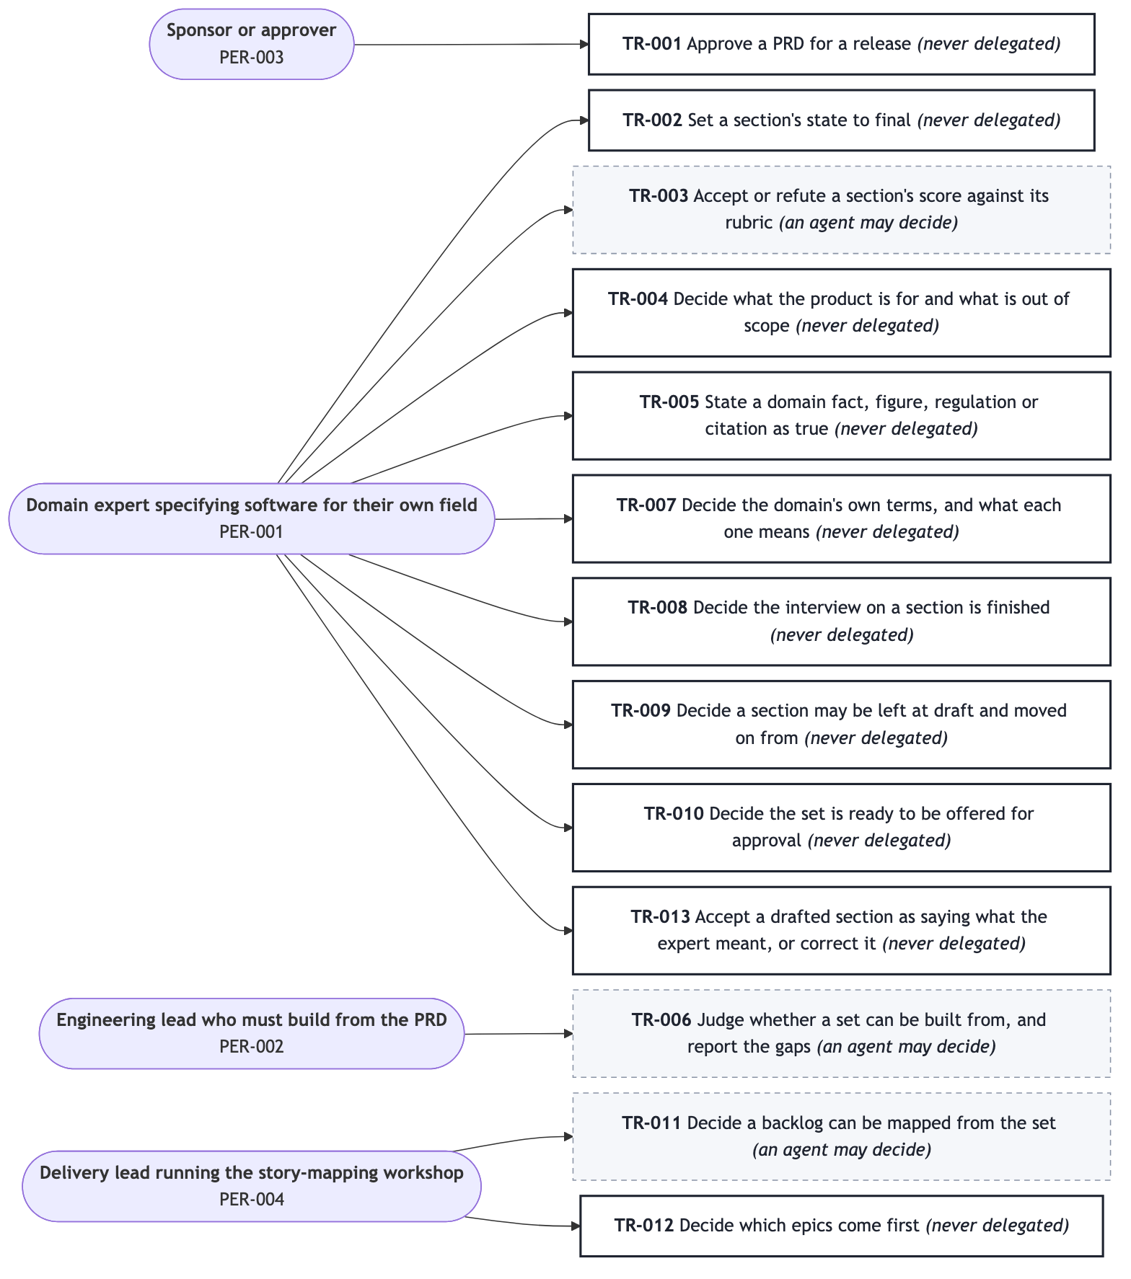
Who decides what
ID | Decision | Approver | Agent may decide | Never delegated
TR-001 | Approve a PRD for a release | PER-003 | no | yes
TR-002 | Set a section to final | PER-001 | no | yes
TR-003 | Accept or refute a section's score | PER-001 | yes | no
TR-004 | Decide scope | PER-001 | no | yes
TR-005 | State a domain fact as true | PER-001 | no | yes
TR-006 | Judge buildability, and report the gaps | PER-002 | yes | no
TR-007 | Decide the domain's own terms | PER-001 | no | yes
TR-008 | Decide a section's interview is finished | PER-001 | no | yes
TR-009 | Decide a section may be left at draft | PER-001 | no | yes
TR-010 | Decide the set is ready to offer for approval | PER-001 | no | yes
TR-011 | Decide a backlog can be mapped | PER-004 | yes | no
TR-012 | Decide which epics come first | PER-004 | no | yes
TR-013 | Accept or correct a drafted section | PER-001 | no | yes

Every decision named in a stage of section 5 appears here. TR-007 to TR-013 were added at version 0.2.0 to close that: five release-line stage decisions and both of J-002's had no rule, which meant gates an engineering team would have had to invent. TR-013 covers the one in the middle of the loop — the expert accepting that a draft says what they meant — which is distinct from scoring it (TR-003), from leaving it at draft (TR-009) and from setting it final (TR-002).

The shape of the trust boundary
Only three of thirteen are delegable, and all three are assessments, not decisions: TR-003 produces a document's score, TR-006 judges whether it can be built from, and TR-011 judges whether a backlog can be mapped from it. All three produce evidence for a person. None changes a document, and none can set a state.
Everything that commits anyone to anything — approving, finalising, choosing scope, asserting a fact — is never delegated. TR-005 is the strictest: a fact nobody can stand behind is not written at all, by anyone.
The delegable assessments all carry the same two obligations: quote the document for every claim, and drop any finding the document does not support. An assessment that cannot be refuted by pointing at the text is not evidence, it is an assertion, and the expert will correctly stop believing it — see R-002 in section 11.
TR-001 Approve a PRD for a release
Approver | PER-003
An agent may decide | no
Never delegated | yes
Evidence required | The summary, the scope, every section's state and grade, every blocking defect, and every open question with its decider and date.
Escalation | No substitute approver, and approval waits. Where no sponsor exists at all — a solo expert, or an internal tool with no PER-003 — the expert approves their own set under this rule, shown the same evidence, and the change log records that no separate approver existed. A set is never treated as approved because its score is high.
Acceptance | • Given a set with any blocking defect, when approval is sought, then the approver is shown the defects and the set is not presented as ready.  • Given a set with no recorded approval, when anyone reads its state, then it reads as not approved, whatever its scores are.  • Given an engagement with no sponsor, when the expert approves their own set, then the approval records that no separate approver existed.  • Given an approver who approves with conditions, when the approval is recorded, then each condition names the open question or requirement it depends on and a date, and the set reads as approved-with-conditions until every condition is cleared by that same approver.

TR-002 Set a section's state to final
Approver | PER-001
An agent may decide | no
Never delegated | yes
Evidence required | The section's grade, its blocking defect count, and the result of validating it.
Escalation | The expert may override the gate; the override and the score at the time are recorded in the change log. Nobody may set a section final on the expert's behalf while they are away: it waits.
Acceptance | • Given a section with one or more blocking defects, when final is requested, then it is not set without an explicit override from the expert.  • Given an override, when it is applied, then the change log records that it was an override and the score at the time.

TR-003 Accept or refute a section's score against its rubric
Approver | PER-001
An agent may decide | yes
Never delegated | no
Evidence required | The rubric's dimensions and a quotation from the document for every score below full marks.
Escalation | The expert may refute any finding by pointing at the document; a finding the document does not support is dropped (FR-016). While the expert is away a grade stands unaccepted, and the section does not advance.
Acceptance | • Given a score below full marks on a dimension, when it is reported, then a quotation from the document is given for it.  • Given a finding the expert refutes and the document does not support, when it is checked, then it is dropped and the expert is told it was dropped.

TR-004 Decide what the product is for and what is out of scope
Approver | PER-001
An agent may decide | no
Never delegated | yes
Evidence required | What the consequence of the choice is, including any release-line stage it would leave uncovered.
Escalation | None, and no substitute. The expert decides; while they are away, scope does not change. Where the choice weakens the PRD the objection is stated once and the decision is recorded with the dissent noted.
Acceptance | • Given an expert decision that leaves a release-line stage uncovered, when it is recorded, then the consequence is stated to the expert once and the decision stands.  • Given a decision the expert reaffirmed after an objection, when later grading passes run, then the objection is not raised again as a new finding.

TR-005 State a domain fact, figure, regulation or citation as true
Approver | PER-001
An agent may decide | no
Never delegated | yes
Evidence required | The expert's own statement of it, or a source that has been checked.
Escalation | Where neither exists the fact is not written at all; it becomes an open question with a decider and a date. Nobody may supply the fact on the expert's behalf while they are away.
Acceptance | • Given a figure or citation the expert did not supply and that has not been verified, when a section is drafted, then it does not appear in the document.  • Given a citation that was checked and could not be confirmed, when it is reported, then it is marked unverified rather than stated as fact.

TR-006 Judge whether a set can be built from, and report the gaps
Approver | PER-002
An agent may decide | yes
Never delegated | no
Evidence required | The release line, the requirements covering each stage, and a quotation for every gap claimed.
Escalation | The engineering lead's own judgement overrides any reported verdict; the report is evidence for them, not a substitute for them. In release 1 no engineering lead is in the loop, so the report goes to the expert, who decides what to do with it under TR-010.
Acceptance | • Given a reported verdict, when the engineering lead disagrees, then their judgement is recorded as the verdict and the report is kept alongside it.  • Given a reported gap, when it is stated, then the document is quoted for it.

TR-007 Decide the domain's own terms, and what each one means
Approver | PER-001
An agent may decide | no
Never delegated | yes
Evidence required | Where the term is already used in the set, and any standard-setter's definition that differs from the expert's.
Escalation | None, and no substitute. Terms are the expert's; while they are away the vocabulary does not change.
Acceptance | • Given a term the expert has defined, when any later question or document uses that idea, then it uses the expert's word and not a synonym.  • Given a standard-setter's definition that differs, when the term is recorded, then both are stated and the expert says which the set uses.

TR-008 Decide the interview on a section is finished
Approver | PER-001
An agent may decide | no
Never delegated | yes
Evidence required | What the section would score as it stands, and what is still missing from it.
Escalation | None. The expert ends the interview; nobody ends it for them, and no question list runs past the point they call it done.
Acceptance | • Given an expert who says they have nothing more to add, when they say it, then no further question is put to them in that section.  • Given an interview ended early, when the section is written, then what is missing is named to the expert, not hidden behind a score.

TR-009 Decide a section may be left at draft and moved on from
Approver | PER-001
An agent may decide | no
Never delegated | yes
Evidence required | The section's score, its blocking defects, and which later sections depend on what is missing.
Escalation | None, and no substitute. While the expert is away the section stays where it is.
Acceptance | • Given a section below 70 or carrying a blocking defect, when the expert chooses to move on, then it is written at `draft` and what was left behind is recorded as an open question or named plainly to them.

TR-010 Decide the set is ready to be offered for approval
Approver | PER-001
An agent may decide | no
Never delegated | yes
Evidence required | Every section's state and grade, every blocking defect, and the buildability report's gaps with, for each, whether it is closed or owned.
Escalation | None, and no substitute. The expert offers the set; nobody offers it for them.
Acceptance | • Given a buildability gap that is neither closed nor given an owner and a date, when the expert offers the set for approval, then that gap is stated to them first.  • Given a set offered for approval, when the approver opens it, then what the expert was shown under this rule is what the approver sees.

TR-011 Decide a backlog can be mapped from the set
Approver | PER-004
An agent may decide | yes
Never delegated | no
Evidence required | Whether a golden thread exists, and which release-line stages have requirements behind them.
Escalation | The delivery lead's own judgement stands over any reported verdict; where they are unavailable the workshop waits rather than proceeding without a backbone.
Acceptance | • Given a set with no journey, when the check runs, then it reports that a backlog cannot be derived, and names that as the reason.

TR-012 Decide which epics come first
Approver | PER-004
An agent may decide | no
Never delegated | yes
Evidence required | The release line, the dependencies in section 11, and the objective each epic moves.
Escalation | The delivery lead may re-order within the release line at any time; order never changes scope, which stays with TR-004. While they are away the order stands as last recorded, and nobody re-orders on their behalf.
Acceptance | • Given an ordering, when it is recorded, then each decision names whether value, dependency or the release line drove it.

TR-013 Accept a drafted section as saying what the expert meant, or correct it
Approver | PER-001
An agent may decide | no
Never delegated | yes
Evidence required | The drafted section in readable form, and its grade, so the expert judges the words and not the score.
Escalation | None, and no substitute. An unaccepted draft stays at draft; nobody accepts a section's wording on the expert's behalf while they are away.
Acceptance | • Given a drafted section the expert has not accepted, when the set's state is read, then that section is not shown as ready for anyone else to read.  • Given an expert who corrects a drafted section, when the correction is applied, then it is their words that are kept, and the section is graded again before it advances.

Section 11

Assumptions, risks and dependencies
draft

Assumptions
ID | Assumption | If false
A-001 | An expert will answer 50-100 questions across a few sittings | The method fails; sections 5-7 change completely
A-002 | An expert will act on a grade they did not produce | The grading is decoration
A-003 | An engineering lead accepts a PRD naming no technology | Test 5 becomes a liability
A-004 | Organisations permit drafting inside an assistant session | C-001 and C-003 have to change

A-001 and A-002 are the two the product stands on, and neither has been tested. Both are validated by the same ten observed sessions (D-002), which makes D-002 the single most load-bearing dependency in this PRD.

Risks
ID | Risk | L | I | Owner
R-001 | High score becomes false assurance | high | high | Richard Hightower
R-002 | Unsupported findings destroy trust in all findings | high | high | Richard Hightower
R-003 | A beautifully graded PRD for the wrong product | medium | high | Richard Hightower
R-004 | Interview too long; sets abandoned | medium | medium | Richard Hightower
R-005 | A version change strands an expert's set | low | high | Richard Hightower

R-003 is not closed. The mitigations listed reduce it and do not solve it. Nothing in this product checks whether the product being specified should exist. That is stated here rather than hidden behind a mitigation that sounds adequate.

Dependencies
ID | Need | From | By | Status
D-001 | An assistant session able to carry the interview | The customer's platform | 2027-01-31 | committed
D-002 | 10 observed first-time experts | Early customers | 2027-03-31 | requested
D-003 | 3 engineering leads to read a set cold | Early customers | 2027-03-31 | requested

D-002 and D-003 are both merely requested, and both are dated after R1's target in section 13. That is a real schedule problem: R1 ships before the assumptions it rests on are tested. Recorded, not resolved.

Assumptions
A-001
Assumption | A domain expert will answer fifty to a hundred questions about their own field across a few sittings, if each one is clearly worth answering.
If false | The whole method fails. The product would have to produce a usable partial PRD from perhaps fifteen answers, which changes sections 5, 6 and 7 completely and makes the grading thresholds meaningless.
Validated by | Observed sessions with 10 first-time experts, counting where they stop - the same sessions NFR-005 uses.
Owner | Richard Hightower

A-002 An expert will act on a grade they did not produce, rather than dismissing it.
If false | The grading is decoration and sections 3 and 7 are measuring something nobody uses. The product reduces to a structured interview.
Validated by | In the same observed sessions, whether the expert answers the one question or moves on regardless.
Owner | Richard Hightower

A-003
Assumption | An engineering lead will accept a PRD that names no technology, rather than reading the absence as incompleteness.
If false | Test 5 becomes a liability rather than a discipline, and the candidate architecture decisions list in FR-007 has to become a first-class output rather than a hand-over note.
Validated by | Three engineering leads reading a completed set cold and saying what they would ask for first.
Owner | Richard Hightower

A-004
Assumption | Organisations will let a specification for their product be drafted inside an assistant session.
If false | C-001 and C-003 are unacceptable as written and the delivery model has to change, which invalidates most of section 7's assumptions about immediacy.
Validated by | The information security review of the first three customer engagements.
Owner | Richard Hightower

Risks
R-001
Risk | The expert accepts a weak PRD because the score was high. The grade becomes false assurance, which is worse than no grade.
Likelihood | high
Impact | high
Mitigation | Blocking defects are counted and reported separately from the score and no score clears them (FR-009); the non-goal in section 6 says explicitly that a grade is evidence, not a warrant; FR-012 puts a buildability verdict in front of the expert before approval.
Owner | Richard Hightower

R-002
Risk | The grading reports findings that are not in the document. The expert catches one, stops trusting all of them, and the grading becomes noise they skip.
Likelihood | high
Impact | high
Mitigation | Every finding must quote the document, and anything unsupported is dropped before the expert sees it (FR-016, TR-003, TR-006); a refuted finding is acknowledged as dropped rather than defended (SC-004).
Owner | Richard Hightower

R-003
Risk | A fluent, well-structured, well-graded PRD is produced for the wrong product, and the structure makes the error harder to see rather than easier.
Likelihood | medium
Impact | high
Mitigation | Section 3 asks what would move the objectives without this product at all; section 1 requires evidence per problem and names what is unmeasured. Neither is sufficient - this risk is not closed, and a reviewer should say so.
Owner | Richard Hightower

R-004
Risk | The interview is too long to finish, so sets are abandoned half-written and the product is remembered as the thing that asked a hundred questions.
Likelihood | medium
Impact | medium
Mitigation | FR-005 lets the expert end any section and records what was left; FR-015 makes resumption cheap; the working order in the method puts the sections that unlock the others first, so an abandoned set is still useful.
Owner | Richard Hightower

R-005
Risk | A set written by one version cannot be read or graded by a later one, and an expert loses weeks of thinking to an upgrade.
Likelihood | low
Impact | high
Mitigation | NFR-004 makes every set readable with no part of the product running; NFR-009 requires older sets to stay gradable within a major version.
Owner | Richard Hightower

Dependencies
D-001
Need | An assistant session the expert is already working in, able to carry a long interview and read and write the documents.
From | The assistant platform the customer already uses
By | 2027-01-31
Status | committed
Blocks | • ST-001  • ST-002

D-002 Ten first-time domain experts willing to be observed completing a PRD.
From | Early customers and the professional network
By | 2027-03-31
Status | requested
Blocks | • A-001  • A-002  • NFR-005

D-003
Need | Three engineering leads willing to read a completed set cold and report what they would ask for first.
From | Early customers
By | 2027-03-31
Status | requested
Blocks | • A-003  • O-001

Section 12

Open questions
draft
ID | Question | Decider | By | Blocks
Q-001 | Today's first-pass buildability rate | R. Hightower | 2027-03-31 | O-001
Q-002 | Today's idea-to-approval elapsed time | R. Hightower | 2027-03-31 | O-002
Q-003 | Today's share of testable requirements | R. Hightower | 2027-03-31 | O-003
Q-004 | Segment sizes, and which converts | R. Hightower | 2027-06-30 | S-001..S-003
Q-005 | Will a sponsor accept a graded specification | R. Hightower + 3 sponsors | 2027-01-31 | FR-013, TR-001
Q-006 | Sections completed per sitting, and where they stop | R. Hightower | 2027-03-31 | R-004, NFR-005
Q-007 | Is the working order right, and how does looping back feel | R. Hightower | 2027-03-31 | ST-004
Q-008 | Disciplined or incomplete, to an engineering lead | R. Hightower + 3 leads | 2027-03-31 | A-003
Q-009 | Where the rubric and the checks live, and who owns them | R. Hightower | 2027-01-31 | FR-004, FR-009..FR-012, NFR-007
Q-010 | Where an answer lives before its section is drafted | R. Hightower | 2027-01-31 | FR-015, NFR-011
Q-011 | How an approver records a decision, and who owns NFR-006/012 | R. Hightower | 2027-02-28 | FR-014, NFR-006, NFR-012

The three that matter most
Q-001 to Q-003 are the baselines for all three objectives. Until they are answered, section 3's targets are intentions. Nothing should be committed to a plan on the strength of them.
Q-009, Q-010 and Q-011 came from the buildability review at 0.2.0, and all three block must requirements on the release line. Q-009 is the largest: four requirements are written against a rubric whose shape the set defines but whose content it does not contain, so two of the six release-line stages can be scaffolded and not finished until it is answered. Q-010 is the one where guessing breaches a stated constraint rather than costing rework.
Q-005 is the one that could invalidate the product's central idea. It was dated after the release it blocks until 0.2.0 moved it to 2027-01-31; it is a two-day question and there was no defence for asking it late. If showing a sponsor a grade reduces their confidence rather than raising it, then FR-013 is wrong and the grading becomes an author's private tool rather than part of the approval. That is a cheap two-day question and it should be asked early.
Q-008 tests test 5. If engineering leads read the absence of technology as incompleteness, the discipline this whole product enforces is a liability, and A-003 fails.

Honest note
Every decider here is the same person. For a one-person product that is accurate; for anything larger it is a defect, and the first thing to fix when there is a second person.
Q-001
Question | What share of specifications reaching a development team today pass a buildability review on first submission?
Decider | Richard Hightower
By | 2027-03-31
Blocks | • O-001
Spike | Run the eleven derivability checks against ten specifications collected from real engagements, and count. Time-boxed to 3 days.

Q-002
Question | How long does it take today, in working days, from a product idea to an approved specification?
Decider | Richard Hightower
By | 2027-03-31
Blocks | • O-002
Spike | Reconstruct the timeline from first discussion to approval for five recent engagements. Time-boxed to 2 days.

Q-003
Question | What share of functional requirements in today's specifications can an engineer who was not in the interview write a test from?
Decider | Richard Hightower
By | 2027-03-31
Blocks | • O-003
Spike | Three engineering leads score the requirements of the same ten specifications from Q-001, independently. Time-boxed to 3 days.

Q-004
Question | How many organisations are in each segment in section 2, and which segment actually converts?
Decider | Richard Hightower
By | 2027-06-30
Blocks | • S-001  • S-002  • S-003
Spike | Name the register or source per segment and count; then compare against the first ten conversations. Time-boxed to 5 days.

Q-005
Question | Will a sponsor accept a specification that carries a machine-produced grade, or does the grade reduce their confidence rather than raise it?
Decider | Richard Hightower, with the first three sponsors
By | 2027-01-31
Blocks | • FR-013  • TR-001
Spike | Show three sponsors the same set with and without grades and ask which they would approve. Time-boxed to 2 days.

Q-009
Question | Where do the rubric and the eleven derivability checks live, who owns them, and how is a set told which version it was graded against?
Decider | Richard Hightower
By | 2027-01-31
Blocks | • FR-004  • FR-009  • FR-010  • FR-011  • FR-012  • NFR-007
Spike | Decide whether they ship as documents of the product, name their owner, and decide whether a grade records the version it was made against. Time-boxed to 2 days. Until it is answered, ST-003 and ST-004 can be scaffolded and not finished.

Q-010
Question | Where does an answer live between the moment the expert gives it and the moment the section is drafted, given that C-003 forbids retaining content outside the documents and NFR-004 requires the set readable with no part of the product running?
Decider | Richard Hightower
By | 2027-01-31
Blocks | • FR-015  • NFR-011
Spike | Decide whether an in-progress interview is itself a document of the set, or whether answers before a draft are not retained at all and FR-015 holds only within a session. Time-boxed to 2 days. Guessing this one breaches a stated policy constraint rather than merely costing rework.

Q-011
Question | How does an approver record a decision, given that C-001 puts the product inside the expert's session and OUT-003 excludes any view of our own, and who owns NFR-006's accessibility and NFR-012's access control, which describe things C-001 and C-002 say we do not own?
Decider | Richard Hightower
By | 2027-02-28
Blocks | • FR-014  • NFR-006  • NFR-012
Spike | Walk one approval end to end with a real sponsor and record every step they take that the product does not provide. Time-boxed to 3 days.

Q-006
Question | How many sections will an expert complete in one sitting before stopping, and which section do they stop at?
Decider | Richard Hightower
By | 2027-03-31
Blocks | • R-004  • NFR-005
Spike | Count in the ten observed sessions from D-002. No extra work.

Q-007
Question | Is the working order in the method right - does writing the requirements really send an expert back to the journeys, and does that feel like progress or like failure to them?
Decider | Richard Hightower
By | 2027-03-31
Blocks | • ST-004
Spike | Count loop-backs and ask the expert how it felt, in the ten observed sessions. No extra work.

Q-008
Question | Does an engineering lead read a PRD that names no technology as disciplined or as incomplete?
Decider | Richard Hightower, with the three leads from D-003
By | 2027-03-31
Blocks | • A-003
Spike | Ask each lead, after reading a set cold, whether anything was missing and whether they wanted a technology named. Time-boxed to 1 day.

Section 13

Release plan
draft
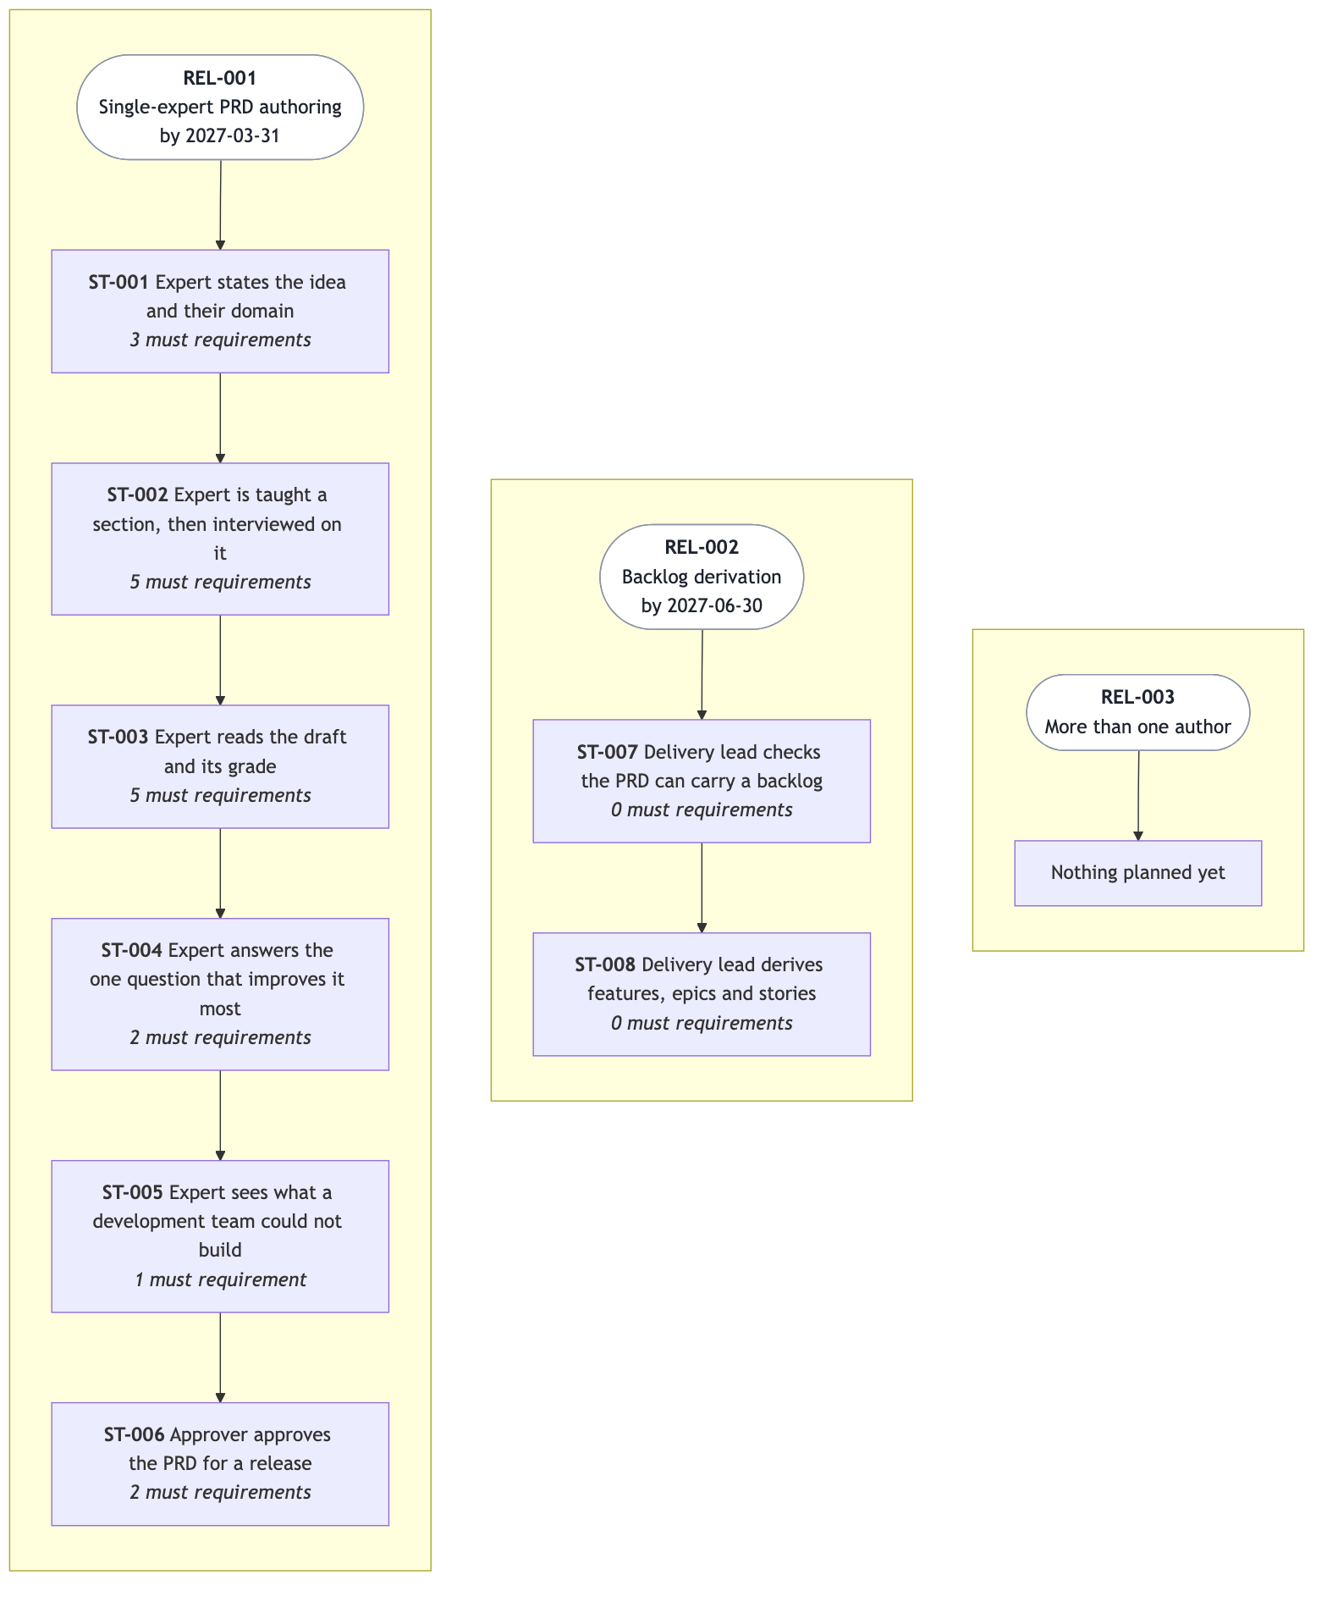
The release line
ID | Release | Stages | Target
REL-001 | Single-expert PRD authoring | ST-001..ST-006 | 2027-03-31
REL-002 | Backlog derivation | ST-007, ST-008 | 2027-06-30
REL-003 | More than one author | — | none

Why this order
REL-001 is exactly the release line in section 6. It is the smallest release in which anyone gets anything: an expert reaching an approved, reviewed PRD.
REL-002 is deferred rather than cut because the PRD REL-001 produces already has to carry everything a backlog needs — FR-012 checks precisely that. Deferring the derivation costs nothing; deferring what it needs would have cost a rewrite.
REL-003 waits for evidence that one author's path works at all. Building for two authors before one is proven would be building on A-001 and A-002 before either is tested.

The schedule problem, stated plainly
REL-001 targets 2027-03-31. D-002 and D-003 in section 11 — the ten observed experts and the three engineering leads — are also dated 2027-03-31 and are only *requested*. So REL-001 ships at the same moment the assumptions beneath it are first tested, not after. Either REL-001 moves, or it ships knowingly as an experiment. That is a decision for the sponsor at TR-001 and it is not made here.

Not in this section, deliberately
No tasks, no estimates, no sizing, no team assignments, and no technology milestone. Those come from engineering design and iteration planning.
REL-001 Single-expert PRD authoring
Outcomes | • A domain expert with no product training can take one product idea to an approved PRD without leaving the session they started in.  • The expert can see, before anyone estimates, which parts of their own specification a development team could not build from.  • A sponsor can see what they are approving, what is still open and who owns each open thing, on one page.
Journey stages | • ST-001  • ST-002  • ST-003  • ST-004  • ST-005  • ST-006
Requirements | • FR-001  • FR-002  • FR-003  • FR-004  • FR-005  • FR-006  • FR-007  • FR-008  • FR-009  • FR-010  • FR-011  • FR-012  • FR-013  • FR-014  • FR-015  • FR-016  • FR-017  • FR-018
Objectives | • O-001  • O-002  • O-003
Target date | 2027-03-31

REL-002 Backlog derivation
Outcomes | • A delivery lead can walk into a story-mapping workshop with features and a release line already derived from the approved PRD.  • Every story names the requirement id it came from, so nobody has to ask why it exists.
Journey stages | • ST-007  • ST-008
Objectives | • O-001
Target date | 2027-06-30

REL-003 More than one author
Outcomes | • Two experts can work on different sections of the same specification without overwriting each other.  • A reviewer can comment on a section without being able to change it.
Objectives | • O-002

Section 14

Glossary
draft
Term | Most often confused with
PRD | A design document
Golden thread | The most important journey
Release line | A date
Stage | A screen
Rubric | A checklist
Blocking defect | A low score
Score | A verdict on the product idea
Spike | A piece of the product
Open question | A risk
Non-goal | Out of scope
Grade | Score
State | Threshold
Assumption | Open question, risk
Candidate architecture decision | A requirement
Section | A file number
Machine-readable form | A storage format

Seventeen terms were added at version 0.2.0. Five of them existed only as see_also pointers to nothing, which is this set's own named blocking defect; the rest were load-bearing inside acceptance criteria while being defined nowhere — threshold, grade, grading pass, state, verdict, override, unit of work and the rest. The five tests are now numbered, because the set cites "test 5" by number five times.
The not column above is the one that earns its keep. Every one of these has been confused in practice, and three of them — golden thread, blocking defect and score — carry a cost when confused: a team picks the wrong journey for release 1, ships a section with a known fault because the number looked good, or believes a well-written specification means a sound product.
PRD
Meaning | A written statement of what to build, for whom, why, and how you know it works, plus what not to build. It does not say how to build it.
See also | • section  • document set
Not | A design document. A PRD that names components or technologies has stopped being a PRD and has started being an architecture sketch.

Document set
Meaning | One directory of documents that together are one PRD: an index and one document per section, each linking to the others.
See also | • PRD

Golden thread
Meaning | The one user journey that release 1 must deliver from end to end.
See also | • journey  • release line
Not | The most important journey in general. It is the journey chosen for release 1, which is often the simplest rather than the most valuable.

Release line
Meaning | The smallest set of journey stages that completes the golden thread, and so the boundary of what release 1 contains.
See also | • golden thread  • scope
Not | A date or a deadline. It is a line across the journey, not across a calendar.

Stage
Meaning | One large step of a journey, naming a person, an input, an output and a decision.
See also | • journey  • step
Not | A screen or a system step. A stage survives a redesign.

The five tests
Meaning | The five numbered properties a statement must have to be a product requirement. Test 1, it names a user or a stakeholder. Test 2, it states an outcome a person can see. Test 3, it has a pass-or-fail acceptance test. Test 4, it has a priority. Test 5, it does not name the component or the technology that delivers it. The numbers are part of the term: the set refers to "test 5" by number.
See also | • blocking defect

Rubric
Meaning | The stated standard a section is scored against: a set of dimensions, each with written anchors for what a score of 0, 2 and 4 look like.
See also | • score  • blocking defect
Not | A checklist. A checklist asks whether something is present; a rubric asks how good it is, against written anchors.

Blocking defect
Meaning | A named fault that stops a section advancing however high its score is, such as a requirement that names a technology or an id that refers to nothing.
See also | • rubric  • score
Not | A low score. Score and blocking defects are counted separately and a high score never clears a blocking defect.

Score
Meaning | A section's total against its rubric, 0 to 100, written by a grading pass and never by hand.
See also | • rubric  • blocking defect
Not | A measure of whether the product is a good idea. It measures how well the section is written, nothing else.

Spike
Meaning | A time-boxed piece of work whose only output is an answer to an open question, or a recorded decision.
See also | • open question
Not | A piece of the product. A spike produces knowledge, not a feature.

Open question
Meaning | Something not yet decided, recorded with the one person who decides it and the date by which they must.
See also | • spike  • assumption
Not | A risk. A risk is something that might happen and nobody can simply decide; an open question has a decider.

Non-goal
Meaning | Something a reasonable reader would expect the product to do, that it will not do, with no plan to.
See also | • scope
Not | Out of scope. Out of scope means not yet, with a condition for revisiting; a non-goal means not ever, with a reason.

Journey
Meaning | The steps one user takes to reach one goal with the product, from start to end, in order.
See also | • stage  • golden thread
Not | A use case. A journey covers the whole path to a goal, including steps outside the product.

Step
Meaning | What a user does, sees or decides at one point inside a stage.
See also | • stage  • journey
Not | A stage. A stage holds many steps.

Section
Meaning | One of the fifteen numbered parts of a PRD, each held in its own document. Section 5 holds two documents, journeys and scenarios, and section 7 holds two, functional requirements and wireframes, so a set has seventeen section documents, prefixed 01 to 16, against fifteen section numbers.
See also | • document set
Not | A file number. The file prefix and the section number differ from section 5 onward; cross-references in this set are by section number.

Scope
Meaning | What a release contains and what it does not, set against the journey stages it completes.
See also | • release line  • non-goal

Assumption
Meaning | Something taken on faith that the product depends on, recorded with what would break if it turned out false.
See also | • open question  • risk
Not | An open question. Nobody can simply decide an assumption true; it is validated or falsified.

Risk
Meaning | Something that may happen and would damage the product, recorded with a likelihood, an impact, a mitigation and one named owner.
See also | • assumption  • spike

Readable form
Meaning | The part of a section a person reads: its prose, its headings and its tables, written to be judged by the expert who gave the answers.
See also | • machine-readable form

Machine-readable form
Meaning | The part of a section a tool reads: the structured record of its items, each with its id, its fields and its links to other sections. Every item in it has a counterpart in the readable form, and the two disagree when an item's id, priority or link differs between them.
See also | • readable form
Not | A storage format. It says what is recorded, not how or where.

Threshold
Meaning | The score at or above which a section may advance, provided it also carries no blocking defect. It is 70.
See also | • score  • blocking defect

Grade
Meaning | A section's score together with its blocking-defect count and its weakest dimension — the rubric dimension that scored lowest, which the set also calls the section's weakest part. A grade is what an expert is shown; a score is one number inside it.
See also | • score  • grading pass
Not | A score. The score is part of the grade, not the whole of it.

Grading pass
Meaning | One run of a section or a set against its rubric, producing a grade. It is the only thing that writes a score, and it never changes the document.
See also | • grade  • rubric

State
Meaning | Where a section stands, one of four in this order: pending (not yet interviewed), draft (written), review (ready for someone else to read), final (approved). A section reaches review at a score of 70 or more with no blocking defects, and final only with an approval recorded.
See also | • threshold  • blocking defect

Override
Meaning | An expert's decision to advance a section past a gate it has not met, recorded in the change log with the score at the time.
See also | • state  • threshold

Verdict
Meaning | What a buildability review concludes, one of three: buildable, buildable with gaps, not buildable.
See also | • derivability checks

Derivability checks
Meaning | The eleven checks a buildability review runs to decide whether a backlog can be derived from a set. They are product content, shipped and versioned with the product, and the set states their count and their verdict vocabulary rather than restating the list.
See also | • verdict  • rubric

Candidate architecture decision
Meaning | A technology or design preference the expert stated during the interview, kept out of the requirements and handed to the engineering lead as a topic for an architecture decision record.
See also | • the five tests
Not | A requirement. It is deliberately not one, because it would fail test 5.

Unit of work
Meaning | What the expert's domain counts one piece of work as: an engagement, a load, a claim, a case, a patient. Every question the expert is asked uses their word for it.

Unverified
Meaning | A citation that was checked and could not be confirmed against its source. It is marked as such and never stated as fact.
See also | • the five tests

MoSCoW
Meaning | The priority scale this set uses: must, should, could, wont. This set uses MoSCoW and not RFC 2119's MUST and SHOULD.
See also | • the five tests

Wireframe
Meaning | A text sketch of one screen a person works in or one report a person reads, drawn in characters and labeled an illustration, not a design. It shows what the person sees and does there, and names the requirements it makes concrete. Every requirement shown in a screen or a report has one, in section 7.
See also | • the five tests

Section 15

Change log and approvals
draft
Version | Date | Author | What changed
0.4.0 | 2026-10-26 | Richard Hightower | Navigation and refresh requirements; wireframes rewritten from their grading
0.3.0 | 2026-10-26 | Richard Hightower | Wireframes for every screen and report, and recorded reasons for the grades
0.2.0 | 2026-10-26 | Richard Hightower | Every defect the grading and the buildability review found, over two rounds
0.1.0 | 2026-10-23 | Richard Hightower | First draft of all sixteen sections

0.2.0 — what the grading changed
The reviewers that graded 0.1.0 were the product's own, run against its own PRD. They found twelve blocking defects and four failed derivability checks. The largest single finding was that FR-009, FR-010 and FR-011 were written against "its rubric" and "its threshold" with neither defined anywhere in the set: the threshold is now stated as 70 in the requirements themselves, and the rubric, the section states and the derivability checks are defined in section 14 as the product content they are.
Two findings were checked and rejected: the claim that "see section 6" pointed at the wrong document, and the claim that the section count was contradicted. Both came from reading file numbers as section numbers. The references were right; the numbering was unexplained, which is now fixed in the root document.

0.1.0 — what to know
Written as prd-forge's own first exercise. Three things a reader should carry forward:
- No baselines. All three objectives carry an explicit unknown with a matching open question (Q-001 to Q-003). The targets are intentions, not commitments.
- C-001 is the tension. The product is delivered inside an assistant session. Naming that in a requirement would fail test 5, so it is recorded as a constraint. A reviewer may fairly call it architecture.
- R-003 is not closed. Nothing in this product checks whether the product being specified should exist at all.

Approvals
None sought. This set is at draft and has not been offered for approval. It cannot reach final without an approval recorded here, per TR-001.
Adds FR-017, moving between sections without losing one's place, and FR-018, seeing the set as it now stands, the requirements behind the navigation and refresh controls the wireframes drew. Rewrites the wireframes from the grading findings: no sketch names a part of the product, every stage matches what its sketch shows, and new sketches draw a new set, no set at all, a re-grade, a review with gaps, and the return after a week away. Corrects the count of section documents to seventeen wherever it appeared.
Version | 0.4.0
Date | 2026-10-26
Author | Richard Hightower
Sections | • 6  • 7  • 8  • 13  • 14

Adds wireframes to section 7. Each functional requirement now says where its user meets the outcome, and the seven shown on a screen or in a report are illustrated by six text sketches: the set with a section open, the empty state, a grade explained, the rubric, the buildability review, and the approval pack. Re-grades user journeys and non-functional requirements with recorded reasons; their scores moved from 90 to 88 and from 79 to 82 with no change to either document. Adds the term "wireframe" to the glossary.
Version | 0.3.0
Date | 2026-10-26
Author | Richard Hightower
Sections | • 5  • 7  • 8  • 14

Fixes every defect the adversarial grading and the buildability review found in 0.1.0. J-001's goal no longer claims an engineering lead's confirmation, which no stage of the release line produced; that confirmation becomes OUT-004, deferred to release 2. FR-003 and FR-004 now state outcomes a person can see rather than internal mental states. FR-015 and FR-016 are split out of FR-002 and FR-009, each having a failure mode of its own. The threshold is stated as a number, 70, everywhere it is used. FR-013's approver page is the set's own root document, which resolves its contradiction with OUT-003. NFR-006 and NFR-008 no longer name a component or the delivery mechanism, and NFR-010, NFR-011 and NFR-012 add the retention, availability and security targets that were simply absent, with NFR-010 answering the half of C-003 that no measurable requirement stood behind. TR-007 to TR-012 close the six stage decisions that had no rule, and every rule now says what happens when its approver is away, not only when they disagree. PER-001's authority is widened to cover the decisions section 10 gives them. Seventeen glossary terms are added, five of which existed only as pointers to nothing, and the five tests are numbered because the set cites test 5 by number. The root document now states how the set is numbered, which three reviewers misread.
Version | 0.2.0
Date | 2026-10-26
Author | Richard Hightower
Sections | • 4  • 5  • 6  • 7  • 8  • 10  • 13  • 14

First draft of the whole set, written with prd-forge's own conventions as the product's first real exercise. Sixteen sections drafted, the golden thread J-001 set to the expert's path from idea to approved PRD, and the release line set to ST-001 through ST-006. All three objectives recorded with unknown baselines and matching open questions rather than invented figures. C-001 records the one tension found while writing: the product is delivered inside an assistant, which would fail test 5 if named in a requirement, so it is a constraint instead.
Version | 0.1.0
Date | 2026-10-23
Author | Richard Hightower
Sections | • 1  • 2  • 3  • 4  • 5  • 6  • 7  • 8  • 9  • 10  • 11  • 12  • 13  • 14  • 15

