Long-Term Themes: An update on the competitive impact on NFLX in the domestic market.

August 24, 2022

*This report is part of our long-term themes initiative, with the goal of providing insights into company and industry-level trends playing out over a longer time horizon.*

**DATA NOTES**

**Overview:** YipitData provides investors with global demand coverage of 5 Streaming Video services: Netﬂix, Disney+, Hulu, HBO Max, and Paramount+. One metric we track is net adds/churn trends across major streaming services. Our analysis is driven by a panel designed to capture emails (including subscription sign-ups and cancellations) from ~1mm consumers. Our analysis is limited to the U.S. market. These trends may vary dramatically in non-U.S. markets where the competitive landscape is much different.

Please refer to the exhibit titles for specific context on how we define each analysis.

**KEY TERMS**

**Absolute Index:** Absolute indexing is a way to show data on a chart where each data series is adjusted to a common starting point, usually 100, so it’s easy to see how each one changes over time compared to the others. When you look at the Y-axis (left) in Exhibit 1, each value represents a comparison to the base year’s count (2020-01-01). For example, a value of 150 on the chart would mean that the count of NFLX churn emails is 50% higher than it was on January 1st, 2020. Similarly, a value of 90 means the count is 10% lower than it was on January 1st, 2020.

**Churn:** Churn is a measure of a company’s loss in subscribers for a given period of time. While we’re unable to directly identify reasons for churn, we can compare the churn rate against company-related news (e.g., price increases, competitor streaming service launches, content launches) to narrow down potential reasons for churn.

**Panel:** The data in this report is provided by email receipts, which are collected through a specific email app. When a user downloads the email app, they can choose whether or not to share their inbox data. If the user chooses to share, the software will parse their inbox for all email receipts and subjects tied to a set of tracked merchants. We then anonymize this data, removing all personally identifiable information (PII), and insert it into a larger dataset containing email receipts from other users. We call this dataset our email receipt panel.

# DATA HIGHLIGHTS

# Question 1: Are competitive services having an impact on NFLX churn?

Outside of the Disney+ and HBO Max platform launches, our data suggests there is limited correlation between NFLX churn and gross additions to competitive services. Since late 2019, we have observed 10-25% of NFLX churners join a competitive service within 2 months of churning, with Disney+ the most consistent replacement service, followed by Hulu. In recent weeks, the share of NFLX churners joining competing services has reached historically low levels, after being elevated through much of 2021 into 1Q22.

**Exhibit 1. NFLX churn (absolute indexed), and the mix of churned NFLX subscribers who join a competing service** within two months of churning.

**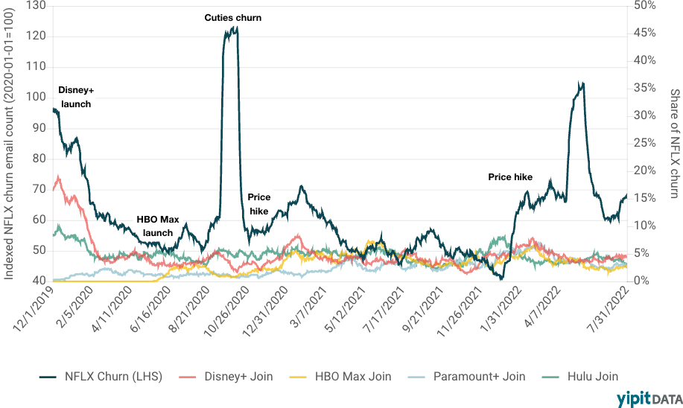***Source: Email receipt data*

# Question 2: Are competitors capturing incremental gross additions from NFLX?

Since Disney+’s launch in November 2019, NFLX has seen the largest number of gross additions of new streaming subscribers (those who were never a prior subscriber of any streaming service), although its share of these subscribers has fallen over the period.

NFLX also has a healthy re-subscription rate. NFLX has historically re-captured 60-80% of churned subscribers that later signed up for one of the 5 streaming video platforms we track.

**Exhibit 2. Total and mix of gross additions to each service that have not been a subscriber to any of the services prior.** We view this as a proxy for the mix of gross additions each service captures that are brand new to streaming.

*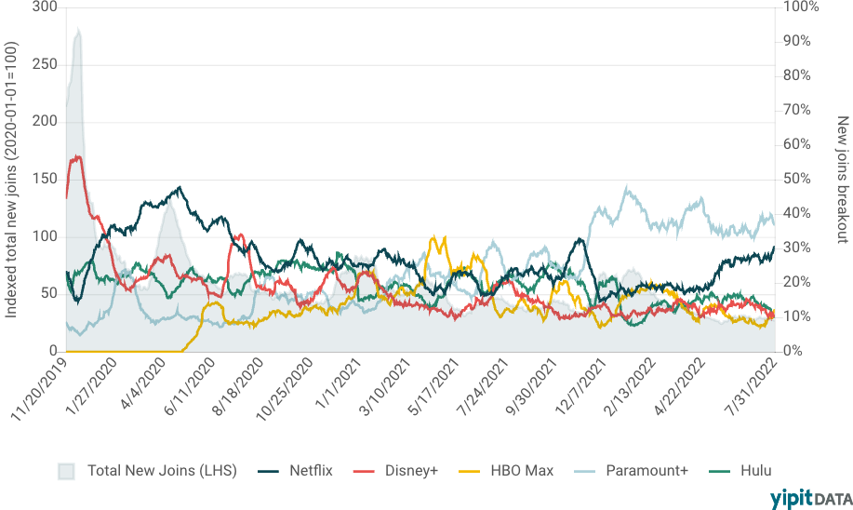Source: Email receipt data*

**Exhibit 3. Mix of gross additions to each service that churned from NFLX within the last 6 months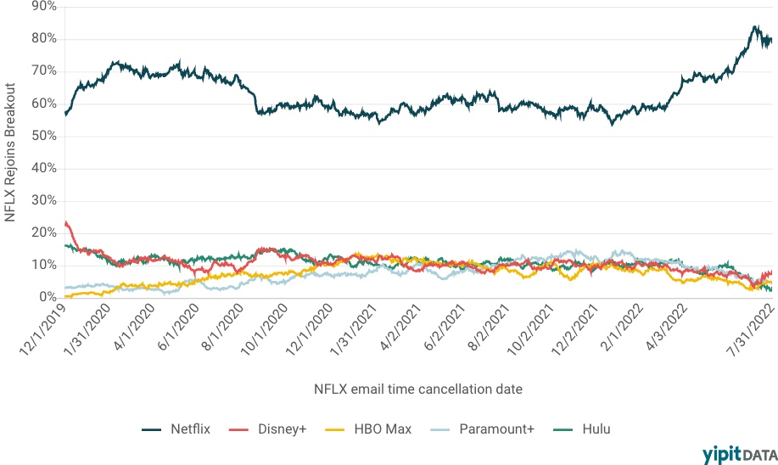***Source: Email receipt data*

# Question 3: What is the mix of subscribers who are subscribed to more than one service?

Our data suggests that slightly more than 40% of NFLX subscribers are members of at least one additional service. Growth in this figure has decelerated to ~4-6pp Y/Y (year over year) since 1Q22, after pacing at ~7-9pp for the prior six quarters. HBO Max and Disney+ see the highest share of subscribers who are members of other services, approaching 80%. Note that Disney+ and Hulu overlap is influenced by the bundling of the services.

**Exhibit 4. The share of subscribers who are subscribed to at least one additional service.** Note that we are only including Netflix, Disney+, HBO Max and Paramount+ in this analysis. Thus the figure would likely be higher if we were to include additional streaming services.

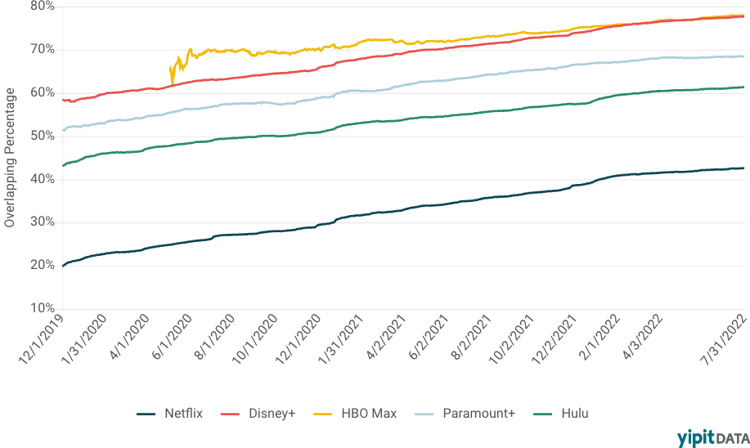

*Source: Email receipt data*