AGAMOTTO
An Automated Task Scheduling System
Backend: Java 25 + Spring Boot (Maven)
Frontend: TypeScript + React · Database: MySQL (Spring Data JPA)
OCR A-Level Computer Science | H446/02
Non-Examined Assessment (NEA) - Programming Project
Candidate: Sixth Form Student (Year 12 Computer Science)
Academic Year: 2026-2027

Table of Contents
Table of Contents 1
1. Analysis 1
1.1 Definition of the Problem 1
1.2 Stakeholders 1
1.3 Research 1
1.3.1 Collection of data 1
1.3.2 Surveys 1
1.3.3 Interviews 1
1.4 Objectives 1
1.5 Requirements and Scope 1
2. Design 1
2.1 Overview 1
2.2 System Architecture 1
2.3 Structure/Hierarchy Diagram 1
2.4 System Flowchart 1
2.5 Dataflow Diagram (DFD) 1
2.6 Class Diagram / UML 1
2.7 Entity Relationship Diagram 1
2.8 Data Dictionary 1
2.9 UI Screens 1
2.10 Algorithm Design 1
2.11 Pseudocode 1
2.11.1 Serenity Mode - scoring and greedy placement 1
2.11.2 Crunch Mode - EDF ordering, Best-Fit exclusion, greedy placement 1
2.11.3 Best-Fit Algorithm - task exclusion when no user changes are made 1
3. Testing 1
3.1 Testing Approach 1
3.2 Test Plan 1

1. Analysis

1.1 Definition of the Problem
The common problem for students and independent workers is that they often have more tasks than available time and inefficiently spend time deciding what should be done first. A normal to-do list records tasks, but it does not decide how those tasks should be better planned into the user's available working timelines.
The problem is computational because generally, the user must process several inputs: task duration, priority, deadline, category, dependencies and available timeframe. Then, the user must derive a timetable where tasks do not overlap, do not exceed the user's available time and follow a clear scheduling rule.
The aim is therefore to build a schedule planning tool that helps the user answer three practical questions: what should I do next, when should I do it, and what should be delayed when there is not enough time? Finally, make smart planning of the activities.
Core problem: Many of the existing tools in the market help users store tasks and provide a plan. However, the proposed solution should help users to provide a more cost-effective, smart planning tool which generates a smart schedule plan that can provide flexibility in editing the given plan as per real-time constraints.

1.2 Stakeholders
The main target audience for the software application I am developing are students or any independent worker with a limited budget to procure top brands in the market. Companies in varying sectors can use the application to manage their workforce, track their schedule plan and monitor their own performance against the plan.

1.3 Research

1.3.1 Collection of data
During the initial kick-off of the project, I spent sufficient time collecting information related to schedule planning, including various tools and processes. This helped me to analyse the functionality and strengths of various tools, as well as their limitations, which helped me to establish the concept.
I reviewed five widely used planning tools to identify what a proposed solution should do differently. The analysis focused on three dimensions for each tool: what it does well, where it falls short for the target audience, and what specific ideas or design decisions Agamotto should take from it.
Notion
Notion is a highly flexible workspace platform built around pages and relational databases. It excels at storing and organising rich task metadata - tags, priorities, due dates and custom properties - within a fully customisable structure. Its documentation capabilities make it popular with students and knowledge workers who want a single place for notes and tasks alike.
Limitations: The core weakness of Notion as a scheduling tool is that it is entirely manual. There is no internal calculation engine - every time block, priority decision and schedule re-arrangement must be made by the user. As task volume grows, the cognitive overhead of planning within Notion scales with it, which ultimately defeats the purpose of having a structured system.
Takeaway for Agamotto: Agamotto can adopt Notion's fluid, 'metadata' approach to task storage while resolving its fundamental gap. Rather than leaving the user to manually interpret and organise their data, the scheduling engine will consume that data and generate a concrete daily plan automatically.
Google Calendar
Google Calendar is one of the most widely adopted time-management tools, offering a clean visual grid for organising time blocks across the day and week. Its deep integration with other Google Workspace products and near-universal device support make it the default scheduling layer for a large proportion of users, particularly students already embedded in the Google ecosystem.
Limitations: The platform's primary limitation is its rigidity as a manual system. Users must decide for themselves which task occupies which time slot, and the calendar has no concept of task weight, cognitive difficulty, or fluctuating energy levels. When one block overruns or an appointment is cancelled, the rest of the schedule does not automatically adapt - it simply breaks, and the user must manually reconstruct the rest of their day.
Takeaway for Agamotto: The intuitive clarity of a time-block grid view is worth preserving. Agamotto will use a similar visual layout, but the engine will fill the grid automatically. If a task runs over its estimated duration, the timeline will reflow dynamically rather than leaving the user to manually shift every subsequent block.
Todoist
Todoist is widely used for its speed of task capture and its clean, minimal interface. Its natural language parsing lets users add tasks with deadlines and priorities in seconds, and its cross-platform availability makes it a popular daily driver for both students and professionals. The focus on low-friction input is one of the strongest design choices in the personal productivity space.
Limitations: Despite its strengths in task capture, Todoist does not translate a list of tasks into a realistic daily schedule. Priority labels sort items vertically by importance but do not map them to the available hours in a day. A user with ten high-priority tasks and four hours of free time receives no indication from Todoist that they are over-committed, making it easy to plan aspirationally rather than realistically.
Takeaway for Agamotto: The quick-capture approach is directly worth adopting. Agamotto will implement a natural language input bar where a user can type something like "finish essay, 2h, due Friday" and have it instantly parsed and passed into the scheduling engine for timeline allocation, giving the same low-friction entry experience with the added benefit of an automatically generated plan.
Motion
Motion is arguably the closest existing product to what Agamotto aims to be. It automatically places tasks into available calendar slots, handles rescheduling when plans change, and supports custom availability windows and meeting buffers. It is designed to replace manual daily planning entirely, and in that respect it succeeds more than any of the other tools reviewed.
Limitations: Motion has two significant drawbacks. First, it is subscription-based and priced at a professional tier, placing it out of reach for most students. Second, and more critically, its algorithm is entirely opaque: users are told what to do next but are given no insight into why tasks are ordered the way they are. This undermines trust and limits the user's ability to make meaningful overrides, since they cannot understand the reasoning behind the schedule they are being asked to follow.
Takeaway for Agamotto: Agamotto borrows Motion's core principle of fully automated scheduling while addressing both of its key weaknesses. It will be free to use with no subscription, and its scheduling engine will surface a plain-language explanation alongside every decision - for example, indicating that a task was placed in the morning because it has the nearest deadline and the highest estimated duration, giving the user the context needed to agree with or confidently override the plan.
Jira / Monday.com
Jira and Monday.com are enterprise-grade project management platforms built primarily for software development teams and larger organisations. They offer powerful features including sprint planning, dependency mapping, burndown charts and detailed audit trails, with deep integrations into development toolchains. Within their intended context, they are highly effective at coordinating work across many people on complex, multi-week projects.
Limitations: These platforms carry the full weight of their enterprise scope, which makes them poorly suited to individual or student use. The configuration and ongoing administrative overhead required to track even simple personal tasks is substantial. Pricing is team-oriented and expensive, and the scheduling logic they contain is primarily manual at the task level: sprints and milestones are defined by humans, not generated by an algorithm.
Takeaway for Agamotto: The most valuable concept to carry forward from Jira and Monday.com is task dependency modelling. Agamotto can support simple dependency linking - ensuring a dependent task is never scheduled before its prerequisite is marked complete - while discarding the broader enterprise complexity that makes these tools inaccessible for the target audience.

1.3.2 Surveys
A survey was conducted in April 2026 and received 37 responses across school/sixth form students, university students, software developers and other professionals. The charts below present the graphical analysis of the responses.
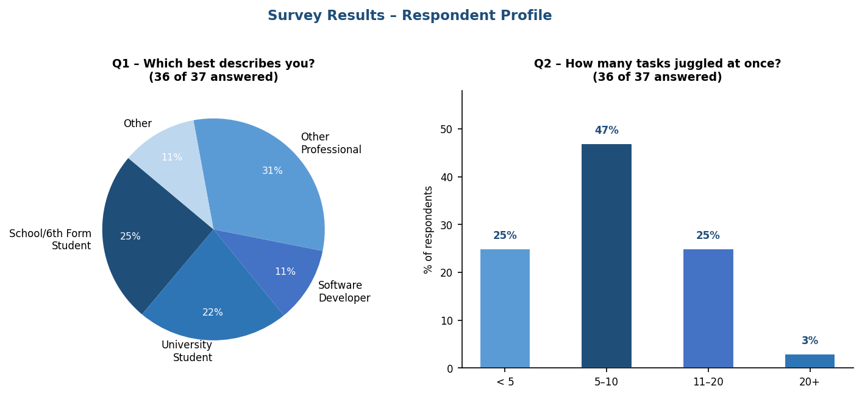
The results confirmed the problem statement. The largest respondent group was other professionals (31%), followed by school/sixth form students (25%) and university students (22%). Most respondents (47%) juggle 5-10 tasks simultaneously, with a further 25% managing 11-20 tasks at once. Workload regularly exceeds available time, scoring an average of 3.6 out of 5.
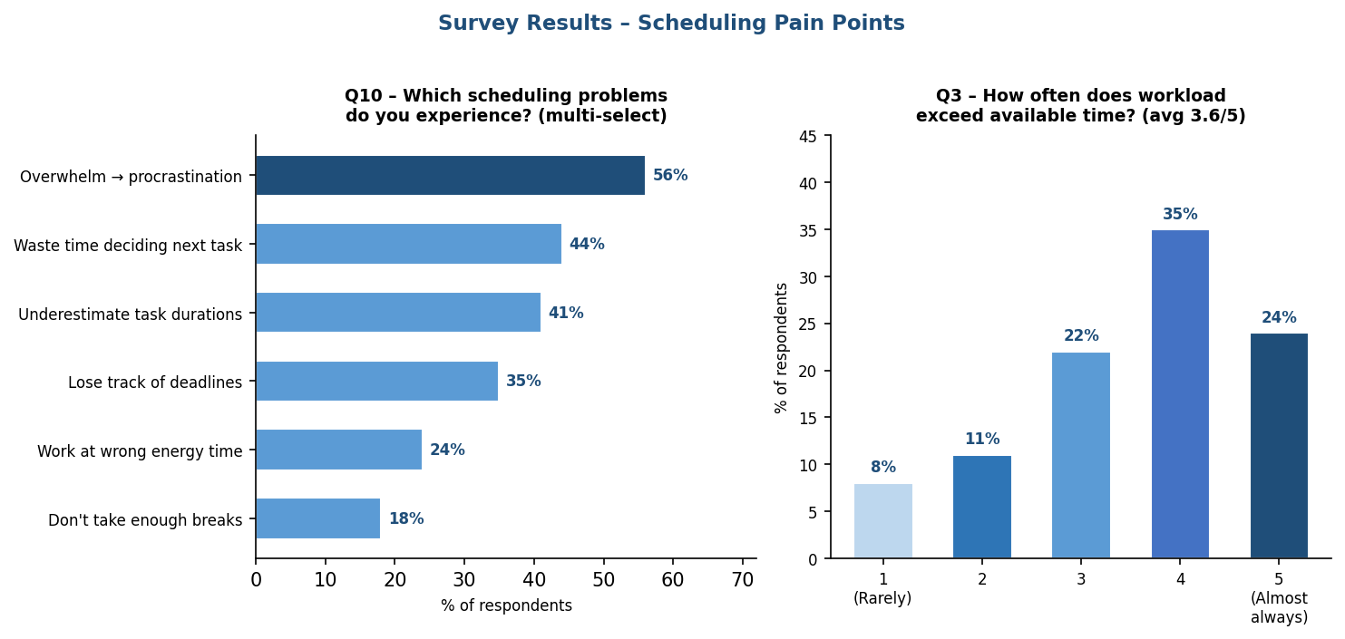
The most common pain points were overwhelm leading to procrastination (56%), wasting time deciding what to do next (44%), underestimating task durations (41%), and losing track of deadlines (35%). Duration estimate accuracy averaged 3.5 out of 5, and when tasks were underestimated, 44% of respondents said work ran over into the next task's slot, while 25% missed the deadline entirely.
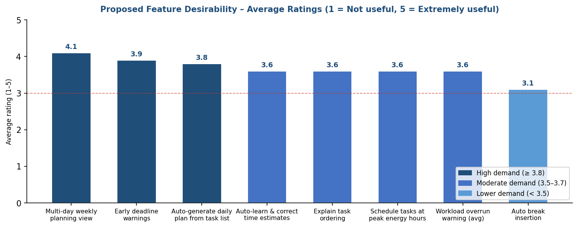
The highest-rated proposed features were a multi-day weekly planning view (avg 4.1/5), early deadline warnings (3.9/5), and auto-generating a daily plan from a task list (3.8/5). Auto-learning and correcting time estimates, explaining task ordering, and scheduling tasks at peak energy hours each scored 3.6/5, all well above the neutral midpoint.
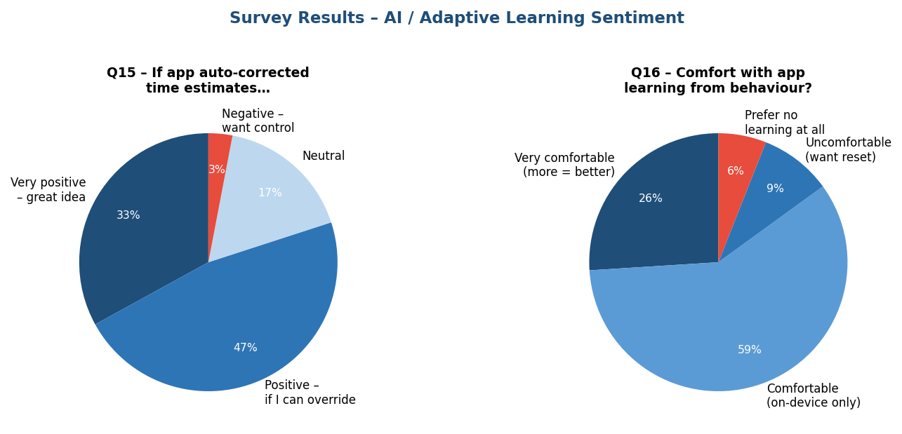
Regarding adaptive learning, 80% of respondents were positive about the app auto-correcting time estimates, with 47% specifying they would accept this only if they could see and override the changes. On data privacy, 85% were comfortable with the app learning from their behaviour, provided data remains on device. The main conclusion from the survey is that users need a smart, flexible scheduling tool that generates a plan with transparent reasoning and allows manual overrides.

1.3.3 Interviews
In addition to the surveys, I conducted interviews with my parents' friends and colleagues in IT and non-IT sectors to get feedback on 'schedule planning' functionality. The sample included individual workers from small and medium IT and non-IT businesses, and students. The interviews were conducted in-person and via personal chat, using a set questionnaire.
The key questions asked included: How do they plan their day? How are tasks noted? How are noted tasks planned? Are they able to execute their plan without slippage? What are the reasons for missing plans? If the system were implemented, how user-friendly would it be? What are the reasons for not implementing a system in small organisations? What is the impact on productivity of implementing such a system?
The observations from the interviews were documented and analysed for patterns. A major observation is that individual users and small organisations are not using a system-based approach, and medium organisations are not happy with their existing system's capabilities. In contrast, large organisations are used to sophisticated cloud-based solutions available in the market, and licence cost is not a key factor for them.
Key observations noted from users:
- Users often manage many tasks in a day
- Users underestimate the task duration
- Users face complexity in decision making, resulting in poor execution of tasks
- Users want their automated decisions to be presented with proper reasoning
- Users want an overriding capability on the system's decisions on the schedule
With all these insights, there is a need for a smart yet cost-effective 'schedule planner' solution which automates the schedule planning functionality.

1.4 Objectives
The research stage had two aims: to confirm that the scheduling problem was real, and to identify what existing planning tools do not solve well. The evidence showed that users do not only need tools to store and display tasks; they need cost-effective and user-friendly tools for converting tasks into a realistic schedule plan. For instance, the expected solution should generate a schedule plan, but the user must still be able to move tasks within the schedule, lock tasks to a fixed time frame, and trigger automatic rescheduling.
The data collected from the surveys and interviews, along with further analysis, helped define the objectives of my project, listed below:
- Allow users to create and manage their tasks
- Support task categorisation by task type, category, priority, deadline and status
- Automatically prepare a smart schedule plan into available time slots
- Remind users about upcoming tasks and their deadlines
- Track task progress and completion
- Reschedule pending or incomplete tasks when needed
- Provide the user with a clear daily, weekly and monthly view/dashboard
- Give each scheduled, delayed or excluded task a readable explanation
- Allow the user to edit scheduled tasks given by the generated plan

1.5 Requirements and Scope
The project scope is to build a task scheduling planner with a clear scheduling engine, user notifications, the ability to track the progress of tasks, and simple analytics. Below are the detailed requirements noted.
ID | Requirement category | Requirements | Source | Success measure
R1 | User Management | 1. Register user  2. Manage user profile  3. Manage user preferences  4. Define/configure available working windows for a working day | Independent workers + students | Users are successfully registered and can log in to the application. User can view/edit their profile details.
R2 | Schedule and Task Management | 1. Create a schedule  2. Create and view tasks with key attributes (title, duration, priority, deadline, category, etc.) under a schedule  3. Edit key attributes of each task  4. Delete unrequired tasks  5. Update task progress status  6. Save tasks with timestamp of change and user details  7. Task history must be maintained 8. Sub-task creation under a task (aspirational requirement) | Independent workers + students | A valid schedule and tasks are created with a unique task ID; user can view and edit the selected fields. User is able to see task history alongside the change timestamp.
R3 | Schedule Planning | 1. Generate schedule plan automatically considering deadlines, priority and other inputs  2. Reschedule incomplete tasks  3. Generate calendar view of the schedule | Independent workers + students | 1. Generate a Serenity schedule when total estimated task duration fits within the available schedule time  2. Generate a Crunch schedule when total estimated task duration exceeds the scheduled plan time, without overlapping tasks, while marking the rest as delayed or excluded  3. Rescheduling of incomplete tasks  4. Calendar view creation
R4 | Schedule Planning (override) | Provide the user the ability to override the system's decisions, to leave it to the user to handle exceptions | Independent workers + students | User can modify the system-generated decision of the schedule plan.
R5 | Schedule Plan Execution | Provide reasoning to the user regarding why a task was delayed or excluded | Research + Survey | System shall provide a short reason using values such as priority, deadline urgency, corrected duration and available time for each delayed/excluded task.
R6 | Notifications | Notify user about the list of tasks in their queue and their deadlines | Independent workers + students | Users are notified over email about their tasks in the queue and deadlines.
R7 | Generate Dashboard/View/Report | Provide a detailed view to the user of assigned tasks with status (completed/in progress/pending). Provide summary view on a daily, weekly and/or monthly basis | Research + Teacher | A view/report showing schedule generation time, number of scheduled, delayed and excluded tasks, giving both a detailed and a summary view.
R8 | System Requirements | Tasks and data must be stored and persist. Schedule generation should complete within an acceptable time limit. Data in the system should be secured and available to the authorised user only. | Research | Records are stored in the database persistently. History of changes is maintained to record who changed what, and when.
Below are the aspirational future features, out of which a few might be included during project implementation based on the initial version:
- Multi-user task scheduling (current solution handles single-user tasks only)
- Mobile app development
- AI/ML model-based scheduler

2. Design

2.1 Overview
Agamotto, the 'schedule planner', is a web application built to meet the objectives listed in the section above. The application allows the user to create a project, enter task details and their preferences and constraints. The system automatically schedules tasks in the preferred time slots, sends notifications/reminders to the user about planned tasks and their deadlines, and provides a user interface to track progress of tasks. Users can reschedule pending or incomplete tasks for later handling, and view a report on their schedule for the day, week and month to monitor their own performance.
Design principle: The system should behave like a planner with an algorithm behind it and bring transparency to the user with proper reasoning. The user needs to be empowered to override the system's decisions to handle exceptions based on real-world situations.

2.2 System Architecture
This is the section of the design that changes the most from the original TanStack Start version of Agamotto. The application keeps its three-tier shape - UI, API and database - but the API and database tiers are now implemented in Java rather than TypeScript, and the previous Convex backend-as-a-service has been replaced with a conventional Spring Boot service talking to a relational database.
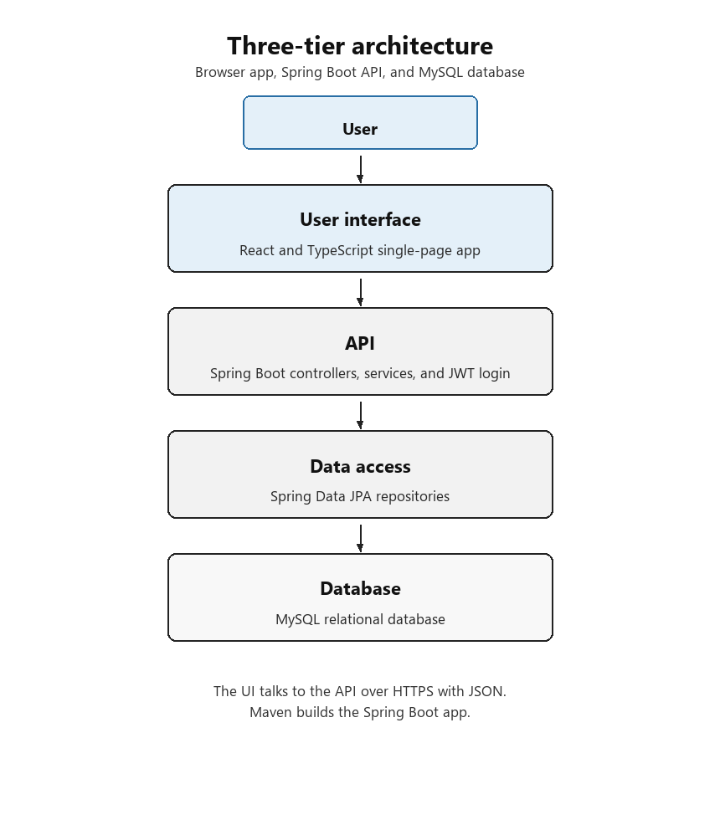
Figure 2.2 - Three-tier architecture (Java/Spring backend)
The solution is spread across three technical layers:
1. User Interface (UI Layer): Capture task inputs, displays the timeline, warnings, explanations and manual override controls. The UI is built using TypeScript and React technologies.
2. Scheduling engine (API Layer): Selects Serenity or Crunch Mode, applies the appropriate algorithm validating the user constraints and returns schedule plan with reasoning as required. The APIs are written using TypeScript
3. Database layer (DB Layer): The database is built using an SQL Database, provided by Neon. Stores tasks, schedules, settings and correction factors within the database.
Everything in the API layer is built using Java and Spring. The React frontend remains a separate package, built with Vite and TypeScript, and calls the Spring Boot API over HTTP.
Below is the layer-wise responsibility table with the equivalent Java package structure:
Layer | Responsibility | Example files / packages
UI | Creating and viewing tasks, viewing the generated schedule, and analytics. | frontend/src/routes/, frontend/src/components/
API - Controller | Exposes REST endpoints for tasks, projects and schedules; validates incoming requests. | src/main/java/com/agamotto/controller/
API - Service / Scheduler | Mode selector plus algorithm modules. Serenity uses greedy score-based placement with EDF as a tiebreaker. Crunch uses EDF ordering, the Best-Fit greedy algorithm to choose which tasks to exclude, then the same greedy placement as Serenity for the remainder. | src/main/java/com/agamotto/service/scheduler/
API - Domain | JPA entity classes mapped to the MySQL schema (User, Task, SchedulePlan, ScheduleBlock, etc.). | src/main/java/com/agamotto/domain/
Database | Spring Data JPA repository interfaces; storage for tasks, settings, schedules and history. | src/main/java/com/agamotto/repository/, src/main/resources/application.yml

2.3 Structure/Hierarchy Diagram
Below diagram depicts the logical modules explaining the hierarchy of the Agamotto application. This module breakdown is a design-level (not implementation-level) view.
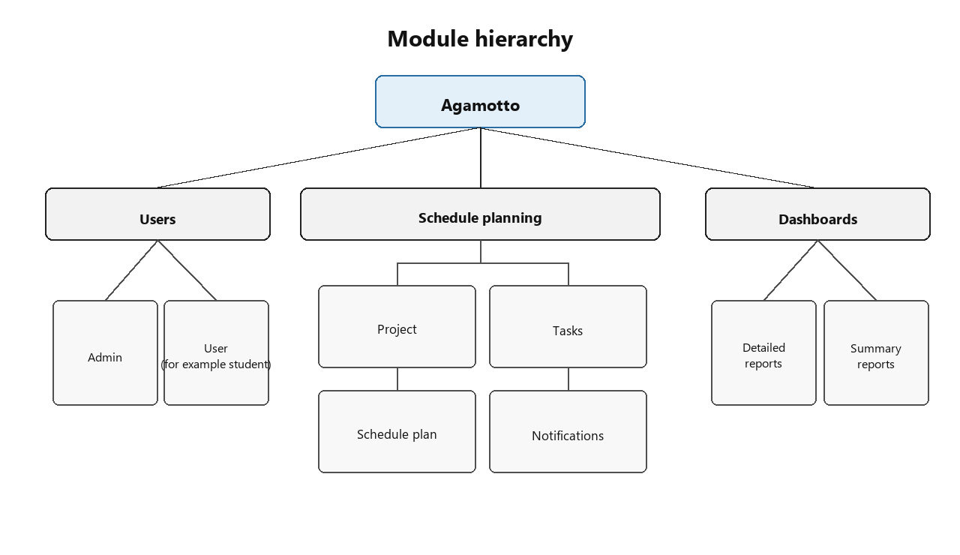
At the high level, the application is logically divided into three modules: Users, Schedule Planning and Dashboards. The Users module handles user registration and login information. The Schedule Planning module has multiple functionalities like project creation, task creation, preparation of the schedule plan and an editable view of the schedule plan; it also handles notifications/reminders about tasks and deadlines. The Dashboard module offers the user a view of their tasks with a summary view and a detailed view.

2.4 System Flowchart
Below is the system flowchart of the Agamotto application.
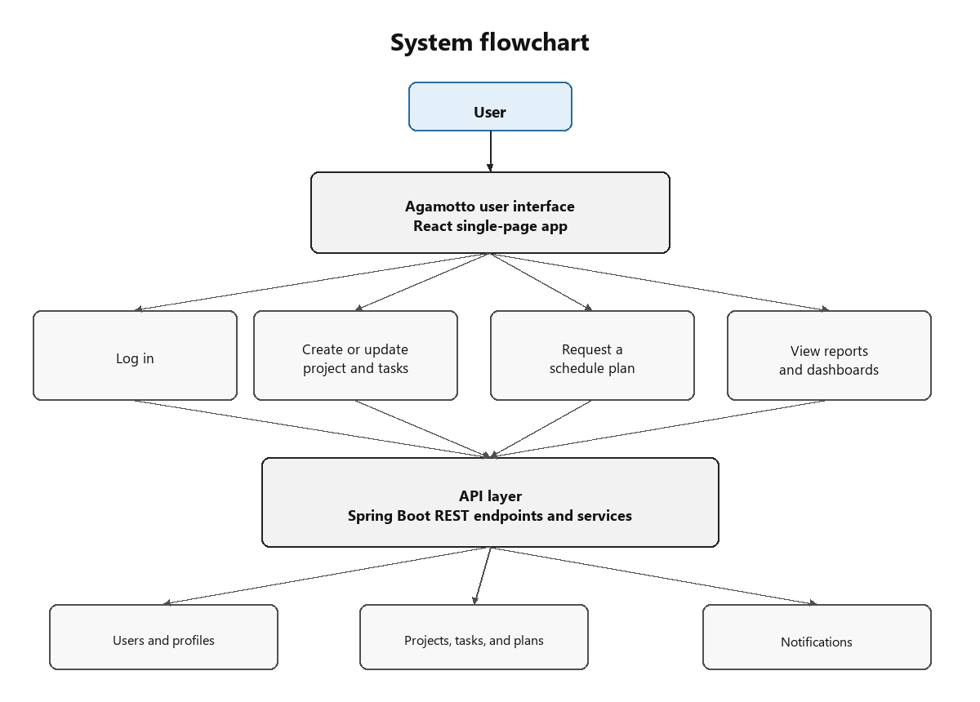
This flowchart shows how data moves through the system:
1. The user interacts with the system by logging into the Agamotto UI, entering project inputs and creating tasks under the project. The user also requests a schedule plan, which considers project timelines and user preferences to generate a detailed schedule plan.
2. The user inputs captured in the UI layer are sent to the API layer (now the Spring Boot REST API), where the main processing takes place.
3. Login details are validated against the users table, and task/schedule plan information is stored and retrieved from the tasks and schedule_plans tables via Spring Data JPA repositories.
4. The system also provides automatic e-mail notifications/reminders to the user about pending tasks and deadlines, run on a daily basis by a Spring @Scheduled job.

2.5 Dataflow Diagram (DFD)
Below is the dataflow diagram for the Agamotto application. The diagram explains the users of the application, the processes handled and how information is stored in the database.
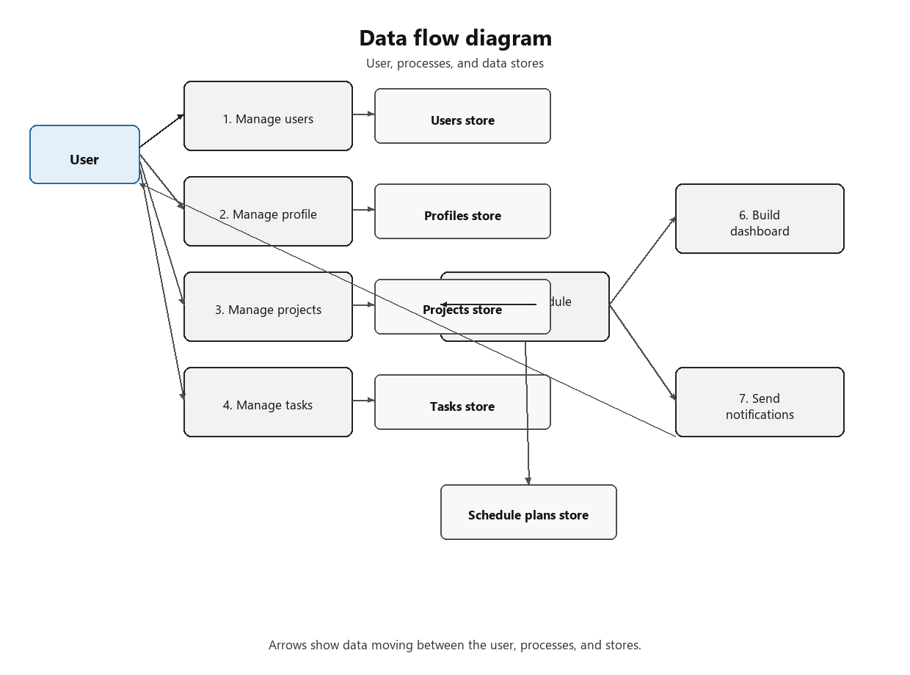

2.6 Class Diagram / UML
Below is the class diagram and relationships between the different classes, updated to use Java types (String, int, double, boolean, LocalDate/LocalDateTime, List<T>) in place of the generic TypeScript-flavoured types (string, number) used in the original design. All entity identifiers are String fields holding a UUID (java.util.UUID.toString()), which map directly onto the VARCHAR(36) primary keys used in the MySQL schema.
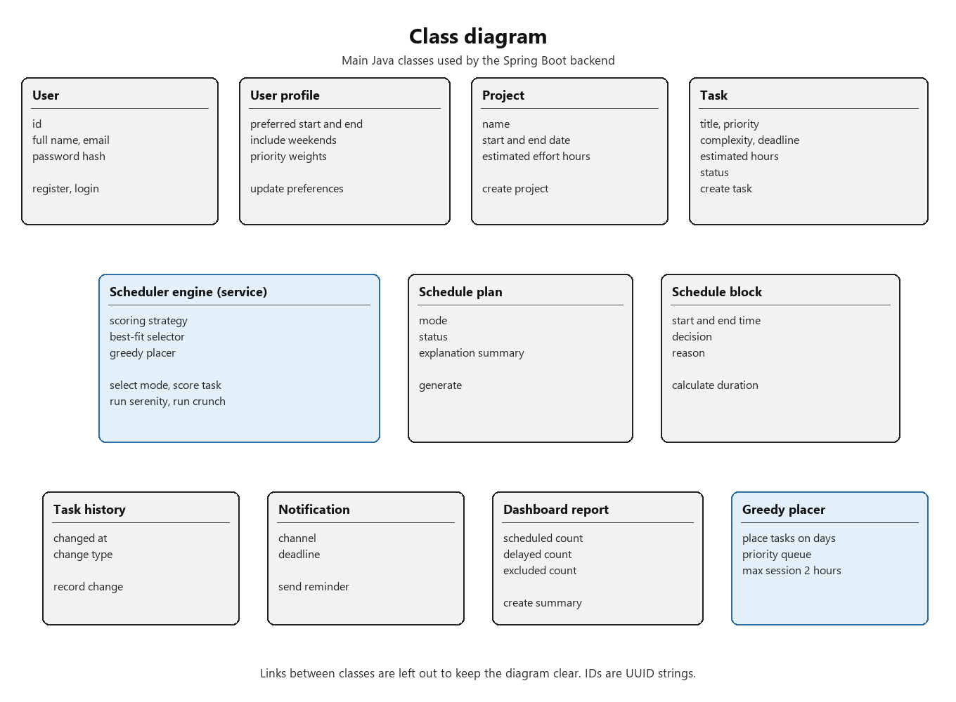
SchedulerEngine is marked as a «service» class rather than an entity: it is a Spring @Service bean that orchestrates the Serenity/Crunch algorithms and is never persisted itself, whereas the other nine classes shown are JPA @Entity classes backed by their own table (see the Data Dictionary in section 2.8).

2.7 Entity Relationship Diagram
Below diagram describes the entities needed in the application and how relationships are established between them, redrawn as a relational schema suitable for MySQL and Spring Data JPA (previously this was a Convex document schema). By default, the system is built for a single-user team; a team can have multiple users when handling group collaboration projects (aspirational, out of current scope). A project contains defined timelines by which it needs to be completed. A project contains many tasks, which are categorised and have their own estimated effort. The user places a schedule planning request, which the system generates automatically and stores in the database.
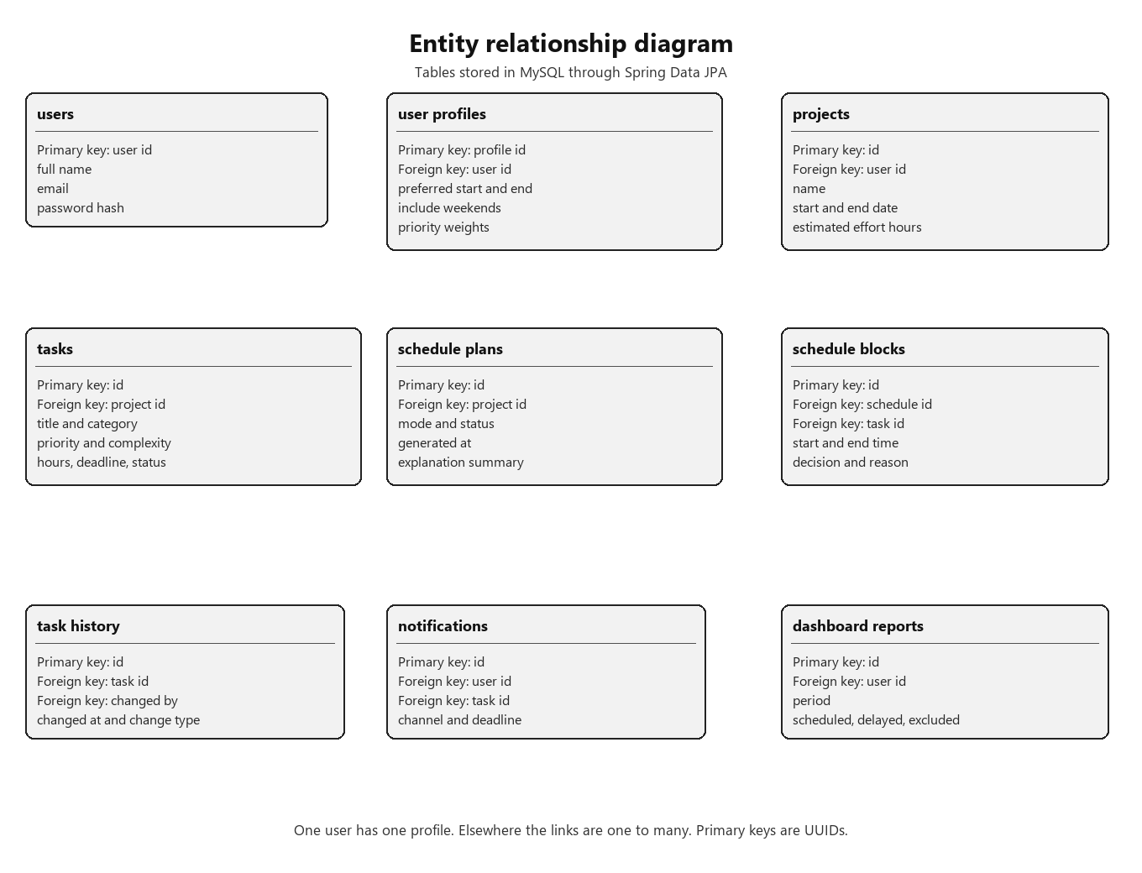

2.8 Data Dictionary
The schema below is normalised to Third Normal Form (3NF): every non-key attribute is fully functionally dependent on the whole of its table's primary key and not on any other non-key attribute, and repeating groups (e.g. a task's history, or a user's notifications) are extracted into their own tables rather than stored as arrays on the parent row. Foreign keys enforce referential integrity between the nine entities.

users
Stores registered account holders.
Field | Type | Key | Validation / notes
user_id | VARCHAR(36) | PK | Generated UUID, immutable
full_name | VARCHAR(120) | - | Not null
email | VARCHAR(150) | UNIQUE | Not null; validated as an email address
password_hash | VARCHAR(255) | - | BCrypt hash; never stores plaintext

user_profiles
Stores each user's scheduling preferences (1:1 with users).
Field | Type | Key | Validation / notes
profile_id | VARCHAR(36) | PK | Generated UUID
user_id | VARCHAR(36) | FK -> users.user_id | Unique - enforces the 1:1 relationship
preferred_start | TIME | - | Start of the user's working window
preferred_end | TIME | - | Must be after preferred_start
include_weekends | BOOLEAN | - | Default false

projects
A container for a group of related tasks with an overall timeline.
Field | Type | Key | Validation / notes
project_id | VARCHAR(36) | PK | Generated UUID
user_id | VARCHAR(36) | FK -> users.user_id | Not null
name | VARCHAR(150) | - | Not null
start_date | DATE | - | Not null
end_date | DATE | - | Must be on/after start_date
estimated_effort | DECIMAL(6,2) | - | Total estimated hours across all tasks

tasks
An individual unit of work to be scheduled within a project.
Field | Type | Key | Validation / notes
task_id | VARCHAR(36) | PK | Generated UUID
project_id | VARCHAR(36) | FK -> projects.project_id | Not null
title | VARCHAR(150) | - | Not null
category | VARCHAR(50) | - | e.g. study, chore, admin
complexity | INT | - | 1 (easy) - 5 (hard); used for session-splitting
priority | INT | - | 1 (low) - 5 (high)
est_hours | DECIMAL(5,2) | - | Candidate's estimate; later corrected by the correction factor
deadline | TIMESTAMP | - | Must be in the future when created
status | VARCHAR(20) | - | PENDING | IN_PROGRESS | COMPLETE

schedule_plans
One generated scheduling run for a project (Serenity or Crunch).
Field | Type | Key | Validation / notes
schedule_id | VARCHAR(36) | PK | Generated UUID
project_id | VARCHAR(36) | FK -> projects.project_id | Not null
mode | VARCHAR(20) | - | SERENITY | CRUNCH
generated_at | TIMESTAMP | - | Server timestamp at generation time
status | VARCHAR(20) | - | DRAFT | ACTIVE | SUPERSEDED
explanation_summary | CLOB | - | Plain-language summary of the mode decision

schedule_blocks
One placed task occurrence within a schedule plan's timetable.
Field | Type | Key | Validation / notes
block_id | VARCHAR(36) | PK | Generated UUID
schedule_id | VARCHAR(36) | FK -> schedule_plans.schedule_id | Not null
task_id | VARCHAR(36) | FK -> tasks.task_id | Not null
start_time | TIMESTAMP | - | Must not overlap another block for the same schedule
end_time | TIMESTAMP | - | Must be after start_time
decision | VARCHAR(20) | - | SCHEDULED | DELAYED | EXCLUDED
reason | VARCHAR(255) | - | Human-readable explanation, e.g. 'priority = 5, deadline tomorrow'

task_history
An audit trail of changes made to a task (1 task : many history rows).
Field | Type | Key | Validation / notes
history_id | VARCHAR(36) | PK | Generated UUID
task_id | VARCHAR(36) | FK -> tasks.task_id | Not null
changed_by | VARCHAR(36) | FK -> users.user_id | The user who made the change
changed_at | TIMESTAMP | - | Server timestamp
change_type | VARCHAR(30) | - | CREATED | EDITED | STATUS_CHANGED | DELETED

notifications
A queued or sent reminder about an upcoming task deadline.
Field | Type | Key | Validation / notes
notification_id | VARCHAR(36) | PK | Generated UUID
user_id | VARCHAR(36) | FK -> users.user_id | Not null
task_id | VARCHAR(36) | FK -> tasks.task_id | Not null
channel | VARCHAR(20) | - | Currently EMAIL only
deadline | TIMESTAMP | - | Copied from the task at send time, for audit purposes

dashboard_reports
A cached daily/weekly/monthly summary of a user's schedule performance.
Field | Type | Key | Validation / notes
report_id | VARCHAR(36) | PK | Generated UUID
user_id | VARCHAR(36) | FK -> users.user_id | Not null
period | VARCHAR(10) | - | DAILY | WEEKLY | MONTHLY
scheduled_count | INT | - | Number of blocks with decision = SCHEDULED
delayed_count | INT | - | Number of blocks with decision = DELAYED
excluded_count | INT | - | Number of blocks with decision = EXCLUDED

2.9 UI Screens
The screens below are unchanged from the original design, since the React/TypeScript frontend has been kept and now simply talks to the Java/Spring Boot API instead of Convex - the candidate's UI code and the user's experience are unaffected by the backend rewrite.
Screen #1:
Below is the screen used for user onboarding. After entering the fields and signing up, a user account is created in the database for the user to use the application's functions.
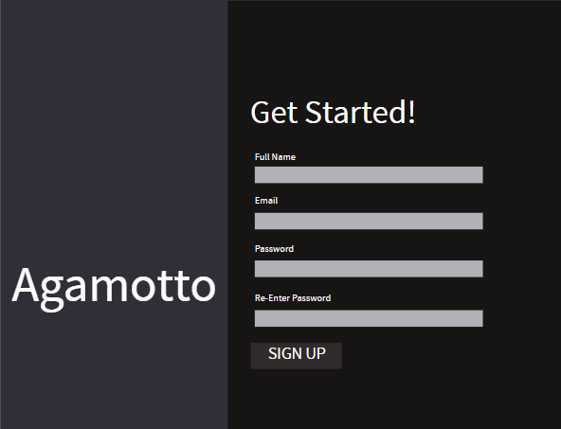
Screen #2:
Below is the screen for user login. When the correct user details have been entered, the user is taken to the dashboard, and the schedules and analytics specific to the user are retrieved and displayed from the database.
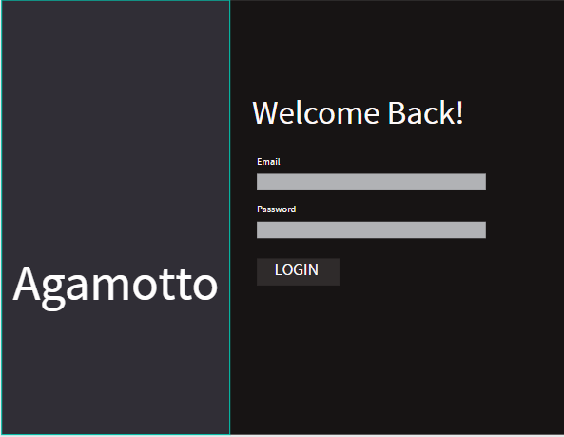
Screen #3:
Below is the screen used when the user wants to create or view a schedule. On this page, the user can view all schedules created by the system. Clicking the Generate Schedule button redirects the user to a page for generating a schedule, where it asks for all the essential parameters the system needs to create an optimised schedule, such as task details and user preferences.
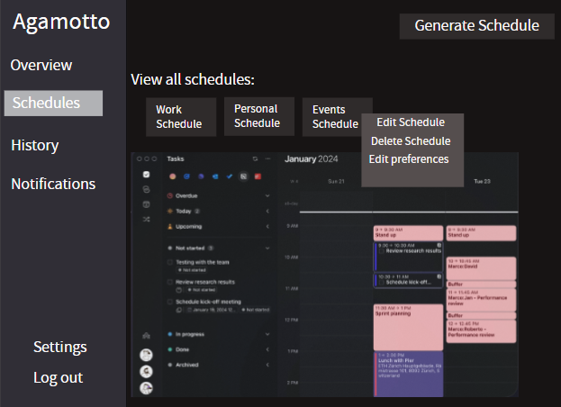
Screen #4:
Below is the screen used for generating a schedule, which appears when the Generate Schedule button is clicked. The page asks the user to enter schedule details such as the start and end date, along with task details. Once the Create Schedule button is clicked, the tasks are registered in the database and the specific mode (Serenity or Crunch) is used to create the schedule.
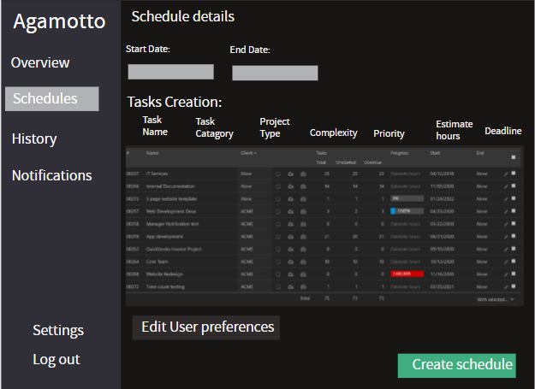
Screen #5:
Below is the dashboard screen, the core of the program, where the user can navigate to the specific function they want to use, such as viewing analytics or generating a tailored schedule. Clicking a function on the left-hand sidebar displays the related page for the user to use.
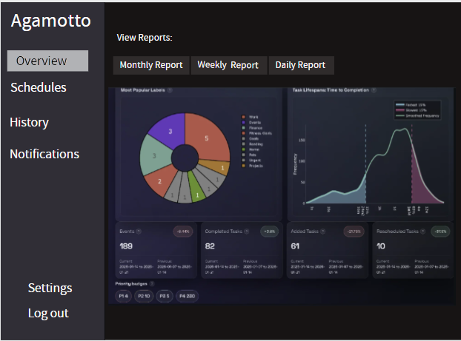

2.10 Algorithm Design
Schedule Plan Algorithm: This algorithm is used once all the inputs have been received from the user and a schedule plan has been requested. It is split into two modes, Serenity and Crunch. If the total cumulative estimated hours of the tasks exceed the project's estimated effort, the program uses the Crunch algorithm to produce an optimal schedule plan with maximum productivity. Otherwise, the program uses Serenity mode and provides the detailed plan as the default approach.
Serenity Mode: Used when the total workload provided by the user does not exceed the schedule period. The algorithm iterates through every task to calculate a score, then arranges the tasks into a priority queue.
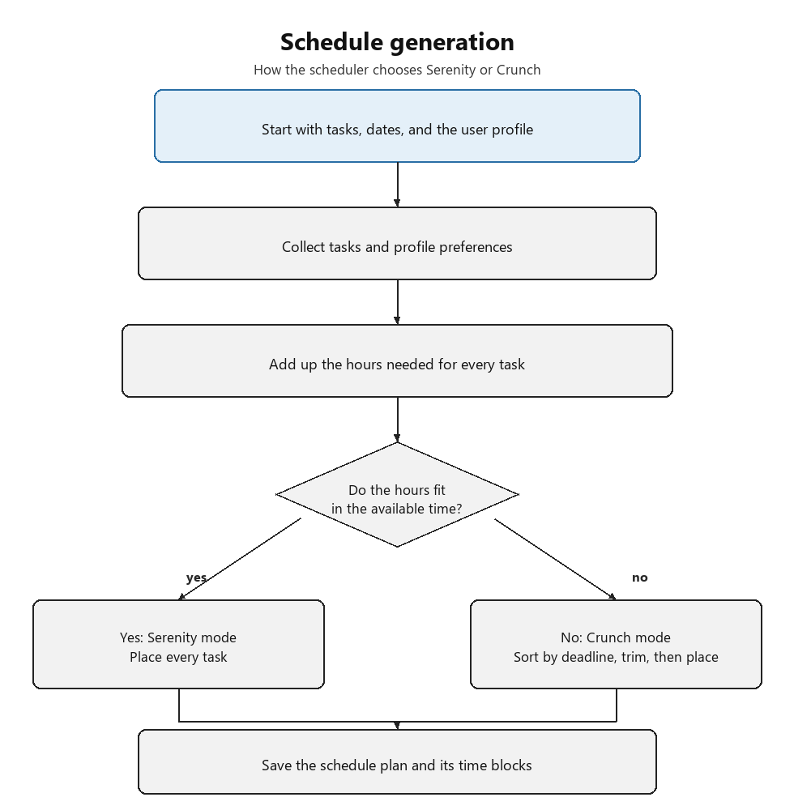
Then, for every scheduled day, depending on the task's category and complexity, the workload of a complex task is split into sessions, which are arranged through the schedule. Sessions are arranged until the total workload requirement has been met.
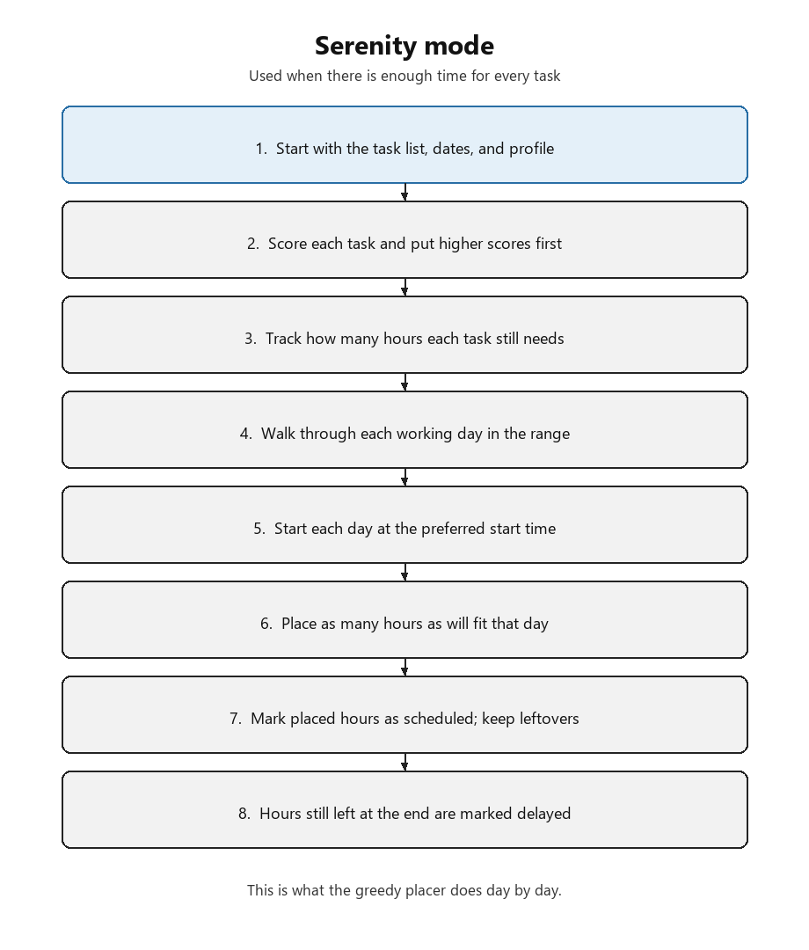
Crunch Mode: A variation of Serenity used when the total estimated workload exceeds the scheduled period. In that case, the system asks the user to either change the inputs - for example, decreasing the estimated hours or eliminating some tasks - to match the workload to the schedule.
If no changes are made by the user, the system uses the Best-Fit Algorithm, which uses calculations to determine a subset of tasks to eliminate so the remaining workload matches the time period of the schedule.
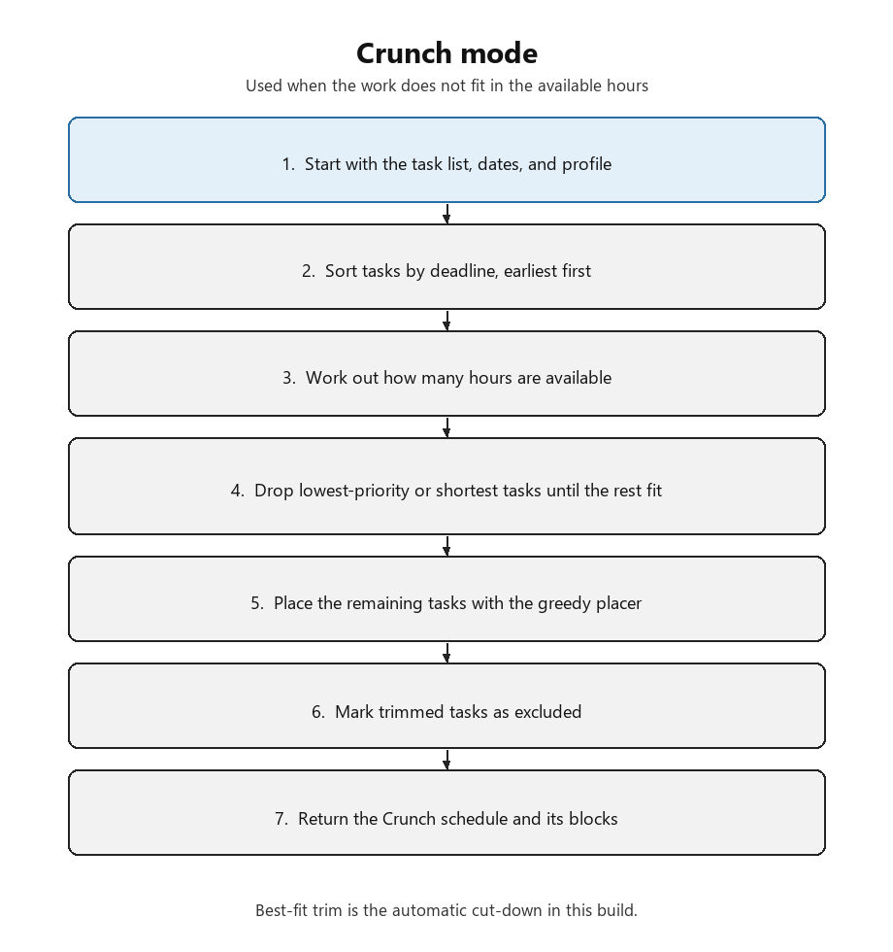
This section defines the algorithms before applying them in Serenity Mode and Crunch Mode. This is important because the application should be understandable to a non-technical user as well as testable. Agamotto does not use vague decision-making; each scheduling decision is produced from visible inputs and a named algorithmic rule.
A schedule block means one placed task in the timetable, with a start time, end time, status and explanation. For example, "Maths revision, 16:00-17:00, scheduled because priority = 5 and deadline is next day" is one schedule block.

2.11 Pseudocode
The pseudocode below is written at an algorithm-design level rather than in any specific language, so it remains valid regardless of the implementation language. The accompanying notes indicate how each block maps onto the Java/Spring implementation (data structures used, and which Spring component is responsible).

2.11.1 Serenity Mode - scoring and greedy placement
PROCEDURE serenityMode(tasks, scheduleStart, scheduleEnd) FOR task IN tasks task.score = (w_p * task.priority) + (w_u * task.deadline.urgency) + (w_ed * task.estDuration) ENDFOR queue = SORT tasks BY score DESC, THEN BY deadline ASC FOR day IN RANGE(scheduleStart, scheduleEnd) remainingWH = workingHours(day) WHILE queue IS NOT EMPTY AND remainingWH > 0 task = queue.peek() scheduledHours = MIN(task.estDuration, remainingWH) ADD block(task, day, scheduledHours) TO schedule task.estDuration = task.estDuration - scheduledHours remainingWH = remainingWH - scheduledHours IF task.estDuration <= 0 queue.remove(task) ENDIF ENDWHILE ENDFOR ENDPROCEDURE
In Java, tasks is a List<Task> loaded via TaskRepository; queue is a java.util.PriorityQueue<Task> ordered by a Comparator built from the score; the whole procedure lives in SchedulerEngine.runSerenity(), a @Service method annotated @Transactional so the generated ScheduleBlock rows are saved atomically alongside the parent SchedulePlan.

2.11.2 Crunch Mode - EDF ordering, Best-Fit exclusion, greedy placement
Crunch Mode does not implement its own separate selection logic. It orders tasks by deadline (EDF), hands the exclusion decision to the Best-Fit algorithm defined in 2.11.3, and then places the surviving tasks using the same greedy placement loop as Serenity Mode. This keeps exactly one exclusion algorithm in the system, rather than two competing ones, and matches the transparency design principle in 2.1: a greedy, one-task-at-a-time exclusion rule is straightforward to turn into a plain-language reason, whereas an optimal 0/1 knapsack solution is not - it can exclude a combination of tasks for reasons that are hard to summarise in a single sentence to the user.
PROCEDURE crunchMode(tasks, scheduleStart, scheduleEnd) capacity = totalWorkingHours(scheduleStart, scheduleEnd) orderedTasks = SORT tasks BY deadline ASC // EDF ordering (selected, excluded) = bestFit(orderedTasks, capacity) // see 2.11.3 schedule = greedyPlace(selected, scheduleStart, scheduleEnd) // identical // placement loop to serenityMode() FOR task IN excluded MARK task AS EXCLUDED WITH reason "workload exceeds available time" ENDFOR RETURN schedule ENDPROCEDURE
In Java, greedyPlace() is extracted out of serenityMode() into its own private method on SchedulerEngine so both runSerenity() and runCrunch() call the same placement code - this also means a single unit test suite covers the placement behaviour for both modes, and only the selection step needs separate tests.

2.11.3 Best-Fit Algorithm - task exclusion when no user changes are made
PROCEDURE bestFit(tasks, availableHours) totalHours = SUM(t.estDuration FOR t IN tasks) overflow = totalHours - availableHours excluded = EMPTY LIST IF overflow > 0 candidates = SORT tasks BY priority ASC, THEN BY estDuration ASC removedHours = 0 FOR task IN candidates IF removedHours >= overflow BREAK ENDIF excluded.ADD(task) removedHours = removedHours + task.estDuration ENDFOR ENDIF remaining = tasks - excluded RETURN remaining, excluded ENDPROCEDURE
This is the fallback used when the user declines to manually trim their task list in Crunch Mode. Candidates are sorted by ascending priority then ascending duration, so the lowest-priority, shortest tasks are excluded first, minimising the number of tasks dropped while still closing the overflow gap. Both branches now return the same (remaining, excluded) pair - when overflow <= 0, excluded is simply empty - so callers never need to special-case the return type. In Java this is a Comparator.comparing(...).thenComparing(...) stream sort inside SchedulerEngine; each excluded Task is written back with status EXCLUDED and a ScheduleBlock row with decision = EXCLUDED and a populated reason column, matching the schedule_blocks entity in the Data Dictionary.

2.12 Test Plans
Testing is planned during design so that each algorithm and feature has clear, measurable acceptance criteria before coding starts. Agamotto uses two complementary layers of testing:

Iterative testing (white-box)
White-box tests are written against the known structure of the code - for example the branches inside SchedulerEngine.selectMode, BestFitSelector.select, and GreedyPlacer.place. A short test plan is prepared for each development iteration before that iteration is implemented. The completed iteration is tested before the next iteration is defined. This matches the iterative DESIGN -> DEVELOPMENT -> TESTING cycle shown below.

Post-development testing (black-box)
Black-box tests are carried out once a vertical slice (or the full solution) is complete. They treat the system as a sealed product: inputs and expected outputs are checked without reference to internal methods. These tests also probe unintended use (invalid dates, empty task lists, overlapping overrides) and basic malicious use (oversized payloads, missing auth tokens). Because designs may change during the project, every test is reviewed for validity before it is executed.
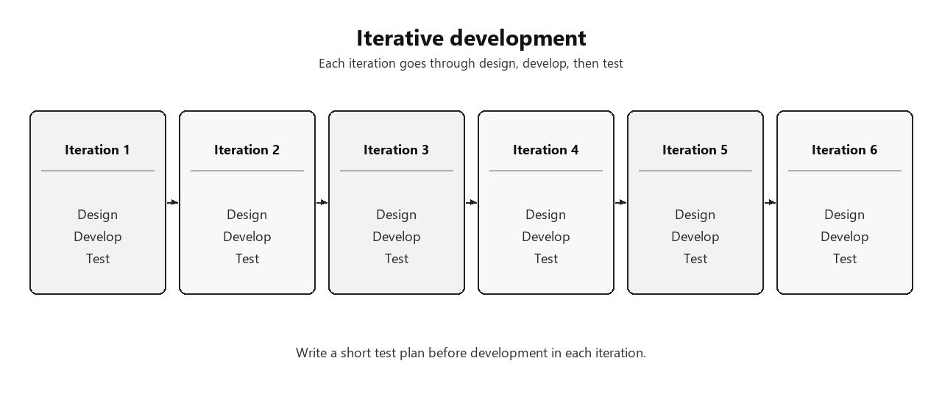
Figure 2.12 - Iterative DESIGN / DEVELOPMENT / TESTING cycle
Remember that projects are usually developed iteratively. For each iteration, a short test plan is written before development is carried out.

2.12.1 Iterative (white-box) test plan
These tests exercise known algorithm paths and data structures. They are intended as JUnit 5 tests against SchedulerEngine, BestFitSelector, GreedyPlacer and ScoringStrategy.
ID | Iteration / focus | Method under test | Input / condition | Expected result
WT1 | Mode selection | SchedulerEngine.selectMode | Sum hours <= availableHours | Returns SERENITY
WT2 | Mode selection | SchedulerEngine.selectMode | Sum hours > availableHours | Returns CRUNCH
WT3 | Scoring | ScoringStrategy.scoreTask | Nearer deadline vs far deadline | Nearer deadline scores higher (same priority/duration)
WT4 | Serenity place | GreedyPlacer.place | includeWeekends=false | No SCHEDULED blocks on Saturday/Sunday
WT5 | Session split | GreedyPlacer.place | complexity >= 4 and duration > 2h | No single SCHEDULED block > 2.0h for that task
WT6 | Cursor advance | GreedyPlacer.place | Two tasks fit one day | Second startTime equals first endTime
WT7 | Queue re-offer | GreedyPlacer.place | Task longer than one day | Same task appears in multiple SCHEDULED blocks
WT8 | Delayed leftover | GreedyPlacer.place | Insufficient window capacity | Leftover hours become DELAYED blocks
WT9 | Best-fit trim | BestFitSelector.select | overflow > 0 | Excluded hours cover overflow; lowest priority/shortest first
WT10 | Crunch pipeline | SchedulerEngine.runCrunch | Overloaded task list | Survivors placed; excluded -> EXCLUDED
WT11 | EPSILON | place / selectMode | Remainders near 0.0 | Values |x| < 1e-9 treated as zero
WT12 | Persistence | ProjectService.create | Valid ownerId + dates | Project saved; listByOwner returns it

2.12.2 Post-development (black-box) test plan
These tests are run through the public HTTP API and/or UI without inspecting private methods. They confirm intended behaviour, recovery from bad input, and resistance to trivial misuse.
ID | Area | Action / input | Expected observable result
BT1 | Auth | Register new user then login | Token + user returned; authenticated calls succeed
BT2 | Auth | Login with wrong password | 401 / invalid credentials; no token
BT3 | Projects | Create project with end before start | 400 Bad Request; nothing stored
BT4 | Projects | Create project while authenticated | 201 Created; appears in project list
BT5 | Schedule | Generate with workload that fits | SERENITY plan with SCHEDULED blocks
BT6 | Schedule | Generate with overloaded workload | CRUNCH plan; some EXCLUDED with reasons
BT7 | Schedule | Override block onto overlapping slot | 409 conflict; times unchanged
BT8 | Schedule | Regenerate schedule for a project | New ACTIVE plan; previous ARCHIVED
BT9 | UI | Create project on Schedules page | List updates; no Unexpected error
BT10 | Misuse | POST /api/projects with blank ownerId | 400 validation error
BT11 | Misuse | Call API with garbage Bearer token | Rejected or ignored per security config
BT12 | Notifications | List unread then mark read | Items returned then cleared

Traceability: white-box IDs WT1-WT12 map to Design sections 2.10-2.11 (algorithms and services). Black-box IDs BT1-BT12 map to Analysis objectives/requirements and the API surface in section 2.2. The detailed cases in 2.12.4 record expected outcomes against the requirements in section 1.5; actual outcomes are filled in during test execution.

2.12.3 Testing Approach
Moving the API layer to Java and Spring Boot brings a mature, standard testing stack that did not exist in the same form under TanStack Start. Testing is carried out at three levels:
Unit tests: JUnit 5 and Mockito are used to test the scheduling algorithms in SchedulerEngine (scoring, Serenity placement, EDF ordering, and the Best-Fit exclusion used by both Crunch Mode and manual trimming) in isolation, with fake Task objects and no database involved.
Repository/integration tests: @DataJpaTest is used to test each Spring Data JPA repository (e.g. TaskRepository, ScheduleBlockRepository) against a real MySQL test database, so foreign-key constraints and query methods are checked against actual SQL rather than mocks.
API/controller tests: @SpringBootTest with MockMvc is used to drive the REST endpoints end-to-end (HTTP request in, JSON response out), covering validation errors, authentication and the full generate-schedule flow.
All three levels run automatically via mvn test, and tests use a separate MySQL test database / profile so they never touch the developer's real MySQL database used during manual testing.

2.12.4 Detailed test cases
The table below lists the test cases used to verify the requirements in section 1.5 against the Java/Spring implementation. The 'Actual outcome' column is left blank for completion during test execution. These cases belong to the Design section so that planned verification is agreed before implementation begins.
ID | Test description | Type | Test data | Expected outcome | Actual outcome
T1 | User registration | Unit + API | Valid name, email, password | User is saved via UserRepository; password_hash is a BCrypt hash, not plaintext; HTTP 201 returned.
T2 | Duplicate email registration | API | Email already present in users table | HTTP 409 Conflict returned; no duplicate row created (unique constraint on email).
T3 | User login | API | Correct email + password | HTTP 200 with a session token; incorrect password returns HTTP 401.
T4 | Create task | API | Title, category, priority, deadline, est_hours | Task persisted with status PENDING and a generated UUID task_id; task_history row created with change_type = CREATED.
T5 | Edit task attributes | API | Existing task_id, updated priority and deadline | tasks row updated; task_history row added with change_type = EDITED; old values retrievable from history.
T6 | Serenity generation (fits within capacity) | Unit | 3 tasks totalling 6h; 8h available in the window | runSerenity() returns a SchedulePlan with mode = SERENITY and 3 ScheduleBlock rows, none overlapping, all decision = SCHEDULED.
T7 | Crunch trigger (over capacity) | Unit | Tasks totalling 12h; 8h available | SchedulerEngine.selectMode() returns CRUNCH; runCrunch() is invoked instead of runSerenity().
T8 | Best-Fit exclusion | Unit | Tasks whose total exceeds capacity by 3h; user declines to edit inputs | bestFit() excludes the lowest-priority/shortest tasks first until removedHours >= overflow; excluded tasks get decision = EXCLUDED with a populated reason.
T9 | Reschedule incomplete tasks | API | A task with status IN_PROGRESS at the end of its scheduled block | A new ScheduleBlock is created for the next available slot; the original block's status is not duplicated as SCHEDULED twice.
T10 | Manual override of a scheduled block | API | PATCH request changing a block's start_time | Block is updated only if the new time does not overlap another block in the same schedule; overlapping request returns HTTP 409.
T11 | Notification generation | Integration | A task with a deadline within 24 hours | A notifications row is created with channel = EMAIL and the scheduled @Scheduled job logs a simulated send (no real SMTP in the NEA build).
T12 | Dashboard summary counts | API | A project with a mix of SCHEDULED, DELAYED and EXCLUDED blocks | GET /reports returns scheduled_count, delayed_count and excluded_count matching the actual block counts in the database.
T13 | Data persistence across restart | Manual | Create tasks, stop the Spring Boot app, restart it | Since data is stored in MySQL, all tasks and schedules are still present after restart.
T14 | Validation - missing deadline | API | POST /tasks with no deadline field | HTTP 400 Bad Request with a field-level validation error message; no row inserted.
T15 | 3NF integrity - orphan foreign key | Repository | Attempt to insert a schedule_blocks row referencing a non-existent task_id | Insert fails with a foreign key constraint violation, confirming referential integrity is enforced at the database level.

