A Multimodal Deep Learning Framework for Explainable, Multi-Horizon Load-Shedding Risk Early Warning in Bangladesh
Swagoto Utsab Singha Roy  Dept. of CSE  University of Asia Pacific  Dhaka, Bangladesh  ID: 23101124 | Lamiya Zaman  Dept. of CSE  University of Asia Pacific  Dhaka, Bangladesh  ID: 23101132 | Jannatul Ferdoushi Islam  Dept. of CSE  University of Asia Pacific  Dhaka, Bangladesh  ID: 23101119

Abstract—Load shedding remains a recurring problem in Bangladesh, but most machine-learning work on the power system forecasts demand, not the risk that demand will go unserved. We treat load shedding as a risk early-warning task: for the national grid and nine distribution zones, a model predicts whether the next day (T+1) and the third day ahead (T+3) will be Low, Medium or High risk. We extended a public 2019–2024 daily dataset to 28 October 2026 with our own parser for the utility’s PDF reports (24,920 leakage-safe samples) and built a multimodal network in which two GRU encoders (grid operations, weather) and an embedding encoder (calendar and fuel-supply context) are fused by learned modality attention. The network is calibrated by temperature scaling, may abstain when it is unsure, and is combined with XGBoost and persistence through weights chosen on validation data. On a strictly later test period (2025–2026) the ensemble ties persistence at T+1 (macro-F1 0.701 vs 0.701), beats it at T+3 (0.619 vs 0.606) and ranks risk far better (macro PR-AUC 0.734 vs 0.582). On the 61.6% of unit-days it chooses to answer, it reaches a macro-F1 of 0.786 and catches 88.4% of High-risk days at T+1. Lab experiments show that attention fusion and multi-task training do not change accuracy measurably, and a walk-forward evaluation over 2023–2026 shows that the ensemble ranks risk better than persistence in every year and overtakes it on macro-F1 only once enough shedding history is available.
Index Terms—load shedding, early warning, multimodal deep learning, GRU, modality attention, calibration, selective prediction, Bangladesh power system
I. Introduction
On many days Bangladesh needs more electricity than its power system can deliver. When the gap cannot be closed, the Bangladesh Power Development Board (BPDB) disconnects parts of the network—load shedding—and homes, factories, hospitals and schools lose power. The causes are structural: domestic gas production fell from 24,993 to 21,075 mmcf between FY2020 and FY2024, the share of imported LNG in the gas supply rose from 7.3% to 25%, and gas-fired plants still produce more than 43% of the country’s electricity [1]. Our own data show how quickly the situation can deteriorate: High-risk unit-days were 2.4% of the 2025 sample (87 of 3,630) but 27.2% of the 2026 sample (812 of 2,980).
Most studies in this area forecast electricity demand, which is a regression problem [2]. That is useful, but a planner asks different questions: how risky are the next few days, why, and how sure is the model? BPDB publishes a detailed daily generation report, yet it is read as a record of yesterday rather than a warning about tomorrow. We therefore frame load shedding as a risk early-warning problem with ten units (the national grid and nine BPDB zones), two horizons (T+1, T+3) and three classes (Low, Medium, High). The main contributions of this work are:
1) Risk warning instead of demand forecasting: one multi-task network predicts three risk classes for two horizons and ten units, with a calibrated confidence and an explicit Uncertain option.
2) Multimodal fusion with modality attention over grid, weather and context encoders, supported by single-modality and leave-one-modality-out ablations, SHAP explanations and per-alert main drivers.
3) A reusable, extended dataset: the public 2019–2024 dataset [3] extended to 28 October 2026 (2,515 daily records) with a scraper and parser for BPDB reports [4], quality checks and automated leakage tests.
4) Honest, alert-oriented evaluation: a strictly chronological test on 2025–2026, strong naive baselines (persistence and a rule on BPDB’s reported reserve margin), missed High-risk days and false alarms, leave-one-division-out tests.
5) Lab extensions: PR-AUC for all models, attention vs. concatenation fusion, multi-task vs. single-task learning, and an expanding-window walk-forward evaluation (test years 2023–2026), plus a public Streamlit dashboard and a Kaggle notebook that reproduce the system.
Section II reviews related work, Section III describes the data, Section IV the method and Section V the experimental protocol. Results follow in Section VI, limitations in Section VII and conclusions in Section VIII.
II. Related Work
A. Neural load forecasting
Deep learning is now a standard tool for time-series forecasting [5]. Recurrent networks such as the LSTM and the gated recurrent unit (GRU) [6] follow non-linear, non-stationary patterns, but a large benchmark found them competitive with statistical methods only when preprocessing and tuning are careful [7]. In energy, an LSTM on four years of hourly Spanish smart-grid data reached 1.22% MAPE [8], and the review in [2] argues that probabilistic forecasts are more useful than point values when decisions are taken under uncertainty—one reason our system reports calibrated probabilities.
B. Studies on Bangladesh
Work on Bangladesh has concentrated on demand. Akhter et al. [9] combine a CNN with stacked BiLSTM layers for short-term demand in Dhaka (1.64% MAPE), and Islam et al. [10] forecast national hourly demand with LSTM, Prophet and random forests using weather, holiday and economic features. Both predict how much power is needed, not how likely shedding is. Hossain et al. [3] released the daily dataset of national and zonal demand, generation, load shedding and supply limitations (November 2019 – December 2024) that our work extends.
C. Fusion, calibration, abstention and explanation
Multimodal learning combines inputs of different forms [11]; attention [12] lets a model weight each input per prediction, and the Temporal Fusion Transformer [13] showed that attention-based multi-horizon forecasting can remain interpretable. Sharing one network across related tasks (multi-task learning) can improve generalization [14]. Modern neural networks are often over-confident; temperature scaling [15] is a simple post-hoc fix whose effect depends on the architecture [16], and the expected calibration error (ECE) measures what remains [17]. Selective prediction lets a model abstain to trade coverage for accuracy [18], [19]. For explanations we use TreeSHAP [20], keeping in mind that attention weights are not, by themselves, feature importance [21]. Finally, tree ensembles often beat deep networks on tabular data [22], [23], so they are essential baselines.
D. Research gap
The studies we found either forecast demand or use one data stream. None of them (i) predicts a zone-level risk class at several horizons, (ii) fuses grid, weather and context through learned modality attention, (iii) reports calibration and abstains when unsure, or (iv) tests on unseen divisions and a strictly later period. This claim is limited to the sources we could access.
III. Data
A. Sources
Table I lists the four sources. The public dataset [3] (processing version V4) gives one row per day with national figures (maximum demand, highest, minimum, day-peak and evening-peak generation, BPDB’s minimum-generation forecast, Dhaka’s maximum temperature), supply limitations (gas, coal, low water in Kaptai lake, plants under maintenance) and demand, supply and load shedding for nine zones. We chose V4 because V3 contains zero-demand days and V5 smooths the peaks that matter for risk. Weather for each zone comes from NASA POWER [24] and the calendar from the dataset’s holiday columns and a holiday library.
Table I
Data sources
Source | Content / period | How obtained
Mendeley V4 [3] | national + 9-zone demand, supply, shedding, fuel limits; 2019-11-21 → 2024-12-30 | download
BPDB archive [4] | daily generation (summary) and NLDC reports; 2024-07 → 2026-10-28 | own scraper (~690 pages) and parser
NASA POWER [24] | T2M, RH2M, rainfall for 9 zone coordinates | REST API, 3–5 day lag
Calendar | weekday, month, holidays, Ramadan / Eid | V4 columns + holidays library

B. Extension and quality control
The public data end in December 2024, so we wrote a resumable scraper for BPDB’s daily-generation archive and a parser for its two report layouts (the BPDB summary and, for the newest days, the NLDC system report). The printed date of every report is checked against its file name, which corrected year typos in January reports. On the dates where both sources exist, the parser matches V4 on 99.3–100% of the zonal values; the exception is maximum demand (82.2%), because V4 interpolated some days that the PDFs report differently. Where both exist, the PDF value wins: on 152 overlapping days, 47 cells on 26 days differed by more than 1%. When only maximum demand is 0 or implausible, it can be rebuilt from the identity demand = evening-peak generation + total shedding, which holds with 0.08% mean error on valid rows; 49 cells that were 0, implausible or more than 2% off this identity were rebuilt and flagged. Nothing else is imputed. The final file has 2,515 days; 19 calendar days have no report, including one 6-day gap in July 2024. BPDB’s forecast column disappears from the newest reports, so the pipeline drops that feature automatically when more than half of the last year is missing.
C. Risk labels
For unit u on day t, let s_{u,t} be the load shed and d_{u,t} the demand (MW). The shedding ratio is
$r_{u,t}=\frac{s_{u,t}}{d_{u,t}}$ (1)
and the label is Low if s_{u,t} = 0, Medium if 0 < r_{u,t} ≤ θ and High if r_{u,t} > θ. The threshold θ is the median of the non-zero ratios in the training period only, pooled over zones (θ = 7.6%) and separately for the national grid (θ = 1.9%). Fig. 1 shows why the problem is hard: almost no shedding happened before 2022, and the share of High-risk days changes strongly from year to year (Fig. 2).
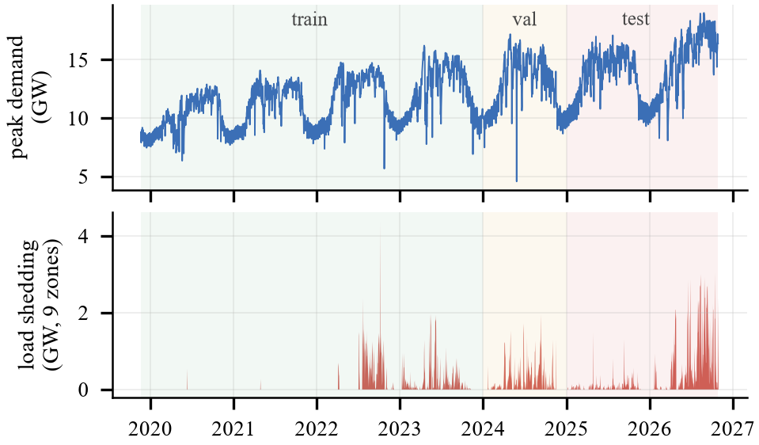
Fig. 1. Daily peak demand (top) and total load shedding of the nine zones (bottom), with the train (≤ 2023), validation (2024) and test (2025–2026) periods shaded.
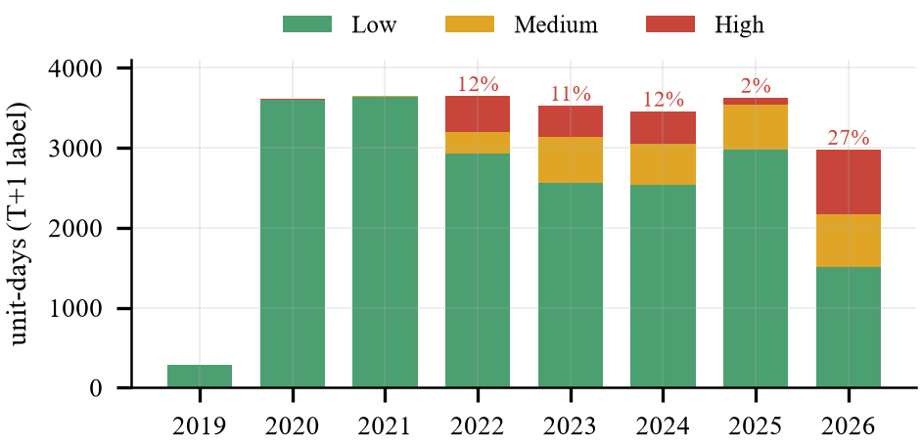
Fig. 2. Risk classes per year (T+1 label, all ten units). The percentage is the share of High-risk unit-days.
D. Samples and leakage control
Each sample is a 14-day window ending on day t for one unit, with labels at t+1 and t+3. Inputs may be forward-filled from the past for at most three days, a window needs at least 70% really observed days, and labels are never filled. Scaling statistics and thresholds use training rows only, and a sample belongs to train, validation or test according to the date of its T+3 target, so no target crosses a split boundary (Table II). An automated test suite checks the split boundaries, recomputes 300 random labels from the raw file and, most importantly, multiplies every value after the validation period by random factors: all training and validation features, labels and thresholds must stay identical, which proves that no future information leaks into training.
Table II
Chronological split (10 units)
Split | Sample dates | Samples | High (T+1)
Train | 2019-12-04 → 2023-12-28 | 14,770 | 5.8%
Validation | 2023-12-29 → 2024-12-28 | 3,480 | 12.0%
Test | 2024-12-29 → 2026-10-27 | 6,660 | 13.5%

IV. Methodology
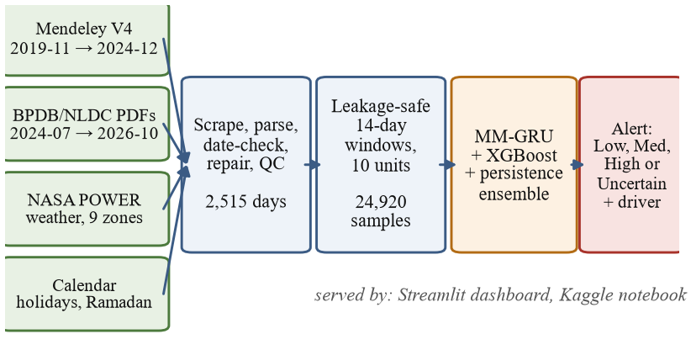
Fig. 3. End-to-end workflow: four data sources are parsed and checked, turned into leakage-safe windows, scored by the models and delivered as alerts through a dashboard and a notebook.
A. Modality encoders
Each window is split into three modalities (Table III). The grid sequence (14 × 13: unit demand, supply, shedding, gap and their ratios, plus national generation figures, reserve margin and national shedding ratio) and the weather sequence (14 × 7: Dhaka maximum temperature, its 3-day mean and change, and NASA temperature, humidity and rainfall) are each encoded by a one-layer GRU [6] with 48 hidden units; the last hidden state is layer-normalized [25]. The context encoder embeds the zone (8-d; id 0 is reserved for an unseen zone), the weekday of t+1 and t+3 (4-d), the month (4-d) and the holiday class of the target days (3-d), concatenates twelve numeric inputs (fuel limitations and Ramadan, Eid and weekend flags for the target days—known in advance, so not leakage) and maps them through a 48-unit ReLU layer. Each embedding is projected to z_{m} ∈ ℝ⁴⁸.
Table III
Inputs per modality
Modality | Features
Grid (14 × 13) | unit demand, supply, shed, shed>0, gap, gap ratio, shed ratio; national max demand, evening-peak, highest and minimum generation, reserve margin, national shed ratio
Weather (14 × 7) | Dhaka max temp., 3-day mean, daily change; NASA T2M, RH2M, rain, 3-day rain
Context | embeddings: zone, weekday (t+1, t+3), month, holiday class (t+1, t+3); numeric: gas, coal, water, maintenance, 7-day gas mean, Ramadan / Eid / weekend flags

B. Attention fusion and multi-task heads
For each horizon h ∈ {1, 3} a separate attention layer scores the three modality embeddings:
$α_{m}^{\left(h\right)}=\frac{\exp\left(w_{h}^{⊤}\tanh{z_{m}}+b_{h}\right)}{\sum_{k=1}^{3}{}\exp\left(w_{h}^{⊤}\tanh{z_{k}}+b_{h}\right)}$ (2)
$v^{\left(h\right)}=\sum_{m=1}^{3}{}α_{m}^{\left(h\right)}z_{m}$ (3)
Because the weights sum to one, α_{m}^{(h)} can be read as modality m’s share of that decision, and the modality with the largest weight is reported as the alert’s main driver. Each fused vector feeds its own head (dropout 0.2, a 48-unit ReLU layer, three logits), so one network learns both horizons [14]. The model has only 31,780 parameters (Fig. 4).
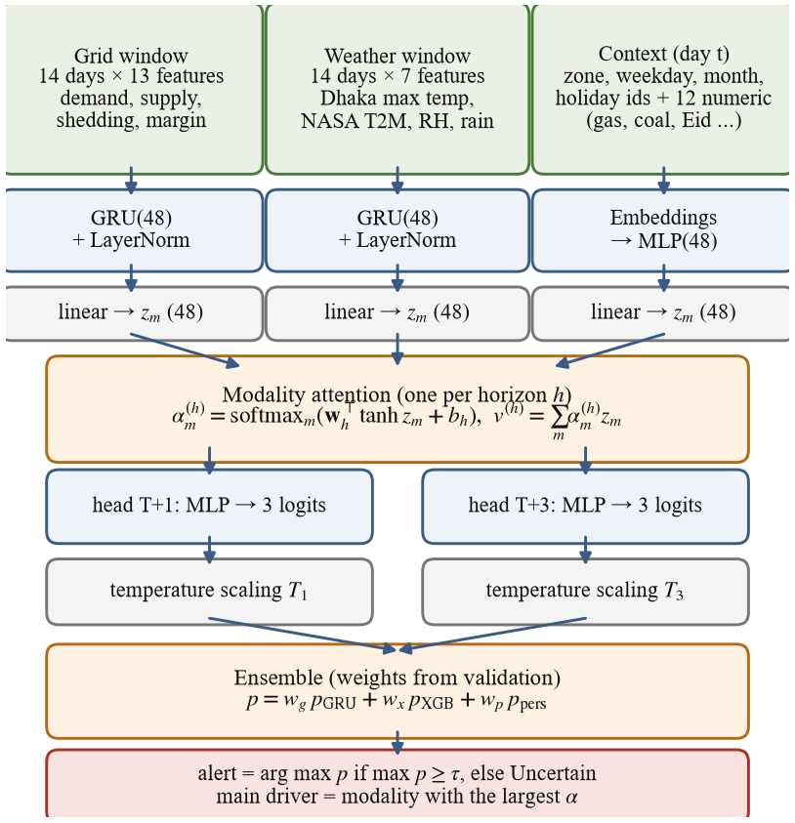
Fig. 4. Multimodal GRU with one modality-attention layer per horizon, followed by temperature scaling, the validation-tuned ensemble and the abstain rule.
C. Training
High-risk days are rare in the training years (Table II), so each horizon uses a class-weighted cross-entropy with w_{c} = N / (3n_{c}) (normalized to mean 1), and the two heads are trained jointly:
$L=-\sum_{h∈\left\{1,3\right\}}{\frac{1}{N}\sum_{i=1}^{N}{w_{y_{i}}^{\left(h\right)}\log{p_{θ}^{\left(h\right)}\left(y_{i} | x_{i}\right)}}}$ (4)
We use AdamW [26] (learning rate 2·10⁻³, weight decay 10⁻⁴), batches of 128, gradient clipping at 1.0 and at most 30 epochs with early stopping (patience 6) on validation macro-F1. Every neural result is the mean of three seeds (42, 43, 44). Training is deterministic on CPU: retraining seed 42 reproduces the saved test logits to within 6·10⁻⁶, and one model trains in about 90 s on a laptop CPU.
D. Calibration and abstention
A single temperature T_{h} per horizon is fitted on validation data by minimizing the negative log-likelihood [15]:
${\hat{p}}^{\left(h\right)}=\text{softmax}\left(\frac{z^{\left(h\right)}}{T_{h}}\right)$ (5)
Calibration is measured with the expected calibration error over B = 15 confidence bins [17],
$\text{ECE}=\sum_{b=1}^{B}{\frac{\left|B_{b}\right|}{N}\left|\text{acc}\left(B_{b}\right)-\text{conf}\left(B_{b}\right)\right|}$ (6)
and the system abstains when the top probability is below a threshold τ. τ is the value in [0.34, 0.96] with the best validation macro-F1 on answered samples, subject to answering at least 70% of validation samples:
$ŷ=\left\{\begin{matrix}\arg{\max_{c}{p_{c}}} & \text{if }\max_{c}{p_{c}}≥τ \\ \text{Uncertain} & \text{otherwise}\end{matrix}\right.$ (7)
E. Baselines and ensemble
Persistence predicts that the risk at t+h equals the risk at t. The BPDB rule is a depth-2 decision tree on BPDB’s published generation forecast and the reserve margin; because the forecast column is missing after 2024, in the final setting it uses the reserve margin only. Logistic regression, a random forest [27] and XGBoost [28] use a flat version of the same window (107 features: last value and 3-, 7- and 14-day means of every sequence feature, the context inputs and one-hot zone) with balanced class weights; XGBoost uses early stopping on validation. The final system blends three members,
$p=w_{g}p_{\text{GRU}}+w_{x}p_{\text{XGB}}+w_{p}p_{\text{pers}}$ (8)
with weights chosen by grid search (step 0.1) on validation macro-F1 using models trained on the training years only: (w_{g}, w_{x}, w_{p}) = (0.1, 0.6, 0.3) at T+1 and (0.3, 0.5, 0.2) at T+3. Explanations come from TreeSHAP on XGBoost [20], the attention weights and the ablations.
V. Experimental Setup
A. Metrics
Because 68–88% of unit-days are Low, accuracy is misleading; macro-F1 over the three classes is the main metric [29]. For the alert view we report High-class recall and precision, missed High days (true High not flagged High) and false alarms (flagged High, not High). Ranking quality is measured threshold-free by the area under the precision–recall curve (PR-AUC, per class and macro), which is more informative than ROC on imbalanced data [30]; calibration by ECE and Brier score; abstention by coverage.
B. Protocol
Following out-of-sample practice for time series [31], [32], every choice—early stopping, temperature, τ and ensemble weights—is made on validation data, and the test period is used once. In the refit setting, GRU and XGBoost are re-trained on the training years plus validation data up to 27 September 2024, and the last validation months (October–December 2024) are kept for early stopping, temperature and τ; the ensemble weights stay fixed. The deployed model is refitted on all labelled data (last 90 days held out for early stopping) and produces the live alert; by construction it cannot be tested.
C. Lab experiments
• PR-AUC of all train-only models on the test period.
• Fusion ablation: the attention layer is replaced by concatenation of the three embeddings and a 48-unit ReLU layer (same heads, same training), three seeds.
• Task ablation: two single-task networks, each trained and early-stopped on one horizon only, three seeds.
• Walk-forward validation: for each test year Y ∈ {2023, …, 2026} the whole dataset is rebuilt with training until 30 September of Y−1 (so thresholds and scaling are refitted), the last quarter of Y−1 is the validation set and year Y is the test set. Persistence, XGBoost, the GRU (three seeds), an untuned 50/50 GRU–XGBoost average and the GRU–XGBoost–persistence ensemble (weights grid-searched on that fold’s validation quarter) are compared.
All code runs on Python 3.13 with PyTorch 2.15 (CPU), scikit-learn 1.9, XGBoost 3.4 and SHAP 0.54.
VI. Results
A. Main comparison on 2025–2026
Table IV
Test results, all ten units pooled
Model | F1 T+1 | F1 T+3 | Rec. High | Prec. High | Missed High | False alarms
Persistence | 0.701 | 0.606 | 0.69 | 0.69 | 279 | 279
BPDB rule | 0.530 | 0.474 | 0.81 | 0.46 | 175 | 836
Logistic reg. | 0.442 | 0.336 | 0.86 | 0.35 | 128 | 1420
Random forest | 0.643 | 0.451 | 0.60 | 0.65 | 357 | 297
XGBoost | 0.620 | 0.495 | 0.53 | 0.66 | 425 | 246
MM-GRU | 0.623 | 0.512 | 0.77 | 0.49 | 206 | 731
Ensemble | 0.701 | 0.611 | 0.68 | 0.71 | 289 | 254
XGBoost (refit) | 0.634 | 0.565 | 0.79 | 0.58 | 190 | 508
MM-GRU (refit) | 0.642 | 0.550 | 0.80 | 0.56 | 178 | 576
Ensemble (refit) | 0.701 | 0.619 | 0.70 | 0.69 | 269 | 286
Ens. + abstain* | 0.786 | 0.720 | 0.88 | 0.73 | 74 | 213
F1 = macro-F1; recall, precision, missed High days and false alarms at T+1. Neural rows: 3-seed average. *Scored on the answered unit-days only (coverage 61.6% at T+1, 59.9% at T+3).

Table IV and Fig. 5 summarize the test period. Persistence is a very strong baseline (macro-F1 0.701 at T+1) because risk carries over from day to day; the BPDB reserve-margin rule reaches only 0.530. On its own the multimodal GRU does not beat persistence (0.623), but it catches more High-risk days (recall 0.77 vs 0.69) at the cost of more false alarms. Re-fitting on recent data helps both XGBoost and the GRU: the GRU improves from 0.623 to 0.642 at T+1 and from 0.512 to 0.550 at T+3. The validation-tuned ensemble ties persistence at T+1 (0.701 vs 0.701) and beats it at T+3 (0.619 vs 0.606), with fewer missed High days than persistence at T+1 (269 vs 279). By year, the ensemble scores 0.638 in the calm year 2025 and 0.678 in the crisis year 2026 (persistence: 0.644 and 0.673).
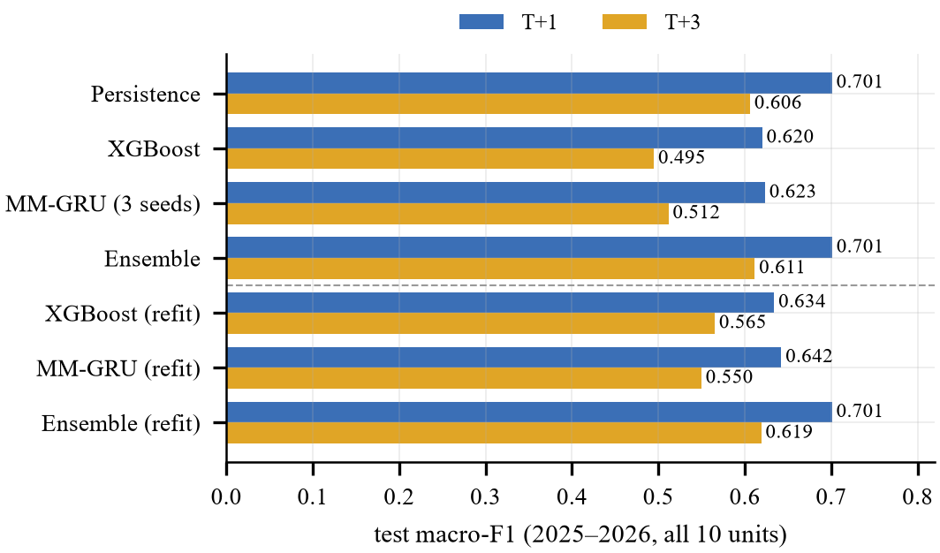
Fig. 5. Test macro-F1 of the main models at both horizons (2025–2026). Rows below the dashed line are refitted on recent data.
B. Ranking quality (PR-AUC)
Macro-F1 judges only the arg-max decision. PR-AUC asks whether the model ranks risky days above safe ones, which is what an operator needs to set a custom alarm threshold. Here the picture changes (Table V, Fig. 6): every model trained on the full feature set (logistic regression, random forest, XGBoost, the GRU and the ensemble) clearly beats persistence, whose one-hot output cannot rank days; only the two-feature BPDB rule falls below it. The ensemble has the best macro PR-AUC at both horizons (0.734 and 0.627 vs 0.582 and 0.490 for persistence), and among single models the GRU has the best High-class PR-AUC at T+1 (0.674) and T+3 (0.457); a random ranking would score 0.135.
Table V
PR-AUC on the test period (train-only models)
Model | Macro T+1 | High T+1 | Macro T+3 | High T+3
Persistence | 0.582 | 0.518 | 0.490 | 0.372
BPDB rule | 0.506 | 0.414 | 0.457 | 0.335
Logistic reg. | 0.624 | 0.642 | 0.542 | 0.437
Random forest | 0.689 | 0.668 | 0.571 | 0.442
XGBoost | 0.702 | 0.671 | 0.573 | 0.438
MM-GRU | 0.679 | 0.674 | 0.562 | 0.457
Ensemble | 0.734 | 0.720 | 0.627 | 0.561

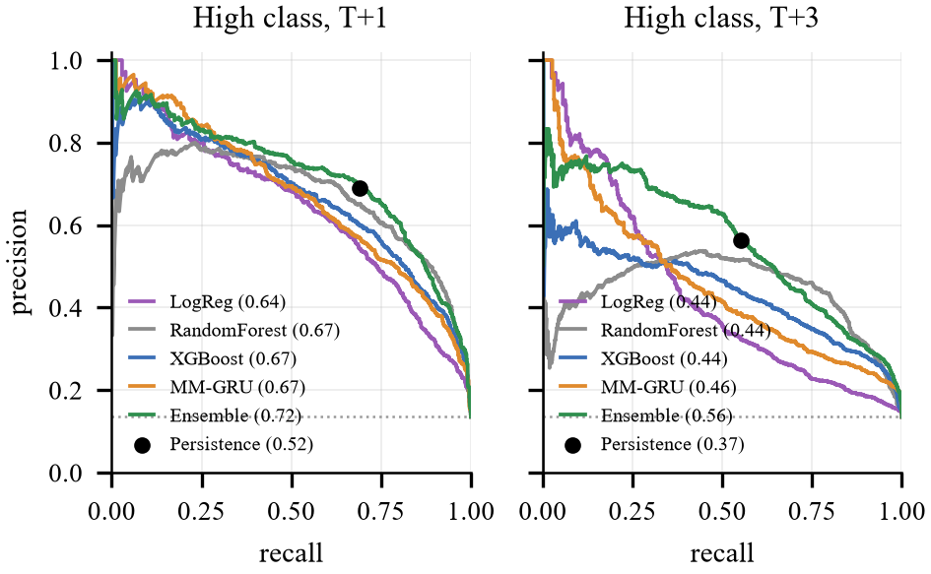
Fig. 6. Precision–recall curves for the High class (AP in brackets). Persistence gives a single operating point; the dotted line is the share of High days.
C. Calibration and abstention
Before scaling, the GRU is over-confident (ECE 0.123 at T+1, 0.184 at T+3). One temperature per horizon reduces the ECE to 0.040 and 0.061 and the Brier score from 0.458 to 0.424 (Fig. 7). Abstention turns this calibration into a trade-off the operator can control (Fig. 8): with τ = 0.66 the refitted ensemble answers 61.6% of unit-days at T+1, and on those its macro-F1 rises to 0.786 and its High recall to 0.88; at T+3 the values are 59.9%, 0.720 and 0.84. Because the ensemble mixes in persistence’s one-hot vote, its ECE (0.076) is higher than the calibrated GRU’s; its probabilities are best read as scores for ranking and abstaining.
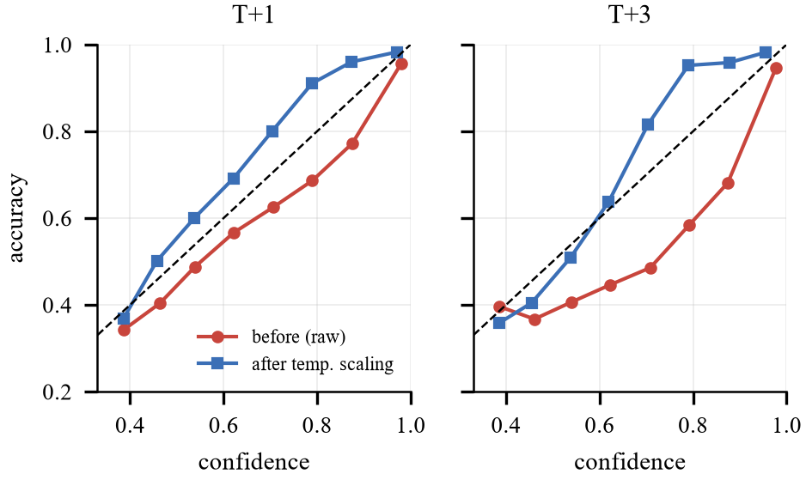
Fig. 7. Reliability diagrams of the GRU (3-seed average, test period) before and after temperature scaling.
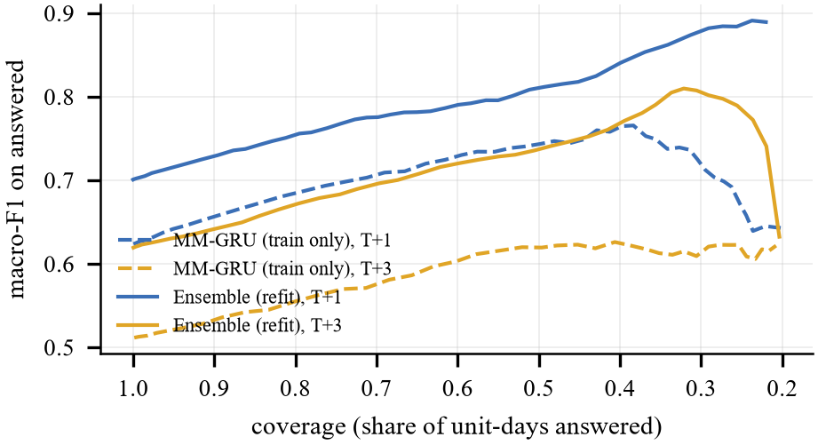
Fig. 8. Abstain trade-off: macro-F1 on the answered unit-days as the confidence threshold rises (coverage falls).
D. Error analysis
Fig. 9 shows where the refitted ensemble errs. 86.4% of its T+1 errors are between neighbouring classes (Low↔Medium or Medium↔High). The costly severe misses (true High predicted Low) are 93 of 899 High unit-days at T+1 and 165 of 894 at T+3; every one of them happens when the unit’s risk on day t is still Low, i.e. at the start of a shedding episode, when the last 14 days look calm. This is the basic limit of a model that sees only the past two weeks, and the reason persistence is hard to beat.
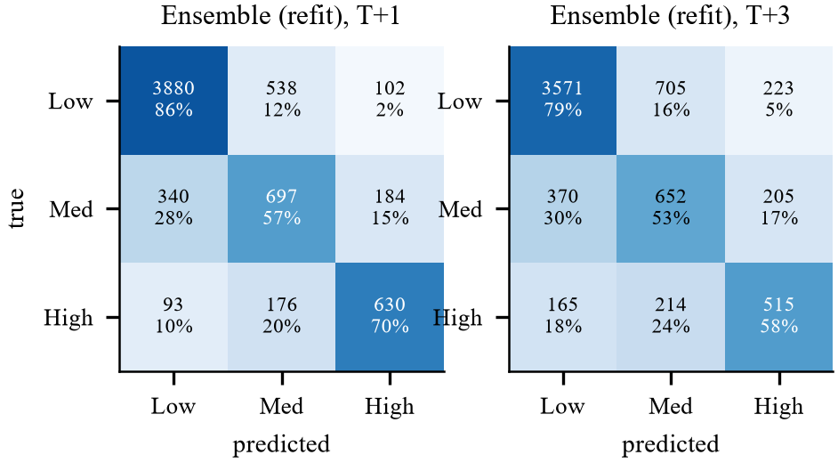
Fig. 9. Confusion matrices of the refitted ensemble on 2025–2026 (counts and row percentages).
E. Which modality matters?
Single-modality and drop-one models (Fig. 10) show that the grid carries most of the signal: grid only reaches 0.598 at T+1 (full model 0.582), weather only 0.435 and context only 0.396; removing the grid costs the most (0.477), removing weather the least (0.575). SHAP on XGBoost agrees: the grid holds 65.2% of the attribution for the High class, context 18.8% and weather 16.0%, led by the recent national shedding ratio, the weekday of the target day, the reserve margin and maximum demand (Fig. 11). The attention weights, however, favour context (0.53 at T+1, 0.61 at T+3) over grid (0.35, 0.29) and weather (0.12, 0.10). Attention shows where the network routes information, not how much a modality adds to accuracy [21], so our conclusions on importance rest on ablation and SHAP.
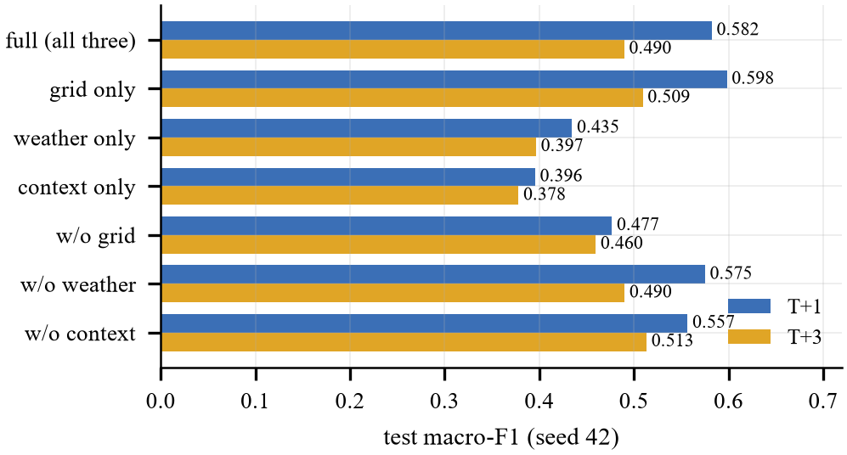
Fig. 10. Modality ablation (GRU, seed 42, test macro-F1).
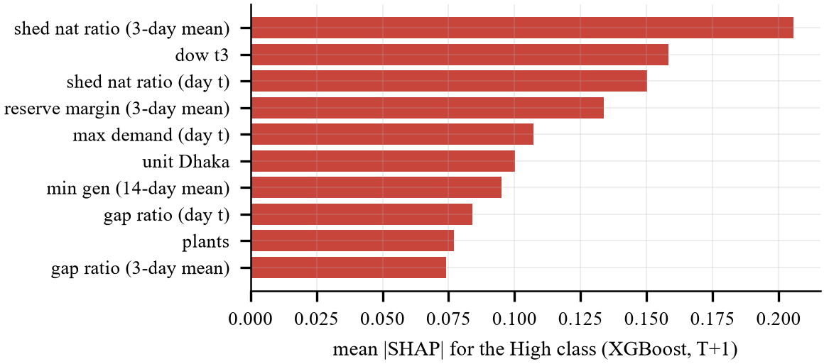
Fig. 11. Top ten XGBoost features for the High class at T+1 (mean |SHAP|).
F. Lab ablations: fusion type and multi-task learning
Table VI
Fusion and task ablations (test, 3 seeds)
Variant | F1 T+1 | F1 T+3 | PR High T+1 | PR High T+3
Attention, multi-task | 0.593 ± 0.046 | 0.499 ± 0.011 | 0.645 | 0.437
Concat., multi-task | 0.596 ± 0.038 | 0.516 ± 0.010 | 0.648 | 0.478
Attention, single-task | 0.606 ± 0.025 | 0.513 ± 0.002 | 0.684 | 0.411

Table VI and Fig. 12 compare the proposed network with two variants trained identically (three seeds each). Replacing attention by concatenation gives a macro-F1 of 0.596 vs 0.593 at T+1 and 0.516 vs 0.499 at T+3; two single-task networks give 0.606 and 0.513. All gaps (at most 0.017 for fusion and 0.015 for multi-task) are of the same size as the seed-to-seed standard deviation of the proposed model (0.046 at T+1), and the High-class PR-AUC shows no consistent winner either (0.645, 0.648 and 0.684 at T+1). With this amount of data, neither learned attention nor sharing one network across horizons improves accuracy measurably. We keep both for practical reasons: attention yields the per-alert main driver at no cost in accuracy, and one multi-task network halves training and deployment effort. This negative result is itself informative—it suggests the remaining errors stem from the data (regime shifts, late reports) rather than from the fusion mechanism.
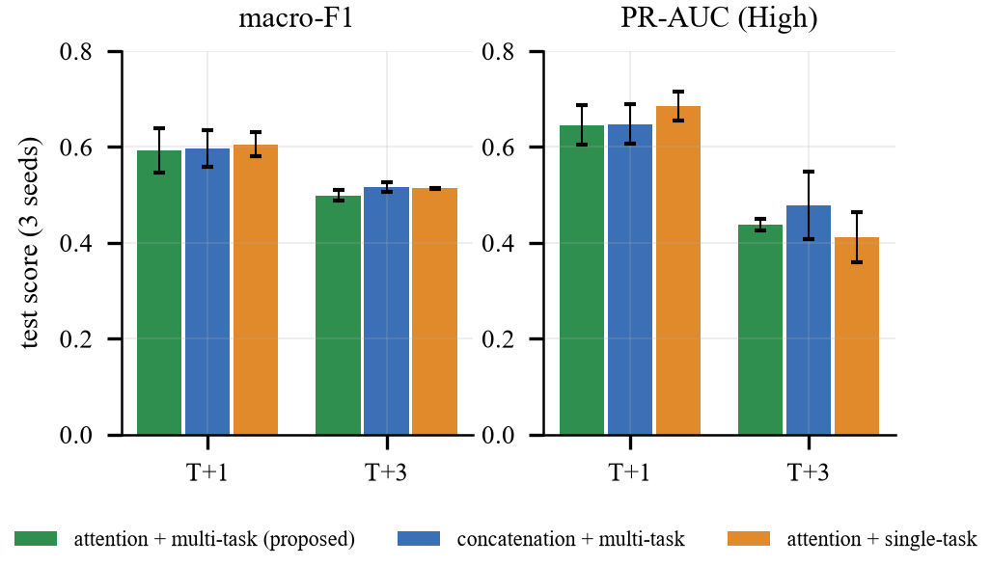
Fig. 12. Lab ablations: macro-F1 and High-class PR-AUC (mean ± std over three seeds).
G. Walk-forward validation
Table VII
Walk-forward macro-F1 (train on all earlier data)
h | Model | 2023 | 2024 | 2025 | 2026 | Mean
T+1 | Persistence | 0.623 | 0.689 | 0.641 | 0.671 | 0.656
T+1 | XGBoost | 0.484 | 0.615 | 0.537 | 0.640 | 0.569
T+1 | MM-GRU | 0.510 | 0.600 | 0.482 | 0.642 | 0.558
T+1 | GRU+XGB 50/50 | 0.524 | 0.621 | 0.532 | 0.652 | 0.582
T+1 | Ensemble* | 0.566 | 0.618 | 0.628 | 0.691 | 0.626
T+3 | Persistence | 0.545 | 0.570 | 0.532 | 0.590 | 0.559
T+3 | XGBoost | 0.396 | 0.521 | 0.441 | 0.565 | 0.481
T+3 | MM-GRU | 0.462 | 0.525 | 0.418 | 0.565 | 0.492
T+3 | GRU+XGB 50/50 | 0.428 | 0.541 | 0.435 | 0.582 | 0.496
T+3 | Ensemble* | 0.448 | 0.542 | 0.527 | 0.608 | 0.531
*GRU + XGBoost + persistence, weights grid-searched on each fold’s own validation quarter. 2026 = January–October.

Table VII and Fig. 13 repeat the whole procedure four times, each time training on all years before the test year. On macro-F1, persistence is the best choice on average (T+1 mean 0.656, against 0.626 for the validation-tuned ensemble, 0.582 for the GRU–XGBoost average and 0.558 for the GRU alone). The learned models, however, catch up as the shedding history grows: the ensemble’s gap to persistence at T+1 moves from −0.057 (2023) and −0.071 (2024) to −0.012 (2025) and becomes a lead of +0.019 in 2026 (+0.017 at T+3). The 2023 fold learns from only 10,260 samples with nine months of shedding history, and its re-estimated thresholds (8.8% for zones, 4.1% national) differ from those of later folds; the test years contain between 89 and 894 High unit-days. On ranking the picture is much clearer: the GRU, the GRU–XGBoost average and the validation-tuned ensemble have a higher macro PR-AUC than persistence in all eight fold–horizon cases (XGBoost in 7 of 8) (ensemble 0.579–0.740 vs persistence 0.497–0.568 at T+1). Two lessons follow: the advantage of learning grows with the length of the high-shedding history, and a deployed system must be retrained regularly and monitored with walk-forward checks.
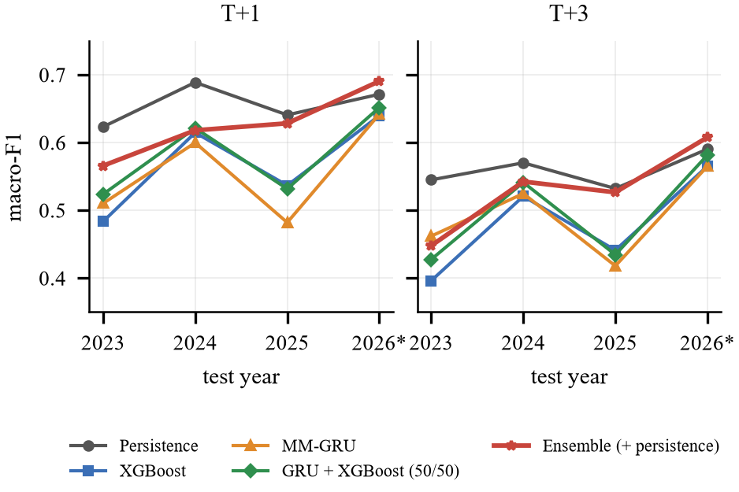
Fig. 13. Walk-forward macro-F1 per test year (2026: January–October).
H. Generalization to unseen divisions
In the leave-one-division-out test, a zone is removed from training together with the national series (which contains it), and the model is evaluated on that zone with the unknown-zone embedding. The GRU’s mean macro-F1 over the nine zones changes only from 0.514 to 0.500 at T+1 and from 0.420 to 0.399 at T+3, while XGBoost goes from 0.525 to 0.535 (Fig. 14). Both models transfer reasonably to a zone they have never seen, which matters for zones with short histories. Per-zone numbers are noisy: Dhaka has only 22 High-risk days in the test period, Mymensingh 210.
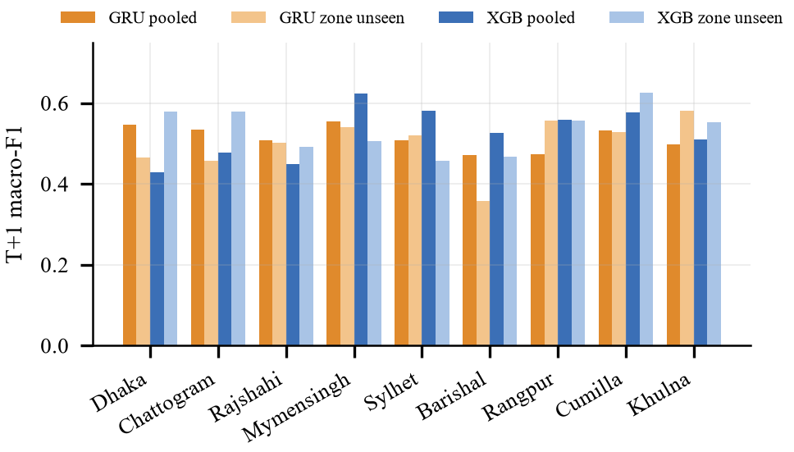
Fig. 14. Leave-one-division-out vs. pooled training (T+1 macro-F1 per zone).
I. Deployed system
The deployed ensemble is refitted on all labelled data. Using reports up to 2026-10-28, it puts the national grid at High risk for 2026-10-29 (confidence 0.63) and High for 2026-10-31 (0.52); Table VIII lists all units. Units below the abstain threshold are shown as Uncertain with their best guess. The same models drive a public Streamlit dashboard with a live alert page, a time machine that re-runs the saved GRUs on any past day and compares them with what happened, and a what-if simulator in which a user edits today’s demand, supply, shedding, gas shortage or temperature and the GRU (re-implemented in NumPy, so no deep-learning library is needed) recomputes the risk instantly. A Kaggle notebook reruns the full pipeline from the public repository.
Table VIII
Live alert issued on 2026-10-28
Unit | T+1 (2026-10-29) | T+3 (2026-10-31) | Driver
National | High (0.63) | High (0.52) | grid
Dhaka | Medium (0.73) | Medium (0.64) | context
Chattogram | Medium (0.56) | Medium (0.49) | context
Rajshahi | Medium (0.57) | Uncertain → Medium (0.46) | context
Mymensingh | Uncertain → Medium (0.54) | Uncertain → Medium (0.46) | context
Sylhet | Medium (0.58) | Medium (0.49) | context
Barishal | Uncertain → Medium (0.49) | Uncertain → Medium (0.43) | context
Rangpur | Medium (0.57) | Uncertain → Medium (0.47) | context
Cumilla | Medium (0.57) | Medium (0.50) | grid
Khulna | Uncertain → Medium (0.51) | Uncertain → Medium (0.46) | context

VII. Discussion and Limitations
• Persistence is hard to beat on macro-F1. The ensemble ties it at T+1 and is only slightly ahead at T+3, and in the walk-forward evaluation persistence stays best on average, with the ensemble overtaking it only in 2026. The added value lies in ranking (the ensemble’s PR-AUC is higher in every fold), calibrated confidence, abstention, earlier detection of High days by the GRU and explanations per unit—not in raw accuracy.
• Architecture choices matter less than data. Attention vs. concatenation and multi-task vs. single-task change macro-F1 by less than the seed-to-seed spread; more (and more recent) shedding history helps much more.
• Distribution shift. High-risk days were almost absent before 2022 and rose from 2.4% of unit-days in 2025 to 27.2% in 2026; models trained on calmer years over-warn in calm years and under-warn at the start of crises, and a threshold set on the training years may mean something different later.
• Label definition. The Medium/High boundary is data-driven (median ratio); another threshold would give other classes and other scores.
• Data quality and latency. V4 contains interpolated values, 49 demand cells are rebuilt, 19 report days are missing, BPDB’s forecast column vanished after 2024, NASA weather arrives 3–5 days late and the 2025–26 Ramadan/Eid dates are approximate. BPDB reports are published days late, so an operational system needs same-day data from the grid operator.
• Reporting bias and ethics. Only shedding reported at zone level is visible; local outages are not. A Low alert can be wrong, so Uncertain outputs must stay visible, error rates should be audited per zone, and public alerts should carry their confidence to avoid panic or speculation.
VIII. Conclusion and Future Work
We built and evaluated a multimodal early-warning system that issues Low/Medium/High load-shedding alerts one and three days ahead for Bangladesh’s national grid and nine zones, on data extended to October 2026. The validation-tuned ensemble of a multimodal GRU, XGBoost and persistence ties persistence at T+1, beats it at T+3, ranks risky days much better (macro PR-AUC 0.734 vs 0.582), is calibrated, and reaches a macro-F1 of 0.79 (T+1) and 0.72 (T+3) on the days it answers. Grid data carry most of the signal, and the models transfer reasonably to unseen divisions. The lab experiments add three lessons: learned attention and multi-task learning do not change accuracy measurably; the ensemble ranks risk better than persistence in every walk-forward year; and its macro-F1 relative to persistence improves with the length of the shedding history, overtaking persistence only in 2026. Future work: same-day grid feeds, weather forecasts instead of reanalysis, ordinal and cost-sensitive losses that penalize severe misses, regular walk-forward retraining, and a longer history of the current high-shedding period.
Code and Data Availability
Code, data, trained models, the Streamlit dashboard and the Kaggle notebook are in the project’s public GitHub repository (link in repo.txt).
References
[1] F. Khatun, M. Rahman, K. G. Moazzem, M. Kamal, and S. Y. Saadat, “Power and energy crisis in Bangladesh,” The Financial Express, Dhaka, May 2025. [Online]. Available: https://thefinancialexpress.com.bd/views/power-and-energy-crisis-in-bangladesh
[2] T. Hong, P. Pinson, Y. Wang, R. Weron, D. Yang, and H. Zareipour, “Energy forecasting: A review and outlook,” IEEE Open Access J. Power Energy, vol. 7, pp. 376–388, 2020.
[3] M. I. Hossain, T. Nafs, S. Yeaser, and A. Newaz, “Multi-year dataset on daily electricity demand, generation, load shedding, and external conditions in Bangladesh,” Data in Brief, vol. 62, Art. no. 112014, 2025.
[4] Bangladesh Power Development Board, “Daily generation archive.” [Online]. Available: https://misc.bpdb.gov.bd/daily-generation-archive (accessed Oct. 2026).
[5] B. Lim and S. Zohren, “Time-series forecasting with deep learning: A survey,” Phil. Trans. R. Soc. A, vol. 379, no. 2194, Art. no. 20200209, 2021.
[6] K. Cho, B. van Merriënboer, C. Gulcehre, D. Bahdanau, F. Bougares, H. Schwenk, and Y. Bengio, “Learning phrase representations using RNN encoder–decoder for statistical machine translation,” in Proc. EMNLP, 2014, pp. 1724–1734.
[7] H. Hewamalage, C. Bergmeir, and K. Bandara, “Recurrent neural networks for time series forecasting: Current status and future directions,” Int. J. Forecast., vol. 37, no. 1, pp. 388–427, 2021.
[8] K. Roy, A. Ishmam, and K. A. Taher, “Demand forecasting in smart grid using long short-term memory,” in Proc. Int. Conf. Automation, Control and Mechatronics for Industry 4.0 (ACMI), Rajshahi, Bangladesh, 2021.
[9] K. F. B. Akhter, S. Mobasshira, S. N. Haque, M. A. K. Hesham, and T. Ahmed, “Short-term electricity demand forecasting of Dhaka city using CNN with stacked BiLSTM,” arXiv:2406.06651, 2024.
[10] M. T. Islam, S. A. Turja, and A. Habib, “Enhanced power demand forecasting for Bangladesh: Using feature engineering associated with environmental and economic impact,” J. Data, Inf. Manag., vol. 7, pp. 1–19, 2025.
[11] P. P. Liang, A. Zadeh, and L.-P. Morency, “Foundations & trends in multimodal machine learning: Principles, challenges, and open questions,” ACM Comput. Surv., vol. 56, no. 10, pp. 1–42, 2024.
[12] D. Bahdanau, K. Cho, and Y. Bengio, “Neural machine translation by jointly learning to align and translate,” in Proc. ICLR, 2015.
[13] B. Lim, S. Ö. Arık, N. Loeff, and T. Pfister, “Temporal fusion transformers for interpretable multi-horizon time series forecasting,” Int. J. Forecast., vol. 37, no. 4, pp. 1748–1764, 2021.
[14] R. Caruana, “Multitask learning,” Mach. Learn., vol. 28, no. 1, pp. 41–75, 1997.
[15] C. Guo, G. Pleiss, Y. Sun, and K. Q. Weinberger, “On calibration of modern neural networks,” in Proc. ICML, 2017, pp. 1321–1330.
[16] M. Minderer, J. Djolonga, R. Romijnders, F. Hubis, X. Zhai, N. Houlsby, D. Tran, and M. Lucic, “Revisiting the calibration of modern neural networks,” in Proc. NeurIPS, vol. 34, 2021.
[17] T. Silva Filho, H. Song, M. Perelló-Nieto, R. Santos-Rodriguez, M. Kull, and P. Flach, “Classifier calibration: A survey on how to assess and improve predicted class probabilities,” Mach. Learn., vol. 112, no. 9, pp. 3211–3260, 2023.
[18] Y. Geifman and R. El-Yaniv, “Selective classification for deep neural networks,” in Proc. NeurIPS, 2017, pp. 4878–4887.
[19] K. Hendrickx, L. Perini, D. Van der Plas, W. Meert, and J. Davis, “Machine learning with a reject option: A survey,” Mach. Learn., vol. 113, no. 5, pp. 3073–3110, 2024.
[20] S. M. Lundberg, G. Erion, H. Chen, A. DeGrave, J. M. Prutkin, B. Nair, R. Katz, J. Himmelfarb, N. Bansal, and S.-I. Lee, “From local explanations to global understanding with explainable AI for trees,” Nat. Mach. Intell., vol. 2, no. 1, pp. 56–67, 2020.
[21] S. Jain and B. C. Wallace, “Attention is not explanation,” in Proc. NAACL-HLT, 2019, pp. 3543–3556.
[22] R. Shwartz-Ziv and A. Armon, “Tabular data: Deep learning is not all you need,” Inf. Fusion, vol. 81, pp. 84–90, 2022.
[23] L. Grinsztajn, E. Oyallon, and G. Varoquaux, “Why do tree-based models still outperform deep learning on typical tabular data?” in Proc. NeurIPS Datasets and Benchmarks Track, vol. 35, 2022.
[24] NASA Langley Research Center, “Prediction Of Worldwide Energy Resources (POWER) project.” [Online]. Available: https://power.larc.nasa.gov/ (accessed Oct. 2026).
[25] J. L. Ba, J. R. Kiros, and G. E. Hinton, “Layer normalization,” arXiv:1607.06450, 2016.
[26] I. Loshchilov and F. Hutter, “Decoupled weight decay regularization,” in Proc. ICLR, 2019.
[27] L. Breiman, “Random forests,” Mach. Learn., vol. 45, no. 1, pp. 5–32, 2001.
[28] T. Chen and C. Guestrin, “XGBoost: A scalable tree boosting system,” in Proc. 22nd ACM SIGKDD Int. Conf. Knowledge Discovery and Data Mining, 2016, pp. 785–794.
[29] M. Grandini, E. Bagli, and G. Visani, “Metrics for multi-class classification: An overview,” arXiv:2008.05756, 2020.
[30] T. Saito and M. Rehmsmeier, “The precision-recall plot is more informative than the ROC plot when evaluating binary classifiers on imbalanced datasets,” PLoS ONE, vol. 10, no. 3, Art. no. e0118432, 2015.
[31] L. J. Tashman, “Out-of-sample tests of forecasting accuracy: An analysis and review,” Int. J. Forecast., vol. 16, no. 4, pp. 437–450, 2000.
[32] V. Cerqueira, L. Torgo, and I. Mozetič, “Evaluating time series forecasting models: An empirical study on performance estimation methods,” Mach. Learn., vol. 109, no. 11, pp. 1997–2028, 2020.

