**Tool-chain setting for pthread debugging support**

* Install kernel headers to RSDK
  + *$ cd {sdk_kernel_directory}*
  + *$ make ARCH=rlx headers_install INSTALL_HDR_PATH=/tmp*
  + *$ cp -r /tmp/include/* {rsdk}/config/kernel*
* Enable ‘General Library Settings > Build pthreads debugging support’
  + *$ cd {rsdk}/bin/*
  + *$ ./rsdk-linux-config*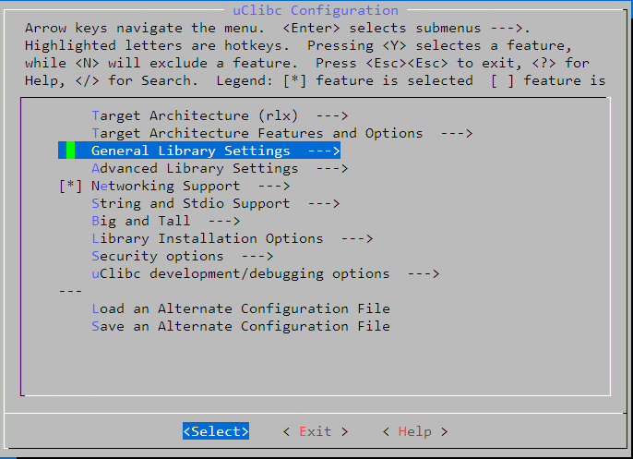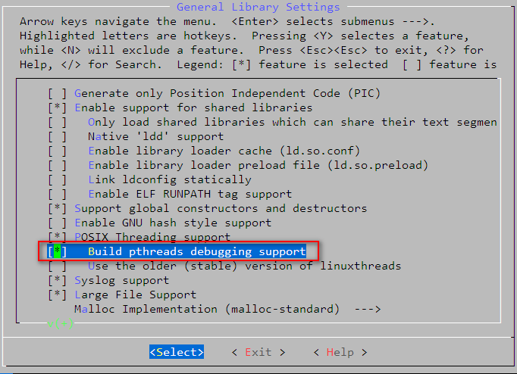
* Remove kernel header folder to fit various sdk kernel sources
  + *$ rm -rf {rsdk}/config/kernel*

Note: If you want to process *rsdk-linux-config*, you should install kernel headers to RSDK first.