Name: Cheng Anzhe(程安哲) Class: ZM1802

****Student ID: 2018214934 NAU ID: 5771734

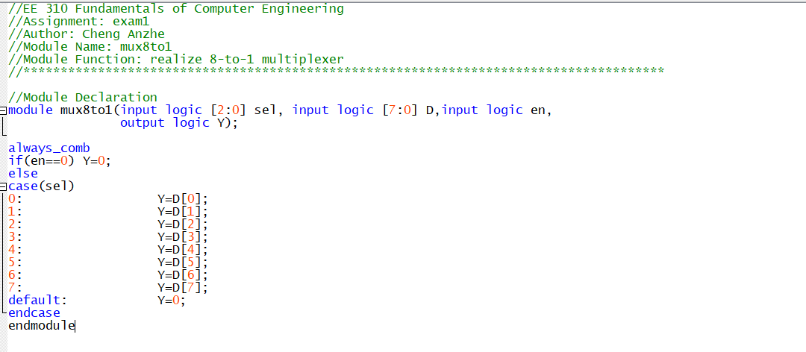

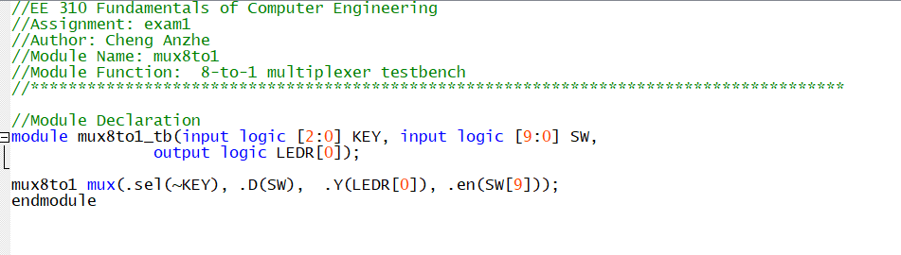

**Do file**

**force D 8'b10011101;**

**force en 0 20ns**

**force en 1 380ns**

**force sel(0) 0 0ns, 1 50ns -r 100ns;**

**force sel(1) 0 0ns, 1 100ns -r 200ns;**

**force sel(2) 0 0ns, 1 200ns -r 400ns;**

**run 400ns;**