**Exam2**

**1.SV for the 5-to-1 16-bit bus Mux**

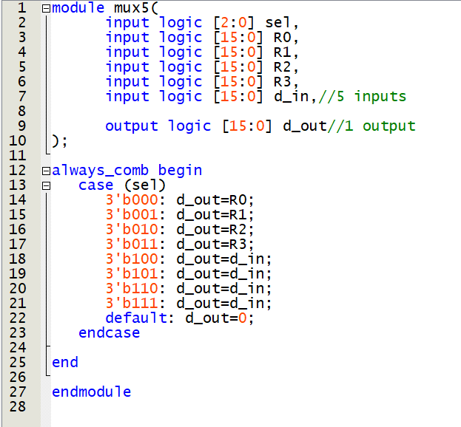

**2.SV code for the 16-bit register**

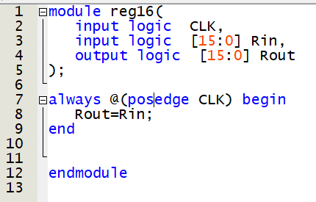

**3.SV code for the 16-bit ALU**

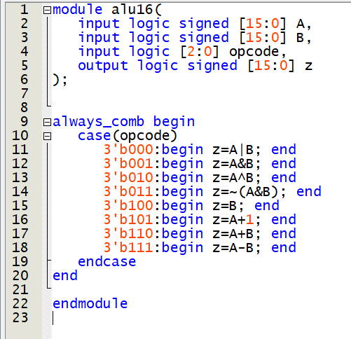

**4.ModelSim do file for part Ⅲ**

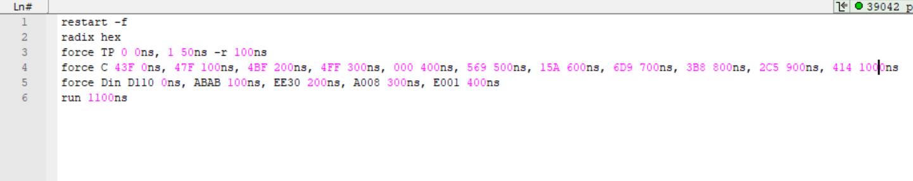

**5.Simulated waveform for part Ⅲ**

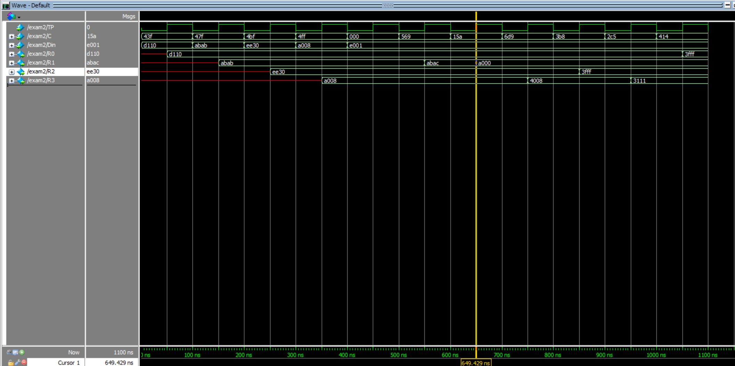

**6.ModelSim do file for part Ⅳ**

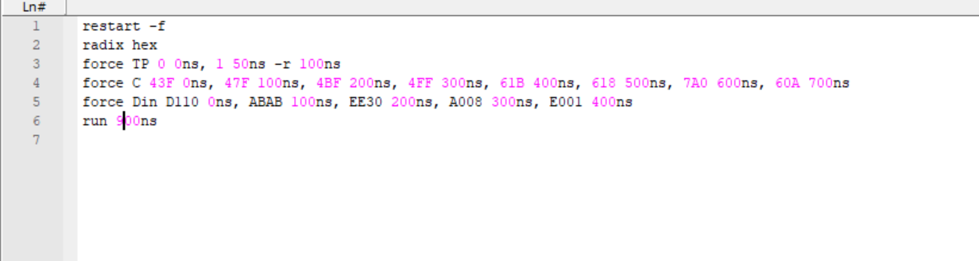

**7.Simulated waveform for part Ⅳ**

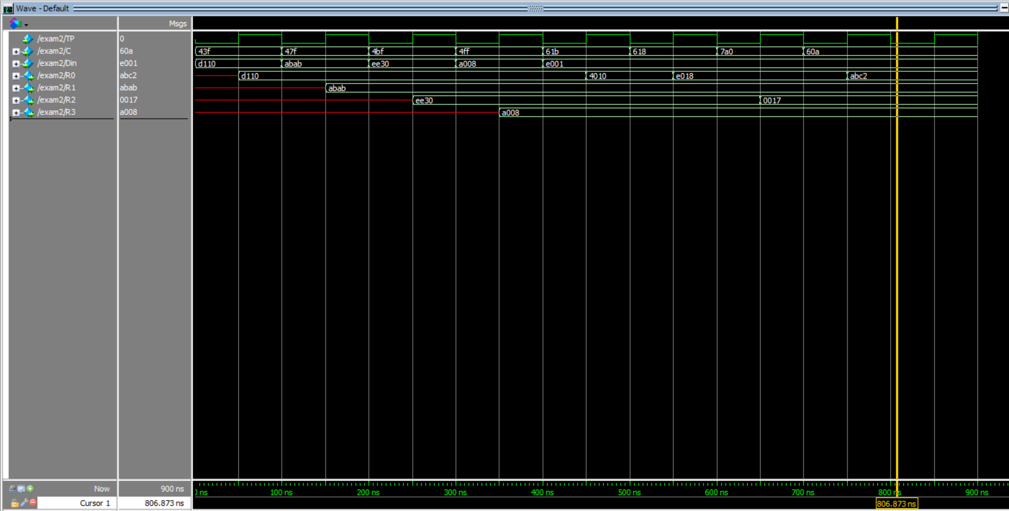

**The code of up3_16.v (I named it exam2.v)**

