**Exam 2 rules and tips:**

1. Read and understand everything in this pre-exam document.
2. On the exam day, bring only this file and lab report of lab4, 5 and 7. No other materials are allowed
3. You would like to rework every step from lab3-7 by yourself if you always let your partner to do the programming and simulation! (strongly recommended)
4. No cell phone, laptop or any electronic device during the exam.

**Pre-exam 2 questions A:**

Below is a very simple microprocessor architecture. For the following control signals:

1. TP is the system clock signal connected to the registers through the **AND** gates;
2. are the clock input for each register, respectively, and all registers load the input data at the rising edge;
3. $C_{8}C_{7}$ are the inputs for the 2-to-4 decoder which will enable only one AND gate at any time;
4. $C_{2}C_{1}$ and $C_{5}C_{4}$ are used to select source register R[0]-R[3], $C_{3}$ and $C_{6}$ is used for $D_{in}$ selection: If $C_{3}=1$, MUX1 output is $D_{in}$, if $C_{6}=1$, MUX2 output is $D_{in}$;
5. $C_{11}C_{10}C_{9}$ are used for ALU selection, and the details are listed in the following table.

**Note: assume that the signals can pass all the components instantly.**

|  |  |  |  |  |  |  |  |  |
| --- | --- | --- | --- | --- | --- | --- | --- | --- |
| $$C_{11}C_{10}C_{9}$$ | 000 | 001 | 010 | 011 | 100 | 101 | 110 | 111 |
| Operation | A AND B | A OR B | A XOR B | $$\overline{A AND B}$$ | A+B | A-B | **2*A** | B |
| Comment | Bitwise and | Bitwise or | Bitwise xor | Bitwise not AB | Addition | multiplication | 2 times data A | Pass data B |

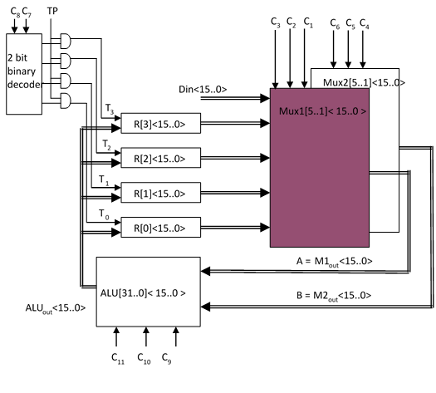

**Operation examples:**

1. Load a data into one of the registers: $R\left[3\right]←Din$

$$C_{11}C_{10}C_{9}C_{8}C_{7}C_{6}C_{5}C_{4}C_{3}C_{2}C_{1}=111111XXXXX$$

**Comments: $C_{11}C_{10}C_{9}=111$** select the function B for ALU; $C_{8}C_{7}=11$ will set the output $Y_{3}$ of the decoder to 1 so that the TP signal can be passed to R[3]; $C_{6}=1$ means the output of MUX2 would be $Din$, which will pass the data on $Din$ through the ALU. $X$ means don’t care value.

1. Add the data stored in one registers to the input data and store the result in the third register: $R\left[0\right]←R\left[1\right]+Din$

$$C_{11}C_{10}C_{9}C_{8}C_{7}C_{6}C_{5}C_{4}C_{3}C_{2}C_{1}=100001XX001$$

**Comments: $C_{11}C_{10}C_{9}=100$** select the function A+B for ALU; $C_{8}C_{7}=00$ will set the output $Y_{0}$ of the decoder to 1 so that the TP signal can be passed to R[0]; $C_{6}=1$ means the output of MUX2 would be $Din$ and $C_{3}C_{2}C_{1}=001$ means the output of MUX1 would be data from $R\left[1\right]$; $X$ means don’t care value.

**Practice problems: What control signals should be used for the following operations? How many clock cycles will it take to complete the operation?**

$R\left[0\right]←R\left[1\right]+Din$ 100001XX001 1 clock cycle

$R\left[1\right]←R\left[3\right]-Din$ 101011XX011 1 clock cycle

$R\left[2\right]←2*R\left[0\right]$ 110100XX000 1 clock cycle

$R\left[3\right]←Din$ 111111XXXXX 1 clock cycle

$R\left[0\right]←R\left[0\right] AND Din$ 000001XX000 1 clock cycle

$R\left[1\right]←R\left[1\right] OR Din$ 001011XX001 1 clock cycle

$R\left[2\right]←R\left[2\right] XOR Din$ 010101XX010 1 clock cycle

$R\left[3\right]←\overline{R\left[0\right] AND R[3]}$ 01111011000 1 clock cycle

**Practice problem: timing diagram**

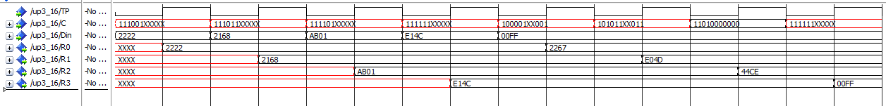

Can you recognize the operation at each TP rising edge? (CX means the Xth clock cycle)

C1: $R\left[0\right]←Din$ C2: $R\left[1\right]←Din$ C3: $R\left[2\right]←Din$ C4: $R\left[3\right]←Din$

C5: $R\left[0\right]←R\left[1\right]+Din$ C6: $R\left[1\right]←R\left[3\right]-Din$ C7: $R\left[2\right]←2*R\left[0\right]$ C8: $R\left[3\right]←Din$

Check the data to verify your answers. (be aware that the operation would be successive, which means you should always use the updated data in the registers)

**Pre-exam 2 questions B:**

Below is a very simple 16-bit microprocessor architecture. For the following control signals:

1. TP is the system clock signal connected to the registers through the **AND** gates;
2. are the clock input for each register, respectively, and all registers load the input data at the rising edge;
3. $C_{6}C_{5}C_{4}$ are the inputs for the 3-to-6 decoder which will enable only one AND gate at any time;
4. $C_{2}C_{1}$ are used to select source register R[0]-R[3], $C_{3}$ is used for $D_{in}$ selection: If $C_{3}=1$, MUX1 output is $D_{in}$.
5. $C_{9}C_{8}C_{7}$ are used for ALU selection, and the details are listed in the following table.

|  |  |  |  |  |  |  |  |  |
| --- | --- | --- | --- | --- | --- | --- | --- | --- |
| Control  signal | 000 | 001 | 010 | 011 | 100 | 101 | 110 | 111 |
| Operation | A+B | A-B | 2*A | A | A AND B | A OR B | A XOR B | $$\overline{A AND B}$$ |
| Comment | Addition | multiplication | 2 times data A | Pass data A | Bitwise and | Bitwise or | Bitwise xor | Bitwise not AB |

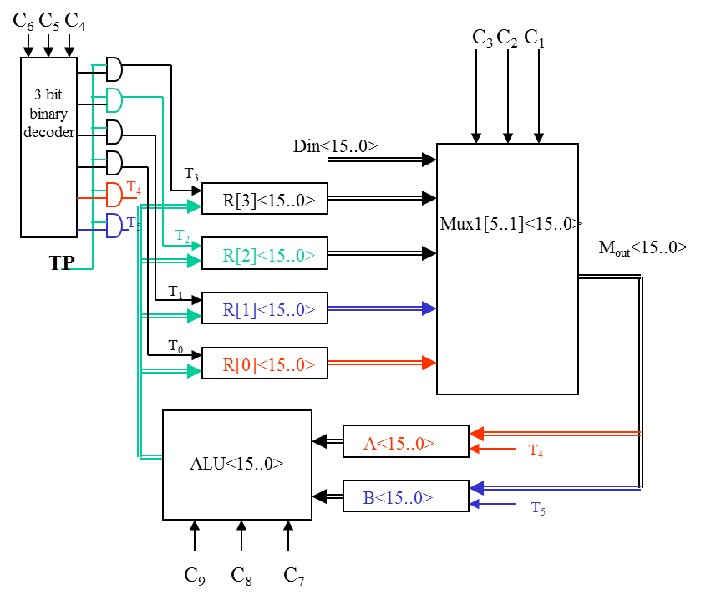

**Operation examples:**

1. Load a data into one of the registers: $R\left[3\right]←Din$

**Clock cycle 1** --- $C_{9}C_{8}C_{7}C_{6}C_{5}C_{4}C_{3}C_{2}C_{1}=XXX1001XX$

**Comments: $C_{6}C_{5}C_{4}=100$** will set the output $Y_{4}$ of the decoder to 1, which will select the register A; $C_{3}=1$ selects $Din$ as data source for MUX, and the data will be stored in register A at rising edge. $X$ means don’t care value.

**Clock cycle 2** --- $C_{9}C_{8}C_{7}C_{6}C_{5}C_{4}C_{3}C_{2}C_{1}=011011XXX$

**Comments**: $C_{9}C_{8}C_{7}=011$ select the function A for ALU. At the 2nd rising edge, data stored in register A will pass ALU and be stored into $R\left[3\right]$.

1. Add the data stored in one registers to the input data and store the result in the third register: $R\left[0\right]←R\left[1\right]+Din$

**Clock cycle 1** --- $C_{9}C_{8}C_{7}C_{6}C_{5}C_{4}C_{3}C_{2}C_{1}=XXX100001$

**Comments: $C_{6}C_{5}C_{4}=100$** will set the output $Y_{4}$ of the decoder to 1, which will select the register A; $C_{3}C_{2}C_{1}=001$ selects $R\left[1\right]$ as data source for MUX, and the data will be stored in register A at rising edge.

**Clock cycle 2 --- $C_{9}C_{8}C_{7}C_{6}C_{5}C_{4}C_{3}C_{2}C_{1}=XXX1011XX$**

**Comments: $C_{9}C_{8}C_{7}=000$** select the function A+B for ALU; $C_{6}C_{5}C_{4}=101$ will set the output $Y_{5}$ of the decoder to 1, which will select the register B; $C_{3}C_{2}C_{1}=1XX$ selects $R\left[1\right]$ as data source for MUX, and the data will be stored in register B at rising edge. $X$ means don’t care value.

**Clock cycle 3** --- $C_{9}C_{8}C_{7}C_{6}C_{5}C_{4}C_{3}C_{2}C_{1}=000000XXX$

**Comments: $C_{9}C_{8}C_{7}=000$** select the function A+B for ALU; $C_{6}C_{5}C_{4}=000$ will set the output $Y_{0}$ of the decoder to 1, which will select the register R[0]; $X$ means don’t care value.

**Practice problems: What control signals should be used for the following operations? How many clock cycles will it take to complete the operation?**

$R\left[0\right]←R\left[1\right]+Din$ XXX100001 $R\left[1\right]→A$ 1 clock cycle

XXX1011XX $Din→B$ 1 clock cycle

000000XXX $A+B→R\left[0\right]$ 1 clock cycle total 3 clock cycles

$R\left[1\right]←R\left[3\right]-Din$ XXX100011 $R\left[3\right]→A$ 1 clock cycle

XXX1011XX $Din→B$ 1 clock cycle

001001XXX $A-B→R\left[1\right]$ 1 clock cycle total 3 clock cycles

$R\left[2\right]←2*R\left[0\right]$ XXX100000 $R\left[0\right]→A$ 1 clock cycle

010010XXX $2*A→R\left[2\right]$ 1 clock cycle total 2 clock cycles

$R\left[3\right]←Din$ XXX1001XX $Din→A$ 1 clock cycle

011011XXX $A→R\left[3\right]$ 1 clock cycle total 2 clock cycles

$R\left[0\right]←R\left[0\right] AND Din$ XXX100000 $R\left[0\right]→A$ 1 clock cycle

XXX1011XX $Din→B$ 1 clock cycle

100000XXX $A AND B→R\left[0\right]$ 1 clock cycle total 3 clock cycles

$R\left[1\right]←R\left[1\right] OR Din$ XXX100001 $R\left[1\right]→A$ 1 clock cycle

XXX1011XX $Din→B$ 1 clock cycle

101001XXX $A OR B→R\left[1\right]$ 1 clock cycle total 3 clock cycles

$R\left[2\right]←R\left[2\right] XOR Din$ XXX100010 $R\left[2\right]→A$ 1 clock cycle

XXX1011XX $Din→B$ 1 clock cycle

110010XXX $A XOR B→R\left[2\right]$ 1 clock cycle total 3 clock cycles

$R\left[3\right]←\overline{R\left[0\right] AND R[3]}$ XXX100000 $R\left[0\right]→A$ 1 clock cycle

XXX101011 $R\left[3\right]→B$ 1 clock cycle

111011XXX $\overline{A XOR B}→R\left[3\right]$ 1 clock cycle total 3 clock cycles

**Practice problem: timing diagram**

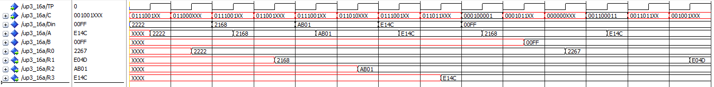

Can you recognize the operation at each TP rising edge? (CX means the Xth clock cycle)

C1: $A←Din$ C2: $R\left[0\right]←A$ C3: $A←Din$ C4: $R\left[1\right]←A$

C5: $A←Din$ C6: $R\left[2\right]←A$ C7: $A←Din$ C8: $R\left[3\right]←A$

C9: $A←R[1]$ C10: $B←Din$ C11: $R\left[0\right]←A+B$

C12: $A←R[3]$ C13: $B←Din$ C14: $R\left[1\right]←A-B$

Check the data to verify your answers. (be aware that the operation would be successive, which means you should always use the updated data in the registers)