Jason Clark

GAT211

Lab Report 4

Lab Report 4

1. First Map – Creation

This map started out as a game project I started working on over the Winter break. In anticipation of taking GAT211 in the Spring, I decided I might want to try to work on some games, especially those with maps that I could potentially use during the second project. It also came out of a desire to make a compelling linear, 1D map. The one I made the last semester was embarrassingly simple and really not in the spirit of the assignment at all. The creation of the basic framework of the map came before anything else. It started out as a pyramid of blocks that I thought I might continue to build off of, but decided to make an opposing one. Seeing that, I thought there might be a way to use four pyramids all facing in on each other.The next thing I thought about was what type of game might fit a map like this and for a reason I cannot adequately explain or even remember, I thought of the idea of a Panopticon, Jeremy Bentham’s famous prison design experiment in which there was one central guard tower surround by all the prisoner cells in a circle around it. The guards could see all prisoners, but the prisoners themselves would have no way of knowing if they were being watched at any given moment, thus causing them—at least so the theory goes—to act as if they are *always* being watched. The word “panopticon” can be broken down into two base words: “pan” meaning all-seeing and “optic” meaning eye—an all-seeing eye. The idea I took from this concept, then, was to try to make a game where the players felt like they could be thrown into battle at any given notice without forewarning.

The initial gameplay went something like this: players would move linearly along the pyramid of blocks towards the center of the board. After every player has made one move (by rolling a die and moving that many spaces forward), a four-pronged spinner in the middle would be spun—each prong tipped with an arrow—and when the spinner stopped, would point towards a line of squares on each player’s grid. If two or more players were currently on a square that the prongs pointed to, they would then be forced to fight. This was as far as I got in my original conception, the results of which can be seen in the picture above. I’ll now list the raw notes from the brainstorming session I had following this basic structure where I tried to flesh out the game a bit, giving it a system that would fit the map:

* Players start at the bottom right of their pyramids and move up towards the center, using a die roll (D4 maybe?)
* Would having the spinner move in a pre-determined format take away from the theme? Would it add any depth to the overall strategy that actually increased enjoyment? Probably not.
* If two or more players are in the “sight” of the eye at the end of the spin, they must fight. The loser(s) must go back to the start of their respective pyramids
* What about loot? Maybe a level up system? Dice upgrades? Battle avoidance?
* Certain tiles could have game-changing effects:
  + Upgrades and Downgrades of Dice
  + Switch direction of the eye (if moving in a pre-determined manner)
  + Gain fold for each row that is passed
  + One-time use benefits are granted that could be used in battle
* Hidden information? The theme is based on the panopticon so it would fit in well narratively speaking.
  + Players will not know where the eye will land until the end of each round when it is then spun.
  + Maybe look at the real models of panopticons for further inspiration here.
* Each different pyramid could be a different space/time period and the player plays as a warrior from a particular culture (Romans, Mongolians, Barbarians, Persians, etc…)
* “Loot” could also be based on the individual culture from whence the warrior comes.
* They are all trying to appease their own god, though this god is actually one “God”, Pan.

1. First Map – Lab Discussion

Unfortunately, since I was gone on Monday, and misunderstood the directions Prof. Holcomb sent me in an email, I did not bring any prepared maps to the lab. It was only until we had joined up in groups that I took out my notepad, remembered I had made this map and game, and realized this was something I could use. Upon showing it to my group (Dakota Galayde and Maddie Santino) and explaining the basic concept behind, their first question was what kind of loot was I thinking about putting into the game. I had showed the basic framework that is pictured above and had only taken the most cursory of notes on what type of loot, if any, I might in the game. I did tell them I had been thinking of the idea of having players be able to buy better weapons and armor every time they were “killed” and sent back to the bottom of the pyramid. Dakota said he really liked the idea of giving such players a tail wind such as this and told me he thought it would definitely work to keep players engaged even if they have just been beaten. I told them about the idea of gaining currency and they both agreed having certain tiles laid out on the pyramids that give player’s gold would add some flavor to the map itself. While I might also want to give out some loot and/or gold after winning a battle, the details of that isn’t necessary for this particular assignment.

While I definitely wanted to give currency out to players using these grid tiles, I also thought gold alone might be a bit dry and decided to start thinking of some other things to add, either as other tiles or other choices when landing on certain “reward” tiles. The result of these thoughts turned into what I called the “Three G’s”:

* Gold – a currency used to buy armor and weapons when defeated in battle and sent back to the start
* Gift from the God – a boost to the player in battle, usually some one-off effect that can be used only on the next time that player fights
* Genuflection – The player character “worships” the God, bringing them further along the path. This would be some boost like jumping ahead a few spaces

I wasn’t sure if this would work best as a choice player’s would make when they landed on certain tiles or if it should be random. Again, this isn’t that important given this assignment, but for the sake of of having something solid, I just decided to go with allowing player’s the choice of which of the three Gs they would take. And that sums up the work done on this first map, both in its creation, in lab, and its second iteration based on feedback after lab. This second iteration of the map, as drawn on large graph paper is presented here:

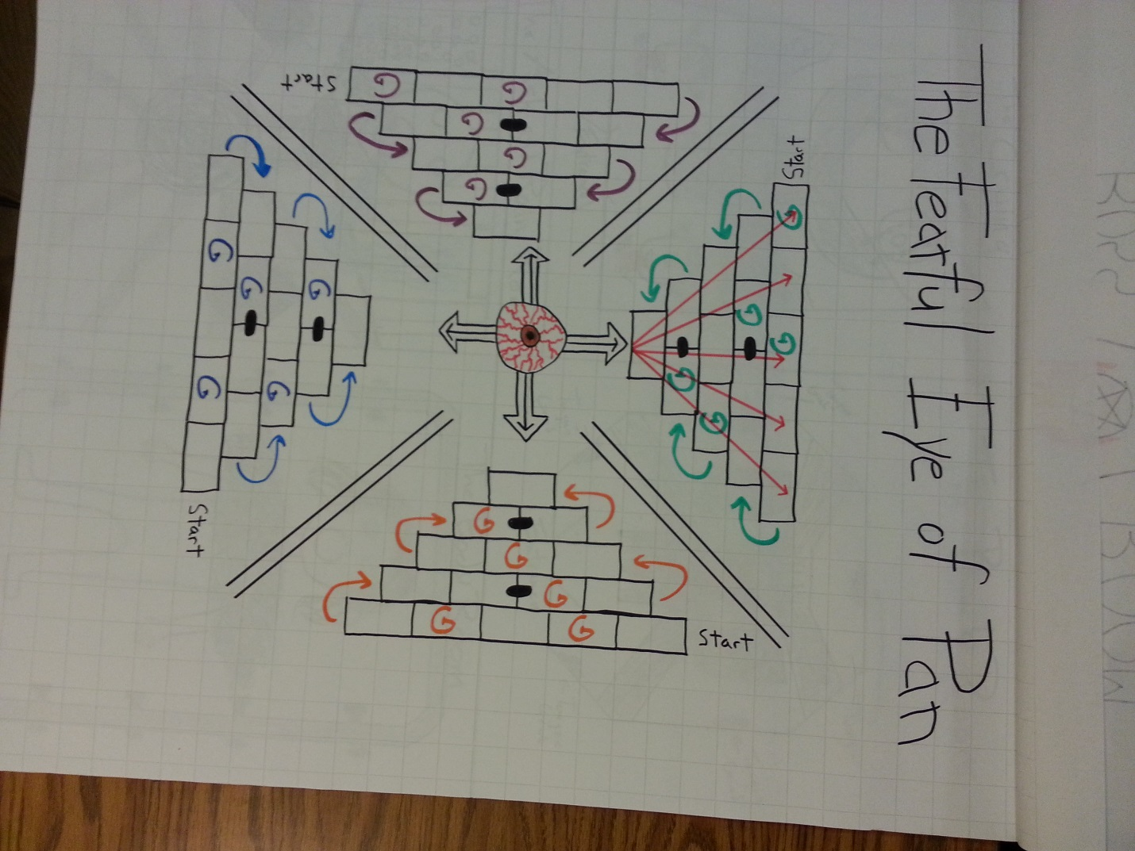

1. First Map – Intensity Curve

Up/Down Lists

UP

* The initial spin after everyone has made their first move on the board. Happens around Time + 1:00.
* The first combat after everyone is settled (might actually be the second combat overall) and knows more or less what they’re doing. Happens around Time + 3:00 (especially if 2nd battle)
* Players getting into the groove of their particular game, gaining gifts and currency, making strategies, and so on. While not a big up at all (just .25 and then stays the same for two more minutes), it’s still not a down. Happens from Time + 4:00 – Time + 6:00.
* One player, either through a particularly tough battle—say where all four players fight, sending all but one player back to the start—or through gaining really great gear, starts to pull ahead of the rest, ratcheting up the tension. Happens at around Time + 7800.
* Other players start to make their last efforts either to gain some last momentum for themselves or to attempt to stop the lead player from making it to the end. Happens around Time + 9:00.
* The player in the lead is at the very last square and the final battle takes place. Happens at Time + 10:00.

DOWN

* Waiting for people to roll their die and move their spaces so the group can get to the spinning of the eye section. This happens every round so it’s a constant.
* After the initial excitement at the start of the game and realizing that most of the exciting parts won’t really happen until mid-game through the endgame. This is because getting knocked back to the start this early on isn’t nearly as big of a penalty as it will be later. This happens at around Time + 1:00 through Time +2:00
* Losing a battle and being pushed back to the start. Again, this is something that will happen any number of times during a game and can’t be pinpointed on the graph at happening at any particular time (except for say the first “real” battle at Time + 2:00 and the final battle at Time + 10:00).
* A good ways through the mid-game when the repetitiveness of the mechanics starts to sink a bit. In a longer game (and honestly, 10 minutes might have been a far too conservative guess at the time) this would be much more pronounced. Happens at around Time + 6:00 through Time + 7:00.
* The end after one player is crowned the victor and everyone reflects on their own game. Happens at Time + 11:00.

1. Second Map – Creation and Descriptoin

The following maps are for a dungeon in a game called *Setusko*. *Setsuko* is the game I’m working on as a member of Demon Parasol for GAM205 and GAM 255. The other members on the team are Eric Gleiser, Garrett Huxtable, and Travis Moore. As the Lead Designer for the game, I’m in the unique and serendipitous position of being able to work on my designs for the level maps in this class so that they might be even better when they are fully implemented in the engine. While I could document the entire creation process of *Setsuko*, it makes much more sense to just give a brief overview of the game and its mechanics providing a context for the maps themselves so that they might be better understood.

*Setsuko* is an action-adventure puzzle game in the same category of games like *The Legend of Zelda* and *Psychonauts*. The setting is immediate post-WWII Japan (in the late 1940s), somewhere in the countryside away from the major cities. The player takes of control of Setsuko, the hero of the game. She is a 12-year-old girl and the only child of her two loving, but battered parents. Her father, a solider during the war, is now crippled, having lost most of an arm and suffering severe nerve damage to his left leg due to shrapnel from a grenade. Her mother is a victim of radiation poisoning received from ubiquitous “black rain” that was everywhere around Hiroshima and Nagasaki after the nuclear blasts that occurred there. Black rain is what results when radioactive ash and dust that gets thrown up into the atmosphere mixes with rain. It turns into a black, radioactive sludge that falls everywhere and contaminates all who are exposed to it. Setsuko’s mother was one of those unfortunate people; her dose, sadly, is fatal.

As the game opens, Setsuko is sent by her father to see the famous Monk of the Mountains. He is their last hope for a cure. On the way, however, Setsuko falls through a rotten bridge into a river and is swept downstream to a woods she does not know. She soon finds hidden in the woods the grand and opulent palace of a yin-yang diviner, a sorcerer of sorts who has many great powers. After hearing her story, the diviner promises Setsuko that he will heal her mother as long as Setsuko retrieves three items for him: three relics of the original and most powerful yin-yang diviner in Japanese history, Abe no Seimei. This first relic lies within a dungeon not far from the diviner’s palace and it is this dungeon that is shown in the maps to be presented. Before she leaves his palace, however, Setsuko is given a very old parasol, or umbrella, that has become a *yokai* creature, gaining sentience and a personality of its own. It is through this yokai parasol that most of the game’s action mechanics emerge. This particular yokai—its common name in Japan is Kasa Obake—is known mostly for its long tongue, which can be seen in this picture, which was used as source material when we were designing him for our own uses:

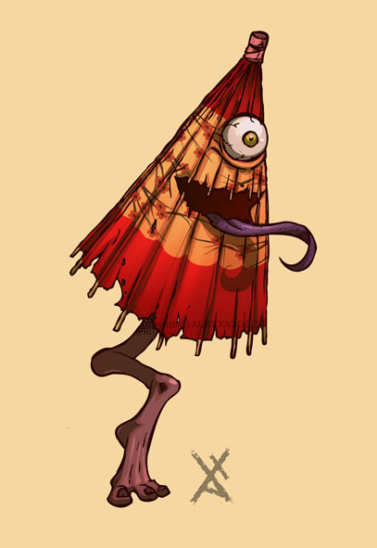

In this first dungeon, the one seen in the maps below, the mechanic based around the yokai’s long, elastic tongue will be featured the most; it finds use as a hook shot, allowing the player to both attach it to something then pull the player to it or to have it attach to an object and pull it back to the player. It can also be used to trigger otherwise unreachable switches or knobs.

Most of the environments in the game after the initial meeting with the diviner are being designed to reflect the internal and external damage caused by the nuclear bombs dropped on Hiroshima and Nagasaki. This first dungeon is thematically based around “black rain”: how it was created and how it affects the body. All of the “puzzle rooms” within the dungeon refer to some aspect of black rain whether it be the bombs that cause it to be made in the first place or the literal effect it has on the human body. While we are trying to keep everything within the bounds of E10, we are also considering talking to the faculty for permission to make a Teen rated game. Some of the effects of a nuclear blast, especially on a human body, are quite graphic and shocking. To tone them down would be disingenuous and, frankly, offensive. These bombs are terrible and they should be shown and known as the life and body destroying tools of war that they are. To do otherwise would be a disservice to all those affected by the bombs.

1. The Maps (Second)

The first map is both the entrance room of the dungeon as well as the “hub”, by which all other rooms are accessed. There are four “puzzle rooms”, each designated by one point of the five-pointed star in the middle of the room (the five-pointed star means something very, very different in Japan then it does in the West; it is the symbol of Abe no Seimei, the legendary yin-yang diviner and is also used to show all of the elements of the world are connected to each other). After each puzzle room is solved, the corresponding part of the star lights up in the color that is presented in the picture below. After all four of the puzzles are solved, the boss room door is finally opened allowing the player to go in and face the final boss. Before going any further, I’ll show the map of this HUB room here:

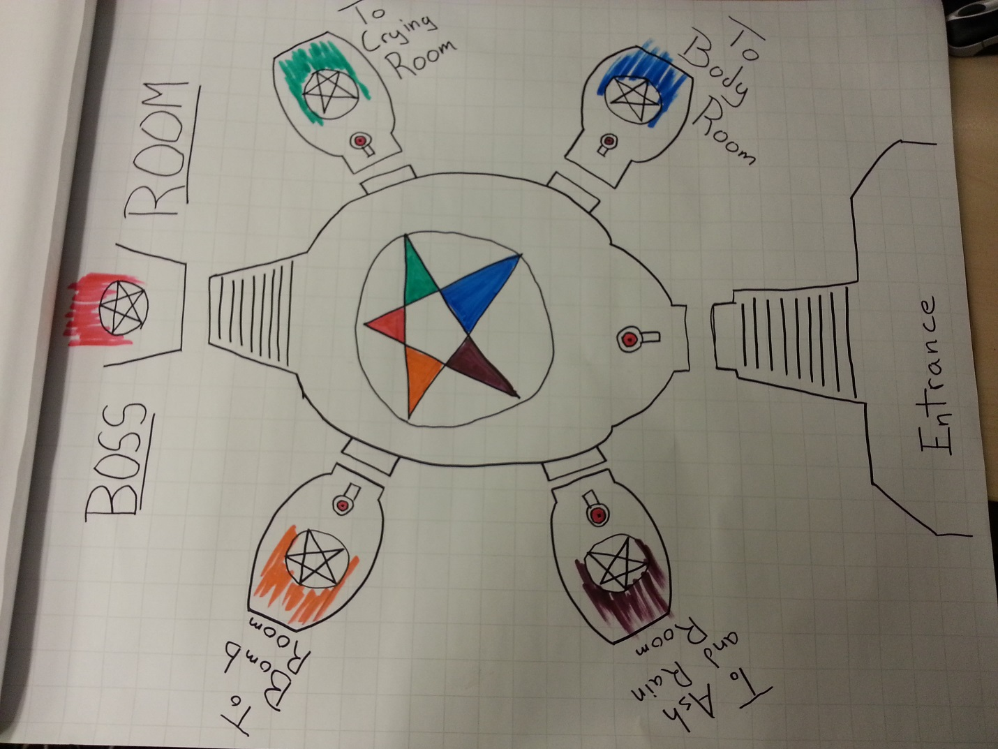

There is no particular order of rooms that the player must go in; they are allowed to choose any of the four from the moment they step into the dungeon. We wanted to keep this open approach so as to not place any undue weight on any one room and thematic context. They are all equally important and all part of the same revolting evil.

The first room I’ll present is what we’ve called the “Bomb Room”. In it, the player can move around to different parts of it by shooting the tongue of the yokai to the hooks on the wall and pulling themselves across. All the while, small nuclear bombs, purposefully designed after the “Fat Man”, one of the two nuclear bombs dropped on Hiroshima and Nagasaki (the other named “Little Boy”), emerge of the bomb bay doors and chase after the player, exploding on impact. The goal is to move into a position so that a bomb will hit one of the two columns in the room. When this happens, the column breaks in half, top half, falling into the black rain stream, both closing one half of the bomb bay doors and stopping up the stream of black rain.

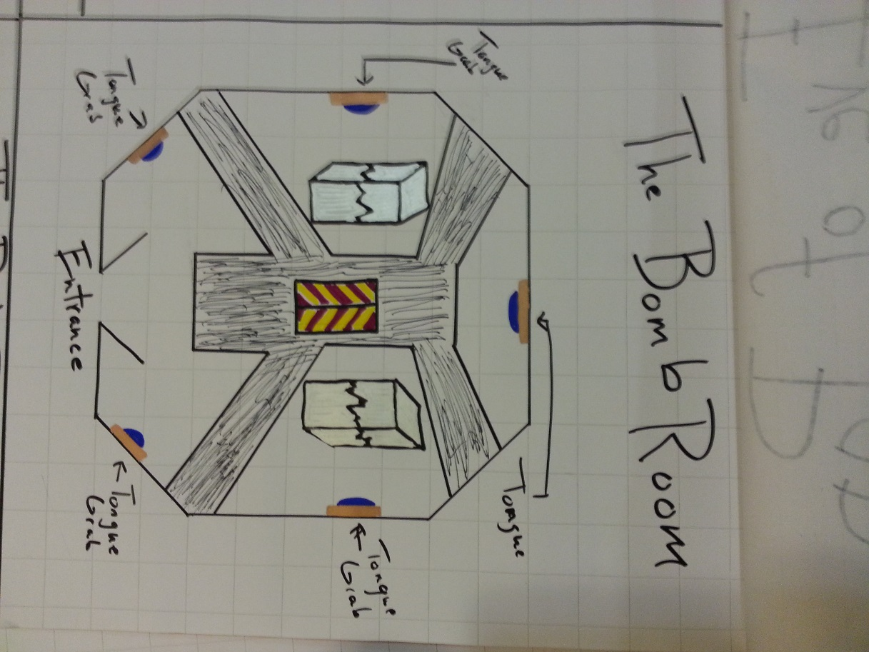

The next room I’ll show is nicknamed “The Crying Room”. In this area, on the back two walls, there are two large faces, abstracted to look like masks, though both faces are clearly in the pain and agony. Out of the eyes of both faces runs tears of black rain, where they gather and collect in a pool below. The two pools connect and flow throughout the room. At the other side of the room, near the entrance, are two malicious yokai that have taken the form of fire-breathing traditional Japanese lanterns. They act as a barrier to the rest of the room. The player must perfectly time their movement to jump past the flames. Once they have moved past, the player must move to the small island of floor directly in front of one of two faces. Once there, they must use the tongue to grab the lantern and pull it back to them, immediately jumping back out of the way. Once there, the lantern will turn and breathe its fire on the face on the wall, leaving behind only a shadow, reminiscent of the “nuclear shadows” frozen forever on walls and streets by the intense light rays and blast of the nuclear bomb.

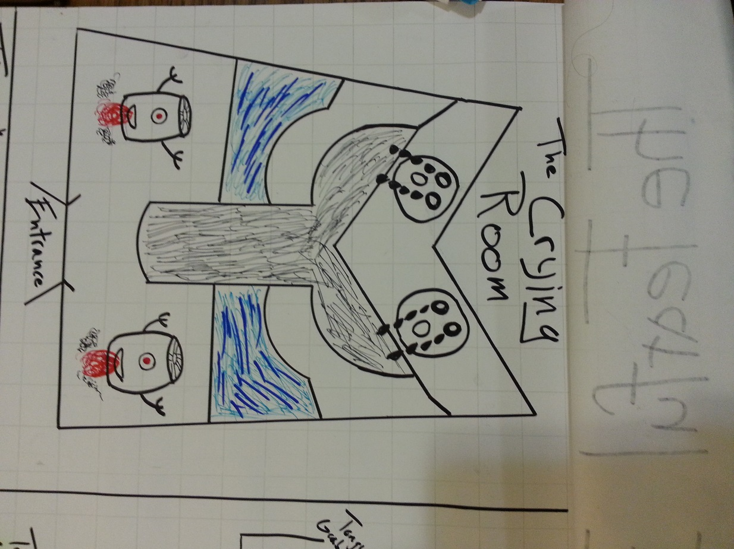

The next room, nicknamed “The Ash and Rain Room”, is meant to show how the black rain is created in the first place. From two spouts at the ceiling, ash and rain water fall down into the room. Before they are allowed to hit the floor, however, they are are-directed by two large turbine propellers, modelled after the propellers from the airplane the *Enola Gay*, the bomber plane that dropped Fat Man and Little Boy on Hiroshima and Nagasaki. Both streams then go into the mouth of a mask situated on the back wall, where they combine and then fall to the floor as black rain. They then flow into a pool in the center of the room, with straight streams sending the black rain out of the room. The image of the pool and the streams evokes the Japanese flag during wartime. The player turn off each turbine and spout in a particular order. If the order is not followed correctly, various bad things happen, such as the room filling up with life-draining ash or the room filling with water causing the player to drown. All of these four things can be switched on and off with the yokai’s tongue.

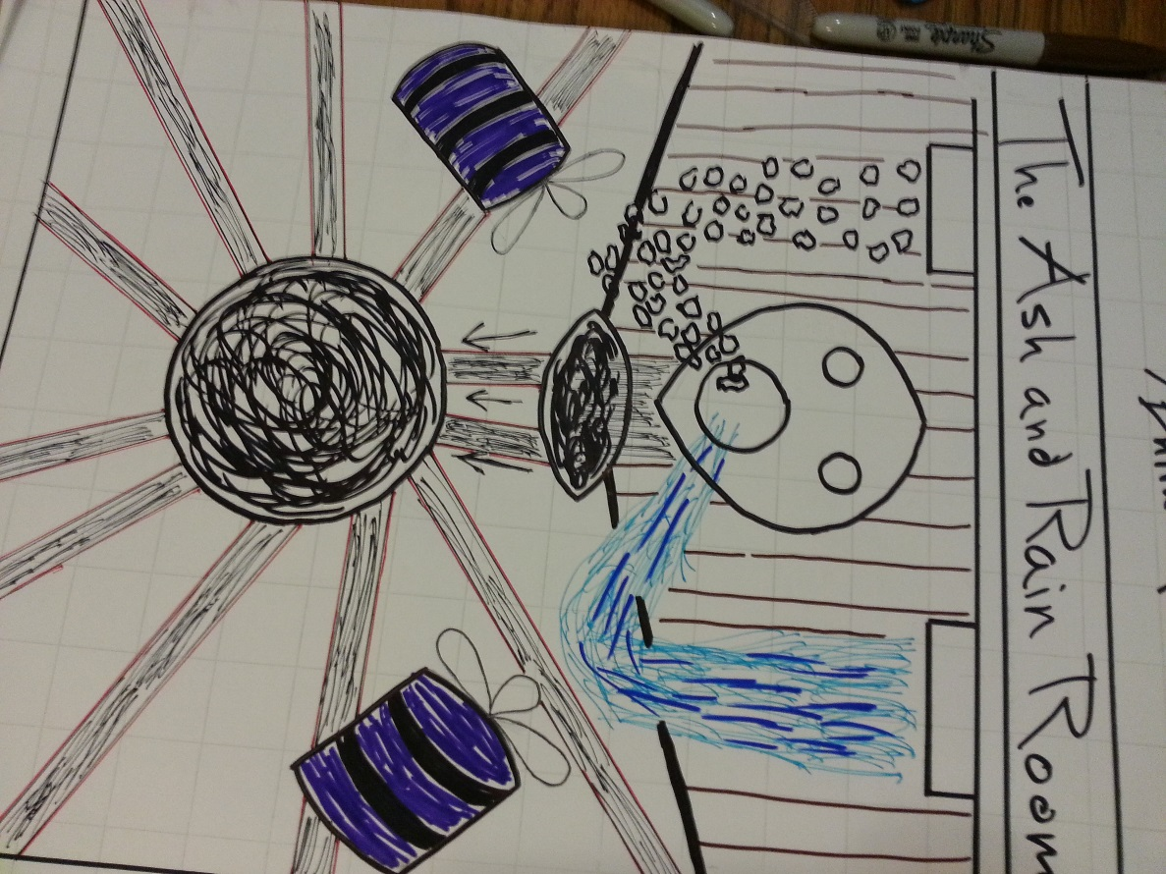

Finally, the fourth room, nicknamed “The Body Room”, demonstrates the effects of radioactive poisoning on the human body. This room is by far the most obvious in terms of what it symbolizes. As the designer, I wanted to make sure the players were at least aware of the most basic theme the game is trying to get across. Still, the body itself is very abstracted, save for the hair, denoting a female, referencing Setsuko’s mother who has been slowly dying from radiation poisoning received through black rain. This is a fairly easy puzzle to solve and involves merely turning off the various spouts on the pipes that run through the room, encircling a gigantic statue of a human body, as the pressure builds on each one, eventually causing them to explode and showing the body with black rain. Once the player has turned the wheel and stop the flow of black rain, that part of the body (there are four spouts on each side of the very large body that cover the, respectively, the head, upper torso, lower torso, and legs/feet) is then shown with different effects from radiation poisoning. The head has lost all of its hair and the mouth turns from a neutral grin to a cry of agony. The upper torso, which will have white circles moving through it in a pattern resembling circulation (and symbolizing the white blood cells within the body), will stop moving and have turned in a decayed, black stain on the body. The lower torso will be have various holes in it now, symbolizing the tumors, boils, and ulcerations that those affected with large doses of radiation suffer from. The legs and feet will take on flash burns, like those received by many of the people exposed to the intense light of the blast when it first hit.

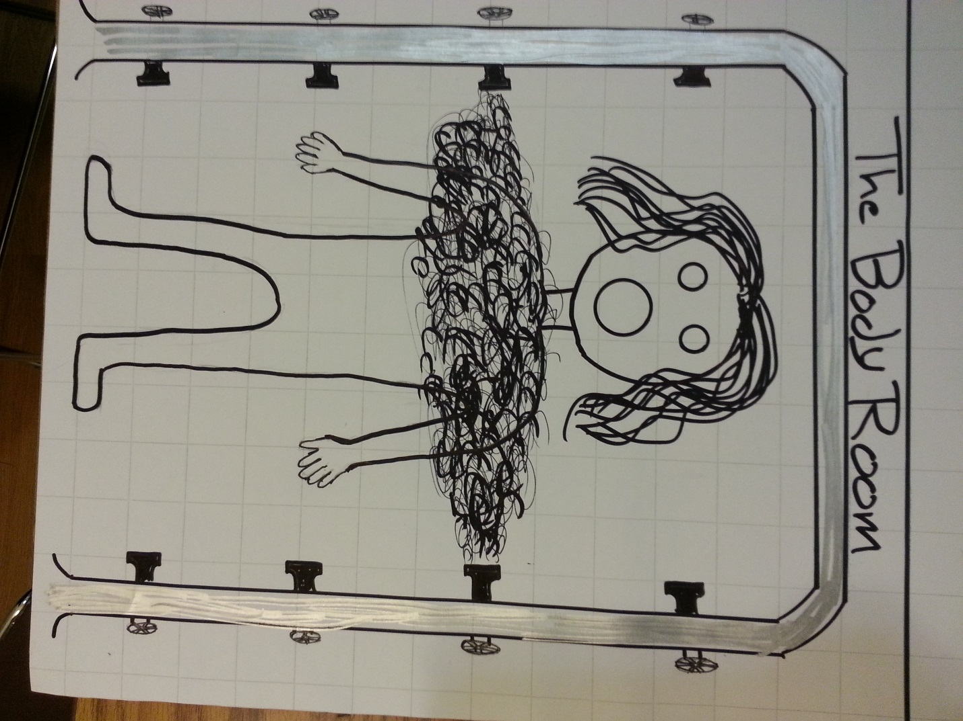

I was not able to speak with my group about these maps and designs because I did not even think of using these maps until well into the class period. I also had my other map—the first one above—to talk about and I did have an example of that at the ready. This is okay, however, as I’ve had quite a bit of discussion about it with teammates and others as I’ve been designing them recently. There are still many places to tweak and I will certainly be doing that during the course of this project as well. The other thing missing from this map section is the intensity graph. Honestly, I’m not sure how to make one for maps such as these, as this game is mean to be more of a poetic experience, where the player interacts with the environment in the hopes (for us designers, that is) of gaining a greater understanding of the costs of nuclear war and the terrible atrocities it commits against human beings. While there are certainly some parts of the room, where there is a bit of “action”, there are others room that don’t have this at all, and aren’t meant too, though I would necessarily want to place, or believe they warrant, a “down” slope on the graph. I think I will need more guidance on this issue before I can confidently create any sort of intensity graph for this map. I do hope, however, that the explanations and analysis of the maps above is enough to give you an idea of the feelings I’m trying to evoke from the player.