Jason Clark

GAT211

Lab Report 5

**Lab Report 5**

1. **Introduction**

These maps were both an attempt to create something quicker than and not quite as polished as some of my other maps and lab reports. I’m pretty sure I’ve failed at least in the mapmaking part. The first one, a region map, was supposed to be a quick planet-wide map with continents broken up into no more than ten discrete countries. The game to go along with it was one of my own creation that partially simulates the politics at play in the contemporary Middle East. While the mapmaking itself only took about 40 minutes, naming everything and then coming up with even a slightly vague set of rules took longer than I imagined. I kept finding some new problem that would make the game unplayable or make no sense. After about two hours of fidgeting with the rules I stopped myself, realizing I could just keep going and going and that was exactly what I was trying not to do.

The second map is a 2D grid based map that would presumably be used in the game *Persona Q*, a game I played recently and enjoyed quite a lot. What I quickly discovered, however, is that the maps for that game (and there are over 20) are finely-honed through thousands of hours of reiteration of playtests. As I kept thinking about all the different mechanics at work on any one map, I realized it would be insane for me to try to make a map that would come close to level of those that actually exist in the game. What I decided to do instead—after debating whether I should even try to continue down this path at all—was to use just a couple of the mechanics from the game. I also decided I wouldn’t be as tight with the spacing as the real maps. Still, this option also took longer than expected. The first map didn’t work out at all, causing me to change to a different mechanic altogether. Then I just made certain parts of the map on a different page first, deciding to create complete areas that I could then fit in to complete map later. The first attempt at trying to put those areas back into a complete map ended with a complete mess on the page with multiple cross-outs, with tiles and arrows all over the place. Finally, on the third try, and after two hours since starting, I was able to finish it. Well, hopefully I can make this lab report shorter, though now that I’m looking back at the length of this introduction, it doesn’t look good.

1. **First Map – Creation**

The idea for this game and map (tentatively titled “Ad Dominari”, Latin for “Towards Domination”) came about when trying to think of what might work for a region map during the extra lab time had at the end of the lecture on Monday. I thought about using a place on the globe as a ready-made region and tried to think of what areas might make for an interesting game. The first place to pop in my mind was the Middle-East. Given the constant stream of news coming from that area over the past decades (and centuries really) it seemed like a suitable environment. What type of game then did it lend itself to? There could be the easy choice of making a barely-disguised *Risk* clone, but I felt that would be a disservice to that area. After about 30 minutes of thought off and on throughout the rest of the day I had settled on making a map for an “alien” world that had political strife similar to that seen in the Middle East. In this way I could try to make an original map while also taking myself out of potentially hazardous territory—a white, American male making overgeneralized comments about the Middle East seems a tad distasteful—but still invoking some of these real-world problems in an abstracted form.

I decided there would be three main factors in play in this game: culture, natural resources, and religion. While this sounds like a potentially troubling set of themes to be using for a board game, especially one in which I’m only supposed to come up with a very simple rule set, if one at all, I couldn’t really stop myself at this point. I also knew that the way I would use religion would be to abstract it as far as possible from any real-world comparisons. I started first by coming up with a resource that players would need to expand themselves across the map. I came with the world Proelium—based on the Latin word for fight—and made certain regions of the map give out more of this resource than the others. Given the map I had already made (see below), I decided the three centrally placed islands the locations that would give the biggest bonus. Players on both sides of the map could try to hold on to them to gain more of the resource, but are also open to attack from both sides.

I then started to think about where I would want players to start. I thought of a number of different ideas before realizing I may be going too deep into this one aspect and just decided that one player would start in a region on the west side, while the other would start on the east side. I realized I was turning too much towards the rules and away from the map, so I then decided how each region would affect the player trying to inhabit it. I decided on making three different “cultures” that are the natural inhabitants of the land (I had come up with some flimsy backstory about two competing, colonizing forces that both want to strip the planet of its natural resources; in other words, the clichéd, extremely liberal, sci-fi type stuff I default to when I can’t think of anything better). These cultures would be defined by how aggressive they were and paired up with names also created from Latin root words: The Bellitor are openly hostile; the Quietus are pacifistic; the Medius are neutral (that is, they have no problems defending or attacking if it’s in their best interests). These cultures would carry an attribute that would make them more or less willing to engage in conflicts with their neighbors, something the players would wish to manipulate as they try to gain control of the world.

At the beginning of the game, players can only inhabit up to two regions at any given time, but they are not bound by cultures. These are manipulative, technologically superior aliens playing politics behind the scenes. By accruing Proelium, however, players can expand and create new technology to help them wage war against their neighbors and eventually the other player. The three central islands—the ones with the Proelium bonuses—would be uninhabited and had no cultural attributes. Every other region besides these three central ones would give 1 Proelium resource per round. Players must also take into consideration the aggression attribute for each region they’ve taken control of. This will affect how successful they are in battle against other regions. For example, the Quietus will only give their full support of force if their “holy land” is invaded (the holy land is explained in the next paragraph), while the Bellitor actually decrease in efficiency the longer they are forced to wait before attacking. There would also be rules dictating what happens when one culture defeats another, and how that region is reassigned. Again, the systems that would control such a scheme are far beyond this assignment, but I thought it was, at the very least, an interesting setup for some potential, future game.

The last part of this game—at the least the last part that I thought of—was the inclusion of religion and “holy lands”. I thought of a rule where if players occupied the same region for more than 3 consecutive turns, that region would then house a holy land for that culture. When holy lands do arise they dramatically alter the allegiances of the population. There can only be three holy lands in any one game and they occur in the regions where one of the two players stays for more than three consecutive turns. Only time this happens for a particular *culture* (the Bellitors, Quietus, and Medius) it cannot happen again. This changes the game by having all the other regions on the map where that culture exists now wishes to actively keep the holy land within that culture’s particular. And it was at this point in my development of the game (a good two hours spent in deliberation) that I realized I had gone way too far and needed to stop. Hopefully I had not gone too far out of the bounds of the assignment and had created a map that could potentially be a first pass for a game of this style.

1. **First Map – Scan**

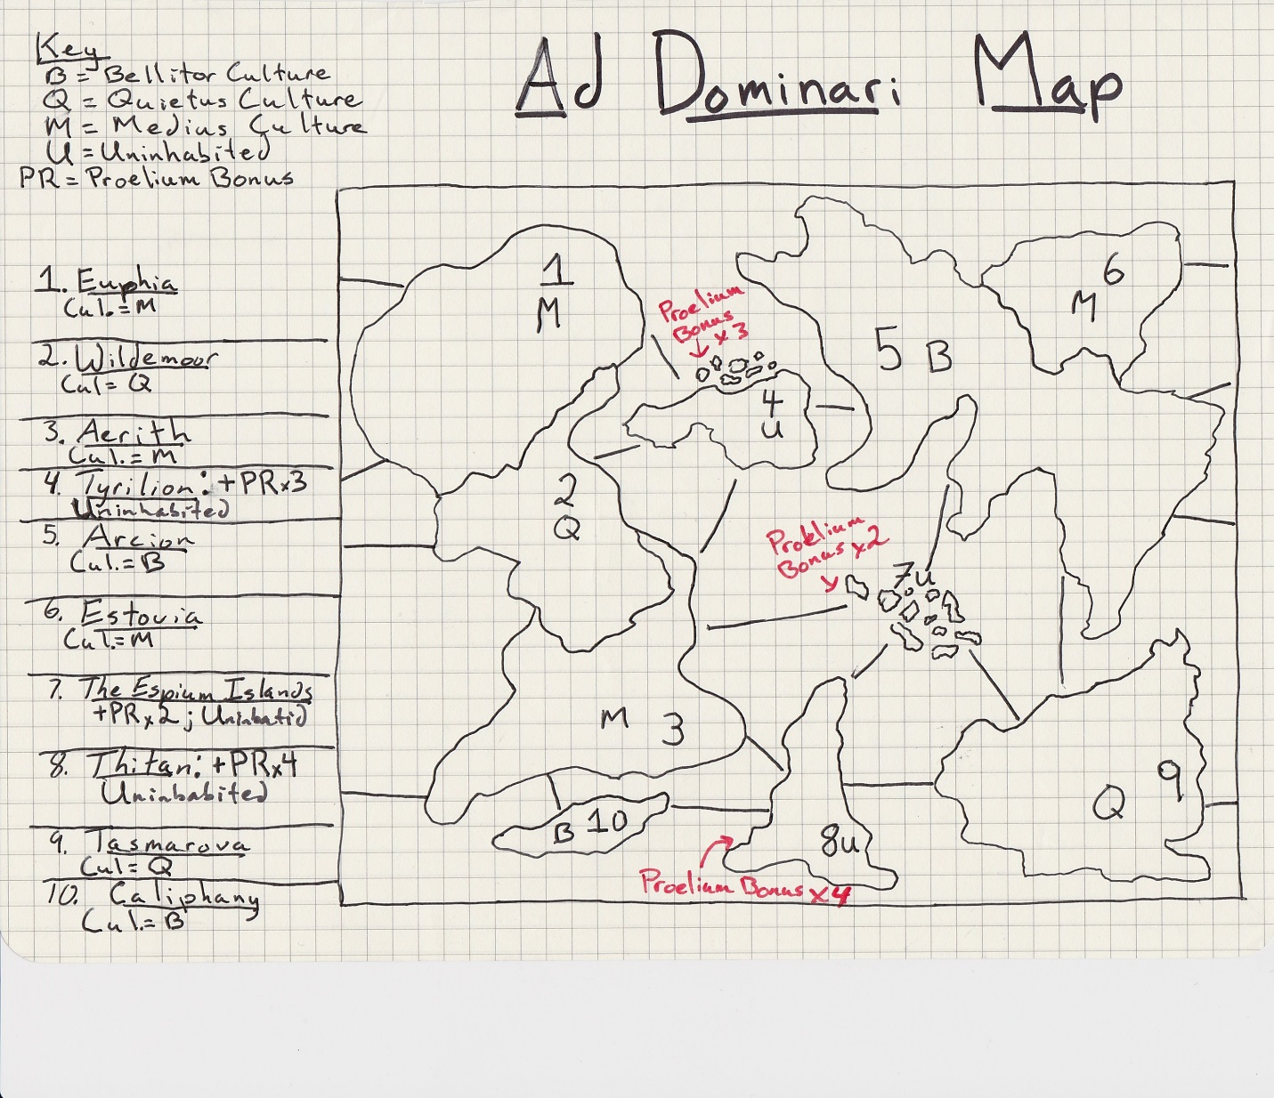

1. **First Map – Intensity Curve with Up/Down Lists**

UP

@ Time + 1:00 – 4:00: Players are getting set up and starting on their first initial moves. There is excitement caused by playing someone either new or someone you’ve had a rivalry with. This is a game about domination and strategy, so opening moves will most likely be very important in terms of one’s own strategy and figuring out how your competitor is planning to play.

@ Time + 12:00 – 16:00: After both players have become more comfortable on their respectable sides of the map, one of the players must eventually make a move towards the central islands or to attack the other player (if they have regions close enough at this point). Also, the first holy land is created, whether intentionally or because a player merely forgot about it, changing the dynamics of the game.

@ Time + 20:00 – 24:00: Both players have made clear their strategy and now they are refocusing their strategies to respond to the state of the board. The other two holy lands have now been “discovered” and are either aiding or hurting the player who has control of that region.

@ Time + 28:00 – 36:00: A continual climb as the game reaches its climax with one or the other player making moves or mistakes that can change the sway of power on the board back and forth. This could come from players over-reaching themselves or being too conservative or even getting an unexpected tailwind due to the other player forgetting about certain regional attributes.

DOWN

@ Time 4:00 – 8:00: Players have seen the opening moves of the other player and gets a bit comfortable in the opening play, making rote decisions without committing to one action yet.

@ Time 8:00 – 12:00: Players are now getting a bit more of a foothold on the map but are perhaps too hesitant to make a big move, in case they have missed something the other player is planning. I’ve personally seen this hesitancy happen more often in the completely strategic type of games this is trying to be.

@ Time 16:00 – 20:00: Players settle back down after the first big movements on the board.

@ Time 24:00 – 28:00: Some hesitancy again as it is clear the game is starting to move towards a point of no return. This can cause an “analysis paralysis” if there are too many rules/attributes at play, something this game could very well lead to.

1. **Second Map – Explanation**

This map is for the game *Persona Q* (exclusive to the Nintendo 3DS, the most recent in a long series of JRPGs made by the development studio Atlus (*sic.*). It combines the narrative and combat from the Persona game series with the map and puzzle mechanics from the Etrian Odyssey game series (also developed by Atlus). Players move a party around a two-dimensional, square grid-based map, moving one grid at a time. Players can in any of the four directions on the grid as long as they are not blocked by obstacles or walls. There is a color indicator that shows how likely one is to be attacked by a monster at random. It goes from blue to green, to yellow, to red, changing from color to color after a certain amount of grid steps are taken. Monsters only attack during the red stage, but it’s still nice that the designers forecast the potential battle period in which the player must be ready so far ahead of time. There are also other monsters that are not random and which are clearly visible on the map. These are called “F.O.E.s” and are meant to be so hard when the player first encounters them that they are basically moving obstacles for the player to avoid.

There are at least two dozen different environmental, map-based mechanics at work throughout the many levels of the game, with often three or four or sometimes more working at the same time on the same level. The difficulty of these puzzles increase steadily as the player progresses through the game. As mentioned in the above introduction, it became impossibly hard to create a map using more than two of these within a reasonable amount of time so I picked my favorite map mechanic as well as a few examples of the ubiquitous F.O.E. encounters. The mechanic I chose has the player navigating moving platforms, or gondolas. The trick with these platforms is that they only move forward in the direction from the which the player walks on to it. That is, if the player approaches it from the “left” side (left in terms of the overall larger map), then the gondola will move the player left across an empty space until it hits a solid platform again, on which the player is then deposited. This mechanic is used so that players’ must figure out the correct way to move around an area so that they can approach the correct gondola from the correct direction in order to proceed to the next area. There are a number of instances where the player must use the same gondola, but approach it from a different direction, sometimes being forced to leave it behind, only to come back to it later on in the level. I thought these puzzles extremely well crafted, giving me a tremendous sense of accomplishment once I was able to figure it out, and have tried to create my own two puzzles based on my experiences in playing through the game.

The map below shows the entire map on a grid (pretty much exactly as it shown on the bottom screen of the Nintendo 3DS when playing the game), with certain grids showing a letter or number that corresponds to a key to the right of the map. There are also green lines and arrows showing the solution to the puzzle as well. I think I failed my initial goal with this map as well as it took me well over 2 ½ hours to come to the final version of this map, having created three iterations of it before I actually was able to get it right. My respect for the makers of the many maps in *Persona Q* has now multiplied based on my experience trying to create the simplest of puzzles using only two mechanics. I will comment more on the details of the puzzle itself in the discussion of the intensity curve below.

1. **Second Map – Scan**

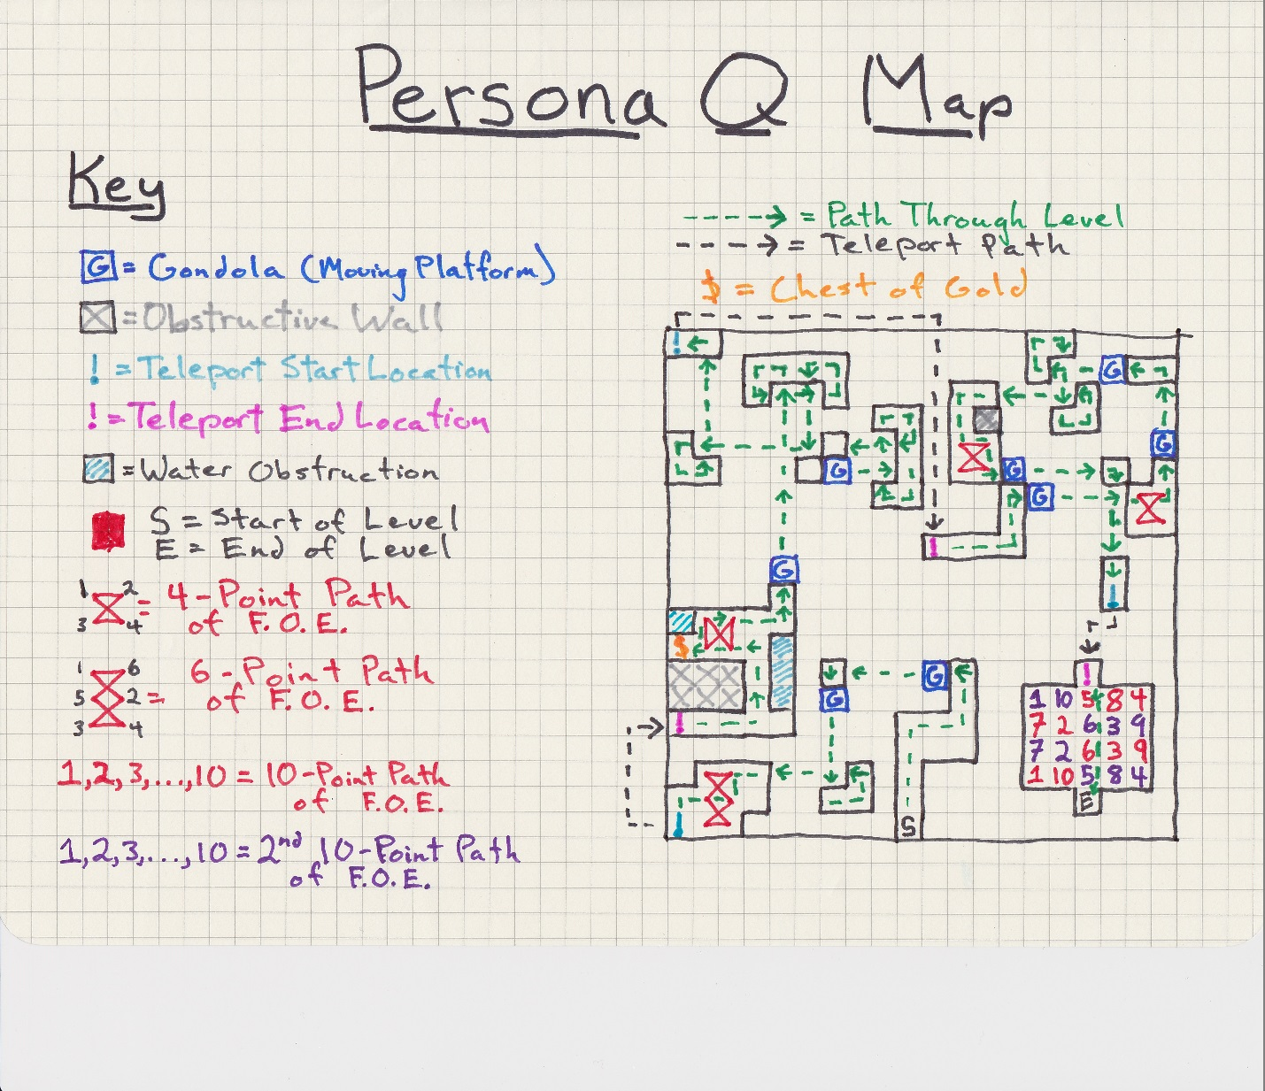

1. **Second Map – Intensity Curve**

UP

@ Time 0:00 – 1:00 – Player gets through the first area in the first 10 seconds and encounters this new, platform-moving mechanic. The first two gondolas are meant to show the player how they work (especially how to use one gondola more than once) but without being very difficult.

@ Time 2:00 – 3:00 – The player starts on the second set of gondolas, seeing that there are many more and that it will be an even greater challenge.

@Time 4:00 – 5:00 – The satisfaction of figuring out the puzzle and feeling the accomplishment of having finished the first half of the map.

@ Time 5:-00 – 6:00 – Immediately seeing there’s another gondola puzzle, the player being confident after the past experience that they are up to the challenge.

@ Time 8:00 – 9:00 – Finishing the second set of gondolas mixed with FOE monster/obstacles and feelings a sense of mastery over the level

@Time 10:00 – Feeling the accomplishment of having beaten the level and taken on a curveball with the two FOEs (there movement is staggered) at the very end.

DOWN

@ Time 1:00 – 2:00 – After seeing the gondolas, the player is given a short “break” where they face a simple FOE obstacle. This would have been something players have seen since the very first level of the game.

@ Time 3:00 – 4:00 – The player realizes the gondola puzzle is a bit trickier than expected—perhaps causing some frustration—being forced to leave behind one gondola in search of a way to come at from a different angle.

@ Time 6:00 – 7:00 – Similar to the frustrating moment in the first gondola puzzle where the player realizes they must now solve the puzzle while also dealing with FOEs, forcing them to correctly time their landing with the gondolas.

@ Time 8:00 – 9:00 – Thinking that at first this last part of the level is going to be easy and a bit of letdown, only to realize that it’s a completely different FOE pattern (and there’s now TWO of them) to navigate through to the end.