**Setsuko: The Unscarred Lands**

Basic Map, Descriptive Walkthrough, and Intensity Curve with Up/Down List

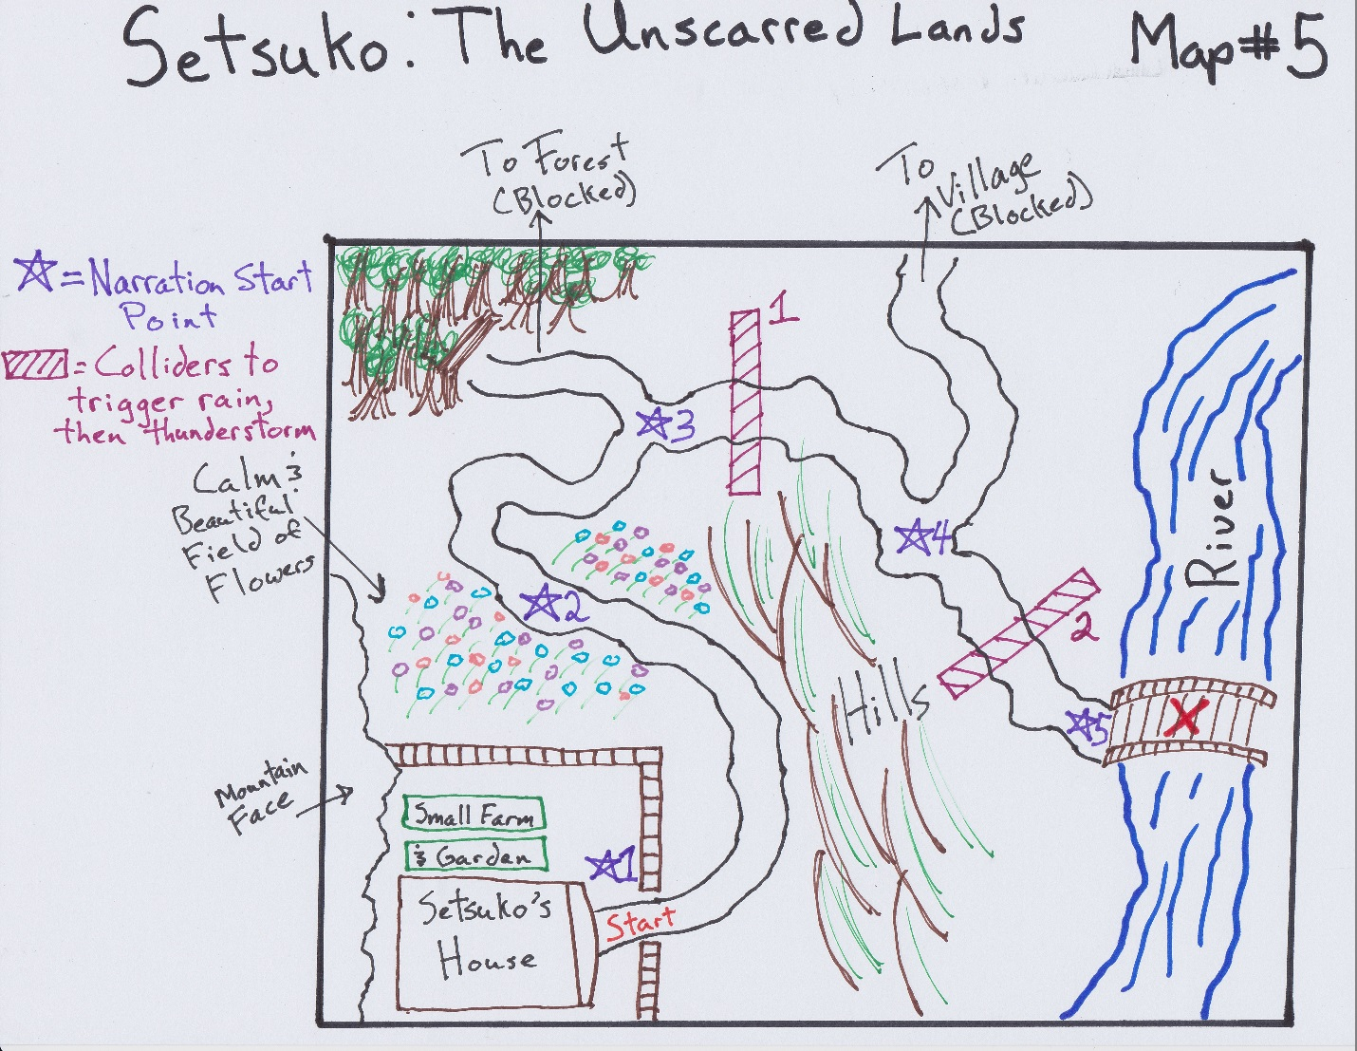

This map was made as a result of needing to completely redo the opening of the game. As of the end of last semester, the opening portion of our game was made at different times without any real overriding design guiding its layout. It developed more out of the need to test technical issues for systems that we spent the majority of that semester building. Now that we had the tech out of the way, it was time to look back at the design and see what we could do with. As a group, we had also decided we wanted to work in the five stages of grief into the design. This is a story of a young girl coming to grips with the death of her mother and as such, we felt it might give the narrative more strength if we were able to include these stages, which most people are at least somewhat familiar if only having the knowledge that it is a concept.

With this in mind, I started to design the beginning section of the game (which would be split into five distinct sections corresponding to the stages of grief). The goal at this point in the game was not to get the player immediately into the mechanics of the game, but rather to give them a feel for the world they were about to traverse *as* a 11 or 12 year old Japanese girl who, up until now, has had a very surface-level experience with the world around her. I wanted that innocence to be the very first thing the player starts out with, knowing this is the first stage: Denial. So, from the beginning I designed Setsuko’s house in a cove backed up to a mountain and with rolling hills closing it off from the rest of the world. I wanted the player to feel like it was leaving an isolated haven where Setsuko has felt safe. (Note: As of right now, there will be a narrator who will deliver lines occasionally throughout this section and others giving information regarding Setsuko’s and her families past as well as their present concerns). She sets out seeking a famous Monk that she has heard stories about, determined that he will be able to help. Soon after leaving this isolated area, the player comes to a fork in the road, ostensibly allowing Setsuko her first choice. She can continue down the sunny path or try to head towards the more foreboding woods. As the woods will be blocked (and the narrator providing a simple explanation), the character will have no choice but to keep Setsuko on the bright and sunny path.

After she makes this choice, however, a light rain shower starts, symbolizing the first break in the illusion she’s set up for herself (that is, that she actually can cure her mother through magical means). The player soon comes to another fork, this time between the road to the city (where Setsuko might retrieve something practical that could ease her mother’s pain) or to continue down the path towards the monk. Again, the player will not actually have a choice and Setsuko will continue to go down the path towards the Monk. The thunderstorm get much worse this time as she quickly comes up to a bridge. This bridge symbolizes, both figuratively and literally, as the last chance to turn back and try things differently. Trapped in her state of denial even though the world itself seems to be telling her to stop, she crosses the bridge. Halfway across, it collapses taking her down a river and onto the rest of the game.

UP

@ Time + 0:00 – 1:00 – The player starts out and walks through the front gate of the house and through the pleasant valley and fields of flowers, with interest climbing steadily but with no real spike or a moment of intense interest.

@ Time + 1:00 – 1:30 – The player hits the first fork in the road and realizes they can’t go down it. The narrator fills them in, ever so slightly, perhaps triggering some thoughts about why they can’t choose to go down a different path.

@ Time + 2:00 – 2:30 – The player hits the second fork and starts to see the pattern emerge. This girl has her mind set and she won’t be swayed. The player might now start to pick up on the overall theme of this area.

@ Time + 3:00 – 4:00 – The thunderstorm hits and the player realizes that they must keep going further down the same path. Hopefully through the symbols and the subtle narration it will now become clear what is going on. This segment then ends with an epic moment as lightning flashes, the camera shakes, and the bridge collapses sending Setsuko down the river.

DOWN

@ Time + 1:30 – 2:00 – The novelty of looking around this area has started to wane, causing the player to start actively looking around for more things to happen instead of just walking around.

@ Time + 2:30 – 3:00 – There is a change to a slight rain shower, but perhaps this underwhelming and it looks like the game might be just walking through landscapes with changing weather and a pointless narrator. Note: This part definitely needs playtesting.