**Setsuko: Washed Up**

Basic Map, Descriptive Walkthrough, and Intensity Curve with Up/Down Lists

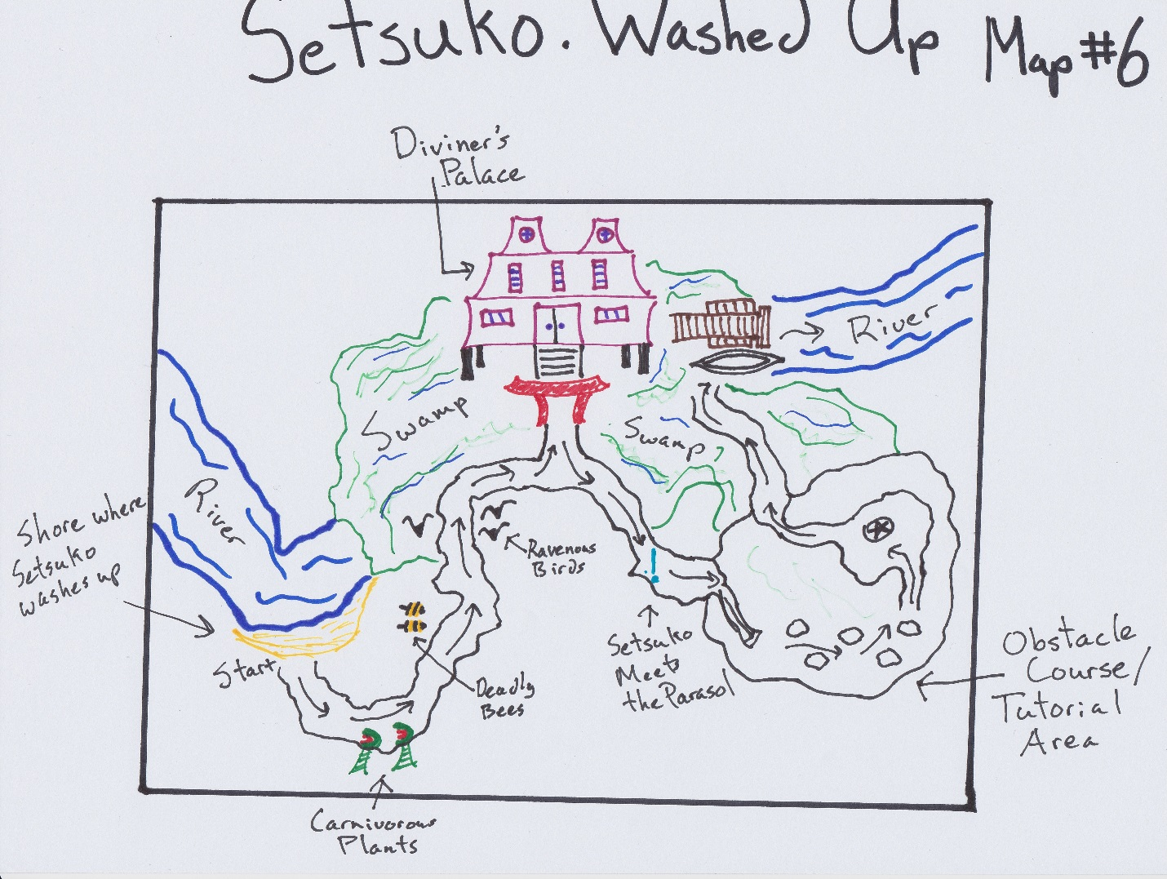

This is the section directly following the previous one (The Unscarred Lands). The player finds Setsuko washed up on the slight shore of the river before it empties into a foul swamp. The atmosphere is completely different from the location previous to this. As she rises to her feet, it’s obvious that her plan has completely gone off course and she is in slightly hostile territory. The player now has some slight control of Setsuko’s action besides walking: she can now punch the air. Not that this will do any good. The environment around her starts to attack as she moves along a barely visible path away from the river/swamp. An enlarged and carnivorous plants lashes out; a swarm of bees descend and chase her; carrion birds dive bomb her from above. She can try to swat at them with her fists, but it does no good at all. The player must run away if they are to survive. She is now in the stage of Anger, but despite all of her fury and indignation at her surroundings and circumstance, she is unable to do anything about it.

Not too far down this path, finally away from the attacking plant and animal life, she approaches a completely out-of-place palace in the middle of this swamp land. As she approaches, a voice calls out to her, entreating her to come inside and away from the creatures. There is a short cut-scene of sorts here where the player meets The Diviner, a character that promises to help Setsuko if she can locate two relics of a former, powerful Diviner. First, however, she must complete a small obstacle course so that he can be sure of her resolve and that she has the skills required. He equips with nothing but an old parasol and sends her out to another part of the swamp land. It is on this path that the parasol “wakes up”, informing Setsuko that it is a yokai (or “spirit demon”) that is under the thrall of the Diviner, forced to help him until he is released. This will be Setsuko’s primary method of interacting with her environment.

The next part of this area is the small obstacle course that is really just a tutorial for players to get used to moving around with the parasol grappling-hook tongue. It also has a simple puzzle using the parasol’s “wind push” ability. After she has finished the obstacle course, the path winds back around to another part of the palace where there is a small boat. The Diviner instructs her to get in and that it will take her to her first destination, The Black Bunker.

UP

@ Time + 0:00 – 1:00 – The player washes up on the shore of a new area and discovers the use of Setsuko’s fist. Not terribly exciting, but a definite change of pace.

@ Time 1:00 – 3:00 – This is from the first encounter with the carnivorous plants, through the bees, and finally running away from the ravenous birds. The shock would first come because this is the first time the player has seen an enemy. The second, larger shock comes when the player realizes they can’t really fight back at all.

@ Time 5:00 – 6:00 – Meeting the parasol for the first time when it “wakes up”. Players who before might have thought an old umbrella was a lame weapon might now be pleasantly surprised at its new sentience.

@ Time 7:00 – 9:00 – First getting used to the basic grapple-hook method of jumping around areas using the parasol’s long, elastic tongue. Then moving immediately on to a puzzle using the parasol “wind push” ability giving the player a sense of accomplishment for learning the control scheme being able to move on to the first real dungeon awaiting them.

DOWN

@ Time + 3:00 – 5:00 – After the race from the deadly plant and animal life, the palace, while out of place, will still serve as a respite. As this is also a major plot point area, it has the potential to drag down players who are not at all interested in the plot.

@ Time + 6:00 – 7:00 – After the initial shock of meeting the umbrella, the player then has to figure out exactly how it is controlled. Figuring out controls, even at the beginning of a tutorial, is never a fun thing to do.