紀錄編號： 填表日期： 年 月 日
系統名稱 |  | 功能名稱 | 成績計算
一、Calculate

二、資料表結構：
請參考資料表pubdep、pubsec、regstusem、selstch、selstchf、selstugracrd、stufile、sclperson

三、輸入條件：
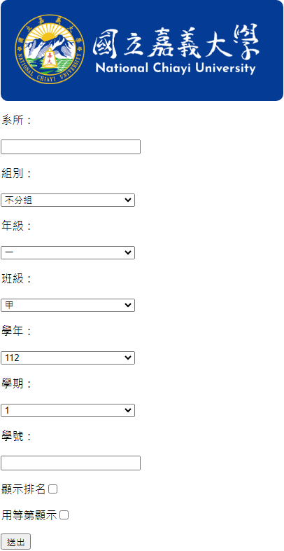
- 學年(syear)、學期(sem)為必要輸入條件，系所(deptno)、組別(secno)、年級(grade)、班級(clacod)與學號(stuno)須擇一輸入。

四、程式權限：
使用者身份別 7:行政(參考 D-029_110-1-A01-000)
■執行：具權限者，可進入程式
■插入：具權限者，進行紀錄插入作業(可不須任何條件查詢)
□刪除：具權限者，完成條件查詢後，從符合紀錄中刪除特定紀錄
■更新：具權限者，完成條件查詢後，從符合紀錄中更新特定紀錄
■查詢：具權限者，完成條件查詢後，顯示符合紀錄

五、資料權限：
使用 PB 原本規劃之資料權限設定(參考 D-029_110-1-A01-000) 控制資料表 stufile，控制欄位 deptno

六、系統流程及邏輯：
學制SQL：SELECT [acadno] FROM [stufile] WHERE [stuno] = '{StudentId}'
學生註冊SQL：
SELECT
[syear],
[sem],
[deptno],
[secno],
[clacod],
[grade]
FROM [regstusem]
WHERE [stuno] = '{StudentId}'
AND (([syear] < {syearEnd})
OR ([syear] = {syearEnd}
AND [sem] <= {semEnd}))
ORDER BY [syear], [sem]
Selstchf：
班級已註冊學生SQL：
SELECT [stuno]
FROM [regstusem]
WHERE [syear] = {regsem.syear}
AND [sem] = {(regsem.sem > 2 ? 2 : regsem.sem)}
AND [deptno] = '{regsem.deptno}'
AND [secno] = {regsem.secno}
AND [grade] = {regsem.grade}
AND [clacod] = {regsem.clacod}
AND [stateno] = 01
是否存在與是否排名SQL：
SELECT [rank_cd]
FROM [selstchf]
WHERE [stuno] = '{stu.stuno}'
AND [syear] = {item.syear}
AND [sem] = {item.sem}
插入：
選取SelstchSQL：
SELECT
[pass],
[credit],
[totalscore],
[dropcd],
[capacity]
FROM [selstch]
WHERE [stuno] = '{StudentId}'
AND [syear] = {syear}
AND [sem] = {sem}
AND [arrival_cd] = '1'
插入SQL：
INSERT INTO [selstchf](
[stuno],
[syear],
[sem],
[deptno],
[secno],
[grade],
[clacod],
[sucrd],
[rgcrd],
[lesscd],
[susco],
[scoavg],
[rank],
[allman],
[gpa],
[user_id],
[updat_date],
[updat_time],
[rank_cd])
VALUES (
'{StudentId}',
{syear},
{sem},
{deptno},
{secno},
{grade},
{clacod},
{sucrd},
{rgcrd},
{(sucrd / 2 < rgcrd ? 0 : (sucrd / 3 < rgcrd ? 1 : 2))},
{susco},
{Math.Round(susco != 0 ? susco / sucrd : 0, 2)},
0,
'',
{Math.Round(GPA != 0 ? GPA / sucrd : 0, 2)},
' {user_id}',
'{DateTime.Now.ToString("yyyy-MM-dd HH:mm:ss.fff", new CultureInfo("en-us"))},
{DateTime.Now.ToString("HHmmss", new CultureInfo("en-us"))},
0)
排名：
選取學生與成績SQL：
SELECT
[stuno],
[scoavg]
FROM [selstchf]
WHERE [syear] = {syear}
AND [sem] = {sem}
AND [deptno] = '{deptno}'
AND [secno] = {secno}
AND [grade] = {grade}
AND [clacod] = {clacod}
ORDER BY [scoavg] DESC
更新SQL：
UPDATE [selstchf]
SET
[rank] = {stu.rank},
[allman] = {size},
[user_id] = ' {user_id}',
[updat_date] = '{DateTime.Now.ToString("yyyy-MM-dd HH:mm:ss.fff", new CultureInfo("en-us"))}',
[updat_time] = {DateTime.Now.ToString("HHmmss", new CultureInfo("en-us"))},
[rank_cd] = 1
WHERE [stuno] = '{stu.stuno}'
AND [syear] = {syear}
AND [sem] = {sem}
AND [deptno] = '{deptno}'
AND [secno] = {secno}
AND [grade] = {grade}
AND [clacod] = {clacod}"
註：學生為研究所時，修大學部與教育學分不列入成績計算
Selstugracrd：
班級已註冊學生SQL：
SELECT [stuno]
FROM [regstusem]
WHERE [syear] = {regsem.syear}
AND [sem] = {(regsem.sem > 2 ? 2 : regsem.sem)}
AND [deptno] = '{regsem.deptno}'
AND [secno] = {regsem.secno}
AND [grade] = {regsem.grade}
AND [clacod] = {regsem.clacod}
AND [stateno] = 01
選取SelstchfSQL：
SELECT
[sucrd],
[rgcrd],
[susco],
[gpa]
FROM [selstchf]
WHERE [stuno] = '{StudentId}'
AND (([syear] < {syear})
OR ([syear] = {syear}
AND [sem] <= {sem}))
ORDER BY [syear], [sem]
是否存在與是否排名SQL：
SELECT
[syear],
[sem],
[rank_cd]
FROM [selstugracrd]
WHERE [stuno] = '{StudentId}'
插入SQL：
INSERT INTO [selstugracrd](
[stuno],
[scoavg],
[clspgnsort],
[acadpgnsort],
[deptprnsort],
[allman],
[syear],
[sem],
[user_id],
[updat_date],
[updat_time],
[rank_cd],
[accsusco],
[accsucrd],
[accrgcrd],
[accgpa])
VALUES(
'{StudentId}',
{avg},
NULL,
NULL
NULL,
NULL,
{syear},
{sem},
' {user_id}',
'{DateTime.Now.ToString("yyyy-MM-dd HH:mm:ss.fff", new CultureInfo("en-us"))}',
{DateTime.Now.ToString("HHmmss", new CultureInfo("en-us"))},
0,
{susco},
{sucrd},
{rgcrd},
{GPA})
更新SQL：
UPDATE [selstugracrd]
SET
[scoavg] = {avg},
[clspgnsort] = NULL,
[allman] = NULL,
[syear] = {syear},
[sem] = {sem},
[user_id] = '{user_id}',
[updat_date] = '{DateTime.Now.ToString("yyyy-MM-dd HH:mm:ss.fff", new CultureInfo("en-us"))}',
[updat_time] = {DateTime.Now.ToString("HHmmss", new CultureInfo("en-us"))},
[rank_cd] = 0,
[accsusco] = {susco},
[accsucrd] = {sucrd},
[accrgcrd] = {rgcrd},
[accgpa] = {GPA}
WHERE [stuno] = '{StudentId}'
註：年分與學期不對時才做更新
排名：
選取學生與成績SQL：
SELECT [scoavg] FROM [selstugracrd] WHERE [stuno] = '{stu.stuno}'
更新SQL：
UPDATE [selstugracrd]
SET
[clspgnsort] = {item.rank},
[allman] = {size},
[user_id] = '{user_id}',
[updat_date] = '{DateTime.Now.ToString("yyyy-MM-dd HH:mm:ss.fff", new CultureInfo("en-us"))}',
[updat_time] = {DateTime.Now.ToString("HHmmss", new CultureInfo("en-us"))},
[rank_cd] = 1
WHERE [stuno] = '{item.stuno}'
七、輸出結果：
更新成績資料

