紀錄編號： 填表日期： 年 月 日
系統名稱 |  | 功能名稱 | 英文成績單
一、Transcript

二、資料表結構：
請參考資料表crscourse、con_behavior、crscredit、pubsec、pubdep、pubcol、regstusem、stufile、selstch、selstchf、selstugracrd、selpaper

三、輸入條件：
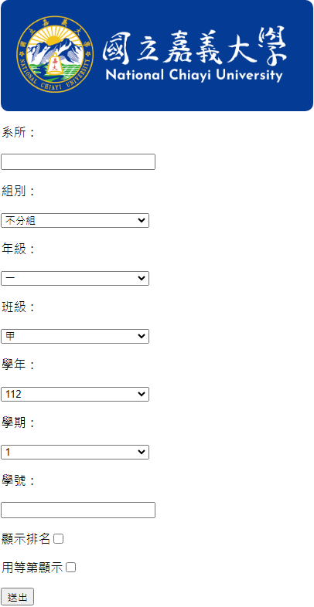
- 學年(syear)、學期(sem)為必要輸入條件，系所(deptno)、組別(secno)、年級(grade)、班級(clacod)與學號(stuno)須擇一輸入。
- 系所(deptno)：
(HTML datalist)
SQL: SELECT[deptno], [deptnam] FROM [pubdep]
- 組別(secno)：
(HTML select)
SQL: SELECT [secno], [secnam] FROM [pubsec] WHERE [deptno] = '{deptno}'
註：預設為不分組，當該系所有分組別即會提供選擇組別
- 年級(grade)：
(HTML select)
資料內容：(一, 二, 三, 四, 五)
- 班級(clacod)：
(HTML select)
資料內容：(甲, 乙, 丙, 丁, 戊, 己, 庚, 辛, 壬, 癸, 子, 丑, 寅, 卯)
- 學年(syear)：
民國年 3 碼(格式“000”)
- 學期(sem)：
(HTML select)
資料內容：(1, 2, 3)
- 學號(stuno)：
(HTML datalist)
SQL:
SELECT [regstusem].[stuno], [ename] FROM [regstusem]
LEFT JOIN [stufile] ON [regstusem].[stuno] = [stufile].[stuno]
LEFT JOIN [sclperson] ON [stufile].[idno] = [sclperson].[idno]
WHERE [regstusem].[deptno] = '{DeptId}' AND [regstusem].[secno] = '{Secno}' AND [regstusem].[grade] = '{Grade}' AND [regstusem].[clacod] = '{Clacod}' AND [syear] = {syearEnd} AND [sem] = {(semEnd > 2 ? 2 : semEnd)}
ORDER BY [regstusem].[stuno]
註：預設為空，若有值則輸出該位學生的成績單，會根據系, 組, 年, 班, 學年, 學期選取有註冊且符合條件的學生
- 顯示排名
在成績單累積排名處不顯示排名
- 用等第顯示
每個科目成績以A, B, C, D, E替代

四、程式權限：
使用者身份別 7:行政(參考 D-029_110-1-A01-000)
■執行：具權限者，可進入程式
□新增：具權限者，進行紀錄新增作業(可不須任何條件查詢)
□刪除：具權限者，完成條件查詢後，從符合紀錄中刪除特定紀錄
□修改：具權限者，完成條件查詢後，從符合紀錄中編輯特定紀錄
■查詢：具權限者，完成條件查詢後，顯示符合紀錄

五、資料權限：
使用 PB 原本規劃之資料權限設定(參考 D-029_110-1-A01-000) 控制資料表 stufile，控制欄位 deptno

六、系統流程及邏輯：
學制SQL：SELECT [acadno] FROM [stufile] WHERE [stuno] = '{StudentId}'

七、輸出結果：
大學部：
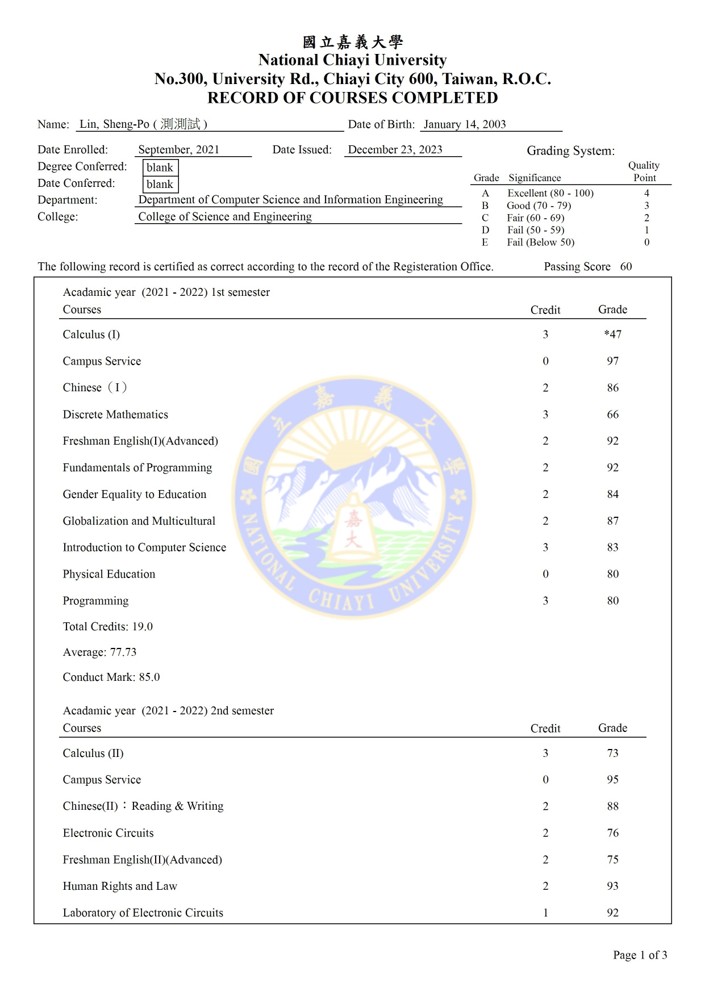
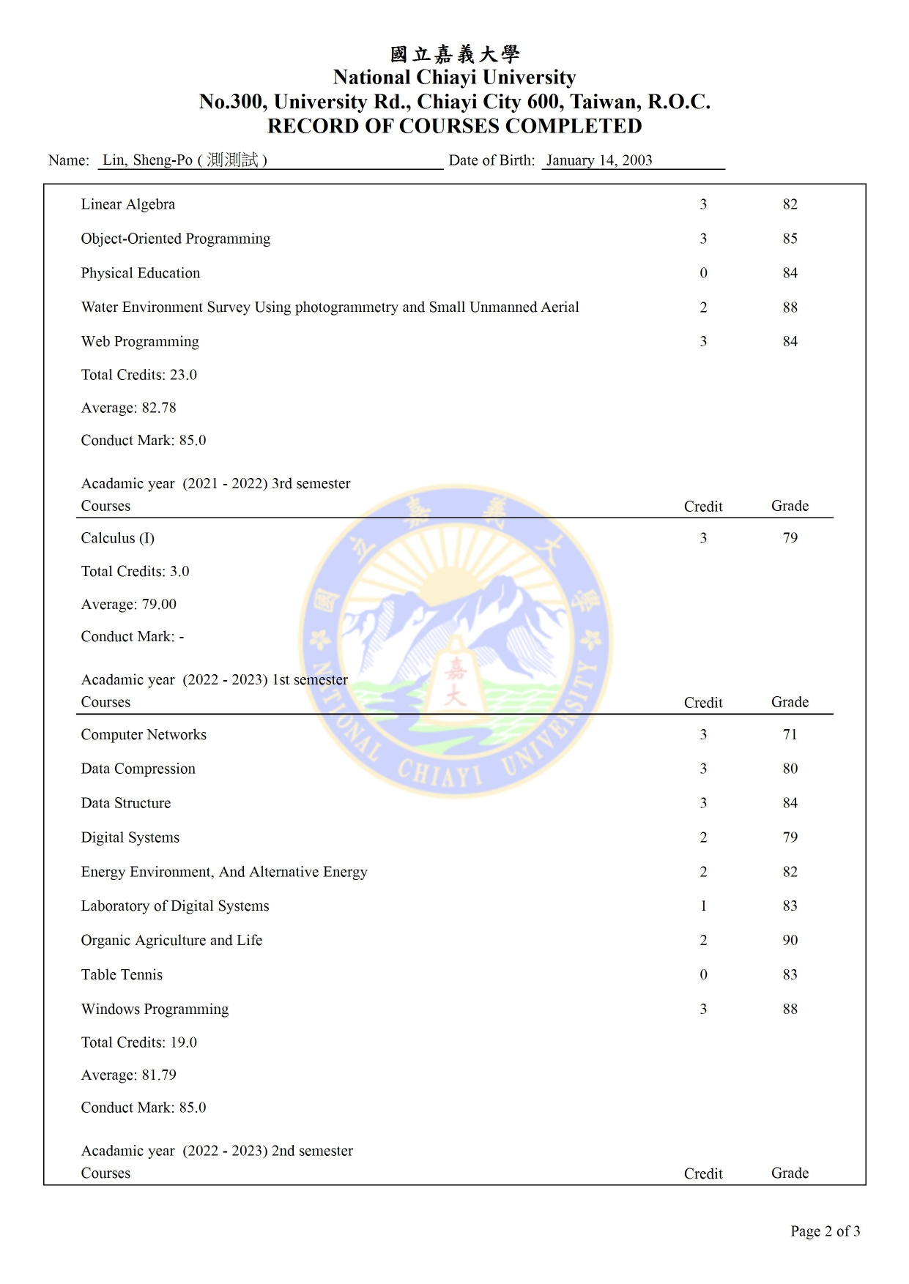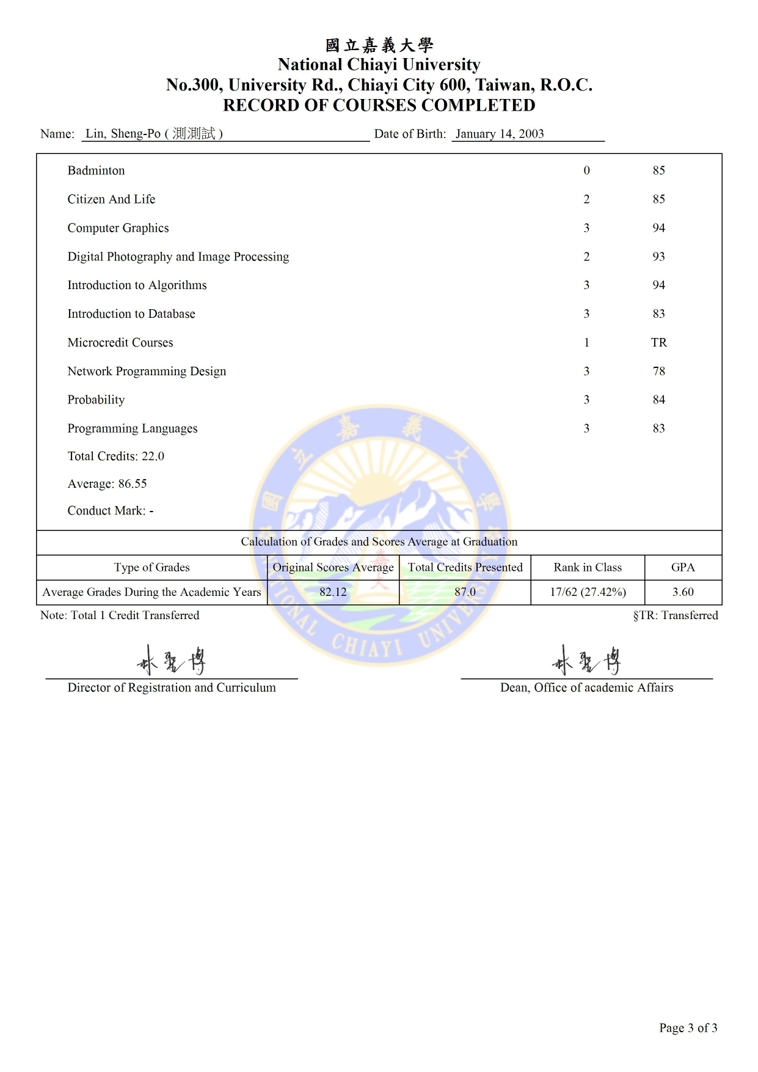
研究所：
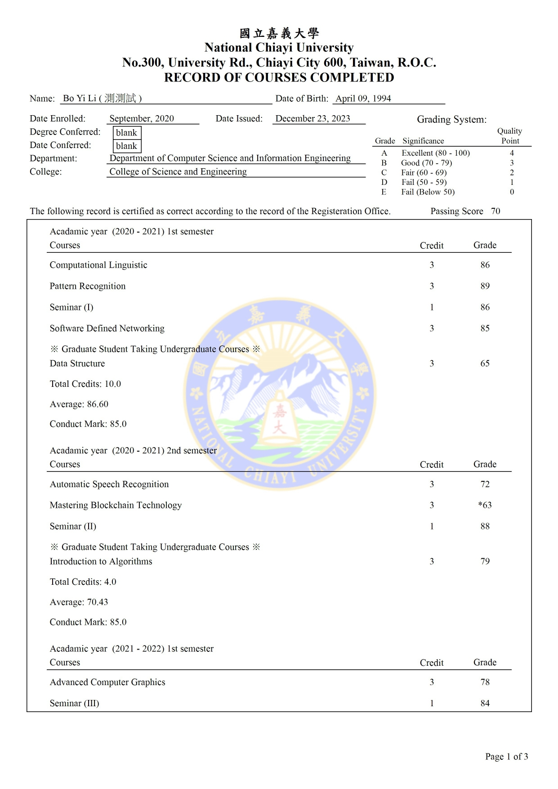
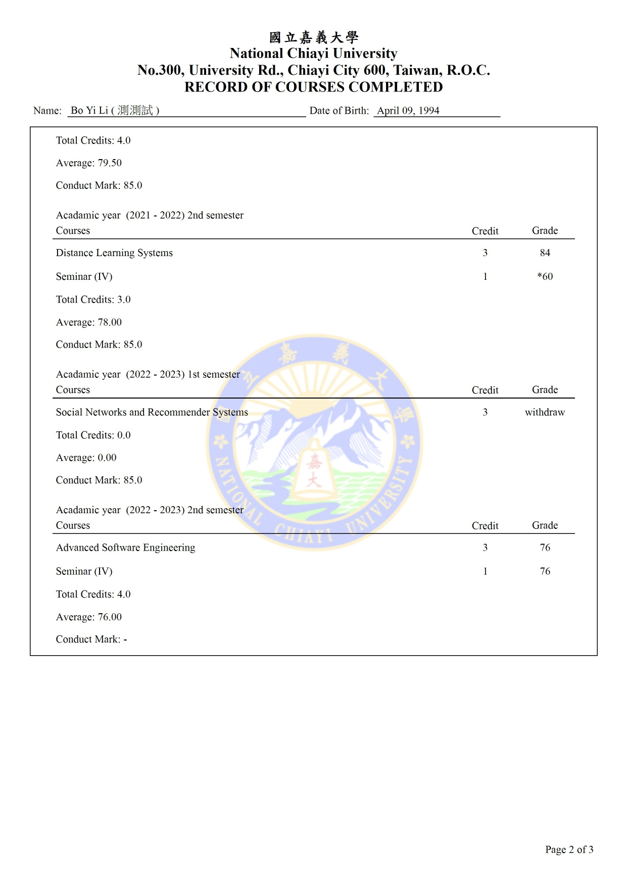
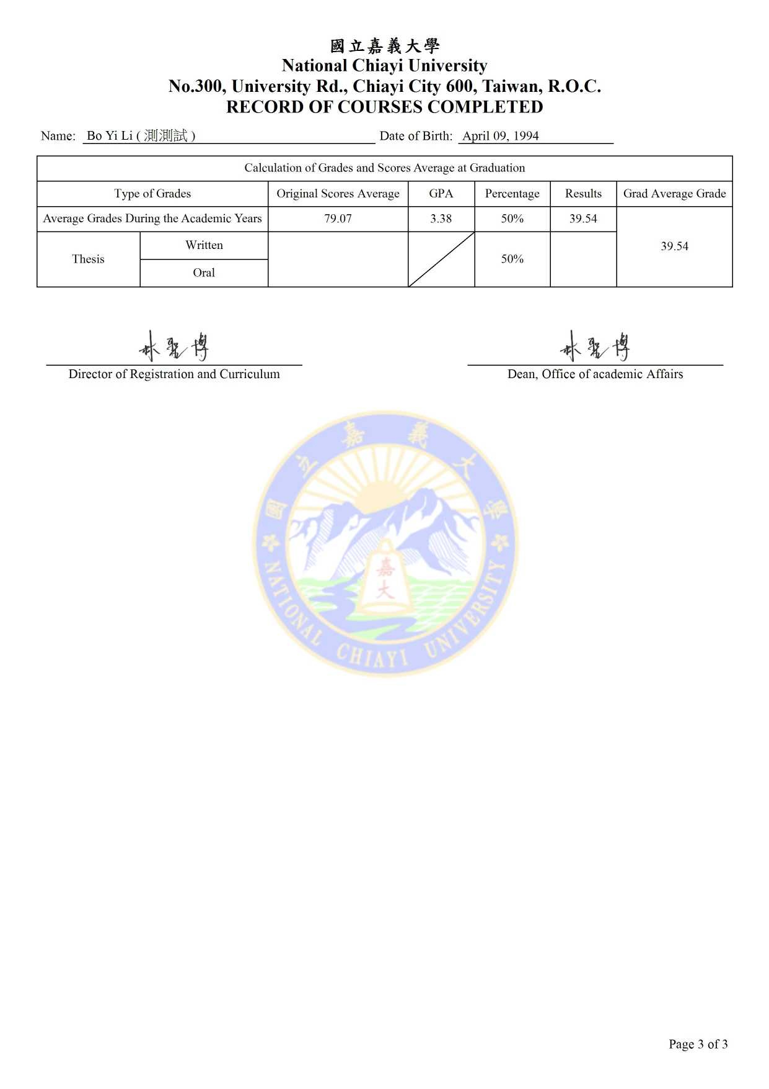
頁頭、頁尾SQL：
SELECT
[ename],
[cname],
[birthday],
[entrym],
[degrenam],
[graddat],
[deptenam],
[colenam],
[scoavg],
[accrgcrd],
[clspgnsort],
[allman],
[accgpa],
[selpaper].[score]
FROM [stufile]
LEFT JOIN [sclperson] ON [stufile].[idno] = [sclperson].[idno]
LEFT JOIN [pubsec] ON [stufile].[deptno] = [pubsec].[deptno]
LEFT JOIN [pubdep] ON [stufile].[deptno] = [pubdep].[deptno]
LEFT JOIN [pubcol] ON [pubcol].[colno] = [pubdep].[colno]
LEFT JOIN [selstugracrd] ON [stufile].[stuno] = [selstugracrd].[stuno]
LEFT JOIN [selpaper] ON [stufile].[stuno] = [selpaper].[stuno]
WHERE [stufile].[stuno] = '{StudentId}'
頁頭：
- Name：[ename] ([cname])
- Date of Birth：[birthday]
- Date Enrolled：[entrym]
- Date Issued：當前日期
- Degree Conferred：[degrenam]
註：[degrenam]如果為空，則顯示blank
- Date Conferred：[graddat]
註：[graddat] 如果為空，則顯示blank
- Department：[deptenam]
- College：[colenam]
註：Passing Score會根據學制輸出60或70
頁尾：
大學部：
- Original Scores Average：[scoavg]
- Total Credits Presented：[accrgcrd]
- Rank in Class：”[clspgnsort] / [allman]” ([clspgnsort] / [allman] %)
註：如顯示排名選項未勾選擇顯示”-”
- GPA：[accgpa]
- TR：上方課程TR的加總
研究所：
(1) Average Grades During the Academic Years：
- Original Scores Average：[scoavg]
- GPA：[accgpa]
- Percentage：50%
- Results：Original Scores Average* Percentage
(2) Thesis：
- Original Scores Average：[selpaper].[score]
- Percentage：50%
- Results：Original Scores Average* Percentage
(3) Grad Average Grade：兩個Result相加
(4) TR：上方課程TR的加總
註：頁尾會根據學制輸出不同樣式
課程與抵免課程SQL：
SELECT
[englishco],
[credit],
[pass],
[totalscore],
[selstch].[syear],
[selstch].[sem],
[rgcrd],
[scoavg],
[total_score],
[capacity],
[dropcd],
[arrival_cd]
FROM [selstch]
LEFT JOIN [crscourse] ON [selstch].[cono] = [crscourse].[cono]
LEFT JOIN [con_behavior] ON [selstch].[syear] = [con_behavior].[syear]
AND [selstch].[sem] = [con_behavior].[sem]
AND [selstch].[stuno] = [con_behavior].[stuno]
LEFT JOIN [selstchf] ON [selstch].[syear] = [selstchf].[syear]
AND [selstch].[sem] = [selstchf].[sem]
AND [selstch].[stuno] = [selstchf].[stuno]
WHERE [selstch].[stuno] = '{StudentId}'
AND (([selstch].[syear] < {syearEnd})
OR ([selstch].[syear] = {syearEnd}
AND [selstch].[sem] <= {semEnd}))
UNION SELECT
[englishco],
[credit],
CAST('Y' AS CHAR) AS [pass],
NULL AS [totalscore],
[crscredit].[syear],
[crscredit].[sem],
[rgcrd],
[scoavg],
[total_score],
CAST('0' AS CHAR) AS [capacity],
CAST('0' AS CHAR) AS [dropcd],
CAST('1' AS CHAR) AS [arrival_cd]
FROM [crscredit]
LEFT JOIN [crscourse] ON [crscredit].[crcono] = [crscourse].[cono]
LEFT JOIN [con_behavior] ON [crscredit].[syear] = [con_behavior].[syear]
AND [crscredit].[sem] = [con_behavior].[sem]
AND [crscredit].[stuno] = [con_behavior].[stuno]
LEFT JOIN [selstchf] ON [crscredit].[syear] = [selstchf].[syear]
AND [crscredit].[sem] = [selstchf].[sem]
AND [crscredit].[stuno] = [selstchf].[stuno]
WHERE [crscredit].[stuno] = '{StudentId}'
AND (([crscredit].[syear] < {syearEnd})
OR ([crscredit].[syear] = {syearEnd}
AND [crscredit].[sem] <= {semEnd}))
AND ([cr_class] = 2 {cr})
ORDER BY [syear], [sem], [capacity]
註：若學制為3, 4, 6，抵免課程cr_class = 4會被記入
課程：
- Acadamic year： ([syear] - [syear] + 1) [sem] semester
- Course：[englishco]
註：若為教育學分會註記(EDU)
- Credit：[credit]
- Grade：[totalscore]
註：會根據[pass]決定是否在前面加”*”
- Total Credits：[rgcrd]
- Average：[scoavg]
- ConductMark：[total_score]
註：若為研究所下修大學部會顯示※Graduate Student Taking Undergraduate Courses※，並且不列入成績計算

