Welcome!

Please scroll down to read introductory information

WordPub
BECE
Mathematics

Past Questions & Answers

2014

Junior High School
Years 1, 2 & 3

Compiled by:


© 2018 Word Publishers. All rights reserved

Unauthorized distribution and/or reproduction of this document prohibited.

CONTACT

Email:
info@wordpub.org

Telephone:
(+233) 030 295 1486,
(+233) 020 893 0787,
(+233) 057 860 0052,
(+233) 024 850 6613.

Postal Address:
Word Publishers,
P.O. Box NT 583,
Newtown – Accra,
Ghana.

Location:
7 Tunemete Street,
Dzorwulu-Accra,
Ghana.

Website:
bece.wordpub.org

ACKNOWLEDGEMENTS

- The West African Examination Council - for the BECE Mathematics past questions used in this document.

- Ernest Ato Bentil and Abdulai Zakaria– for your invaluable contribution to this work.

- Mr Eric Arthur – for your expert counsel and assistance.

- Ruth, Baaba and Fiifi Arthur – for your relentless support

- Teachers, parents and educational institutions – for your continuous patronage and tireless efforts at ensuring quality education for the 21st century child

- Junior High School students – you are the ultimate reason for this work.

DEDICATION
To the Lord Jesus Christ, our Saviour and soon-coming King

JUNE 2014

MATHEMATICS 1

Objective Test

1 Hour

- If set N is a subset of set M, then
  - sets M and N have the same number of elements
  - some members of set N can be found in set M
  - no member of set N is in set M
  - all members of set N are in set M

The Venn diagram shows the number of pupils who offer Mathematics (M) and / or English in a class.
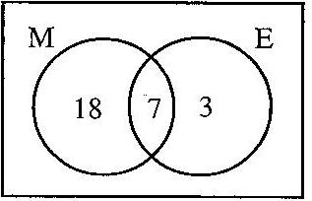
Use this information to answer Questions 2 and 3.

- How many pupils offer Mathematics?
  - 10
  - 18
  - 25
  - 28

- How many pupils offer only one subject?
  - 3
  - 7
  - 18
  - 21

- Simplify: 12 – 7 – (– 5)
  - – 10
  - – 2
  - 0
  - 10

- Express 72 as a product of its prime factors
  - 2 × 3³
  - 2² × 3³
  - 2³ × 3
  - 2³ × 3²

- Find the smallest number which is divisible by 16 and 20?
  - 40
  - 80
  - 120
  - 160

- Convert 243_{five} to a base ten numeral.
  - 40
  - 43
  - 45
  - 73

- A pineapple which was bought for GH¢ 1.00 was sold at GH¢ 1.30. Calculate the profit percent.
  - 10%
  - 20%
  - 23%
  - 30%

- Simplify 35x⁵y³ ÷ 7 xy²
  - 5x⁴y
  - 5x⁴y⁵
  - 5x⁶y
  - 5x⁶y⁵

- Two bells P and Q ring at intervals of 3 hours and 4 hours, respectively. After how many hours will the two bells first ring simultaneously (at the same time)?
  - 6 hours
  - 8 hours
  - 12 hours
  - 24 hours

- A boy scores in a French test. Express his score as a percentage.
  - 17%
  - 34%
  - 68%
  - 85%

- Arrange the following fractions in ascending order of magnitude 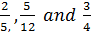, ,
  - 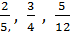
  - 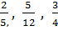
  - 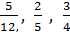
  - 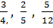

- Kofi paid rent of GH¢ 1,800.00 each year. If the rent is 0.3 of his annual income, find his annual income.
  - GH¢ 600.00
  - GH¢5,400.00
  - GH¢ 6,000.00
  - GH¢ 18,000.00

- I gave a storekeeper a GH¢10.00 note for goods I bought. He asked me for another 15Gp for ease of change. If he then gave me 50 Gp, how much did I pay for the goods?
  - GH¢ 9.35
  - GH¢ 9.45
  - GH¢ 9.65
  - GH¢ 10.65

- Kojo can buy 15 shirts at GH¢ 4.00 each. If the price is increased to GH¢ 5.00, how many shirts can he now buy?
  - 12
  - 15
  - 19
  - 20

- A hall which is 8m long is represented on a diagram as 4 cm long. What is the scale of the diagram?
  - 1:200
  - 1:250
  - 1:400
  - 1:800

- Jane arrived at work at 7:55 am and left at 4:15 pm. For how long was she at work?
  - 7 hr 20 min
  - 7 hr 45 min
  - 8 hr 20 min
  - 8 hr 40 min

- Given that (3.14 × 18) × 17.5 = 3.14 × (3p × 17.5), find the value of p
  - 3.0
  - 5.8
  - 6.0
  - 9.0

The pie chart shows how Kwaku spends his monthly salary.

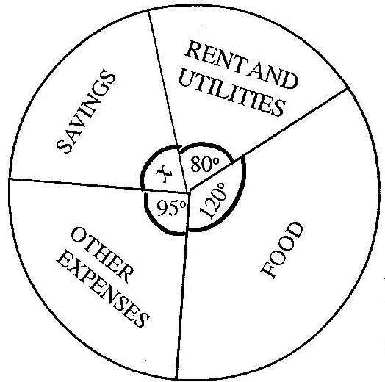
Use this information to answer Questions 19 to 21

- Find the value of x
  - 65°
  - 75°
  - 85°
  - 100°

- Kwaku earns GH¢ 630.00 a month. How much of this does he spend on food?
  - GH¢ 140.00
  - GH¢ 157.00
  - GH¢ 210.00
  - GH¢ 350.00

- What percentage of his salary does he spend on rent and utilities?
  - 12.1%
  - 12.5%
  - 22.2%
  - 33.3%

- In an enlargement with scale factor 2, which of the following statements is not true?
  - Each length is multiplied by 2
  - Each angle remains the same
  - The shape of the figure does not change.
  - The size of the figure does not change.

- Kofi, Kojo and Ama shared GH¢ 480,000.00 in the ratio 3:5:4. How much did Ama receive?
  - GH¢ 160,000.00
  - GH¢ 200,000.00
  - GH¢ 218,181.81
  - GH¢ 342,859.14

- If w = 12, x = 5, y = 6 and z = 4, find the value of wx – yz.
  - 18
  - 27
  - 36
  - 84

- A man was 24 years old when his son was born. Now he is three times as old as his son. Find the age of the son.
  - 6 years
  - 12 years
  - 18 years
  - 36 years

- There are 20 identical balls in a box. Twelve are blue and the rest are green. If one ball is taken at random from the box, find the probability that the ball is green.

- Using the following mapping, find the missing numbers p and q.

x 1 2 3 4 5 6
↓ ↓ ↓ ↓ ↓ ↓ ↓
y 3 5 p 9 11 q

  - p = 6, q = 12
  - p = 6, q = 13
  - p = 7, q = 12
  - p = 7, q = 13

- The perimeter of a rectangle is 24 cm. If the length is 7 cm, find its width.
  - 3 cm
  - 5 cm
  - 10 cm
  - 12 cm

- A boy walks on a bearing 070°. Which of the following diagrams show his direction?

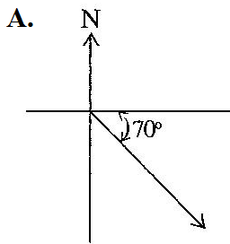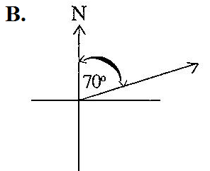

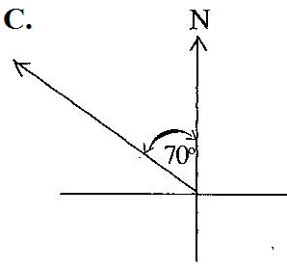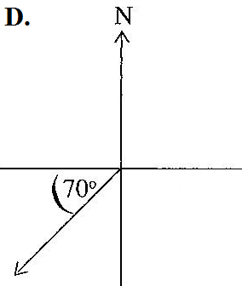

- How many faces has a cube?
  - 4
  - 6
  - 8
  - 12

- The diameter of a circular tray is 28 cm. Find the area of the tray. [Take π = ]
  - 44 cm2
  - 88 cm2
  - 154 cm2
  - 616 cm2

- Calculate the volume of a cylinder with radius 7 cm and height 10 cm. [Take π = ]
  - 220 cm3
  - 440 cm3
  - 1,540 cm3
  - 3,080 cm3

Use the diagram below to answer questions 33 and 34

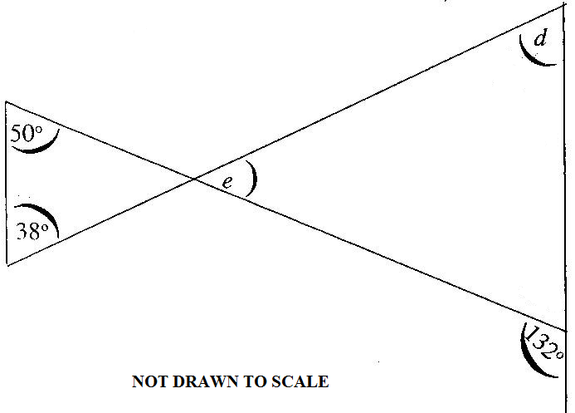

- Find the value of e.
  - 38°
  - 40°
  - 88°
  - 92°

- Find the angle marked d
  - 38°
  - 40°
  - 48°
  - 88°

- A 3.6 m long string is to be cut into pieces, each of length 40 cm. How many pieces can be cut from the string?
  - 4
  - 6
  - 8
  - 9

- Solve the inequality
  - x ≤ 10
  - x ≥ 10
  - x ≤ 40
  - x ≥ 40

- The point P (5, 4) is reflected in the y-axis. Find its image.
  - (– 5, 4)
  - (5, –4)
  - (–4, 5)
  - (4, –5)

- If 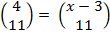 , find the value of x.

  - –1
  - 1
  - 7
  - 12

- Find the gradient of the line which passes through the points M(–1, 2) and N(6, –3)

- Find the next two terms in the sequence 11, 7, 3, –1, ___, ___.
  - 5, 9
  - 3, 7
  - –4, –9
  - –5, –9

END OF PAPER

JUNE 2014

MATHEMATICS 1

Objective Test
SOLUTIONS

- D. all members of set N are in set M
- C. 25
- D. 21
- D. 10
- D. 2³ × 3²
- B. 80
- D. 73
- D. 30%
- A. 5x⁴y
- C. 12 hours
- C. 68%
- B.
- C. GHC 6,000
- C. GHC 9.65
- A. 12
- A. 1:200
- C. 8hr 20 min
- C. 6.0
- A. 65°
- C. 210°
- C. 22.2%
- D. The size of the figure does not change
- A. GHC 160,000.00
- C. 36
- B. 12 years
- B.
- D. p = 7, q = 13
- B. 5 cm
- B.
- B. 6
- D. 616 cm²
- C. 1540 cm3
- D. 92°
- B. 40°
- D. 9
- A. x ≤ 10
- A. (-5, 4)
- C. 7
- A.
- D. –5, –9

JUNE 2014

MATHEMATICS 2

Essay

1 hour

- (a) P = {factors of 30}
Q = {Multiples of 5 less than 40}
Find P ∩ Q

(b) A trader saved GH¢ 200.00 for 3 years at 12% simple interest per annum.
What will be the total amount in the trader’s account at the end of the 3 years?

(c) Evaluate 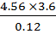 and leave your answer in standard form.

- (a) (i) Ama scored 82, 74 and 90 in three tests. What mark should she score in the fourth test so that her average mark for the four tests would be 85?

(ii) What was her median score in the four tests?

(b)
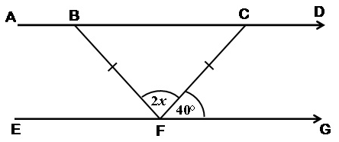
In the diagram is parallel to , angle CFG = 40° and triangle BCF is isosceles.
Find the value of :
- angle CBF
- angle DCF;
- x

- (a) Solve for x, if
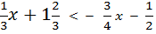

(b) The following shows the distribution of marks of students in an examination.

6 43 26 18 27
42 8 22 31 39
55 44 37 47 59
10 12 36 53 48

- Make a stem-and-leaf plot of the marks above
- Find the probability of selecting a student who scored between 40 and 50.
- Find the number of students who passed the examination, if the pass mark was 30.

- (a) A box has length 8.0 cm, width 5.0 cm and height 10.0 cm.
Find the:
- total surface area of the box
- the volume of the box.

(b) (i) Using a scale of 2cm to 1 unit on both axes, draw two perpendicular axes Ox and Oy on a graph sheet.
(ii) On the same graph sheet mark the x-axis from –5 to 5 and the y-axis from – 6 to 6
- Plot and join the points
A(0, 3), B(2, 3), C(4, 5) to form triangle ABC.
- Draw the image A₁B₁C₁ of triangle ABC under a translation by the vector 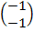
- Draw the image A₂B₂C₂ of triangle ABC under a reflection in the x - axis

- (a) Using a ruler and a pair of compass only;
- construct triangle PQR such that = 8cm, = 6 cm and = 5cm;
- construct the perpendicular bisector of and label it l₁;
- construct the perpendicular bisector of and label it l₂;
- Label the point of intersection of l₁ and l₂ as N;
- With N as centre and radius equal to |PN|, draw a circle.

(b) (i) Measure the radius of the circle.
(ii) Calculate the circumference of the circle, correct to 3 significant figures.
[Take π = 3.14]

- (a) Factorize completely 6xy – 3y + 4x – 2

(b)
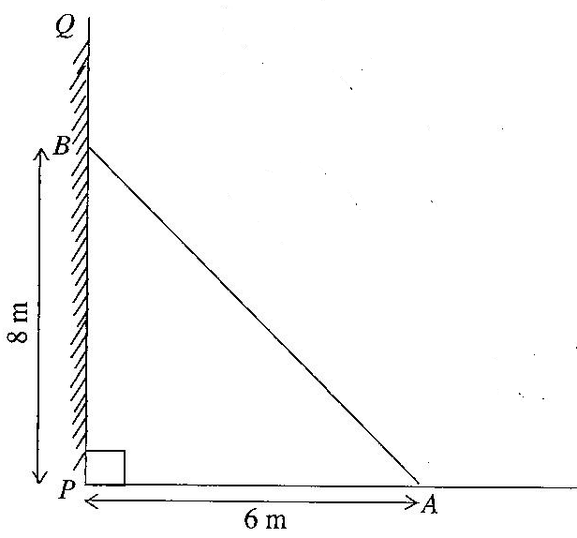
NOT DRAWN TO SCALE

The diagram shows a ladder AB which leans against a vertical wall PQ at B.
If |PB| is 8 m, and the other end of the ladder is 6 m away from the foot of the wall (at P), find the length of the ladder (|AB|)

(c) Kojo had 1800 bags of rice in stock for sale. In January, he sold ⅔ of it.
In February, he sold ¾ of what was left.

- What fraction of the stock of rice did he sell
(α) in February?
(β) in January and February?
(ii) How many bags of rice were left unsold, by the end of February?

JUNE 2014

MATHEMATICS 2

Essay
SOLUTIONS

1. (a) P = {1, 2, 3, 5, 6, 10, 15, 30}
Q = {5, 10, 15, 20, 25, 30, 35}
P∩Q = {5, 10, 15, 30}

1. (b) Total amount = Simple Interest + Principal

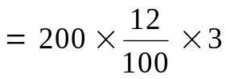
= 2 × 12 × 3
Simple interest = GHC 72.00

Total amount = Interest + Principal
= GHC 72.00 + GHC 200.00
= GHC 272.00

1. (c) 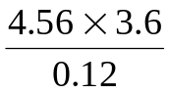
STEPS (1st Method)
1. Multiply both numerator and denominator by 1000
(or shift the decimal point 3 places to the right in both numerator and denominator – to convert to whole numbers)
2. Divide (‘cancel’) both 36 and 120 by 12 to get 3 and 10 resp.
3. Multiply 456 by 3 to get 1368
4. Shift the decimal point 1 place to the left (because of division by 10)
5. Convert to standard form by shifting decimal point 2 places to the left and multiplying by 10 to the power 2 (because decimal point was shifted 2 times)

1st Method
= 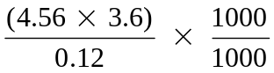
= 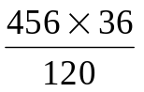
= 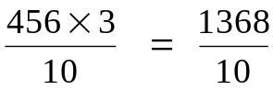
= 136.8
= 1.368 × 10²

1 (c) 2nd Method
STEPS (2nd Method)
1. Express using the ÷ sign
2. Change all decimals to fractions
3. Change the ÷ sign to × and
turn the divisor (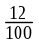) upside down to (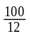)
4. Divide (‘cancel’) 36 and 12 by 12 to get 3 and 1 resp.&
Divide (‘cancel’) 100 (numerator) by 100 (denominator) to get 1 and 1 respectively
5.Multiply 456 by 3 to get 1368
6. Shift the decimal point 1 place to the left (because of division by 10)
7. Convert to standard form by shifting decimal point 2 places to the left and multiplying by 10 to the power 2 (because decimal point was shifted 2 times to the left)

= (4.56 × 3.6) ÷ 0.12
= 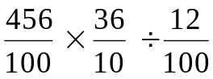
= 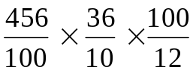
= 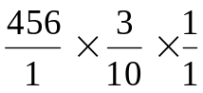
=
= 136.8
= 1.368 × 10²

1 (c) 3rd Method
=
STEPS (3rd Method)
1. Change decimals to whole numbers by shifting decimal point to the right and multiplying by 10 raised to negated same no.of times the point was shifted.
2. Rearrange to group similar number forms
3. Divide 36 (numerator) by 12 (denominator) to get 3
4. Divide 10 ^{–2} (numerator) by 10 ^{–2} (denominator) to get 1
5. Multiply 456 by 3 to get 1368
6. Express 1368 in standarm form to get 1.368× 10³
7. Simplify 10³ × 10^{–1} by adding the powers [3 + (-1) = 3-1 = 2]

= 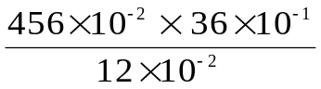
= 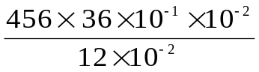
= 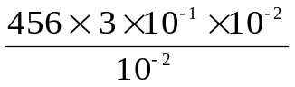
= 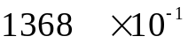
= 1.368 × 10³ × 10⁻¹
= 1.368 × 10³⁺ ⁽⁻¹⁾
= 1.368 × 10²

2. (a) (i) Let x = Ama’s score in the fourth test

Method 1
Mean = 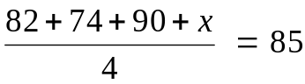
1. Write an expression for her mean score, using the given scores,
2. Multiplying both sides by 4 (to clear fraction)
Or ‘Cross-multiply’
3. Subtract 246 from both sides
(send 246 across the ‘=’ sign and negate it)
4. Simplify to get answer.
⇒ 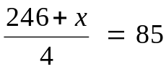
⇒ 246 + x = 4 × 85
⇒ x = 340 – 246
⇒ x = 94

2. (a) (i) Method 2
Total marks = No. of marks × mean mark
= 4 × 85
= 340
Sum of first 3 marks = 82 + 74 + 90
= 246
Ama’s fourth mark = Total mark – sum of first three
= 340 – 246
= 94

(a) (ii) Median score
Scores arranged in order gives 74, 82, 90, 94
Median = 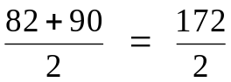
= 86

(b) (i) Since angles BCF and CFG are alternate angles,
⇒ Angle BCF = 40°
Now, since base angles of isosceles triangle BFC are equal,
⇒ Angle CBF = 40°

(ii) angle DCF + angle BCF = 180° (angles at a point on a straight line = 180°)
⇒ angle DCF + 40° = 180°
⇒ angle DCF = 180° – 40°
= 140°

(iii) 2x + 40° + 40° = 180° (Sum of interior angles of a triangle = 180°)
2x + 80° = 180°
2x = 180° – 80°
2x = 100°
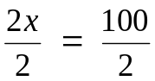
x = 50

3. (a) Solve for x,
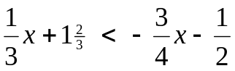

Method 1
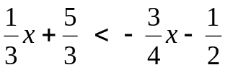
STEPS (Method 1)
1. Change mixed fraction (1 ²/₃) to improper fraction (⁵/₃)
2. Multiply both sides by 12 (LCM of denominators)
3. Simplify each term
4. Group like terms on same side
5. Simplify
6. Divide both sides by 13

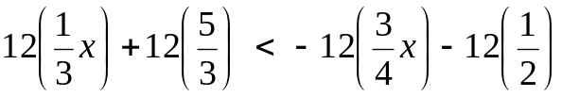
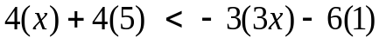
4x + 20 < – 9x – 6
4x + 9x < – 20 – 6
13 x < – 26
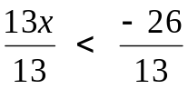
x < – 2

3. (a) Method 2
STEPS (Method 2)
1. Simplify (add / subtract) fractions on both sides
2. Multiply both sides by 12 (LCM of denominators)
3. Simplify (‘cancel’)
4. Expand and simplify
5. Group like terms on same side
6. Simplify
7. Divide both sides by 13

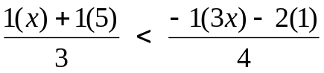
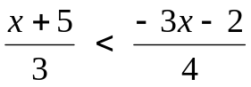
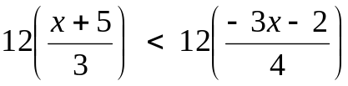
4 (x + 5) < 3(– 3x – 2)
4x + 20 < – 9x – 6
4x + 9x < – 20 – 6
13 x < – 26
x < – 2

3.(b) (i) Stem-and-leaf plot

Stem | Leaf
0 | 6, 8
1 | 0, 2, 8
2 | 2, 6, 7
3 | 1, 6, 7, 9
4 | 2, 3, 4, 7, 8
5 | 3, 5, 9

(ii) Probability of selecting a student who scored between 40 and 50

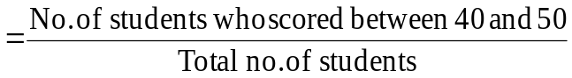
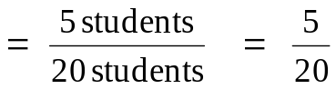
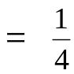

(iii) Number of students who passed, if the pass mark was 30
= n (31, 36, 37, 39, 42, 43, 44, 47, 48, 53, 55, 59)
= 12 students

4. (a) (i) Let length = l, width = w, height = h

Total surface area = 2lw + 2lh + 2wh,
= (2× 8cm × 5cm) + (2 × 8cm × 10cm) + (2 × 5cm × 10cm)
= 80cm² + 160cm² + 100cm²
= 340 cm²

(ii) Volume = l × w × h
= 8cm × 5cm × 10cm
= 400 cm³

4 (b)
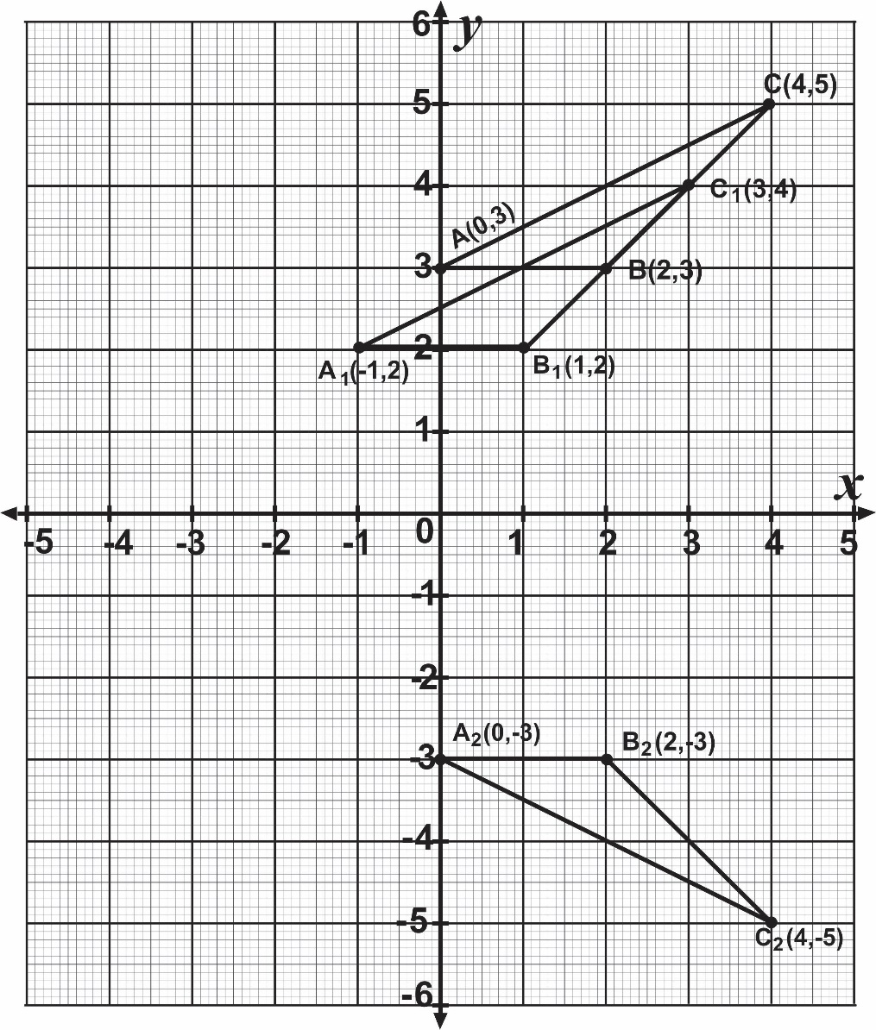

5. (a)

P
R
Q
L₂
L₁
N

(b) (i) Radius = 4.0cm (or 4.1cm)

(ii) If r = 4.0 cm
C = 2 π r
= 2 × 3.14 × 4 cm
= 25.12 cm

Or if r = 4.1cm
C = 2 × 3.14 × 4.1 cm
= 25.748 cm

6. (a) 6xy – 3y + 4x – 2
3y(2x – 1) + 2(2x – 1)
(2x – 1) (3y + 2)

(b) The length of the ladder AB forms the hypotenuse of the right-angled triangle ABP
From the Pythagorean theorem,
|AB|² = |AP|² + |BP|²
= (6)² + (8)²
= 36 + 64
|AB|² = 100
⇒ |AB| = 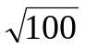
= 10 m
The length of the ladder AB is 10 m

6. (c) Method 1

No. of bags sold in January = 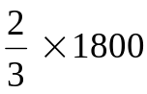
= 2 × 600
= 1200

No. of bags left = 1800 – 1200
= 600

No. of bags sold in February = 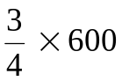
= 3 × 150
= 450

(i) (𝛼) Fraction of bags sold in February = 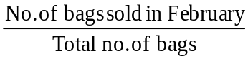
= 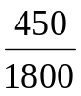
= 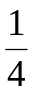

(i) (𝛽) Fraction of bags sold in Jan and Feb = 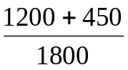
= 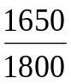
= 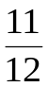

(ii) No.of bags left unsold by the end of February = 1800 – 1650
= 150

6. (c) Method 2

Fraction sold in January = 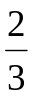
Fraction left = 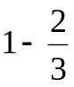
= 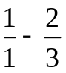
= 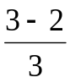
= 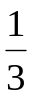

(i) (𝛼) Fraction sold in February = of fraction left
= 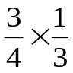
= 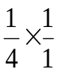
Fraction sold in Feb. = 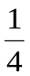

(i) (𝛽) Fraction sold In January and February
= 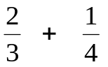
= 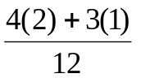
= 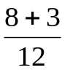 = 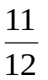

(ii) No. of bags left unsold by end of February

= Fraction left unsold × Total no. of bags
But fraction left unsold = 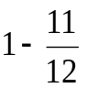
= 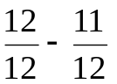
= 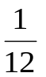

Therefore No. of bags left unsold by end of February
= 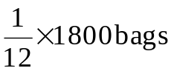
= 1 × 150 bags
= 150 bags

