2019 Basic Design And Technology (Home Economics ) – Paper One
1. The plan of a cylinder is a
A. circle
B. rectangle
C. square
D. triangle
2. The first stage of the design process is
A. brief
B. evaluation
C. situation
D. specification
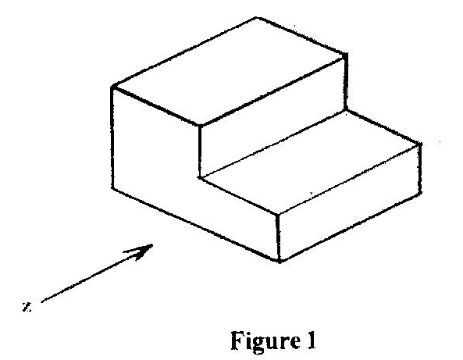
Figure I show the pictorial view of a block. Use it to answer questions 3 and 4.
3. Which of the following represents the front view in the direction of arrow Z?
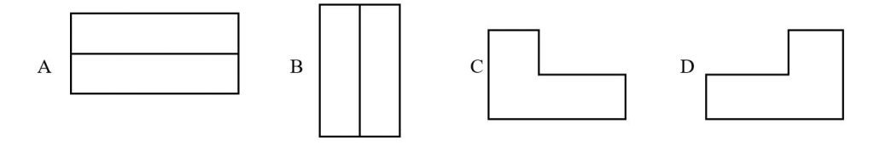
4. Which of the following represents the right end elevation?
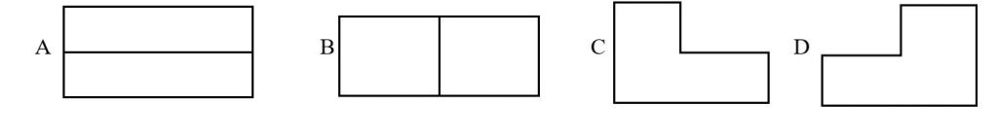
5. In the design process, the selected idea is developed in order to
A. determine the cost
B. evaluate final product
C. improve upon it
D. reduce its beauty
6. The most suitable pencil for drawing construction lines is
A. B
B. HB
C. 2B
D. 2H
7. A common method of cooking used for most Ghanaian staple foods is
A. steaming
B. boiling
C. frying
D. stewing
8. A seam that is often used for outer garment is
A. plain seam
B. French seam
C. Machine felled seam
D. Overlaid seam
9. When setting a table, the first course cutlery should be placed
A. at the top edge of the dinner plate
B. on the dinner plate
C. near the dinner plate
D. further away from the dinner plate
10. Stranded cotton thread is used for
A. decorative stitches
B. neatening seams
C. joining seams
D. temporary stitches
11. Red, Orange and violet are
A. warm colours
B. cool colours
C. opposite colours
D. neutral colours
12. The inscription BB on a pencil indicates that, it
A. is hard
B. is soft
C. breaks easily
D. sharpens well
13. A circle is
A. a form
B. a principle of design
C. a sphere
D. an element of design
14. The colour violet symbolizes
A. wealth
B. peace
C. aggression
D. royalty
15. The primary colours are
A. red, violet, yellow
B. green, yellow, red
C. red, yellow, blue
D. violet, yellow, green
16. The most important nutrients found in vegetables are vitamins and
A. carbohydrates
B. proteins
C. minerals
D. fats
17. In frying meat, heat is transferred by means of
A. conduction
B. convection
C. conduction and radiation
D. radiation and convention
18. Elements of design in nature include
A. lines, shape and dot
B. shape, dot and balance
C. line, rhythm and texture
D. texture, balance and rhythm.
19. An adolescent whose diet is deficient in iron is likely suffer from
A. rickets
B. goiter
C. scurvy
D. anaemia
20. Wounds and fractures can heal quickly if one takes in adequate amount of
A. starchy roots and plantain
B. fruits and vegetables
C. animal products
D. legumes and pulses
21. A stitched that is worked from right to left on the right side of an article is
A. overcasting
B. oversewing
C. hemming stitch
D. slip stitch
22. Which of the following elements of design is likely to be seen on whole baked rock buns?
A. Lines, colour and dot
B. Shape, texture and dot
C. Texture, shape and lines
D. Colour, lines and dot
23. Incorrect threading of a sewing machine will cause
A. puckering of seams
B. missing stitches
C. thread breaking
D. loose stitches forming
24. Suitable inexpensive fabric for making bag is
A. poplin
B. denim
C. damask
D. calico
25. The cause of spoilage in dried beans is
A. weevil
B. bugs
C. yeast activities
D. enzymes action
26. The rubbing -in method is used in the preparation of
A. queen cakes
B. fish turnovers
C. banana fritters
D. sweet pancakes
27. A suitable leavening agent that can be used in the preparation of banana cake is
A. palm wine
B. cream of tartar
C. baking powder
D. bicarbonate of soda
28. Heat is transferred by conduction and convection when food is cooked by
A. steaming
B. frying
C. grilling
D. baking
29. In Ghana, a popular method for preserving most food commodities at home is
A. drying
B. salting
C. smoking
D. bottling
30. The main use of fat in cake making to
A. enhance appearance
B. increase volume
C. improve keeping quality
D. improve flavour

Paper One – Answers
- A. circle
- C. situation
- C.
- A.
- B. evaluate final product
- D. 2H
- B. boiling
- A. plain seam
- A. at the top edge of the dinner plate
- A. decorative stitches
- A. warm colours
- B. is soft
- D. an element of design
- D. royalty
- C. red, yellow, blue
- C. minerals
- B. convection
- A. lines, shape and dot
- D. anaemia
- B. fruits and vegetables
- B. oversewing
- B. Shape, texture and dot
- D. loose stitches formin
- D. calico
- A. weevil
- A. queen cakes
- D. bicarbonate of soda
- A. steaming
- A. drying
- B. increase volume

2019 Basic Design And Technology (Home Economics ) – Paper Two
Share:


1. (a) List two uses of a table napkin.
(b) State four causes of food spoilage.
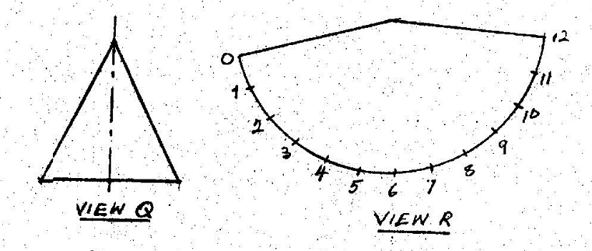
Figure 1
(c) Figure 1 shows two views of a solid.
(i) Name the type of solid represented as view Q.
(ii) State the type of view represented as view R.
(iii) List any three equipment that are used to draw the views Q and R.
(d) (i) List the primary colours.
(ii) Name four types of line.
2. (a) (i) Describe opening in sewing.
(ii) State the two main groups of openings.
(b) (i) Explain fastening.
(ii) Outline three functions each of openings and fastenings.
(c) List five types of fastenings used on adult garments.
(d) Enumerate four qualities of a good packaging material for a shirt.
(e) State any two rules for patching articles.
3. (a) State any four ways by which a caterer can maintain good health and a clean environment.
(b) State three reasons for storing dried beans.
(c) Explain food commodities.
(d) List five examples of food commodities.
(e) State two reasons why it is necessary for a caterer to stay clean and healthy.
4. (a) Give four reasons why yam is boiled.
(b) State three disadvantages of frying.
(c) With the aid of two diagrams explain how to test for the freshness of an egg using the brine test.
(d) Explain food preservation
(e) In the table below some food commodities have been provided. List one dish and one cooking method each that can be prepared from the food commodities.
Food Commodity | Dish | Cooking method
e.g. corn meal | Porridge | Boiling
Overripe plantain
Cowpeas
Rice
Yam
meat

Paper 2 – Answers
1 (a) 1. It used for wiping the mouth and fingers while eating.
2. Napkins can be used to cover the mouth when coughing at the table.
3. It can be used to prevent food from staining clothes.
(b) oxidation, moulds,enzymes,bacteria & oxidation.
(c) (i) A cone
(ii) Surface development
(iii) A pair of compasses,pencils, sets square, divider,ruler & drawing board
(d) (i) Red,Blue & Yellow
(ii) Construction lines, center lines, hidden line, dimension line & break lines

2. (a) (i) Openings are slits or cuts that are intentionally made on articles for easy opening or closing.
(ii) Opening with a wrap & opening without a wrap.
(b) (i) Fastenings are devices attached to openings and often used to close openings.
(ii) They allow garments to be put on and off quickly.
They make it possible for garments to be made in close-fitting styles.
They are used as decorations.
(c) Buttons and Button holes
Hooks and eyes
Press studs
Velco
Tapes
Zippers
Chinese loop/frog
Rouleaux loops and buttons
(d) Packaging must serve the purpose for which it is being used.
It must not be more expensive than the actual product.
It must be neatly fabricated.
It must be durable
It must be made of appropriate material
(e) Choose fabrics that match the article in color, texture, and design.
The thread used must match the article
The grains of the patch must match that of the article
The patch must be made flat, neat & strong.
3. (a) (i) Covering hair with hairnet or piece of cloth when cooking
(ii) Wearing neat clothes
(iii) Washing hands before handling food.
(iv) washing hands with soap under running water after visiting the toilet.
(v) Keeping the kitchen and its surroundings neat
(vi) Proper disposal of kitchen refuse & waste
(vii) Keeping utensils clean
(viii) washing foodstuff thoroughly before cooking.
(b) (i) Saves money
(ii) Preserves beans for future usage
(iii) Maintains colour
(iv) preserves nutrients
(v) reduces its weight for easy transportation
(c) Food commodities are commonly consumed foods that are ingested for their nutrient properties.
(d) (i) Meat
(ii) Rice
(iii) Maize
(iv) Beans
(v) Fruits
(vi) poultry
(vii) Fish
(e) (i) To avoid food contamination.
(ii) To attract customers
(iii) Prevents accidents
(iv) promotes self respect.
4. (a) (i) To make it soft and edible
(ii) It aids digestion
(iii) Gives it a better taste
(iv) Makes it more appetizing
(b) S(i) Its more expensive as compared to other methods of cooking
(ii) It requires attention
(iii) fried foods do not digest easily.
(iv) Fried foods are unappetizing when cold
(c)
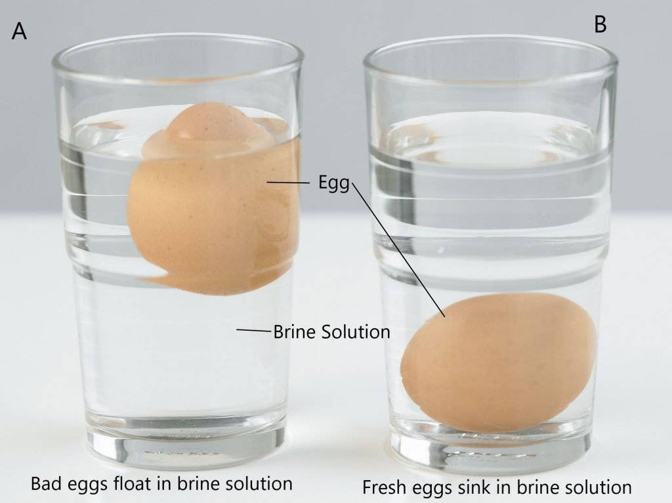
1. Two containers are filled with brine solution.
2. Place an each in each container
3. If the egg is fresh, it will sink to the bottom of container. If its bad, it will float.
(d) It is the treatment given to food to maintain its safety and freshness for an extended period of time.
(e)
Food Commodity | Dish | Cooking method
e.g. corn meal | Porridge | Boiling
Overripe plantain | Tatale,Kaaklo  Ofam | Frying  baking
Cowpeas | Beans Stew  Beans soup,boiled beans,beans porridge  Koose, agawu | Stewing  Boiling  Frying
Rice | Boiled rice  Rice Porridge  Jollof rice  Rice Balls | Boiling
Yam | Fufu,boiled yam,yam slices,oto,mashed yam  Yam chips,yam balls,yam slices | Boiling  Frying
meat | Meat Stew  Meat Soup  Khebab  Fried meat | Stewing  Boiling  Grilling  Frying

