Basic Design And Technology

(Pre Technical Skills ) – Paper Two
1. (a) List two uses of a table napkin.
(b) State four causes of food spoilage.
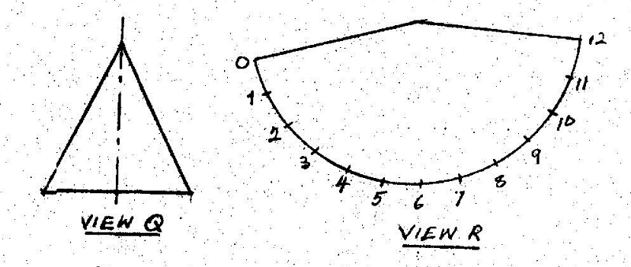
Figure 1
(c) Figure 1 shows two views of a solid.
(i) Name the type of solid represented as view Q.
(ii) State the type of view represented as view R.
(iii) List any three equipment that are used to draw the views Q and R.
(d) (i) List the primary colours.
(ii) Name four types of line.

2. (a) (i) State three Uses of mortar
(ii) List three tools for moulding bricks.
(b) (i) Make a sketch of a spirit level
(ii) State one use of the spirit level
(iii) State two care and maintenance measures to be observed when using the spirit level.
(c) (i) List two types of screw drivers
(ii) State one use of screw drivers.

3. Figure 2 shows the pictorial view of a block prepared from Odum. Use it to answer questions (a)(i) to (a)(iii)
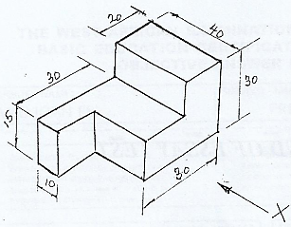
(a) (i) Draw full size the view in the direction of arrow X
(ii) List three tools required to prepare the wooden block
(iii) List two finishes that would be applied to make the wooden block attractive.
(b) (i) Make a freehand pictorial sketch of a spade.
(ii) Label any two parts of the spade sketched in question 3(b)(i)
(iii) State two uses of the spade
4. (a) Copy and complete the table below with the following tools where appropriate:
Spirit level,straight edge, tape measure,trowel,float,gauge rod, builder’s square and mortar board
Note: A tool may be selected more than once
Operation | Two Tools Required
Set Out a wall
Pick and spread mortar
Lay end blocks
Gauge the blocks
Level the blocks
(b) (i) Make a freehand pictorial sketch of a bolster.
(ii) State one use of the bolster
(c) Sketch the representative symbols of the following components.
(i) Battery
(ii) Bulb
Paper Two – Answers
1. (a) 1. It used for wiping the mouth and fingers while eating.
2. Napkins can be used to cover the mouth when coughing at the table.
3. It can be used to prevent food from staining clothes.
(b) oxidation, moulds,enzymes,bacteria & oxidation.
(c) (i) A cone
(ii) Surface development
(iii) A pair of compasses,pencils, sets square, divider,ruler & drawing board
(d) (i) Red,Blue & Yellow
(ii) Construction lines, center lines, hidden line, dimension line & break lines

2. (a) (i) It is used for plastering.
It is used for building
It is used for screeding
It is used for bonding
it is used in molding blocks
It is used for tiling
It is used in making concrete
(ii) Spade/Shovel
Gauge box
Hand trowel
Wooden tamping rod
(b) (i)
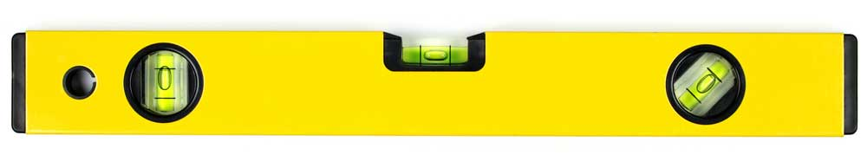
(ii) For checking Horizontal and vertical levelling
For checking alignment
(iii) It should be stored appropriately after use.
It should be well cleaned after use.
It should be used for correct job.
(c) (i) Flat head screw driver
Philips screw driver
Pozidriv screw driver
(ii) It is used for tightening screws
It is used for removing screws.
(a) (i)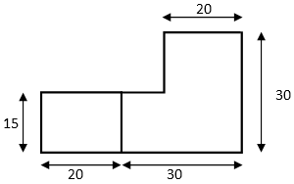
(ii) Pencil
Marking gauge
Try Square
Tenon Saw
Rip Saw
Rule
Tape Measure
(iii) Oil Paint
Vanish
Lacquer
Wax Polish
(b) (i) 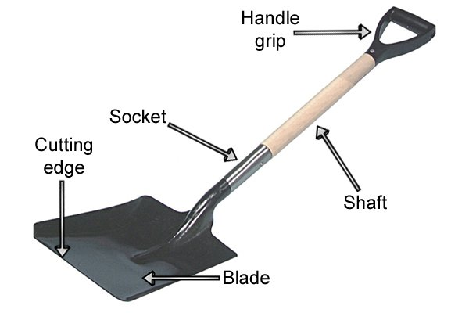
(ii) Handle
shaft
Blade
Cutting edge
Socket
(iii) Mixing mortar
Fetching mortar
Mixing concrete
Straightening the edges of trenches
Filling headpan with materials
4.
Operation | Two Tools Required
Set Out a wall | Straight edge, Tape measure, builders square
Pick and spread mortar | Trowel, float, mortar board
Lay end blocks | Trowel,builders-square,gauge rod,spirit level,straight edge
Gauge the blocks | Builders square,gauge rod,tape measure
Level the blocks | Spirit level, straight edge

(b) 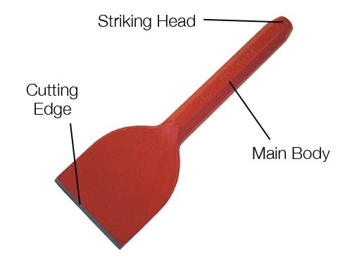
(ii) For cutting bricks/blocks
For creating openings in preexisting walls.
(c) (i) 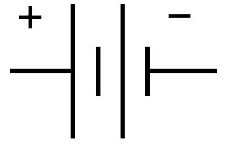
(ii) 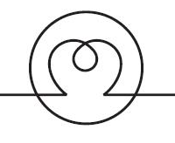

Basic Design And Technology (Pre Technical Skills ) – Paper One
1. The plan of a cylinder is a
A. circle
B. rectangle
C. square
D. triangle
2. The first stage of the design process is
A. brief
B. evaluation
C. situation
D. specification
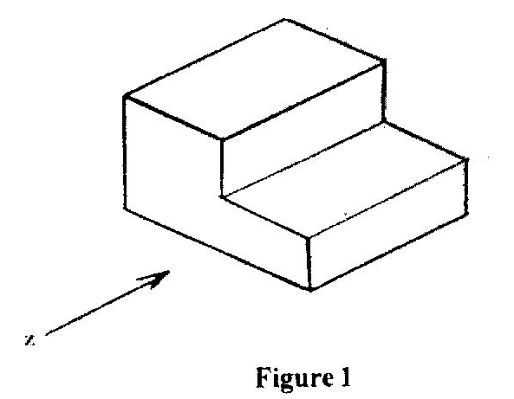
Figure I show the pictorial view of a block. Use it to answer questions 3 and 4.
3. Which of the following represents the front view in the direction of arrow Z?
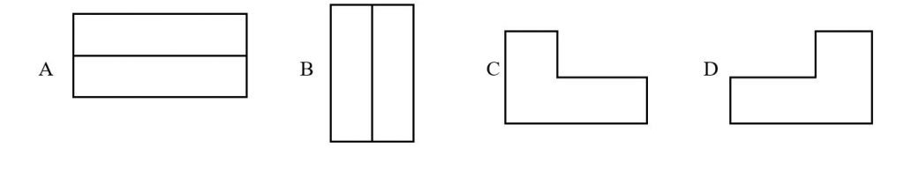
4. Which of the following represents the right end elevation?
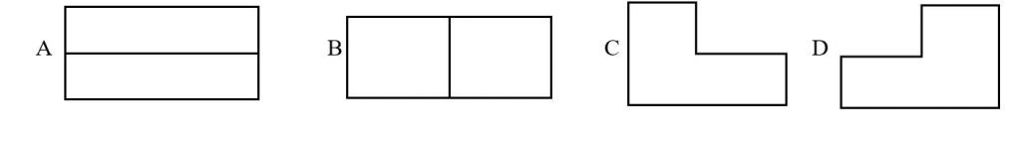
5. In the design process, the selected idea is developed in order to
A. determine the cost
B. evaluate final product
C. improve upon it
D. reduce its beauty
6. The most suitable pencil for drawing construction lines is
A. B
B. HB
C. 2B
D. 2H
7. A common method of cooking used for most Ghanaian staple foods is
A. steaming
B. boiling
C. frying
D. stewing
8. A seam that is often used for outer garment is
A. plain seam
B. French seam
C. Machine felled seam
D. Overlaid seam
9. When setting a table, the first course cutlery should be placed
A. at the top edge of the dinner plate
B. on the dinner plate
C. near the dinner plate
D. further away from the dinner plate
10. Stranded cotton thread is used for
A. decorative stitches
B. neatening seams
C. joining seams
D. temporary stitches
11. Red, Orange and violet are
A. warm colours
B. cool colours
C. opposite colours
D. neutral colours
12. The inscription BB on a pencil indicates that, it
A. is hard
B. is soft
C. breaks easily
D. sharpens well
13. A circle is
A. a form
B. a principle of design
C. a sphere
D. an element of design
14. The colour violet symbolizes
A. wealth
B. peace
C. aggression
D. royalty
15. The primary colours are
A. red, violet, yellow
B. green, yellow, red
C. red, yellow, blue
D. violet, yellow, green
16. Goggles are worn when working on a grinding machine in order to protect the
A. Head
B. Nose
C. Eyes
D. Ears
17. The binding agent in mortar is
A. Water
B. Cement
C. Sand
D. Stone
Use the figure below to answer questions 18 and 19
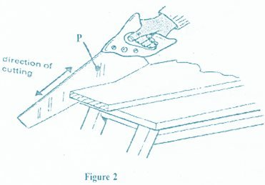
18. The figure shows the procedure for cutting
A. The shoulders of a joint
B. The tenon of a joint
C. Along the grain of timber
D. Across the grain of timber
19. 1The tool labelled P is called
A. Hacksaw
B. Crosscut Saw
C. Tenon saw
D. Rip Saw
20. The process of keeping blocks damp is
A. Batching
B. Bonding
C. Curing
D. Rendering
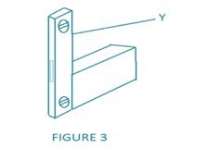
21. The figure shows the procedure for
A. Plumbing a wall
B. Measuring a wall
C. Levelling a wall
D. Setting out a wall
22. The tools labelled Y is a
A. Gauge rod
B. Tamping rod
C. Straight edge
D. Spirit level
23. Soft solder is an alloy of
A. Tin and lead
B. Lead and copper
C. Tin and zinc
D. Lead and zinc
24. Which of the following is a quality of a good mortar? It should
A. Contains impurities
B. Allow water to pass-through
C. Develop cracks easily
D. Be easily workable
25. Cable insulators are made from
A. Acrylic
B. Urea formaldehyde
C. Polyvinyl chloride
D. Nylon
26. In order to oppose the flow of electric current in a circuit, use
A. A resistor
B. An inductor
C. LED
D. A capacitor
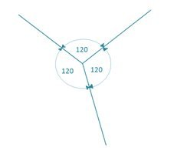
27. Figure 4 above illustrates the principle of
A. Isometric axes
B. Perspective axes
C. Orthographic axes
D. Oblique axes
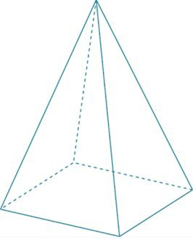
28. The figure above shows a
A. Triangle prism
B. Square pyramid
C. Square prism
D. Triangle prism
Use the sketch shown below to answer questions 29 & 30
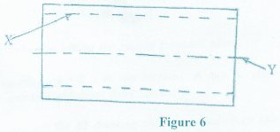
29. The line labelled X is a
A. Cutting plane
B. Dimension line
C. Centre line
D. Hidden line
30. The line labelled Y is used for
A. Dimensioning
B. Sectioning
C. Indicating the centre of an object
D. Indicating the hidden detail of an object

Paper One – Answers
1. A. circle
2. C. situation
3. C.
4. A.
5. C. improve upon it
6. D. 2H
7. B. boiling
8. A. plain seam
9. A. at the top edge of the dinner plate
10. A. decorative stitches
11. A. warm colours
12. B. is soft
13. D. an element of design
14. D. royalty
15. C. red, yellow, blue
16. C. Eyes
17. B. Cement
18. C. Along the grain of timber
19. D. Rip Saw
20. C. Curing
21. A. Plumbing a wall
22. D. Spirit level
23. A. Tin and lead
24. D. Be easily workable
25. C. Polyvinyl chloride
26. A. A resistor
27. A. Isometric axes
28. B. Square pyramid
29. D. Hidden line
30. C. Indicating the centre of an object

