2019 BECE Social Studies Past Questions – Paper One
1. Environmental degradation is mainly caused by
A. natural disasters
B. human activities
C. civil wars
D. global warming
2. Respiratory disease can be caused by
A. water pollution
B. land degradation
C. air pollution
D. deforestation
3. The right of a citizen of Ghana does not include
A. equality before the law
B. freedom from taxes
C. right to life
D. right to work
4. Which of the following factors is mostly needed for the continuous existence of map?
A. Wealth
B. Family
C. Religion
D. Environment
5. The right to be protected and heard at trials is an example of
A. social right
B. political right
C. legal right
D. natural right
6. The following options are advantages of colonization in Ghana except
A. introduction of formal education
B. excessive use of foreign goods
C. introduction of new crops
D. introduction of paper currency
7. Which of the following do not constitute environmental degradation?
A. Deforestation
B. Bush burning
C. Air pollution
D. Mixed farming
8. Which of the following factors is a reason for Ghana’s cultural diversity?
A. Ethnic grouping
B. Foreign trade
C. Internal trade
D. Colonization
9. Utilities and services are more easily supplied when settlements are
A. built any how
B. close together
C. far apart
D. well planned
10. The dry season in southern Ghana starts from the month of November and ends in
A. February
B. May
C. June
D. April
11. One of the problems facing primary production in Ghana is
A. availability of skilled labour
B. long period of bush burning
C. poor road network
D. the use of complex machines
12. Payments are elected into office of parliament through a process called
A. taxes
B. salaries
C. premiums
D. bonds
13. People are elected into office parliament through a process called
A. presidential election
B. appointment taking
C. referendum
D. voting
14. The revolution of the earth causes
A. day and night
B. differences in length of the day and night
C. differences in time and between two places
D. rise and fall of ocean tides
15. The best way to resolve conflicts in Ghana is through
A. peaceful demonstration
B. law courts
C. mediation
D. harsh sanctions
16. The following are reasons for the migration of ethnic group in Ghana except
A. peace and security
B. fertile lands
C. outbreaks of diseases
D. trade and commerce
17. One measure that can best help to minimize indiscipline among the youth is
A. police arrest
B. long-term imprisonment
C. corporal punishment
D. access to quality education
18. The main reason for which Ghana cooperates with other countries is to
A. benefit in times of need
B. get free goods for her citizens
C. maintain political stability
D. prevent attack on Ghanaians
19. Which instrument is used to measure rainfall amounts?
A. Wind vane
B. Barometer
C. Thermometer
D. Rain gauge
20. Ghana’s contribution to the United Nation (UN) can be seen in the following areas except
A. provision of funds to refugees
B. peace keeping
C. payment of dues
D. sale of produce
21. To effectively build the nation, every Ghanaian must
A. be involved in production process
B. learn to speak at least one foreign language
C. join the leading political party
D. study the 1992 Constitution
22. Which of the following is the highest court in Ghana?
A. Traditional Court
B. Magistrate Court
C. Supreme Court
D. Tribunal
23. Ghana lies between latitudes
A. 10 North and 110 North
B. 50 North and 110 North
C. 110 North and 150 North
D. 50 North and 110 South
24. Paper money is properly handled when it is
A. received from church
B. not crumpled
C. not spent
D. spent wisely

25. State Owned Enterprises are established mainly to
A. make substantial profit
B. produce goods for export
C. provide vital services
D. supervise private businesses
26. Social change in rural areas is slow because of
A. customs and traditions
B. poverty and unemployment
C. rural-urban migration
D. rural-rural migration
27. Which of the following features is not associated with rivers?
A. Waves
B. Delta
C. Meander
D. Valley
28. If the time 12 noon at longitude 00, what will be the time at a place on longitude 150
A. 12:30 pm
B. 12:30 am
C. 1:00 pm
D. 1:00 am

29. The application of checks and balances in democratic governments to help to prevent
A. plebiscite
B. dictatorship
C. voting
D. unemployment
30. Which institution is responsible for making the main laws of Ghana?
A. District Assembly
B. Parliament
C. Supreme Court
D. Jury

31. Which of the following languages is not indigenous to Ghana?
A. Dagaare
B. Dagbani
C. Hausa
D. Ga

32. The type of settlement where buildings are arranged close to each other is
A. linear
B. dispersed
C. nodal
D. nucleated

33. If the scale of a map is 1:100,000, what will be the actual distance when 4 cm is measured on the map?
A. 44 km
B. 41 km
C. 40 km
D. 4 km
34. Private businesses can ensure their continuous survival mainly through
A. exporting their products
B. making more profits
C. paying less tax to the government
D. production of quality goods

35. Ghanaians can contribute towards rapid development of the nation by
A. engaging in domestic trade
B. importing more food items
C. participating in festivals
D. patronizing made in Ghana goods
36. Which of the following conditions will occur when fire breaks out in a poor layout community?
A. Selling in the streets
B. Evening markets may spring up
C. Loss of property and life
D. Armed robbery cases may rise
37. The financial security of an individual can be assured through
A. bank loan
B. borrowing
C. hard work
D. money saving

38. Improvement in tourism is important for the rapid development of the nation because, more
A. local tourists will leave the country
B. infrastructure will be provided
C. local tourists will not visit places of interest
D. tour guides will be unemployed
39. The physical environment can best be protected through
A. building of dams
B. burning of refuse
C. recycling of waste
D. underground mining
40. A bill passed by parliament becomes law when the president gives his
A. veto
B. assent
C. accord
D. authority

Paper 1 Answers
- B. human activities
- C. air pollute
- B. freedom from taxes
- D. Environment
- C. legal right
- B. excessive use of foreign goods
- D. Mixed farming
- D. Colonization
- D. well planned
- D. April
- A. availability of skilled labour

- D. voting
- B. differences in length of the day and night
- B. law courts
- B. fertile lands
- D. access to quality education
- A. benefit in times of need
- D. Rain gauge
- C. payment of dues
- A. be involved in production process
- C. Supreme Court
- B. 50 North and 110 North
- B. not crumpled
- C. provide vital services
- C. rural-urban migration
- D. Valley
- C. 1:00 pm
- B. dictatorship
- B. Parliament
- C. Hausa
- D. nucleated
- C. 40 km
- D. patronizing made in Ghana goods
- C. Loss of property and life
- C. Loss of property and life
- D. money saving
- B
- C. recycling of waste
- B. assent

2019 BECE Social Studies Past Questions – Paper Two
1. (a) Explain the following:
(i) Cardinal points
(ii) Scale of a map.
(b) Draw a diagram to show the four cardinal points of a compass.
(c) Describe how one can use the four cardinal points to determine direction without the use of a compass.
2. (a) Define the following terms:
(i) national unity
(ii) national integrity
(b) Outline four ways by which the integrity of the nation can be defended.
3. (a) Define colonization. .
(b) List five negative effects of colonization.
(c) List four ways in which the negative effect of colonization in Ghana can be reduced.
4. (a) Describe four attitudes and values needed to prevent conflicts in the community.
(b) Explain two effects of conflicts on the community.
(c) List two peaceful ways by which conflicts in society can be resolved.
5. (a) List five examples of cases which can be reported at the office of Domestic Violence and Victim Support Unit of the Ghana Police Service (DOVVSU).
(b) Describe five functions of the Domestic Violence and Victim Support Unit of the Ghana Police Service (DOVVSU).
6. (a) Differentiate between tourism and leisure.
(b) Name the regional capitals in which the following tourist sites can be located in Ghana.
(i) Lake Bosomtwi
(ii) Volta Estuary
(iii) Mole National Park
(iv) Ussher Fort
(c) Describe four ways by which tourism can be promoted in Ghana.

Paper 2 Answers
1 (a)
(i) Cardinal points – They are the four major directional points on the compass namely North,South,East & West.
(ii) Scale of a map – A scale of a map shows the mathematical relationship between a distance on the map and the actual distance on the ground.
(b) 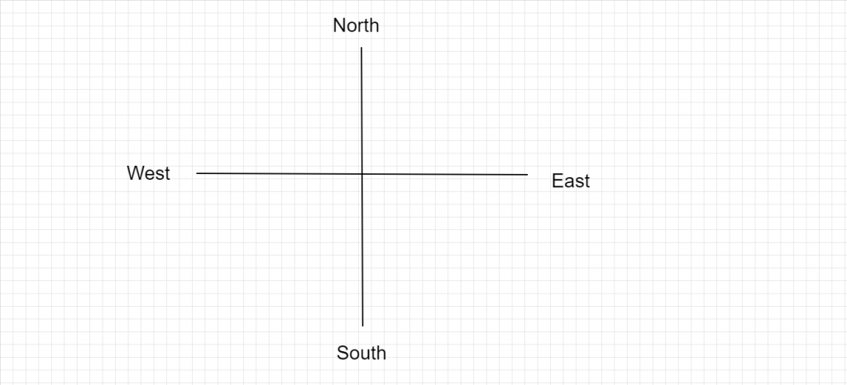
(c). (i) Let the right-hand point to the direction of where the sun rises – East.
let the right hand point in the direction where the sun sets – West.
The direction you face is North
Your back faces the South.

2. (a) (i) national unity – The situation in which the varius ethnic groups ofa country live together in peace.
(ii) national integrity – upholding the good name of a country through uprightness anywhere and at anytime.
(b).(i) living by the constitution
(ii) accepting responsibility of work anywhere in the country
(iii) reporting criminals to law enforcement authorities
(iv) taking part in national assignments
(v) protecting national properties
defending the nation at international fora
being patriotic
3. (a) Colonization is the process by which one country takes control of the administration of another. The controlling country is termed the colonizer, whereas the country being controlled is the colony. In most cases, the colonizer exploits the markets and resources (human, natural, mineral, financial, etc) of its colony.
(b) (i) Depletion of cultural values
(ii) breakdown of traditional systems of goverment
(iii) excessive taste for foreign goods
(iv) weak economic systems
(v) dependence on colonial masters
(vi) exploitation of natural resources
(vii) exploitation of human resourses
(c)(i) Development of human resource
(ii) patronage of made in Ghana goods
(iii) Producing foods for self sufficiency
(iv) rejection of negative foreign ideas
(v) cultivation of possitve attitudes towards work
(vii) appreciation of human resource
(viii) Restructuring educational structure
(ix) encouraging patriotism
4. (a) (i) Tolerance
Tolerance is the willing acceptance of the views and behaviours of other people or groups of people. When this attitude of tolerance is cultivated, there will be peace and harmony in our communities and conflicts shall be prevented.
(ii) Forgiveness
Forgiveness is the act of pardoning a person or a group of persons for an offence or wrongdoing. Since in any given human society there would always be offence in one way or the other, it is necessary for people to have the willingness to forgive others, just as God also forgives our sins, when we pray and ask Him to.
(iii) Courtesy in speech and actions
Courtesy is a show of politeness or good manners towards others. There is the need to show courtesy when relating to others in order not to offend them. Courtesy is an important element in preventing conflicts.
(iv) Proper investigation
Sometimes people take vengeful actions based only on hearsay. This causes conflicts and must be discouraged. People or groups must always endeavour to do proper investigation into issues so as to ascertain the truth of a matter, and thereafter, take only prudent actions which would prevent conflicts.
(v) Respect for human rights of others
Every human being has basic human rights which must be respected by everyone. Examples of such rights are the right to life, personal liberty, dignity, etc. If people would consider and respect these rights of others, conflicts would be prevented in our communities.
(vi) Discouragement of rumour-mongering
People must desist from spreading rumours about other people or groups, and must rather be careful about what they say and how they speak.
(vii) Respect for cultures and traditions of others
People in communities, especially cosmopolitan ones, have different backgrounds in terms of race, education, religion, etc and therefore have different cultures. It is important to respect the cultures and traditions of others in order to maintain the peace and harmony in our communities.
(viii) Fairness
It is essential for fairness to be upheld by all members of the community in their dealings among themselves. This encourages harmony, discourages resentment and jealousy and therefore prevents conflicts.
(ix) Honesty
Honesty is the character of being sincere and upright. This is a very important value for people to have in order to maintain the bond of mutual trust, harmony and peace.
(b). (i) loss of property
(ii) loss of lives
(iii) Prevents or slows down development
(iv) discourages local investments
(v) discourages foreign investments
(vi) creates instability / insecurity
(vii) destruction of infrastructure
(viii) intensifies ethnic hatred and bigotry
(ix) human rights abuses
(x) causes suffering among children and women
(xi) displacement of people and property
(xii) increase of government expenditure
(xiii) restriction of goods and services
(xiv) living with constant fear of attack
(xv) imposition of curfews / state of emergency
(xvi) economic activity becomes stagnant
(xvii) lead to famine
(xviii) lead to brain drain / loss of professionals
(xix) lead to emotional and psychological problems
(xx) retardation of education
(c)(i)Arbitration
(ii) Negotiation
(iii) Reconciliation
5. (a). (i)Non-maintenance of children
(ii)Sexual abuse – rape and defilement
(iii)Physical assault
(iv) Child neglect.
(v) domestic violence
(b)(i). To investigate all female and children related offences;
(ii). To handle cases involving domestic violence;
(iii). To handle cases of child abuse;
(iv). To handle juvenile offences;
(v). To handle cases of child delinquency;
(vi). To prosecute all such cases, where necessary, and [to perform] any other functions [as] directed by the Inspector General of Police.
6. (a) Tourism is the practice of travelling for recreation. Tourism is travel for pleasure, the business of attracting, accommodating and entertaining tourists and the business of operating tours. Tourism can be domestic or international.
Leisure on the other hand is taking time off normal duty for relaxation, games or rest. Leisure is time spent away from business or work
(b)(i) Lake Bosomtwi – Kumasi
(ii) Volta Estuary – Ho
(iii) Mole National Park – Tamale/Damango
(iv) Ussher Fort – Accra
c(i) 1. Providing a secure environment for tourists.
2. Preserving historic / tourist sites.
3. Development of infrastructure within the environment where tourist sites are located.
4. Affordable User fees
5. Beautifying tourist sites
6. Extensive marketing / publicizing tourist sites
7. Education on benefits of tourism.

