Welcome!

Please scroll down to read introductory information

WordPub
BECE
Integrated Science

Past Questions and Answers

2010

Junior High School
Years 1, 2 & 3

Compiled by:


© 2018 Word Publishers. All rights reserved

Unauthorized distribution and/or reproduction of this document prohibited.

CONTACT

Email:
info@wordpub.org

Telephone:
(+233) 030 295 1486,
(+233) 020 893 0787,
(+233) 057 860 0052,
(+233) 024 850 6613.

Postal Address:
Word Publishers,
P.O. Box NT 583,
Newtown – Accra,
Ghana.

Location:
7 Tunemete Street,
Dzorwulu-Accra,
Ghana.

Website:
bece.wordpub.org

ACKNOWLEDGEMENTS

- The West African Examination Council - for the BECE Integrated Science past questions used in this document.

- Ernest Ato Bentil and Francisco Ameyedowo – for your invaluable contribution to this work.

- Mr Eric Arthur – for your expert counsel and assistance

- Ruth, Baaba and Fiifi Arthur – for your relentless support

- Teachers, parents and educational institutions – for your continuous patronage and tireless efforts at ensuring quality education for the 21st century child

- Junior High School students – you are the ultimate reason for this work.

DEDICATION
To the Lord Jesus Christ, our Saviour and soon-coming King

April 2010
INTEGRATED SCIENCE 1
OBJECTIVE TEST
45 minutes

- Water that forms lather readily with soap is said to be
A. clean
B. hard
C. soapy
D. soft

- Which of the following life activities are common to both plants and animals?
I. Feeding
II. Locomotion
III. Respiration

A. I and II only
B. I and III only
C. II and III only
D. I, II and III

- A suitable instrument that could be used to measure the internal diameter of a bamboo flute is
A. beam balance
B. metre rule
C. surveyor’s tape
D. vernier calipers

- The ability of soils to supply the right amounts of essential nutrients to plants is known as
A. soil consistency
B. soil fertility
C. soil structure
D. soil texture

- The simplest way of making well water suitable for laundry purposes is by
A. adding alum
B. boiling
C. chlorination
D. filtering

- Washing down of soil nutrients beyond the reach of roots of plants is referred to as
A. aeration
B. infiltration
C. leaching
D. percolation

- Which of the following statements explain(s) why an object floats in water?
A floating object
I. is less dense than water
II. is denser than water
III. has the same density as water

A. I only
B. II only
C. III only
D. I and III only

- An example of leafy vegetable crops is
A. cucumber
B. lettuce
C. okro
D. onion

- The structure in the respiratory system of humans where gaseous exchange occurs is
A. alveolus
B. bronchus
C. nostril
D. trachea

- The gas produced when glucose is oxidized during internal respiration is
A. carbon (II) oxide
B. carbon (IV) oxide
C. hydrogen
D. nitrogen

- The farm animal which has crop as part of its digestive system is the
A. fowl
B. goat
C. pig
D. sheep

- A beneficial effect of wind on the environment is
A. promotion of photosynthesis in green plants
B. pollination in flowering plants
C. leaching in soils
D. erosion in soils

- The chemical solution that can be used to test for the presence of protein in food substances is
A. Benedict’s solution
B. Fehling’s solution
C. Iodine solution
D. Million’s reagent

- Which of the following statements about bushfires is/are true?
I. They cause air pollution
II. They deplete vegetation cover
III. They contribute to global warming
A. I only
B. II only
C. II and III only
D. I, II and III

- The most effective method of controlling soil erosion on steep slopes is
A. cover cropping
B. mulching
C. strip cropping
D. terracing

- Which of the following agencies is responsible for providing information on the weather and climatic conditions of an area?
A. Animal Husbandry Department
B. Extension Services Department
C. Information Services Department
D. Meteorological Services Department

- The farming system which involves the growing of one type of crop on the same piece of land every season is known as
A. mixed cropping
B. mixed farming
C. mono cropping
D. monoculture

- The fifth planet from the sun in the solar system is
A. Jupiter
B. Mars
C. Neptune
D. Venus

- The process that takes place when the sperm and the egg of humans fuse together is referred to as
A. fertilization
B. menstruation
C. ovulation
D. reproduction

- The process by which water vapour moves through the stomata of leaves into the atmosphere is known as
A. absorption
B. diffusion
C. osmosis
D. transpiration

- An example of intensive system of poultry keeping is the
A. deep litter system
B. fold unit system
C. free range system
D. Free-running system

The diagram below represents a circuit symbol in an electronic device. Study it carefully and use it to answer questions 22 and 23
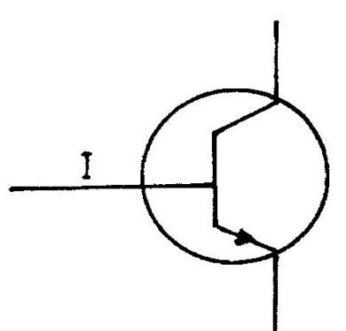
- The symbol represents
A. a light emitting diode
B. n-p-n transistor
C. light dependent resistor
D. p-n-p transistor

- The part of the diagram labelled I has
A. more electrons than holes
B. no holes
C. more holes than electrons
D. the same number of holes as electrons

- A spot made on a white paper with a given food substance turned the spot on the paper translucent.
The food substance is likely to contain
A. glucose
B. oil
C. protein
D. starch

- Which of the following sources of energy is non-renewable?
A. Sun
B. Waves
C. Wind
D. wood

- Which of the following farm animals is / are housed in a hutch?
I. Goats
II. Pigs
III. Rabbits

A. I only
B. II I only
C. I and II only
D. II and III only

- Which of the following blood vessels carries deoxygenated blood?
A. Aorta
B. Pulmonary artery
C. Pulmonary vein
D. Renal artery

- The energy transformation that takes place in a car battery is
A. electrical energy → chemical energy → light energy
B. chemical energy → light energy → electrical energy
C. chemical energy → electrical energy → light energy
D. electrical energy → light energy → chemical energy

- The type of liquid suitable to construct a thermometer to read temperatures of about 150°C is
A. alcohol
B. mercury
C. turpentine
D. water

- Amino acids are the end-products of the digestion of
A. carbohydrates
B. fats
C. oils
D. proteins

- The type of teeth used by mammals to cut food materials is
A. canine
B. incisor
C. molar
D. premolar

- Fishponds are often stocked using
A. anchovies
B. fingerlings
C. fish eggs
D. frys

- Which of the following processes result(s) in the formation of a new substance?
I. Burning of wood
II. Rusting of iron nail
III. Heating water into vapour

A. I only
B. I and II only
C. II and III only
D. I, II and III

- The use of resistant breeds of farm animals in controlling diseases is a
A. biological control method
B. chemical control method
C. cultural control method
D. physical control method

- A load of 10 N is moved through a distance of 2 m. Calculate the work done.
A. 5 J
B. 10 J
C. 20 J
D. 50 J

- Which of the following components of human blood is dissolved in the plasma?
A. Mineral salts
B. Phagocytes
C. Platelets
D. Red blood cells

- An atom of carbon is represented as 12C. How many neutrons are in the nucleus of the carbon atom?
6
A. 2
B. 4
C. 6
D. 12

- In agribusiness, middlemen operate within the
A. production chain
B. processing chain
C. supply chain
D. value chain

- Which of the following illustrations shows the correct direction of the lines of force around a bar magnet?
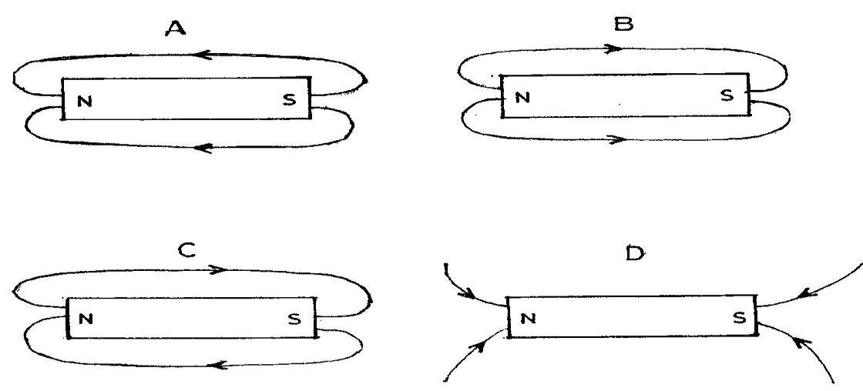

- The human sex cells are produced in the
A. scrotum and uterus
B. testis and ovary
C. penis and vagina
D. scrotum and ovary

April 2010
INTEGRATED SCIENCE 1
ANSWERS
OBJECTIVE TEST
1. D. soft

2. B. I and III only

3. D. vernier calipers

4. B. soil fertility

5. B. boiling

6. C. leaching

7. A. I only

8. B. lettuce

9. A. alveolus

10. B. carbon (IV) oxide

11. A. fowl

12. B. pollination in flowering plants

13. D. Million’s reagent

14. D. I, II and III

15. D. terracing

16. D. Meteorological Services Department

17. D. monoculture

18. A. Jupiter

19. A. fertilization

20. D. transpiration

21. A. deep litter system

22. B. n-p-n transistor

23. C. more holes than electrons

24. B. oil

25. D. wood

26. B. III only

27. B. Pulmonary artery

28. C. chemical energy → electrical energy → light energy

29. B. mercury

30. D. proteins

31. B. incisor

32. B. fingerlings

33. B. I and II only

34. A. biological control method

35. C. 20 J

36. A. Mineral salts

37. C. 6

38. C. supply chain

39. B 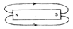

40. B. testis and ovary

April 2010
INTEGRATED SCIENCE 2
1 ¼ hours
ESSAY
[100 marks]

This paper is in two parts, I and II
Answer Question 1 in Part I and any other four questions in Part II.
Credit will be given for clarity of expression and orderly presentation of material

PART I
[40 marks]
Answer all of Question 1

- (a) The diagram below is used to demonstrate an activity in the laboratory.
Study it carefully and use it to answer the questions that follow:
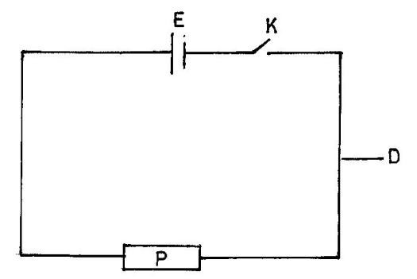

(i) What does the diagram represent?

(ii) Identify the components labelled D, E, K and P in the diagram

(iii) State one function each of the parts labelled D, E, K and P.

(iv) Mention the energy transformation that occurs in E in the diagram when K is closed.
[10 marks]

(b) In an experiment, red and blue litmus papers were dipped separately into three test tubes each containing one of the test substances listed in the table below.

Test substances | Observations |  | Conclusion
Test substances | Red litmus paper | Blue litmus paper | Conclusion
Lemon juice
Calcium hydroxide solution
Dilute hydrochloric
acid

(i) Copy and complete the table by making the necessary observation and conclusion for
each substance.
(ii) Name two of the test substances that would react with each other to produce salt and water.
(iii) Write down a balanced chemical equation for the reaction in (ii) above.
[10 marks]
(c) The diagram below is an illustration of the human digestive system.
Study it carefully and use it to answer the questions that follow:

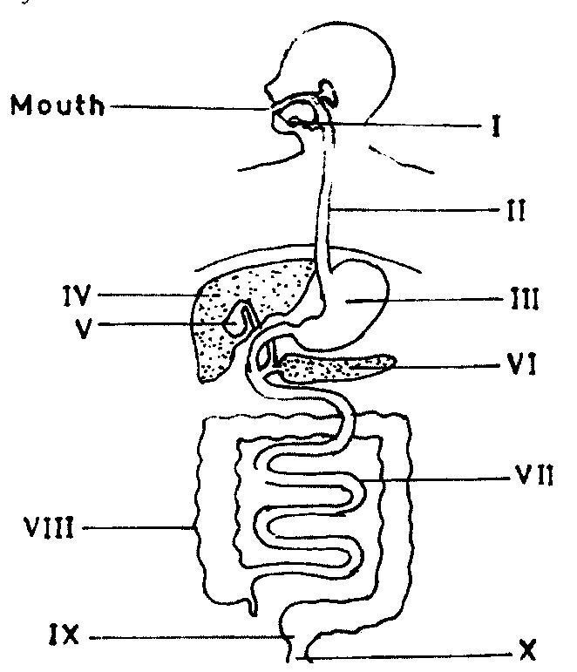

(i) Name the parts labelled I, II, III and IV
(ii) State one function of each of the parts labelled V and VI
(iii) Name the part where the digestion of protein starts.

(iv) Identify the part where
(α) absorption of end-products of digestion takes place
(β) re-absorption of water takes place
(γ) egestion takes place
[10 marks]

(d) The diagram below is an illustration of a simple farm tool.
Study it carefully and use it to answer the questions that follow:

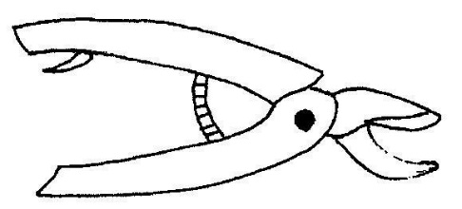

(i) Identify the tool
(ii) State three uses of the tool
(iii) Mention three ways of maintaining the tool
[10 marks]

PART II
[60 marks]
Answer four questions only from this part.

- (a) (i) What is neutralization reaction?
(ii) Write a balanced chemical equation for the reaction between each of the following pairs of substances:
(α) Sodium metal and dilute hydrochloric acid.
(β) Sodium hydroxide and dilute hydrochloric acid
[6 marks]
(b) Explain weaning as used in animal production
(c) (i) What is milky way?
[2 marks]
(ii) State one use of artificial satellites [3 marks]

(d) (i) What is a habitat?
(ii) Give two examples of a habitat. [4 marks]

- (a) (i) Define pressure.
(ii) Explain why it is important to sharpen a knife before use
[4 marks]
(b) (i) State two differences between metals and non-metals
(ii) What is an alloy?
(iii) Mention the components of each of the following alloys:
(α) steel
(β) brass
[6 marks]
(c) Mention three conditions suitable for rearing tilapia in a fishpond
[3 marks]
(d) Explain how the streamlined body of a bony fish enables it to live successfully in water

[2 marks]
- (a) (i) What is a disease vector?
(ii) Mention two methods of controlling each of the following types of pests of farm
animals:
(α) ectoparasites
(β) endoparasites
[6 marks]
(b) (i) State two symptoms of nitrogen deficiency in a tomato plant.
(ii) Describe side dressing as a method of fertilizer application.
[5 marks]
(c) (i) Define power
(ii) State the S.I. unit of power.
[2 marks]

(d) Draw the electronic structure of sulphur
{Atomic number of sulphur = 16}
[2 marks]

- (a) (i) What is respiration?
(ii) Name the types of respiration that occur in humans
[4 marks]
(b) List three ways of maintaining soil fertility
[3 marks]

(c) (i) Write the systematic name of each of the following chemical compounds:
(α) FeS;
(β) SO2
(γ) CO2
(ii) Give one reason why copper, silver and gold are mostly used in making ornaments and jewellery.
[4 marks]
(d) (i) What is a fuse?
(ii) Explain why a fuse is used in an electrical circuit.
[4 marks]

- (a) (i) What is the difference between unicellular organism and multicellular organism
(ii) State two reasons why vegetable crops are important to humans
[4 marks]
(b) (i) State two elements of climate
(ii) What is the difference between climate and weather?
[4 marks]
(c) Mention three advantages of staking in crop production
[3 marks]

(d) Explain each of the following processes:
(i) corrosion;
(ii) sublimation
[4 marks]

April 2010
INTEGRATED SCIENCE 2
ANSWERS
ESSAY
1. (a) (i) An electrical circuit

(ii) The components:
D - Conductor wire
E - Cell or emf source
K - Switch or key
P - Resistor

(iii) Function of
D - Electric current flows through it
Or it conducts electricity
E - Provides the electromotive force (emf)
Or: provides the potential difference or voltage
Or: produces the electric current or electricity
Or: converts chemical energy to electrical energy
K - Opens or closes the circuit
Or: stops or starts the flow of current through the circuit
P - Opposes the flow of current through the circuit
Or: converts electrical energy to other forms

(iv) energy transformation that occurs in E in the diagram when K
Chemical energy → Electrical energy
(b) (i)
Test substances | Observations |  | Conclusion
Test substances | Red litmus paper | Blue litmus paper | Conclusion
Lemon juice | Remains red or: no colour change | Turns red | Acidic substance or: Contains acid
Calcium hydroxide solution | Turns blue | Remains blue  or: no colour change | Basic substance  or: Contains base
Dilute hydrochloric acid | Remains red or: no colour change | Turns red | Acidic substance  Contains acid

(ii) Reactants to form salt and water:
Calcium hydroxide solution and dilute hydrochloric acid

(iii) Balanced chemical equation:
Ca(OH)2 + 2 HCl → CaCl2 + 2 H2O

(c) (i) The parts:

I - salivary gland
II - oesophagus
III - stomach
IV - liver or: gullet

(ii) Function of:

Part V - Stores bile Or: Concentrates bile

Part VI - Secretes juices containing enzymes into the small intestines
Or: secretes hormones such as insulin into the bloodstream

(iii) Digestion of protein starts at: Part III or The stomach

(iv) (α) absorption of end-products - Part VII - Small intestines

(β) re-absorption of water - Part VIII - Large intestines

( γ) egestion - Part X - Anus

(d) (i) The Tool - Secateurs or a pair of secateurs

(ii) Uses of the tool
▪ Trimming
▪ Cutting
▪ Pruning

(iii) Ways of maintaining the tool

▪ Oiling or greasing metal parts
▪ Washing and drying after use
▪ Tightening bolts and nuts when loose
▪ Sharpening cutting edges when blunt (any three)

2. (a) (i) Neutralization reaction
A chemical reaction between an acid and a base to produce salt and water

(ii) (α) Sodium metal and dilute hydrochloric acid.
2 Na + 2 HCl → 2 NaCl + H2
(β) Sodium hydroxide and dilute hydrochloric acid
NaOH + HCl → NaCl + H2O
(b) Weaning
Starting to feed a young animal with food other than its mother's milk

(c) (i) Milky way
the spiral galaxy to which Earth and its solar system belong

(ii) Use of artificial satellites
▪ Weather studies and forecasting
▪ Telecommunication
▪ Sending and receiving TV signals
▪ Taking photographs from space for various purposes
▪ Internet networking
▪ Global Positioning System (GPS) - a worldwide navigation system
[any one of the above]

(d) (i) Habitat
The natural living place of a plant or animal
Or: The natural conditions and environment of an organism

(ii) Examples of habitat
Forest, desert, river or wetlands, tree, etc (any two)

3. (a) (i) Pressure

The force per unit area

Or: Pressure = force / area

(ii) When a knife is sharpened, the area at the cutting edge is reduced; hence greater pressure is attained at a given applied force. Therefore it cuts easily with less applied force.

(b) (i)

METALS | NON-METALS
High melting point | Low melting point
Shiny surface | Dull surface
Malleable | Not malleable
Ductile | Not ductile
Good conductors of heat | Bad conductors of heat
Good conductors of electricity | Bad conductors of electricity

(ii) Alloy
A substance containing a metal and another metal or non-metal uniformly physically combined

Or: A homogeneous mixture of a metal and another metal or non-metal

(iii) (α) Steel - Iron and Carbon
(β) brass - Zinc and copper

(c) Conditions suitable for rearing tilapia in a fishpond
▪ Suitable salinity (salt concentration) of the pond
▪ Non-polluted water
▪ Favourable temperature of water
▪ Sufficient dissolved oxygen in the water
▪ Suitable pH of the water

(d) Importance of the streamlined body of a bony fish
Enables the fish to move smoothly or easily in the water
Or: it reduces the friction between the water molecules and the body of the fish.

4. (a) (i) Disease Vector
An organism that transmits disease-causing microorganisms from an infected person or
animal to another

(ii) Methods of control

(α) ectoparasites
▪ Use of pesticides
▪ Dipping
▪ Dusting
▪ Handpicking
▪ Use of footbath
▪ Rotational grazing

(β) endoparasites
▪ Drenching
▪ Deworming
▪ Vaccination
▪ Regular change of feed and litter

(b) (i) Symptoms of nitrogen deficiency in a tomato plant
▪ Stunted growth
▪ Weak stem or branches
▪ Leaves turn yellowish
▪ Fruits are smaller and fewer than normal

(ii) Side dressing (fertilizer application)
Applying the fertilizer on / in the ground at the sides of the crop

(c) (i) Power
The time rate of doing work Or: The work done per unit time
Or: (work done) / (time taken)

(ii) S.I. unit of power = watt or W

(d) The electronic structure of sulphur (atomic no. 16)
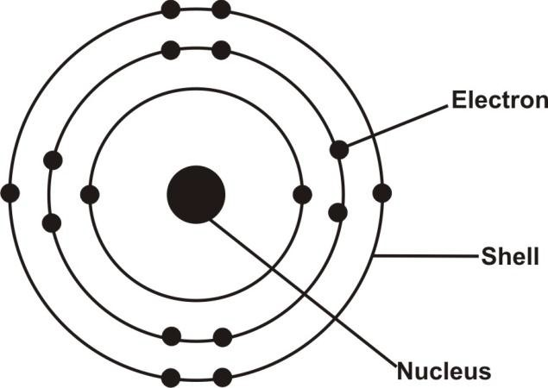

5. (a) (i) Respiration
The breakdown of food substances in an organism to release energy, carbon dioxide,
water

(ii) Types of respiration

External respiration and internal respiration
Or: Aerobic and anaerobic respiration

(b) Ways of maintaining soil fertility
▪ Crop rotation
▪ composting
▪ mulching
▪ Fertilizer application
▪ Bush fallowing
▪ Green manuring
▪ Planting of cover crops
▪ Mixed farming

(c) (i) Systematic names of:

(α) FeS - Iron (II) sulphide
(β) SO2 - Sulphur (IV) oxide
(γ) CO2 - Carbon (IV) oxide

(ii) Reasons
They are very malleable, ductile, have high lustre and less reactive.

(d) (i) Fuse
An electrical safety device containing a piece of a metal that melts if the current running
through it exceeds a particular level, thereby breaking the circuit.

(ii) Why fuse is used in an electrical circuit
To protect the electrical circuit from damage caused by abnormal power surges or
increases

6. (a) (i)

Unicellular organism | Multicellular organism
organism is made up of only one cell | organism is made up of more than one cell

(ii) Why vegetable crops are important to humans
▪ Good source of vitamins
▪ Good source of mineral salts
▪ Make food tasty
▪ They have high fibre content

(b) (i) Elements of climate
▪ Rain
▪ Temperature
▪ Humidity
▪ Sunshine
▪ Atmospheric pressure
▪ Cloud
▪ Wind

(ii) Difference

Climate | Weather
atmospheric condition of a place over a long period of time | atmospheric condition of a place over a short period of time

(c) Advantages of staking in crop production
▪ Keeps fruits clean
▪ Enables easy weeding
▪ Enables easy harvesting
▪ Prevents early spoilage of fruits
▪ Keeps plant from falling during storms
▪ Keeps plant from falling under the weight of mature fruits

(d) (i) Corrosion explanation
A process by which a substance, especially a metal, is destroyed progressively by
chemical action.
Example: the rusting of iron

(ii) Sublimation explanation
A process in which a substance is converted directly from a solid to a gas or from a gas to
a solid without passing through the liquid state
Example: the conversion of naphthalene ball (camphor) from solid to gas directly

