Welcome!

Please scroll down to read introductory information

WordPub
BECE
Integrated Science

Past Questions and Answers

2017

Junior High School
Years 1, 2 & 3

Compiled by:


© 2018 Word Publishers. All rights reserved

Unauthorized distribution and/or reproduction of this document prohibited.

CONTACT

Email:
info@wordpub.org

Telephone:
(+233) 030 295 1486,
(+233) 020 893 0787,
(+233) 057 860 0052,
(+233) 024 850 6613.

Postal Address:
Word Publishers,
P.O. Box NT 583,
Newtown – Accra,
Ghana.

Location:
7 Tunemete Street,
Dzorwulu-Accra,
Ghana.

Website:
bece.wordpub.org

ACKNOWLEDGEMENTS

- The West African Examination Council - for the BECE Integrated Science past questions used in this document.

- Ernest Ato Bentil and Francisco Ameyedowo – for your invaluable contribution to this work.

- Mr Eric Arthur – for your expert counsel and assistance

- Ruth, Baaba and Fiifi Arthur – for your relentless support

- Teachers, parents and educational institutions – for your continuous patronage and tireless efforts at ensuring quality education for the 21st century child

- Junior High School students – you are the ultimate reason for this work.

DEDICATION
To the Lord Jesus Christ, our Saviour and soon-coming King

JUNE 2017

INTEGRATED SCIENCE 1

OBJECTIVE TEST

45 minutes

Answer all the questions
Do all rough work on this question paper

- The instrument used to measure relative humidity is the
  - hydrometer.
  - hygrometer.
  - rain gauge.
  - wind vane.

- The S.I. unit for density is
  - ms ^{–1}
  - ms ^{–2}
  - kg m ^{–3}
  - m³ kg ^{–1}

- When light travels from glass to air, its speed is
  - increased.
  - reduced.
  - halved.
  - unchanged.

- When a piece of iron rod is brought near a permanent magnet for a while it becomes magnetised by
  - stroking method.
  - electrical method.
  - friction.
  - induction.

- A rheostat is used in an electric circuit in order to
  - increase electric current only.
  - decrease electric current only.
  - keep electric current constant
  - increase and decrease electric current.

- Which of the following statements about an opaque object is correct? An opaque object
  - allows light to pass through it partially.
  - allows light to pass through if fully.
  - forms a shadow.
  - does not form a shadow

- One of the characteristics of a solid is that
  - its particles are tightly packed.
  - it assumes the shape of the container it occupies.
  - it has no fixed volume.
  - its particle can easily be separated.

- The instrument used to measure current in an electrical circuit is the
  - ammeter.
  - photometer.
  - thermometer.
  - voltmeter.

- The bottom of a pool of water appears closer to the surface than it is. Which of the following properties accounts for this observation?
  - Reflection
  - Transparency of water
  - Refraction
  - Rectilinear propagation

- An example of a source of energy which is non-renewable is
  - petroleum.
  - solar.
  - tide.
  - wind.

- Which of the following apparatus is not required in the process of distillation in the laboratory?
  - Condenser
  - Evaporating dish
  - Bunsen burner
  - Round bottom flask

- The number of oxygen atoms present in three molecules of carbon dioxide is
  - 3.
  - 4.
  - 5.
  - 6.

- The chemical formula Cl₂ represents two
  - atoms of chlorine.
  - neutrons of chlorine.
  - ions of chlorine.
  - molecules of chlorine.

- Which of the following substances can rust?
  - Aluminium
  - Bauxite
  - Copper
  - Steel

- Energy stored in food is referred to as
  - chemical energy.
  - heat energy.
  - solar energy.
  - kinetic energy.

- Which of the following substances is a mixture?
  - Water
  - Sodium chloride
  - Sodium chloride solution
  - Iron filing

- The mole is the S.I. unit of
  - amount of substance.
  - luminous intensity.
  - temperature.
  - mass of substance.

- An atom has a proton number of 17 and neutron number 18. Determine the number of electrons in the third shell of the atom.
  - 1
  - 3
  - 5
  - 7

- An example of mixtures that can be separated by the method of filtration is
  - sugar in water.
  - sand in water.
  - oil in water.
  - ink in water.

- Which of the following liquids would turn blue litmus paper red?
  - Vinegar
  - Water
  - Ammonia solution
  - Bicarbonate solution

- Which of the following particles constitute matter?
I. Atoms
II. Molecules
III. Ions

  - I only
  - II only
  - II and III only
  - I, II and III

- An example of inheritable characteristics in humans is
  - shape of nose.
  - knowledge.
  - ability to speak different languages.
  - handwriting.

- Which of the following statements about aerobic respiration is correct?
  - The by-products are carbon dioxide and water.
  - Little amount of energy is produced.
  - Oxygen is not required.
  - The by-products are alcohol and carbon dioxide.

- Sperms produced by the testes in humans are temporarily stored in the
  - epididymis.
  - prostate gland.
  - seminal vesicle.
  - sperm duct.

- Which of the following changes normally occur during old age in humans?
  - Grey hair starts appearing
  - Mental alertness increases
  - Broadening of the chest
  - Attraction to the opposite sex

- One of the characteristics of wind pollinated flowers is that they
  - are large and conspicuous.
  - are usually scented.
  - have nectar.
  - have feathery stigma.

- The testes is normally located outside the body of the male because
  - the temperature of the body is too high for effective sperm production.
  - it cannot increase in size when it is in the body.
  - it can absorb moisture from the atmosphere.
  - it occupies too much space.

- The organelle which occupies the largest portion of a plant cell is the
  - chloroplast.
  - mitochondrion.
  - nucleus.
  - vacuole.

- Movement of the ribs is brought about by the
  - pleural cavity.
  - intercostal muscle.
  - larynx.
  - trachea.

- Fertilisation in humans usually occurs in the
  - ovary.
  - uterus.
  - vagina.
  - fallopian tube.

- Which of the following processes is an example of osmosis?
  - Spreading of perfume in a room
  - Absorption of food nutrients into the small intestines
  - Spreading of potassium permanganate in water
  - Absorption of water into the root hairs

- The part of a living cell which is semi-permeable is
  - cytoplasm.
  - nucleus.
  - protoplasm.
  - cell membrane.

- Which of the following statements about soil profile is/are correct? It helps the farmer to determine
I. soil fertility.
II. water-holding capacity of the soil.
III. depth of the soil.

  - I only
  - I and II only
  - II and III only
  - I, II and III

- Which of the following practices is not a principle of crop rotation?
  - Legumes should be added to the rotation programme.
  - Deep rooted crops should be followed by shallow rooted crops.
  - Crops that are closely related should follow each other.
  - Fallow periods should be allowed during the time of rotation.

- The relative proportion of sand, silt and clay in a given sample of soil is soil
  - profile.
  - porosity.
  - structure.
  - texture.

- The first factor to be considered when deciding to cultivate a particular vegetable is
  - cultural practices.
  - selection of land.
  - harvesting.
  - method of propagation.

- Which of the following factors should be considered when selecting a site for vegetable crop production?
I. Nearness to the market.
II. Topography of the land.
III. Nearness to the sea

  - I and II only
  - I and III only
  - II and III only
  - I, II and III

- Which of the following activities are cultural practices in the cultivation of cabbage?
I. Pruning
II. Weeding
III. Watering

  - I and II only
  - I and III only
  - II and III only
  - I, II and III

- An example of a vegetable crop is
  - cocoa.
  - cotton.
  - potato.
  - tomato.

- The majority charge carriers in a p-type semi-conductor are
  - electrons.
  - holes.
  - neutrons.
  - protons.

END OF PAPER

JUNE 2017

INTEGRATED SCIENCE 1

OBJECTIVE TEST
SOLUTIONS

- B. hygrometer.
- C. kg m ^{–3}
- A. increased
- D. induction
- D. increase and decrease electric current
- C. forms a shadow
- A. its particles are tightly packed
- A. ammeter
- C. Refraction
- A. petroleum
- B. Evaporating dish
- D. 6
- A. atoms of chlorine
- D. Steel
- A. chemical energy
- C. Sodium chloride solution
- A. amount of substance
- D. 7
- B. sand in water
- A. Vinegar
- D. I, II and III
- A. shape of nose
- A. The by-products are carbon dioxide and water
- A. epididymis
- A. Grey hair starts appearing
- D. have feathery stigma
- A. the temperature of the body is too high for effective sperm production
- D. vacuole
- B. intercostal muscle
- D. fallopian tube
- D. Absorption of water into the root hairs
- D. cell membrane
- D. I, II and III
- C. Crops that are closely related should follow each other
- D. texture
- B. selection of land
- A. I and II only
- D. I, II and III
- C. potato
- B. holes

JUNE 2017

INTEGRATED SCIENCE 2

ESSAY [100 marks]

1 ¼ hours

This paper is in two sections: A and B. Answer Question 1 in section A and any other four questions in section B
Credit will be given for clarity of expression and orderly presentation of material.

SECTION A
[40 marks]

Answer all of Question 1

- (a) The diagram below is an illustration of a longitudinal section of a canine tooth in humans.

Study the diagram carefully and answer the questions that follow.

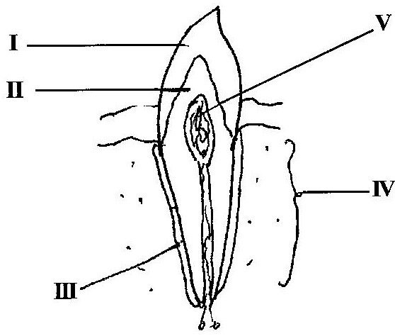

    - Name each of the parts labelled I, II, III, IV and V. [5 marks]
    - What is the function of each of the parts labelled I and III? [2 marks]
    - Which of the labelled parts could be affected by tooth decay? [1 mark]
    - State three ways by which tooth decay may be prevented. [3 marks]

(b) The diagram below is an illustration of a scientific phenomenon which occurs in nature.
Study the diagram carefully and answer the questions that follow.

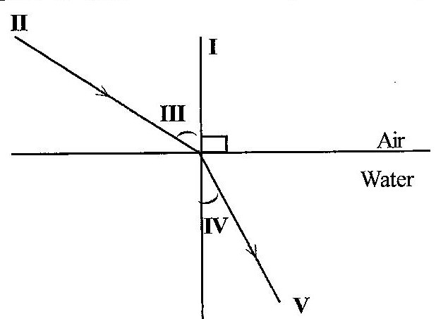

- What phenomenon does the diagram illustrate? [1 mark]
- Identify each of the parts labelled I, II, III, IV and V. [5 marks]
- Explain why an object at the bottom of a pond appears
closer to the surface than it actually is. [3 marks]

(c) The diagram below is an illustration of an experiment performed to separate the components of muddy water.

Study the diagram carefully and answer the questions that follow.

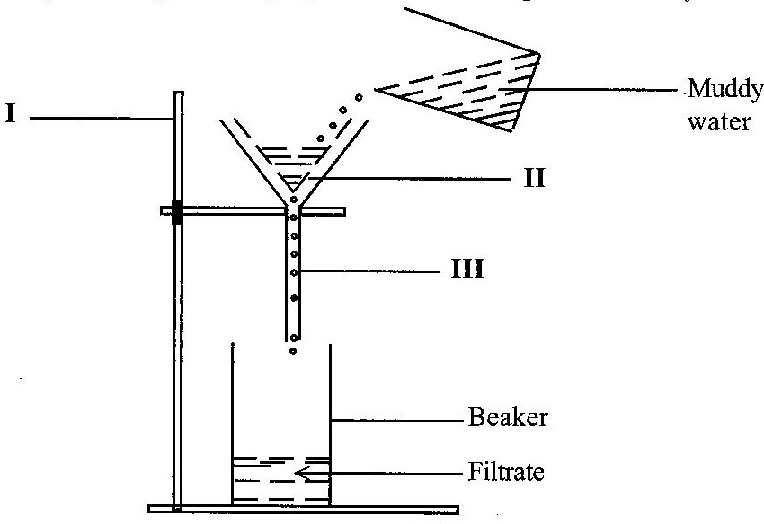

- Name each of the parts labelled I, II and III. [3 marks]
- State the function of the part labelled II. [1 mark]
- Name the substance obtained as the filtrate. [1 mark]
- State three physical properties of the filtrate. [3 marks]
- Name two other materials that could be used in place
of the part labelled II. [2 marks]

(d) The diagram below illustrates a farmland on a slopy area.

Study the diagram carefully and answer the questions that follow.

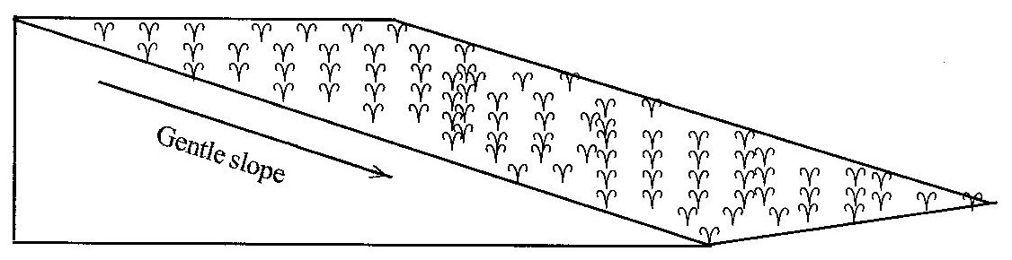

- What process is likely to occur on the farmland when it
rains heavily? [1 mark]
- State two farming practices that can also lead to the process
mentioned in (i). [2 marks]
- List four farming practices that could be used to control
the process mentioned in (i). [4 marks]
- Mention three soil resources that would be depleted from
the farmland when it rains heavily. [3 marks]

SECTION B
[60 marks]

Answer four questions only from this section

- (a) An atom Y has atomic number 12. It loses two electrons in order to be stable.
    - State the proton number of the atom before it loses electrons. [1 mark]
    - State the electron number of the atom:
(α) before it loses electrons.
(β) after losing electrons.
[2 marks]
    - Name the type of ion formed by the atom when it loses two electrons.
[1 mark]

(b) Name four farming systems used in crop production. [4 marks]

(c) (i) What is dispersal of seeds? [2 marks]
(ii) State two characteristics of seeds dispersed by wind. [2 marks]

(d) Explain the term forward bias of a p-n junction diode. [3 marks]

- (a) (i) What is an acid? [2 marks]
(ii) Give two differences between an acid and a base, in terms
of taste and feel. [2 marks]

(b) (i) Define pressure.
(ii) A force of 200 N is exerted on an area of 50 m².
Calculate the pressure exerted by the force. [3 marks]

(c) Explain the following terms as associated with living organisms:
(i) unicellular;
(ii) multicellular.
[4 marks]

(d) Give two reasons why soil air is important. [2 marks]

- (a) (i) Explain the following terms as applied to machines:
(α) work input;
(β) work output.
[4 marks]
(ii) State one factor that limits work output for a given work input in a simple machine. [1 marks]

(b) (i) What is chloroplast? [2 marks]
(ii) Differentiate between aerobic respiration and anaerobic respiration.
[2 marks]

(c) (i) State the colour change that would occur when blue litmus paper is dipped into a solution of:
(α) vinegar;
(β) wood ash.
[2 marks]
(ii) Name the products formed when hydrochloric acid reacts with sodium hydroxide. [2 marks]

(d) List two benefits of vegetables to humans. [2 marks]

- (a) (i) Differentiate between egestion and digestion in nutrition. [2 marks]
(ii) What is the end-product of digestion? [2 marks]

(b) Give one example of a chemical compound used in:
(i) medicine;
(ii) agriculture;
(iii) industry.
[3 marks]

(c) (i) Define the term soil profile. [2 marks]
(ii) State two ways in which soil profile is important in crop production.
[2 marks]

(d) (i) State two steps used by scientists in doing their work. [2 marks]
(ii) Give two subjects that may be considered as applied sciences. [2 marks]

- (a) (i) What is an alloy? [2 marks]
(ii) State two causes of corrosion of metals. [2 marks]

(b) (i) What is a planet? [2 marks]
(ii) Name two planets between the Sun and the Earth. [2 marks]

(c) State four functions of the circulatory system in humans. [4 marks]

(d) (i) Define the term crop rotation. [2 marks]
(ii) Give one example of a chemical method of controlling pests on crop farms.
[ marks]

END OF ESSAY TEST

JUNE 2017

INTEGRATED SCIENCE 2

ESSAY

SOLUTIONS

- (a) The diagram below is an illustration of a longitudinal section of a canine tooth in humans.
Study the diagram carefully and answer the questions that follow.

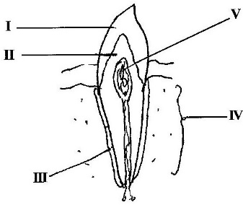

    - Name each of the parts labelled I, II, III, IV and V. [5 marks]

I - Crown / Enamel
II - Dentine
III - Cement / Periodontal membrane
IV - Jaw bone / Root
V - Pulp Cavity

    - What is the function of each of the parts labelled I and III? [2 marks]

I - Protects teeth from harmful bacteria
- Enable teeth withstand pressure of chewing
- Cutting / chewing / protects dentine / protect pulp cavity
III - hold tooth firmly (in socket / Jaw bone)

    - Which of the labelled parts could be affected by tooth decay? [1 mark]

V - Pulp cavity

    - State three ways by which tooth decay may be prevented. [3 marks]

- avoid using sharp-pointed objects
- avoid having dry mouth
- use water containing fluorides to wash teeth / mouth
- avoid smoking
- the teeth should be cleaned regularly after each meal / remove food particle from the teeth / flossing
- wash the mouth vigorously after each meal
- regular visit to the dentist
- avoid eating too hot foods
- avoid eating too much sugary food
- avoid eating too cold food / taking too cold drinks

(b) The diagram below is an illustration of a scientific phenomenon which occurs in nature.
Study the diagram carefully and answer the questions that follow.

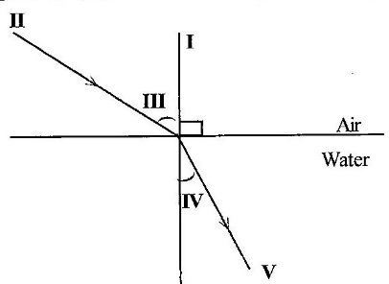

- What phenomenon does the diagram illustrate? [1 mark]

Refraction of light

- Identify each of the parts labelled I, II, III, IV and V. [5 marks]

I - Normal
II - Incident ray
III - angle of incidence / incident angle
IV - angle of refraction
V - refracted ray

- Explain why an object at the bottom of a pond appears
closer to the surface than it actually is. [3 marks]

Rays from the object at the bottom are bent away from the normal as they come out of the water. In a straight line, these rays appear to come from a point above the bottom

(c) The diagram below is an illustration of an experiment performed to separate the components of muddy water.

Study the diagram carefully and answer the questions that follow.

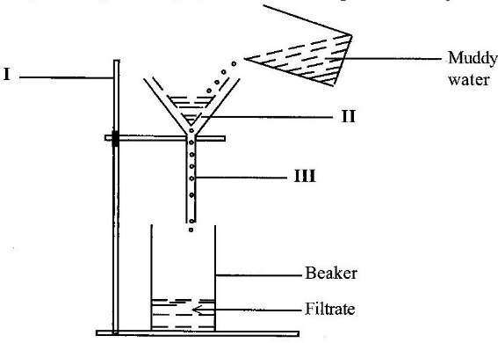

- Name each of the parts labelled I, II and III. [3 marks]

I - Retort / clamp stand
II - filter paper
III - funnel

- State the function of the part labelled II. [1 mark]

- to prevent the residue / solid / insoluble particles / mud from entering the filtrate
- to filter (solid / insoluble particles / residue)
- to separate the nud, solid / insoluble particles from the water

- Name the substance obtained as the filtrate. [1 mark]

Water

- State three physical properties of the filtrate. [3 marks]

- it has a density of 1 gcm –3 / 1000 kgm–3
- it boils at 100°C
- it freezes at 0°C (at 1 atm)
- it is colourless
- it is tasteless / insipid
- it is odourless
- it has a high surface tension, etc

- Name two other materials that could be used in place
of the part labelled II. [2 marks]

- foam
- cotton wool
- glass wool
- Clean / white cloth

(d) The diagram below illustrates a farmland on a sloppy area.

Study the diagram carefully and answer the questions that follow.

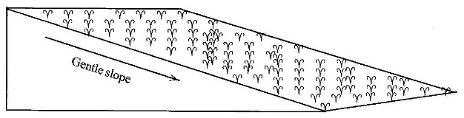

- What process is likely to occur on the farmland when it
rains heavily? [1 mark]

Erosion

- State two farming practices that can also lead to the process
mentioned in (i). [2 marks]

- Deforestation
- bush burning
- continuous cropping
- cultivation / ploughing along slope
- crop removal
- excessive use of chemical / inorganic fertilizers
- overgrazing

- List four farming practices that could be used to control
the process mentioned in (i). [4 marks]

- planting cover crops
- terracing
- cultivating / ploughing across slope / contour
- heavy mulching
- constructing drainage channels
- planting trees beside farm
- strip cropping
- contour bunding

- Mention three soil resources that would be depleted from
the farmland when it rains heavily. [3 marks]
- soil organisms
- nutrients (macro / micro) / mineral matter
- soil particles / mineral matter
- growing crops
- air
- organic matter / humus

SECTION B
[60 marks]

Answer four questions only from this section

- (a) An atom Y has atomic number 12. It loses two electrons in order to be stable.
    - State the proton number of the atom before it loses electrons. [1 mark]

12

    - State the electron number of the atom: [2 marks]
(α) before it loses electrons.

12

(β) after losing electrons.

10

    - Name the type of ion formed by the atom when it loses two electrons.
[1 mark]
Cation / positively charged ion

(b) Name four farming systems used in crop production. [4 marks]

- Land rotation
- Crop rotation
- Mixed cropping
- Mixed farming
- Organic farming
- Monoculture
- Mono cropping
- Shifting cultivation
- Ecological farming / Eco-farming

(c) (i) What is dispersal of seeds? [2 marks]

It is a process by which seeds are carried away from the parent plant

(ii) State two characteristics of seeds dispersed by wind. [2 marks]

- seeds are very small
- they are very light
- they have hair
- they have wing-like structures / parachutes

(d) Explain the term forward bias of a p-n junction diode. [3 marks]

It is when the positive terminal of an electric source is connected to the p-type of the diode and the negative terminal of the source is connected to the n-type of the diode, resulting in the flow of charges / current.

- (a) (i) What is an acid? [2 marks]
It is a proton donor
OR
A substance or compound that produces excess hydrogen ion (H+) in water
OR
A substance that contains replaceable hydrogen

(ii) Give two differences between an acid and a base, in terms
of taste and feel. [2 marks]

 | Acid | Base
Taste | Sour | Bitter
Feel | Non slippery / stinging | Slippery / soapy

(b) (i) Define pressure.

It is the force acting (normally) per unit area
OR
Pressure = 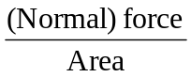

(ii) A force of 200 N is exerted on an area of 50 m².
Calculate the pressure exerted by the force. [3 marks]

Pressure =
= 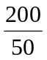
= 4 Pa OR 4 Nm^{–2}

(c) Explain the following terms as associated with living organisms: [4 marks]

(i) Unicellular -
(Very small) living organisms that consist of only one cell.

(ii) Multicellular -
(Large) living organisms that consist of (many) cells

(d) Give two reasons why soil air is important. [2 marks]

- It enhances the absorption of mineral salts / nutrients by plant roots
- It enhances the absorption of water by plant roots
- It makes oxygen available for seed germination
- Presence of aeration prevents the formation of toxic / acidic substances in the soil by micro organisms.
- Plant roots use soil air for respiration / metabolism / growth
- Soil micro organisms use soil air for respiration
- Air is required for the decomposition of organic matter.
- Aeration is required to prevent development of plant diseases

- (a) (i) Explain the following terms as applied to machines: [4 marks]
(α) work input;

It is total energy / work applied to a machine for it to be able to work

(β) work output.

It is the total energy / work obtained by using machines to do work

(ii) State one factor that limits work output for a given work input in a simple machine. [1 marks]

- friction / wear and tear
- age of machine / period of usage
- weight of machine parts

(b) (i) What is chloroplast? [2 marks]

It is an organelle / structure found only in (plant) cell and it contains chlorophyll / green pigment

(ii) Differentiate between aerobic respiration and anaerobic respiration.
[2 marks]

Aerobic Respiration | Anaerobic Respiration
Requires oxygen | Does not require oxygen
Produces large amount of energy | Produces small amount of energy
Water is produced | Ethanol / lactic acid is produced

(c) (i) State the colour change that would occur when blue litmus paper is dipped into a solution of: [2 marks]
(α) vinegar; - changes to red
(β) wood ash. - there is no colour change / remains the same

(ii) Name the products formed when hydrochloric acid reacts with sodium hydroxide. [2 marks]

Sodium chloride and water

(d) List two benefits of vegetables to humans. [2 marks]

- Prevents constipation
- supply roughage for easy digestion of food.
- to garnish / decorate food
- provide humans with vitamins / proteins / mineral salts / carbohydrates / food nutrients / food
- source of medicine

- (a) (i) Differentiate between egestion and digestion in nutrition. [2 marks]

Egestion is the removal of undigested food / semi-solid / waste / faeces from the anus while digestion is the breaking down of food into smaller building blocks / components that can be absorbed into the blood stream.

(ii) What is the end-product of digestion? [2 marks]

- glucose / simple sugar
- amino acids
- fatty acids and glycerol

(b) Give one example of a chemical compound used in: [3 marks]
(i) medicine;
Drugs / other pharmaceutical products, etc

(ii) agriculture;
Insecticides, pesticides, fertilizers, etc

(iii) industry.
Hydrochloric acid, sodium chloride, ethanol, ammonia, nitric aced, etc

(c) (i) Define the term soil profile. [2 marks]

It is the vertical section of the land showing the various horizons / layers and their composition

(ii) State two ways in which soil profile is important in crop production.
[2 marks]
- helps to know the type of tools to choose
- helps to select good soil for the crop
- to determine depth at which tillage implements must be set
- to know soil management practices to adopt
- helps to determine fertility of soil
- helps to determine type of crop to grow
- helps to know the water holding capacity of the soil.
- helps to determine the type of fertilizer to use / apply

(d) (i) State two steps used by scientists in doing their work. [2 marks]

- Identifying the problem
- Observation
- Experimenting
- Analyzing data
- Drawing conclusions
- Hypothesis
- Collection of data

(ii) Give two subjects that may be considered as applied sciences. [2 marks]

- Engineering
- Medicine
- Agriculture
- Pharmacy
- Electronics
- ICT
- etc

- (a) (i) What is an alloy? [2 marks]

It is a uniform mixture of a metal and another metal or non-metal or two or more metals

(ii) State two causes of corrosion of metals. [2 marks]

- Presence of oxygen / air
- Presence of moisture / water
- Presence of alkali
- Presence of salt
- Presence of acid

(b) (i) What is a planet? [2 marks]

It is a heavenly body that moves round the sun / star

(ii) Name two planets between the Sun and the Earth. [2 marks]

- Mercury
- Venus

(c) State four functions of the circulatory system in humans. [4 marks]

- Transports blood
- Transports hormones / drugs / chemical
- Transports oxygen to cells / tissues / organs of the body
- Transports nutrients / glucose to organs
- Carries away excretory products / CO₂ / waste materials / urea.
- Regulates body temperatures / transport
- Consists of / transports white blood cells / antibodies / attack foreign bodies.
- Transports blood platelets to clot blood
- responsible for pumping blood / erection of penis / clitoris

(d) (i) Define the term crop rotation. [2 marks]

It is a system of farming where different types of crops are grown on the same piece of land but on different plots in a definite order / cycle / sequence from season to season.

OR
It is a system of farming where variety of crops are grown on the same piece of land in a repeated cycle

(ii) Give one example of a chemical method of controlling pests on crop farms.
[1 mark]
- spraying of recommended / appropriate pesticides
- placement of recommended / appropriate pesticides

