2011 BECE Mathematics (Maths) Past Questions Paper One

OBJECTIVE TEST

1 hour

- Which of the following is the set of prime factors of 12?
A. {2, 3}
B. {1, 2, 3}
C. {1, 2, 4, 6}
D. {2, 3, 4, 6}

- Expand 3a (a – 4b)
A. 3a – 12ab
B. 3a² – 12ab
C. 3a² – 12b
D. 3a² – 12a

- Express 5 as a percentage of 4
A. 125%
B. 120%
C. 25%
D. 20%

- Express 2700 as a product of prime numbers.
A. 2² × 3² × 5²
B. 2 × 3³ × 5²
C. 2² × 3³ × 5²
D. 2 × 3² × 5³

- The ratio of mangoes to oranges in a basket is 3:2. If there are 36 mangoes, how many oranges are in the basket?
A. 90
B. 60
C. 24
D. 12

- Express 0.125 as a fraction in its lowest form.
A. $\frac{1}{8}$
B. $\frac{1}{9}$
C. $\frac{1}{12}$
D. $\frac{1}{16}$

- Convert 222_{five} to a number in base ten.
A. 30
B. 52
C. 60
D. 62

- If A = {18, 19, 20} and B = {15, 16, 17}, find A∩B
A. {15, 16, 17, 18, 19, 20}
B. {15, 16, 18, 19}
C. {18, 19}
D. {}

- Simplify 3⁹÷ 3³
A. 3²⁷
B. 3¹²
C. 3⁶
D. 3³

- An article which costs GH¢ 25.00 was sold for GH¢ 35.00. Find the percentage profit made.
A. 10%
B. 28%
C. 40%
D. 70%

- Factorize completely b² + fb – mb – fm
A. (b – f) (b – m)
B. (b + f) (b – m)
C. (b + f) (m – b)
D. (b + f) (m + b)

- Simplify: -13 – (-3) + (-10)

A. -26
B. -20
C. -10
D. - 6

- Find the HCF of 3³ × 5² and 3² × 5⁴
A. 3² × 5²
B. 3³ × 5²
C. 3² × 5⁴
D. 3⁵ × 5⁶

- State the rule for the mapping
x 1 2 3 4
y 15 30 45 60

A. x→ 15 x
B. x→ 15 + x
C. x→ $\frac{15}{x}$
D. x→ 10 + 5x

- Solve the inequality $x- \frac{1}{3} ≥ \frac{2}{3} – x$
A. $x ≤ \frac{1}{2}$
B. $x ≤ \frac{2}{3}$
C. $x ≥ \frac{1}{2}$
D. $x ≥ \frac{2}{3}$

- Find the area of a square, if its perimeter is 28 cm.
A. 784 cm²
B. 196 cm²
C. 49 cm²
D. 14 cm²

- Simplify: $\frac{1}{3}\left(\frac{1}{2}- \frac{1}{3}\right)- \frac{1}{3}\left(\frac{1}{3}-\frac{1}{2}\right)$

A. $-\frac{1}{9}$
B. $-\frac{1}{18}$
C. $\frac{1}{18}$
D. $\frac{1}{9}$

- Make n the subject of the relation $θ=180- \frac{360}{n}$
A. $\frac{θ+180}{2}$
B. $\frac{θ-180}{2}$
C. $\frac{360}{180- θ}$
D. $\frac{360}{180+ θ}$

- If $R = \frac{h}{2}+ \frac{d^{2}}{8h}$, find R when d = 8 and h = 6.

A. $3\frac{1}{6}$
B. $4\frac{1}{3}$
C. $4\frac{3}{4}$
D. $4\frac{9}{16}$

- Eight copies of a book cost GH¢ 16.00. Find the cost of 5 copies.
A. GH¢ 2.00
B. GH¢ 3.20
C. GH¢ 5.00
D. GH¢ 10.00

- Solve the equation $\frac{1}{5}\left(2+y\right)= \frac{1}{2} (y-1)$
A. -3
B. $\frac{3}{4}$
C. $\frac{5}{3}$
D. 3

- The gradient of the straight line that passes through points A(3,2) and B(4,8) is
A. $-\frac{1}{6}$
B. $-\frac{1}{2}$
C. 2
D. 6

- A car is travelling at 60 km per hour. How far does it travel in 2 ½ hours?
A. 30 km
B. 60 km
C. 120 km
D. 150 km

- In the diagram below RS and WV are parallel lines. The value of the angle marked α is

A. 38°
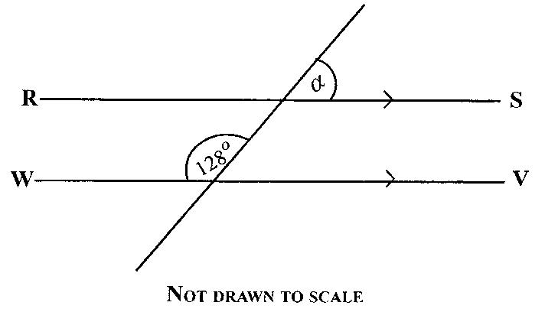
B. 52°
C. 58°
D. 64°

- Given that $a= \left(\begin{aligned}5 \\ 2n\end{aligned}\right)$ and $b= \left(\begin{aligned}2n-1 \\ 6\end{aligned}\right)$. If $a=b$, find the values of n.

A. 6
B. 3
C. 2
D. 1

- Find the volume of a cube of side 5 cm.
A. 10 cm³
B. 15 cm³
C. 25 cm³
D. 125 cm³

- In the diagram below, AB and CD are two intersecting straight lines. Find the value of the angle marked y.

A. 130°
B. 115°
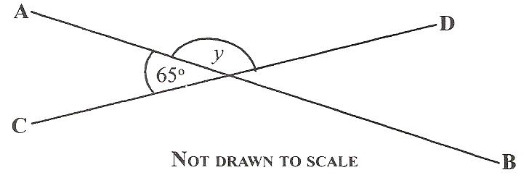
C. 65°
D. 60°

- Kwame and Ama shared an amount of money in the ratio 5:4 respectively. If Kwame had GH¢ 9.00, how much did they share?
A. GH¢ 16.20
B. GH¢ 36.00
C. GH¢ 45.00
D. GH¢ 81.00

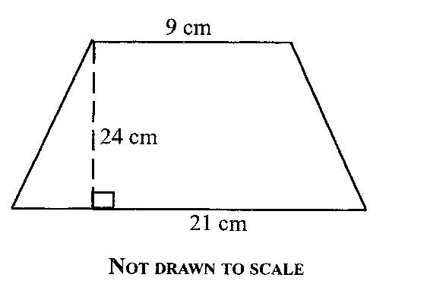

The area of the trapezium above is
A. 120 cm²
B. 180 cm²
C. 256 cm²
D. 360 cm²

- If $r= \left(\begin{aligned} 2 \\ -5\end{aligned}\right)$ and $s= \left(\begin{aligned}-2 \\ 5\end{aligned}\right)$, calculate 2r – 3s

A. $\left(\begin{aligned}-10 \\ -25\end{aligned}\right)$
B. $\left(\begin{aligned}-2 \\ -25\end{aligned}\right)$
C. $\left(\begin{aligned} 10 \\ -25\end{aligned}\right)$
D. $\left(\begin{aligned}10 \\ 25\end{aligned}\right)$

- There are 10 red and 15 green balls in a bag. Find the probability of selecting at random a red ball from the bag.
A. $\frac{3}{5}$
B. $\frac{2}{5}$
C. $\frac{1}{10}$
D. $\frac{1}{25}$

The table below gives the distribution of ages of students in a class. Use it to answer Questions 32 – 34
Ages (years) | 13 | 14 | 15 | 16 | 17
Number of students | 3 | 10 | 6 | 7 | 4

- How many students are in the class?
A. 20
B. 30
C. 45
D. 75

- What is the modal age?
A. 14
B. 15
C. 16
D. 17

- If a student is chosen at random from the class, what is the probability that the student is 15 years old?
A. $\frac{1}{5}$
B. $\frac{1}{3}$
C. $\frac{1}{2}$
D. $\frac{2}{3}$

- A length of a ribbon is 16.8 m long. How many ribbons 0.36 m long can be cut from it?
A. 0.46
B. 4.60
C. 46
D. 460

- A refrigerator was sold for GH¢ 200.00 at a loss of 10%. Find the cost price.
A. GH¢ 180.00
B. GH¢ 190.00
C. GH¢ 220.00
D. GH¢ 222.22

- The diagram below is the net of a

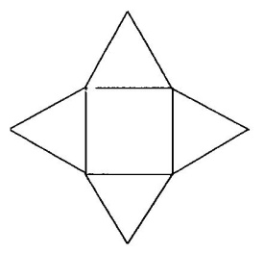
A. cone
B. cuboid
C. rectangular prism
D. pyramid

- What is the value of 7 in the number 832713?
A. Seven thousand
B. Seven hundred
C. Seventy
D. Seven

- Write 3560 in standard form.
A. 3.56 × 10⁻⁴
B. 3.56 × 10⁻³
C. 3.56 × 10³
D. 3.56 × 10⁴

- Correct 0.02751 to three decimal places
A. 0.027
B. 0.028
C. 0.03
D. 0.28

OBJECTIVE TEST
SOLUTIONS

- A. {2, 3}
- B. 3a² – 12ab
- A. 125%
- C. 2² × 3³ × 5²
- C. 24
- A. $\frac{1}{8}$
- D. 62
- D. {}
- C. 3⁶
- C. 40%
- B. (b + f) (b – m)
- B. -20
- A. 3² × 5²
- A. x→ 15 x
- C. $x ≥ \frac{1}{2}$
- C. 49 cm²
- D. $\frac{1}{9}$
- C. $\frac{360}{180- θ}$
- B. $4\frac{1}{3}$
- D. GH¢ 10.00
- D. 3
- D. 6
- D. 150 km
- B. 52°
- B. 3
- D. 125 cm³
- B. 115°
- A. GH¢ 16.20
- D. 360 cm²
- C. $\left(\begin{aligned} 10 \\ -25\end{aligned}\right)$
- B. $\frac{2}{5}$
- B. 30
- A. 14
- A. $\frac{1}{5}$
- C. 46
- D. GH¢ 222.22
- D. pyramid
- B. Seven hundred
- C. 3.56 × 10³
- B. 0.028

2011 BECE Mathematics (Maths) Past Questions Paper Two

ESSAY

1 hour

[60 marks]

Answerfour questions only from this section
All working must be clearly shown.
The use of calculators is not allowed
Marks will not be awarded for correct answers without corresponding working.
All questions carry equal marks

- (a) In a school of 255 students, 80 of them study Arabic only and 125 study French only. Each student studies at least one of the two subjects

(i) Draw a Venn diagram to represent the information
(ii) How many students study
(α) both subjects?
(β) French?

(b) Make h the subject of $v = \frac{1}{3}πr^{2}h$
(c) A bookseller bought 80 copies of books at GH¢ 3.50 per copy. He sold each of them at GH¢ 4.20. Find
(i) the total cost price
(ii) his percentage profit

- (a) The pie chart below shows the distribution of exercise books to six schools ABCDE and F in a town. School D was given 8000 exercise books.

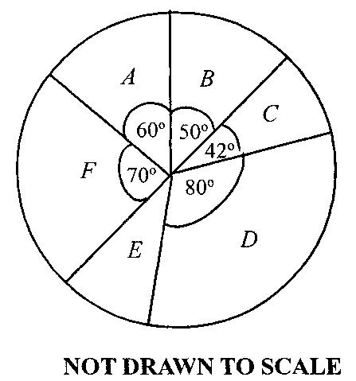

(i) How many exercise books were given to each of the rest of the schools?

(ii) What is the average number of exercise books given to the schools?

(iii) How many schools had less than the average number of exercise books?

(b) Solve the inequality below and illustrate the answer on the number line
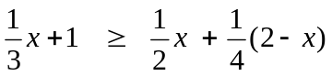

- (a) Using a ruler and a pair of compasses only, construct
(i) triangle ABC such that │AB│ = 8cm, angle CBA = 45° and CAB = 60°.

(ii) the bisector of angle ACB to meet AB at T

(b) Measure
(i) │CT│;
(ii) angle CTB.
(c) A boy spent $\frac{3}{8}$ of his money and had GH¢ 15.00 left. How much did he have?

- (a) The perimeter of a rectangular plot of land whose length is (2x+5) m and width (x – 10) is 80 m. Find the

(i) value of x;
(ii) area of the plot;
(iii) cost of weeding the plot at GH¢ 0.24 per m².

(b) Find the value of x and w in the diagram below if │AB│ = │BC│
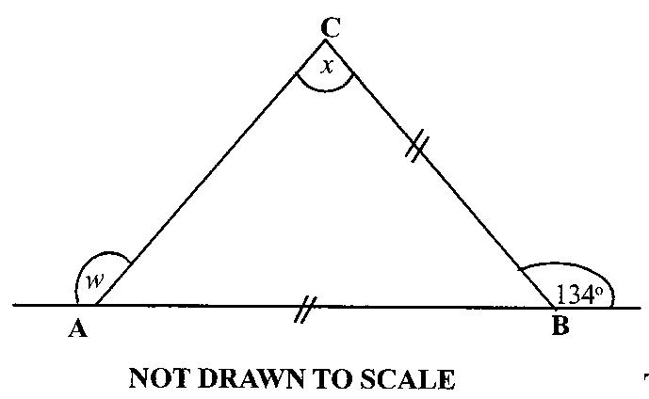

- (a) Given that 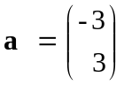 and 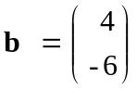, calculate

(i) a + 2b;
(ii) 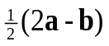

(b) The number of pupils in a primary school is given in the table below:
Class | One | Two | Three | Four | Five | Six
Number of pupils | 24 | 35 | 35 | 20 | 21 | 45

(i) Find the number of pupils in the school
(ii) What is the mean number of pupils in a class?
(iii) What percentage of pupils is in class six?

(c) Convert 312_{five} to a base ten numeral

- (a) Copy and complete the table for the relation 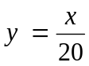, where y is the cost (in Ghana cedis) and x is the weight (in grammes) of rice sold in a market.

x (weight in grammes) | 50 | 100 | 150 | 200 | 250 | 300
y (cost in GH¢) |  | 5.00 |  |  | 12.50

(b) (i) On a graph sheet, draw two perpendicular axes OX and OY.
(ii) Using a scale of 2 cm to 50 grammes on the x-axis and 2 cm to GH¢ 2.00 on the y-axis draw the graph of the relation .

(c) Using the graph, find
(i) the cost of 175 grammes of rice
(ii) the weight of rice that can be bought with GH¢14.00
(d) Factorize: 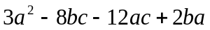

ESSAY
SOLUTIONS

- (a) (i) Let U = Number of students in the school
b = Number of students who study both Arabic and French
The Venn diagram is shown below
Arabic
U = 255
b
French
80
125

(ii) (α) From the Venn diagram above,
80 + b + 125 = 255

⇒ b + 205 = 255
⇒ b = 255 – 205 [Subtracting 205 from both sides (carrying + 205 to the other side)]
⇒ b = 50
⇒ 50 students study both Arabic and French.

(β) Number of French students = b + 125
= 50 + 125
= 175

(b) $v = \frac{1}{3} π r^{2} h$
$3 × v = 3 × \frac{1}{3} π r^{2} h$ [Multiplying both sides by 3 (to clear fraction)]
⇒ $3 v = π r^{2} h$ [Simplifying]
⇒ $\frac{3 v}{πr^{2}} = \frac{πr^{2} h}{πr^{2}}$ [Dividing both sides by$πr^{2}$]
⇒ $\frac{3 v}{πr^{2}} = h$
⇒ $h = \frac{3 v}{πr^{2}}$

(c) (i) Total cost price = 80 × GHc 3.50
= GHc 280.00

(ii) Profit on each book = GHc 4.20 – GHc 3.50
= GHc 0.70 (or 70 Gp)
Cost price of each book = GHc 3.50 (or 350 Gp)

Percentage profit = $\frac{Profit}{Original Cost} ×100\%$ [NB: 100%, not 100]
= $\frac{70}{350} ×100\%$ [Substituting values (of profit and original cost)]
= $\frac{1}{5} ×100\%$ [Simplifying]
= 20%

- (a) (i) Since School D’s share = 80° ≡ 8000 books
By inspection of the above correspondence, it is obvious that
there is a factor of 100 (ie, 80 × 100 = 8000). Hence,
School A’s share = 60° ≡ 6000 books
School B’s share = 50° ≡ 5000 books
School C’s share = 42° ≡ 4200 books
School F’s share = 70° ≡ 7000 books
Now, School E’s angle = 360° - (80°+42+50°+60°+70°)
= 360° - 302°
= 58°
Hence, School E’s share = 5800 books

(ii) Average number of books given
= $\frac{Total number of books given }{Number of schools}$
= $\frac{8000 + 6000 + 5000 + 4200 + 7000 + 5800 }{6}$books
= $\frac{36000}{6}$books
= 6000 books

(iii) Schools B, C and E had less than 6000 books
Therefore 3 schools had less than the average number of books.

(b) $\frac{1}{3}x+1 ≥ \frac{1}{2}x+ \frac{1}{4}\left(2-x\right)$
⇒ $12\left(\frac{1}{3} x\right)+ 12\left(1\right) ≥ 12 \left(\frac{1}{2} x\right)+ 12\left[\frac{1}{4}\left(2-x\right)\right]$ Multiplying through by 12 (the LCM of the denominators)
⇒ $4x+12 ≥ 6 x + 3\left(2-x\right)$ Simplifying
⇒ $4x+12 ≥ 6 x + 6-3x$
⇒ $4x+12 ≥ 3x + 6$
⇒ $4x-3x ≥ 6 -12$ Grouping like terms on one side
⇒ $x ≥ -6$

- (a)
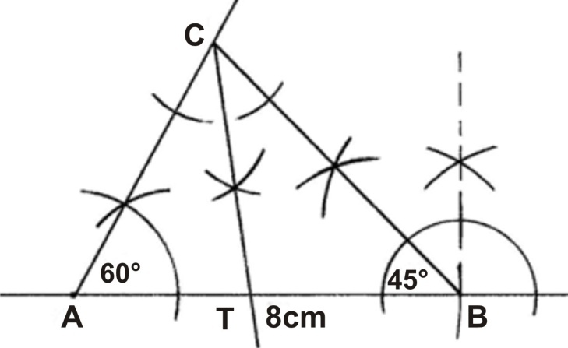

(b) (i) │CT│ ≈ 5.1 cm
(ii) angle CTB ≈ 97° (or 98°)

(c)
 |  | Fraction | Amount (GH¢)
 | Spent | 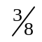 | ?
 | Left | 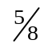 | 15
 | Total  (M. salary) | 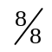 | m
NB: Fraction left
= ‘Total fraction’ – Fraction spent
=$1 - \frac{3}{8}$
$$= 8/8-3/8 =5/8$$

From the above table, we have $\frac{5/8}{8/8} = \frac{15}{m}$ [From the ‘Left’ and ‘Total’ rows]
⇒ $\frac{5}{8} × m = 15 × \frac{8}{8}$ [Cross-multiplying]
⇒ $\frac{5}{8} × m = 15$
⇒ $\frac{8}{5} × \frac{5}{8} × m = 15 × \frac{8}{5}$ [Multiplying both sides by $\frac{8}{5}$ (to remove $\frac{5}{8}$ )
⇒ $m = 15 × \frac{8}{5}$
⇒ $m = 3 × 8$ [Simplifying]
⇒ $m = 24$
Therefore he had GHc 24.00

- (a)
(2x + 5) m
(x – 10) m

(i) Since Perimeter = 80 m
⇒ 2 (Length) + 2 (width) = 80 m
⇒ 2 (2x + 5) + 2 (x – 10) = 80 Substituting the values of length and width
⇒ 4x + 10 + 2x – 20 = 80 Expanding
⇒ 4x + 2x + 10 – 20 = 80 Grouping like terms
⇒ 6x – 10 = 80 Simplifying
⇒ 6x = 80 + 10 Adding 10 to both sides (carrying -10 to the other side)
⇒ 6x = 90
⇒ $\frac{6x}{6} = \frac{90}{6}$ Dividing both sides by 6 (the co-efficient of x)
⇒ x = 90 ÷ 6
⇒ x = 15

(ii) Area of the plot = Length × Width
= [ 2x + 5] × [x – 10] Substituting the expressions of length and width
= [ 2(15) + 5] × [15 – 10] Substituting the value of x(15)
= [30 + 5] × [15 – 10] Simplifying
= 35m² × 5m²
= 175 m²

(iii) If 1m² costs GHc 0.24
Then, 175 m² costs 175 × GHc 0.24
⇒ 175 m² costs GHc 42.00
⇒ The cost of weeding the plot is GHc 42.00

(b) ∠ABC = 180° – 134° (Sum of angles at a point on a straight line = 180°) = 46°
Since │AB│ = │BC│
⇒ ∠BCA = x = ∠BAC (Base angles of isosceles triangle equal)
Now, ∠BCA+∠BAC + 46° = 180° (Sum of angles in a triangle = 180°)
x + x + 46° = 180° (Substituting: ∠BCA=x, ∠BAC=x)
2 x + 46 = 180° [Simplifying]
2 x = 180° – 46° [Grouping like terms]
2 x = 134°
$\frac{2x}{2} = \frac{134°}{2}$ [Dividing both sides by 2 (the co-efficient of x)
x = 134° ÷ 2
x = 67°

Therefore ∠BAC = 67°
⇒ ∠BAC + w = 180° (Sum of angles at a point on a straight line)
⇒ 67° + w = 180°
⇒ w = 180° – 67°
⇒ w = 113°

- (a) (i) a + 2b
= $\left(\begin{aligned}-3 \\ 3\end{aligned}\right)+2\left(\begin{aligned} 4 \\ -6\end{aligned}\right)$ Substituting
= $\left(\begin{aligned}-3 \\ 3\end{aligned}\right)+\left(\begin{aligned} 8 \\ -12\end{aligned}\right)$ Simplifying
= $\left(\begin{aligned}-3+8 \\ 3+\left(-12\right)\end{aligned}\right)$
= $\left(\begin{aligned} 5 \\ -9\end{aligned}\right)$

(ii) $\frac{1}{2}\left(2a-b\right)$
= $\frac{1}{2}\left[2\left(\begin{aligned}-3 \\ 3\end{aligned}\right)- \left(\begin{aligned} 4 \\ -6\end{aligned}\right)\right]$
= $\frac{1}{2}\left[\left(\begin{aligned}-6 \\ 6\end{aligned}\right)- \left(\begin{aligned} 4 \\ -6\end{aligned}\right)\right]$
= $\frac{1}{2}\left[\left(\begin{aligned}-6-4 \\ 6-\left(-6\right)\end{aligned}\right)\right]$
= $\frac{1}{2}\left(\begin{aligned}-10 \\ 12\end{aligned}\right)$
= $\left(\begin{aligned}\frac{1}{2}×-10 \\ \frac{1}{2}×12\end{aligned}\right)$
= $\left(\begin{aligned}-5 \\ 6\end{aligned}\right)$

(b) (i) The number of pupils in the school
= 24 + 35 + 35 + 20 + 21 + 45
= 180
There are 180 pupils in the school

(ii) The mean number of pupils in a class
= $\frac{Total number of pupils in the school}{Number of classes}$
= $\frac{24 + 35 + 35 + 20 + 21 + 45}{6}$
= $\frac{180}{6}$
= 30 pupils

(iii) The percentage of pupils in class six
= $\frac{No. of pupils in class six}{Total no. of pupils} × 100\%$
= $\frac{45}{180} × 100\%$
= $\frac{1}{4} × 100\%$
= 25%

(c) 312_{five} to a base ten numeral
3 | 1 | 2
5² | 5¹ | 5⁰

⇒ ( 3 × 5² ) + ( 1 × 5¹ ) + ( 2 × 5⁰ )
= ( 3 × 25) + (1 × 5) + (2 × 1)
= 75 + 5 + 2
= 82 (or 82_{ten})

- (a) $y=\frac{x}{20 }$
$$\frac{50}{20} =2.50, \frac{150}{20} =7.50, \frac{200}{20} = 10.00, \frac{300}{20} = 15.00$$

x (weight in grammes) | 50 | 100 | 150 | 200 | 250 | 300
y (cost in GHc) | 2.50 | 5.00 | 7.50 | 10.00 | 12.50 | 15.00

(b) (i)

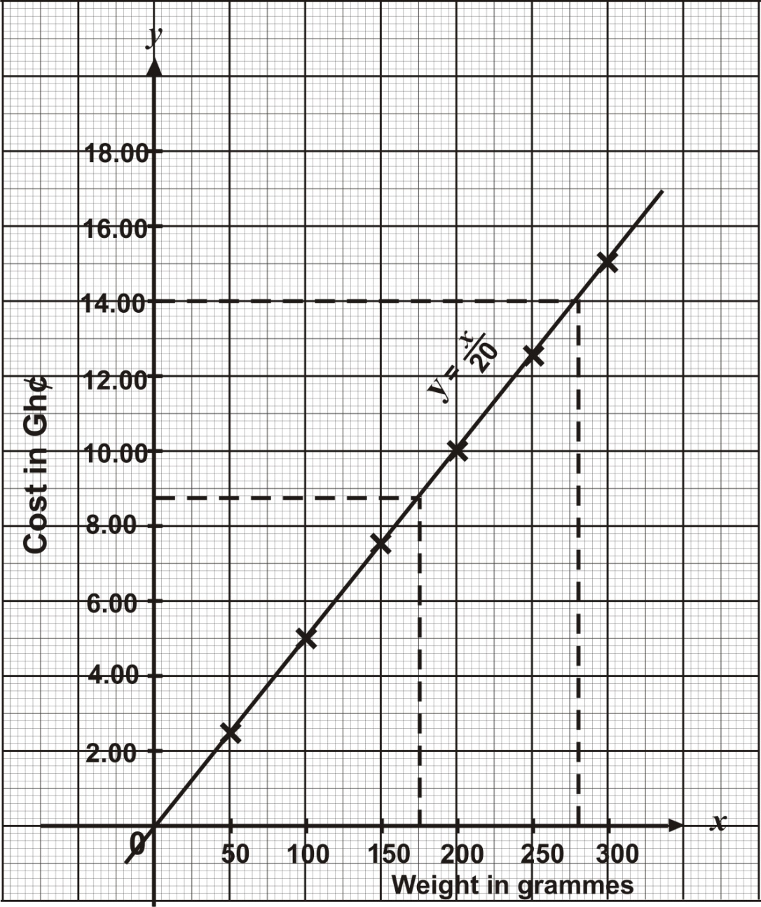

(c) (i) The cost of 175 grammes of rice = GHc 8.75
(ii) The weight or rice that can be bought with GHc 14.00 = 280 grammes

(d) $3a^{2} - 8bc - 12ac + 2ba$
= $3a^{2} - 12ac + 2ba- 8bc$ [Re-arranging terms]
= $3a\left(a-4c\right)+2b\left(a-4c\right)$ [Factorizing]
= $\left(a-4c\right)\left(3a+2b\right)$

