2016 BECE Mathematics (Maths) Past Questions Paper One
Objective Test
1 Hour

1. Which of the following is a finite set?
A. {2, 4, 6, 8, …} B. {1, 2, 3, 4, …}
- {…, 2, 3, 5, 7}
- {3, 6, 9, 12}

2. Given that M = {a, b, c}, find the number of subsets of M A
A. 3
B4
C6

D. 8

- If P = {2, 3, 4, 6, 8} and Q = {1, 2, 3, 4}, find PQ
  - {2, 3, 4}
  - {7, 9, 10}
  - {2, 3, 4, 6, 8}
  - {1, 2, 3, 4, 6, 8}

- A boy bought 3 pairs of socks at GHc 17.50 per a pair and paid with two GHc 50.00 notes. How much change was he given?
  - GHc 27.50
  - GHc 37.50 C. GHc 47.50 D. GHc 48.50

- Find the least Common Multiple (LCM) of the numbers 5, 10 and 12
  - 2 × 3 × 5
  - 2 × 3² × 5
  - 2² × 3 × 5
  - 2² × 3² × 5²

- Correct 48,947.2547 to the nearest hundred.
  - 490
  - 48,900
  - 48,950

  - 49,000

- Simplify: 16 + 5.6 + 0.681
  - 2.2281 B. 22.281 C. 222.81
D. 2228.1

- Evaluate: − +
  - 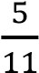

B. 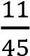

C. 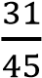
D. 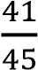

- Arrange the following integers from the least to the highest – 4, 9, – 10, – 7 and 2.
  - –10, –7, –4, 2, 9
  - –10, 9, –7, –4, 2 C. –4, –7, –10, 2, 9
D. 2, –4, –7, 9, –10

- Simplify: (46 × 102) + (102 × 54)
  - 1,020
  - 10,200
  - 102,000
  - 1,020,000

- Correct 5178.3426 to two decimal places
  - 5178.00 B. 5178.30 C. 5178.34 D. 5178.35

- Find the simple interest on GHc 120,000.00 for 5 months at 12% per annum.
  - GHc 6,000.00
  - GHc 7,200.00
  - GHc 50,000.00
  - GHc 72,000.00

- Fifteen boys took 12 hours to weed a plot of land. If nine boys work at the same rate, how long will it take them to weed the plot of land?
  - 6 hours
  - 7 hours
  - 11 hours
  - 20 hours

- A car cost GHc 12,500.00. A discount of 9% is given for cash payment. Find the cost of the car when payment is made by cash.
  - GHc 10,250.00 B. GHc 11,250.00 C. GHc 11,375.00
D. GHc 13,625.00

- Simplify: 5² × 2² × 5² × 2
  - 2² × 5² B. 2² × 5⁴ C. 2³ × 5²
D. 2³ × 5⁴

The table shows the marks of some students in a test.

Marks | 0 | 1 | 2 | 3 | 4 | 5 | 6 | 7 | 8 | 9 | 10
Number of students | 3 | 4 | 5 | 4 | 5 | 4 | 7 | 3 | 4 | 2 | 2

Use the information to answer questions 16 and 17

- What is the modal mark?
  - 2 B. 5
  - 6
  - 10

- How many students failed the test, if the pass mark was 4?
  - 4
  - 6
  - 16 D. 21

- What is the probability of obtaining 4, when a fair die is tossed once?

- Make P the subject of the relation, 𝑅 = ^{(𝑃+𝑄)} 2
  - P = Q – 2R
  - P = 2R – Q
  - P = 2R + Q
  - P = 2Q + R

- Given that t = p² + 1, find p when t = 10.
  - 3.0
  - 4.5
  - 11.0
  - 81.0

- Simplify: 4(x + 2) – 3(x + 1).
  - x + 5
  - x + 11
  - 7x + 5
  - 7x + 11

- When a number is doubled and the result is decreased by 9, the answer is 19. Find the number.
  - 5
  - 7
  - 14
  - 16

- Solve the inequality 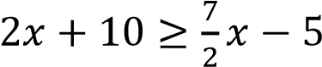
  - 𝑥 ≥ 10 B. 𝑥 ≤ 10 C. 𝑥 ≤ 40
D. 𝑥 ≥ 40

- Find the image of 5, under the mapping 𝑥 → 4𝑥 − 7
  - 3
  - 13 C. 20
D. 27

- An angle which is greater than 180° but less than 360° is A. a right angle
  - an acute angle
  - an obtuse angle
  - a reflex angle

- How many lines of symmetry has a rectangle?
  - 1 B. 2 C. 3
D. 4

- The perimeter of an isosceles triangle is 45 cm. Find the length of the third side, if each of the equal sides is 14 cm long.
  - 11 cm B. 14 cm C. 17 cm
D. 31 cm

- Find the area of a circle whose diameter is 7cm. [Take π = 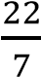]
  - 11 cm²
  - 38 ¹ cm²
  - 44 cm²
  - 54 cm²

- The mean of three numbers is 12. If two of the numbers are 14 and 16, find the third number.
  - 6
  - 12 C. 30
D. 36

- The sum of the interior angles of a regular polygon is 540°. Find the number of sides of the polygon.
  - 7 B. 6 C. 5 D. 4

- The figure QPR is an equilateral triangle. If angle PRS = (2x – 10°), find the value of x.
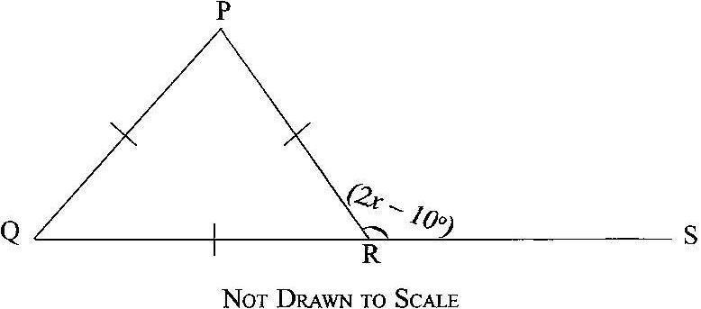
  - 55° B. 65° C. 85°
D. 95°

- The diagonal of a rectangle is 10 cm long. If the length of the rectangle is 8 cm, find its breadth.
  - 2 cm B. 3 cm C. 5 cm
D. 6 cm

- In an enlargement, 𝑋𝑌 → 𝑋₁ 𝑌₁. If |XY| = 24 cm and |X₁Y₁| = 8 cm, calculate the scale factor of the enlargement.
  - 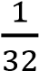
  - 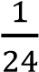

Study the triangle of odd numbers and use it to answer Questions 34 and 35.

13 b c 19
7 9 a
3 5
1

- Evaluate: 13 + b + c + 19.
  - 62 B. 64 C. 74 D. 76

- Evaluate: a + b + c
  - 24 B. 29 C. 36
D. 43

- Simplify: (⁻³) + ( ²)
5 −7
  - (⁻¹)
2
  - (⁻⁵)
12
  - (⁻¹)
−2
  - ( ⁻⁵ )
−12

- The bearing of X from Y is 196°. What is the bearing of Y from X?
  - 016° B. 074° C. 106°
D. 244°

3𝑎+2𝑏
- If a = – 4 and b = 3, evaluate
𝑎𝑏
B. | 1
  - −

- The point P (– 3, 7) is reflected in the x-axis. Find its image.
  - (–3, –7)
  - (–3, 7) C. (–7, 3) D. (3, –7)

- The instrument used to measure the angle between two lines that meet at a point is known as a
  - pair of compasses
  - set-square
  - protractor
  - pair of dividers

JUNE 2016

MATHEMATICS 1

Objective Test
SOLUTIONS

- D. {3, 6, 9, 12}

- D. 8
3.

A.

{2
, 3, 4}

4.

C.

GHc 47.50

5.

C.

2
2

× 3 × 5

6.

B.

48,900

7.

B.

22.281

8.

C.

9.

A.

–
10
,
–
7
,
–
4
, 2,
9

10.

B.

10,200

11.

C.

5178.34

12.

A.

GHc 6,000.00

13.

D.

20

hours

14.

C.

GHc 11,375.00

15.

D.

2
3

× 5
4

16.

C.

6

- C. 16
- A.
- B. P = 2R – Q
- A. 3.0
- A. x + 5
- C. 14
- B. 𝑥 ≤ 10
- B. 13
- D. a reflex angle

- B. 2
- C. 17 cm
- B. 38 cm²
- A. 6
- C. 5
- B. 65°
- D. 6 cm
- D.
- B. 64
35.

D.

43

36.

C.

(
−
1
−
2
)

37.

A.

016
°

38.

C.

39.

A.

(
–
3
,
–
7)

40.

C.

protractor

2016 BECE Mathematics (Maths) Past Questions Paper Two

Answer four questions only.
All questions carry equal marks.
All working must be clearly shown.
Marks will not be awarded for correct answers without corresponding working

- (a) In an examination, 50 candidates sat for either Mathematics or English Language. 60% passed in Mathematics and 48% passed in English Language. If each candidate passed in at least one of the subjects, how many candidates passed in :
    - Mathematics?
    - English Language?

  - Illustrate the information given in (a) on a Venn diagram.

  - Using the Venn diagram, find the number of candidates who passed in
    - both subjects;
    - Mathematics only.

  - If a = ( ⁴ ) and b = ( ^{2𝑥} ) are equal vectors, find the values of x and y
−5 3 + 𝑦

- (a) The cost (P), in Ghana cedis, of producing n items is given by the formula,
𝑃 = 𝑛 + 1800. Find the:
    - cost of producing 2,000 items;
    - number of items that will be produced with GHC 2,400.00; (iii) cost when no items are produced.

  - A passenger travelling by air is allowed a maximum of 20 kg luggage.
A man has four bags weighing 3.5 kg, 15 kg, 2 kg and 1.5 kg.
    - Find the excess weight of his luggage
    - Express the excess weight as a percentage of the maximum weight allowed.

- (a) A doctor treated 2,000 patients over a period of time. If he worked for 5 hours a day and spent 15 minutes on each patient, how many days did the doctor spend to treat all the patients?

  - The pie chart shows the distribution of textbooks to six classes A, B, C, D, E and F in a school.
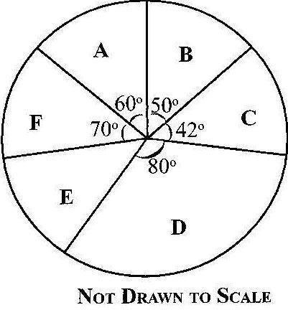

    - If Class D was given 720 textbooks, how many textbooks were distributed to each of the remaining classes?
    - What is the average number of textbooks distributed to the classes?
    - How many classes had less than the average number of textbooks distributed?

- (a) Using a scale of 2 cm to 1 unit on both axes, draw on a graph sheet, two perpendicular axes OX and OY for –5−5 ≤ 𝑥 ≤ 5 𝑎𝑛𝑑 − 5 ≤ 𝑦 ≤ 5.
    - Plot, indicating the coordinates of all points P(1, 1), Q(1, 2), R(2, 2) and S(2, 1) on a graph sheet. Join the points to form square PQRS.
    - Draw and indicate clearly all coordinates, the image P₁Q₁R₁S₁ of square PQRS under an enlargement from the origin with a scale factor of 2, where P → P₁, Q→Q₁, R→R₁ and S→S₁.
    - Draw and indicate clearly all coordinates, the image P₂Q₂R₂S₂ of square P₁Q₁R₁S₁ under a reflection in the x-axis where P₁→P₂, Q₁→Q₂, R₁→R₂ and S₁→S₂

  - Using the graph in 4(a), find the gradient of line R₂S.

- (a) Given that u = 4, t = 5, a = 10 and 𝑠 = 𝑢𝑡 + ¹ 𝑎𝑡², find the value of s. 2

  - The selling price of a gas cooker is GHC450.00. If a customer is allowed a discount of 20%, calculate the
:
    - discount;
    - amount paid by the customer.

  - A crate of minerals containing ten bottles of Coca Cola and fourteen bottles of Fanta was given to some children for a birthday party. If a child chose a drink at random from the crate, find the probability that it was Fanta.

- (a) Using a ruler and a pair of compasses only, construct:
(i) triangle XYZ with |XY| = 9 cm, |YZ| = 12 cm and |XZ| = 8cm; (ii) the perpendicular bisector of line XY; (iii) the perpendicular bisector of line XZ.

  - (i) Label the point of intersection of the two bisectors as T; (ii) With point T as centre, draw a circle of radius 6 cm.

  - Measure:
    - |TX|
    - angle XYZ

MATHEMATICS 2
ESSAY
SOLUTIONS

1. (a) (i) Number of candidates who passed in Mathematics
= 60% of 50 candidates
= 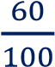 × 50
= 6 x 5

= 30

(ii) Number of candidates who passed in English Language
= 48% of 50 candidates
= 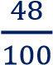 × 50
= 

= 24

- Venn diagram
Let U = Total number of Candidates,
M = Number of candidates who passed in Mathematics and E = Number of candidates who passed in English
b = Number of candidates who passed in both Mathematics and English
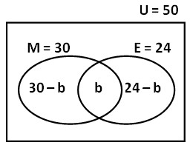

- (i) From the Venn diagram above,
30 – b + b + 24 – b = 50
⇒ 54 – b = 50

⇒ b = 4
Hence, 4 candidates passed in both subjects

(ii) Mathematics only = 30 – b = 30 – 4

= 26

(d) If a = b, then
taking the horizontal component, 4 = 2x
⇒ x = 4 ÷ 2

⇒ x = 2

Now, taking the vertical component, – 5 = 3 + y
⇒ y = – 5 – 3

⇒ y = – 8

2. (a) (i) Since Cost, 𝑷 = ^{𝟑} 𝒏 + 𝟏𝟖𝟎𝟎, where n = the number of items,
𝟒
Cost of producing 2,000 items
= × 2000 + 1800 [Substituting n = 2000]
= 3 × 500 + 1800 [Simplifying]
= 1500 + 1800
= 3300
Cost of producing 2,000 items = GHC 3,300.00

(ii) Method 1 (Substitution and solving)

From 𝑃 = 𝑛 + 1800
2400 = 𝑛 + 1800 [Substituting P = 2400]
⇒ 4 × 2400 = (4 × 𝑛) + (4 × 1800) [multiplying through by 4]
⇒ 9600 = 3𝑛 + 7200 [Simplifying]
⇒ 9600 − 7200 = 3𝑛 [Subtracting 7200 from both sides]
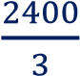
⇒ 2400 = 3𝑛 [Simplifying] ⇒ = ^{3𝑛} [Dividing through by 3]
3
⇒ 800 = 𝑛 [Simplifying]
n = 800

Hence, the number of items = 800

(ii) Method 2 (Making n the subject, substituting and simplifying)

From 𝑃 = 𝑛 + 1800
⇒ 4𝑃 = (4 × 𝑛) + (4 × 1800) [Multiplying through by 4]
⇒ 4𝑃 = 3𝑛 + 7200 [Simplifying]
⇒ 4𝑃 − 7200 = 3𝑛 [Subtracting 7200 from both sides]
4𝑃−7200 3𝑛
⇒ = [Dividing through by 3]
3 3
⇒ 𝑛=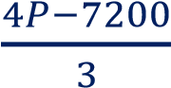 [Simplifying]
⇒ 𝑛=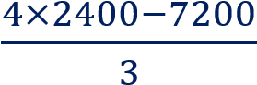 [Now, substituting P = 2400]
⇒ 𝑛=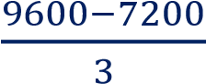 = 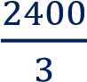 [Simplifying]
n = 800
Hence, the number of items = 800

(iii) When no items are produced, | n = 0
From 𝑃 = 𝑛 + 1800
= ( × 0) + 1800 [Substituting n = 0]
= 0 + 1800 [Simplifying]
𝑃 = 1800
Cost when no items are produced = GHC 1,800.00

3.5
15.0
2.0
1.5
22.0
(b) (i) Total weight of four bags = 3.5 + 15 + 2 + 1.5
= 22 kg
Hence, excess weight = 22 – 20

= 2 kg

(ii) Excess weight as a percentage of maximum weight allowed
= ×100%
= | 2 × 5%
= | 10%

3. (a) If doctor works 5 hours a day and spends 15 minutes on each patient, then
5 ℎ𝑜𝑢𝑟𝑠
Number of patients treated a day =
15 𝑚𝑖𝑛𝑢𝑡𝑒𝑠
5 ×60 𝑚𝑖𝑛𝑢𝑡𝑒𝑠
=
15 𝑚𝑖𝑛𝑢𝑡𝑒𝑠
= 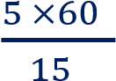 = 5 × 4
= 20

Hence, he treats 20 patients each day
2000 𝑝𝑎𝑡𝑖𝑒𝑛𝑡𝑠
Number of days used =
20 𝑝𝑎𝑡𝑖𝑒𝑛𝑡𝑠
= 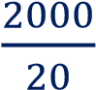
= 100
Hence, he treats 2000 patients in 100 days
NOTE: Alternatively the idea of ratio or simple proportion can be applied to solve the question.

(b) (i) If Class D (80°) → 720 textbooks Then Class A (60°) → ? (less)

If less, then more (80°) divides
60°
⇒ ×720
80°

= 60 × 9 = 540 textbooks

Now, if number of textbooks of Class A (60°) = 60 × 9,
then, | Class B (50°) = 50 × 9 | = | 450 textbooks
 | Class C (42°) = 42 × 9 | = | 378 textbooks
 | Class F (70°) = 70 × 9 | = | 630 textbooks
Now, angle for Class E = 360° – (70°+60°+50°+42°+80°)
= 360°– 302°
= 58°
Hence, Class E (58°) = 58 × 9 = 522 textbooks

(ii) Average number of textbooks = 𝑇𝑜𝑡𝑎𝑙 𝑛𝑢𝑚𝑏𝑒𝑟 𝑜𝑓 𝑡𝑒𝑥𝑡𝑏𝑜𝑜𝑘𝑠
𝑇𝑜𝑡𝑎𝑙 𝑛𝑢𝑚𝑏𝑒𝑟 𝑜𝑓 𝑐𝑙𝑎𝑠𝑠𝑒𝑠
= 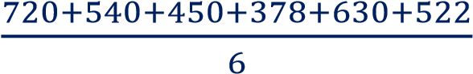
= 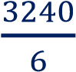

= 540

(iii) Number of classes which had less than average
= 3 (Classes B, C and E had less than 540 textbooks)

4. (a)
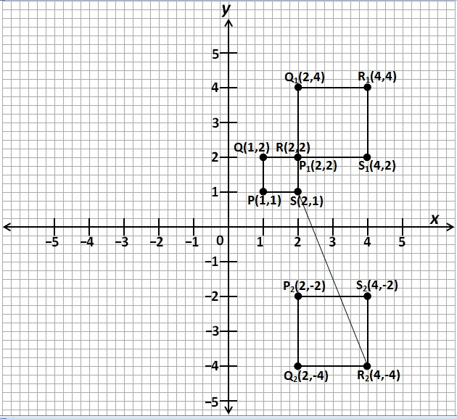

(
b
)

Gradient of line R
2
S

=

𝑉𝑒𝑟𝑡𝑖𝑐𝑎𝑙

𝑖𝑛𝑡𝑒𝑟𝑣𝑎𝑙

𝐻𝑜𝑟𝑖𝑧𝑜𝑛𝑡𝑎𝑙 𝑖𝑛𝑡𝑒𝑟𝑣𝑎𝑙
= | 𝑦2−𝑦1  𝑥2−𝑥1
= 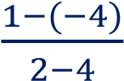 = 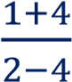 = 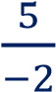

= – 2.5 or −2
5. | (a) |  | From 𝒔 = 𝒖𝒕 + ^{𝟏} 𝒂𝒕^{𝟐}  𝟐
= (4)(5) + (10)(5)²
= 20 + ( × 10 × 25)
 |  |  | = 20 + 125
 |  | Hence s | = 145
(b) | (i) | Discount | = 20% of GHC 450.00
= 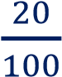×450
= 2 × 45
Discount = GHC 90

(ii) Method 1
Amount paid = Original Selling Price – Discount
= 450 – 90
= 360

Method 2
Amount paid = 80% of GHC 450.00 [100% - 20% = 80%]
= 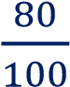×450
= 8 × 45
= 360
 | The amount paid by the customer | = | GHC 360.00
(c) | Probability of randomly choosing Fanta | = | 𝑁𝑢𝑚𝑏𝑒𝑟 𝑜𝑓 𝐹𝑎𝑛𝑡𝑎 𝑑𝑟𝑖𝑛𝑘𝑠 𝑇𝑜𝑡𝑎𝑙 𝑛𝑢𝑚𝑏𝑒𝑟 𝑜𝑓 𝑑𝑟𝑖𝑛𝑘𝑠
= 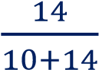 = 
= 

6. (a), (b)
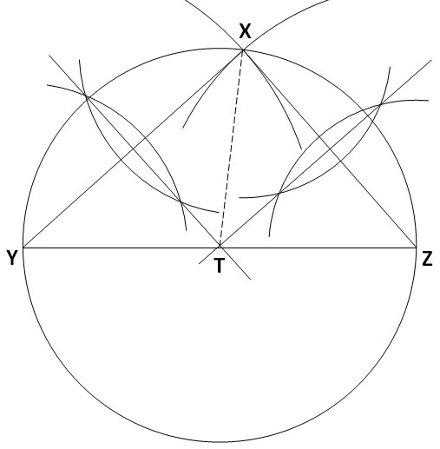
(c) (i) |TX| = 6 cm (± 0.1cm)
(ii) angle XYZ = 40° (± 1°)

