2018 BECE Mathematics (Maths) Past Questions Paper One
1. Which of the following is arranged in ascending order?
A. -25, -64, 4, 17
B. -64, -25, 4, 17
C. -64, -25, 17, 4
D. 17, 4, -25, -64
2. If P = {x: x is an even number greater than two and less than or equal to twelve}, list the members of P.
A. {2, 4, 6, 8, 10, 12}
B. {3, 4, 6, 8, 10, 12}
C. {2, 4, 6, 8, 10}
D. {4, 6, 8, 10, 12}
3. Which of the following is an infinite set?
A. {1, 2, …, 5, 6, 7}
B. {4, 6, 8, 10, 12}
C. {2, 3, 5, 7, 11, …}
D. {3, 6, …, 18, 21, …, 33, 36}
4. Find the HCF of 18, 36 and 60.
A.
B.
C.
D.
5. Write two hundred and two million, two thousand, two hundred and two in figures.
A. 202,002,202
B. 202,020,202
C. 202,022,202
D. 202,200,202
6. Find the number that can be added to 207 to make the sum divisible by 17.
A. 3
B. 13
C. 14
D. 30
7. If P = {factors of 36} and Q = {multiples of 4 less than 40}, find the number of subsets in P ∩ Q.
A. 10
B. 8
C. 6
D. 4
8. Find the LCM of 10, 15 and 25.
A. 90
B. 120
C. 150
D. 300
9. Evaluate
A.
B.
C.
D.
10. Arrange , and in ascending order.
A. , ,
B. , ,
C. , ,
D. , ,
11. Find the simple interest on GHC 600.00 saved for 2 years 8 months at 5% per annum.
A. GHC 64.00
B. GHC 80.00
C. GHC 84.00
D. GHC 92.00
12. The number of girls in a mixed school is 420. If the ratio of boys to girls in the school is 3:2, how many students are in the school?
A. 1050
B. 1470
C. 1630
D. 1680
13. Mary had a chance to select a number from 1 to 20 randomly. What is the probability that the number is divisible by 3?
A.
B.
C.
D.
14. Ama bought a pair of sandals for GHC 20.00 and sold it at GHC 24.00. Find her percentage profit.
A. 4%
B. 17%
C. 20%
D. 44%
15. Eight men can do a piece of work in 12 days. How long will 6 men take to do the same work if they work at the same rate?
A. 14 days
B. 16 days
C. 18 days
D. 20 days
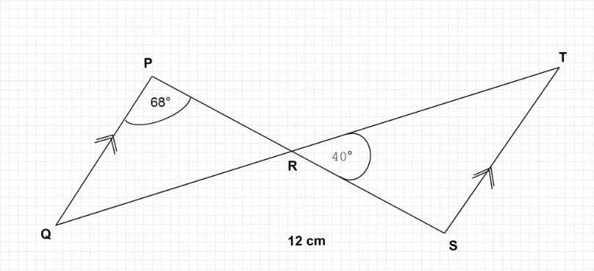
In the diagram QP is parallel to ST, angle QPR = 68° and angle SRT = 40°
16. Find the value of angle PQR.
A. 40°
B. 68°
C. 72°
D. 108°
17. Find the value of angle TSR.
A. 40°
B. 68°
C. 72°
D. 112°
18. A train is travelling at a speed of 60 km/h. What distance would it cover from 10:45 am to 12:15 pm?
A. 75 km
B. 87 km
C. 90 km
D. 150 km
19. The perimeter of a rectangle is 26 cm. If its length is 10 cm, find its area.
A. 30
B. 60
C. 130
D. 160
20. Find the slope of the line 3x – 6y = 33.
A. -3
B. –
C.
D. 3
21. If y = c + b, find y when c = , b=45 c=145, b= and x = 2.
A. 3
B. 4
C. 6
D. 7
22. The volume of a cylinder is 20. If the height of the cylinder is 5 cm, find the base radius.
A. 1 cm
B. 2 cm
C. 3 cm
D. 4 cm

23.
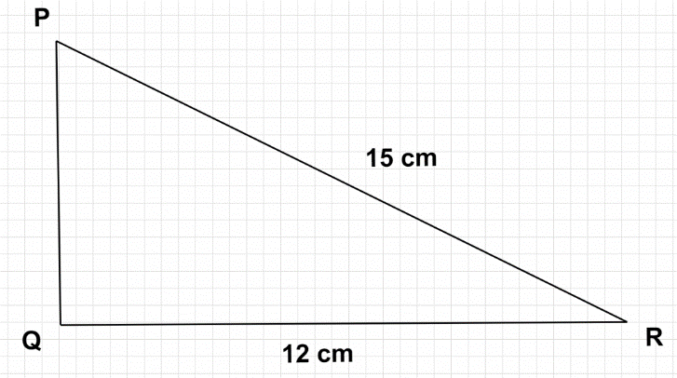

In the diagram, PQR is a right-angled triangle with |PR| = 15 cm and |QR| = 12 cm. Find the length PQ.
A. 3.0 cm
B. 8.0 cm
C. 9.0 cm
D. 19.2 cm
24. How many edges has a triangular prism?
A. 3
B. 5
C. 6
D. 9
25. Make m the subject of the relation q=
A. m=
B. m= 3q-hn
C. m= 3q+hn
D. m=
26. Simplify:
A.
B.
C.
D.
27. Simplify: 4a – 9b – 2(2a – 3b).
A. 8a + 3b
B. 8a – 3b
C. -15b
D. -3b
28. If u= and v= evaluate 6v+2u.
A.
B.
C.
D.
29. Find the image of the point (2, 5) under the transformation:
A. (2, –3)
B. (2, 2)
C. (2, 3)
D. (2, 7)
30. Find the image of Q(–4, 5) when rotated anticlockwise through 90° about the origin.
A. Q(-5, 4)
B. Q(-5, -4)
C. (4, -5)
D. (4, 5)
The following data show the marks of students in a test:
10, 4, 1, 4, 3, 3, 2, 1, 1, 7, 8
Use the information to answer questions 31 and 32.
31. If the pass mark is 4, find the number of students who scored more than the pass mark.
A. 1
B. 2
C. 3
D. 4
32. Find the mean mark.
A. 3
B. 4
C. 7
D. 8
33. How many lines of symmetry has a rhombus?
A. 2
B. 3
C. 4
D. 5
34. In an enlargement length AB = 3 cm and the length of its image = 15 cm. Calculate the scale factor.
A.
B.
C. 5
D. 12
35. Find the rule of the mapping:
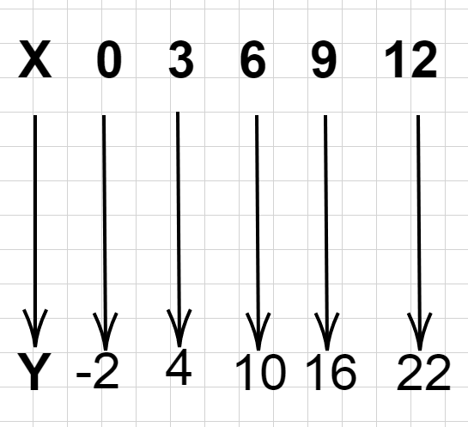
A.
B.
C.
D.
36. Solve the inequality:
A.
B.
C.
D.
37. If 4 – x = 3(4x + 5), find the value of x.
A.
B.
C. -1
D. –
38. In class, there are 12 girls and 48 boys. Find the percentage of boys in the class.
A. 20%
B. 40%
C. 60%
D. 80%
39. The bearing of P from Q is 060°. Find the bearing of Q from P.
A. 120°
B. 150°
C. 210°
D. 240°
40. Which of the following statements best describes the construction below?
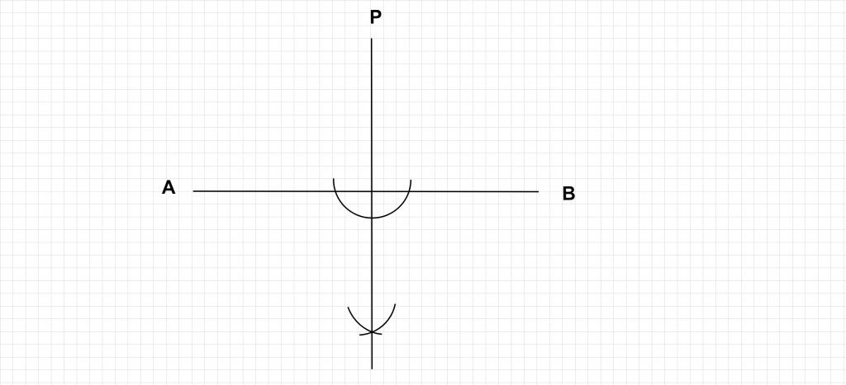
A. construction of line AB from P.
B. construction of perpendicular from P to meet line AB.
C. construction of an arc of a circle with centre P.
D. construction of the bisector of line AB.

Objective Answers
- B
- D
- C.
- D
- A
- C
- D
- C
- A
- D
- B
- A
- C
- C
- B
- C
- B
- C
- A
- C
- C
- B
- C
- D
- A
- B
- D
- B
- A
- B
- C
- B
- A
- C
- D
- C
- D
- D
- D

2018 BECE Mathematics (Maths) Past Questions Paper Two
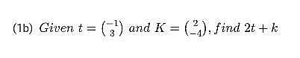
1(a) Solve the inequality:

(1c) The sides of a triangle are in the ratio 6 : 8 : 10. If the perimeter of the triangle is 288 cm, find the:
(i) longest side
(ii) Shortest side
(iii) difference between the longest and the shortest sides.
2. (a) An English textbook costs GHc 25.00. The author of the book agreed to take 20% of the cost of each book sold. If 1,702 copies were sold, calculate the author’s share.
(2b)
(2c)
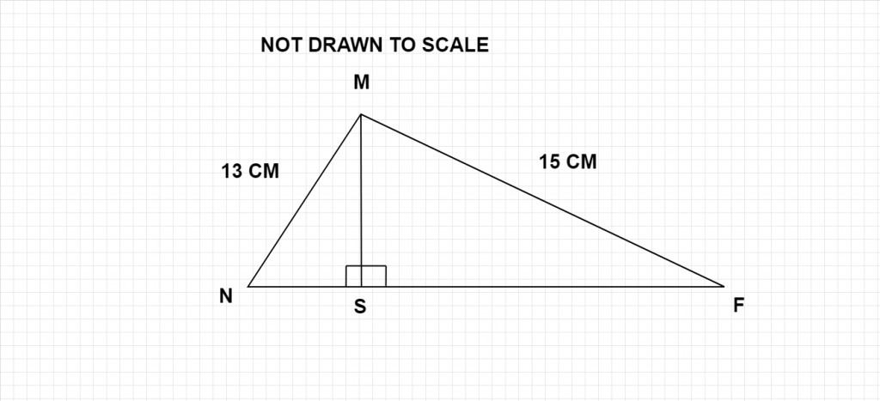
In the diagram, |MN| = 13 cm, |MP| = 15 cm, |MN | = 12 cm and is perpendicular to |NP| . Calculate length |NP|
3. (a) Simplify , leaving the answer in standard form.
(3b) (i) Make r the subject of the relation:
(ii) From (b)(i), find the value of r when y = 3 and x = 10
(3c) Juliet bought 1,756 kg of frozen chicken, 675 g of vegetables, and 95 g of corn oil from a shopping mall. What is the total weight of the items she bought in kilograms?
4. (a) The sum of the interior angles of a regular polygon is 900°. Find the number of sides of the polygon.
(4b) Using a ruler and a pair of compasses only, construct:
(i)Triangle XYZ such that the length XY = 10cm, angle XYZ = 30 degrees and length YZ = 9cm:
(ii) Perpendicular line from Z to meet line XY at P
(iii) measure the (1) length PZ (2) Angle XZY
(iv) Calculate,correct to the nearest whole number,the area of triangle XYZ
5. (a) A property worth GHc 10,480.00 is shared between a widow and her 10 children in the ratio 1 : 4 respectively. The children shared their portions equally. Find each child’s share.
(5b) The data shows the distribution of marks in a class test.
27 55 19 65 69 46
38 42 14 57 11 13
14 67 22 10 25 17
45 39 61 52 43 24
28 63 56 49 64 32
Use the data to answer the following questions:
(i) make a Stem and Leaf plot of the data;
(ii) how many students scored more than 10 marks and less than 20 marks?
(iii) what is the probability of a student scoring less than 20 marks?
6. (a) An aeroplane left the Kotoka International Airport on Wednesday at 7:26 pm and reached its destination after nine hours thirty minutes. Find the day and the time the aeroplane reached its destination.
(6b)
(i) Using a scale of 2 cm to 2 units on both axes, draw two perpendicular axes Ox and Oy on a graph sheet for
.
(ii) Draw on this graph, indicating the co-ordinates of all vertices, the quadrilateral ABCD with vertices A(0,10), B(-6,-2) , C(-3,-11) and D(4,3).
(iii) Draw the line X = -2 to meet AB at P and CD at Q
(iv) Measure angles BPQ and PQD
(i) State the relationship between:
(α) angles BPQ and PQD;
(β) lines AB and CD.

Paper 2 Answer

1a
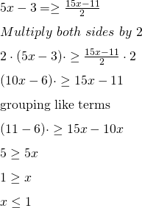
1b 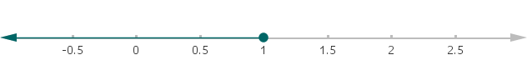

1b
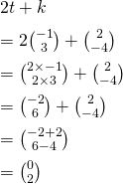

1c
longest side
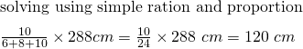
shortest side
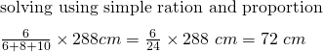
difference between the longest and the shortest sides.
=120 – 72
= 48 cm
2a
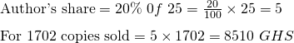

(2b)
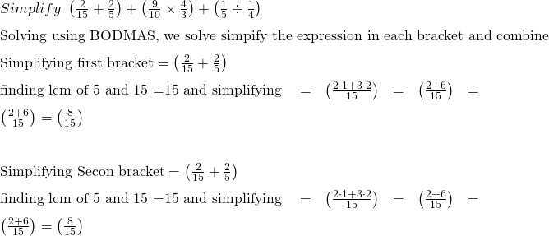
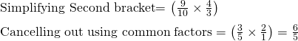
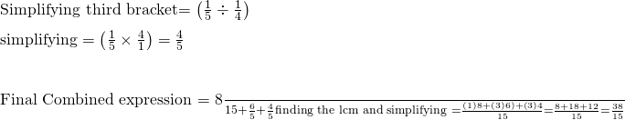

(2c)
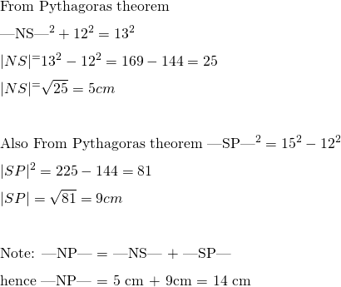

3. (a)
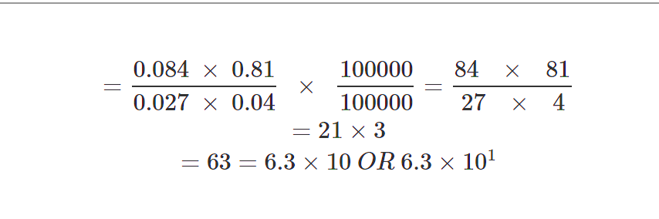

(3b) (i)
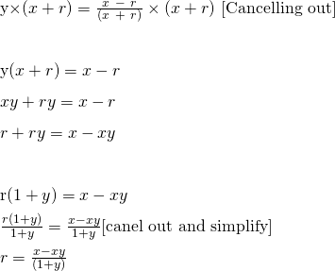

(ii)
(3c)
Weight of chicken = 1,756 kg (Already in Kilograms so no conversion is needed
Weight of vegetables in kilograms =
Weight of Corn Oil in kilograms =
Total weight of items = 1756 + 0.675 + 0.095 = 1756.77 kg
4. (a)
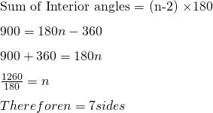

4b
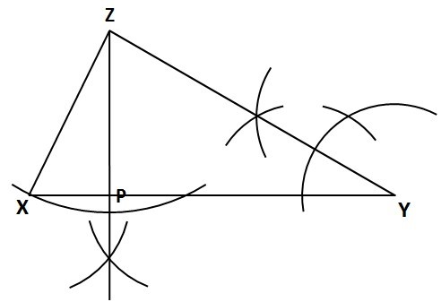
(iii) measure the:
(α) length = 4.5 cm – 4.6 cm
(β) angle = 86° to 87°
(iv) calculate, correct to the nearest whole number, the area of triangle .
Area of a triangle = (1/2) × Base × Height
Area of triangle XYZ = (1/2) × |XY| × |PZ|
= × 10cm × 4.5
= × 45
= 22.5
≈ 23 cm2 (to nearest whole number)
5. (a)
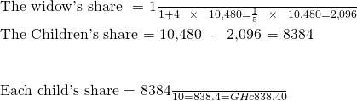
5b
Stem | Leaf
1 | 0, 1, 3, 4, 4, 7, 9
2 | 2, 4, 5, 7, 8,
3 | 2, 8, 9
4 | 2, 3, 5, 6, 9
5 | 2, 5, 6, 7,
6 | 1, 3, 4, 5, 7, 9
(ii) how many students scored more than 10 marks and less than 20 marks?
= 6 students
(iii) what is the probability of a student scoring less than 20 marks?
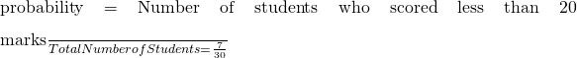

6. (a) 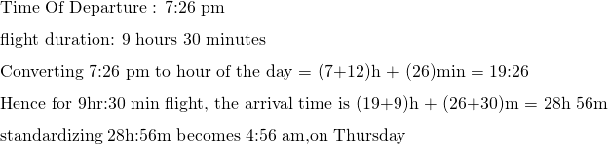

(6b)
CD.
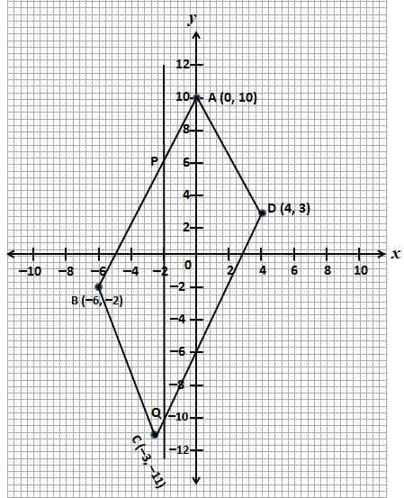
(iv) Measure angles BPQ and PQD
Angle BPQ = 26°
Angle PQD = 26°
(i) State the relationship between:

