ESC takes 50Hz PWM signal, same as SERVO – USE SERVO LIBRARY on the Nano -
https://www.quora.com/What-signal-does-a-brushless-motor-ESC-electronic-speed-controller-use
https://www.arduino.cc/en/Tutorial/PWM

Restrict to Y axis, Vy/1023 gives strength ratio
https://arduinomodules.info/ky-023-joystick-dual-axis-module/

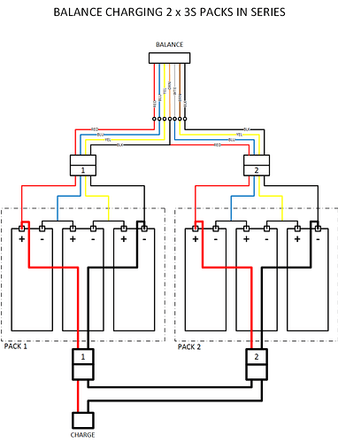
Charging:
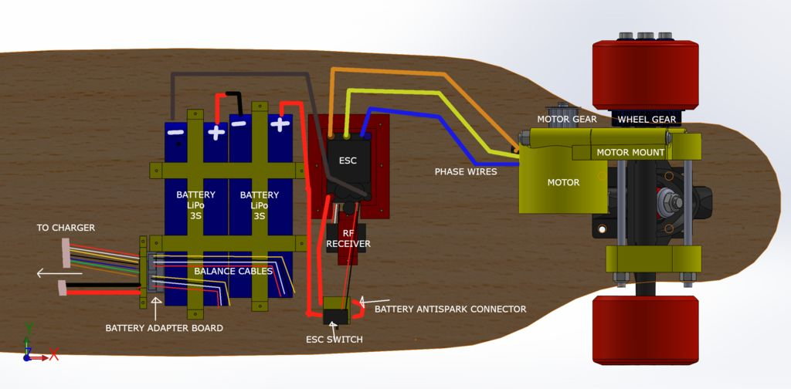
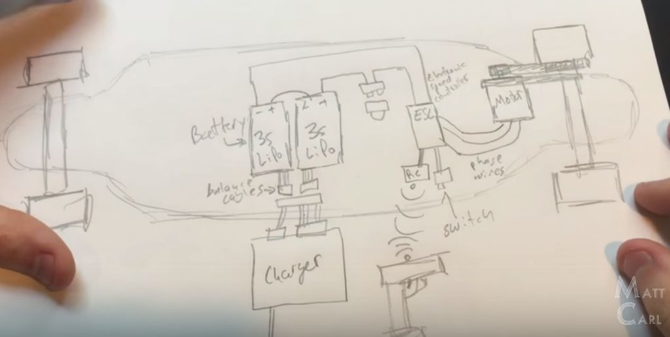
https://www.electric-skateboard.builders/t/charging-2-x-3s-lipos-in-series-please-look-over-my-schematic/734/8

Analog 0-1023 → PWM
https://www.youtube.com/watch?v=WYraDqirg3c

Analog to 50hz PWM

Upload code to ProMini
https://www.youtube.com/watch?v=kecsB87cT74
usb to ttl
https://www.google.com/search?biw=1920&bih=975&ei=xpruXO6uA8HK-gT9mYmwDg&q=TTL-232R+USB+-+TTL&oq=TTL-232R+USB+-+TTL&gs_l=psy-ab.3..0i22i30l2.14852.14852..15199...0.0..0.135.135.0j1....1..0....2j1..gws-wiz.......0i71.aQZIG0R3yo0

