System Design & Architecture

1. SYSTEM OVERVIEW
Bookify is a web-based event booking syste designed to allow users to browse events and reserve tickets online. The system also provides administrators with tools to create and manage events

The app follows a client server architecture here the frontend communicates with the backend server which interacts with the SQL database.

2. TECHSTACK

Component | Technology
Frontend | HTML, CSS, JavaScript
Backend | Node.Js
Database | SQL
Architecture Type | Web Application

3. SYSTEM ARCHITECTURE
Frontend Layer
The frontend provides the user interface for interacting with the system. Users can:
- Browse events
- Search and filter events
- View event details
- Book tickets
- Access their profiles
Built using HTML, CSS, and JavaScript.

Backend Layer
The backend handles:
- Business logic
- User authentication
- Event management
- Booking processing
- Communication with the database
Implemented using Node.js.

Database Layer
The SQL database stores:
- User information
- Event details
- Booking records
- Ticket information
The database ensures persistent storage and retrieval of system data.

4. HIGH LEVEL SYSTEM FLOW
User → Frontend → Backend → SQL Database

Flow Explanation:
User interacts with frontend
Frontend sends request to backend
Backend processes requests and communicates with the database
Database returns requested data
Backend sends response to frontend
Frontend displays updated info to the user

5. IMPORTANT SYSTEM MODULES

Authentication Module
Handles:
- User registration
- User login
- Session validation

Event Management Module
Handles:
- Event creation
- Event editing
- Event deletion
- Event retrieval

Booking Module
Handles:
- Ticket selection
- Booking confirmation
- Booking storage
- Booking history retrieval

Search & Filter Module
Allows users to:
- Search events by name
- Filter events by category

6. DATABASE OVERVIEW
The system uses a relational SQL database with the following core entities:
- Users
- Events
- Bookings
- Tickets

Entity Relationships
- One user can make multiple bookings
- One event can have multiple bookings
- Each booking belongs to one user and one event

7. USER FLOW INTEGRATION
The user flows were designed using FigJam and integrated into the system design process:
- User Registration & Login Flow
- Event Booking Flow
- Admin Event Management Flow
These flows illustrate the interaction between users, admins, and the system during major operations.

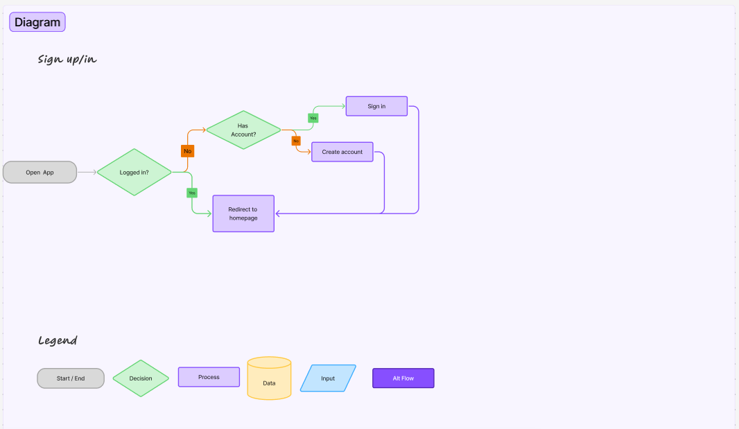
Figure 7.1: User Registration/Login Flow

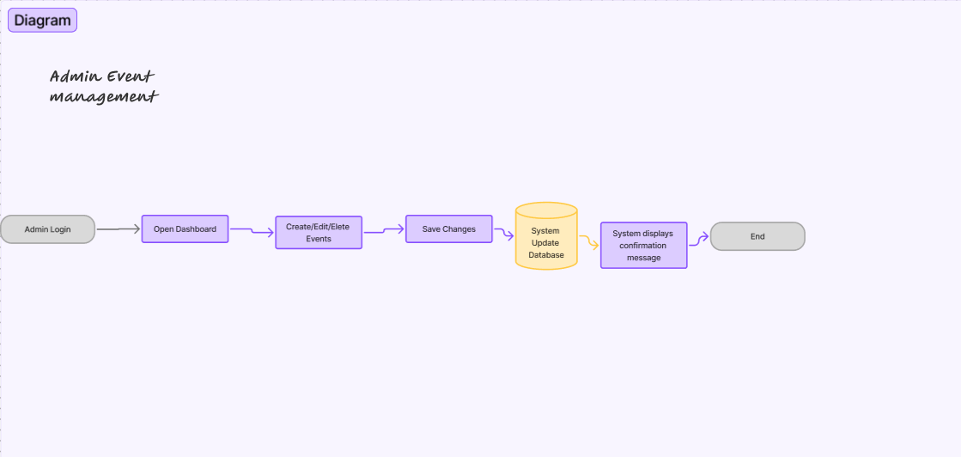
Figure 7.2: Admin Event Management Flow

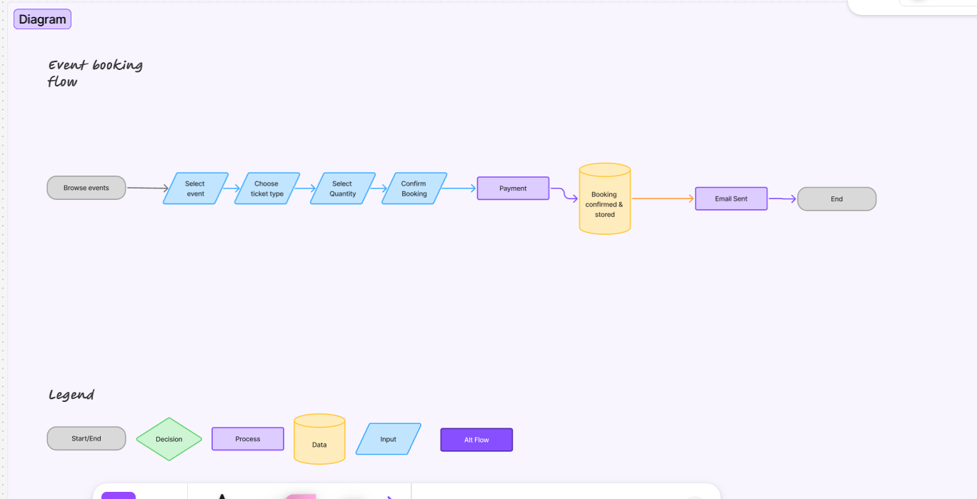
Figure 7.3: Event Booking Flow

8. DESIGN CONSIDERATIONS
- Minimalist user interface
- Simple and intuitive navigation
- Responsive web design principles
- Separation of frontend, backend, and database responsibilities

9. LIMITATIONS
- The application is for academic purposes only
- Real payment processing is not supported
- Real email notifications are not implemented

