Sql injection

Spencer wise

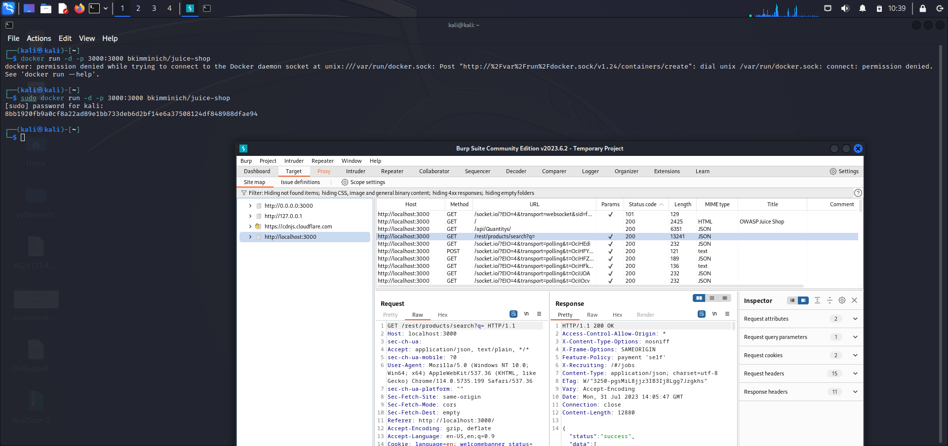

Got my target “Juice Shop” running in my Kali terminal. Opened Burp Suite, under the target tab I clicked on the “Juice Shop” URL. From there I have my “IN” the query response needed for SQL injection.

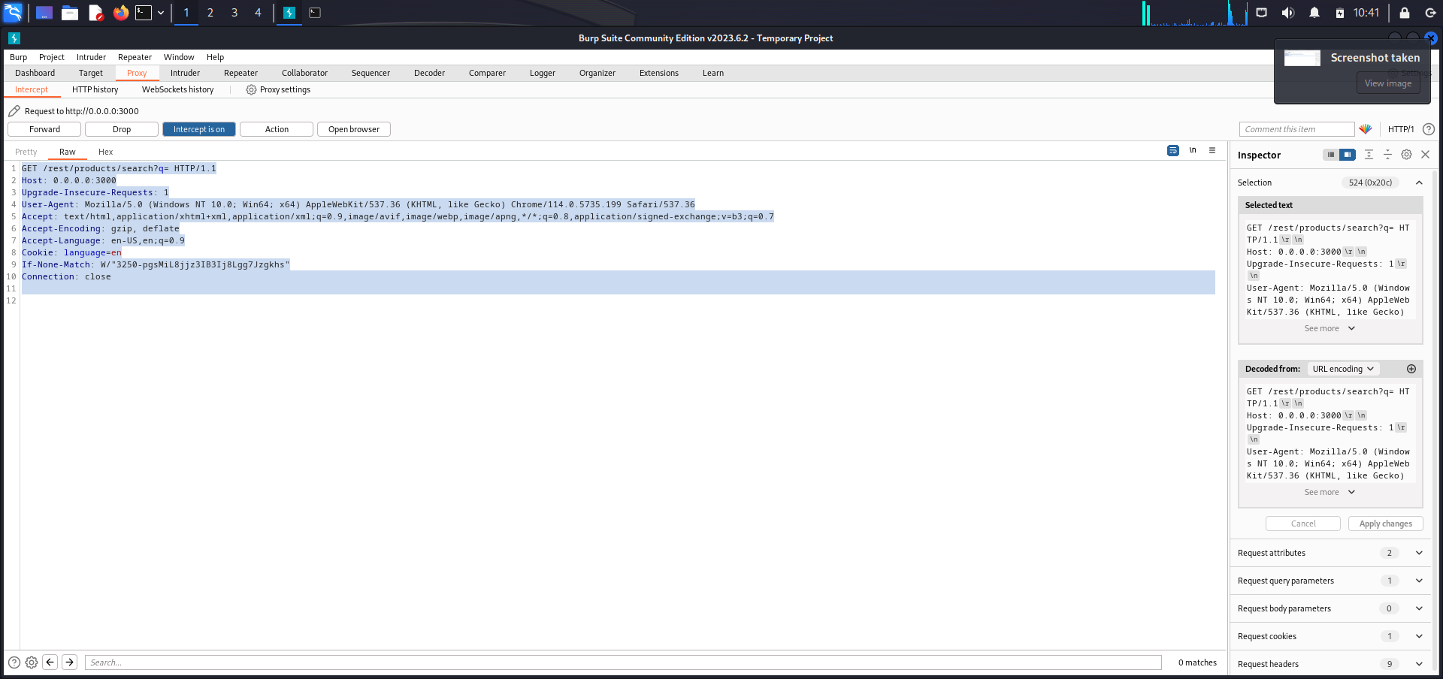

Under the Proxy tab I turn intercept on and navigate to the target URL and included the query at the end. With intercept on it captures all incoming/outgoing responses. I forward this to my repeater to get my SQL injection started.

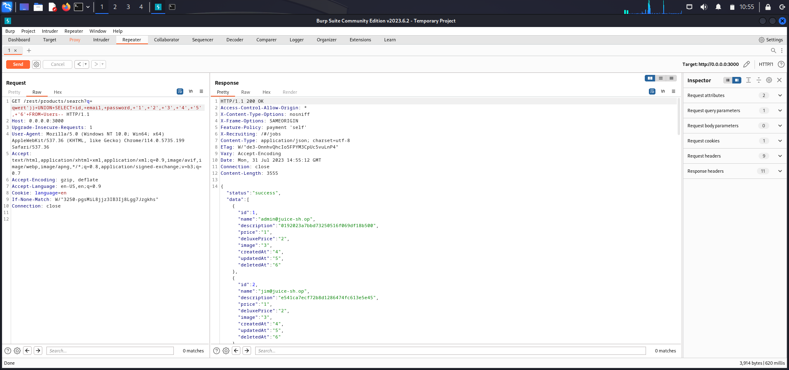

I input injections (as seen above) thatll prompt the website to divulge the information I am requesting. ID, EMAIL, PASSWORDS.

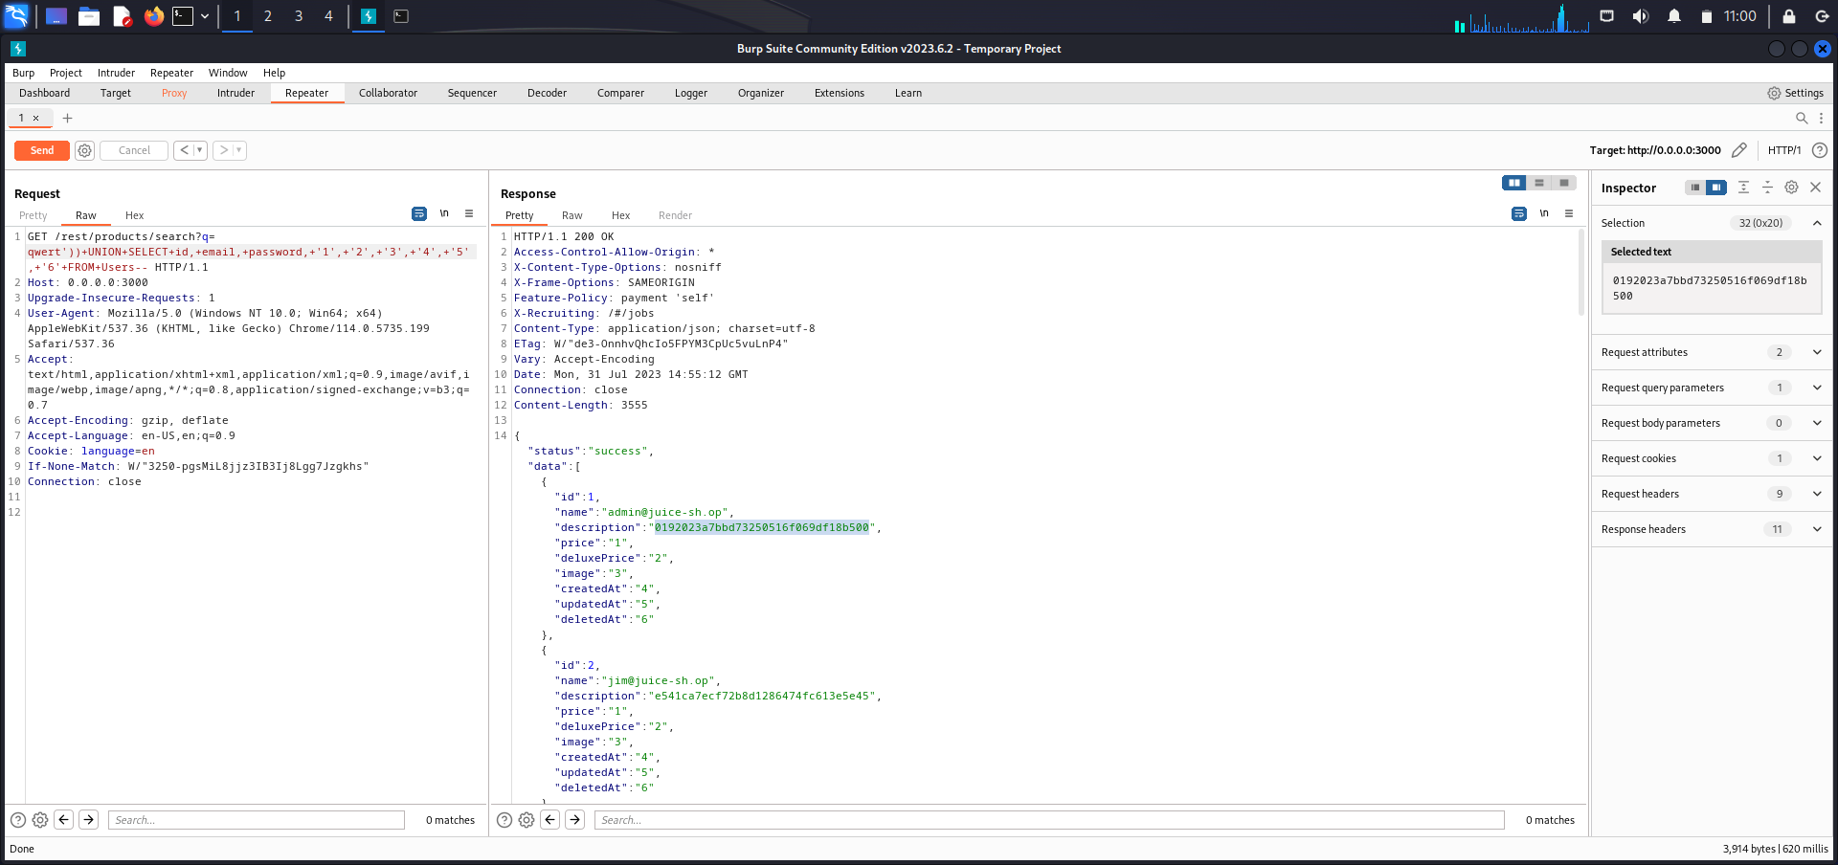

The injection went through successfully as notated by the 200 response. What came back that was readily clear was the ID and username. The encoded hash still has to be deciphered. So I copy it.

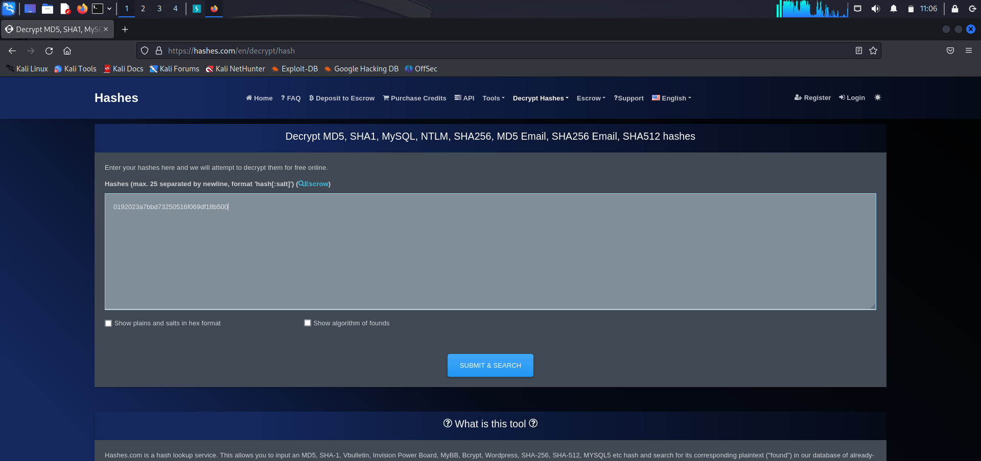

Go to a hash decoder site. Paste my selection.

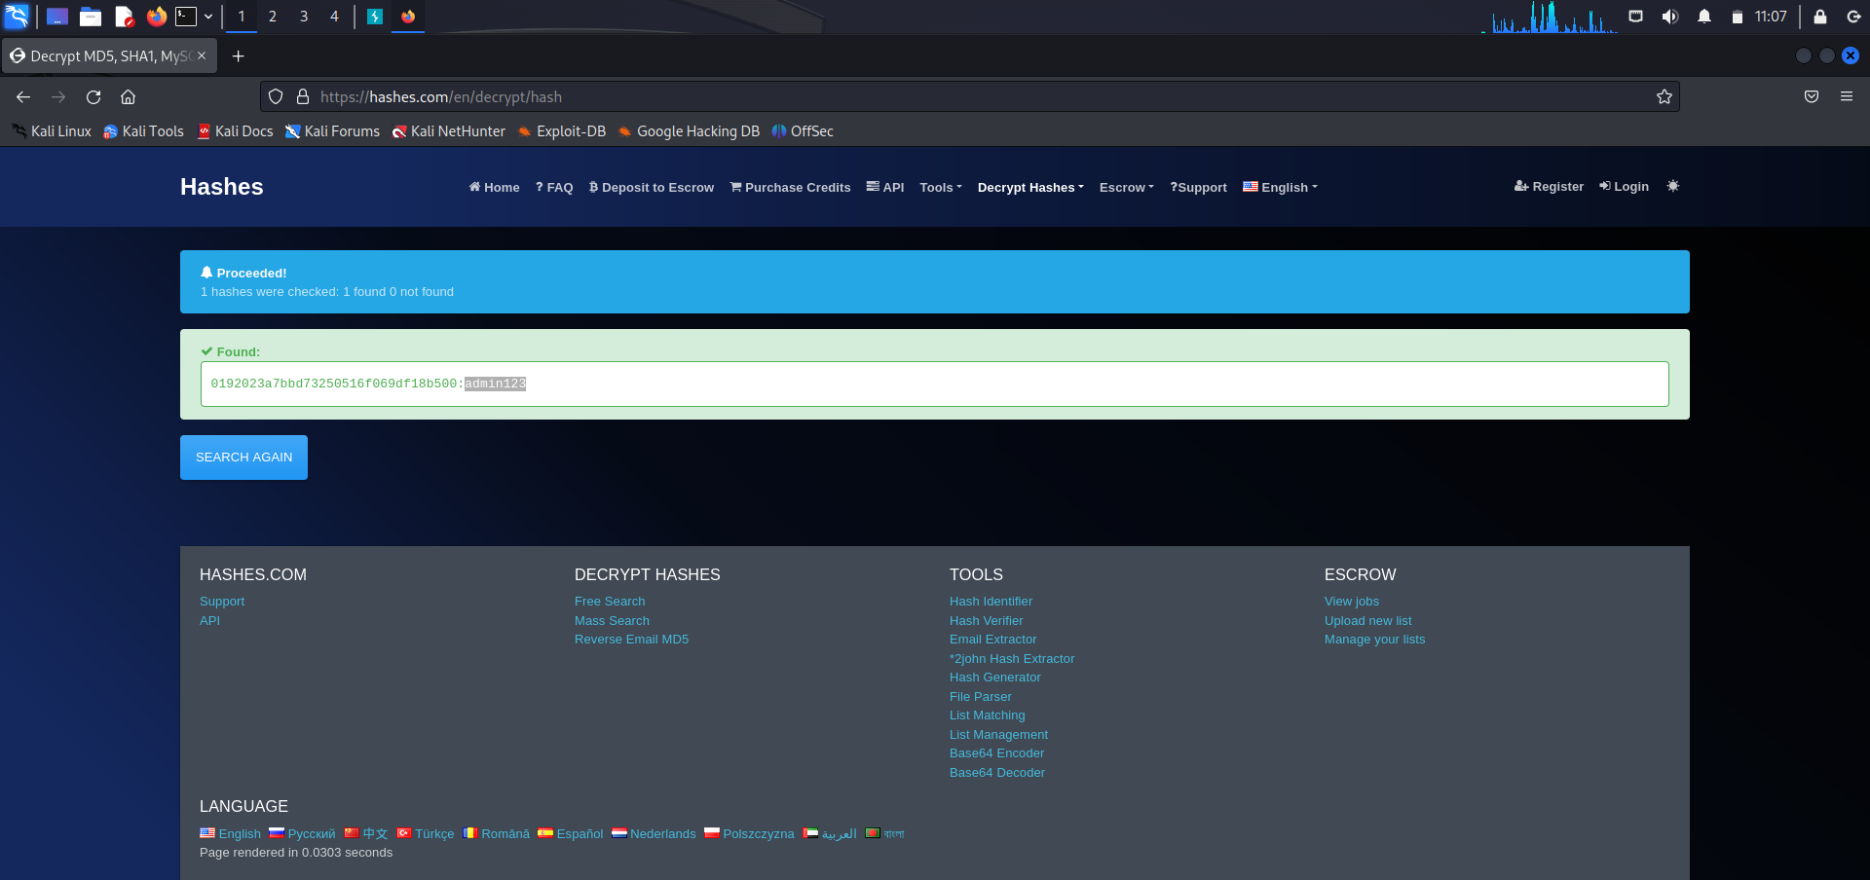

There you have what seems to be a password.