Operability Index and Constrained Optimization of a Natural Gas Processing Plant via DWSIM and Latin Hypercube Sampling
Gabriel Freitas ª, Roymel R. Carpio ^{a*}, Nicolas Spogis ^{b}
ª School of Chemistry, Universidade Federal do Rio de Janeiro – UFRJ, Rio de Janeiro, RJ, Brazil
^{b} School of Chemical Engineering, University of Campinas (UNICAMP), Campinas, SP, Brazil
* Corresponding author. E-mail: roymel@eq.ufrj.br

Highlights
• Operability Index (OI) of 14.1% reveals a severely constrained operating envelope for the natural gas processing plant.
• Reid Vapor Pressure of Natural Gasoline is the dominant bottleneck constraint, with only 48.5% individual satisfaction.
• Strong inverse coupling between C₅₊ content in LPG and RVP of Natural Gasoline (r = −0.65) creates a fundamental trade-off.
• Cold separator temperature (V-02) dominates revenue with |r| = 0.984, providing a clear lever for process optimization.
• Open-source DWSIM simulator coupled with Latin Hypercube Sampling enables accessible, reproducible operability analysis.

Abstract
Natural gas processing plants must satisfy multiple product-quality specifications simultaneously while maximizing revenue; yet conventional optimization approaches focus on identifying single optimal operating points without characterizing the extent of the feasible operating region. This limitation leaves critical questions unanswered: how much of the available operating space actually meets all specifications? Which constraints are the true bottlenecks? And how do inter-constraint couplings shape the feasible envelope? This work addresses these gaps by applying the Georgakis process operability framework — traditionally used in reactor design and process intensification — to a conventional natural gas processing plant for the first time. The plant, modelled in the open-source simulator DWSIM with the Peng–Robinson equation of state, considers the processing of a 16-component Brazilian natural gas and comprises several gas-liquid separators, three distillation columns, and other auxiliary unit operations. Five manipulable variables were systematically varied across 2,000 Latin Hypercube Sampling scenarios, and the resulting outputs were evaluated against four product-quality constraints derived from ANP regulatory standards. The Operability Index reveals a severely constrained process in which most technically accessible operating conditions fail to produce compliant products. Constraint decomposition analysis identifies the Reid Vapor Pressure specification as the dominant bottleneck and uncovers a previously unreported inverse thermodynamic coupling between C₅₊ content in LPG and RVP of Natural Gasoline — a trade-off that compresses the feasible envelope far below what independent constraint analysis would predict. This coupling, invisible to single-point optimization, emerges as the primary mechanism limiting plant operability and provides a clear engineering target for process improvement. Beyond the specific findings, this study demonstrates that operability analysis offers a fundamentally different perspective from conventional optimization: rather than asking where is the best operating point? it asks how large is the space of acceptable operation? — a question with direct implications for process robustness, control strategy design, and regulatory negotiation. The exclusive use of open-source tools (DWSIM for simulation and Python for analysis) ensures full reproducibility and accessibility to researchers without commercial software dependencies.
Keywords: Process operability; Natural gas processing; DWSIM; Latin Hypercube Sampling; Constraint analysis; Open-source simulation

Nomenclature
AIS | Available Input Set
ANP | National Agency for Petroleum, Natural Gas and Biofuels (Brazil)
AOS | Achievable Output Set
DOS | Desired Output Set
DPU | Dew Point Unit
DWSIM | Open-source chemical process simulator
LFU | Liquid Fractionation Unit
LHS | Latin Hypercube Sampling
LPG | Liquefied Petroleum Gas
LPG_C2 | Ethane content in LPG (mol%)
LPG_C5 | C₅₊ content in LPG (mol%)
M(·) | Steady-state process model
N | Number of LHS samples
NG | Natural Gasoline
NG_RVP | Reid Vapour Pressure of Natural Gasoline (kPa)
OI | Operability Index
pp | Percentage points
PR | Peng–Robinson equation of state
PSO | Particle Swarm Optimisation
r | Pearson correlation coefficient
RVP | Reid Vapour Pressure (kPa)
SG | Sales Gas
SG_C1 | Methane content in Sales Gas (mol%)
SLSQP | Sequential Least Squares Programming
u | Vector of decision variables (inputs)
y | Vector of output variables
μ(·) | Lebesgue measure (volume)

1. Introduction
Natural gas processing is a cornerstone of the global energy supply chain, transforming raw natural gas into pipeline-quality Sales Gas (SG), Liquefied Petroleum Gas (LPG), and Natural Gasoline (NG) that meet stringent commercial specifications. The processing train typically involves gas-liquid separation, fractionation through a sequence of distillation columns, and product conditioning. In Brazil, these operations must comply with the specifications set by the National Agency for Petroleum, Natural Gas and Biofuels (ANP), notably Resolution 16/2008 for SG quality and Resolution 825/2020 for LPG composition and vapor pressure limits.
Optimizing such plants is challenging because the decision variables—column temperatures, pressures, and separator conditions—are tightly coupled through thermodynamic interactions. A change in the deethaniser reboiler temperature, for instance, affects not only ethane recovery but also propagates downstream, altering LPG composition.
Prior studies have addressed this challenge through deterministic single-point optimization. Carpio et al. (2024) introduced a hybrid optimization framework to identify the optimal operating conditions for an industrial natural gas processing plant. Their approach combines global optimization using surrogate models—which significantly reduces computational cost—with local refinement optimization employing the first-principles simulation to ensure strict adherence to all process constraints. Souza et al. (2023) applied particle swarm optimization (PSO) combined with Nelder–Mead refinement to a multi-unit Brazilian gas plant, achieving a 7.3% profit increase. Franco et al. (2020) evaluated the effect of feed stream composition on energy consumption. Zhang et al. (2017) formulated a global optimization model for raw gas refining complexes. Campos et al. (2012) and Ribeiro et al. (2020) reported industrial-scale optimization efforts at Petrobras facilities.
While these contributions are valuable, they share a common limitation: they identify optimal operating points without quantifying the size and shape of the feasible operating region. In practice, plants do not operate at a single point—they operate within a range of conditions dictated by feed variability, equipment constraints, ambient temperature fluctuations, and product-market dynamics. The question of how much of the available operating space actually satisfies all specifications simultaneously remains unanswered by conventional optimization.
The process operability framework, introduced by Vinson and Georgakis (2000) and subsequently extended by Georgakis et al. (2003) and Subramanian and Georgakis (2005), provides a rigorous methodology for addressing this question. The framework maps the Available Input Set (AIS)—the space of manipulable decision variables—through the process model to obtain the Achievable Output Set (AOS), and then quantifies the overlap between the AOS and the Desired Output Set (DOS)—the region of acceptable product quality—through the Operability Index (OI). An OI of 100% indicates that every achievable output meets specifications; lower values reveal constrained operation. Gazzaneo et al. (2020) provided a comprehensive review of operability algorithms, and Alves et al. (2024) released the Opyrability Python package for their computation.
The operability framework has been applied to diverse chemical processes, including modular natural gas utilization systems (Carrasco and Lima, 2017), dynamic methane-to-aromatics reactors (Dinh and Lima, 2023), and flowsheet-level analysis with commercial simulators (Ferreira et al., 2025). However, to the best of the authors’ knowledge, no study has applied operability analysis to quantify the feasible operating envelope of a conventional natural gas processing plant with explicit regulatory constraints.
This paper addresses this gap through three contributions: (i) we apply the Georgakis operability framework to a natural gas processing plant modelled in the open-source simulator DWSIM, using Latin Hypercube Sampling to systematically explore a five-dimensional input space; (ii) we identify the dominant constraint bottleneck and quantify inter-constraint coupling through correlation analysis and constraint relaxation studies; and (iii) we demonstrate that the resulting operability map provides actionable insights—such as the inverse coupling between C₅₊ content in LPG and Reid Vapor Pressure of NG—that are invisible to conventional single-point optimization.

2. Methodology

2.1. Process Operability Framework
The operability framework of Georgakis and co-workers characterizes the relationship between the set of manipulable inputs and the set of achievable outputs of a process. For a steady-state process model y = M(u), where u is the vector of decision variables and y is the vector of output variables, the framework defines:
- Available Input Set (AIS): the range of input variables that the process can physically access, defined by equipment and safety limits;
- Achievable Output Set (AOS): the set of all outputs y = M(u) for u ∈ AIS;
- Desired Output Set (DOS): the region of output space where product specifications are satisfied.
The Operability Index (OI) is defined as the ratio of the achievable outputs that fall within the desired region to the total desired region:
OI = μ(AOS ∩ DOS) / μ(DOS) (1)
where μ denotes the Lebesgue measure (volume) of the respective sets. In this work, since the DOS is defined by four inequality constraints on the outputs, we approximate the OI by the fraction of uniformly sampled AIS points whose outputs satisfy all constraints simultaneously. With N = 2,000 Latin Hypercube samples, the standard error of this fraction estimate is approximately 0.78 percentage points (based on binomial standard error), providing sufficient precision for comparative analysis.

2.2. Process Description and DWSIM Model
The natural gas processing plant was simulated using DWSIM version 9.0.5 (Medeiros, 2024), an open-source, CAPE-OPEN compliant chemical process simulator. The simulation model comprises two highly integrated processing units: a Dew Point Unit (DPU), which processes the vapor phase from the slug catchers, and a Liquid Fractionation Unit (LFU), which handles the condensate. These units are tightly coupled due to significant material recycle streams; specifically, lighter condensate from the DPU is sent to the LFU for stabilization, while off-gas from the LFU is recycled back to the DPU for further recovery. The main products of the facility are: (1) Sales Gas, (2) Liquefied Petroleum Gas, and (3) Natural Gasoline, a stream with components heavier than C₄. The complete process flowsheet is presented in Figure 1.
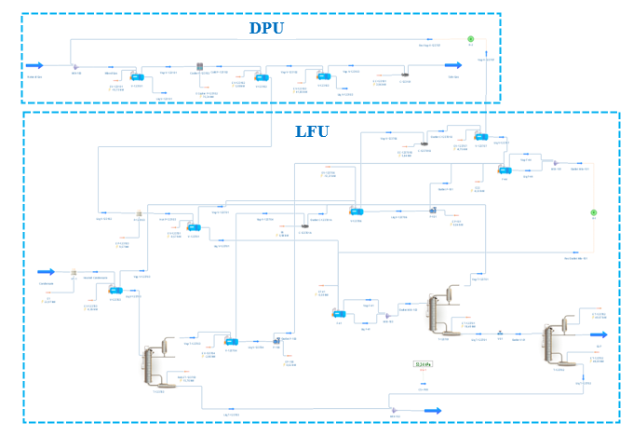
Fig. 1. Process flowsheet in DWSIM.

The process flowsheet comprises the following major unit operations:
a) Several gas-liquid separation units, including a cold separator (V-02) that operates between −33 °C and −17 °C. This vessel governs the gas-liquid split and exerts the most significant influence on overall liquid product recovery.
b) Three distillation columns: an 11-stage deethaniser (T-01), a 21-stage debutaniser (T-02), and a 6-stage stabilizer (T-03), the latter of which receives the condensate from the slug catchers.
c) Three compressors (C-01, C-01A/B), each modeled with an adiabatic efficiency of 75%.
d) Auxiliary equipment, including heat exchangers, pumps, and recycle blocks.
The 16-component system includes nitrogen, carbon dioxide, and methane through dodecane. Therefore, Peng–Robinson equation of state (Peng and Robinson, 1976) was selected as the thermodynamic model, which is appropriate for hydrocarbon-dominated systems at moderate pressures. The feed gas composition (mol%): methane 79.43, ethane 9.88, propane 5.65, CO₂ 2.17, n-butane 1.28, isobutane 0.79, nitrogen 0.61, isopentane 0.18, and trace amounts of heavier hydrocarbons (C₆–C₁₂) entering via a condensate mixing point. Table 1 summarizes the column specifications.

Table 1. Distillation column specifications in the DWSIM model.
Column | Function | Stages | ΔP (kPa) | Condenser spec. | Reboiler spec.
T-01 | Deethaniser | 11 | 9 | No applicable | Feed Recovery [%]
T-02 | Debutanizer | 21 | 261 | Reflux ratio | Feed Recovery [%]
T-03 | Stabilizer | 6 | 100 | No applicable | Feed Recovery [%]

2.3. Decision Variables (AIS)
Five decision variables were identified based on process sensitivity analysis and operational practice. These variables represent the primary degrees of freedom available to plant operators for controlling product quality and recovery. Although the DWSIM model internally uses component recovery fractions to aid convergence, the operability analysis is performed using the physically meaningful reboiler temperatures (read from the converged simulation at each LHS point), since these are the actual manipulated variables in plant operation. Table 2 presents the decision variables and their ranges.
Table 2. Decision variables (AIS) and their operating ranges.
Variable | Symbol | Description | Lower | Upper | Unit
u₁ | V_02_Temp | Cold separator temperature | −33 | −17 | °C
u₂ | T_01_Reb | Deethaniser reboiler temperature | 51 | 94 | °C
u₃ | T_02_RR | Debutanizer reflux ratio | 0.7 | 4.5 | –
u₄ | T_02_Reb | Debutanizer reboiler temperature | 107 | 183 | °C
u₅ | T_03_Reb | Stabilizer reboiler temperature | 152 | 206 | °C

The cold separator temperature (u₁) controls the quality of SG as well as the initial gas–liquid split: lower temperatures recover more heavy hydrocarbons as liquid, increasing the production of liquid products. The deethaniser reboiler (u₂) governs ethane rejection from the LPG stream. The debutanizer reflux ratio (u₃), debutanizer reboiler temperature (u₄), and the stabilizer reboiler temperature (u₅) determine the split between LPG (C₃–C₄) and NG (C₅₊).

2.4. Product-Quality Constraints (DOS)
The Desired Output Set is defined by four inequality constraints derived from Brazilian regulatory requirements (ANP Resolutions 16/2008 and 825/2020) and industry practice (GPSA, 2004). Table 3 presents these constraints.
Table 3. Product-quality constraints defining the Desired Output Set (DOS).
Constraint | Output var. | Physical meaning | Limit | Regulatory basis
g₁ | SG_C1 | Methane content in SG (mol%) | ≥ 80 | ANP 16/2008
g₂ | LPG_C2 | Ethane content in LPG (mol%) | ≤ 12 | ANP 825/2020
g₃ | LPG_C5 | C₅₊ content in LPG (mol%) | ≤ 2 | ANP 825/2020
g₄ | NG_RVP | Reid Vapor Pressure of NG (kPa) | ≤ 76 | ANP 825/2020

Constraint g₁ ensures SG quality; constraints g₂–g₃ ensure LPG quality. Specifically, g₂ limits light impurities (ethane) and g₃ limits heavy impurities (pentanes and heavier). Meanwhile, g₄ limits the vapor pressure of the NG stream to ensure safe handling and storage. A point u ∈ AIS is considered feasible if and only if all four constraints are simultaneously satisfied.

2.5. Sampling Strategy: Latin Hypercube Sampling
To explore the five-dimensional AIS uniformly and efficiently, we employed Latin Hypercube Sampling (McKay et al., 1979) with N = 2,000 samples. LHS partitions each input dimension into N equally probable intervals and samples exactly once from each interval, producing a space-filling design with superior coverage compared to simple random sampling at the same sample size. Each of the 2,000 input combinations was evaluated through the DWSIM flowsheet model to obtain the corresponding output values (Revenue, SG_C1, LPG_C2, LPG_C5, NG_RVP), generating the AOS.
The choice of N = 2,000 provides a balance between computational cost and statistical precision. For the observed OI of 14.1%, the binomial standard error is SE = [OI(1 − OI)/N]½ ≈ 0.78 percentage points, yielding a 95% confidence interval of approximately [12.6%, 15.6%].

3. Results and Discussion

3.1. Output Space Characterization and Operability Index
The 2,000 LHS-generated operating scenarios were evaluated through the DWSIM model, producing output vectors in the four-dimensional output space (SG_C1, LPG_C2, LPG_C5, NG_RVP). Of these, 281 scenarios (14.1%) satisfied all four constraints simultaneously, yielding an Operability Index (OI) of 14.1%. This remarkably low value indicates that only a small fraction of the technically accessible operating space produces compliant products, revealing a severely constrained process.
Table 4 reports the individual constraint satisfaction rates. Constraint g₁ (methane in SG ≥ 80) is universally satisfied across all 2,000 scenarios, indicating that methane content in the SG is never a binding constraint within the explored AIS. In contrast, g₄ (RVP of NG ≤ 76 kPa) is the most restrictive constraint, satisfied by only 48.5% of scenarios individually. Constraints g₂ (ethane in LPG ≤ 12 mol%) and g₃ (C₅₊ in LPG ≤ 2 mol%) show intermediate satisfaction rates of 56.2% and 74.7%, respectively.
Table 4. Individual and joint constraint satisfaction across 2,000 LHS scenarios.
Constraint | Individual satisfaction | % of scenarios | Constraint class
g₁: SG_C1 ≥ 80 | 2,000 / 2,000 | 100.0% | Non-binding (slack)
g₂: LPG_C2 ≤ 12 | 1,125 / 2,000 | 56.2% | Active
g₃: LPG_C5 ≤ 2 | 1,493 / 2,000 | 74.7% | Active
g₄: NG_RVP ≤ 76 | 970 / 2,000 | 48.5% | Dominant bottleneck
All constraints | 281 / 2,000 | 14.1% | OI

The substantial gap between the most restrictive individual constraint (48.5% for g₄) and the joint OI (14.1%) demonstrates significant inter-constraint coupling. If the constraints were independent, the joint feasibility would be approximately 0.562 × 0.747 × 0.485 ≈ 20.4%, but the observed 14.1% is materially lower, indicating negative correlation between constraint satisfaction.

3.2. AOS Projections and Constraint Boundaries
Figure 2 presents two-dimensional projections of the AOS onto the three most informative output pairs, with DOS boundaries shown as dashed lines and feasible points (those satisfying all four constraints) highlighted in green.
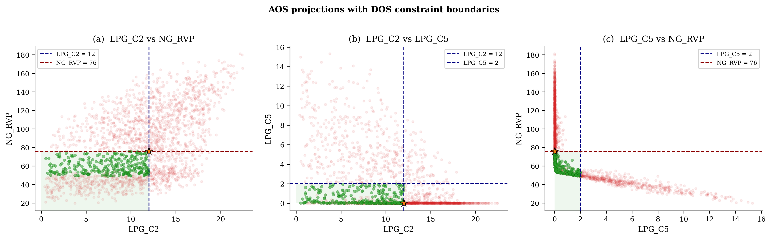
Fig. 2. AOS projections onto output-pair planes with DOS constraint boundaries. (a) LPG_C2 vs. NG_RVP; (b) LPG_C2 vs. LPG_C5; (c) LPG_C5 vs. NG_RVP. Green points satisfy all four constraints simultaneously; light red points violate at least one constraint. Orange star marks the SLSQP optimal point.

Panel (a) reveals that the feasible region in the LPG_C2–NG_RVP plane occupies the lower-left quadrant, bounded by LPG_C2 ≤ 12 and NG_RVP ≤ 76. The scatter of infeasible points extends to LPG_C2 values exceeding 22 mol% and NG_RVP values exceeding 180 kPa, illustrating the breadth of the AOS relative to the DOS. Panel (b) shows a distinctive triangular-shaped structure in the LPG_C2–LPG_C5 plane: high LPG_C2 (ethane-rich LPG) tends to coincide with low LPG_C5, and vice versa, reflecting the fractionation sequence logic. Panel (c) presents the LPG_C5–NG_RVP coupling, which is analyzed in detail in Section 3.4.

3.3. Variable Correlations
Pearson correlation analysis between the five input variables and the key outputs reveals the dominant relationships that govern process behavior. Table 5 presents the most significant correlations. Figure 4 provides visual confirmation through scatter plots of the four key relationships.
Table 5. Dominant variable correlations (Pearson r).
Variable 1 | Variable 2 | Pearson r | Physical mechanism
V_02_Temp | Revenue | −0.984 | Colder separator → more liquid recovery → higher revenue
T_01_Reb | LPG_C2 | −0.970 | Hotter deethaniser → more ethane stripped → lower ethane in LPG
T_02_Reb | NG_RVP | −0.976 | Hotter debutanizer → fewer lighter compounds in NG → lower RVP
LPG_C5 | NG_RVP | −0.650 | More C₅₊ in LPG → fewer lighter compounds in NG → lower RVP

The cold separator temperature (V_02_Temp) exhibits an exceptionally strong negative correlation with Revenue (r = −0.984, p < 10⁻³⁰⁰). This near-perfect linearity indicates that, within the explored AIS, the cold separator is effectively the single dominant lever for revenue maximization. Physically, lower separator temperatures condense more heavy hydrocarbons from the gas phase, increasing the volume of higher-value liquid products (LPG and NG) at the expense of sales gas volume. This finding is consistent with the general process behavior reported by Kidnay et al. (2011) and the sensitivity structure identified by Souza et al. (2023) in their multi-unit optimization study, where inlet conditions and separation temperatures dominated the profit function.
The deethaniser reboiler temperature exhibits a strong negative correlation with ethane content in LPG (r = −0.970 with LPG_C2): higher reboiler temperatures vaporize more ethane from the bottom product, which is fed to the debutanizer for producing LPG in the overhead. The debutanizer reboiler temperature governs NG_RVP (r = −0.976): higher temperatures produce heavier bottoms, reducing the vapor pressure of NG.
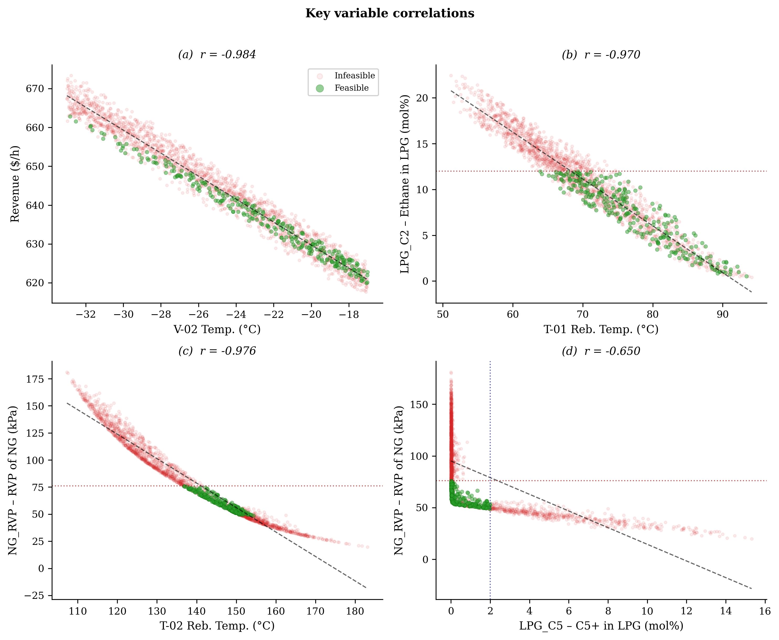
Fig. 4. Key variable correlations. (a) V-02 temperature vs. Revenue (r = −0.984); (b) T-01 reboiler temperature vs. LPG_C2 (r = −0.970); (c) T-02 reboiler temperature vs. NG_RVP (r = −0.976); (d) LPG_C5 vs. NG_RVP (r = −0.650). Green: feasible; red: infeasible. Dashed lines show constraint boundaries.

3.4. The LPG_C5–NG_RVP Trade-off: A Fundamental Thermodynamic Coupling
The most consequential inter-output relationship is the inverse correlation between C₅₊ content in LPG (LPG_C5) and Reid Vapor Pressure of the NG stream (NG_RVP), with r = −0.650. Figure 3 visualizes this trade-off with the DOS boundary region and revenue color-coding.
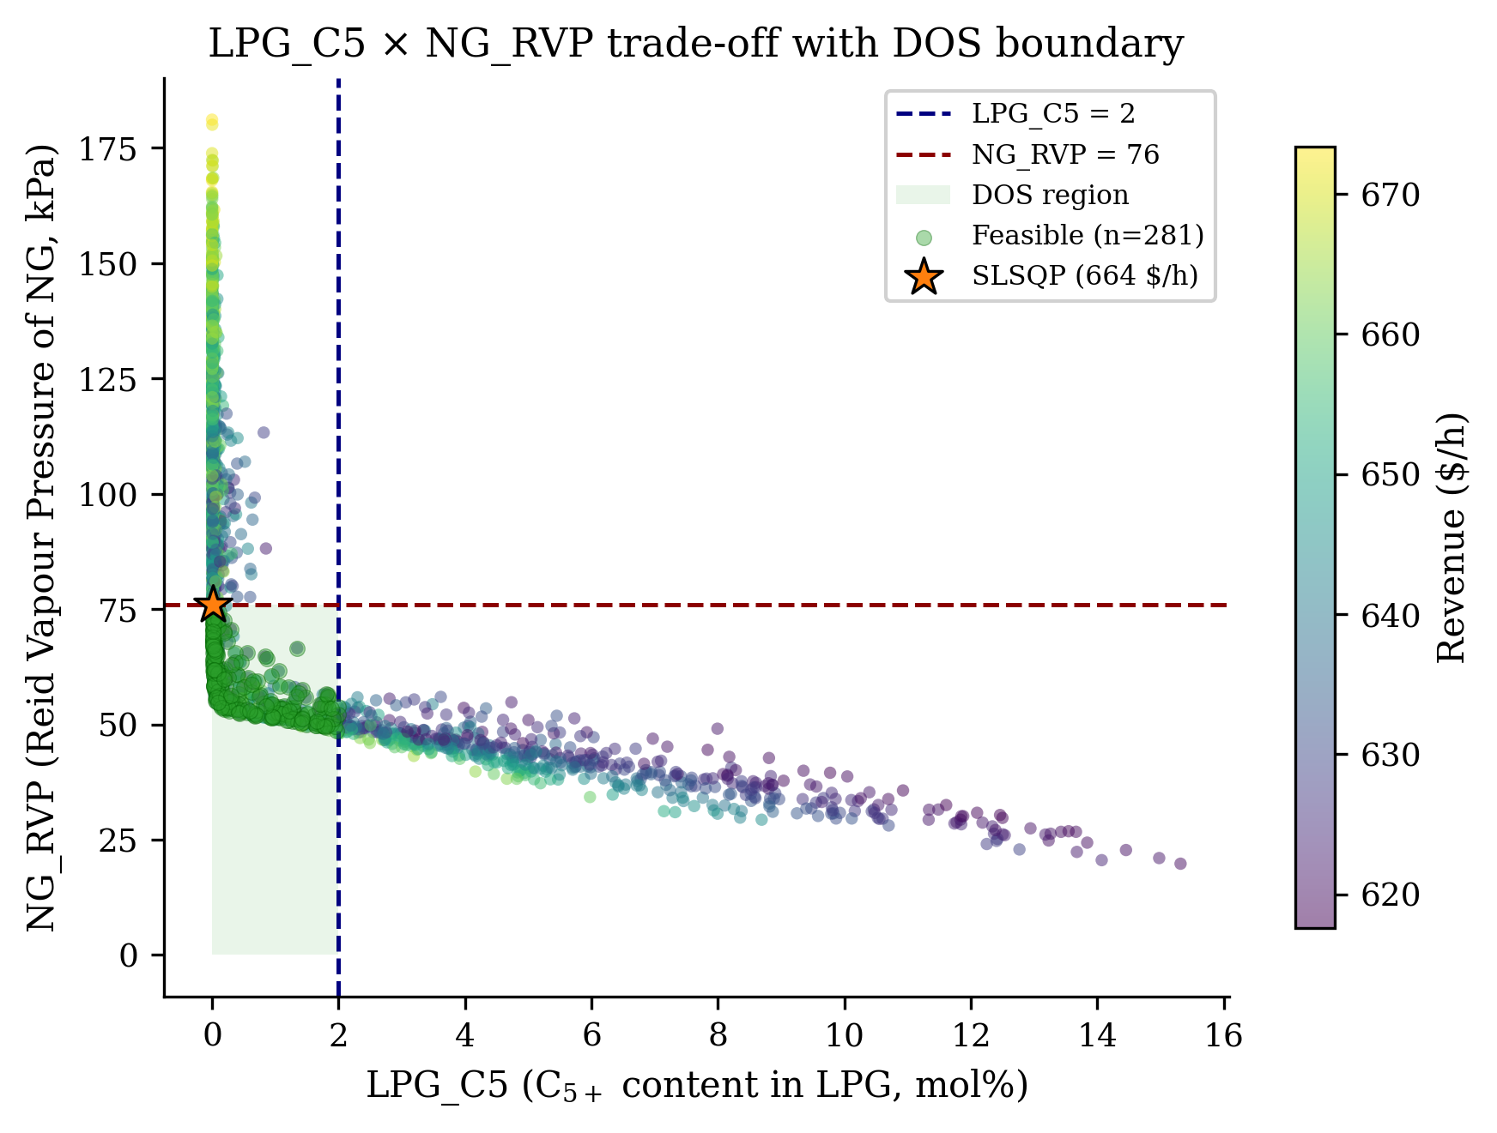
Fig. 3. LPG_C5 vs. NG_RVP trade-off with DOS boundary. The shaded green rectangle represents the feasible DOS region (LPG_C5 ≤ 2 mol%, NG_RVP ≤ 76 kPa). Color scale indicates Revenue ($/h). Feasible points (n = 281) are highlighted in green. Orange star marks the SLSQP optimal point.
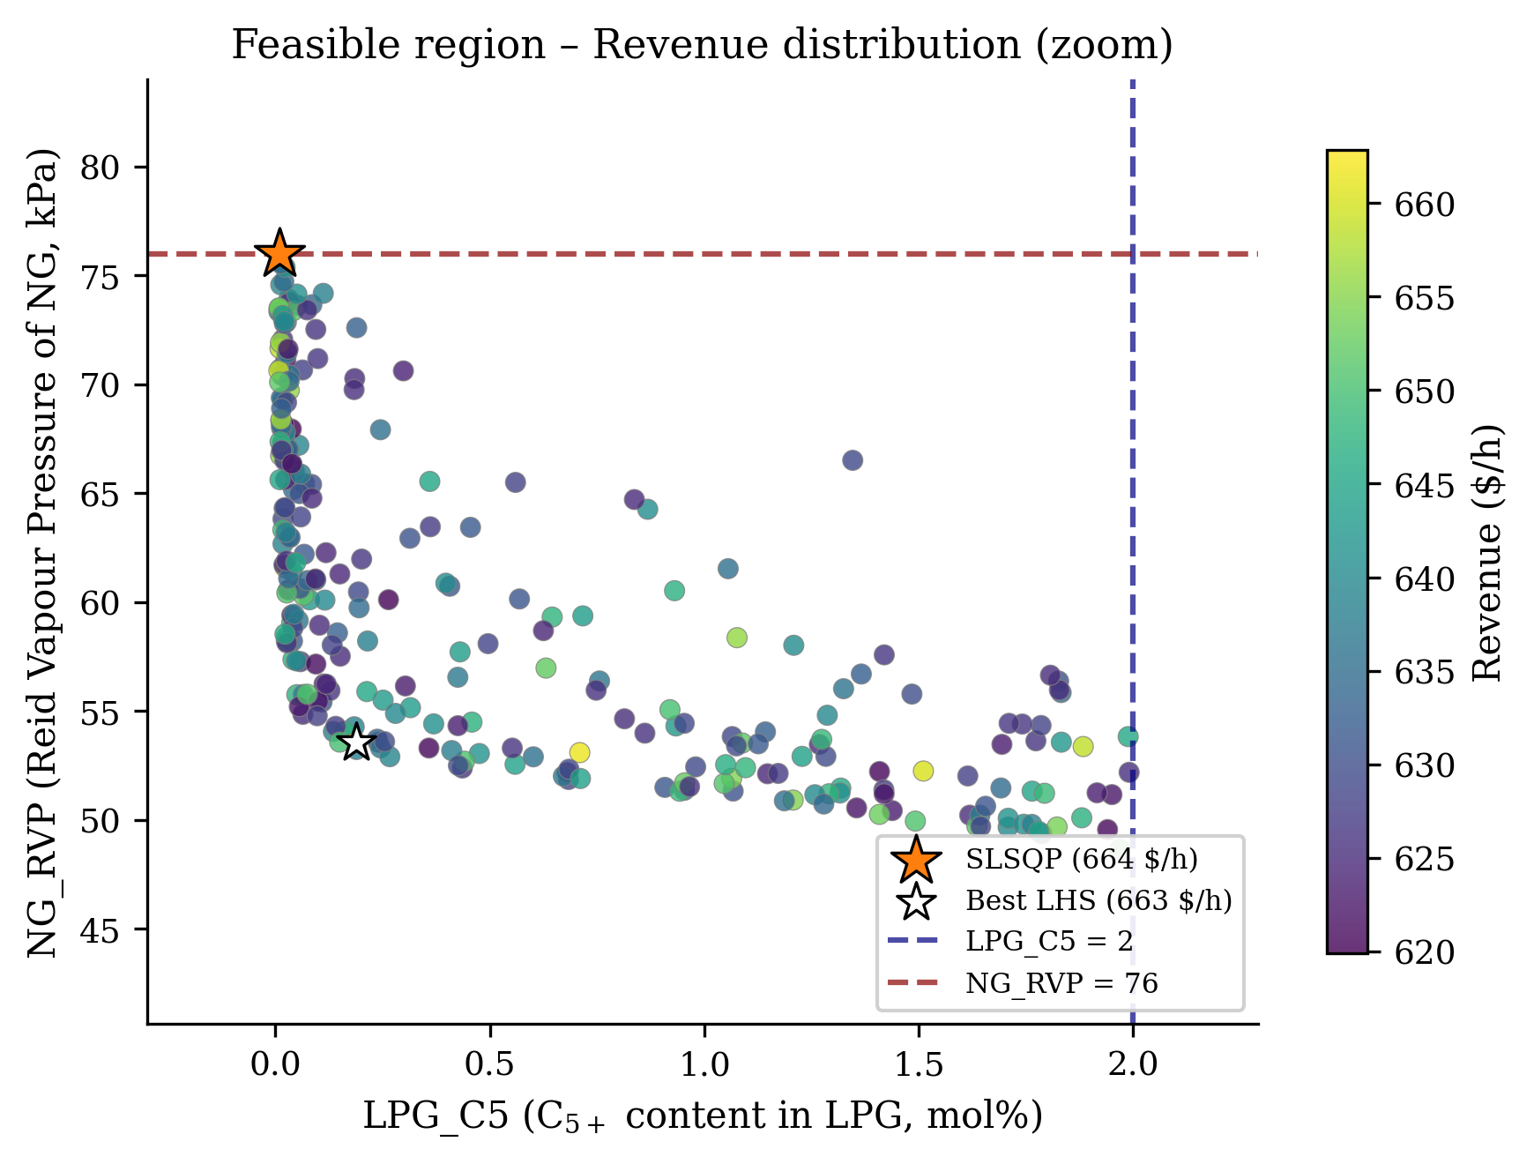
Fig. 3b. Zoom on the feasible region showing only compliant operating points with revenue color scale. The narrow band of feasible operation and the revenue gradient within it illustrate the constrained optimization landscape.

This trade-off has a clear thermodynamic origin. When the debutanizer operates to minimize C₅₊ leakage into LPG (satisfying g₃: LPG_C5 ≤ 2), the NG stream becomes enriched in lighter components, which increases its Reid Vapor Pressure due to composition effects. Conversely, allowing more C₅₊ into LPG reduces lighter components in the NG stream and, consequently, decreases its RVP. The resulting hyperbolic cloud in Fig. 3 shows that the feasible region (shaded green) occupies only a narrow band where both constraints are marginally satisfied.
This inverse coupling is the primary mechanism responsible for the low OI: the two constraints (LPG_C5 and NG_RVP) compete rather than cooperate, compressing the feasible envelope far below what each constraint would allow individually. The joint satisfaction of these constraints is 23.1%, compared to 74.7% and 48.5% individually—a clear signature of negative correlation.
From a practical standpoint, this coupling suggests that incremental improvements in debutanizer design or operation (e.g., additional stages, optimized reflux ratio, or side-draw configurations) would have a disproportionately large impact on plant operability. Alternatively, renegotiating the RVP specification from 76 kPa to a moderately relaxed value could substantially expand the feasible envelope, as quantified in Section 3.5.

3.5. Constraint Relaxation Analysis
To quantify the individual contribution of each constraint to the overall OI limitation, we performed a constraint relaxation analysis: each constraint was removed one at a time, and the resulting OI was recalculated. Table 6 presents the results.
Table 6. Constraint relaxation analysis: OI change upon removing each constraint.
Removed constraint | Remaining OI (%) | ΔOI (pp) | Interpretation
None (baseline) | 14.1 | — | Full constraint set
g₁: SG_C1 ≥ 80 | 14.1 | +0.0 | Non-binding; no impact on OI
g₂: LPG_C2 ≤ 12 | 23.1 | +9.0 | Moderate impact
g₃: LPG_C5 ≤ 2 | 34.8 | +20.7 | Strong impact
g₄: NG_RVP ≤ 76 | 35.5 | +21.4 | Dominant bottleneck

Removing constraint g₄ (RVP of NG ≤ 76 kPa) yields the largest OI increase (+21.4 percentage points, from 14.1% to 35.5%), confirming its status as the dominant bottleneck. Removing g₃ (C₅₊ in LPG ≤ 2 mol%) yields a nearly equivalent improvement (+20.7 pp), which is expected given the strong inverse coupling between g₃ and g₄ established in Section 3.4: relaxing either member of the coupled pair releases the other. Removing g₂ (ethane in LPG ≤ 12 mol%) yields a moderate improvement (+9.0 pp), while removing g₁ has no effect, consistent with its universal satisfaction.
These results provide a rigorous, quantitative basis for prioritizing process improvement efforts. If constraint renegotiation is possible, the RVP of NG offers the highest return; if it is not, then debutanizer process modifications to alleviate the LPG_C5–NG_RVP coupling represent the most impactful engineering pathway.

3.6. Optimal Feasible Operating Point via Constrained Optimisation
Beyond characterizing the feasible envelope through LHS sampling, a formal constrained optimization was performed to identify the revenue-maximizing operating point. The Sequential Least Squares Programming (SLSQP) algorithm (Kraft, 1988), implemented in SciPy (Virtanen et al., 2020), was employed with the four product-quality constraints formulated as nonlinear inequality constraints. The initial guess was selected from the best-performing feasible point identified in the LHS dataset, and the optimizer was configured with a step size of ε = 0.5 and a function tolerance of 10⁻². Each candidate solution was evaluated directly through the DWSIM simulation model via its Python/COM automation interface, ensuring full-fidelity process evaluation rather than surrogate approximation. The optimizer converged in 5 iterations requiring 32 DWSIM evaluations (approximately 254 seconds of computation time).
Table 7 presents the optimized operating point. The SLSQP solution achieves a sales revenue of 663.85 $/h, representing a 7.1% improvement over the best feasible point identified by LHS sampling (619.89 $/h). The optimizer drives the cold separator temperature to the lower bound of the AIS (−33.00 °C), maximizing liquid recovery and confirming the dominant role of this variable in revenue generation (|r| = 0.984). The deethaniser reboiler settles at 66.29 °C, keeping ethane in LPG at 12.00 mol%—precisely at the g₂ constraint boundary. The debutanizer reflux ratio reaches 4.31 (near its upper bound), while the debutanizer reboiler operates at 140.11 °C, yielding negligible C₅₊ leakage into LPG (LPG_C5 = 0.01 mol%). The stabilizer reboiler temperature settles at 197.24 °C.
Table 7. Optimal feasible operating point (maximum revenue under all constraints).
Variable | Value | Unit | Constraint status
V_02_Temp (u₁) | −33.00 | °C | —
T_01_Reb (u₂) | 66.29 | °C | —
T_02_RR (u₃) | 4.31 | – | —
T_02_Reb (u₄) | 140.11 | °C | —
T_03_Reb (u₅) | 197.24 | °C | —
Revenue | 663.85 | $/h | Maximized
SG_C1 | 83.74 | mol% | ≥ 80 ✔
LPG_C2 | 12.00 | mol% | ≤ 12 ✔ (active)
LPG_C5 | 0.01 | mol% | ≤ 2 ✔
NG_RVP | 76.00 | kPa | ≤ 76 ✔ (active)

Notably, the optimal solution prioritizes the production of more valuable liquid products—namely, NG and LPG—at the expense of SG. This trade-off is enabled by the cold separator operating at its lowest temperature, which maximizes condensation. The resulting revenue (663.85 $/h) confirms that the economic optimum sits precisely at the intersection of two active constraint boundaries (g₂ and g₄), a characteristic signature of constrained optimization.
A particularly revealing outcome is that two constraints are simultaneously active at the optimal point: LPG_C2 = 12.00 mol% (exactly at the g₂ boundary) and NG_RVP = 76.00 kPa (exactly at the g₄ boundary). This dual-active configuration means the optimal operating point is inherently fragile to operational perturbations—any disturbance that increases either ethane in LPG or the RVP of NG would immediately push the plant into constraint violation. This fragility, invisible to single-point optimization, is precisely the kind of insight that operability analysis provides.
The complementarity between the two approaches is noteworthy: LHS-based operability mapping reveals that only 14.1% of the operating space is feasible and identifies the LPG_C5–NG_RVP coupling as the structural bottleneck, while SLSQP optimization pinpoints the revenue-maximizing point within this constrained envelope. Together, they provide both a system-level understanding of the feasible landscape and a precise, actionable operating target.

4. Comparison with Previous Studies
The approach presented here differs fundamentally from conventional optimization studies of natural gas processing plants, both in scope and in the nature of the insights obtained. Souza et al. (2023) applied PSO + Nelder–Mead optimization to a comparable multi-unit Brazilian gas plant and achieved a 7.3% profit increase; our SLSQP optimization achieves a comparable 7.1% improvement. However, the operability analysis reveals a critical piece of information that no conventional optimization study provides: the optimal point sits at the intersection of two active constraints (LPG_C2 = 12.00 and NG_RVP = 76.00), making it inherently fragile to process disturbances.
This finding has direct practical consequences. An optimal point with generous margins in all constraints is robust to operational perturbations; an optimal point at the intersection of two constraint boundaries is not. Operability analysis does not merely tell us where the optimum is—it tells us how constrained the path to it is and how much room exists for safe operation around it.
Within the operability literature, Carrasco and Lima (2017) applied the framework to modular natural gas utilization systems focusing on design intensification rather than regulatory-constraint mapping. Dinh and Lima (2023) addressed dynamic operability of methane-to-aromatics reactors. Ferreira et al. (2025) demonstrated flowsheet-level operability analysis using commercial simulators. The present work extends this body of knowledge by applying the framework to a conventional multi-column gas plant with explicit ANP regulatory constraints—a configuration representative of the majority of gas processing facilities in Brazil.
The identification of the LPG_C5–NG_RVP inverse coupling (r = −0.65) as the primary mechanism limiting operability is a novel finding with no precedent in the gas processing literature. While the thermodynamic origin of this coupling is intuitive in hindsight, its quantitative impact on the feasible envelope—compressing the OI from an expected ~20.4% (under independence) to the observed 14.1%—has not been previously documented.
The use of DWSIM as the process simulator, rather than commercial alternatives such as Aspen Plus, HYSYS, or UniSim, is a deliberate methodological choice. While commercial simulators offer broader thermodynamic libraries and validated unit operation models, the open-source nature of DWSIM enables complete reproducibility: any researcher can download the simulation file, replicate the LHS sampling, and verify the reported OI without license restrictions.

5. Limitations and Future Work
Several limitations of the present study should be acknowledged. First, the OI is approximated through discrete sampling (N = 2,000) rather than exact computation. While the binomial standard error of 0.78 pp provides reasonable precision, the true OI may differ slightly. Integration with the Opyrability package (Alves et al., 2024) for exact volumetric computation is a natural next step.
Second, the analysis is limited to steady-state operation. Natural gas processing plants are subject to dynamic disturbances from feed composition variability, ambient temperature changes, and demand fluctuations. Extending the framework to dynamic operability (Dinh and Lima, 2023) would capture time-varying feasibility.
Third, the DWSIM model does not include a dedicated amine-based gas sweetening section. While the feed CO₂ content (2.17 mol%) is below typical pipeline specifications, a comprehensive plant model would benefit from including this unit.
Fourth, the current analysis treats all constraints as equally important. In practice, some specifications may be negotiable (e.g., RVP limits for specific market segments), and incorporating constraint priority weighting could yield more nuanced operability assessments.
Future directions include: (i) integration with the Opyrability package for exact OI computation; (ii) multi-objective optimization coupling revenue maximization with OI maximization; (iii) sensitivity analysis of the OI to feed composition variability; and (iv) extension to dynamic operability under typical disturbance scenarios.

6. Conclusions
This paper presented the first application of the Georgakis process operability framework to a conventional natural gas processing plant, using the open-source simulator DWSIM and Latin Hypercube Sampling with 2,000 scenarios. The key findings are:
(1) The Operability Index of 14.1% reveals a severely constrained process. Only 281 of 2,000 sampled operating conditions satisfy all four product-quality specifications simultaneously.
(2) The Reid Vapor Pressure constraint of Natural Gasoline (NG_RVP ≤ 76 kPa) is the dominant bottleneck, individually satisfied by only 48.5% of scenarios. Removing this constraint alone would increase the OI to 35.5%.
(3) A strong inverse coupling between C₅₊ content in LPG and RVP of Natural Gasoline (r = −0.650) creates a fundamental thermodynamic trade-off that compresses the feasible envelope below what independent constraint analysis would predict.
(4) The cold separator temperature dominates revenue generation (|r| = 0.984 with revenue), providing a clear, single-variable lever for economic optimization. The deethaniser and debutanizer reboiler temperatures exhibit strong negative correlations with their respective quality indicators (r = −0.970 and r = −0.976), confirming physically intuitive control relationships.
(5) The methane content specification (SG_C1 ≥ 80 mol%) is universally satisfied across the explored operating range and can be safely excluded from future analyses within this AIS.
These results demonstrate that operability analysis provides actionable, system-level insights that complement conventional single-point optimization. While optimization answers the question “where is the best operating point?”, operability analysis answers “how large is the space of acceptable operation?”—a question with direct implications for process robustness, control system design, and regulatory negotiation.

Credit Author Contribution Statement
Nicolas Spogis: Conceptualization, Methodology, Software, Formal analysis, Investigation, Data curation, Writing – original draft, Writing – review & editing, Visualization. Roymel R. Carpio: Conceptualization, Methodology, Supervision, Validation, Writing – review & editing. Gabriel Freitas: Software, Investigation, Data curation, Visualization.

Declaration of Generative AI and AI-Assisted Technologies in the Writing Process
During the preparation of this manuscript, the authors used Claude (Anthropic) for assistance with text formatting, English language review, and layout generation of the Word document. The authors have reviewed and edited all AI-assisted output and take full responsibility for the content of the publication.

Declaration of Competing Interest
The authors declare that they have no known competing financial interests or personal relationships that could have appeared to influence the work reported in this paper.

Data availability
The datasets, simulation files, and analysis scripts are available at: https://github.com/Spogis/operability-natural-gas-processing

Acknowledgements
The authors acknowledge the AI4Tech (https://ai4tech.ai/) for providing the computational infrastructure. The authors also acknowledge the DWSIM open-source simulator community and the Opyrability framework developers for making their tools freely available to the research community.

References
Al-Sobhi, S.A., Elkamel, A., 2015. Simulation and optimization of natural gas processing and production network consisting of LNG, GTL, and methanol facilities. J. Nat. Gas Sci. Eng. 23, 500–508.
Alves, V., Dinh, S., Kitchin, J.R., Gazzaneo, V., Carrasco, J.C., Lima, F.V., 2024. Opyrability: A Python package for process operability analysis. J. Open Source Softw. 9(94), 5966.
Alves, V., Gazzaneo, V., Lima, F.V., 2022. A machine learning-based process operability framework using Gaussian processes. Comput. Chem. Eng. 163, 107835.
ANP, 2008. Resolução ANP nº 16, de 17.6.2008. Especificação do gás natural. Diário Oficial da União, Brasília.
ANP, 2020. Resolução ANP nº 825, de 28.8.2020. Especificação do GLP. Diário Oficial da União, Brasília.
Campos, M., Gomes, M., Souza, A., et al., 2012. Optimisation of natural gas plant – Gains in profitability, stability and energy efficiency. Proc. IGU World Gas Conference 3, 2089–2120.
Carpio, R.R., Paiva, C.R., Guedes, T.A.L., Pinho, B.V., Souza, T.E.G., Santos, L.C., Ribeiro, L.D., Secchi, A. R., 2024. Hybrid Optimization Strategy Applied to an Industrial Natural Gas Processing Plant. Comp. Aided Chem. Eng., 53, 3229–3234.
Carrasco, J.C., Lima, F.V., 2017. An optimization-based operability framework for process design and intensification of modular natural gas utilization systems. Comput. Chem. Eng. 105, 246–258.
Dinh, S., Lima, F.V., 2023. Dynamic operability analysis for process design and control of modular natural gas utilization systems. Ind. Eng. Chem. Res. 62(5), 2052–2066.
Ferreira, U.G., Neiro, S.M.S., Oliveira-Lopes, L.C., Costa, T.V., Bispo, H., Lima, F.V., 2025. Operability for process flowsheet analysis. Digit. Chem. Eng. 15, 100229.
Franco, S.V.D.A., Ribeiro, D.C., Meneguelo, A.P., 2020. A comprehensive approach to evaluate feed stream composition effect on natural gas processing unit energy consumption. J. Nat. Gas Sci. Eng. 83, 103607.
Gazzaneo, V., Carrasco, J.C., Vinson, D.R., Lima, F.V., 2020. Process operability algorithms: Past, present, and future developments. Ind. Eng. Chem. Res. 59(6), 2457–2470.
Georgakis, C., Uzturk, D., Subramanian, S., Vinson, D.R., 2003. On the operability of continuous processes. Control Eng. Pract. 11(8), 859–869.
GPSA, 2004. Engineering Data Book, 12th ed. Gas Processors Suppliers Association, Tulsa, OK.
Kidnay, A.J., Parrish, W.R., McCartney, D.G., 2011. Fundamentals of Natural Gas Processing, 2nd ed. CRC Press, Boca Raton, FL.
Kraft, D., 1988. A Software Package for Sequential Quadratic Programming. DFVLR-FB 88-28, Köln.
McKay, M.D., Beckman, R.J., Conover, W.J., 1979. A comparison of three methods for selecting values of input variables in the analysis of output from a computer code. Technometrics 21(2), 239–245.
Medeiros, D.W., 2024. DWSIM – Open Source Chemical Process Simulator, version 9.0. https://dwsim.org.
Peng, D.-Y., Robinson, D.B., 1976. A new two-constant equation of state. Ind. Eng. Chem. Fundam. 15(1), 59–64.
Ribeiro, L.D., Delou, P.A., Santos, L.L.D., et al., 2020. SORAIA: A Petrobras system of revenue optimization and artificial intelligence. Proc. Rio Oil & Gas Expo and Conference, 1–11.
Souza, T.E.G., Secchi, A.R., Santos, L.C., 2023. Modeling and economic optimization of an industrial site for natural gas processing: A nonlinear optimization approach. Digit. Chem. Eng. 6, 100070.
Subramanian, S., Georgakis, C., 2005. Methodology for the steady-state operability analysis of plantwide systems. Ind. Eng. Chem. Res. 44(20), 7770–7786.
Vinson, D.R., Georgakis, C., 2000. A new measure of process output controllability. J. Process Control 10(2–3), 185–194.
Virtanen, P., Gommers, R., Oliphant, T.E., et al., 2020. SciPy 1.0: Fundamental algorithms for scientific computing in Python. Nat. Methods 17, 261–272.
Zhang, B.-J., Chen, Q.-L., Li, J., Floudas, C.A., 2017. Operational strategy and planning for raw natural gas refining complexes: Process modeling and global optimization. AIChE J. 63(2), 652–668.

