
EGE UNIVERSITY
FACULTY OF ENGINEERING
COMPUTER ENGINEERING DEPARTMENT

High Performance Data Processing
2025–2026 FALL SEMESTER

PROJECT REPORT
(High Performance Analysis of Twitter Data)

DELIVERY DATE
03/01/2026

PREPARED BY
05220000310, Yavuz Fatih Karacaer
05220000340, Emre Efe Serin
05220000359, Bora Özden
Contents
Track Decision and Rationale 3
System Architecture 3
Architecture Overview 3
Components 4
1. Batch Layer (Apache Spark) 4
2. Stream Layer (Kafka + Flink) 4
3. Storage Layer (HDFS) 4
4. Metadata Catalog (Apache Hive) 5
Instructions 5
1. Prerequisites 5
2. Start the Docker Environment 6
3. Prepare HDFS Paths and Upload Data 6
4. Create Kafka Topics 7
5. Create Hive Tables 8
6. Run Spark Batch Job (Part 1) 8
7. Run Flink Streaming Job (Part 2 – Track A) 9
8. Run Kafka Producer 9
9. Copy Stream Output from Local to HDFS (Required for Hive) 10
10. Query Hive Tables (Deliverables) 10
Results 11
Spark Analytics 11
Flink Bash - Job Submit 12
Flink Running Job on UI 12
Bash Alerts Kafka 13
Batch Airline Sentiment - HIVE 13
Tweets Raw CSV - HIVE 13
Tweets Stream Avro - HIVE 14
Discussion 14

Track Decision and Rationale
We Selected Track A – Real Time Airline Complaint Alerting.

System Architecture

Architecture Overview
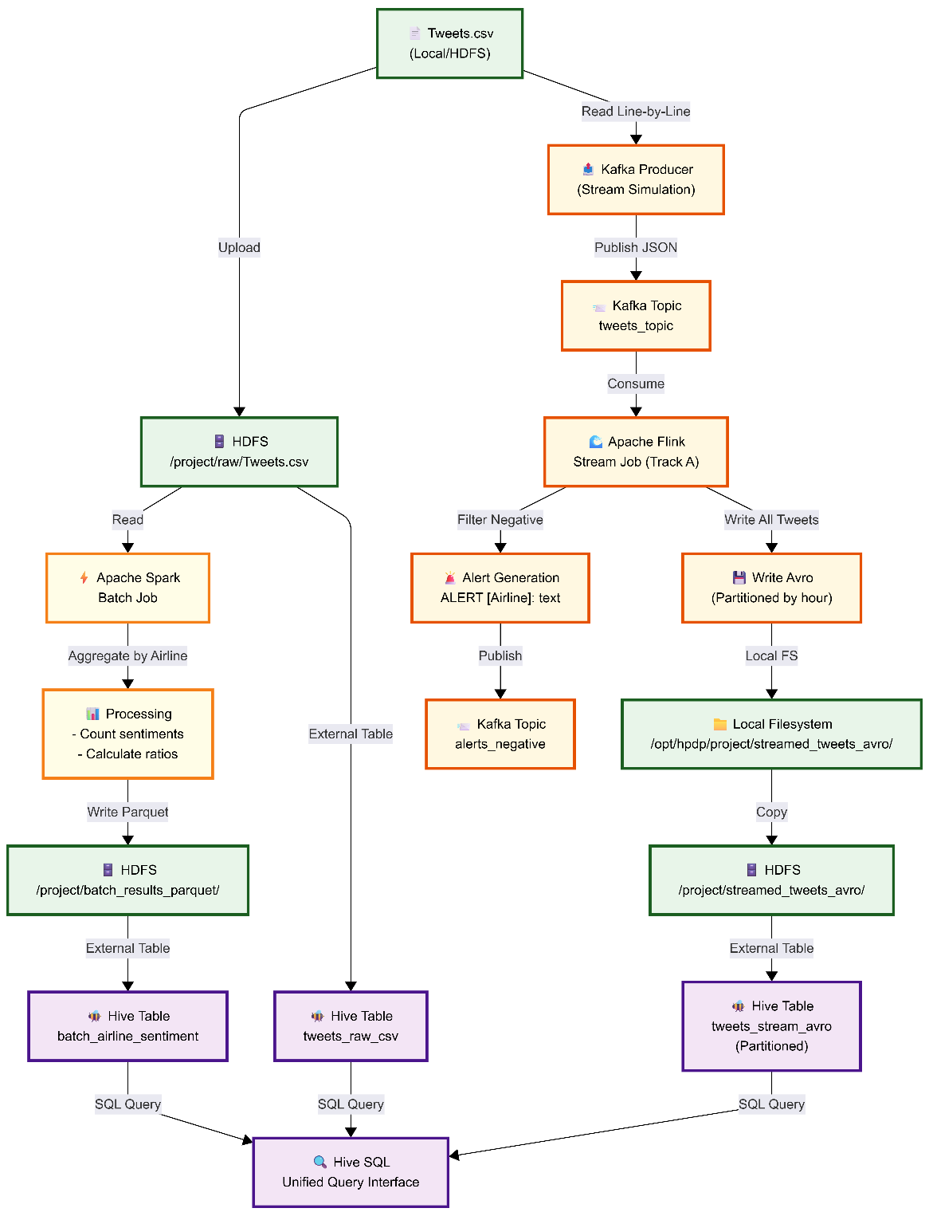

Components

1. Batch Layer (Apache Spark)
- HDFS üzerinden Tweets.csv dosyasını tamamen okur
- Havayolu (airline) bazında agregasyon işlemleri yapar
- Duygu (sentiment) istatistiklerini hesaplar:
  - Pozitif tweet sayısı
  - Negatif tweet sayısı
  - Nötr tweet sayısı
  - Negatif oran (negative ratio)
- Sonuçları Parquet formatında aşağıdaki dizine yazar:
- /project/batch_results_parquet/

2. Stream Layer (Kafka + Flink)
Kafka Producer
- CSV dosyasını satır satır okur
- Canlı veri akışı simülasyonu yapar
- Tweet verilerini tweets_topic adlı Kafka konusuna gönderir
Flink Job
- tweets_topic konusundan verileri tüketir
- Negatif duyguya sahip tweetleri filtreler
- Negatif tweetler için uyarılar (alerts) üretir
- Tüm tweetleri Avro formatında yazar
- Saatlik bölümlendirme (partitioning) kullanır:
- dt=YYYY-MM-DD-HH

3. Storage Layer (HDFS)
- Ham CSV verisi:
- /project/raw/Tweets.csv
- Streaming katmanından gelen Avro dosyaları:
- /project/streamed_tweets_avro/
- Batch katmanından üretilen Parquet dosyaları:
- /project/batch_results_parquet/

4. Metadata Catalog (Apache Hive)
- Üç adet external table tanımlanmıştır
- Tüm verilere SQL arayüzü üzerinden erişim sağlar
- Batch ve stream verileri üzerinde birleşik sorgulama (unified querying) yapılmasına olanak tanır

Instructions

1. Prerequisites
Before running the project, ensure that the following requirements are met:
- Docker Desktop
(or Docker Engine + Docker Compose)
- Python 3.8 or higher
- Required Python packages:
  - kafka-python
  - pyflink
  - pyspark
- Dataset
Tweets.csv from Kaggle
Download link:
https://www.kaggle.com/datasets/crowdflower/twitter-airline-sentiment
Place the dataset in:
data/raw/Tweets.csv

2. Start the Docker Environment
Start all required services (Hadoop, Spark, Hive, Kafka, Flink):
docker-compose up -d
Verify that all containers are running:
docker ps
Expected containers:
- hpdp-bigdata
- hpdp-zookeeper
- hpdp-kafka
- hpdp-flink

3. Prepare HDFS Paths and Upload Data
Enter the Big Data container:
docker exec -it hpdp-bigdata bash

Create required HDFS directories (safe to re-run):
hdfs dfs -mkdir -p \
/project/raw \
/project/streamed_tweets_avro \
/project/batch_results_parquet

Upload the dataset to HDFS:
hdfs dfs -put /opt/hpdp/project/data/raw/Tweets.csv /project/raw/Tweets.csv

Verify that the file exists:
hdfs dfs -ls -h /project/raw/
hdfs dfs -cat /project/raw/Tweets.csv | head -5

Exit the container:
exit

4. Create Kafka Topics
Create required Kafka topics:
docker exec hpdp-kafka kafka-topics --create \
--bootstrap-server localhost:9092 \
--topic tweets_topic \
--partitions 3 \
--replication-factor 1 \
--if-not-exists
docker exec hpdp-kafka kafka-topics --create \
--bootstrap-server localhost:9092 \
--topic alerts_negative \
--partitions 1 \
--replication-factor 1 \
--if-not-exists
Verify topics:
docker exec hpdp-kafka kafka-topics \
--bootstrap-server localhost:9092 --list

5. Create Hive Tables
Create Hive external tables:
docker exec hpdp-bigdata bash -c \
"cd /opt/hpdp/project && hive -f hive/ddl/01_create_tweets_raw_csv.hql"
docker exec hpdp-bigdata bash -c \
"cd /opt/hpdp/project && hive -f hive/ddl/02_create_tweets_stream_avro.hql"
docker exec hpdp-bigdata bash -c \
"cd /opt/hpdp/project && hive -f hive/ddl/03_create_batch_airline_sentiment.hql"

6. Run Spark Batch Job (Part 1)
Enter the Big Data container:
docker exec -it hpdp-bigdata bash

Run the Spark batch job:
cd /opt/hpdp/project
spark-submit batch/spark_job/spark_batch_job.py
Verify Parquet output:
hdfs dfs -ls -h /project/batch_results_parquet/

Optional: Inspect Results with PySpark
pyspark
df = spark.read.parquet("hdfs:///project/batch_results_parquet/")
df.show()
df.printSchema()
df.orderBy(df.negative_ratio.desc()).show()
Exit PySpark and container:
exit()
exit

7. Run Flink Streaming Job (Part 2 – Track A)
Enter the Flink container:
docker exec -it hpdp-flink bash
List running jobs (initially empty):
/opt/flink/bin/flink list

Start the Flink job:
/opt/flink/bin/flink run -d \
-py /opt/hpdp/project/streaming/flink_job/flink_trackA.py

Verify streamed output on local filesystem:
ls -lh /opt/hpdp/project/streamed_tweets_avro/
cat /opt/hpdp/project/streamed_tweets_avro/tweets-*.json | head -20

Exit container:
exit
Flink Web UI:
http://localhost:8081

8. Run Kafka Producer
Start the Kafka producer from the host machine:
python streaming/producer/twitter_producer.py
This sends all tweets from Tweets.csv to Kafka and triggers Flink processing.

9. Copy Stream Output from Local to HDFS (Required for Hive)
Flink writes files locally. Copy them to HDFS so Hive can read them.
Create archive inside Flink container
docker exec hpdp-flink bash -c \
"cd /opt/hpdp/project/streamed_tweets_avro && tar czf /tmp/avro_files.tar.gz dt=*"

Copy archive to Big Data container
docker cp hpdp-flink:/tmp/avro_files.tar.gz ./avro_files.tar.gz
docker cp ./avro_files.tar.gz hpdp-bigdata:/tmp/

Extract and upload to HDFS
docker exec hpdp-bigdata bash -c \
"cd /tmp && tar xzf avro_files.tar.gz && hdfs dfs -put dt=* /project/streamed_tweets_avro/"

Update Hive partitions:
docker exec hpdp-bigdata bash -c \
"hive -e 'MSCK REPAIR TABLE tweets_stream_avro;'"

10. Query Hive Tables (Deliverables)
Enter Hive:
docker exec -it hpdp-bigdata bash
hive
Query 1 – Raw CSV
SELECT * FROM tweets_raw_csv LIMIT 10;
Query 2 – Streamed Avro
SELECT * FROM tweets_stream_avro LIMIT 10;
Query 3 – Batch Results
SELECT * FROM batch_airline_sentiment;

Results

Spark Analytics
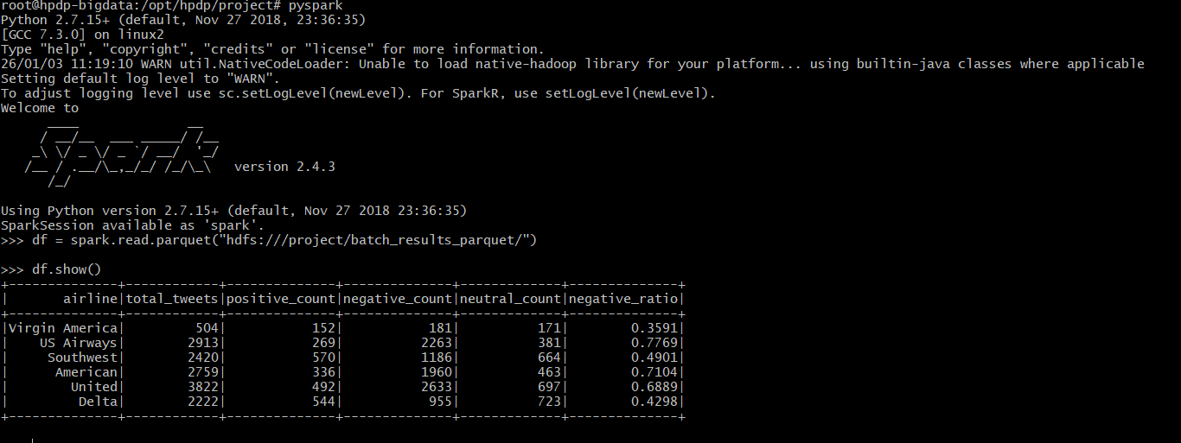

Flink Bash - Job Submit
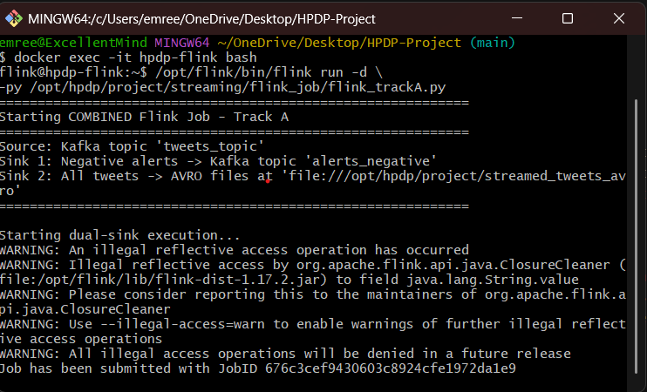

Flink Running Job on UI
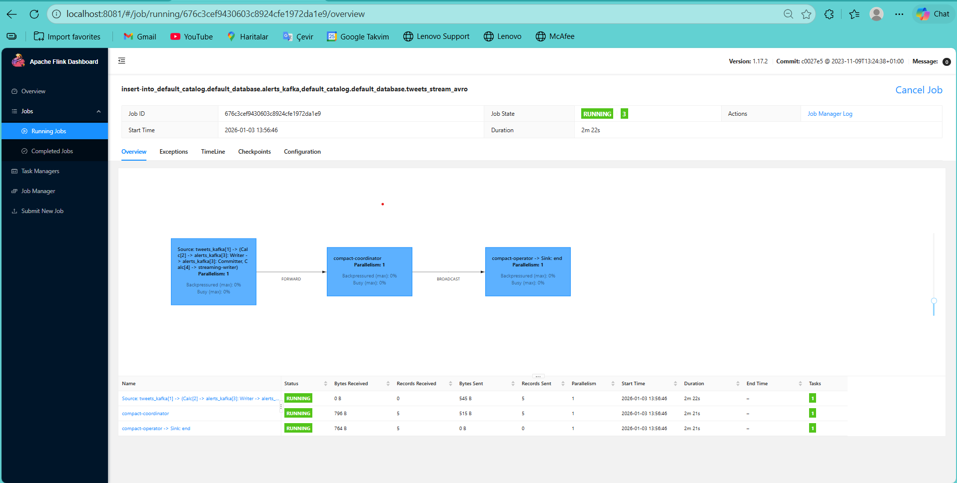

Bash Alerts Kafka
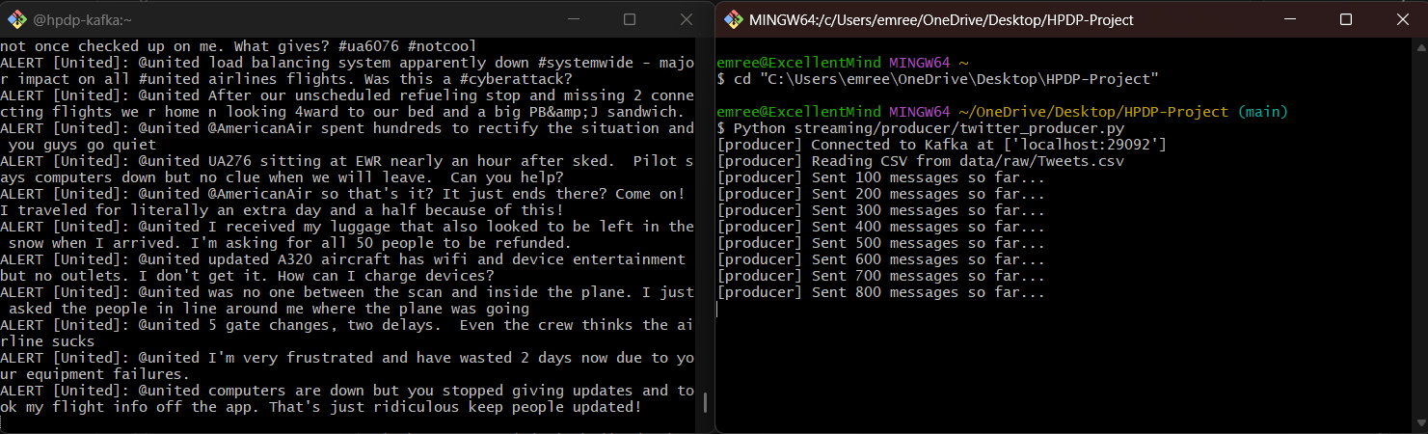

Batch Airline Sentiment - HIVE
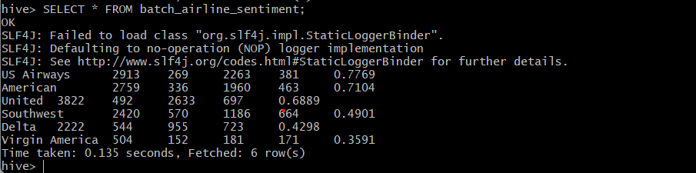

Tweets Raw CSV - HIVE
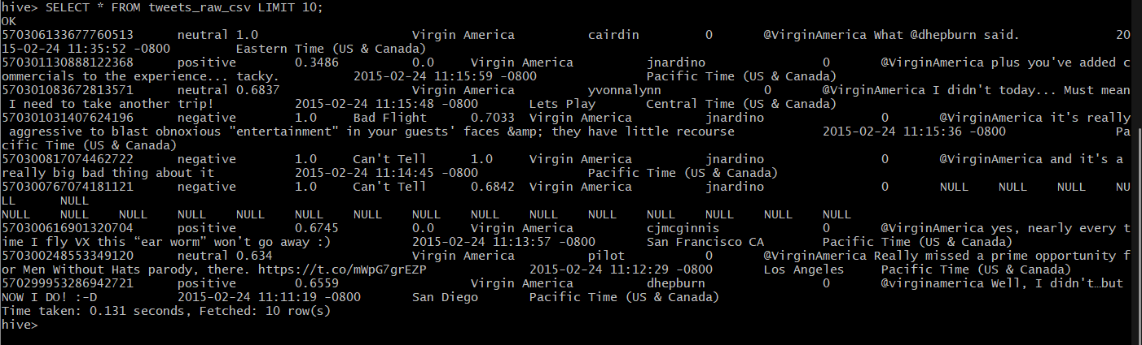

Tweets Stream Avro - HIVE
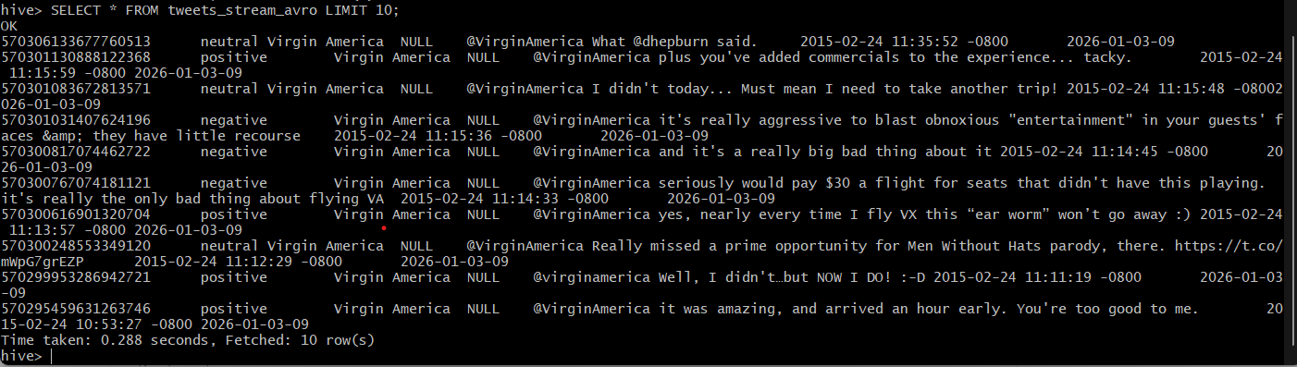

Discussion
During the development of this project, we encountered several practical challenges, mainly related to system resources and environment configuration. One of the most significant issues was memory management. Since the project was developed on a machine with limited RAM, running multiple Docker containers (Hadoop, Spark, Kafka, and Flink) simultaneously caused memory pressure. We addressed this problem by setting memory limits for the containers, which stabilized the system and allowed all components to run successfully.
Another challenge was configuration and version compatibility. In some cases, we could not rely on pre-built Docker images and had to manually configure required components and install specific versions. Ensuring compatibility between different systems (Kafka, Flink, Spark, and Hive), especially when backward compatibility was not guaranteed, required careful configuration and testing.
We chose Track A (Real-Time Airline Complaint Alerting) because it fits both the dataset and our available resources well. The Twitter US Airline Sentiment dataset contains a large number of negative sentiment tweets, which makes it suitable for demonstrating real-time alert generation. Additionally, Track A’s message-by-message processing approach is simpler than window-based streaming. This allowed us to focus on core streaming concepts such as Kafka consumption, Flink processing, and dual outputs, without the additional complexity of windowing logic.
Overall, despite the challenges, the project was a valuable learning experience. Most of the important lessons came from dealing with real system issues such as memory limits, configuration management, and containerized environments, which are common in real-world big data applications.

