Stewart Schuler
ECE 545
HW 4
Due: 20231028

Deliverable 1/2:
Testbench, constraint, and testvector files for all three cases can be found at https://github.com/Spoogius/gmu-ece-545/tree/main/HW_4

Deliverable 3:

Case i - Behavioral Simulation
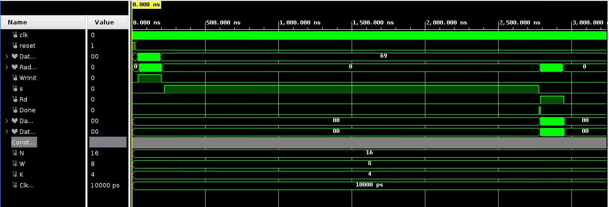
Figure 1. Case i - full behavioral simulation

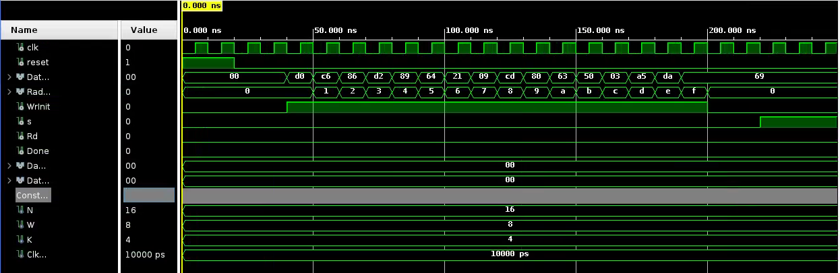
Figure 2. Case i - Loading behavioral simulation
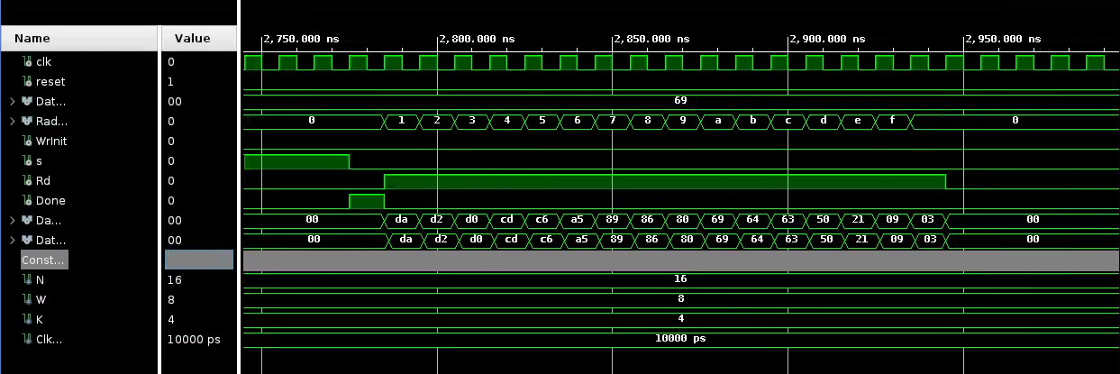
Figure 3. Case i - Reading behavioral simulation

Case i - Post-synthesis Simulation

Case i - Post-implementation Simulation

