

Inclusive Preschool and Pediatric Therapy Clinic

Clinical Admissions Packet

Thank you for choosing High Hopes for your child’s therapy. In an effort to better serve you, please fill out this entire Admissions Packet and return it to High Hopes Clinic.

We appreciate the opportunity to participate in your child’s development and look forward to working together with your family and celebrating accomplishments!

Thank you,

High Hopes Clinical Staff
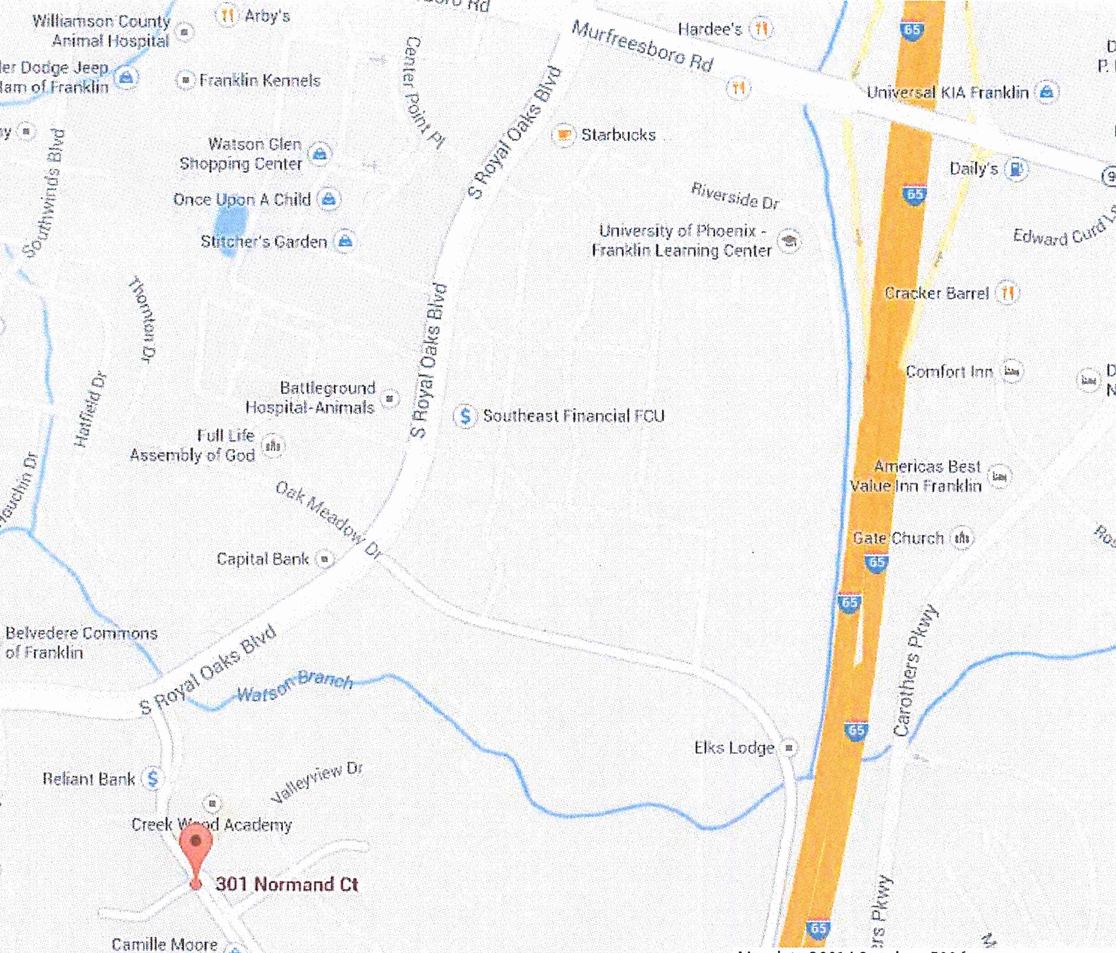

Website:
www.highhopesforkids.org

Physical Address:
301 High Hopes Court
Franklin, TN 37064
Phone:
(615) 661-KIDS (661-5437)

Therapy Scheduling/Cancellations:
(615) 661-5437

Fax:
301 High Hopes Court
(615) 277-2838

High Hopes Inc.
Clinical Admissions Registration Form
For Office Use Only
Received ________
Update __________

Child’s Name: _______________________________ Nickname: _______________________________
DOB: _______________________________ Gender: _____ Male _____ Female
Race* (optional): ____African American ____Asian ____Caucasian ____Hispanic/Latino
____Indian ____Middle Eastern ____Native American ____Other

Name of Parent(s)/Guardian: __________________________________________________________________
Address: City: ST: Zip: _____________
County*: _______________________________ Home Phone: _______________________________
Mom Cell Phone: ________________________ Dad Cell Phone: _____________________________
Mom Work Phone: _______________________ Dad Work Phone: ____________________________
Mom Employer: _________________________ Dad Employer: _______________________________
Mom Work County*: _____________________ Dad Work County*: ___________________________
Mom Email: _____________________________ Dad Email: _________________________________

* Information used for grant purposes

Person to Contact in Case of Emergency
Name: Relationship:
Home Phone: Work Phone: Mobile:

Transport to Which Hospital in Case of Emergency: ____________________________________________

Other Information

High Hopes is a nonprofit organization and often seeks funding from grants and other sources to help fund the high quality services that we provide at the lowest possible cost. Many grants require High Hopes to report demographics and financial need for the population we serve. We ask that you fill out the information below regarding your family’s household income. No names will be used. This information will be confidential and used only statistically for grant purposes.
Persons in Family or Household Size | Annual Income
1 | $21,278
2 | $29,637
3 | $37,296
4 | $44,955
5 | $52,614
6 | $60,273
7 | $67,951
8 | $75,647
Each Add'l Member Add | +$7,696

WIC Income Eligibility Guidelines
(Effective from 1/1/17)

Does your family’s household income level fall below the
WIC Income Eligibility Guidelines listed?

Yes _____ No ______

High Hopes Inc.

Consent for Release of Medical Information to High Hopes

To help us better serve your child it is very important that we have access to previous evaluations and other relevant information about your child. Please send copies of the reports along with this packet. If you would like us to contact an outside associate and ask them to fax information directly to High Hopes, please provide us with a name, telephone and/or fax number.

Check any of the following professionals your child has been evaluated by:

_____ Dev. Pediatrician _____ Occupational Therapist _____ Neurologist
_____ Speech Therapist _____ Psychologist _____ Orthopedist
_____ Audiologist _____ Physical Therapist
_____ Other: __________________________________

Detail any of the following agencies who have pertinent information to share:
Agency Contact Name Phone Fax
_____ School System ________________ _____________ ____________
_____ TEIS ________________ _____________ ____________
_____Vanderbilt Bill Wilkerson ________________ _____________ ____________
_____ Other: ________________ ________________ _____________ ____________

I hereby give permission to release my child’s health/ medical/ psychological/ educational/ early intervention/ therapeutic records to High Hopes, Inc. and to discuss my child’s care or treatment with appropriate professional staff. I understand that information in my child’s records will not be released to any other individual without my specific written consent.

Parent’s Printed Name:

Parent’s Signature: Date:

High Hopes Inc.

Consent to Share Medical Information to High Hopes

Patients Name:_____________________________________________________________________________
Date of Birth: __________________________

I HEREBY AUTHORIZE HIGH HOPES TO SHARE:
Any of my medical information
My appointment times, dates, and reasons for visits
The following information (specify)____________________________________________________

WITH THE FOLLOWING PEOPLE:
Full Name:_______________________________________________ Relationship_________________
Full Name:_______________________________________________ Relationship_________________
Full Name:_______________________________________________ Relationship_________________
Full Name:_______________________________________________ Relationship_________________

I understand that I may cancel this consent at any time (in writing to High Hopes Medical Records), but that canceling it will not affect any information that has already been released.

I understand that I do not have to sign this form, and that I should only sign it if I want my medical provider or my clinic to share my information with someone.

This authorization expires: When I cancel it in writing ________________________________________
If no expiration date or event is specified, this authorization will expire one (1) year after the date it is signed.

Signature:______________________________________________________Date:_______________________

Relationship to minor patient (If patient or legal guardian)*_________________________________________

Email Communication Consent Form

Risks of using email

Our therapists offer patients the opportunity to communicate by email. Transmitting patient information poses several risks of which the patient should be aware. The patient should not agree to communicate with the therapists via email without understanding and accepting these risks. The risks include, but are not limited to, the following:

- The privacy and security of email communication cannot be guaranteed.
- Employers and online services may have a legal right to inspect and keep emails that pass through their system.
- Email is easier to falsify than handwritten or signed hard copies. In addition, it is impossible to verify the true identity of the sender, or to ensure that only the recipient can read the email once it has been sent.
- Emails can introduce viruses into a computer system, and potentially damage or disrupt the computer.
- Email can be forwarded, intercepted, circulated, stored or even changed without the knowledge or permission of the physician or the patient. Email senders can easily misaddress an email, resulting in it being sent to many unintended and unknown recipients.
- Email is indelible. Even after the sender and recipient have deleted their copies of the email, back‐up copies may exist on a computer or in cyberspace.
- Use of email to discuss sensitive information can increase the risk of such information being disclosed to third parties.
- Email can be used as evidence in court.

Conditions of using email

- Our therapists will use reasonable means to protect the security and confidentiality of email information sent and received. However, because of the risks outlined above, the therapists cannot guarantee the security and confidentiality of email communication. Thus, patients must consent to the use of email for patient information and communication. Consent to the use of email includes agreement with the following conditions:
- Emails to or from the patient concerning diagnosis or treatment may be printed in full and made part of the patient’s medical record. Because they are part of the medical record, other individuals authorized to access the medical record, such as staff and billing personnel, will have access to those emails.
- Our therapists may forward emails internally to the to those involved, as necessary, for diagnosis, treatment, reimbursement, healthcare operations, and other handling. Our therapists will not, however, forward emails to independent third parties without the patient’s prior written consent, except as authorized or required by law.
- The patient is responsible for informing the therapist of any types of information the patient does not want to be sent by email. Such information that the patient does not want communicated over email includes:________________________________________________________________________________________________________________________________________________________________

The patient can add to or modify this list at any time by notifying the physician in writing.

Our therapists are not responsible for information loss due to technical failures associated with the patient’s email software or internet service provider.

Instructions for communication by email

To communicate by email, the patient shall:
•Limit or avoid using an employer’s or other third party’s computer.
•Inform the therapist of any changes in the patient’s email address body
•Review the email to make sure it is clear and that all relevant information is provided before sending to the therapist.
•Take precautions to preserve the confidentiality of emails, such as using screen savers and safeguarding computer passwords.

Patient acknowledgment and agreement
I acknowledge that I have read and fully understand this consent form. I understand the risks associated with the communication of email between the therapist and me, and consent to the conditions outlined herein, as well as any other instructions that the therapist may impose to communicate with patients by email. I acknowledge the therapist’s right to, upon the provision of written notice, withdraw the option of communicating through email. Any questions I may have had were answered.

Patient Name: Caregiver Signature Date Print Name Date

High Hopes Inc.

Permission to Photograph or Videotape

High Hopes likes to use pictures of students/clients in our website, brochures, invitations, slideshows, etc. This form allows or prohibits High Hopes to use your child’s picture or videotape for marketing purposes.

_____ Yes, I give permission for my child to be photographed and/or videotaped for publicity or fund-raising purposes to benefit High Hopes. My child’s first name may be used; however, if my child is to be identified by first and last name, I must be notified in advance to give express approval prior to publication.

_____ No, please do not use pictures of my child for anything outside of the center.

Parent’s Printed Name:

Parent’s Signature: Date:

High Hopes Inc.

Clinical Services Financial Contract

High Hopes, Inc. establishes this financial policy to ensure fiscal accountability including appropriate billing, payments and reimbursements on all accounts.

High Hopes has contracted with Practice Resource Network (PRN) to provide billing services. High Hopes office staff and PRN representatives will work with families on issues concerning insurance coverage for therapy services. It is primarily the responsibility of the parent(s)/caregiver to know insurance benefits and provide information on policy requirements in a timely fashion, including any changes to coverage. High Hopes/PRN will call to verify benefits before initiating therapy but in most instances, the information provided by the insurance company is not a guarantee of payment. While we cannot assure you that your child’s therapy will be a covered service, we pledge to work with you and the insurance company throughout the billing process. It is the responsibility of the parent/guardian to inform High Hopes Pediatric Therapy Clinic of any and all changes in insurance information, including insurance carrier, ID number, group number, phone numbers and/or address as soon as possible. Failure to do so may result in total patient responsibility for charges incurred.

I authorize the release of medical information, including the Physician Referral Form and Therapy Notes, to my insurance company for the purpose of obtaining prior authorization for services and the adjudication of charges for services rendered.

Monthly statements will be mailed and will list balances determined after services filed to insurance are paid or denied. All balances will be due in full on receipt of statement.

In the event it is necessary to employ counsel to enforce the terms of this contract, the undersigned agrees to pay reasonable costs and expenses (including attorney fees) incurred to enforce this contract.

Parent’s Printed Name: ___________________________________ Date: _______________

Parent’s Signature: ______________________________________ Date: _______________

High Hopes Inc.
HIPAA Consent and Disclosure

Our Notice of Privacy Practices provides information about how we may use and disclose protected health information about your child. We understand that his or her medical information is personal to you, and we are committed to protecting that information. As our client, we create medical records about your child’s health, our care for him/her, and the services we provide for your child. By law, we are required to make sure that your child’s protected health information is kept private.

By signing this form, you consent to our use and disclosure of protected health information about your child for treatment, payment and health care operations. The practice provides this form to comply with the Health Insurance Portability and Accountability Act of 1996 (HIPAA).

I, __________________________________________, have received a copy of the HIPAA privacy practices.

Parent’s Name: ___________________________________

Parent’s Signature: ________________________________ Date: ____________________
Clinic Parent Handbook

Please review the Clinic Parent Handbook available on our website at www.highhopesforkids.org in the Therapy section under Clinical Forms, then initial and sign the below acknowledgement. If you do not have internet access we can provide you with a copy of the Clinic Parent Handbook at your first appointment.

High Hopes Clinic Parent Handbook Acknowledgement

Please initial that you have read and agree with each of the following:

_____ Inclement Weather Policy

_____ Non-smoking Policy

_____ Insurance Billing Policy

_____ Photographs Policy

_____ Illness Policy

_____ Parent Participation and Support Policy

_____ Patient Cancellation/No Show Policy

_____ HH Therapist Cancellation Policy

______________________________________________ _______________
Parent Signature Date

______________________________________________
Printed Name

Notice of Privacy Practices

This Notice describe how medical information about your child may be used and disclosed and how you can get access to this information. Please review it carefully.

Notice of Privacy Practices
This notice describes how medical information about you may be used and disclosed and how you can get access to this information. Please review it carefully.
Your Rights
When it comes to your health information, you have certain rights. This section explains your rights and some of our responsibilities to help you.
Get an electronic or paper copy of your medical record
- You can ask to see or get an electronic or paper copy of your medical record and other health information we have about you. Ask us how to do this.
- We will provide a copy or a summary of your health information, usually within 30 days of your request. We may charge a reasonable, cost-based fee.
Ask us to correct your medical record
- You can ask us to correct health information about you that you think is incorrect or incomplete. Ask us how to do this.
- We may say “no” to your request, but we’ll tell you why in writing within 60 days.
Request confidential communications
- You can ask us to contact you in a specific way (for example, home or office phone) or to send mail to a different address.
- We will say “yes” to all reasonable requests.
Ask us to limit what we use or share
- You can ask us not to use or share certain health information for treatment, payment, or our operations. We are not required to agree to your request, and we may say “no” if it would affect your care.
- If you pay for a service or health care item out-of-pocket in full, you can ask us not to share that information for the purpose of payment or our operations with your health insurer. We will say “yes” unless a law requires us to share that information.
Get a list of those with whom we’ve shared information
- You can ask for a list (accounting) of the times we’ve shared your health information for six years prior to the date you ask, who we shared it with, and why.
- We will include all the disclosures except for those about treatment, payment, and health care operations, and certain other disclosures (such as any you asked us to make). We’ll provide one accounting a year for free but will charge a reasonable, cost-based fee if you ask for another one within 12 months.
Get a copy of this privacy notice
You can ask for a paper copy of this notice at any time, even if you have agreed to receive the notice electronically. We will provide you with a paper copy promptly.
Choose someone to act for you
- If you have given someone medical power of attorney or if someone is your legal guardian, that person can exercise your rights and make choices about your health information.
- We will make sure the person has this authority and can act for you before we take any action.
File a complaint if you feel your rights are violated
- You can complain if you feel we have violated your rights by contacting us using the information on page 1.
- You can file a complaint with the U.S. Department of Health and Human Services Office for Civil Rights by sending a letter to 200 Independence Avenue, S.W., Washington, D.C. 20201, calling 1-877-696-6775, or visiting www.hhs.gov/ocr/privacy/hipaa/complaints/.
- We will not retaliate against you for filing a complaint.
Your Choices
For certain health information, you can tell us your choices about what we share. If you have a clear preference for how we share your information in the situations described below, talk to us. Tell us what you want us to do, and we will follow your instructions.
In these cases, you have both the right and choice to tell us to:
- Share information with your family, close friends, or others involved in your care
- Share information in a disaster relief situation
- Include your information in a hospital directory
If you are not able to tell us your preference, for example if you are unconscious, we may go ahead and share your information if we believe it is in your best interest. We may also share your information when needed to lessen a serious and imminent threat to health or safety.
In these cases we never share your information unless you give us written permission:
- Marketing purposes
- Sale of your information
- Most sharing of psychotherapy notes
In the case of fundraising:
- We may contact you for fundraising efforts, but you can tell us not to contact you again.
Our Uses and Disclosures
How do we typically use or share your health information?
We typically use or share your health information in the following ways.
Treat you
We can use your health information and share it with other professionals who are treating you.

Run our organization
We can use and share your health information to run our practice, improve your care, and contact you when necessary.
Bill for your services
We can use and share your health information to bill and get payment from health plans or other entities.
How else can we use or share your health information?
We are allowed or required to share your information in other ways – usually in ways that contribute to the public good, such as public health and research. We have to meet many conditions in the law before we can share your information for these purposes. For more information see: www.hhs.gov/ocr/privacy/hipaa/understanding/consumers/index.html.
Help with public health and safety issues
We can share health information about you for certain situations such as:
- Preventing disease
- Helping with product recalls
- Reporting adverse reactions to medications
- Reporting suspected abuse, neglect, or domestic violence
- Preventing or reducing a serious threat to anyone’s health or safety
Do research
We can use or share your information for health research.
Comply with the law
We will share information about you if state or federal laws require it, including with the Department of Health and Human Services if it wants to see that we’re complying with federal privacy law.
Respond to organ and tissue donation requests
We can share health information about you with organ procurement organizations.
Work with a medical examiner or funeral director
We can share health information with a coroner, medical examiner, or funeral director when an individual dies.
Address workers’ compensation, law enforcement, and other government requests
We can use or share health information about you:
- For workers’ compensation claims
- For law enforcement purposes or with a law enforcement official
- With health oversight agencies for activities authorized by law
- For special government functions such as military, national security, and presidential protective services
Respond to lawsuits and legal actions
We can share health information about you in response to a court or administrative order, or in response to a subpoena.
Our Responsibilities
- We are required by law to maintain the privacy and security of your protected health information.
- We will let you know promptly if a breach occurs that may have compromised the privacy or security of your information.
- We must follow the duties and privacy practices described in this notice and give you a copy of it.
- We will not use or share your information other than as described here unless you tell us we can in writing. If you tell us we can, you may change your mind at any time. Let us know in writing if you change your mind.
For more information see: www.hhs.gov/ocr/privacy/hipaa/understanding/consumers/noticepp.html.
Changes to the Terms of this Notice
We can change the terms of this notice, and the changes will apply to all information we have about you. The new notice will be available upon request, in our office, and on our web site.

High Hopes may use patient demographic information to contact them about general fundraising activities without a signed authorization.

Contact Person
If you have any questions, requests, or complaints, please contact:

Kristin Garner, MPT
Director of Clinical Services
High Hopes, Inc.
301 High Hopes Court
Franklin, TN 37064

Effective Date: Effective Date of this Notice is 1/1/2017

