Assignment 2
  - Report

Design

UML class diagram
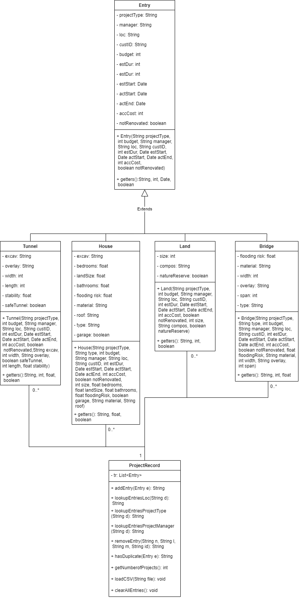

Justification for design
Before making the diagram, we had to analyse the provided to us CSV file. The file has 4 project types, all 4 of them have different categories for each type, for example House type project has bedrooms but Tunnel type doesn’t. However, there are few categories that exist in each project type, therefore we can use inheritance and organize the information in a hierarchal form to save ourselves some writing. As a result, we have a class Entry that contains all the same categories across the project types and 4 classes that inherit from it – Tunnel, House, Land and Bridge. Our next goal is to make the diagram as simple as possible, since it will be accessed by other programmes in the future, and we don’t want them to take too long to figure out the diagram and the program structure. Less classes there is, less complicated the diagram would be for other workers, so instead of separating each method showed in ProjectRecords, we just have all of them in 1 class that later would be accessed by the GUI class.

Post-documentation
The CSV file has 4 project types. Each project type has different categories and categories that every type has. Therefore, classes Entry, Tunnel, House, Bridge and Land were created. Entry has common categories of 4 project types, which are ‘Project Type’, ‘Budget’, ‘Project manager’, ‘Location’, ‘New not renovated’, ‘Customer id’, ‘Estimated duration’, ‘Estimated start’, ‘Actual start’, ‘Actual end’, ‘Accumulated Cost’. The classes that inherit from the Entry class have additional categories on top of the listed ones. A constructor was created for each of these classes, as well as getters. There was no place in our GUI application where we would want to use setters, therefore it was decided to not include them in the classes that have been mentioned. Date was stored in YYYY-MM-DD format in the provided CSV file, which means that the company is most comfortable with this format and hence all the getters for dates were converted to it. Some cells don’t have date which either means that they haven’t been started or that they have started but haven’t been finished yet. In order to handle this data, we will later assign a random date that cannot exist in the real world. And if this imaginary date is present, instead of returning the non-existing date, we return ‘No Data’. The similar approach was used to handle Boolean variables – if ‘true’ convert to ‘Yes’, if ‘false’ convert to ‘No’. It’s been done to make it easier for other people to understand. Then, ProjectRecord class was created. It contains the method to add a new entry, check for duplicates, remove an entry and find entries by manager, type and location. Duplicate checking method iterates over all the entries and check whether the project with the same project type, location, manager and customer id already exists. If yes, the Boolean variable which has been initiated as false, gets set to true, otherwise (if no project with the same category values found) it stays false. Remove entry method checks the same categories to find the entry and remove it. Add entry method checks for duplicates and adds the entered entry to the record, if the entry doesn’t have an actual starting date and ending date, it prints ‘No Data’ instead. For the search options location, manager and project type were used. To assign the project to a certain manager the company would need to see the all the projects that this manager has managed before. For example, if the manager that the company wants to assign to a House project, worked only on Tunnel projects, then it wouldn’t be the best decision to put him in charge of it. Searching by location might be useful when deciding where the most resources should be allocated, and for other prediction and analytical purposes. For example, if there are a lot of house projects in New York then more resources for house building should be gathered from the nearby area or at least from the United States, as it would be easier to and less money consuming to transport them. Project type search essentially serves the same purpose, as it would mostly be used for analytical and prediction purposes. It might be used to see which project type is in demand nowadays and focus on it rather than the other 3 types. All 3 lookup methods use the requested category to find and show all the matches. There is also an edit entry in the GUI itself, it’s not handled in the class with all the function because it includes 2 of the mentioned methods to perform the editing, it just uses the removeEntry method to remove the existing entry that has the same attributes and uses the addEntry method to add the new one with one or more attributes changed. There are a lot of options that can be used to handle the editing, such as taking the unique identifiers and changing the attributes of the entry or by using setters. However, none of those methods would be as robust, flexible and easy as the one that has been chosen. Now we would like to load the data from the CSV file that has been provided to us. Essentially, there are 2 methods of handling that. First method is to use BufferReader which would load the entire file into the system and the only thing that would be left to do is to put each line, one by one, into the array by splitting the attributes by a comma. This would allow us to access every attribute by their position in the array. The other method is to use the scanner to load the file into the system. The method is similar to the one explained, but in this case, we would need to store each attribute in its own variable assign to it. This would require us to create 28 additional variables. In both of those methods we required to create the if statement that would convert an empty date field into a 1111-11-11 date. Both methods are presented in the submitted code.

