Issue:
When trying to read all of the data pairs from the input file, it will not read the last pair of data. It has to do with what condition you use for the while() loop.
This did not work:
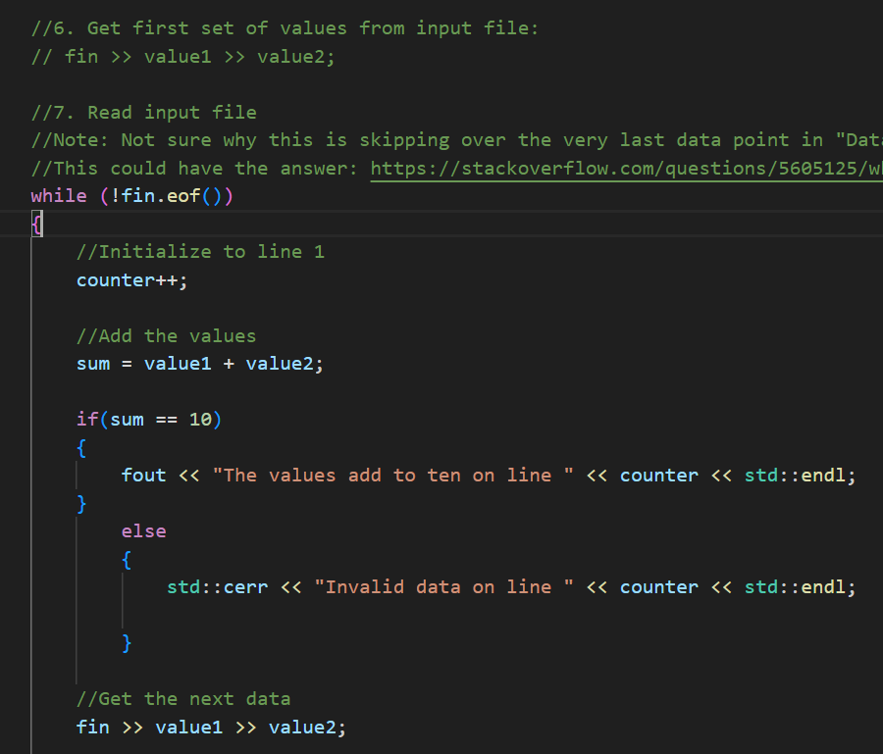

Using Data1.txt it read to the end of the file (line 8) but when the last pair was (2,8) it did not consider the pair valid (adding to 10 ) and did not put it in the output file. Not sure why?

This also did not work:
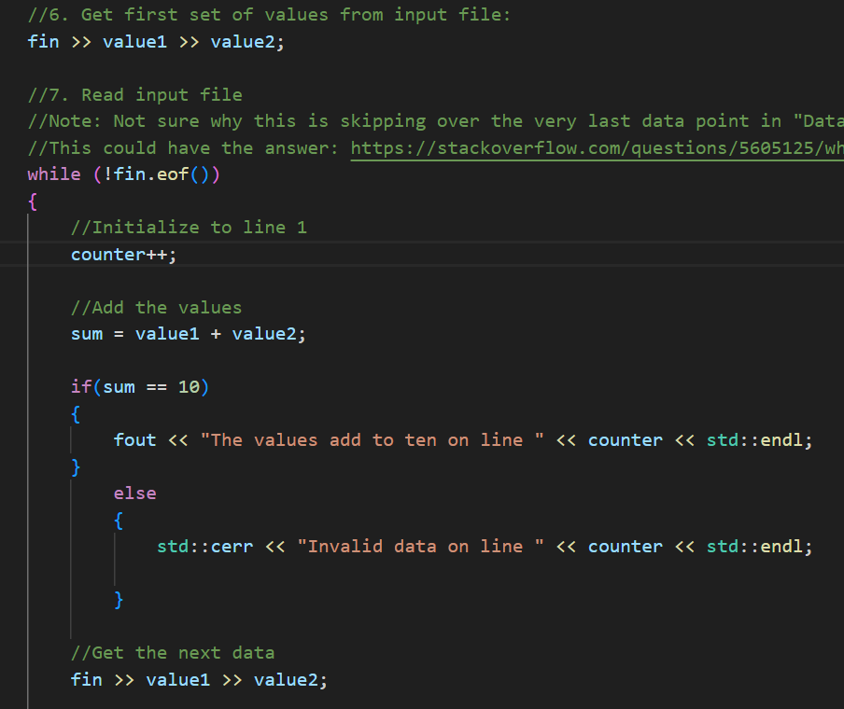
This method did not work at all. It did not read to the last data pair (again using Data1.txt) and instead only read to line 7. I assume it is because we grabbed the first set of values before we entered the while loop

This is the only way that worked:
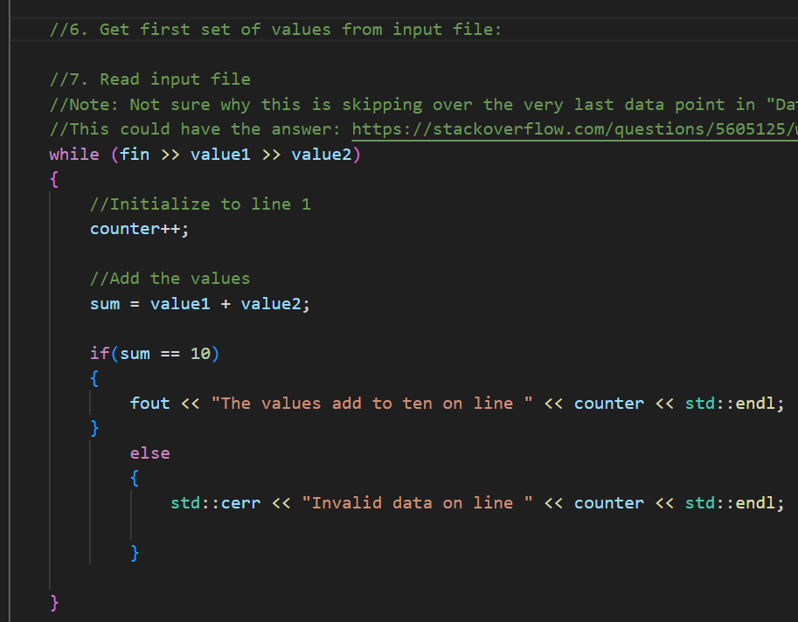
The one that worked, I got the idea from stackoverflow.
Not sure exactly why this method worked but not the other 2 methods.

Follow Up:
The book shows that while(!fin.eof()) should work with the proper setup but for some reason it is not. Maybe I can use compiler explorer to investigate a basic while(!fin.eof()) loop.

