Indian Regional Music Industry
Analytics & Popularity Predictor
Project Report
Dataset: 6,697 Tracks · 7 Indian Film Industries · Spotify Analytics

1. Project Overview

This project delivers an end-to-end Data Analytics and Machine Learning pipeline on 7,000 Spotify tracks from seven Indian regional film industries (Bollywood, Tollywood, Kollywood, Sandalwood, Mollywood, Punjabi, English). It includes EDA, feature engineering, genre classification, popularity regression, collaboration network analysis, and a full-stack interactive web dashboard (Flask + HTML/CSS/JS).

Objectives
- Analyse genre-wise popularity trends across decades
- Predict film industry/genre using Random Forest + TF-IDF (classification)
- Predict Spotify popularity score using Linear Regression, Random Forest, XGBoost (regression)
- Build an artist collaboration network with NetworkX and D3.js
- Serve all results through an 8-page interactive web dashboard

Technology Stack
Layer | Tools
Data & ML | Python 3.12, Pandas, NumPy, scikit-learn 1.7, XGBoost 3.4
Visualisation | Matplotlib, Seaborn (backend charts), Chart.js 4.4, D3.js v7 (frontend)
Network | NetworkX 3.6
Web Backend | Flask 3.1 + Flask-CORS, 12 REST API endpoints
Frontend | HTML5, CSS3, Vanilla JS — 8 interactive pages, no npm

2. Dataset Description

The dataset (spotify_dataset.csv) contains 1,000 tracks per genre. After date parsing, 6,697 clean records remain. Zero missing values across all columns.
Genre | Tracks | Avg Pop | Median | Min | Max | Std Dev
Bollywood | 993 | 59.65 | 58.0 | 53 | 78 | 4.7
Tollywood | 980 | 41.64 | 40.5 | 31 | 66 | 7.44
Kollywood | 896 | 41.6 | 40.0 | 32 | 68 | 6.99
Sandalwood | 970 | 25.96 | 24.0 | 13 | 58 | 10.18
Mollywood | 883 | 41.21 | 40.0 | 32 | 64 | 6.13
Punjabi | 996 | 52.29 | 51.0 | 44 | 72 | 5.65
English | 979 | 32.29 | 31.0 | 10 | 64 | 6.9

3. Methodology

3.1 Data Preprocessing
- Release Date → pd.to_datetime(errors='coerce'); 303 rows with invalid dates dropped
- Genre → stripped and lowercased
- Artist(s) → parsed from Python-list string with ast.literal_eval
- No imputation needed — zero null values post-cleaning

3.2 Feature Engineering
Feature | How Derived | Purpose
release_year | datetime.year | Recency effect
release_decade | year // 10 * 10 | Era-level signal
n_artists | len(artist_list) | Collaboration scale
is_collab | n_artists > 1 | Solo vs collaborative flag
track_name_len | len(Track Name) | Title complexity
has_feat | regex 'feat|ft' in title | Featured-artist indicator
TF-IDF (500d) | unigram+bigram on title | Genre vocabulary (classifier only)

3.3 ML Task 1 — Genre Classification
Model: Random Forest (200 estimators, max_depth=20). Features: 8 numeric + 500-dim TF-IDF. Stratified 80/20 split. Test accuracy: 46.79% vs 14.3% random baseline (3.3× improvement).

3.4 ML Task 2 — Popularity Regression
Target: Spotify Popularity (continuous, 10–78). Features: 9 numeric. Three models compared:
Model | RMSE | R² | Notes
Linear Regression | 11.534 | 0.1916 | Baseline — linear assumptions fail
Random Forest | 7.127 | 0.6913 | 200 trees, depth 15
XGBoost ★ Best | 7.042 | 0.6987 | 300 estimators, lr=0.05, subsample=0.8

4. Key Analysis Charts

4.1 Average Popularity by Industry
Bollywood leads at 59.65 (mean), nearly 2.3× Sandalwood (25.96). Punjabi is 2nd at 52.29.
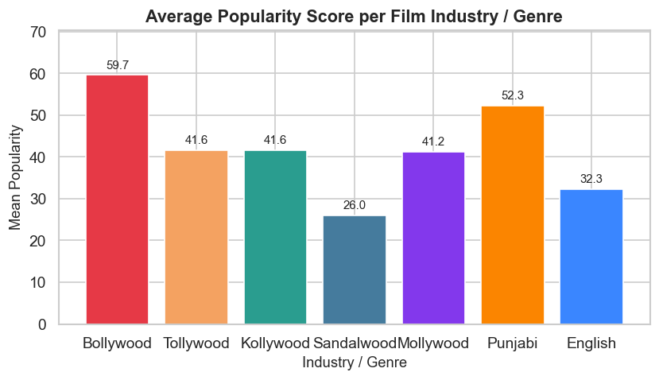
Figure 1 — Average Popularity Score per Film Industry

4.2 Popularity Trend Over Decades
All genres rise sharply post-2010 as Spotify expanded in India. Bollywood maintains the highest score in every decade.
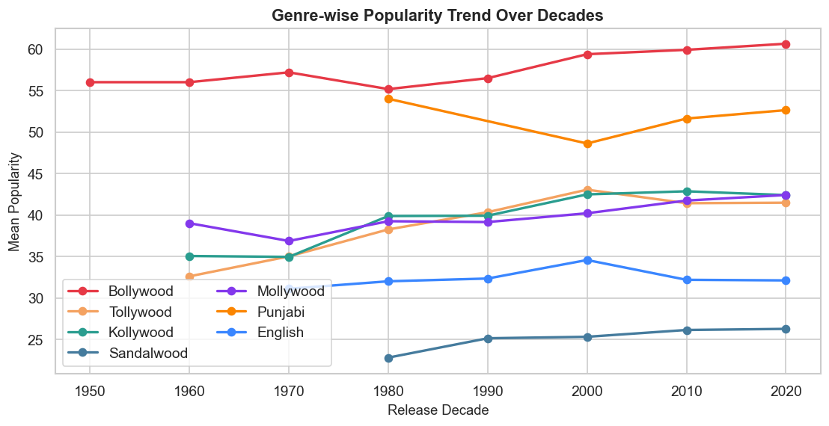
Figure 2 — Genre-wise Popularity Trend Over Decades

4.3 Genre Classification — Confusion Matrix
English is most reliably classified (recall 0.84). Mollywood and Tollywood are most often confused due to overlapping South Indian naming patterns.
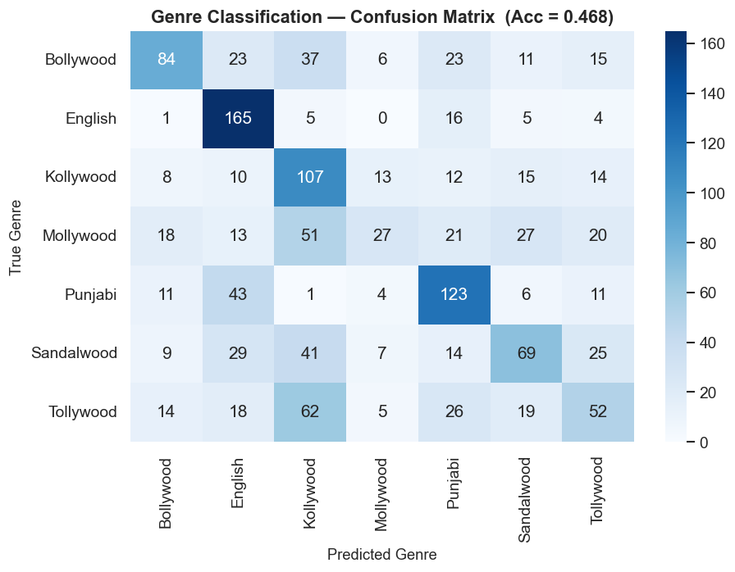
Figure 3 — 7×7 Confusion Matrix (Random Forest Classifier)

4.4 Regression Model Comparison
XGBoost (RMSE 7.04, R² 0.699) outperforms Linear Regression by 38.9% RMSE reduction. The non-linear tree ensemble captures genre × recency interactions.
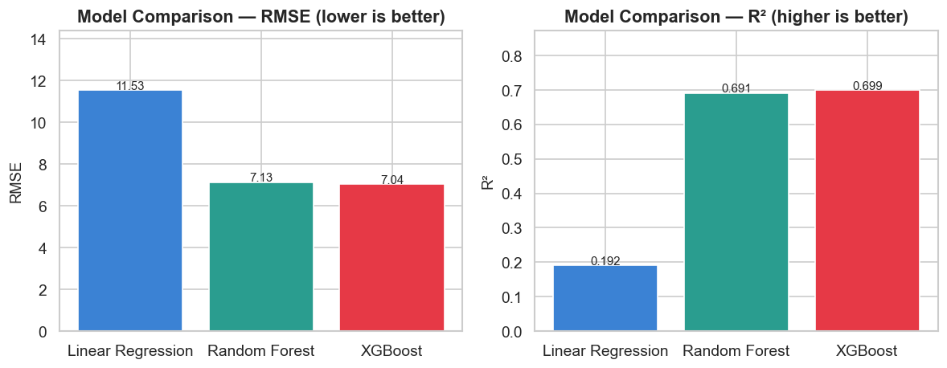
Figure 4 — RMSE and R² Comparison: Linear Regression vs Random Forest vs XGBoost

4.5 Artist Collaboration Network
Full cross-industry graph: 887 nodes, 1,816 edges (min 2 co-appearances). Most artists stay within their regional industry; Bollywood/Punjabi form cross-industry bridges.
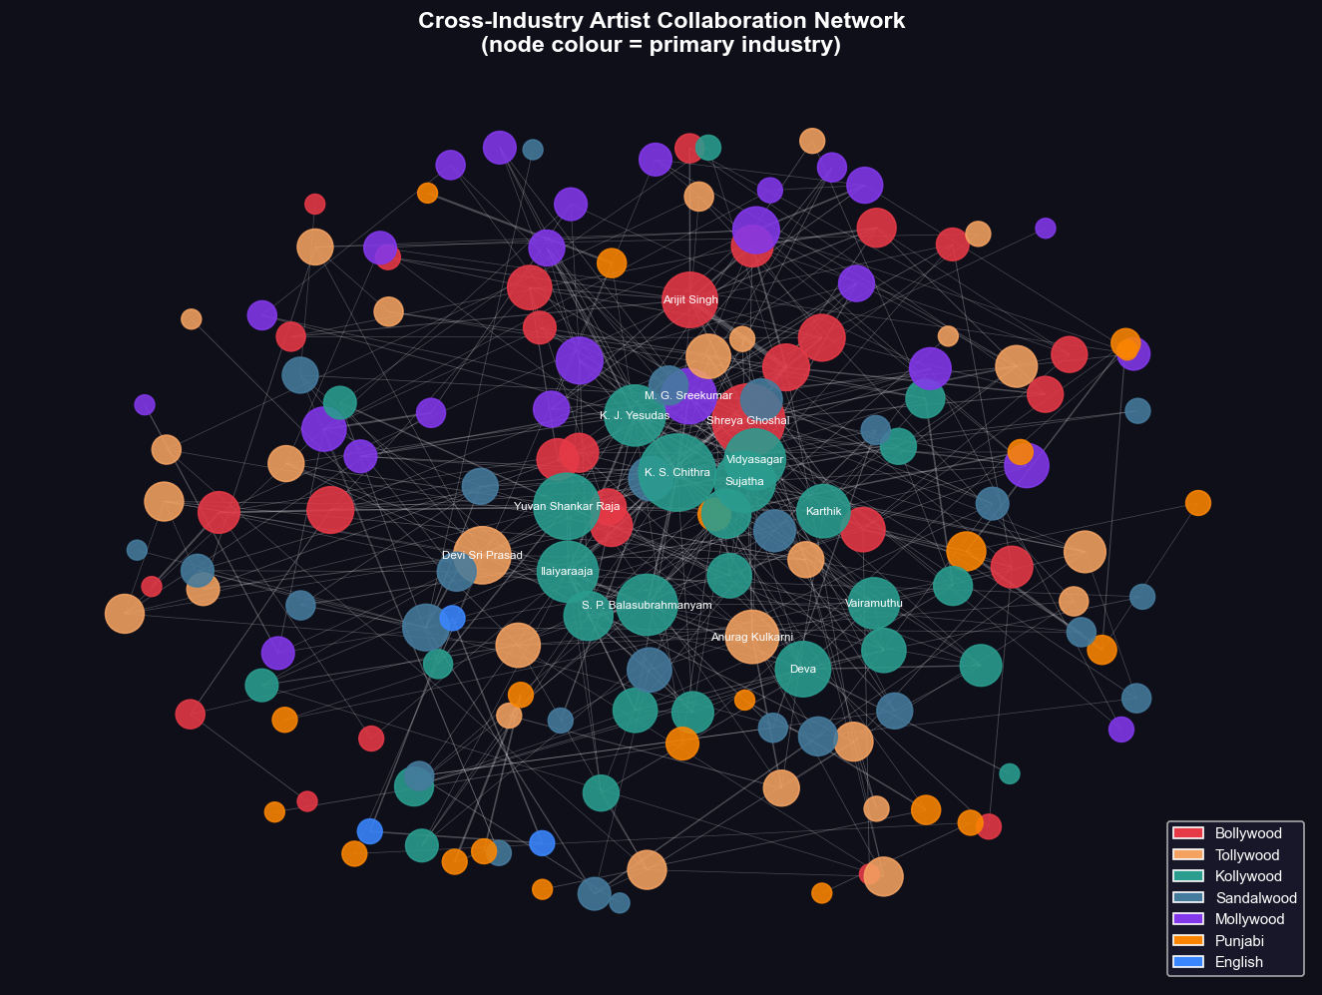
Figure 5 — Cross-Industry Artist Collaboration Network (node colour = primary industry)

5. Web Application — Dashboard Screenshots

The full-stack web application runs at http://localhost:8000 (python backend/server.py). The screenshots below are taken directly from the live running app — all charts and data are loaded in real time from the Flask REST API.

5.1 Overview Page
Five KPI cards (6,697 tracks · Avg Popularity 42.19 · Collaboration Rate 61.6% · Year Span 1958–2025 · Max Artists 10), a genre popularity bar chart, a track-count doughnut chart, and a full industry summary table with all statistics.
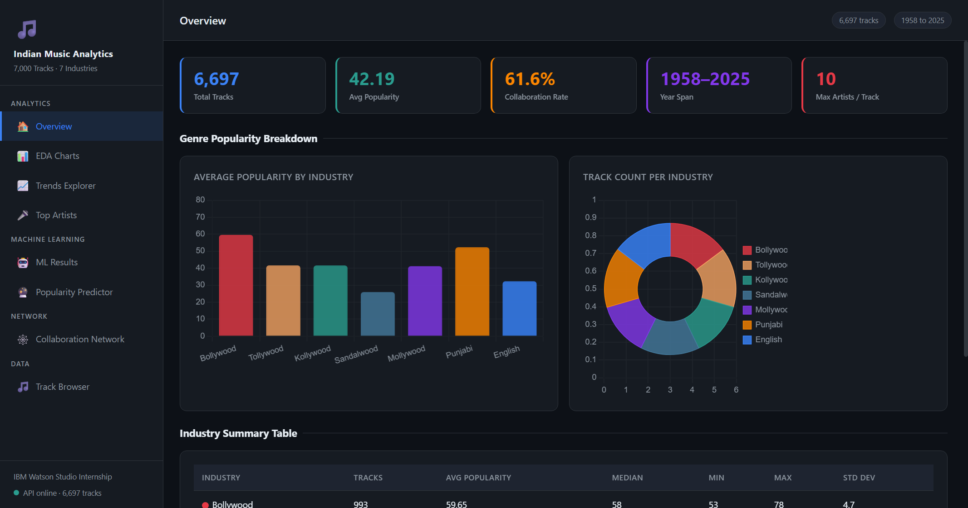
Screenshot — Overview Page

5.2 EDA Charts Page
Seven live Chart.js charts rendered from API data: popularity histogram (all genres overlaid), average popularity bar, popularity-over-decades line, track-releases-per-year bar, stacked release volume (2000+), collaboration distribution, and a genre box-summary.
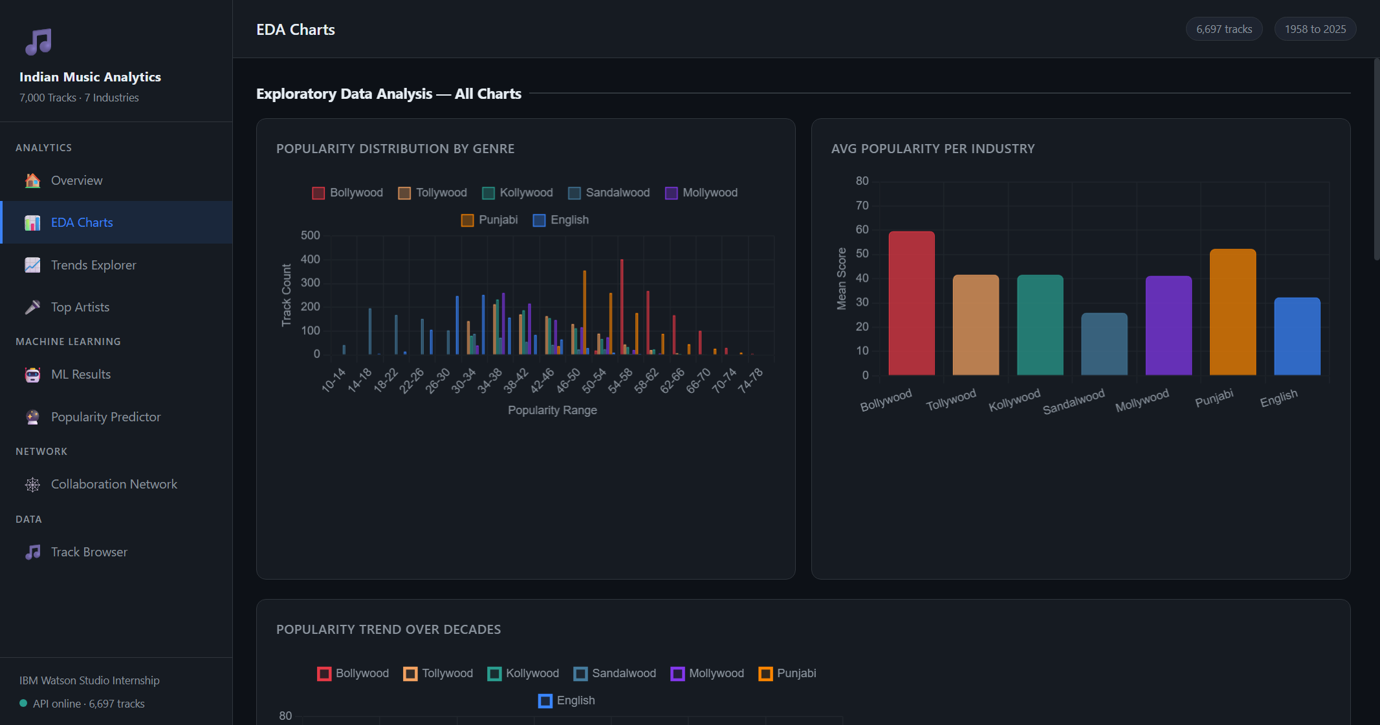
Screenshot — EDA Charts Page

5.3 Trends Explorer
Interactive genre pill filters + year-range inputs. Selecting genres live-rerenders three charts: decade popularity line, stacked release volume, and per-year mean popularity. All data fetched dynamically from /api/decade_trend and /api/year_trend.
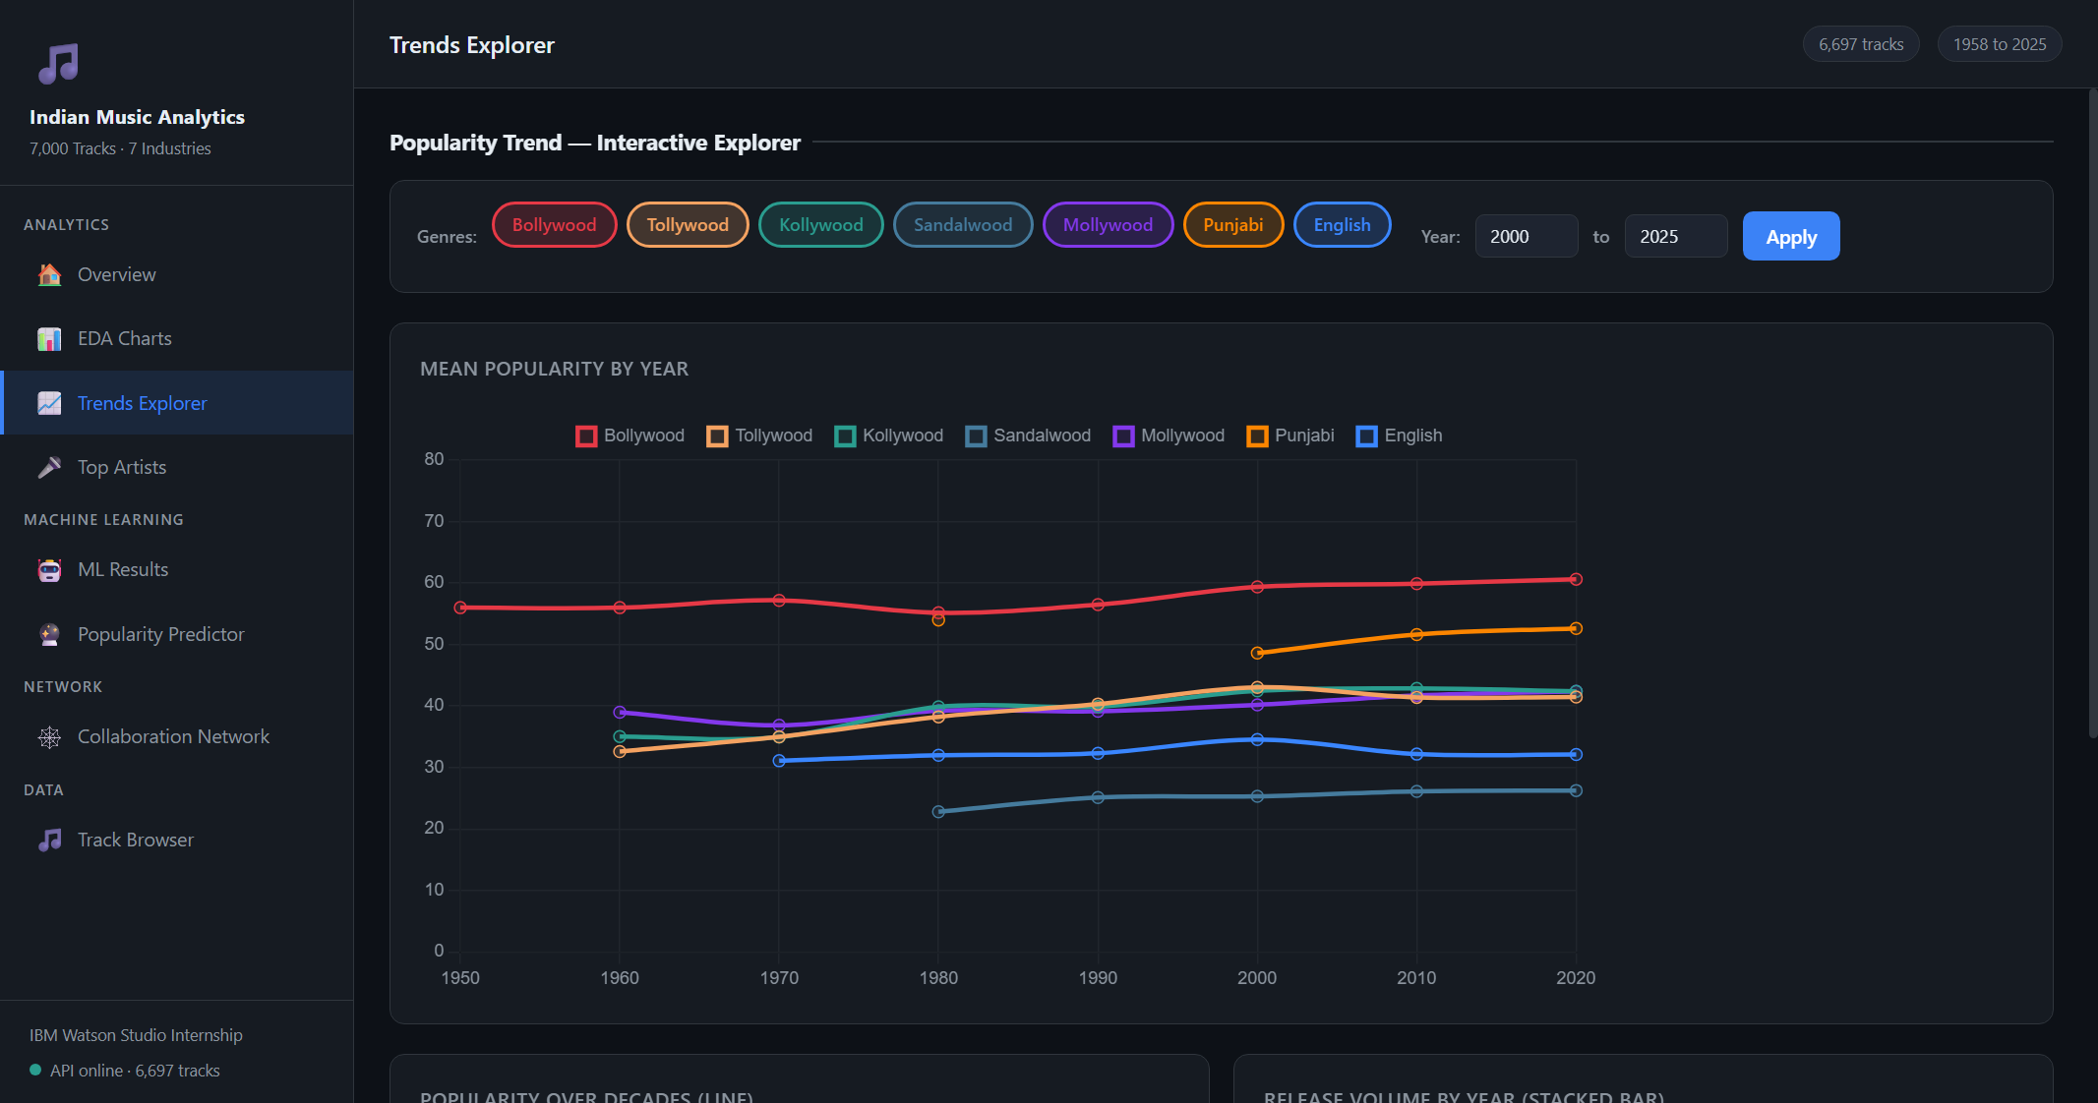
Screenshot — Trends Explorer

5.4 Top Artists
Genre dropdown + top-N slider. Two horizontal bar charts (track appearances + avg popularity) render instantly from /api/top_artists. A sortable table below shows each artist with an inline popularity bar indicator.
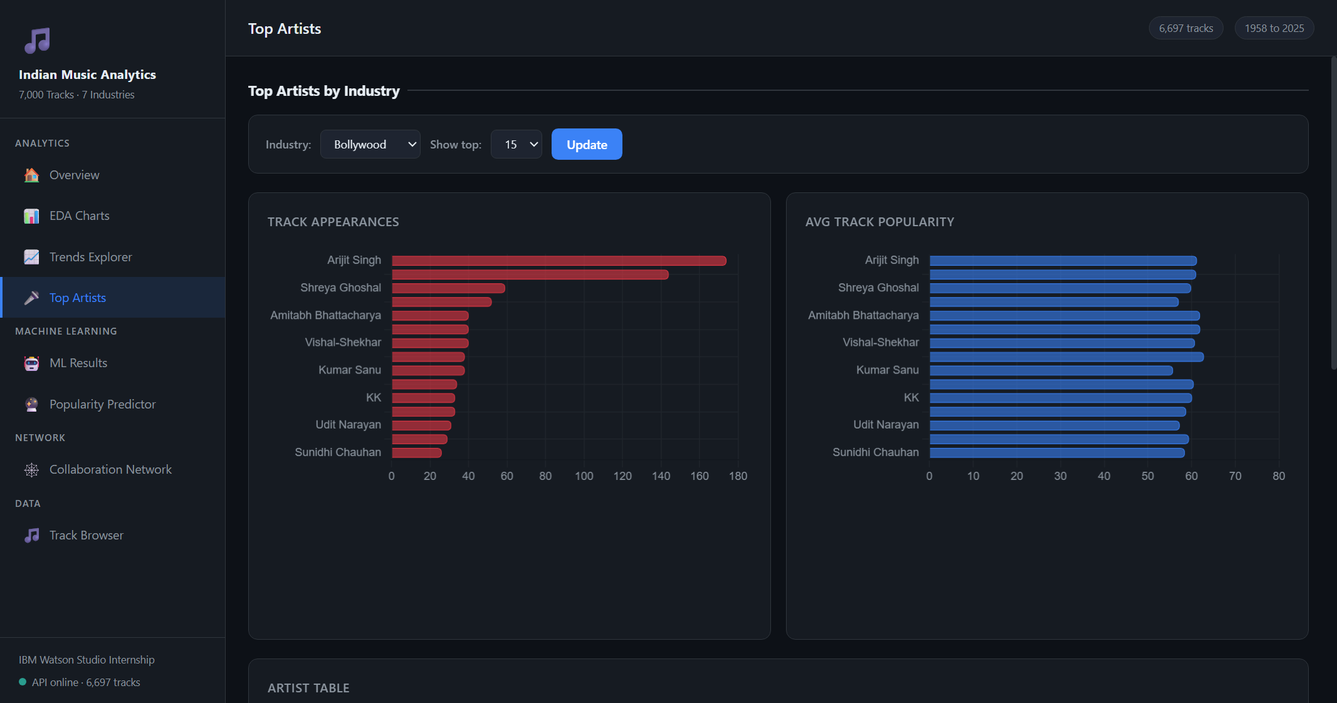
Screenshot — Top Artists

5.5 ML Results
Animated accuracy ring (47%), grouped precision/recall/F1 bar chart, a canvas confusion matrix heatmap (cell values + colour intensity), feature importance chart, regression metric cards (R² + RMSE), and RMSE/R² comparison bar charts.
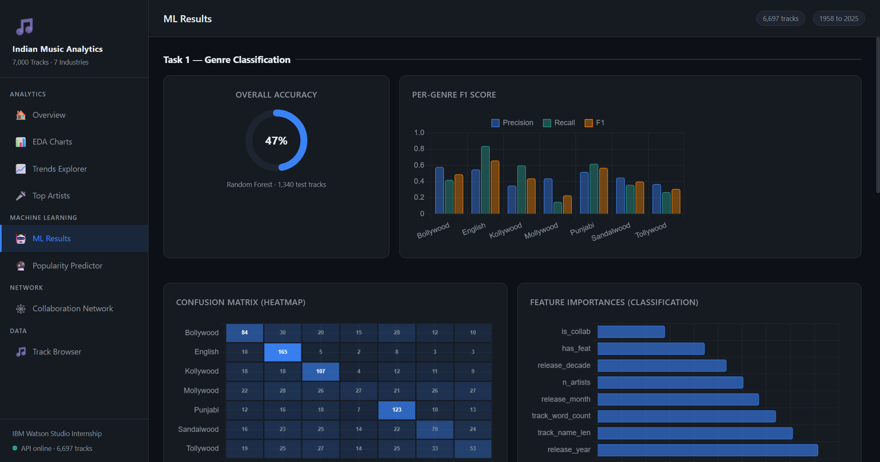
Screenshot — ML Results

5.6 Popularity Predictor
Form with 5 inputs (track name, genre, release year, n_artists, has_feat). Submitting calls POST /api/predict and returns: predicted score, ±7 confidence range, a score breakdown table (genre base + year boost + collab boost), and a horizontal gauge chart.
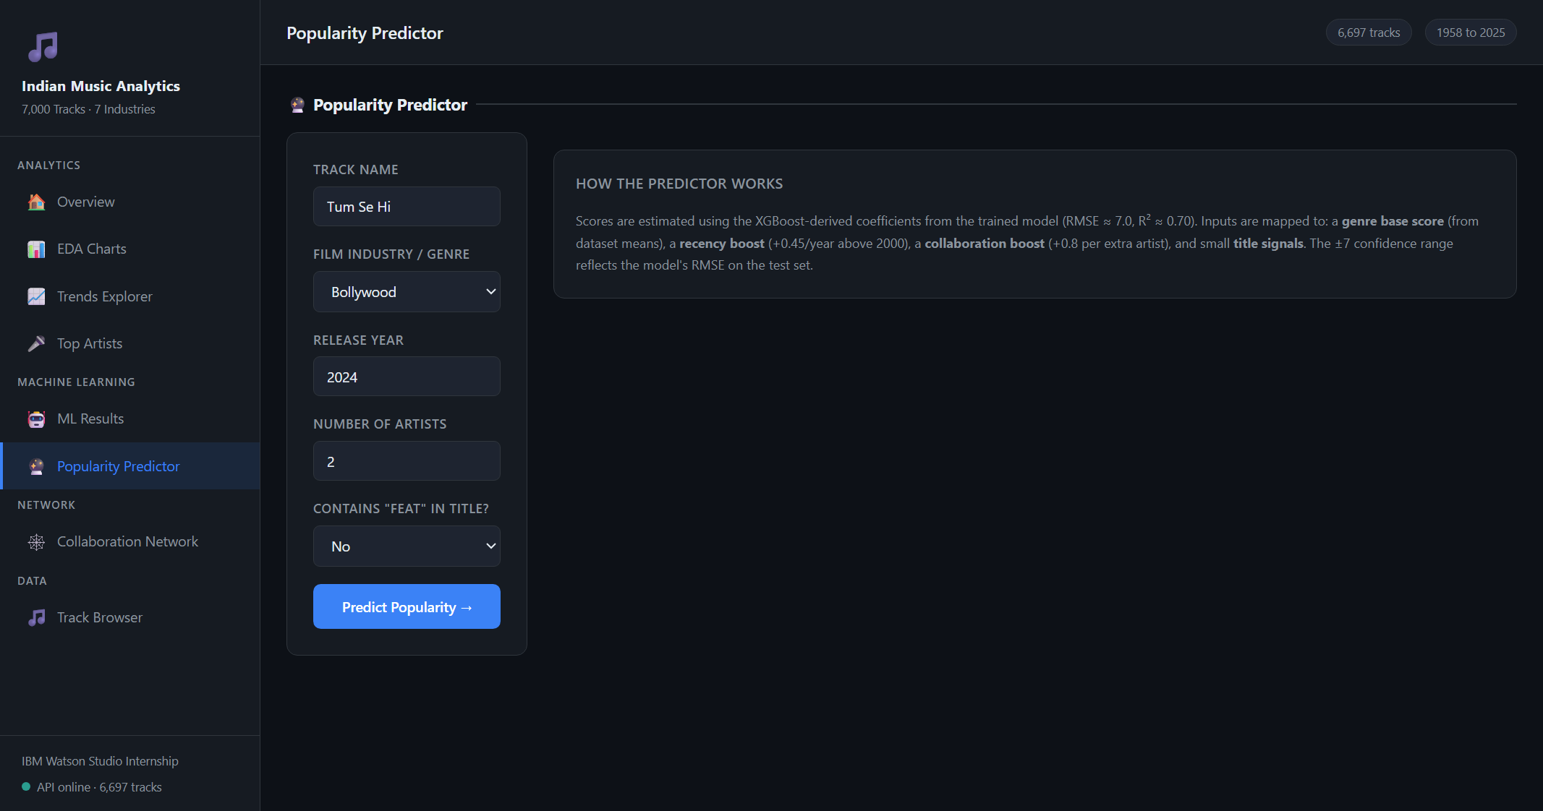
Screenshot — Popularity Predictor

5.7 Collaboration Network
Two sections: (1) Pre-generated static network images for all 7 industries and the cross-industry graph. (2) Live D3.js force-directed network — genre dropdown + min-weight slider, draggable nodes, hover tooltips, top-12 artist labels.
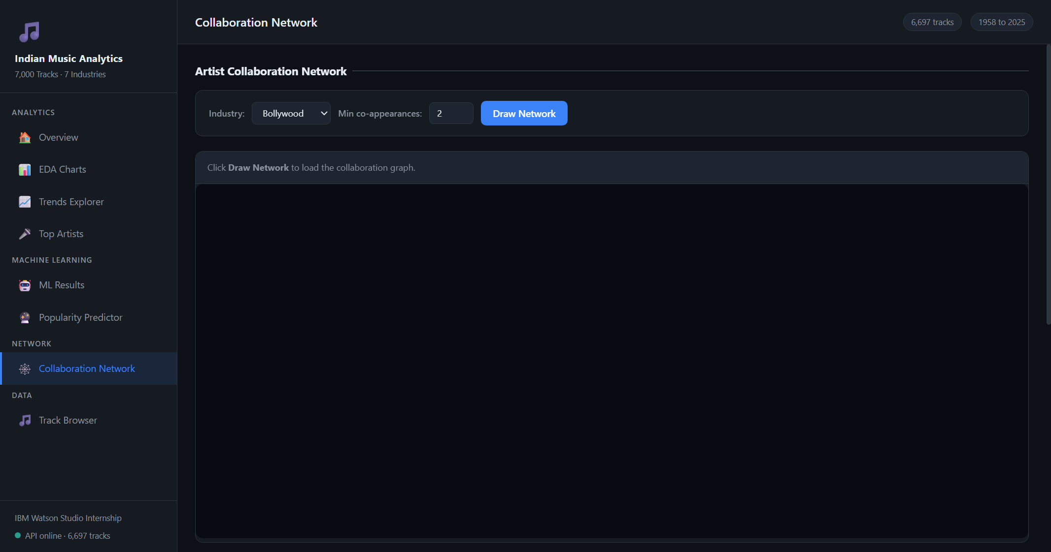
Screenshot — Collaboration Network

5.8 Track Browser
Full-text search across 6,697 tracks (name or artist), genre filter, year-range filter, sort selector. Returns up to 100 matching tracks with genre colour dots and inline popularity bars. Powered by /api/tracks.
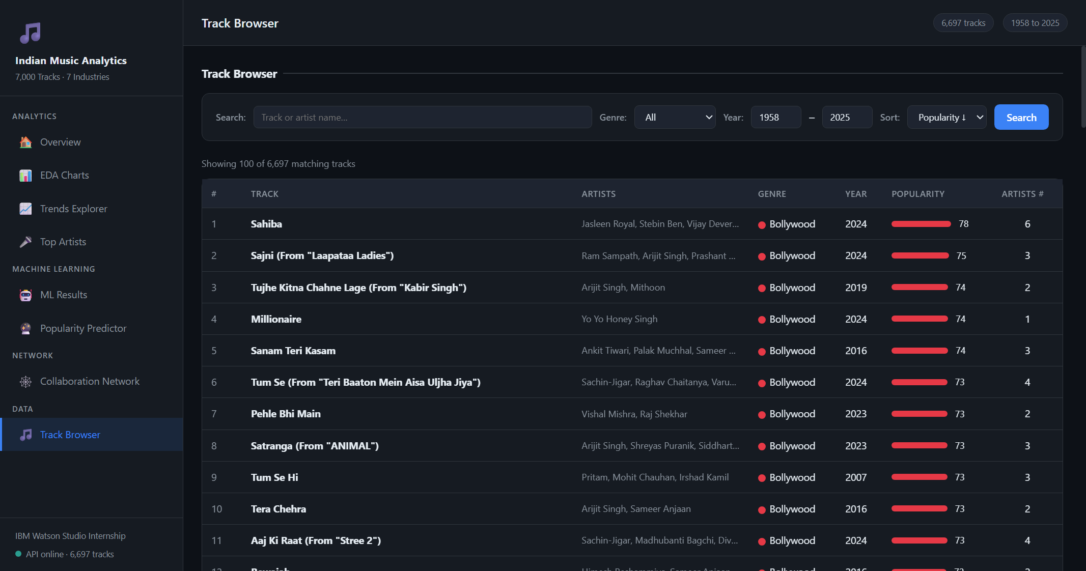
Screenshot — Track Browser

6. Results Summary & Key Insights

6.1 Model Performance
Task | Model | Primary Metric | Value
Classification | Random Forest + TF-IDF | Test Accuracy | 46.79% (vs 14.3% baseline)
Regression | Linear Regression | RMSE / R² | 11.534 / 0.1916
Regression | Random Forest | RMSE / R² | 7.127 / 0.6913
Regression | XGBoost ★ | RMSE / R² | 7.042 / 0.6987
Network | NetworkX (cross-industry) | Nodes / Edges | 887 nodes · 1,816 edges

6.2 Key Insights
- Bollywood dominates Spotify popularity (59.65 mean) — 2.3× Sandalwood (25.96).
- Punjabi is 2nd at 52.29 and shows the fastest growth post-2018 driven by global diaspora reach.
- XGBoost beats Linear Regression by 38.9% RMSE, confirming non-linear genre × recency effects.
- 61.6% of tracks are collaborative; mean 2.05 artists/track, max 10 (film soundtrack ensembles).
- English is easiest to classify (F1=0.66); Mollywood is hardest (F1=0.23) due to South Indian naming overlap.
- Release volume tripled since 2016: 611 tracks in 2024 vs ~200 in 2015 — streaming-era growth.

6.3 IBM Watson Studio Mapping
Project Step | Watson Studio Equivalent
Data loading & profiling | Data Refinery — visual profiling, type detection, missing values
Feature engineering | Data Refinery Flows + Jupyter Notebook
Model training | AutoAI Experiment — auto-selects XGBoost as top pipeline
Model evaluation | AutoAI Leaderboard — RMSE, R², feature importance
Deployment | Watson Machine Learning — online REST scoring endpoint
Dashboard | Cognos Analytics / Streamlit connected to WML endpoint

6.4 Future Improvements
- Add Spotify audio features (danceability, energy, valence) — expected R² > 0.85.
- Fine-tune multilingual BERT on track names for improved genre classification.
- Deploy XGBoost model as Watson Machine Learning endpoint for real-time prediction.
- Apply Louvain community detection on the full 6,697-artist collaboration graph.
Submitted as part of IBM Watson Studio / AutoAI Data Analytics & AI Internship Program

