

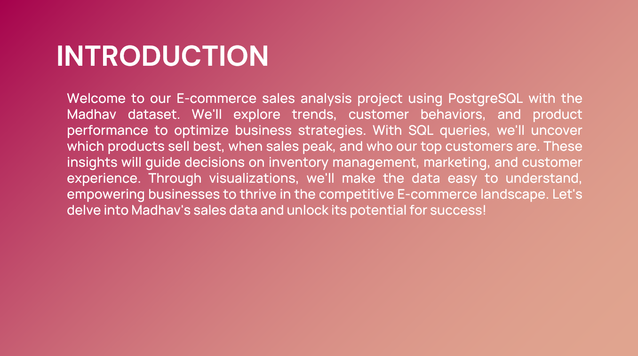

**ABOUT THE DATA**

**Dataset:** [**Madhav Store: Kaggle**](https://www.kaggle.com/datasets/mohammadkaiftahir/madhav-store-dataset)

**Orders Table**

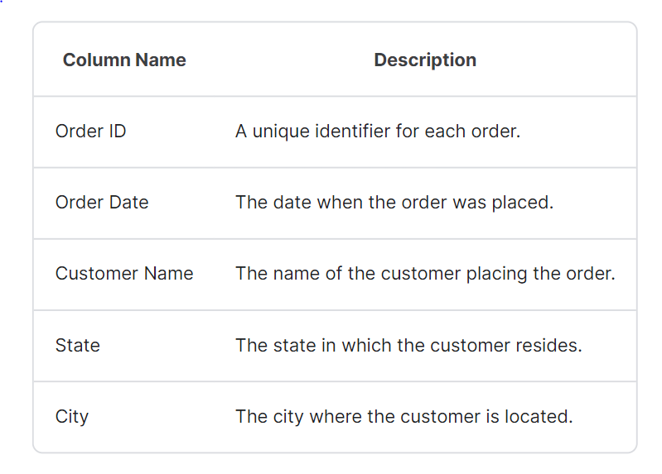

**Details Table**

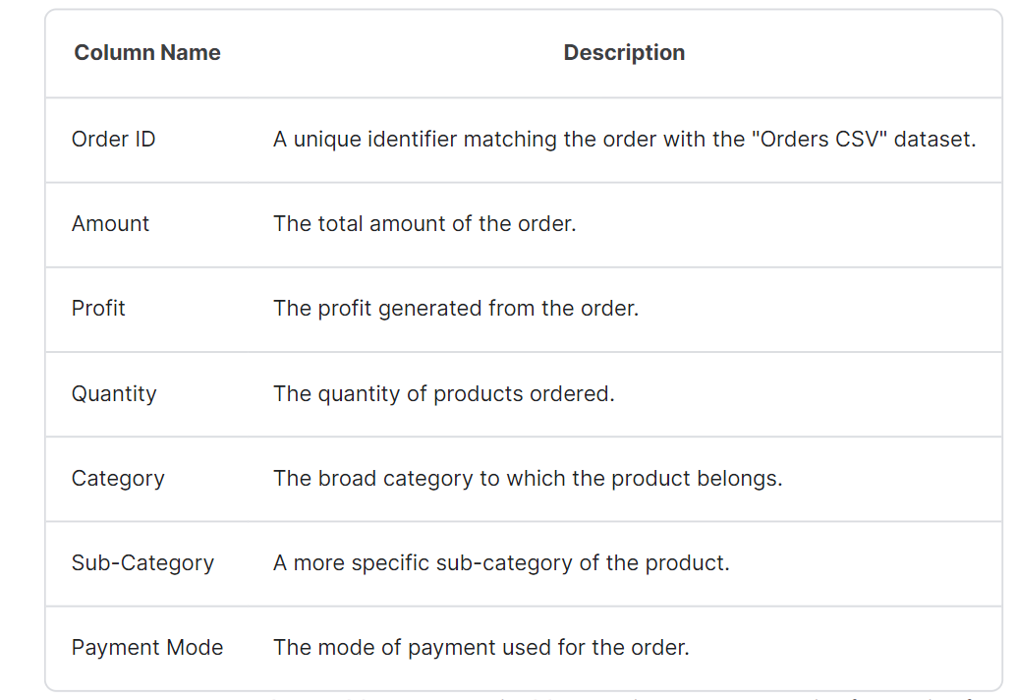

**QUESTIONS**

1.Retrieve orders placed in the city of "Chennai"

2.Retrieve orders placed by customers who have placed orders in more than one state

3.Calculate the total revenue generated per state and city

4.Identify the customer who has placed the highest number of orders

5.Calculate the average order amount per payment mode

6.Retrieve orders with quantities greater than the average quantity per order

7.Identify the top 3 customers with the highest total revenue

8.Retrieve orders with a profit margin greater than 50%

9.Identify category with the highest average profit margin

10.Retrieve orders with the maximum profit in each category

11.Find the total profit generated from each category

12.List the top 5 customers who have spent the most amount of money

13.Calculate the total profit generated from each sub-category within the 'Electronics' category

14.List the top 3 states with the highest average order amount

15.Identify customers who have used multiple payment modes

16.List the top 5 customers who have purchased the highest quantity of items

17.Rank customers based on the total amount they have spent, with the highest spender ranked first

18.Write a SQL query to segment customers into different groups based on their total purchase amount. Assign customers to categories "High", "Medium", or "Low" based on their total purchase amount.

19.Percentage of orders paid via each payment mode

20.Top 3 most profitable sub-categories in terms of total profit

**Q1: Retrieve orders placed in the city of "Chennai"**

**Query:**



**Output:**

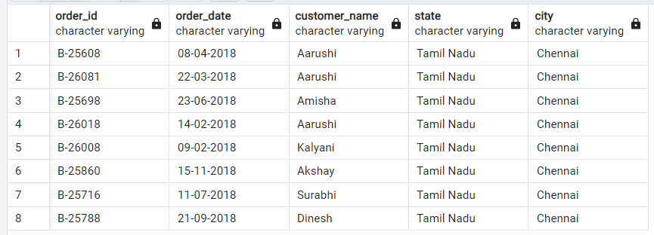

**Interpretation:**

These are the orders placed by various customers in the city of Chennai.

**Q2: Retrieve orders placed by customers who have placed orders in more than one state**

**Query:**

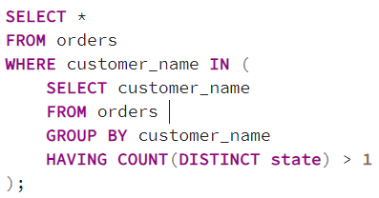

**Output:**

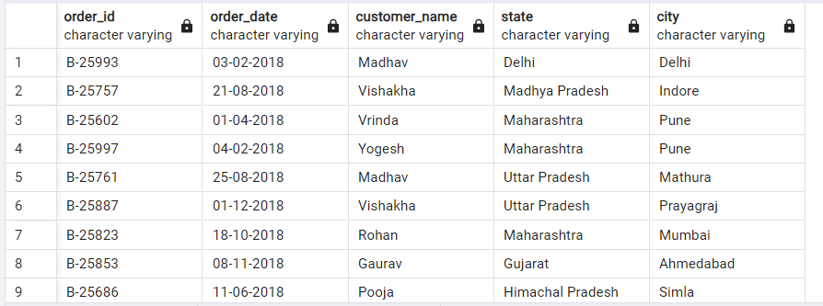

**Interpretation:**

Several customers have placed orders in multiple states, indicating they might have diverse business or travel needs.

The dataset contains a wide geographical spread of customers, including those from different regions like Madhya Pradesh, Maharashtra, and Uttar Pradesh.

**Q3: Calculate the total revenue generated per state and city**

**Query:**

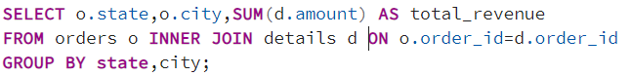

**Output:**

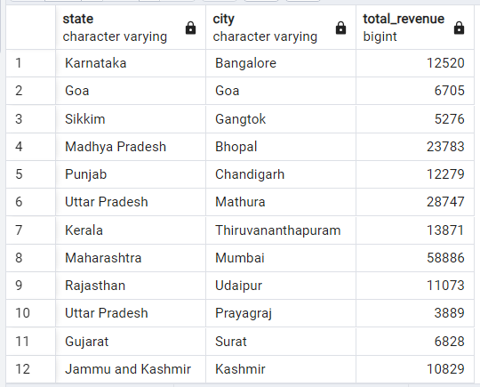**Interpretation:**

Revenue generation is spread across various states and cities, indicating a broad customer base and market presence.

**Q4: Identify the customer who has placed the highest number of orders**

**Query:**

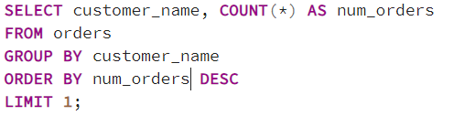

**Output:**

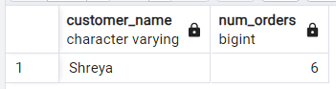

**Interpretation:**

The query identifies the customer with the highest number of orders, which is "Shreya," with a total of 6 orders placed.

**Q5: Calculate the average order amount per payment mode**

**Query:**

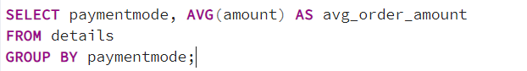

**Output:**

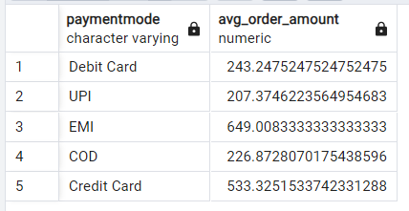

**Interpretation:**

EMI payments have the highest average order amount, followed by Credit Card payments. Debit Card payments have the lowest average order amount among the listed payment modes. COD and UPI payments fall in between EMI and Debit Card payments in terms of average order amount.

**Q6: Retrieve orders with quantities greater than the average quantity per order**

**Query:**

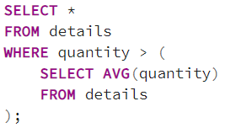

**Output:**

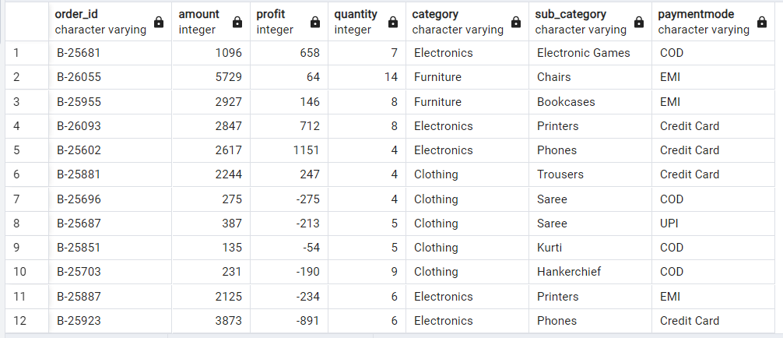

**Interpretation:**

These orders exhibit higher-than-average quantities, indicating potentially larger purchases or orders with a higher quantity of items compared to the average order. This could suggest bulk purchases, increased demand for specific products, or perhaps special promotions or deals that incentivize customers to buy more items at once. It may be worth further analysis to understand the specific factors driving these higher quantities and their impact on overall sales and customer behaviour.

**Q7: Identify the top 3 customers with the highest total revenue**

**Query:**

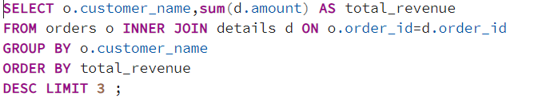

**Output:**

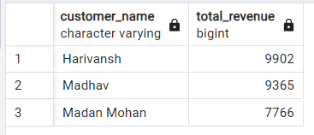

**Interpretation:**

Top three customers by total revenue are "Harivansh" with 9902, "Madhav" with 9365, and "Madan Mohan" with 7766. These customers contribute significantly to the overall revenue, indicating their importance to the business. Understanding their preferences, purchase patterns, and satisfaction levels could help in retaining them and attracting similar high-value customers.

**Q8: Retrieve orders with a profit margin greater than 50%**

**Query:**

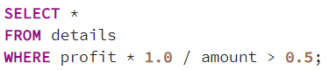

**Output:**

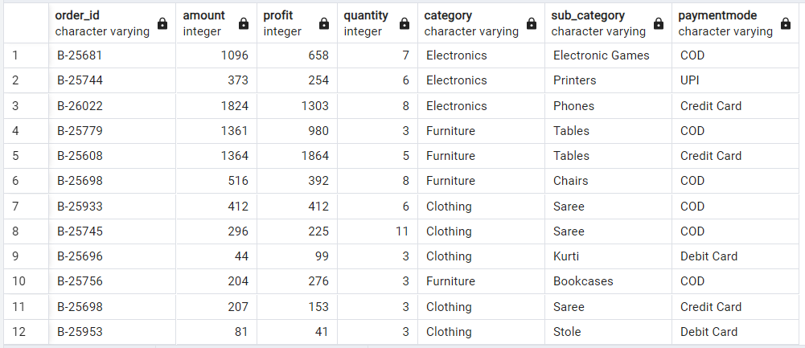**Interpretation:**

Among the orders with profit margins greater than 50%, there are significant purchases across different product categories. These include electronic items like printers and phones, as well as furniture such as tables and bookcases. The data suggests that customers are willing to invest in high-profit-margin products, indicating potential areas for business growth and strategic marketing efforts.

**Q9: Identify category with the highest average profit margin**

**Query:**

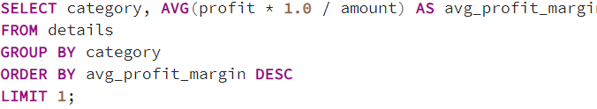

**Output:**

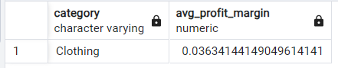

**Interpretation:**

The clothing category has the highest average profit margin of approximately 3.63%. This indicates that, on average, clothing items generate higher profits relative to their selling price compared to other categories. It suggests that the clothing segment might be more lucrative for the business in terms of profitability per sale.

**Q10: Retrieve orders with the maximum profit in each category**

**Query:**

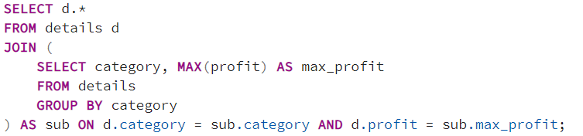

**Output:**

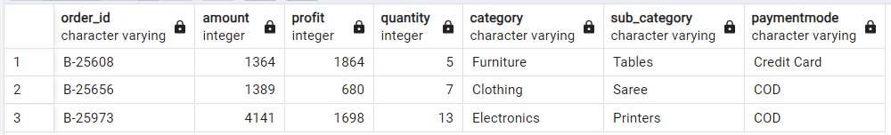

**Interpretation:**

This query retrieves the details of transactions with the highest profit within each category.

The transaction with order ID "B-25608" in the "Furniture" category has the highest profit of 1864.

The transaction with order ID "B-25656" in the "Clothing" category has the highest profit of 680.

The transaction with order ID "B-25973" in the "Electronics" category has the highest profit of 1698.

**Q11: Find the total profit generated from each category**

**Query:**

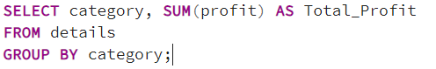

**Output:**

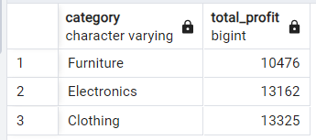

**Interpretation:**

Clothing is the most profitable category, followed closely by Electronics and then Furniture. Understanding the profitability of each category can help businesses allocate resources and focus their efforts on the most lucrative product lines. It may be beneficial for the company to explore opportunities to further enhance profitability in the Clothing category, given its high performance compared to other categories.

**Q12: List the top 5 customers who have spent the most amount of money**

**Query:**

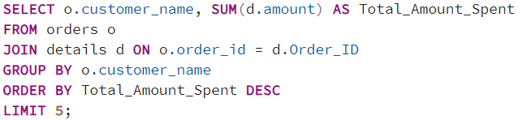

**Output:**

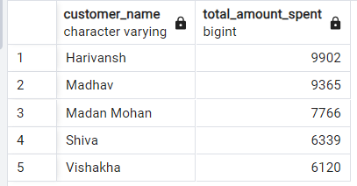

**Interpretation:**

The query reveals the top five customers by total spending. Harivansh leads with Rs. 9902, followed closely by Madhav at Rs. Madan Mohan ranks third with Rs. 7766 spent. Shiva and Vishakha complete the list with Rs. 6339 and Rs. 6120, respectively. These insights highlight key customers for targeted marketing and retention strategies, essential for driving revenue growth and enhancing customer satisfaction.

**Q13: Calculate the total profit generated from each sub-category within the 'Electronics' category**

**Query:**

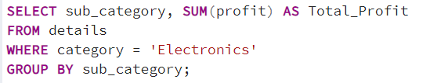**Output:**

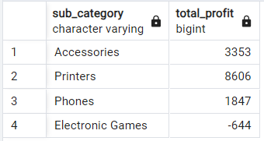

**Interpretation:**

The query showcases the total profits earned from different sub-categories within the 'Electronics' category. 'Printers' emerge as the most profitable sub-category, generating Rs. 8606 in profits. Following closely are 'Accessories' with Rs. 3353 in profits. However, 'Phones' and 'Electronic Games' yield relatively lower profits, with Rs. 1847 and -Rs. 644, respectively. Such insights help in identifying lucrative product lines and optimizing marketing strategies to maximize profitability in the electronics segment.

**Q14: List the top 3 states with the highest average order amount**

**Query:**

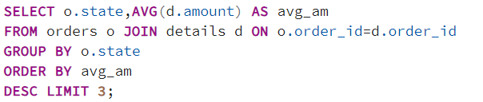

**Output:**

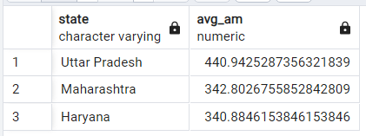

**Interpretation:**

The query presents the average amount spent on orders in the top three states by average amount. Uttar Pradesh leads with an average order amount of Rs. 440.94, followed by Maharashtra with Rs. 342.80, and Haryana with Rs. 340.88. These figures provide insights into regional spending patterns, which can be useful for targeting marketing efforts and optimizing product offerings in these areas to maximize sales and revenue.

**Q15: Identify customers who have used multiple payment modes**

**Query:**

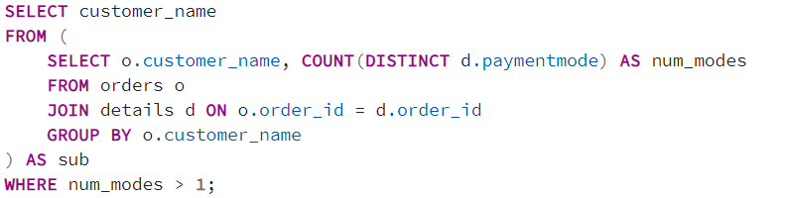

**Output:**

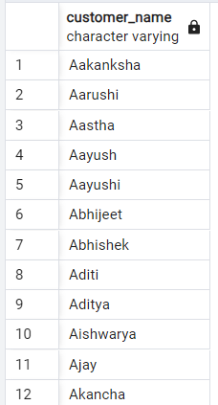

**Interpretation:**

The query retrieves customer names who have used more than one payment mode for their orders. This insight suggests that these customers may prefer flexibility in payment methods or may have different preferences for various types of transactions. Understanding these preferences can help businesses tailor their payment options to meet customer needs and enhance their overall shopping experience.

**Q16: List the top 5 customers who have purchased the highest quantity of items**

**Query:**

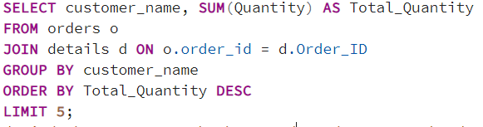

**Output:**

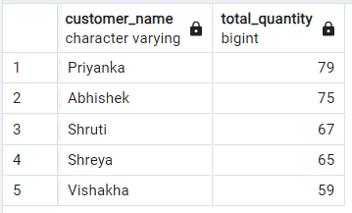

**Interpretation:**

The query returns the top five customers based on the total quantity of items they've ordered. "Priyanka" leads the list with a total quantity of 79 items, followed closely by "Abhishek" with 75 items. "Shruti", "Shreya", and "Vishakha" round out the top five with 67, 65, and 59 items respectively. This insight provides valuable information about the purchasing behaviour of these customers, helping businesses tailor their marketing strategies and inventory management to meet the demands of their most active buyers.

**Q17: Rank customers based on the total amount they have spent, with the highest spender ranked first**

**Query:**

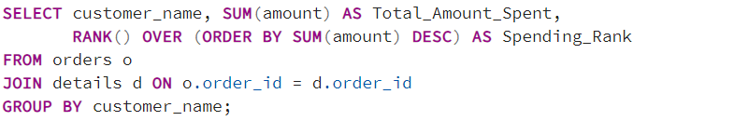

**Output:**

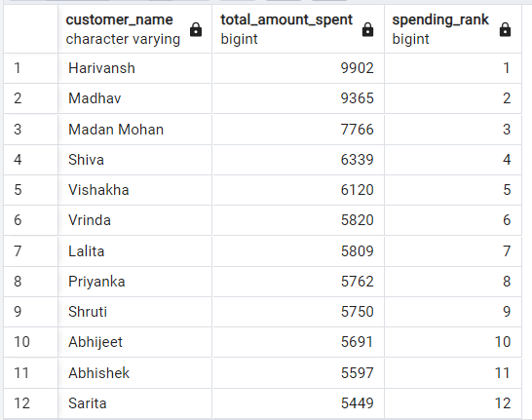

**Interpretation:**

The query retrieves the customer names along with their total amount spent on orders and assigns a rank to each customer based on their spending, with the highest spender receiving rank 1. The output displays the top spenders, with "Harivansh" leading the list, spending a total of 9902. Following closely, "Madhav" ranks second with 9365, and "Madan Mohan" ranks third with 7766. The table continues with other customers and their respective spending ranks, providing valuable insights into the distribution of spending among customers, which can inform marketing strategies and customer retention efforts.

**Q18: Write a SQL query to segment customers into different groups based on their total purchase amount. Assign customers to categories "High", "Medium", or "Low" based on their total purchase amount**.

**Query:**

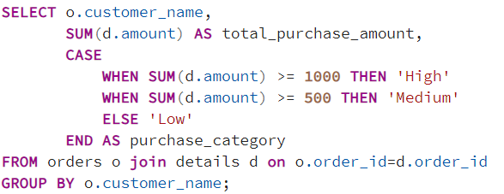

**Output:**

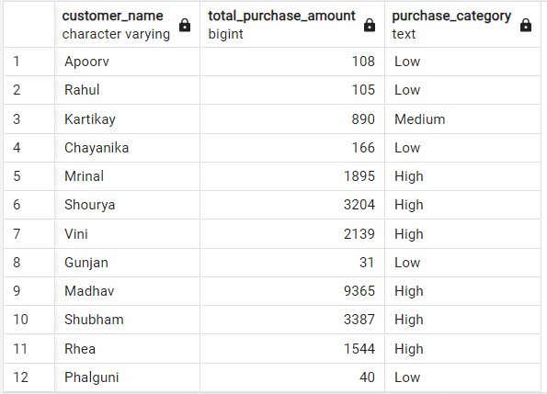

**Interpretation:**

The SQL query provided retrieves data on customer purchases from a database. It selects the customer's name, total purchase amount, and categorizes their purchasing behaviour into "High," "Medium," or "Low" based on their total purchase amount. The results display each customer's name along with their total purchase amount and corresponding purchase category. This information can be valuable for businesses to analyse customer spending patterns and tailor marketing strategies accordingly.

**Q19: Percentage of orders paid via each payment mode**

**Query:**

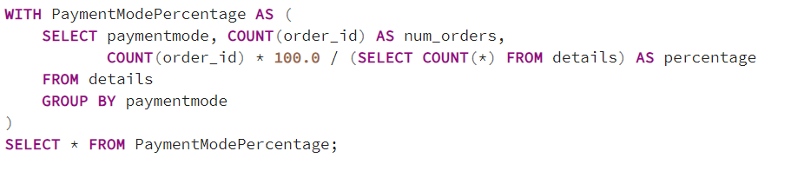

**Output:**

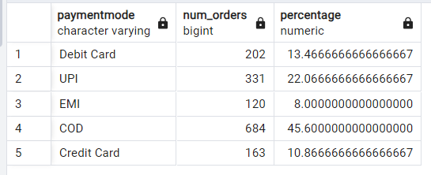

**Interpretation:**

The data reveals the distribution of orders across various payment modes. Among these, the most popular payment method is Cash on Delivery (COD), constituting 45.6% of all orders. Following closely behind is UPI with 22.07% of orders, indicating a significant adoption of digital payment methods. Debit Card transactions account for 13.47% of orders, showcasing a notable preference for card-based payments. Credit Card payments constitute 10.87% of orders, while EMI transactions represent 8% of the total. This breakdown highlights the diverse preferences among customers regarding payment methods, with a considerable portion still opting for traditional cash-based transactions, albeit alongside a substantial uptake of digital payment alternatives like UPI and card-based payments.

**Q20: Top 3 most profitable sub-categories in terms of total profit**

**Query:**

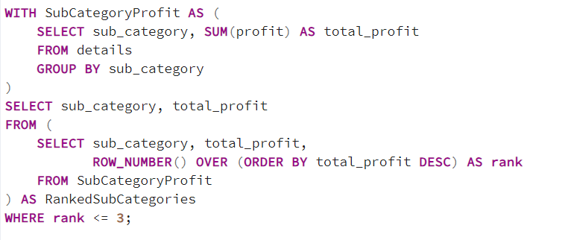

**Output:**

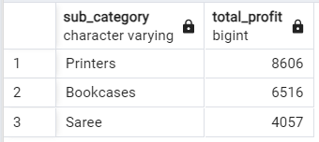

**Interpretation:**

The query results present the top three sub-categories with the highest total profits. Topping the list is "Printers" with a total profit of Rs. 8,606, followed closely by "Bookcases" with Rs. 6,516 in profit. "Saree" secures the third position with a total profit of Rs. 4,057. This information provides valuable insights into the most lucrative product categories within the dataset, aiding in strategic decision-making and resource allocation for maximizing profitability.

**DASHBOARD**

