OUTPUTS:

EXPERIMENT 5 :

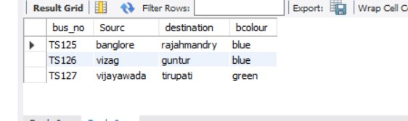

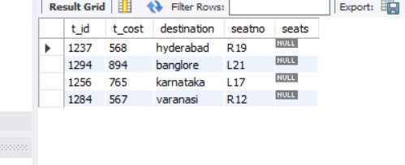

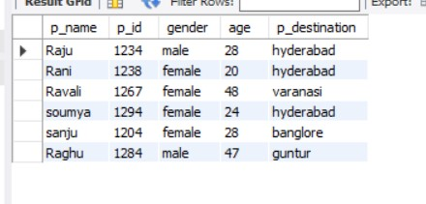

EXPERIMENT 6:

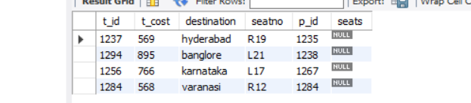

EXPERIMRNT 7:

1



2



3

4



5



6



7

