**DevOps Notes**

1. What is Linux?

Ans: * Linux is a completely open-source OS kernel. Linux is also one of the most widely used OS for server-side application.

* Linux is a free, open source OS, released under GNU General Public License(GPL). Anyone can run, study, modify and redistributed the source code, or even sell copies of their modified code as long as they do so under the same license.

1. Where Linux is Used?

Ans: * Linux is used to run web servers and data networks, supercomputers and smartphones, wireless routers and home security cameras, and much more.

Some Linux distributions are : MX Linux, Manjaro, Linux Mint, elementary, Ubuntu, Debian, SUSE

1. The Architecture of Linux:

Ans: Main Components of Linus is : H/w, Kernel, shell, Applications, Utilities.

Kernel : is one of the fundamental parts of an OS. It is responsible for each of the primary duties of the Linux OS.

The kernel is in charge of creating an appropriate abstraction for concealing trivial h/w or application strategies.

System Utility: A system utility program performs specific and individual jobs.

Hardware Layer: The h/w layer of Linux is made up of several peripheral devices such as a CPU, HDD and RAM.

Shell : Is a different OS are classified as graphical shells and command line shells. Graphical shells allows a graphical user interface and command line allows a command line interface.

Graphical line shells are faster than command line shells.

Applications : Google Browser, Steam, VLC Media Player, Atom text editor.

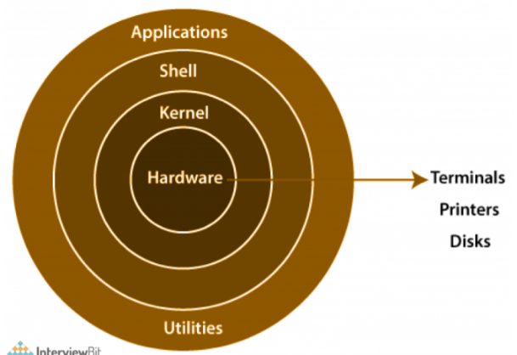

**Linux Important commands:**

1. **CD : Change Directory**:The **cd** command is used to navigate between directories. It allows you to move the current working directory to a new location in the filesystem
2. PWD: Print Working Directory : The **pwd** command allows you to print the current working directory on your terminal.
3. MKDIR : Make Directory : The **mkdir** command allows you to create directories from within the terminal.
4. RM : Remove: The **rm** command deletes a file from the current directory
5. GREP: Global Regular Expression Print: The “**grep**” command in Linux is used to search for specific patterns or text within files
6. RMDIR : Remove Directory (Empty) : This command is used to remove a specified directory
7. LS: Lists : It lists the contents of a directory, showing all files and subdirectories contained inside.
8. TOUCH : To create a new file, the **touch command** will be used.
9. CP : Copy : copying files and directories in Linux.
10. ECHO: used for displaying lines of text or string which are passed as arguments on the command line
11. MV: Move : Use the **mv command** to move a file from a given directory to a different directory
12. HEAD :I've created a file named “Words” with a lot of words arranged alphabetically in it. The **head command** will output the first 10 lines from the file,
13. SORT: The **sort command** will provide a sorted output of the contents of a file. And a tool for sorting file contents and printing the result in standard output.
14. CAT: Concatenate: The “**cat**” command in Linux is used to display the contents of a file on the terminal. It is also commonly used to concatenate and combine multiple files
15. CHMOD : Change Mode:It can help you change the permissions of the files and directories. It allows users to modify the access rights for administrator.
16. CLEAR: The **clear** command clears the contents of the terminal screen
17. LOCATE: It's used to find files by their name.
18. SUDO: Super User Do/ Substitute User Do:act as a superuser or root user while you're running a specific command.

Vim Editors and it’s modes: (sudo apt-get install vim / sudo pacman -S vim)

Vim stands for Vi IMproved is a text editor, Vim is widely used by programmers, system administrator.

Modes: there are several types in Modes

1. Normal Mode: This is the default mode when you 1st open Vim. In this mode, you can navigate the file, delete text, copy text and perform other commands.
2. Insert Mode: This mode allows you to insert and edit text. To enter Insert mode from normal mode use “i”.
3. Visual Mode: In this mode, you can visually select blocks of text. To enter Visual mode from normal mode use “v”.
4. Command-Line Mode : This mode lets you enter Vim cmd. Use “ : “.

**Basic Commands in Vim:**

1. Save file “ :w “
2. Exiting Vim “ :q” or “ :q!”
3. Save and Quit “ :wq”

**Filter Command**: Is used to append to or replace the current path name filter.

Types of filter commands:

**Cat :** this command displays the content available in the file as the standard out(stdout).

Syntax: cat simple.txt

**Tac**: this command does the same as cat but reverses the order of sentences in a file.

Syntax : tac simple.txt

**Grep**: cmd in Linux tells you about a particular text in the sentence in a file.

Syntax: grep exit sample.txt, grep same sample.txt, grep -c exit sample.txt

**Head**: to display the starting 10 lines from top of the specific file. To display some specific lines in the file u need to add -n flag and add total number of lines.

Syntax: head sample.txt, head -n 5 sample.txt

**Tail:** it will display first 10 lines from bottom of the file. To display some specific lines in the file u need to add -n flag and add total number of lines.

Syntax: tail sample.txt, tail -n 2 sample.txt

**Sort:** this cmd will use to display the sort of alphabetical order and display the sentence.

Syntax: sort sample.txt

**Wc**: wc cmd will display the total number of lines, words, and character count.

Syntax: wc sample.txt

**Find:** cmd is used to display the particular files or directory.

Syntax: find sample.txt

**Sed**: u can find and replace the particular text in the file.

Syntax: sed ‘s/exit/enter/g’ sample.txt

**Uniq**: u can filter out the duplicate sentence in the file.

Syntax: cat sample.txt, uniq sample.txt

**Less**: used to filter and viewing text file one screen page at a time

Syntax: less sample.txt

**More or most**: ready really long text files in segments without having to load the whole file.

Syntax: more sample.txt

**Networking:**

A computer network comprises two or more computers that are connected either by cables or wifi with the purpose of transmitting, exchanging data and resources.

Types of Network:

**LAN (Local Area Network**) : is designed to connect multiple network devices and systems within a limited geographical distance.

* The date transmit speed in the LAN n/w is relatively higher than the other n/w types, MAN & WAN.
* LAN uses private network address to connect the resources.

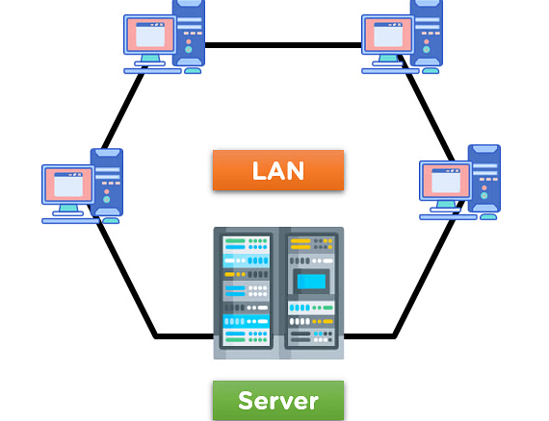

**MAN (Metropolitan Area Network)** : is a n/w type that covers the network connection of an entire city or connection of a small area. The area covered by the network is connected using a wired network, like data cables.

* N/w covers an entire town area or a portion of a city.
* Data transmission speed is relatively high due to the installation of optical cables and wired connections.

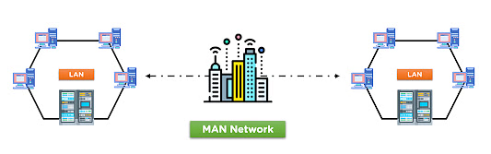

**WAN (Wide Area Network)** : the WAN is designed to connect devices over large distance like states or between countries. The connection is wireless in most cases and uses radio towers for communication.

* The speed of the WAN date transfer is lower than in comparison to LAN and MAN networks due to the large distance covered.
* The WAN network uses a satellite medium to transmit date between multiple locations and network towers.

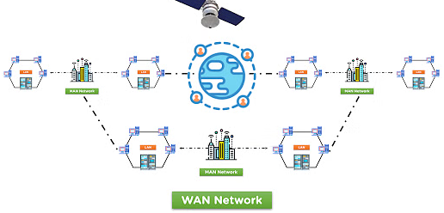

**Network Topology**: is the physical and logical arrangement of nodes and connections in a network.

* Nodes usually include devices such as switches, routers and software with switch and router features.
* Types of n/w topologies, Physical network topology, logic network topology.

Several network Topologies in physical are

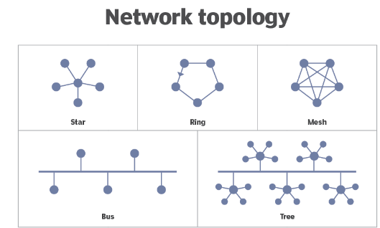

**Network Protocol**: are a set of rules outlining how connected devices communicate across a network to exchange information easily and safely.

Network Protocols Layers are/ OSI (Open Systems Interconnection)

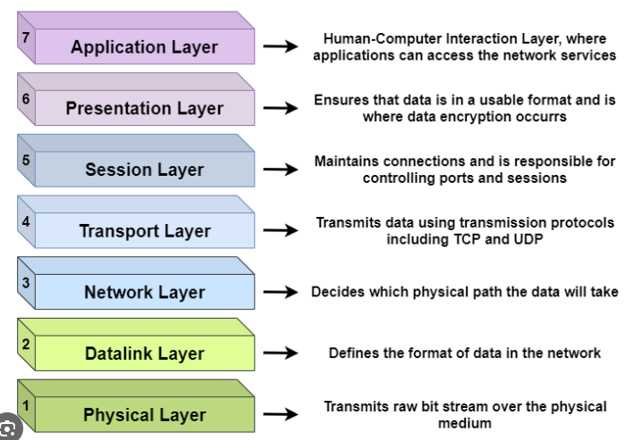

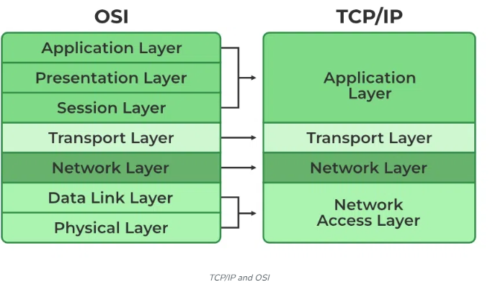

**IP Address and MAC Address** :

Both MAC and IP address are used to uniquely define a advice on the internet.

NIC Card’s Manufacturer provides the MAC address, on the other hand, Internet Service Provider provides IP Address.

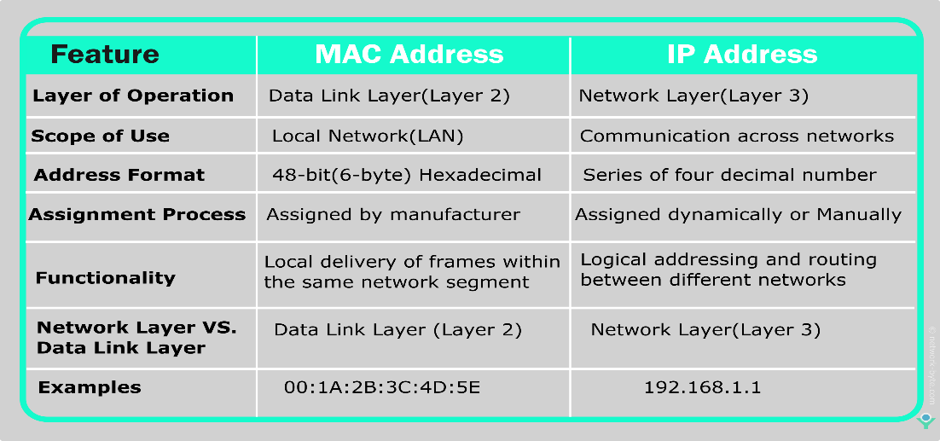

**Kernel**: The kernel is a computer program that is the core of a computer’s OS, with complete control over everything in the system.

**Shell Scripting**: It is command language interpreter that executes commands read from input devices such as keyboards or from files. The shell gets started when the user logs in or start the terminal.

Example:

#!/bin/bash

# example of using arguments to a script

echo "My first name is $1"

echo "My surname is $2"

echo "Total number of arguments is $#"

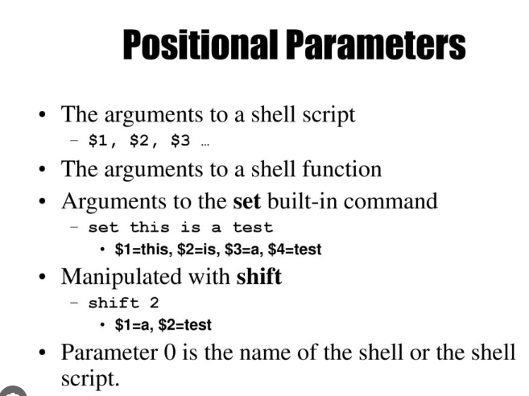

**File Redirection**: Redirection simply means capturing o/p from a file, cmd, prgrm, script or even code block within a script and sending it as i/p to another file, cmd, prgrm or script.

**Piping Command**: Is a form of redirection (transfer of standard output to some other destination) that is used in Linux and other Unix OS to send the output of one cmd/prgrm/process to another cmd/prgr/process for further processing.

Character of piping “|”.

**AWS – AMAZON WEB SERVICES**

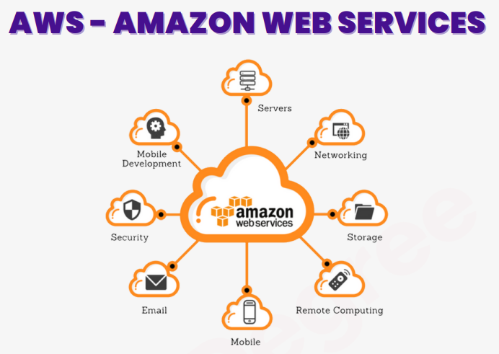

AWS is designed to allow application providers, ISV’s and vendors to quickly and securely host your application---- whether an existing application or a new SaaS-based application.

**Networking:**

VPC : Virtual Private Cloud:

VPC is a secure, isolated private cloud hosted within a public cloud. VPC customers can run code, store data, host websites and do anything else they cloud do in an ordinary private clous, but the private cloud is hosted remotely by a public cloud provider.

VPC supports :

VPCs per Region : 5

VPCs security group per Region : 2500

The difference b/w region and availability zone: region is a network boundary and availability zone is within a region.

**Subnet**: Is a range of IP address in our VPC./ Network inside a network.(table we will use)

200 subnet can create in VPC

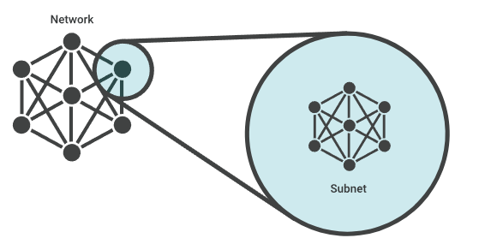

**CloudFront**: is a web service that gives businesses and web application developers an easy and cost effective way to distribute content with low latency and high data transfer speeds.

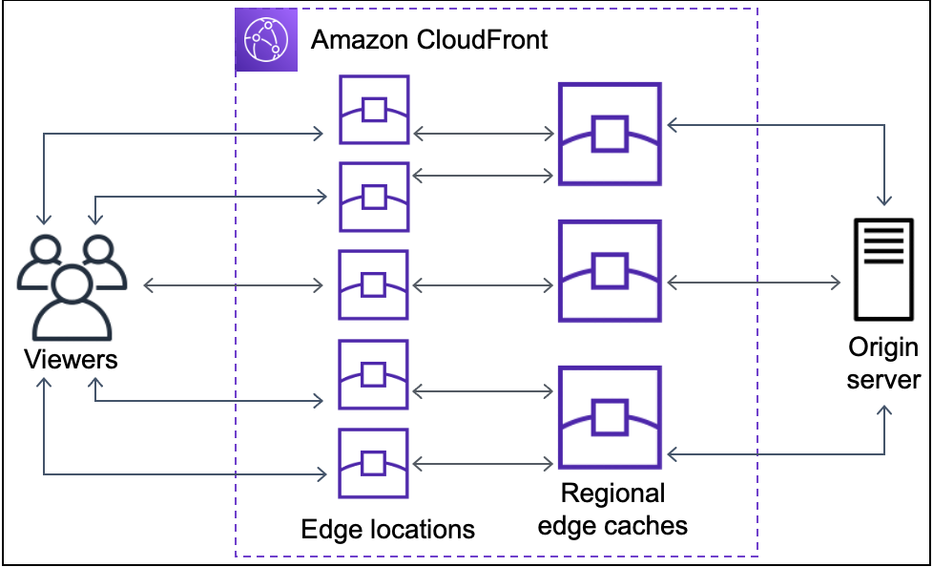

**Route 53**: Amazon Route 53 is a highly available and scalable Domain Name System(DNS) web service. We can use Route 53 to perform three main functions in any combination : Domain registration, DNS routing and Health checking.

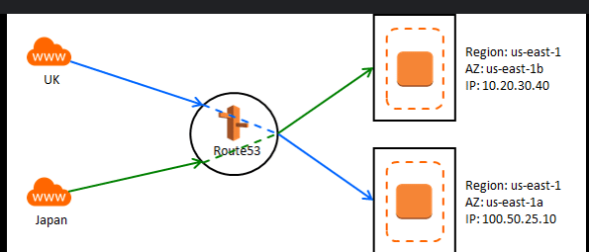

**S3: Simple Storage Service**: * is an object storage service that offers industry- leading scalability, data availability, security and performance. We can use Amazon S3 to store and retrieve any amount of data at any time, from anywhere.

>> S3 is an object storage service that stores data as objects within buckets. Up to 100 buckets we can create.

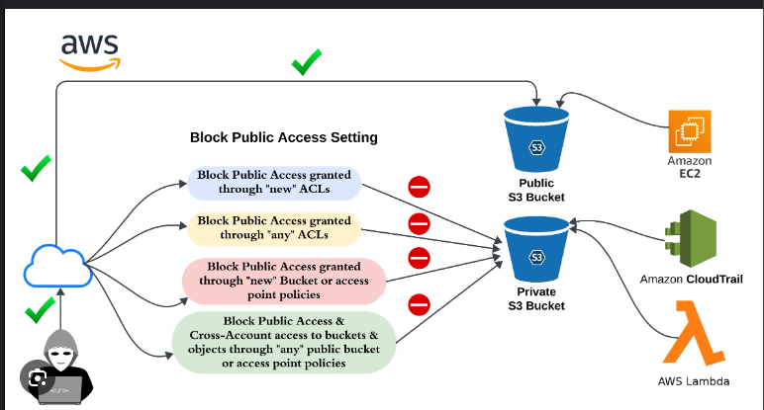

**Why we use S3:** Amazon S3 automatically creates & stores copies of all uploaded objects across multiple systems allowing your data to be protected against, error and threats and available when needed.

IP Classes.

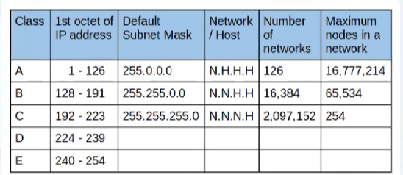

**Bucket**: is a container for objects. To store your data in Amazon S3, 1st create a bucket and specify a bucket name and AWS Region. Then, upload your data to that bucket as objects in Amazon S3. Each object has a key, which is the Unique Identifier for the object within the bucket.

**DevOps: Development and Operation:**

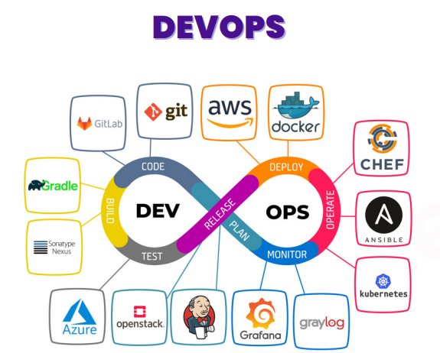

DevOps is an approach to working that emphasizes the quick, incremental and continuous delivery of products.

