**COMPSOFT TECHNOLOGIES**

Bengaluru, Karnataka, India



**AN**

**INTENSHIP PROJECT REPORT**

**ON**

“Made4You Pvt Ltd”

**Bachelor of Engineering**

**In**

**Computer Science and Engineering**

**Submitted by: Spoorthi R Subedar (1ME18CS062)**



**MS Engineering College**

**Department of Computer Science & Engineering**

**23-09-2021**

**TABLE OF CONTENTS**

Overview of the Project **3**

About **4**

Tools Used **5**

Implementation **6**

Snapshots **13**

Bibliography **16**

**OVERVIEW OF THE PROJECT**

In this Web-Development Project we were asked to make a webpage about the Made4You client.

Numerous tags including the paragraph tag, title tag, form tag, anchor tag, to name a few were used.

**HOME PAGE:**

A basic webpage showing information about Made4You was shown, with a creative background.

It describes about the client company Made4You and the services they provide.

**SERVICES :**

The next tab was about the services they provide. It had detailed description of the services provided by Made4You.

**CONTACT US:**

This page typically includes a form through which the user can try to contact the client for their queries. It has a submit button which takes to the next tab.

Further the HTML was customized in a creative way using CSS.

We indeed got a lot to learn from this project.

**ABOUT THE COMPANY**

M4Y is a digital service provider that aims to provide software,

designing and marketing solutions to individuals and

businesses.

At M4Y, it is believed that service and quality is the

key to success.

Founded and Funded by Graphic designers

from Jahirathu Junction, M4Y has now set a new path towards

Digital Solutions.

**Services Provided by M4Y group Pvt Ltd:**

**Development** - We develop responsive, functional and super-fast websites.

We keep User Experience in mind while creating websites.

A website should load quickly and should be accessible even on a small view-port and slow internet connection.

**Consultancy** - We are here to provide you with expert advice on your design and

development requirements.

**Videos** - We create a polished professional video that impresses your audience.

**TOOLS USED**

### Software Requirements

* Visual Studio Code 2019.
* Google Chrome or Microsoft Edge of latest version.
* Front End : HTML, CSS,JS(optional)
* Linux 7.1 or Windows XP/7/8/10 OS or Mac OS

### Hardware Requirements

* Pentium 200-MHz computer with a minimum of 64 MB of RAM (128 MB of RAM recommended).
* Monitor with a refresh rate of at least 40Hz for a smooth GUI experience (optional).

**IMPLEMENTATION**

<html>

    <head>

        <meta charset="utf-8">

        <title>M4Y</title>

        <link rel="stylesheet" type="text/css" href="styles.css">

        <link href="https://fonts.googleapis.com/icon?family=Material+Icons" rel="stylesheet">

        <link rel="stylesheet" href="https://fonts.googleapis.com/css?family=Sofia&effect=neon|outline|emboss|shadow-multiple">

    </head>

    <h1 class="font-effect-outline" style="text-align: center; color: rgb(248, 118, 112);"><u>MADE4YOU PVT LTD</u></h1>

    <div style="text-align: center";>

    <img src="C:\Users\Spoorthi\Desktop\ProjectFullStack\Made4You.png" height="20%" width="20%" alt="logo"><br>

    </div><br><br>

    <body>

        <div id="t1">

            <table border="0" width="100%" bgcolor:"white" height="8%">

                <tr>

                 <th width="20%"><font color="white" size="4"><a href="#"><span class="material-icons">

                     cottage

                     </span>HOME</a></font></th>

                     <th width="20%"><font color="white" size="4"><a href="services.html"><span class="material-icons">

                        miscellaneous_services

                        </span>SERVICES</a></font></th>

                 <th width="20%"><font color="white" size="4"><a href="contactus.html"><span class="material-icons">

                     contact_page

                     </span>CONTACT-US</a></font></th>

                 <th width="20%"><font color="white" size="4"><a href="#"><span class="material-icons">

                     feedback

                     </span>FEED-BACK</a></font></th>

                </tr>

            </table>

                </a>

            </div>

            <div id="p1">

                <p >M4Y is a digital service provider that aims to provide software,<br>

                designing and marketing solutions to individuals and

                businesses. At M4Y, it is believed that service and quality is the<br>

                key to success. Founded and Funded by Graphic designers

                from Jahirathu Junction, M4Y has now set a new path towards<br>

                Digital Solutions.</p></div>

        <div>

        <h2  style="text-align: center; color:rgb(45, 101, 105);"><u>Services We Provide</u></h2>

        </div>

        <div id="d1">

        <p style="text-align:center; color:rgba(99, 10, 10, 0.966);"><strong>1.Development</strong> </p><br>

        <p style="text-align:center; color: rgba(99, 10, 10, 0.966);"><strong>2.Consultancy</strong> </p><br>

        <p style="text-align:center; color: rgba(99, 10, 10, 0.966);"><strong>3.Videos</strong> </p>

        </div>

    </body>

</html>

<html>

    <head>

        <meta charset="utf-8">

        <title>services</title>

        <link rel="stylesheet" type="text/css" href="styles1.css">

        <link href="https://fonts.googleapis.com/icon?family=Material+Icons" rel="stylesheet">

        <link rel="stylesheet" href="https://fonts.googleapis.com/css?family=Sofia&effect=neon|outline|emboss|shadow-multiple">

        <h1 class="font-effect-outline" style="color: rgb(241, 149, 144);"><u>SERVICES PROVIDED</u></h1>

    </head>

    <body>

        <div>

            <table border="0" width="100%" bgcolor:"white" height="8%">

                <tr>

                 <th width="20%"><font color="white" size="4"><a href="Home.html"><span class="material-icons">

                     cottage

                     </span>HOME</a></font></th>

                     <th width="20%"><font color="white" size="4"><a href="contactus.html"><span class="material-icons">

                        contact_page

                        </span>CONTACT-US</a></font></th>

                    </tr>

                </table>

                    </a>

                </div>

    <div  style="text-align: center;">

        <p><strong><u>DEVELOPMENT</u></strong></p>

        <img src ="https://previews.123rf.com/images/mindscanner/mindscanner1709/mindscanner170900066/85497683-word-cloud-with-talent-development-related-tags.jpg" style="width: 40%;

        height: 50%;">

        <p style="color: rgb(73, 214, 73); font-weight: bold;" >We develop responsive, functional and super-fast websites.

            We keep User Experience in mind while creating websites. <br>A website should load

            quickly and should be accessible even on a small view-port and slow internet

            connection.</p><br>

            </div>

            <div style="text-align: center;">

                <p><strong><u>CONSULTANCY</u></strong></p>

                <img src="https://indipe.in/wp-content/uploads/2020/07/Contact-Us-Indipe.jpg" style="width: 40%; height: 50%;">

                <p style="color: blue; font-weight: bold;">We are here to provide you with expert advice on your design and

                    development requirements.</p><br>

            </div>

            <div style="text-align: center;">

                <p><strong><u>VIDEOS</u></strong></p>

                <img src="https://image.shutterstock.com/image-vector/modern-video-player-design-template-260nw-762468283.jpg" style="width: 40%; height: 50%;">

                <p style="color: brown; font-weight: bold;">We create a polished professional video that impresses your audience.</p>

            </div>

        </body>

</html>

<html>

    <head>

        <meta charset="utf-8">

        <title>need help?</title>

        <link href="https://fonts.googleapis.com/icon?family=Material+Icons" rel="stylesheet">

        <link rel="stylesheet" href="https://fonts.googleapis.com/css?family=Sofia&effect=neon|outline|emboss|shadow-multiple">

        <h1 class="font-effect-outline" style="text-align: center; color: rgb(248, 118, 112);"><u>CONTACT US</u></h1><br>

    </head>

    <body style="background:url(https://www.pngkit.com/png/detail/816-8165708_contact-us-vignette-white-background-hd.png);

    background-size:cover;">

        <div style="text-align:center; font-style:italic; font-weight:bold; font-style:large; ">

        <p>Feel free to contact us in case of any queries. We would love to hear from you.<br>

        We will get back to you as early as possible.</p>

    </div>

        <div>

            <table border="0" width="100%" bgcolor:"white" height="8%">

                <tr>

                 <th width="20%"><font color="white" size="4"><a href="Home.html"><span class="material-icons">

                     cottage

                     </span>HOME</a></font></th>

                     <th width="20%"><font color="white" size="4"><a href="services.html"><span class="material-icons">

                        miscellaneous_services

                        </span>SERVICES</a></font></th>

                    </tr>

                </table>

                    </a>

                </div>

                <div style="text-align: center; color: coral;">

                <form style="color: darkcyan;">

                <span class="material-icons">

                    person

                    </span><input type="text"placeholder="Name"><br><br>

                        <span class="material-icons">

                            dialpad

                            </span><input type="number"placeholder="Contact Number"><br><br>

                            <span class="material-icons">

                                school

                                </span><input type="text"placeholder="Organization"><br><br>

                                <span class="material-icons">

                                    email

                                    </span><input type="varchar"placeholder="Email"><br><br>

                                <span class="material-icons">

                                    location_on

                                    </span><input type="text"placeholder="City"><br><br>

                                    <span class="material-icons">

                                        library_books

                                        </span><input type="text"placeholder="Enter Your Message Here"><br><br>

                </form>

                <a href="thanku.html">

                    <button>SUBMIT</button>

                    </a>

                </div>

    </body>

</html>

<html>

    <head>

        <meta charset="utf-8">

        <title>Thankyou</title>

    </head>

    <body style="background:url(https://wallpapercave.com/wp/wp3315704.jpg);

    background-size:cover;">

    <div style="text-align:center; font-weight: bold; font-size: large; font-style:italic;">

        <p>Thank You for contacting us.!!</p>

    <p>We would get back to you as soon as possible.!!</p>

    </div>

    </body>

</html>

<html>

    <head>

        <meta charset="utf-8">

        <title>Thankyou</title>

    </head>

    <body style="background:url(https://wallpapercave.com/wp/wp3315704.jpg);

    background-size:cover;">

    <div style="text-align:center; font-weight: bold; font-size: large; font-style:italic;">

        <p>Thank You for contacting us.!!</p>

    <p>We would get back to you as soon as possible.!!</p>

    </div>

    </body>

</html>

body{

    background: url(https://images.unsplash.com/uploads/141103282695035fa1380/95cdfeef?ixid=MnwxMjA3fDB8MHxzZWFyY2h8MXx8d2Vic2l0ZSUyMGhlYWRlcnxlbnwwfHwwfHw%3D&ixlib=rb-1.2.1&w=1000&q=80);

    background-size: cover;

}

#p1{

    text-align: center;

    font-weight: bold;

    font-size: large;

    font-style: italic;

    color: rgb(247, 168, 78);

}

h1{

    color: rgb(204, 140, 21);

}

h2{

    color: black;

}

#d1{

    font-style: italic;

    font-size:large;

}

#t1{

    color: chartreuse;

}

h1{

    color: rgb(248, 20, 8);

    text-align: center;

}

p{

    font-size: large;

}

**SNAPSHOTS**

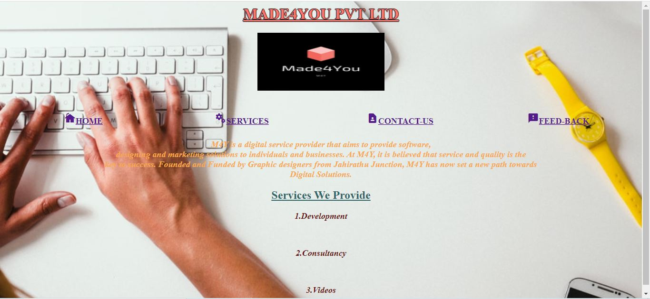

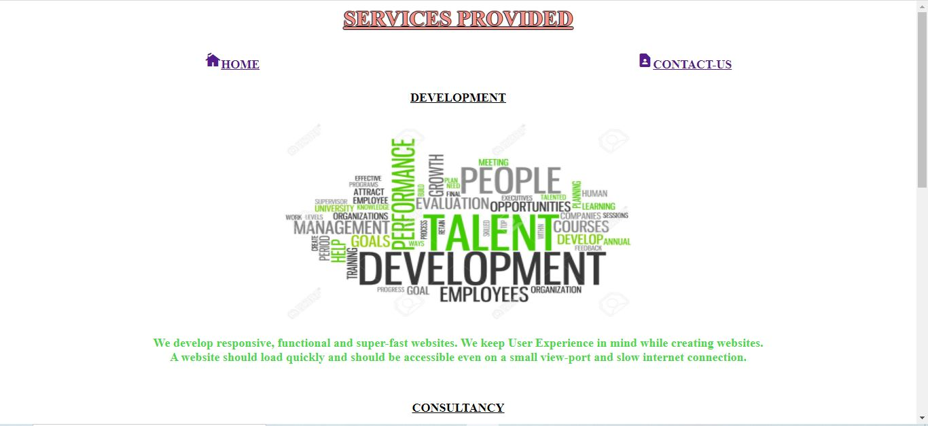

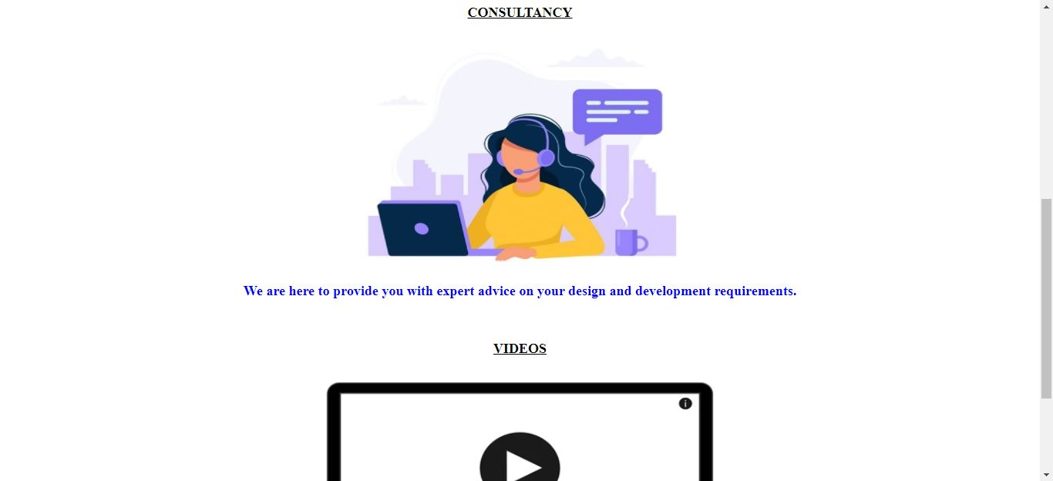

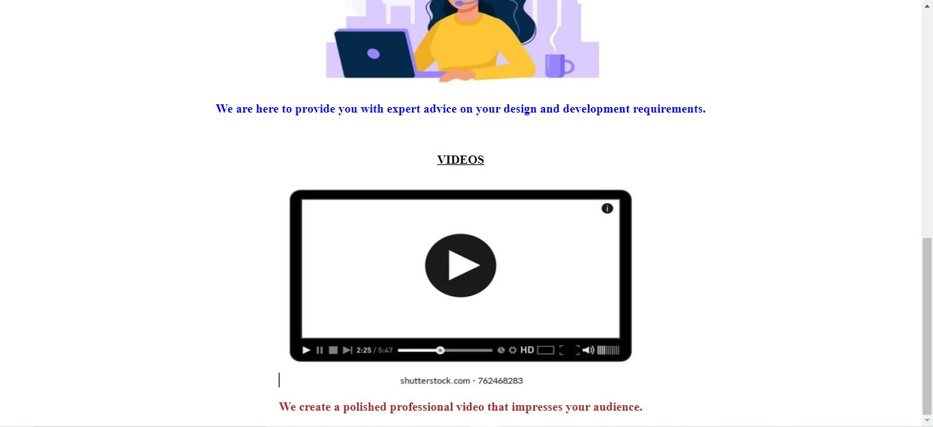

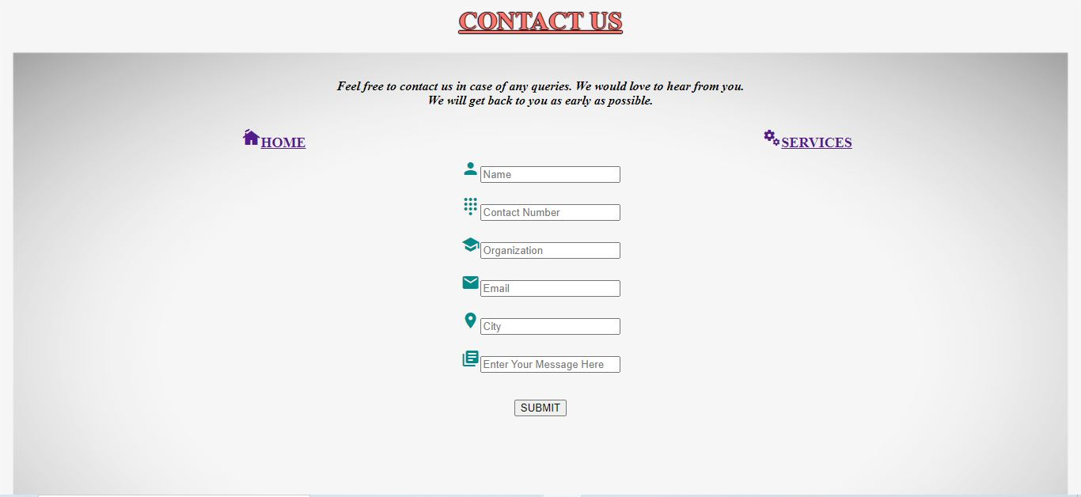

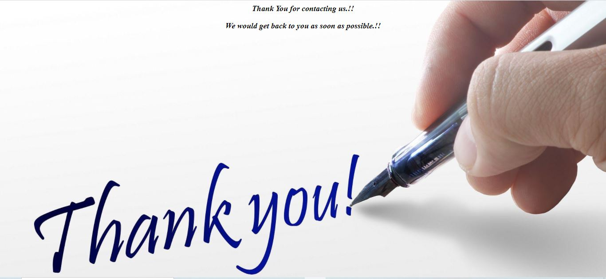

**LOGO**



**BIBLIOGRAPHY**

* https://[www.w3schools.com](http://www.w3schools.com/)
* https://[www.geeksforgeeks.org](http://www.geeksforgeeks.org/)
* https://freefrontend.com

**About My Team**

**Ghanavi TN** - HTML and page layout

**Spoorthi R Subedar –** HTML, CSS and Designing

**Priya** - Report

**THANK YOU**