**Design Principles and Patterns**

**Exercise 1: Implementing the Singleton Pattern**

public class Logger {

private static Logger instance;

private Logger() {

System.out.println("Logger instance created.");

}

public static Logger getInstance() {

if (instance == null) {

instance = new Logger();

}

return instance;

}

public void log(String message) {

System.out.println("Log: " + message);

}

}

public class Main {

public static void main(String[] args) {

Logger logger1 = Logger.getInstance();

Logger logger2 = Logger.getInstance();

logger1.log("First log message.");

logger2.log("Second log message.");

if (logger1 == logger2) {

System.out.println("Both logger instances are the same (Singleton works).");

} else {

System.out.println("Logger instances are different (Singleton failed).");

}

}

}

**OUTPUT :**

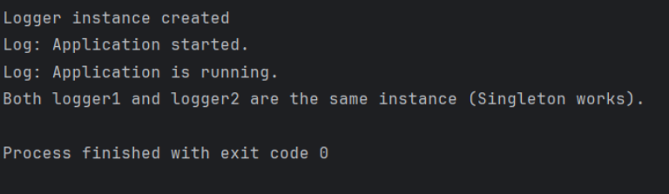

**Exercise 2: Implementing the Factory Method Pattern**

**// Document.java**

interface Document {

void open();

}

**// WordDocument.java**

class WordDocument implements Document {

public void open() {

System.out.println("Opening Word Document...");

}

}

**// PdfDocument.java**

class PdfDocument implements Document {

public void open() {

System.out.println("Opening PDF Document...");

}

}

**// ExcelDocument.java**

class ExcelDocument implements Document {

public void open() {

System.out.println("Opening Excel Document...");

}

}

**// DocumentFactory.java**

abstract class DocumentFactory {

public abstract Document createDocument();

}

**// WordFactory.java**

class WordFactory extends DocumentFactory {

public Document createDocument() {

return new WordDocument();

}

}

**// PdfFactory.java**

class PdfFactory extends DocumentFactory {

public Document createDocument() {

return new PdfDocument();

}

}

**// ExcelFactory.java**

class ExcelFactory extends DocumentFactory {

public Document createDocument() {

return new ExcelDocument();

}

}

**// Main.java**

public class Main {

public static void main(String[] args) {

DocumentFactory wordFactory = new WordFactory();

Document wordDoc = wordFactory.createDocument();

wordDoc.open();

DocumentFactory pdfFactory = new PdfFactory();

Document pdfDoc = pdfFactory.createDocument();

pdfDoc.open();

DocumentFactory excelFactory = new ExcelFactory();

Document excelDoc = excelFactory.createDocument();

excelDoc.open();

}

}

**OUTPUT :**

