**TDD using JUnit5 and Mockito**

**JUnit_Basic Testing Exercises**

**Exercise 1: Setting Up Junit**

**//Test3.java**

package com.settingUp.junit;

import static org.junit.jupiter.api.Assertions.*;

import org.junit.jupiter.api.Test;

public class Test3 {

@Test

public void testAssertions() {

// Assert equals

assertEquals(5, 2 + 3);

// Assert true

assertTrue(5 > 3);

// Assert false

assertFalse(5 < 3);

// Assert null

assertNull(null);

// Assert not null

assertNotNull(new Object());

}

}

**//pom.xml**

<project xmlns="http://maven.apache.org/POM/4.0.0"

xmlns:xsi="http://www.w3.org/2001/XMLSchema-instance"

xsi:schemaLocation="http://maven.apache.org/POM/4.0.0 https://maven.apache.org/xsd/maven-4.0.0.xsd">

<modelVersion>4.0.0</modelVersion>

<groupId>SettingJUnit</groupId>

<artifactId>SJUnit</artifactId>

<version>0.0.1-SNAPSHOT</version>

<dependencies>

<!-- JUnit Jupiter (API + Engine) -->

<dependency>

<groupId>org.junit.jupiter</groupId>

<artifactId>junit-jupiter</artifactId>

<version>5.9.3</version>

<scope>test</scope>

</dependency>

</dependencies>

<build>

<plugins>

<!-- Correct Surefire Plugin version to support JUnit 5 -->

<plugin>

<groupId>org.apache.maven.plugins</groupId>

<artifactId>maven-surefire-plugin</artifactId>

<version>3.0.0-M9</version>

</plugin>

</plugins>

</build> </project>

**OUTPUT :**

**JUnit Test:**

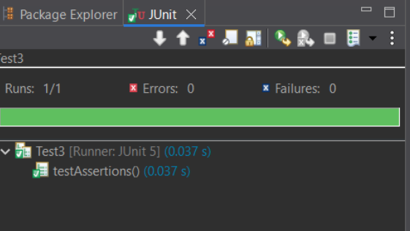

**Maven Test:**

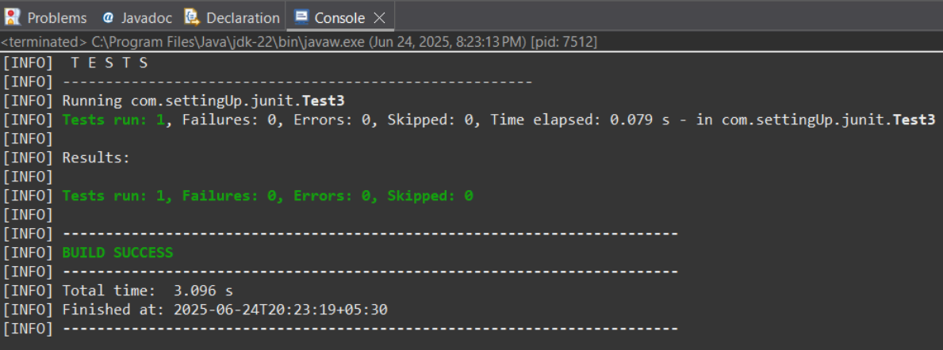

**Exercise 3: Assertions in JUnit**

**//Assertion.java**

package com.AssertionInJUnit.junit;

import org.junit.jupiter.api.Test; // Required to mark the method as a test

import static org.junit.jupiter.api.Assertions.*;

public class Assertion {

@Test

public void testAssertions() {

// Assert equals

assertEquals(5, 2 + 3);

// Assert true

assertTrue(5 > 3);

// Assert false

assertFalse(5 < 3);

// Assert null

assertNull(null);

// Assert not null

assertNotNull(new Object());

}

}

**//pom.xml**

<project xmlns="http://maven.apache.org/POM/4.0.0"

xmlns:xsi="http://www.w3.org/2001/XMLSchema-instance"

xsi:schemaLocation="http://maven.apache.org/POM/4.0.0 https://maven.apache.org/xsd/maven-4.0.0.xsd">

<modelVersion>4.0.0</modelVersion>

<groupId>sudeep</groupId>

<artifactId>AssertionInJUnit</artifactId>

<version>0.0.1-SNAPSHOT</version>

<dependencies>

<!-- JUnit Jupiter (API + Engine) -->

<dependency>

<groupId>org.junit.jupiter</groupId>

<artifactId>junit-jupiter</artifactId>

<version>5.9.3</version>

<scope>test</scope>

</dependency>

</dependencies>

<build>

<plugins>

<!-- Correct Surefire Plugin version to support JUnit 5 -->

<plugin>

<groupId>org.apache.maven.plugins</groupId>

<artifactId>maven-surefire-plugin</artifactId>

<version>3.0.0-M9</version>

</plugin>

</plugins>

</build>

</project>

**OUTPUT:**

**Junit Test:**

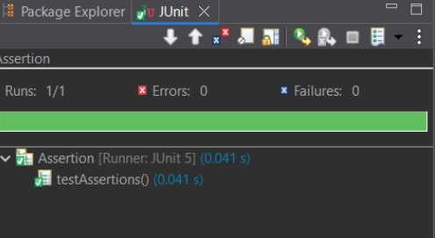

**Maven Test:**

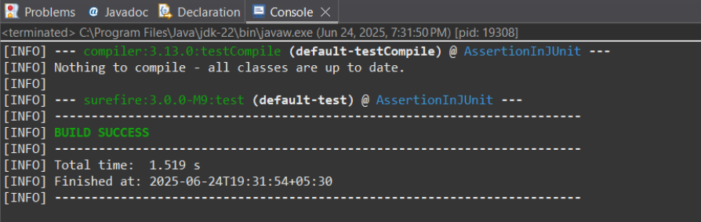

**Exercise 4: Arrange-Act-Assert (AAA) Pattern, Test Fixtures, Setup and Teardown Methods in Junit**

**//Calculator.java**

package com.AAA.patterns;

public class Calculator {

public int add(int a, int b) {

return a + b;

}

public int subtract(int a, int b) {

return a - b;

}

}

**//CalculatorTest.java**

package com.AAA.patterns;

import org.junit.jupiter.api.*; // JUnit 5 imports

import static org.junit.jupiter.api.Assertions.*; // JUnit 5 assert

public class CalculatorTest {

private Calculator calculator;

@BeforeEach

void setUp() {

calculator = new Calculator();

System.out.println("Setup complete.");

}

@AfterEach

void tearDown() {

calculator = null;

System.out.println("Teardown complete.");

}

@Test

void testAddition() {

// Arrange

int a = 10;

int b = 5;

// Act

int result = calculator.add(a, b);

// Assert

assertEquals(15, result);

}

@Test

void testSubtraction() {

// Arrange

int a = 10;

int b = 3;

// Act

int result = calculator.subtract(a, b);

// Assert

assertEquals(7, result);

}

}

**//pom.xml**

<project xmlns="http://maven.apache.org/POM/4.0.0"

xmlns:xsi="http://www.w3.org/2001/XMLSchema-instance"

xsi:schemaLocation="http://maven.apache.org/POM/4.0.0 https://maven.apache.org/xsd/maven-4.0.0.xsd">

<modelVersion>4.0.0</modelVersion>

<groupId>AAA</groupId>

<artifactId>AAA_Pattern</artifactId>

<version>0.0.1-SNAPSHOT</version>

<dependencies>

<!-- JUnit Jupiter (API + Engine) -->

<dependency>

<groupId>org.junit.jupiter</groupId>

<artifactId>junit-jupiter</artifactId>

<version>5.9.3</version>

<scope>test</scope>

</dependency>

</dependencies>

<build>

<plugins>

<!-- Correct Surefire Plugin version to support JUnit 5 -->

<plugin>

<groupId>org.apache.maven.plugins</groupId>

<artifactId>maven-surefire-plugin</artifactId>

<version>3.0.0-M9</version>

</plugin>

</plugins>

</build>

</project>

**OUTPUT:**

**Junit Test:**

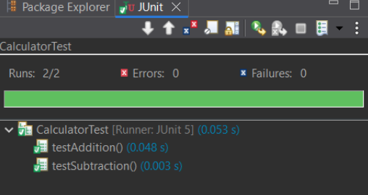

**Maven Test for CalculatorTest:**

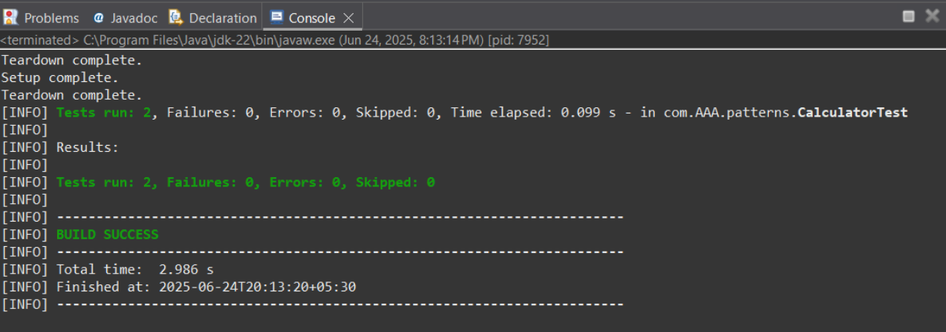

**Maven Test for Calculator:**

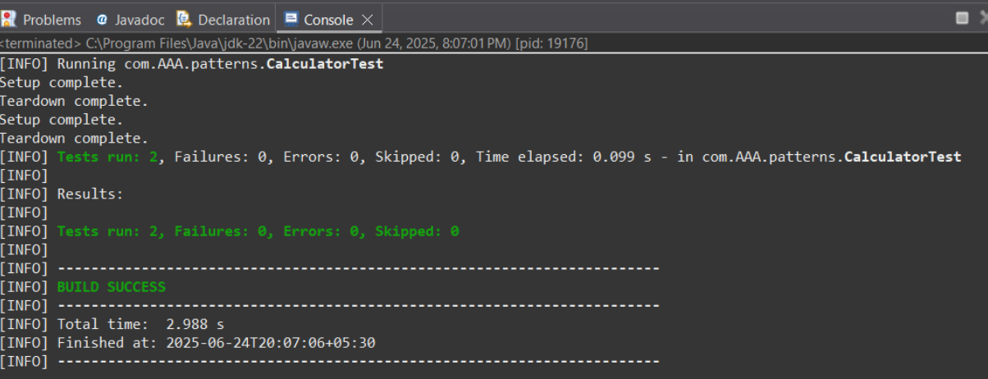

**Pom.xml:**

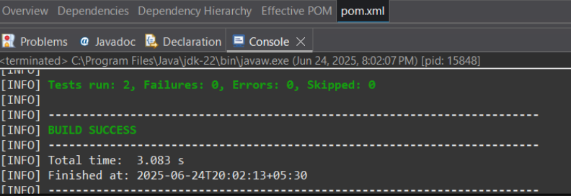

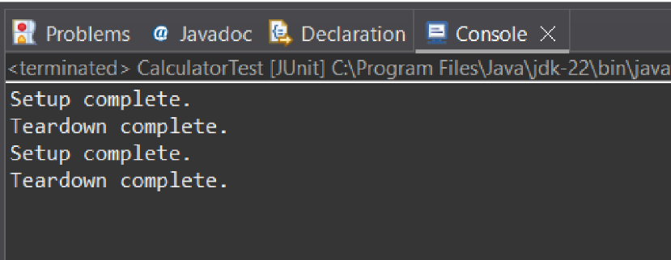

**Mockito exercises**

**Exercise 1: Mocking and Stubbing**

**//ExternalApi.java**

package com.mockito.stubbing;

public interface ExternalApi {

String getData();

String getData1();

}

**//MyService.java**

package com.mockito.stubbing;

// Service that uses ExternalApi

public class MyService {

private ExternalApi api;

public MyService(ExternalApi api) {

this.api = api;

}

public String fetchData() {

return api.getData();

}

}

**//TestCase.java**

package com.mockito.stubbing;

// Needed for assertEquals

import static org.junit.jupiter.api.Assertions.*;

import static org.mockito.Mockito.*;

import org.junit.jupiter.api.Test;

import org.mockito.Mockito;

// Test class

public class TestCase {

@Test

public void testExternalApi() {

// Create a mock for the ExternalApi

ExternalApi mockApi = Mockito.mock(ExternalApi.class);

// Stub the getData() method

when(mockApi.getData()).thenReturn("Mock Data");

// Inject mock into MyService

MyService service = new MyService(mockApi);

// Call the method under test

String result = service.fetchData();

// Assert the result

assertEquals("Mock Data", result);

}

}

**//pom.xml**

<project xmlns="http://maven.apache.org/POM/4.0.0"

xmlns:xsi="http://www.w3.org/2001/XMLSchema-instance"

xsi:schemaLocation="http://maven.apache.org/POM/4.0.0 https://maven.apache.org/xsd/maven-4.0.0.xsd">

<modelVersion>4.0.0</modelVersion>

<groupId>TDDMockito</groupId>

<artifactId>mockito</artifactId>

<version>0.0.1-SNAPSHOT</version>

<properties>

<maven.compiler.source>11</maven.compiler.source>

<maven.compiler.target>11</maven.compiler.target>

<project.build.sourceEncoding>UTF-8</project.build.sourceEncoding>

<junit.jupiter.version>5.10.0</junit.jupiter.version>

<mockito.version>5.11.0</mockito.version>

<surefire.version>3.2.3</surefire.version> <!-- Updated surefire version -->

</properties>

<dependencies>

<!-- JUnit 5 -->

<dependency>

<groupId>org.junit.jupiter</groupId>

<artifactId>junit-jupiter</artifactId>

<version>${junit.jupiter.version}</version>

<scope>test</scope>

</dependency>

<!-- Mockito Core -->

<dependency>

<groupId>org.mockito</groupId>

<artifactId>mockito-core</artifactId>

<version>${mockito.version}</version>

<scope>test</scope>

</dependency>

<!-- Mockito JUnit 5 integration -->

<dependency>

<groupId>org.mockito</groupId>

<artifactId>mockito-junit-jupiter</artifactId>

<version>${mockito.version}</version>

<scope>test</scope>

</dependency>

<!-- Add ByteBuddy dependency for Mockito's modern mocking -->

<dependency>

<groupId>net.bytebuddy</groupId>

<artifactId>byte-buddy</artifactId>

<version>1.14.9</version>

<scope>test</scope>

</dependency>

</dependencies>

<build>

<plugins>

<!-- Updated Maven Surefire Plugin configuration -->

<plugin>

<groupId>org.apache.maven.plugins</groupId>

<artifactId>maven-surefire-plugin</artifactId>

<version>${surefire.version}</version>

<configuration>

<argLine>

--add-opens java.base/java.lang=ALL-UNNAMED

--add-opens java.base/java.util=ALL-UNNAMED

</argLine>

</configuration>

</plugin>

<!-- Add Maven Compiler Plugin for explicit configuration -->

<plugin>

<groupId>org.apache.maven.plugins</groupId>

<artifactId>maven-compiler-plugin</artifactId>

<version>3.11.0</version>

<configuration>

<release>11</release>

</configuration>

</plugin>

</plugins>

</build>

</project>

**OUTPUT:**

**JUnit for TestCase:**

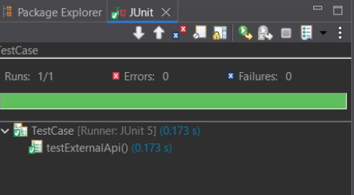

**Maven Test for ExternalApi:**

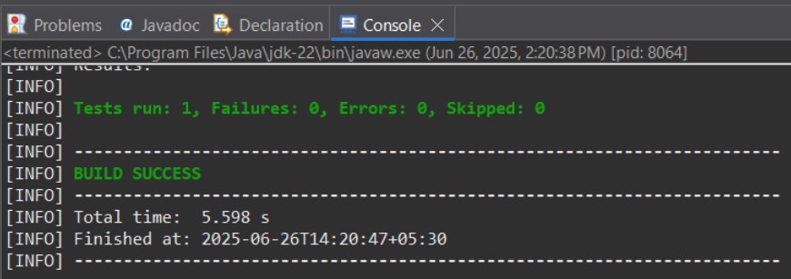

**Maven Test for MyService:**

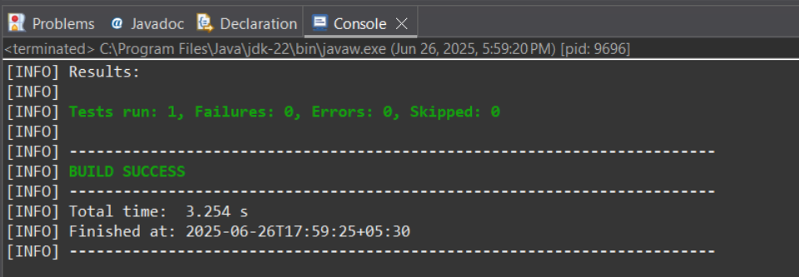

**Maven Test for TestCase:**

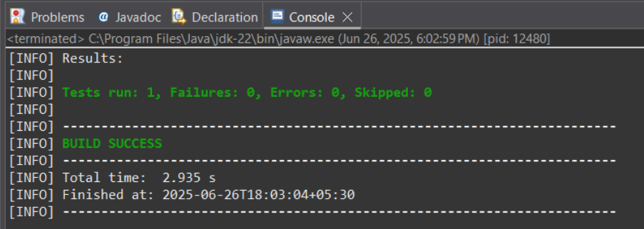

**Pom.xml**

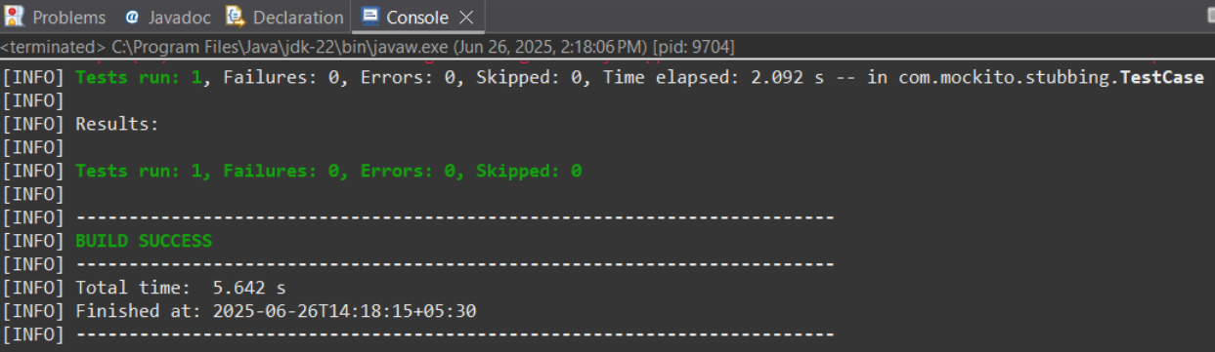

**Exercise 2: Verifying Interactions**

**//DataUploader.java**

package com.mockito;

public class DataUploader {

private final NetworkClient client;

public DataUploader(NetworkClient client) {

this.client = client;

}

public void performUpload() {

client.upload("TestPayload");

}

}

**//NetworkClient.java**

package com.mockito;

public interface NetworkClient {

void upload(String payload);

}

**//TestDataUploader.java**

package com.mockito;

import static org.mockito.Mockito.*;

import org.junit.jupiter.api.Test;

import org.mockito.Mockito;

public class TestDataUploader {

@Test

public void testUploadCalledWithCorrectArgument() {

// Step 1: Create mock

NetworkClient mockClient = Mockito.mock(NetworkClient.class);

// Step 2: Call method with specific argument

DataUploader uploader = new DataUploader(mockClient);

uploader.performUpload();

// Step 3: Verify interaction

verify(mockClient).upload("TestPayload");

}

}

**//pom.xml**

<project xmlns="http://maven.apache.org/POM/4.0.0"

xmlns:xsi="http://www.w3.org/2001/XMLSchema-instance"

xsi:schemaLocation="http://maven.apache.org/POM/4.0.0 https://maven.apache.org/xsd/maven-4.0.0.xsd">

<modelVersion>4.0.0</modelVersion>

<groupId>Verify</groupId>

<artifactId>VerifyingInteractions</artifactId>

<version>0.0.1-SNAPSHOT</version>

<dependencies>

<!-- JUnit 5 (Jupiter) for testing -->

<dependency>

<groupId>org.junit.jupiter</groupId>

<artifactId>junit-jupiter</artifactId>

<version>5.10.0</version>

<scope>test</scope>

</dependency>

<!-- Mockito core library -->

<dependency>

<groupId>org.mockito</groupId>

<artifactId>mockito-core</artifactId>

<version>5.11.0</version>

<scope>test</scope>

</dependency>

</dependencies>

<build>

<plugins>

<!-- Maven Surefire Plugin to run JUnit 5 tests -->

<plugin>

<groupId>org.apache.maven.plugins</groupId>

<artifactId>maven-surefire-plugin</artifactId>

<version>3.2.5</version>

<configuration>

<useModulePath>false</useModulePath>

</configuration>

</plugin>

</plugins>

</build>

</project>

**OUTPUT :**

**JUnit test for TestDataUploader:**

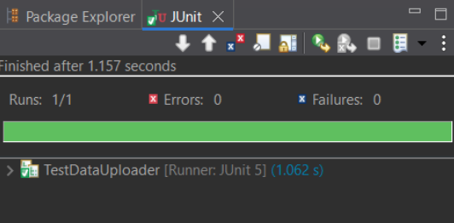

**Maven Test for DataUploader:**

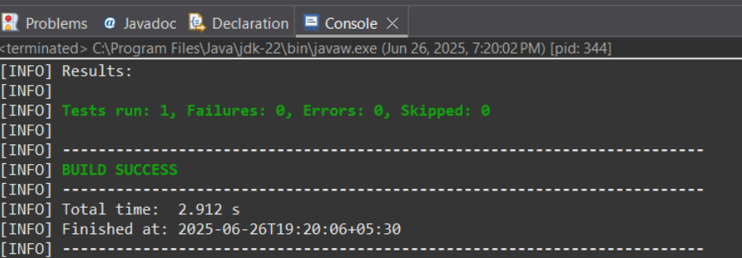

**Maven Test for NetworkClient:**

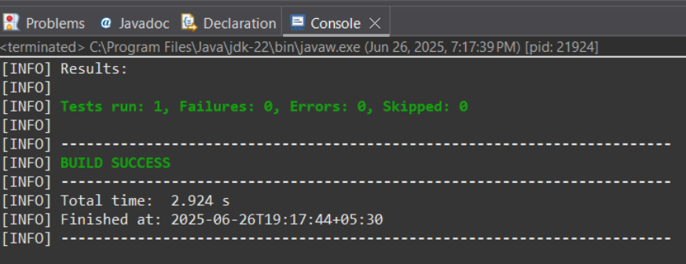

**Maven Test for TestDataUploader:**

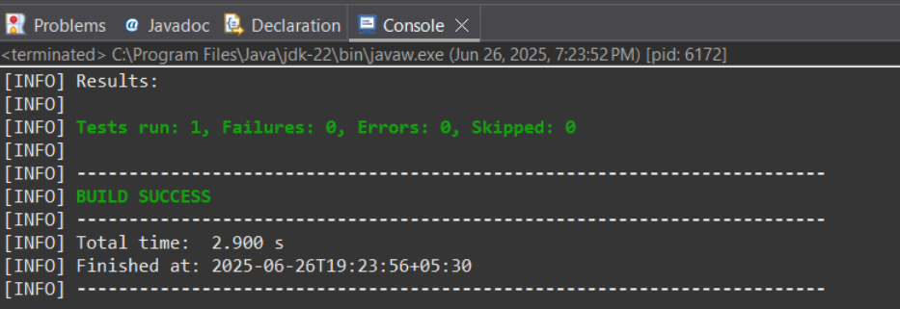

**Pom.xml:**

