Accident Application

To run project double click on ‘run.bat’ file to get below screen

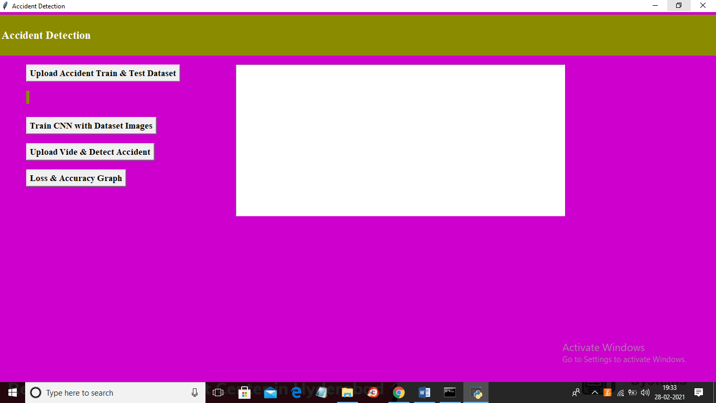

In above screen click on ‘Upload Accident Train & Test Dataset’ button to load dataset

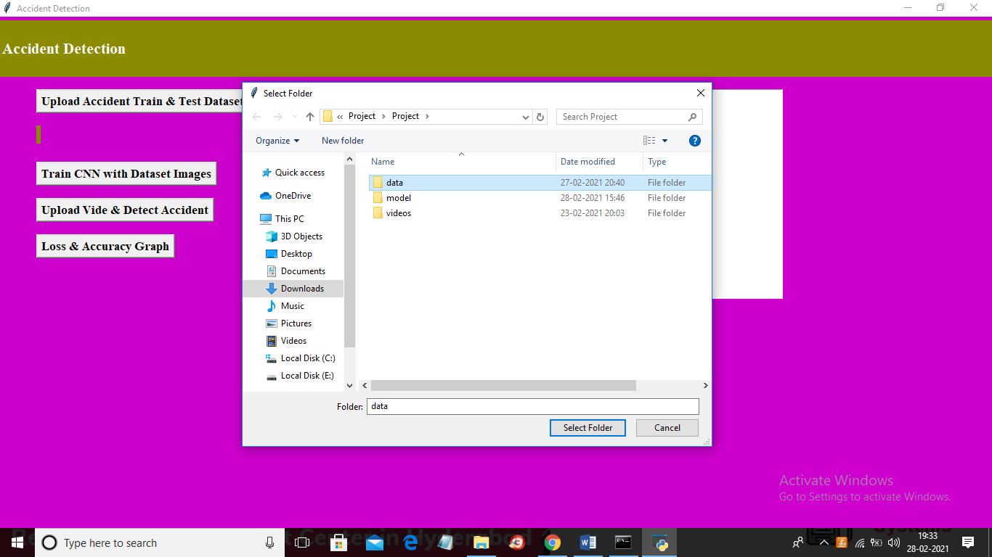

In above screen selecting and uploading ‘data’ folder and then click on ‘Select Folder’ button to load dataset and to get below screen

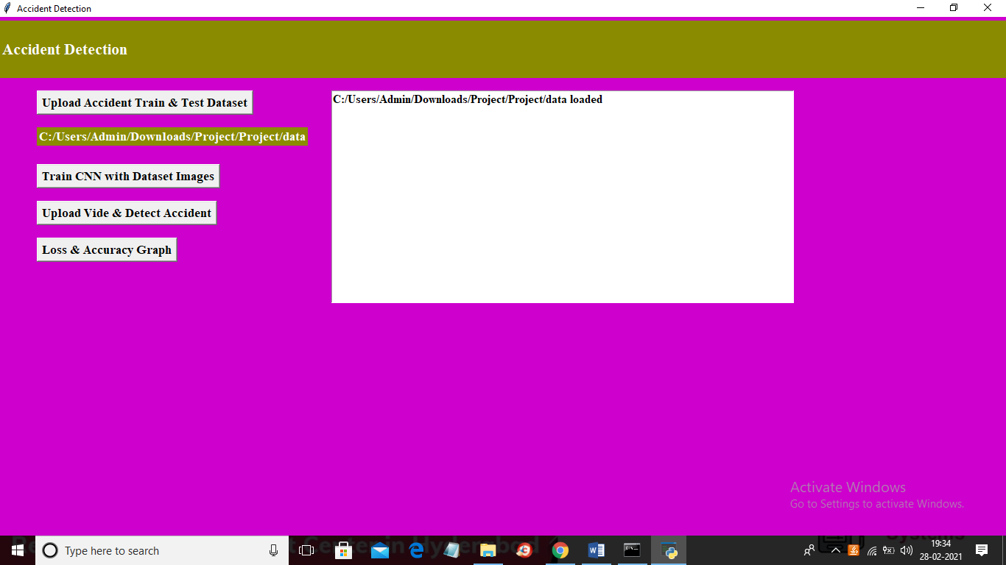

In above screen dataset loaded and now click on ‘Train CNN with Dataset Image’ button to train dataset with CNN and to get below screen

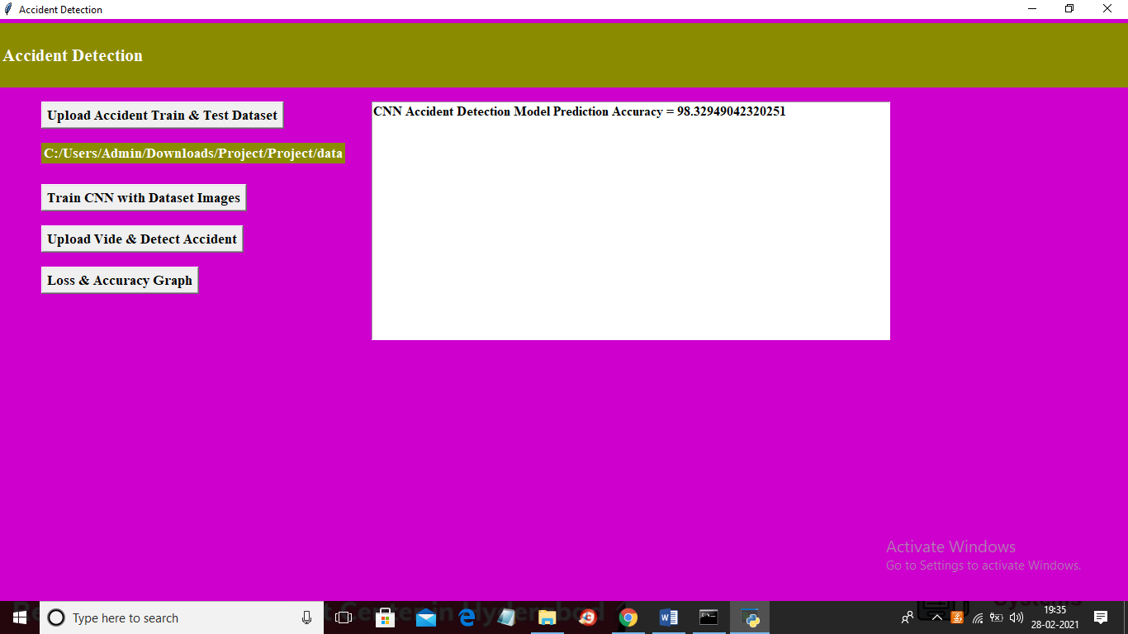

In above screen CNN model generated with prediction accuracy as 98.32% and now model generated and now click on ‘Upload Video & Detect Accident’ button to upload video and to get below screen

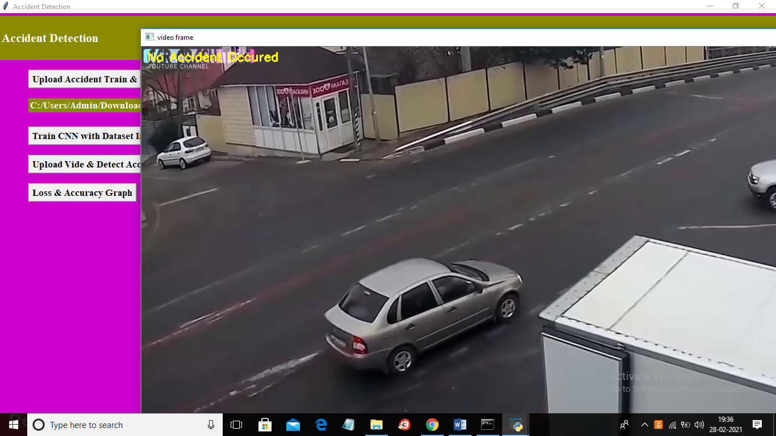

In above screen in yellow colour text application display predicted result as ‘No Accident Occurred’ and now when video play further then will get below screen

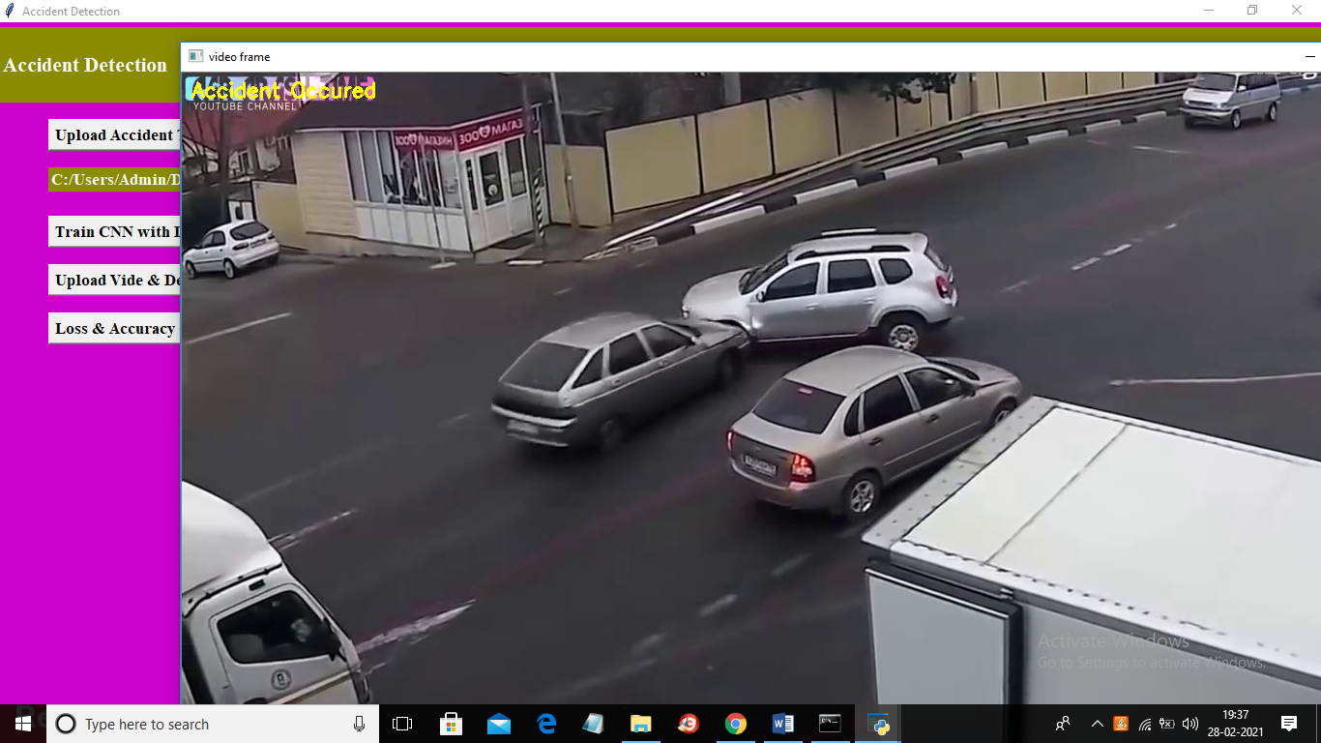

In above screen when accident occurred then beep sound generated and display prediction result as ‘Accident Occurred’

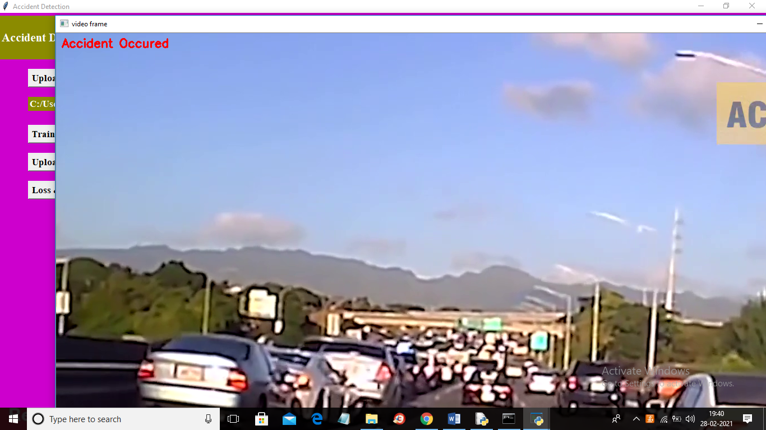

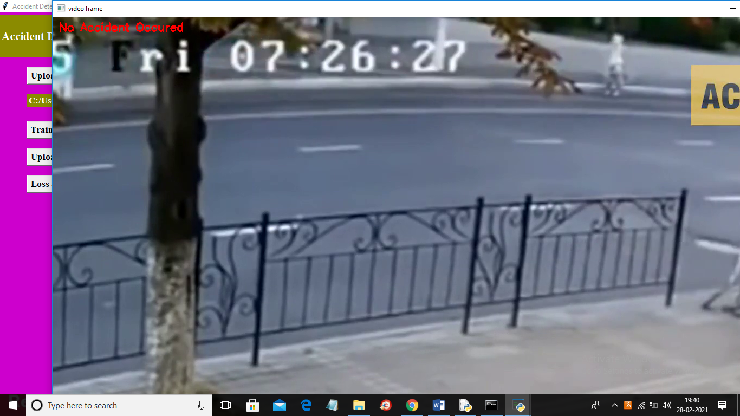

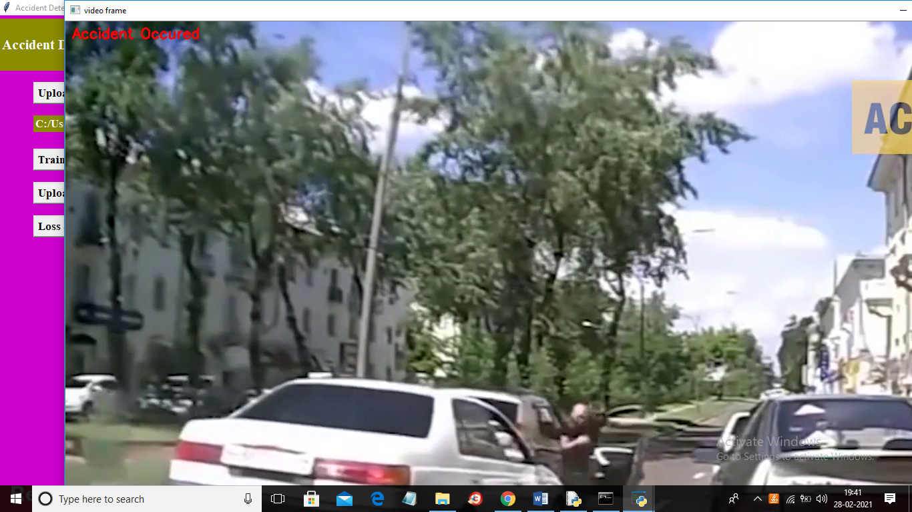

As this is computer program so its detection result will not be 100% as this is normal processing computer and if in image accident happened with fast speed then application will not detect such accident due to laptop normal processing speed