Brains.
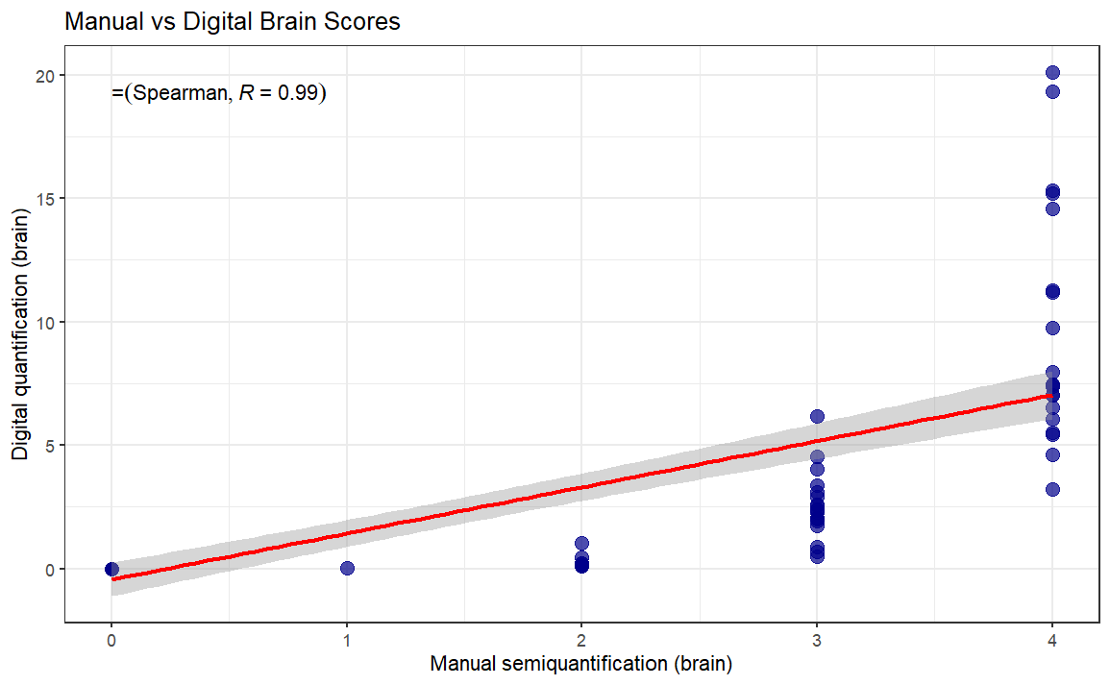

Brains stratified.
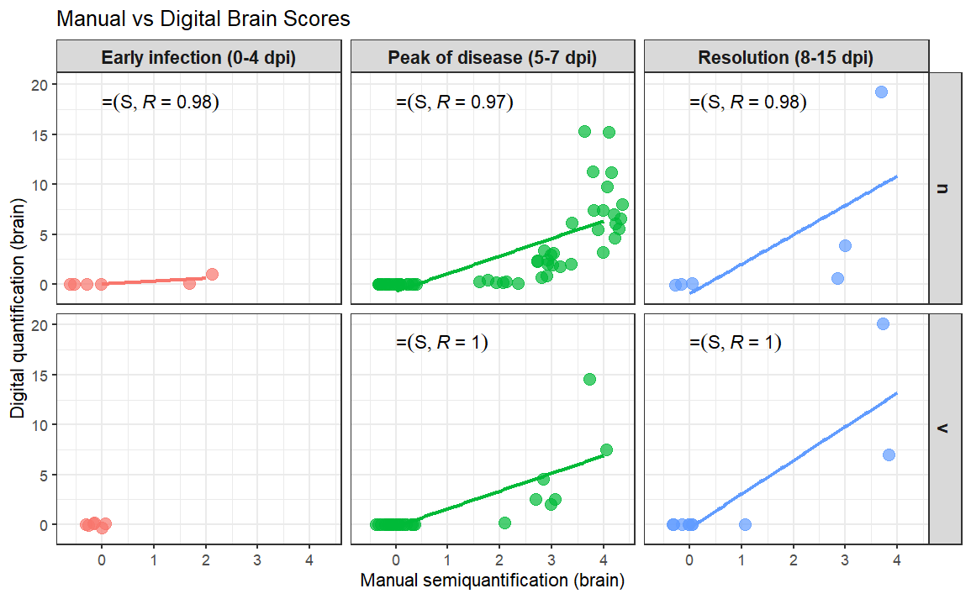

Brains and other parameters.

CCC BRAINS Manual vs Digital not stratified but used with “scale comparable groups”
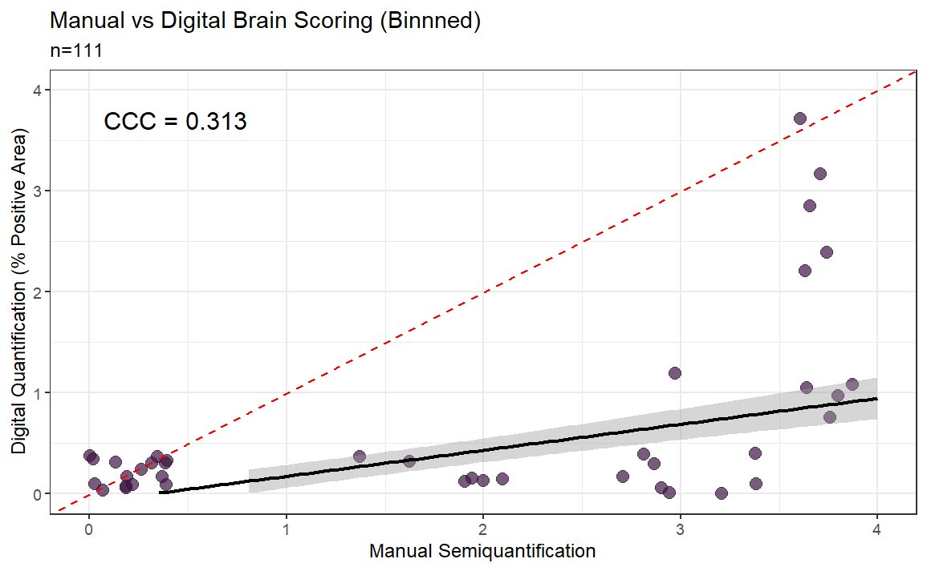

Lungs.
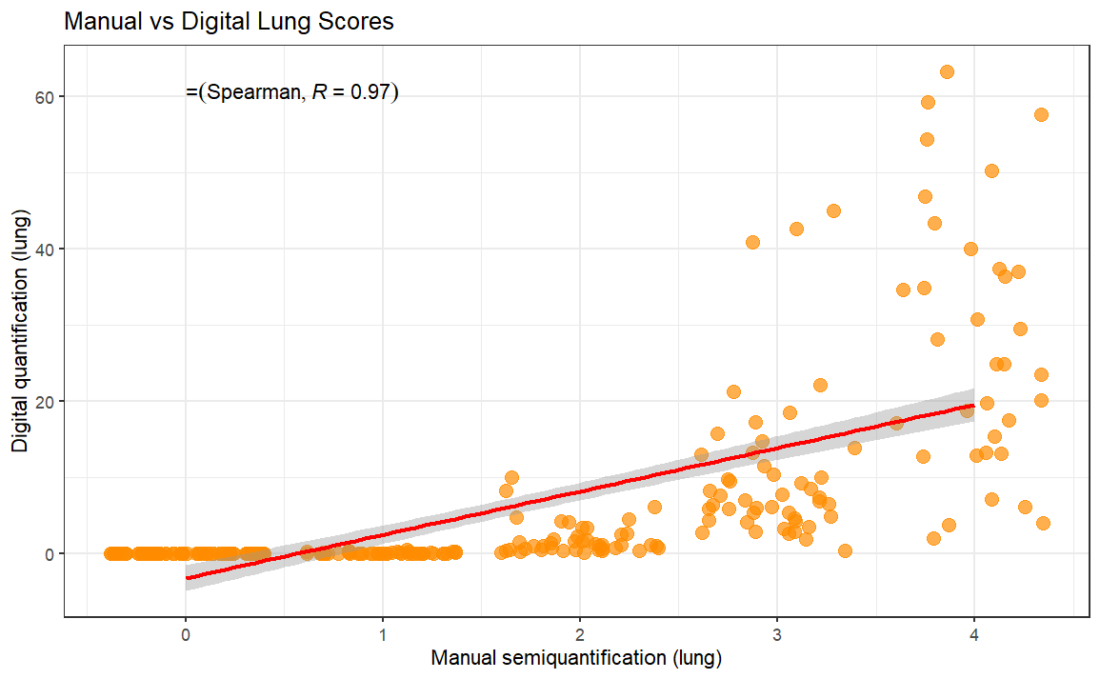

Lungs stratified.
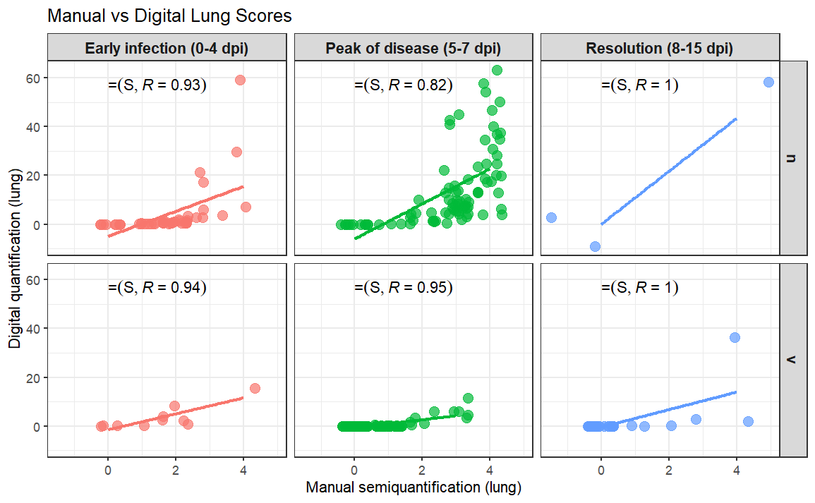

Lungs and other parameters.

CCC Lungs Manual vs Digital not stratified but used with “scale comparable groups”

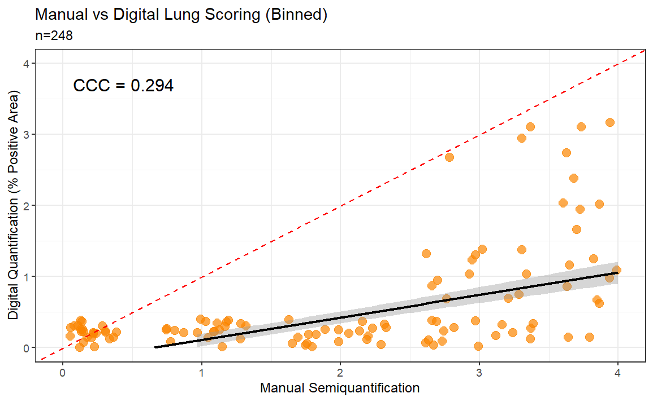

CCC Brain and Lung QUCIK VIEW
