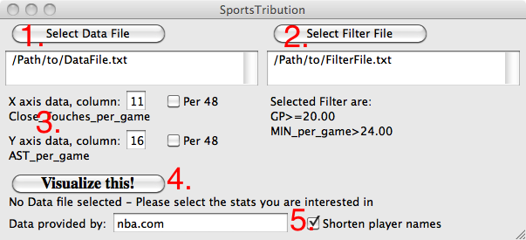

**Main Window**

1. Select the data file, containing tab delimited text (see example file ‘DataFile.txt’). If the data is in the correct format, an additional ‘Data List’ window will open. To be in the correct format:  
   - first row has to contain the respective name of the statistics (e.g. Points per game)  
   - first column has to contain the player names  
   - if you want to use minute normalization, the minute per game data has to be the third row
2. Select filter file, containing data separated by comma (see example file ‘FilterFile.txt’)  
   - input is data column number (ignoring player names), comparison sign, threshold value  
   - example: 1,>=,20 would mean in our case that players would need to have played at least 20 games to be shown on the figure
3. Select the data columns that you want to express on x and y axis. For each axis, you can select if you want to normalize data by 48 minutes (only makes sense for ‘per game’ data)
4. Click on this button to plot your data. If you have done everything correctly the following window will appear
5. Additional information that can be seen on the plot (future versions will also allow to adjust font size etc.)

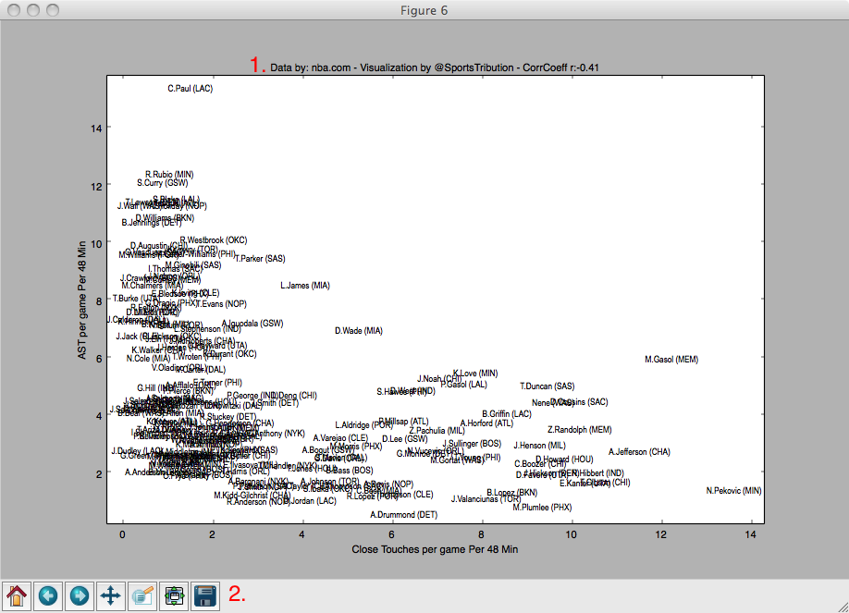  
**Data Plot**

1. general information about data source etc.. CorrCoeff is the correlation coefficient. In this example, it is a negative value, meaning that players that touch the ball closer to the basket generally produce less assists
2. Tools to zoom into the plot and to save the data. The best way saving the data is to save it as pdf (using ‘example.pdf’ as name). This allows to easier manually post-process the data (e.g. changing font colors or slightly moving overlapping player names