RINGWOOD AND DISTRICT
CRICKET ASSOCIATION INC.
No. A0110509M
ABN 33 869 448 061

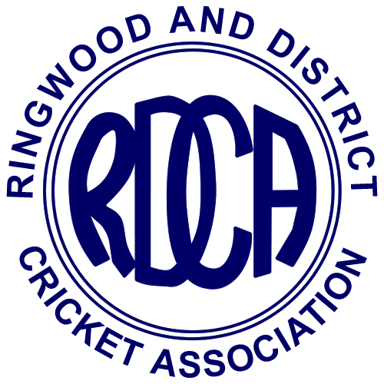

2024/2025
ANNUAL REPORT

Presented to Club Delegates at the Annual General Meeting
held on Monday 18th August 2025
RINGWOOD AND DISTRICT CRICKET ASSOCIATION INC
OFFICE BEARERS – SEASON 2024/25

Board of Management

President of RDCA (Chairman) Michael Finn
Administration Manager Timothy Court
Finance Manager Graeme Seymour
Senior Representative Stuart Mineti / Wayne Hartley
Junior Representative Sean Flynn
Umpires Representative Jordan Russell
Women's Representative Linda Bailey
Outer East Region Director & VMCU delegate Pat Meehan
Marketing Manager Jo Fairy

Senior Committee

Chairman Stuart Minetti* / Wayne Hartley
Secretary Paul Brousard
Registration Secretary/My Cricket Admin Adam Kuklycx
Veterans Secretary: Peter Chamings
Other committee members Steve Oxley, Dwayne Paisley*, Damian Ford*, Pat Meehan, Doug Wooles, Mat Millar*, Trent Touhy and Chris Anderson
* resigned during the season
Junior Committee

Junior President: Sean Flynn
Junior Secretary: Bill Stafford
Junior Representative Coordinator: Bill Stafford

Women's Committee

Women’s Chair: Linday Bailey
Other committee members Dee Callanan, Belinda Carter, Pamela Vodopier, Natasha Jorgenson, Pat Meehan

Other

Umpires Association President Jordan Russell
Umpires Association Secretary Adam Kuklycx
Ball Manager Ian Spencer

Life Members:

J. Austin (dec) R. Baldwin (dec) W. Baldwin (dec) W. Barkway (dec)
J. Barrett (dec) D. Beatty F. Bibby (dec) R. Bisset (dec)
A. Bonnett (dec) J. Browne (dec) I. Callen G. Chandler (dec)
G. Chapman (dec) F. Clota (dec) M. Cooper (dec) T. Court
W. Dean (dec) I. Dench K. Dunham (dec) R. Ellis (dec)
P. Edie (dec) T. Gawne J. Goodall (dec) T.A. Hall (dec)
C. Hochkins (dec) F. Hodgkins (dec) P. James (dec) K. Johnston (dec)
R. Johnston (dec) S. Lennard (dec) J. Luscombe H. Matthews (dec)
L.H. McLeod (dec) P. McCallum (OAM) (dec) J. Macmillan (dec) G. Mason
S. Minetti A. Miles (dec) P. Meehan A. Neil (dec)
S. Newey (dec) Mrs. A. Pascoe S. Pascoe (OAM) F. Pegler (dec)
C. Puddyphatt (dec) A. Reidy (dec) L. Salvana (dec) C. Sleeman (dec)
D. Smith (dec) I. Spencer J. Springett (dec) W. Stafford
R. Stoney (dec) N. Taylor (dec) L. Trollope (dec) N. Tull
A. Wescott (dec) R.G. Wilkins (dec) W. Wilkins (OAM) (dec) M. Williams (dec)

Awarded Life Membership in the YVCA

D Campbell (dec) A. Cowley (dec) T.H.T. Drummond (dec) R. Finger (dec)
V. Haag (dec) A. Hammond C. Hodgson (dec) G.L. Johnson (dec)
W. Johnson (dec) W. Madden (dec) R. McGuire (dec) W. McLean (dec)
G. Mitchell J. Pocket (dec) D.J. Strachan (dec) H.W. Riseborough (dec) K. Thompson

Hall of Fame:
Legends  A.R. (Bob) Bisset,  W.D. (Bill) Dean OAM J.P. ,  J.F. (Fred) Hodgkins,  P.T. (Pat) Meehan,  S.N. (Stuart) Newey,  S.J.(Steve) Pascoe OAM  I.J. (Ian) Spencer,  W.G. (Bill) Stafford,  D.J, (Don) Strachan ASM J.P,  K.L. (Lindsay) Trollope ASM  W.R. (Bill) Wilkins OAM | Inductees  R. W. (Roy) Baldwin OAM,  W.K. (Bill) Baldwin,  A.R. (Bob) Bisset,  T.C. (Timothy) Court,  J. (Jason) Disney,  A.R. (Andrew) Downs,  K.J. (Ken) Dunham,  M. (Michael) Edwards,  L.J. (Lincoln) Grigg,  A.R. (Adrian) Hammond  K.B. (Ken) Johnston,  J.W. (Jeff) Luscombe,  P.T. (Pat) Meehan,  G.A.C. (Greg) Mitchell,  D.P. (Dave), Mooney,  S.N. (Stuart) Newey,  W. (Bill) Oliver,  A. J. (Ann) Pascoe,  M.F. (Michael) Piggott,  M. (Martien) Pruysers,  J. (Jay) Sansom,  D.W. (Don) Smith,  W.G. (Bill) Stafford,  A. (Andrew) Tonkin.  K.G. (Ken) Trollope,  M.A. (Mark) Unternahrer
TABLE OF CONTENTS

IN MEMORIAM 4
W.R. (Bill) Wilkins OAM 4
S.N. (Stuart) Newey 5
BOM REPORTS 7
President - Michael Finn 7
Finance Manager - Graeme Seymour 10
VMCU - Pat Meehan 16
Outer East - Pat Meehan 17
SENIOR COMMITTEE REPORTS 18
Secretary - Paul Broussard 18
Representative Cricket - Pat Meehan 20
Umpires Association - Jordan Russell 23
JUNIOR COMPETITION REPORT 24
Chairman - Sean Flynn 24
Junior Secretary - Bill Stafford 25
VMCU Carnival- Bill Stafford 29
VETERANS COMPETITION REPORT 32
Secretary - Peter Chammings 32
WOMEN'S COMPETITION REPORT 34
Chair - Linda Bailey 34
STATISTICAL INFORMATION 2024/2025 36
LINDSAY TROLLOPE SHIELD 37
BILL WILKINS CUP 38
STUART NEWEY PLATE 39
STEVE PASCOE SHIELD 40
PAT MEEHAN SHIELD 41
IAN SPENCER SHIELD 42
DAVID BEATTY SHIELD 43
DON SMITH SHIELD 44
JOHN SPRINGETT SHIELD 45
“A” GRADE – NEIL TULL SHIELD 46
“B” GRADE – ANN PASCOE SHIELD 47
“C” GRADE – DJ STRACHAN SHIELD 48
“D” GRADE – ADRIAN HAMMOND 49
“E” GRADE - Stuart Minetti Shield 50
“F” GRADE – IAN DENCH SHIELD 51
“G” GRADE – JOHN MACMILLAN SHIELD 52
“H” GRADE – TIMOTHY COURT SHIELD 53
“I” GRADE – TONY GAWNE SHIELD 54
“J” GRADE - GREGOR MASON SHIELD 55
“K” GRADE - GREG MITCHELL SHIELD 56
“L” GRADE 57
Vets T20 Big Bash 58
Premiers: Eildon Park CC 58
Masters 1 - Peter White Memorial Shield 60
Masters 2 - Ken Johnston Trophy 61
Masters 3 - Bill and Marg Stafford Trophy 62
Women's - A Grade 63
Women's - B Grade 64
Women's - C Grade 65
Women's - D Grade 66
Women's - E Grade 67
AWARD WINNERS 68

IN MEMORIAM

In September the RDCA was saddened to learn of the passing of two of its finest contributors to the Association over a very long period of time.

The RDCA would like to thank both Bill Wilkins and Stuart Newey for their outstanding service and for the lasting impact they have both left on the association.

The following is the information prepared by Ian Dench on the amazing contribution made by both Bill and Stuart to the RDCA.

W.R. (Bill) Wilkins OAM

Cricket has always been Bill's first sporting love. Bill has been a member and Office Bearer
of the Bedford/East Ringwood Cricket Club for 70 years where he is a Life Member. Bill was President of the club for a total of 35 years, and the club has honoured him by naming their Best Club Person Award the "Bill Wilkins Shield".

Bill played his early cricket at Bedford Cricket Club which later merged with East Ringwood Cricket Club. Bill continued playing for many years and with an involvement now stretching to around an imposing 75 years, Bill has received a Fifty Year Service Award from Cricket Australia.

Bill's service to the RDCA includes 11 years as President of the Association, 13 years as a Vice President, and 12 years as the first President of the Junior competition. He has a junior grade trophy (Under 16-1) and the second highest senior premier grade competition and Best and Fairest Player Medal named after him (the Bill Wilkins Cup and the Bill Wilkins Medal).

He was made a Life Member of the Association in 1978/79, over 40 years ago – incredible. Bill has offered significant service to this Association and other voluntary organisations for most of his life - a magnificent and ongoing achievement.

As further testament to Bill’s involvement in the Community and Sport, he was awarded the Medal of the Order of Australia (OAM) in 2013.

Bill was inducted into the inaugural RDCA Hall of Fame in March 2021 and was immediately elevated to Legend status.

The following words about Bill were included in the RDCA Centenary and Hall of Fame program for the dinner held on 26th March 2021

“A playing career covering some 65 years showed Bill’s love for the game of cricket and the East Ringwood C.C. where he has held numerous committee positions including many as club President and he is a Life Member of the club. Bill also volunteered to assist the Association Executive where he served as President of the junior section for 12 years, as an Association Vice President (13 years) and President of the Association for 11 years. Bill received the Medal of the Order of Australia for his service to the community and to sport and has a Premier Association grade competition and player award named in his honour as well as a junior grade.”

S.N. (Stuart) Newey
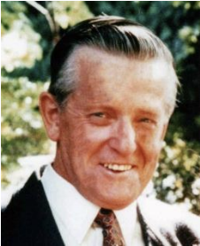
Stuart married Joan (RDCA Treasurer for 11 years) in 1955 and they have 4 children, all of who played in the RDCA. Stuart's cricket career commenced at Beaufort where he played in the senior side from ages 14 to 16 while at school locally. Over the years Stuart was involved in many sporting organisations including being a Foundation and Charter member of the Ararat YMCA, a Foundation Member and player for the Ringwood Saints Baseball Club and a Foundation Member, player and Treasurer of the Croydon and District Table Tennis Association.

Examples of Stuart's long history of volunteer involvement can be demonstrated by noting that he was Treasurer of his local church for 50 years and his magnificent contribution to the Monkami Centre for the Intellectually Disabled where he was President for over 25 years. Remarkable achievements.

Stuart has had a long and successful history within the RDCA as a player and an Administrator.

He was President and is a Life Member of North Ringwood Cricket Club. He opened the batting in North Ringwood's consecutive Chandler Shield premierships in 1967/68 and 1968/69. Stuart also captained the Chandler Shield and C Grade sides in other years and coached the successful Under 16 team. Stuart was a club delegate to the Association for many years from 1961/62. He was President at North Ringwood from 1969/70 to 1975/76 and Secretary from 1958/59 to 1966/67. He was also an RDCA Umpire and Umpires Advisor for many years and is a proud Life Member of the RDCA Umpires Association.

Volunteer service to the RDCA includes long term service on the Association Executive - Records Secretary for 27 years, and Treasurer for 11 years (Stuart’s wife Joan was also RDCA Treasurer for 11 years). Stuart was honoured as a Life Member of the Association in 1981/2 and has a Senior Grade named after him (Newey Plate from 2001/02) as well as the Stuart Newey Medal for the Best and Fairest player in the Newey Plate competition.

In March 2021 Stuart was inducted into the inaugural RDCA Hall of Fame, another acknowledgement of his dedicated and lengthy service in, and to, the Ringwood and District Cricket Association. Stuart was not able to attend the RDCA Centenary and Hall of Fame Dinner held on 26th March 2021. Stuart’s wife Joan was present to proudly accept Stuart’s award.

The following words about Stuart were included in the RDCA Centenary and Hall of Fame program for the dinner held on 26th March 2021.

“Stuart Newey played in the North Ringwood Chandler Shield premierships in 1967-68 and 1968-69 and served the club as Secretary for 9 years and President for 7 years. He was elected as a Life Member of the club and holds Cap #51 after debuting in the 1958-9 season. After playing at the highest local level, Stuart gave back to the local game by joining the Association Executive where he provided excellent service for some 33 years. A Life Member of the Association (elected in 1981-82), Stuart served as a senior umpire for many years and was a member of the Umpire’s Association including 4 years as President and 19 years as the Umpire’s Advisor. He was elected as a Life Member of the Umpire’s Association in 1984-85. Stuart has a Premier Grade trophy named after him, along with a Best and Fairest Medal.”

Stuart was elevated to Legend status within the RDCA Hall of Fame at the Senior Presentation Night in April 2024 – a very well deserved recognition of many years of service to the Association.”

BOM REPORTS

President - Michael Finn

It is with great pleasure and pride that I present the President’s Report for the 2024/25 season. Congratulations to all clubs, volunteers, officials, and supporters on another successful and rewarding year of community cricket within the RDCA.

Acknowledgements
To our Board members, Committee Chairs, umpires, and all RDCA stakeholders—your passion, professionalism, and dedication remain the bedrock of our Association’s success.
To our valued sponsors: thank you for your continued support. Your investment plays a vital role in maintaining our position as one of Victoria’s most respected and forward-thinking community cricket associations.
Congratulations to all Premiership-winning clubs. A sincere thank you goes to each club, its committee, players, and above all, our volunteers—your contributions are essential and deeply appreciated.

Hall of Fame & Legend Inductees
This year, we welcomed the following esteemed individuals into the RDCA Hall of Fame and Legends:
- Bill Stafford – Legend
- William Oliver – Hall of Fame
- Jay Sansom – Hall of Fame
- Andrew Tonkin – Hall of Fame
- Timothy Court – Hall of Fame

Special Mentions
- Damian Ford (Montrose CC) and Shawn Goodwin (Kilsyth CC) for their long-standing commitment and leadership at club level, helping shape the broader RDCA landscape.
- Sean Flynn, whose tenure as Junior President has been marked by clear vision and impactful direction.
- Linda Bailey and Paul Attfield, for their outstanding efforts delivering our inaugural Emergency Services Cup.
- Ray Baird, for his service on the RDCA radio show and his appointment as RDCA Umpires Life Member.
- Dave Raggett, for his ongoing excellence on the RDCA radio show.
- Dwayne Paisley and Michael Cardamone, for the success of the RDCA Show podcast.
- Stuart Minetti, for his valued contribution as Senior Committee Chair, and Wayne Hartney for stepping confidently into the role.
- Paul Broussard, Linda Bailey, and the Junior Committee for navigating extreme weather and ensuring finals were played and completed.
- Croydon Ranges CC, on a memorable Trollope Premiership three-peat—an unforgettable finale to a remarkable season.

Season in Review
- Senior Men’s Competition
The men’s senior competition continues to remain stable. Our focus is to consolidate participation while creating visible and sustainable pathways for our junior boys to progress into senior cricket. This strategic alignment will help ensure the long-term strength of our competition.
- Women’s Senior Competition
Now in its fifth season, the women’s competition continues to grow and consolidate. The RDCA is proud of the vibrant and expanding female cricket landscape, made possible through the tireless efforts of a passionate Women’s Committee. Their advocacy ensures the RDCA’s women’s voice is both clear and powerful within our community.
- Junior Competition
The junior competition goes from strength to strength—in both player numbers and performance. Our representation and success at the VMCU level have been a testament to the hard work of Sean, Bill, and the outstanding Junior Committee. Their leadership ensures the RDCA remains a nurturing environment for the next generation.
- PlayHQ Integration
With PlayHQ becoming further embedded into cricket operations, we thank clubs for their continued adaptability and support in managing the transition.
- T20 Competition Expansion
Our T20 Bash continues to flourish, with strong participation and growing interest. Special recognition goes to Damian Ford for leading this initiative. Plans are already underway to expand even further in 2025/26.
- Emergency Services Cup Launch
This season saw the successful launch of the inaugural Emergency Services Cup—a heartfelt tribute to the frontline workers across our district. This fixture now takes its place as a meaningful annual celebration of community and service.
- Finals Season & Inclement Weather
Once again, the finals were challenged by unpredictable weather. Unlike years past, the proactive response by our Senior Men’s, Women’s, and Junior Committees ensured all matches proceeded with minimal disruption—a commendable effort.
- Social Media Conduct
Unfortunately, the season saw instances of unacceptable social media behaviour. The RDCA stands firmly against any actions that cause harm or distress to individuals. A comprehensive review of our Social Media Policy is underway, with significant enhancements set to be implemented before the next season.
- Constitution Review & SGM Outcomes
A Special General Meeting was held to pass key constitutional amendments. Clubs participated thoughtfully, and we thank them for their engagement. Discussions also included a proposed points system and preparations for the appointment of an RDCA Administrative Manager.

Looking Ahead – Season 2025/26
Our focus for the upcoming season is the continued delivery of our strategic roadmap:
- Implementation of Points & Heat Policy
A refined points system and expanded inclement weather policy—developed with input from the CFA—are set to be introduced, ensuring fairness and safety for all participants.
- Appointment of Administrative Manager
After years of planning, the time is right to introduce the RDCA Administrative Manager role. This key appointment will strengthen our internal operations and help future-proof our administrative and governance structures.
- New Social Media Policy
A new, clearly articulated Social Media Policy will be enforced across all competitions, ensuring accountability, respect, and a safe digital environment.
- T20 Bash Growth
Interest from new clubs signals another strong year ahead for our flagship T20 competition, which continues to set a benchmark in local cricket.
- Wilkins Grade Transition
In line with the previously endorsed plan, the Wilkins Grade will return to an eight-team format in 2025/26. With several clubs in contention, this promises to be one of the most hotly contested seasons in recent memory.

Final Reflections
To all members of the RDCA community, thank you once again for your trust, your collaboration, and your passion. Your support over the past year has been truly humbling. I remain as committed as ever to serving this extraordinary Association and look forward to what lies ahead.

Finance Manager - Graeme Seymour
Season 2024/25 continued the growth of the RDCA as the pre-eminent Metropolitan Cricket Competition in Melbourne’s Eastern region with Heatherdale & Vermont Cricket Clubs joining our Competition.

On the financial front our income (excluding Umpire Match Day fees where we act as a collection & payment agency for the RDCAUA) increased from $402,193 to $424,354 this year. Major revenue increases were the expanded T20 Competitions entry fees of $20,909 (last year $11,273), Sponsorship Income $75,699 ($66,681), Senior Presentation nights $21,891 ($17,400), Interest on Funds $6,599 ($4,193).

Expenditure increased from $388,792 last season to $412,175 this year. Major increases were Ball Costs $211,182 ($205,584), Marketing costs $14,745 ($12,000), External Consultants fee $6,000 ($Nil), Umpire Fees (predominantly for VMCU Junior Carnival) $13,605 ($10,520), T20 Competition increased prize monies $11,600 ($8,000).

For the year ended 31st May 2025, the RDCA recorded a Surplus of $12,179 which was slightly down on the 2024 result of $13,402, but nevertheless a pleasing result for the year.
At year end we have Cash Reserves of $173,803 (last year $161,654) & minimal debt.

Stocks of Balls, Medals & Clothing have increased slightly to $12,495 ($10,606). The holding of Telstra Corporation shares (resulting from the RDCA/YVCA merger 5 years ago) whilst shown in our records with a value of $4,921, have a current Market Value of approximately $6,970.

I should also mention that after five years since the amalgamation of the RDCA & the Yarra Valley Cricket Association (YVCA) it was decided by the Board of Management that we would transfer the residual YVCA Transition Funds Reserve into the Association’s Accumulated Funds. This transfer of $43,174 is reflected in the current year financial report & was made in accordance with the Transition Committee’s recommendations from the 2022/23 year.

One person I would like to single out for his contribution to my task as Association Treasurer is Lothar Pilz whose work in recording all Umpire appointments each week to every game & then producing his spreadsheet to enable me to a) invoice all Clubs appropriately & b) pay the umpires every fortnight, is greatly appreciated. As can be seen from the financial report, this year Umpire Fees collected & paid totalled more than $213,000. The time involved in all this is huge for both Lothar & myself.

In last year’s report I referred to the hopeful appointment of an Administration Manager during the 2024/25 Season to help lessen the workload on our Association Volunteers. This obviously didn’t happen as hoped for but will be our number one priority heading into the 2025/26 Season. Some of the details outlining this appointment were detailed at the Special General Meeting of members held on 12th May.

In closing my report, I would like to thank all the Associations’ sponsors for their continuing support, both in cash & kind. Without these sponsors, together with all the Club & Association Volunteers, the RDCA would not be the pre-eminent Metropolitan Cricket Competition that it is.

My final comment is a big thank you to all Club Treasurer’s for their co-operation during the season & I look forward to a successful 2025/26 season.

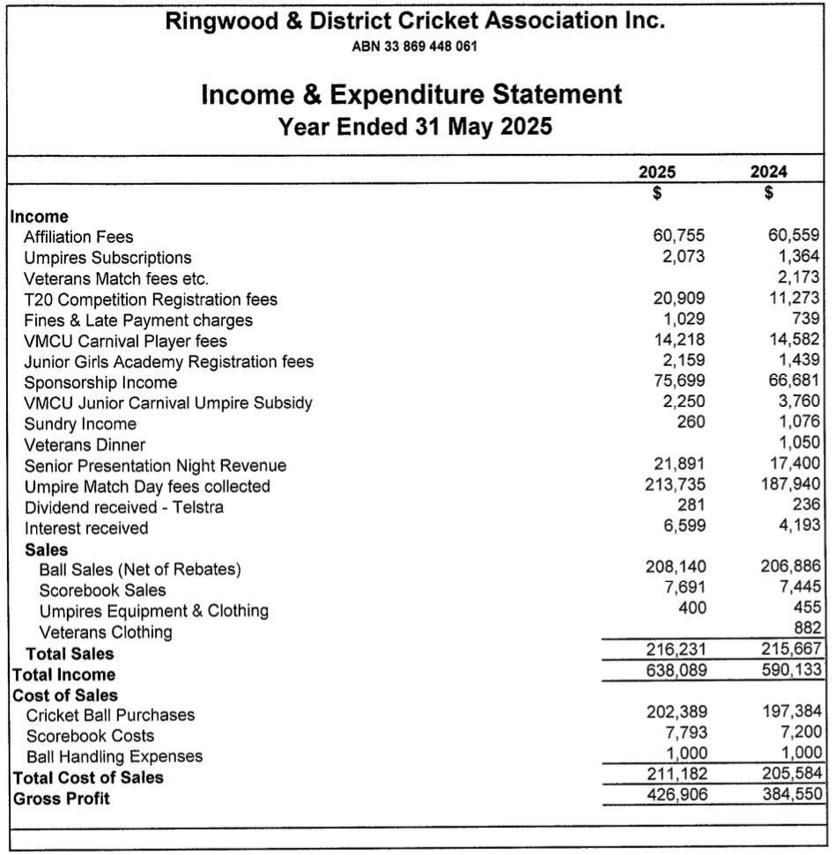

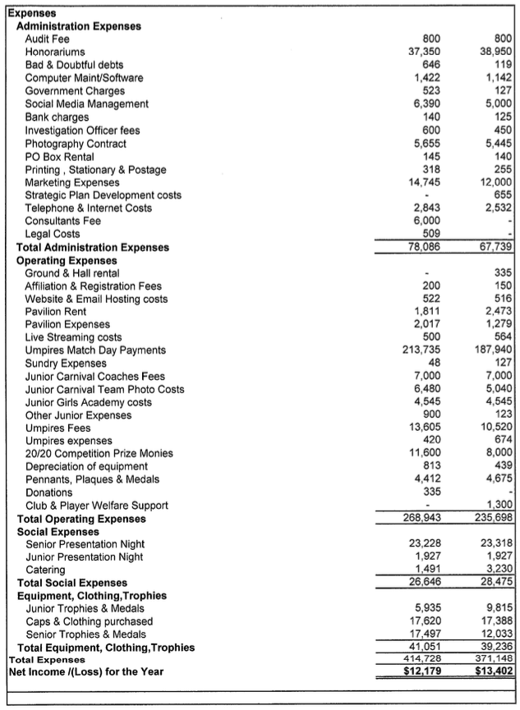

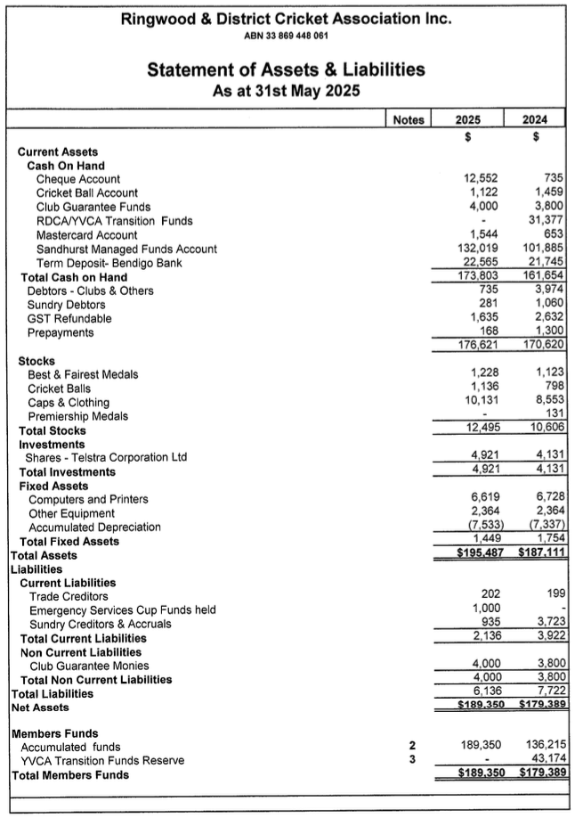

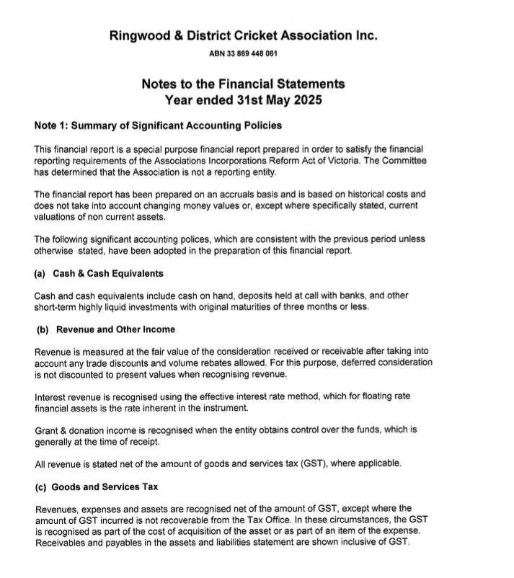

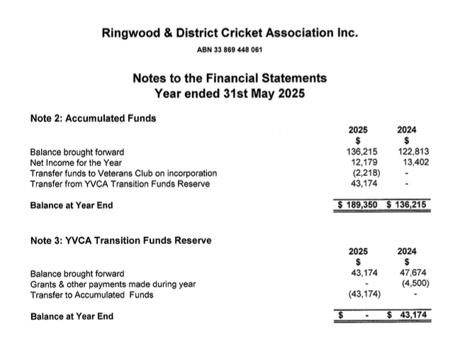

VMCU - Pat Meehan
The VMCU consists of a Board made up of the 8 Directors of each Metropolitan Region, together with delegates from every Metropolitan Cricket Association. Pat Meehan is both the Director – Outer East on the Board and the RDCA Delegate.
Over the past season the main cricket activities relate to the management and implementation of metropolitan cricket. The VMCU Carnival proceeded in January 2025 with 107 teams competing, including 34 girls teams, and having 1,300 approx. players from 12 Associations in 10 grades. The RDCA was strongly represented with 10 teams entered in all grades. Success came with premierships in both the U/16 Beitzel and U/14 Nolan Shields, runners up in U/18 Arnold, U17 Jones and U12 Browne Shields, and two teams competing in the semi-finals – U/16 Mackay and U12/ Fatone Shields. A huge thanks are extended to all the players, coaches, managers, parents and umpires for their significant contribution to this very successful Carnival.
The most significant matters dealt with during the season were:
· A new Association – Southern Cricket Association – covering Berwick and Clyde Areas with 17 clubs was admitted to the VMCU this season.

· Implementation of Australian Cricket’s Child Safety Framework by all Associations and clubs to meet the updated CA’s Child Safe Standards, with the appointment of Child Safety Officers at all clubs state-wide. Clubs need to formally minute the new safety declaration and forward to CV before the commencement of each season. Monitoring the progress of the implementation within each Association is ongoing. This season all RDCA clubs were compliant.

· Continuing negotiations with CA/CV on PlayHQ (with some enhancements) and OfficialsHQ Version 2.0 (with the latter being for umpires appointments and administration) on the need to address many issues experienced during the implementation phase. As part of these packages, relevant fees have been set by CA for insurance, player registration and administration. All players senior and junior both male and female must register online through PlayHQ with the appropriate payments made before they can play in the next season. A key issue is “fill-in players not being registered and thus not covered by insurance. The VMCU Board is monitoring the implementation progress with CV Management, particularly on the many issues raised by Associations and clubs.

· Regular updates have been held with CV staff on organisational changes, cricket participation statistics, schools and cricket blast programs, available cricket grants to clubs and associations, the interaction with the Premier Pathway, Premier Cricket and the VMCU Junior Carnival and CV annual strategic plans for next season. The former Premier Pathways for U/18 Male and Female, U/16 Male (Dowling Shield) and U/15 Female(Marg Jennings Cup) are now being administered by the individual premier clubs. The VMCU Board is ensuring that the role played by the VMCU Junior Carnival, or Associations, in the development of junior cricket and representative opportunities, is considered by during the squad selection process to compliment and not compete for Associations junior players, especially with fixturing of matches during the Carnival two-week period. A firm date in early October or earlier must be set by CV’s High Performance Group to ensure no repeat of the currently poaching of players from the association squads as happened this season. Based upon the possible dates for both competitions for next season, CV has no problems with U/18 Male Premier players also playing in the VMCU Carnival.

· Following the identification of the loss of association volunteers and the difficulty in finding replacements, the Board suggested to CV Management that paid replacement administrators appeared to be the best option for the near future. Three Associations( CSB, BHRDCA AND DVCA) have engaged a paid administrator during the season using either their own funding or levying clubs. Some success has been reported. CV staff will be available to assist in the selection process (without any specific CV funding). The RDCA is currently investigating possible options and funding methods for a paid administrator to determine the final RDCA position to ultimately be put to all clubs for consideration and approval at either a Special General Meeting or the Annual General Meeting this year.

· All associations administrators (17 No. statewide) met with CV/VMCU in December 2024 and identified 20 No. policy issues to be co-ordinated. The top six policies needing early resolution were codes of behaviour, transfers and permits, umpires fees, player points and tribunals. These will be undertaken as a group and any sub-groups to formulate options for consultation to associations. CV/VMCU plans to have administrator meetings three to four times throughout the year, either face to face or online.

· Discussion on disciplinary issues with players and clubs with suspensions, bonds, etc. , who can participate in different associations, including winter competitions, has recently been undertaken due to some concerns and the need to share information. This would involve assessing the PlayHQ process and the possible need to have this information on the VMCU website to assist all relevant parties. This is ongoing.
In addition, the VMCU is also the body which deals with both club and player appeals against penalties imposed by an Association, which if it meets the criteria, would be considered by its independent panel for final resolution.

Outer East - Pat Meehan
The Outer East Region covers the municipalities of Knox, Maroondah and Yarra Ranges and comprises of clubs in the Ringwood and District Cricket Association (VMCU Affiliate) and the Ferntree Gully Cricket Association (VCCL Affiliate). This season the RDCA had 58 clubs with 151 senior teams, 250 junior teams (male and female), 32 women’s teams and 35 veterans teams with 4,800 overall participants. The RDCA Headquarters is located at the Board Room and Office upstairs in the new R O Spencer Pavilion at Jubilee Park, Ringwood (together with Ringwood Cricket Club and CV regional staff).Premier Cricket is represented in the region by Ringwood Cricket Club with the Victorian Sub-District Cricket Association represented by both Bayswater and Croydon Cricket Clubs.

C V staff operating in the region for the season were Clinton Kennon / Mark Freeman, Area Manager - Stars and Stephen Box, Cricket Manager- Outer East Metro. These people assisted all clubs and work closely with them and schools in the region to offer a program of clinics, competitions, and activities to increase the availability of cricket in various formats to both male and female participants.

Ringwood C.C. is our partner for the regional pathway program and assists in the management and coaching of the Outer East Eagles male and female squads in the State Championships. The Annual RCC v RDCA match was played at Jubilee Park, main oval, on Wednesday 5th February 2025 with the RDCA winning by 13 runs, being the first time in 17 years. An RDCA Womens East match was played against RCC Women on the same night with RCC winning in 11 overs. The latter team comprised mostly of first eleven players.

The region was strongly represented in the VMCU Junior Carnival held in January 2025 as the RDCA entered 10 male and female teams in all grades and FTGDCA entered 6 teams (5 male and 1 female). A total of 107 teams competed. RDCA were the premiers in the U/16 Beitzel and U/14 Nolan Shields and runners up in the U/18 Arnold, U/17 Jones and U/12 Browne Shields with another three teams competing in the semi-finals in U/18 Arnold, U/16 Mackay and U/12 Fatone Shields. The FTGDCA won the U/16 Mackay Shield. Huge thanks are extended to all players, parents, players, managers, coaches, and umpires for their significant contribution to this successful Carnival.

Women’s cricket continues to grow within the region both at Premier Cricket level with RCC and the Associations. The RDCA girls competition had 35 teams in 5 grades. The standard is also improving as evidenced with some Stage 3 girls players making their debuts in women’s teams. The RDCA managed the “RDCA Women’s East” competition again this season to provide a pathway for allow all women and junior girls in both the Outer and Inner East Regions to participate in cricket at all skill levels. This resulted in 17 clubs entering 32 women’s teams in 5 grades. (FTGDCA conducted a fortnightly T20 social sixes competition). Many of these were new teams included women who have never played cricket before and Stage 3 girls. This was once again highly successful with many other clubs from both the RDCA and other Associations indicating that they hope to enter teams in this competition next season.In the Men’s competition the top grades (Premier 1 and 2) played a mix of two day and one day matches with the lower grades (District 1 and2) playing one day and two day matches – some with split innings. Thankfully, the season and all finals were successfully completed with minimal impact on team numbers. A successful T20 competition open to teams from adjacent associations had 44 teams competing with Ainslie Park (RDCA) winning over Lilydale (RDCA) in the final.

SENIOR COMMITTEE REPORTS

Secretary - Paul Broussard
Firstly, on behalf of the senior committee I would like to thank all of the clubs and particularly their executives who deal with us on a regular basis on the senior committee. We have continued to build some highly valuable relationships which has helped us immensely in keeping the competition running quite seamlessly.

After the previous seasons restructure to the senior grading format, the latest season came together very efficiently and was executed without any real turbulence. This was very pleasing, particularly as we had two new clubs in Vermont CC and Heatherdale CC enter the competition, from what we sore both clubs fitted in really well and with a few minor adjustments coming up next season they will have integrated very well indeed.

Whilst we managed to execute a very effective season just gone, once again the only real contention that we came across was the way the RDCA handles all things around weather and fire danger etc. The RDCA Senior Committee is very mindful of the contention in this area, and I can assure all clubs that this is something that always raises itself in our agenda and is being highly focused on leading into the upcoming season.

I would like to now take the opportunity to thank the current committee as well as the four gentlemen who ended their time on the RDCA Senior Committee before the end of the season. All of our committee members do a great job as volunteers, though I would like to extend my congratulations and thank you to two relatively recent additions to the committee for doing a marvellous job in their fields. Damian Ford ran an outstanding T20 competition, and Dwayne Paisley put in a great effort with his work around the Senior Rep team that defeated the Ringwood Rams in the T20 match at Jubilee Park. Both guys have stepped aside from our committee now, but I must thank you for a job well done.

It has not been officially documented, but by the look of it the Senior Committee has a new position of Secretaries assistant. Chris Anderson who is our minutes secretary has gone above and beyond this season in helping myself and others on our committee particularly putting in a power of work around PlayHq, Statistics, and Presentation Night preparations. Chris your efforts have not gone unnoticed and have been immensely appreciated

Stuart Minetti served as chairman for most of the season, providing excellent direction and support to the committee and especially to me as secretary. Stuart has been a great resource for me as secretary and is always on call for me but having him as our chairperson took his assistance to the next level, Stuart I will sorely miss your direct involvement on our committee and I thank you for your time and effort.

Finally I would like to thank Michael, Timothy, Graeme and the rest of the RDCA Board along with all of the other Committee members throughout the RDCA for their efforts and I look forward to moving forward into the upcoming season.

Representative Cricket - Pat Meehan
A. Annual Mens’ RDCA “All Stars” v Ringwood Rams.

This annual mens’ match was played on Wednesday 5th February 2025 at Lucas Oval, Jubilee Park, Ringwood. The RDCA team comprised of the following players:

1. Andy Solomon – Kilsyth
2. Jesse Lynne – St. Andrews (captain)
3. Kieran Perkins – Montrose
4. Ryan Peter-Budge – North Ringwood
5. Joe Blyth – Croydon Ranges
6. Blake Podesta – Montrose
7. Morgan Persson – Clark – South Warrandyte
8. Mitch Plant – St. Andrews
9. Jack Blyth – Croydon Ranges
10. Shifran Muthaliph – Lilydale
11. Ben Joseph – Heatherdale
12. Dillon Bettess – Ainslie Park
13. Daniel Thompson – Lilydale

RCC won the toss and elected to bowl.

RDCA 1st Innings

M. Persson Clark- bowled Fotia 6
B. Podesta caught Gibson bowled Sugumar 17
A. Solomons caught Beaton bowled Mountain 67
D. Thompson caught D. Walker bowled Mountain 9
R. Peter- Budge not out 35
B. Joseph caught E. Walker bowled Mountain 4
J. Lynn caught Edwards bowled Fotia 5
K. Perkins bowled Fotia 0
D. Bettess not out 0

(Did not bat – Joe Blyth, Jack Blyth, S.Murthaliph, M. Plant)
Extras - 13
Total = 7 / 156 cc. (20 overs)

Bowling : J. Beaton 0/35 (3 overs), M. Fotia3/27 (4 overs), D. Walker 0/21 (4 overs),
G. Lawson 0/25 (2 overs), T. Sugumar 1/20 (3 overs), M. Mountain 3/24 (4 overs).

Fall of Wickets: 1/7, 2/45, 3/63, 4/129, 5/143, 6/153, 7/155.

RCC 1st Innings

E. Walker bowled Plant 0
A. Flynn caught Persson-Clark bowled Jack Blyth 22
D. Ivanovic caught Persson-Clark bowled Plant 7
B. Gibson caught and bowled Jack Blyth 2
M. Mountain caught Lynn bowled Joe Blyth 14
L. Ivanovic run out (Persson/Joe Blyth) 31
J. Edwards not out 47
T. Sugumar run out (Bettess) 9
D. Walker run out (Bettess) 0
G. Lawson not out 1

(Did not bat – J. Beaton, M. Fotia.)

Extras - 10
Total = 8 / 143 ( 20 overs)

Bowling : M. Plant 2/28 (4 overs), Joe Blyth 1/37 (4 overs), Jack Blyth 2/23 (4 overs),
A . Solomons 0/33 (4 overs), S. Multhaliph 0/18 ( 4 overs).

Fall of Wickets: 1/0, 2/28, 3/33, 4/40, 5/51, 6/117, 7/135, 8/136.

RDCA won by 13 runs in a great game. This was the RDCA’s first win since 2007/2008.

Congratulations to the players of both teams for making themselves available for this significant match for the RDCA.

Thanks to the umpires – Noel Gilbert (RDCA) and Srivatsan Velamur (Premier) who made themselves available.

Thanks also to the scorers – Janet Howard (RCC) and Stuart Minetti (RDCA)

Special thanks to Dwayne Paisley (Senior Committee Player’s Representative) for
undertaking the roles of selector and coach of the RDCA team.

B. RDCA Womens’ All Stars v Ringwood Rams

This match was played on No.2 oval, Jubilee Park, Ringwood on Wednesday 5th February 2025 in conjunction with the men’s match.

The RDCA team comprised of the following players:

1. Caitlyn Parker – Lusatia Park
2. Sarah Smith – Bayswater Park
3. Kellie Emmett – Bayswater Park
4. Jess Sanders – Bayswater Park
5. Briony Polkinghorne – Mooroolbark
6. Tam Polkinghorne – Mooroolbark
7. Jess Adams – Mooroolbark
8. Lily Osborne – Norwood
9. Rachel Harris – Canterbury
10. Varsha Avulanna – Canterbury
11. Tiarna Mayoh – St. Andrews
12. Hailey Ferris – Heatherdale
13. Sharni Di Marno - Mooroolbark

The RDCA won the toss and elected to bat

RDCA 1st innings

S. Smith stumped Carpenter bowled Devlin 20
J. Adams caught and bowled Spencer 6
R . Harris bowled Rule 4
V. Avulanna run out ( Miutescu) 2
L. Osborne not out 17
C. Parker bowled Devlin 11
H. Ferris caught Carroll bowled Wijesena 12
B. Polkinghorne not out 12

Extras - 7

Total = 6/91 ( 20 0vers)

( Did not bat – K. Emmett. J. Sanders, T. Polkinghorne, T. Mayoh, D. Marno.)

Bowling – H. Spencer 1/13 ( 4 overs), H. Robbins 0/7 ( 2 overs),
E. Carroll 0/16 ( 3 overs), M. Kuth 0/15 ( 4 overs), T. Rule 1/12 ( 2 overs),
S. Devlin 2/13 ( 3 overs), U. Wijesena 1/12 ( 2covers).

Fall of wickets – 1/13, 2/29, 3/36, 4/40, 5/58, 6/77.

Ringwood 1st innings.

T. Atkinson caught B. Polkinghorne bowled Parker 19
T.R Rule run out ( Ferris) 52
S. Devlin caught B. Polkinghorne bowled Parker 5
K. Miutescu caught unknown bowled Parker 2
A. Sheedy not out 4
V. Wijesena not out 9

Extras - 5

Total = 4/ 96 ( 11 overs)

Did not bat – H. Spencer, H. Robbins , E. Carroll, A. Kuth, E. Wood,
U Raymond – Hoey, S. Carpenter.

Bowling – J. Sanders 0/11 (2 overs), T. Mayoh 0/22 (I over), V. Avulanna 0/18
( 1 over), L. Osborn 0/8 (I over), H. Ferris 0/19 (3 overs), C. Parker 3/12 (3 overs).

Fall of wickets – 1/70, 2/76, 3/77, 4/83.

Ringwood Rams won in the 11th over.

Thanks to the umpires – Mark Waller (Premier), Matt Jarrett (RDCA).

Thanks to the Coaches – Chris O’Brien(Ringwood), Shane Larmour (RDCA).

Thanks to the RDCA selectors – Sarah Smith, Briony Polkinghorne.

Thanks to RDCA scorer – Linda Bailey.

We look forward for the continuation of the women’s match in future seasons.

Umpires Association - Jordan Russell

Firstly I would like to say thank you to the RDCA Committee’s for a well run season with not to many hiccups.
From an umpires’ point we had another very good season with a good solid 20-25 umpires being available for most weeks of the season and finals. We are still a bit light on to be able to cover 2 umpires in the top 3 grades, but we always endeavor to appoint 2 umpires where we could.
We saw some new faces and old faces return for another season. This season we saw the inclusion of a former state and international umpire whose wealth and knowledge was fantastic I look forward to working with John again this season.
I would also like to congratulate the winner of the umpire of the year and Ken Dunham award winner Doug Wooles.
Congratulate the umpires who umpired in all grand finals this season but in particular the 2 men who stood in the Trollope grand final Doug Wooles & Andrew Tonkin.
I would also like to thank the umpiring fraternity for all of their support along the way in my first season in the chairperson position.
Lastly I would like to thanks my wife Belinda for all of her support and during the long season.

JUNIOR COMPETITION REPORT

Chairman - Sean Flynn
The 2024/25 was another hugely successful season for the RDCA juniors. Our club
competition saw some brilliant Grand Finals and we had our strongest Representative
carnival ever. The added bonus is the large number of junior players playing senior
cricket within the RDCA.

The quality of the girls competition continues to thrive, with winter academies and clubs
investing heavily in expert coaching. Warranwood made 7/122 in the stage 3 Grand
Final and defeated Norwood who made 8 for 100.

We had 22 divisions of cricket playing for premierships and we had 17 clubs win Grand
Finals. I cannot remember a time when the competition was so even. East Ringwood
won 3 premierships whilst Mitcham, North Ringwood and Ainslie Park each collected a
division 1 premiership. North Ringwood were our champion club narrowly defeating
Warranwood. Congratulations to all the Bulls players, coaches, volunteers and
supporters who helped them earn enough points to win this award.

Bill Stafford completed another remarkable season as our junior secretary. Bill has
overseen the growth in our competition, both from a club perspective as well as our
representative program. This has created a larger amount of work for him which he has
embraced. Bill is a life long Croydon Ranges supporter and he loved that they won the
Trollope Shield this season. However his heart lies with the game of cricket and junior
sport. I have never and will never see a better administrator.

Dale Ingleton continued in his role of rep cricket co-ordinator and lead us to our most
successful carnival ever. Dale oversees a thorough trial process where we give every
player the opportunity to trial. We see this as aspirational for our young players and
they become better players for the experience. The RDCA keeps producing Victorian
under age players and they all get their first experience of representative cricket
through our program.

Doug Dowling again took charge of our hugely successful umpires program. His hard
work has seen more umpires join which allows up to cover more junior games. Whilst
many sports face umpiring challenges, Doug has managed to increase our numbers
through his passion and genuine interest in our young people.

Davis Sykes, Kristi Disney, Cherie and Eloise Howland ensured that our girls program
continued to progress forward. They all watched games early in the season to ensure we
could get the grading as accurate as possible. We continue to provide opportunities for
young girls to fall in love with the game and allow them to progress into more
competitive cricket as their skills improve.

Our junior committee is full of great administrators who share a passion for junior sport.
We are lucky to have so many excellent people from varying clubs prepared to
contribute extra time for the benefit of our competition. As well as those already
mentioned we are assisted by Luke Henderson and Leah Parker who are always ready to
help in any way possible.

Saxon Sports has played an important role in the success of our junior competition. Paul
Attfield shares our vision and understands the important role that cricket plays in our
community. Our representative program benefits enormously from their support and
they are a big part of our success.

We had 223 teams which was 10 less than the previous season.

Under 10 up 4 from 44 to 48
Under 12 down 4 from 59 to 55
Under 14 down 9 from 54 to 45
Under 16 down 4 from 40 to 36
Girls up 3 from 36 to 39

Our numbers are strong but we would prefer them to be going up than down. We will
keep working with our clubs and cricket Victoria to identify strategies to improve
Participation.

This is my last Presidents report. I have had so much fun over the last 11 years and there
have been so many memorable moments. I have met some amazing people and I have
taken great satisfaction in the growth of the RDCA. My wife Maree has provided endless
support. She has gone from tolerating the sport, to understanding the sport, to now
being a genuine expert!

I look forward to watching our association continue to thrive.

Junior Secretary - Bill Stafford
PlayHQ was into its 2nd season and clubs were a lot more familiar with the system and processes. OfficalHQ (Umpiring system) attached to PlayHQ was still causing problems for the Junior, as were unable to appoint umpires to Junior games.
At our last AGM two significant changes were made:
· U14/5 and grades below would play all one-day games.
· U14 and U16 finals would move away from Saturday/Sunday finals to only Saturday finals. The number of RDCA junior players, also playing in Sunday competitions is increasing causing a conflict during finals. As result of playing only Saturday final meant that our home and away season finished a week earlier.
This season we finished up with 222 teams which is slightly below our 230 teams last year. U12 have reduced from 9 to 7 grades over the last two years. Girl’s teams fell from 37 to 35 teams but there was a more even spread of teams across the 5 grades.
Umpiring number continue to grow. This season we were able to provide umpires in U12/1- 2, U14/1-3, U16/1-3 and Girls Stage 3. All finals had a least one umpire appointed.
Congratulations to our premiership winners:
Grade | Winners
Stage 1 Girls Stars | Knox Gardens
Stage 2 Girls Spirit | Vermont
Stage 2 Girls Stars | Heatherdale
Mandy Dolman Shield Girls Stage 3 | Warranwood
U/12-1 Timothy Court Shield | Mitcham
U/12-2 Roy Baldwin Shield | Wonga Park
U/12-3 | Bayswater Park
U/12-4 | Boronia Hawks
U/12-5 | East Ringwood
U/12-6 | South Croydon
U/12-7 | Wandin Bulldogs
U/14 -1 Jeff Luscombe Shield | North Ringwood
U/14 -2 Alan L Reidy Shield | East Ringwood
U/14 -3 | Healesville
U/14 -4 | Boronia Hawks
U/14 -5 | Mt Evelyn
U/14 -6 | Boronia Hawks
U/14 -7 | Heatherdale
U/16-1 Bill Wilkins Shield | Ainslie Park
U/16-2 John Springett Shield | Mooroolbark
U/16-3 | Wonga Park/ East Ringwood
U/16-4 | South Croydon
U/16-5 | Templeton

Also congratulations to our trophy winners:
Grade | Batting |  |  |  | Bowling
 | Player | Club | Runs | Ave | Player | Club | W | Ave
Girls Stage 1 Stars | Kyra Shah | St Andrews | 146 |  | Chenuthi Adikariwattage | Knox Gardens | 11 | 7.2
Girls Stage 2 Stars | Chelsea Waters | Heatherdale | 241 | 120.5 | Ava Colaneri | South Croydon | 12 | 5.5
Girls Stage 2 Spirit | Aaradhya Patel | South Croydon | 130 | 130 | Chloe Aumann | Templeton | 17 | 3.4
Girls Stage 3 | Tegan Pitt | Warranwood | 170 | 170 | Amelia Larkins | Norwood | 12 | 7.5
U/12-1 | Vivaan Varun | Wantirna South | 305 | 101.7 | Pranay Sharma | Mitcham | 15 | 5.1
U/12-2 | Ezra Joyce | Moutn Evelyn | 328 | 109.3 | Harry Dunstone | Mount Evelyn | 20 | 4.4
U/12-3 | Xavier Freeman | Ainslie Park | 482 | 160.7 | Max Parish | Eastfield | 14 | 5.9
U/12-4 | Reyansh Goswami | Heatherdale | 171 | 57 | Farhan Alam | Heatherdale | 19 | 5.8
U/12-5 | Adyansh Singh | Wantirna South | 184 | 92 | Mehaan Kanani | Heatherdale | 17 | 4.2
U/12-6 | Lincoln White | East Ringwood | 134 | 67 | Riley Yorke | Warranwood | 8 | 6.5
U/12-7 | Archie Stubbs | Wandin | 224 | 112 | Hudson Curwood | Wandin | 13 | 7.5
U/14-1 | Archie Cleary | Vermont | 243 | 121.5 | Sarang Chavali | Mitcham | 16 | 8.1
U/14-2 | William Reid | Warranwood | 296 | 74 | Harry Monahan | Warranwood | 11 | 9.1
U/14-3 | Aeden Senti | Healesville | 301 | 50.2 | Lachlan Morrow | Montrose | 10 | 7.6
U/14-4 | Will Butler | South Croydon | 152 | 76 | Brodie Aumann | Rowville | 17 | 5.6
U/14-5 | Jaiden Lever | Yarra Junction | 329 | 82.3 | Charly Cochrane | Yarra Junction | 17 | 6.9
U/14-6 | Lachlan Torney | Croydon Ranges | 420 | 70 | Samanyu Chiniwal | Wantirna South | 11 | 9.2
U/14-7 | Flynn Pritchard | Lusatia Park | 466 | 93.2 | Svanik Gundu | Heatherdale | 14 | 8.4
U/16-1 | Ezra Horneman | North Ringwood | 261 | 62.3 | Luke Spencer | Ainslie Park | 16 | 7.9
U/16-2 | Camdyn Jones | Mooroolbark | 387 | 77.4 | Harper Sinclair | Mooroolbark | 18 | 8.1
U/16-3 | Sam Drost | Bayswater Park | 322 | 322 | Coby Baker | Norwood | 13 | 9.6
U/16-4 | Billie Laird | Mount Evelyn | 306 | 102 | Caleb Hawkins | South Croydon | 14 | 7
U/16-5 | Jobe Walton | Ainslie Park | 257 | 85.7 | Giuseppe Strati | Templeton | 13 | 10.1

Bill Dean Memorial Trophy Best Player Leaving U16 – Charlie Moore North Ringwood
Di Day Best Female – Violet Muleta Norwood
Andy Exley Umpire Award – Josh Tolcher
Best First Year Umpire – Daniel Spencer
Bill Stafford Championship Club – North Ringwood
Jeff Luscombe Volunteers of the Year - Nathan Hale
Fiona Carroll
Julian Holland
Tahnee Bungey

Sean Flynn All Stars Team
Charlie Moore (c) North Ringwood
Ezra Hornemann North Ringwood
Camdyn Jones Mooroolbark
Luke Spencer Ainslie Park
Harper Sinclair Mooroolbark
James Matthews Norwood
George Lyons Ainslie Park
Charlie Sheers Norwood
Ben Excell Warranwood
Taj Johnstone Ainslie Park
Cooper Thomson Mooroolbark
Lincoln Walker Montrose

Jas Harrison Stage 3 All Stars Team
Violet Muleta (C) | Norwood
Imogen Farrell | Norwood
Tiarna Mayoh | St Andrews
Methuli Weerawala | Vermont south
Tilly Pearce | Hoddles creek
Teagan Pitt | Warranwood
Ruby Bracegirdle | Warranwood
Narelle Bahlo | Norwood
Amelia Larkins | Norwood
Maya Kelaita (VC) | St Andrews
Charlotte Witchell | Warranwood

Thanks to all Clubs and particularly the Junior co-ordinators who have all provided tremendous support throughout the year. Without your efforts the Junior program would not run as well as it does.

Thanks also to the Junior Committee for all your support throughout the year – Doug Dowling (Umpires), Sherie and Eloise Howland. (Girls Junior Co-ordinator), David Sykes (Junior Girls Rep), Kristi Disney, Luke Henderson and Leah Parker

Tribute to Sean Flynn
A special thanks to Sean who has decided to stand down as our president of the RDCA Juniors next season.
Sean has held this position since 2014/15 season, 11 seasons, and this makes him the longest serving junior president.
In Sean’s first year, he has introduced a number of changes, which coincided with a number of changes being recommended by Cricket Australia. The aim was getting players more involved in the game, with greater participation. Sean’s overall main aim was to make young players lifelong cricketers. Some of these changes were:
· Batting restrictions changed from runs scored to balls faced. Under the old rule a batter could use up a lot of balls before reaching their retirement score. The new rule allowed more batters to get a hit in each game and also encouraged batter to score more quickly.
· Increased the numbers of bowlers that had to bowl each day
· Reduced the length the length of the wicket for U12 and mini bash grades. This allowed for better bowling and with this the batter had more balls to hit.
· Reduced the number of players in the bottom grades of U12 from 11 to 9 players and in mini bash grade from 9 to 7 players.
When Sean took over as president there were only 119 teams. In season 2020/21 we got up to 250 teams. A good example of the increase in teams is in our U16. They have gone from 3 grades with 17 teams to 5 grades with 36 teams. Having this many U16 teams is a huge benefit for the RDCA, as more juniors are transiting through to play senior cricket.
In season 16/17 was the first year we had a junior girl grade . Sean was the driving force in getting the girls up and running. Each year we have seen the girls’ numbers increase. This season we had 5 grades with 35 teams.
Another area where Sean has had a significant influence is in the VMCU carnival. He moved us away from relying on dad coaches to independent coaches. These coaches were generally in the early 20s age group and had previous experience in playing representative cricket and were also playing a high level of cricket themselves.
The VMCU provides a great pathway for young cricketers and we have seen a number of players come through the system go on to representing Victoria in national championships and also a good number going on and playing premier cricket. RDCA senior cricket has also benefited with more players going through and playing in club’s 1stx1 teams. Whilst the VMCU is not all about winning premierships the RDCA has batted above its weight and been very successfully in winning 13 premierships over the last 11 years.
Sean has left a great legacy to junior cricket. With his wisdom, leadership and passion for cricket, our juniors are in a much better place. Thank you, Sean.

VMCU Carnival- Bill Stafford
Once again, we entered 10 teams (7 boys and 3 girls) into the January VMCU two week carnival. As far as teams making finals go, this was our most successful carnival ever. We had 8 teams make finals, with 5 of those teams winning through to the grand final and of those, two teams went on to win the premiership.
U12 Josh Browne
Semi Final – ECA 187 (Bryce Johnson 4/21) defeated by RDCA 9/188 (Givan Samaraweera 43, and Panav Solanki 39).
Grand Final -Western Region 8/209 defeated RDCA 128 (Luke Taylor 49*)
U14 Des Nolan
Semi Final -RDCA 6/183(Lachlan Torney 42, Quinlan Doddrell 32) defeated SECA 132 (Krish Kothare 3/12)
Grand Final -Western Region 9/191 (Ryder Crowe 4/47) defeated by RDCA 6/194 (William Reid 60*, Finn Johnson 46)
U14 Julie Savage Girls
Semi Final – RDCA 135 defeated by NWMCA 7/137
U14 Rusell Allen
Semi Final – DDCA 3/168 defeated RDCA 150 (Ronan Delea 45)
U16 Jim Beitzel
Semi Final -Mornington Peninsular 9/140 defeated by RDCA 4/143 (Nate Lucas 51, Shevinn Weeraratna 39*)
Grand Final – Western Region 8/171 defeated by RDCA 3/173 (Nate Lucas 69, Nishaan Sandhu 55*)
U17 Mel Jones Girls
Semi final – Western Region 9/135 (Tilly Pearce 2/25) defeated by RDCA 8/138 (Heidi Crowe 25, Avanthi Jayawickrema 25)
Grand final – ECA 6/182 defeated RDCA 108
U18 Phil Arnold
Semi Final – DDCA 172 (Jace Hamilto 3/25) defeated by RDCA 4/173 (Cooper Sticht 97, Luke Pearse 41)
Grand Final – RDCA 144 (Yug Pandya 33) defeated by Mornington Peninsular 4/146
Congratulations to Jessie Barlett for winning player of the carnival in U12 C Fatone. Also, to Kiara Torney for getting a hat trick in U17 Mel Jones.
Within the VMCU there are 4 grades that are turf competitions. Associations are having difficulties in sourcing turf wickets. With more competitions playing on turf, councils are stating that grounds are being over used and will not allocate any grounds for the VMCU carnival. In finals, if a higher placed team cannot source a turf wicket the opposition will be given the opportunity to host the game on turf. The RDCA has submitted a joint proposal with BHRDCA and FTGDCA to the VMCU, regarding the allocation of turf wicket wickets during finals. We have recommended that all finals will be played on grounds hosted by the team placed higher on the ladder. Games can be played on turf or on synthetic wickets.
This season we again established a girls development academy during the off season focusing on girls playing u/12 and u/14 representative cricket. Thanks to Dave Sykes for getting this up and going, ably supported by Dwayne Paisley, Brendon Freeman and Daniel Barsenbach. We also had a number of sponsors who contributed to reduce the individual cost per player- big thanks to those sponsors :
· Saints Landscaping & Garden Maintenance
· The Suburban Bar (Ringwood)
· McPhail and Partners Accounting
· Moneyquest Camberwell
Thanks also to Dave for taking on running the girls rep trials held at Saxon Sports.
Dale Ingleton took on the role of chairman of selection and run the indoor trials for the 7 boys teams. Dale has been around junior rep cricket, coaching our U/14 Russell Allen for a number of years.
Each year we award a best player of the carnival and a coaches award for each team. Congratulations to our winners this season.
Team | Best Player | Coaches award
U/12 Mitchell Shield | Vivaan Varun | Baxter Smyth
U/12 Josh Browne | Ahaan Bhardwaj | Bryce Johnson
U/14 Russell Allen | Max Willis | Archie Cleary
U/14 Des Nolan | Finn Johnson | Will Reid
U/16 Jim Beitzel | Rishaab Sandhu | Charlie Sheers
U/16 Keith Mackay | Isaac Parsons | Mahin Shah
U/18 Phil Arnold | Jack Childs | Zac Disney
U/12 Fatone | Jessie Bartlett | Isabel Paisley
U/14 Julie Savage | Teagan Pitt | Jada Barsenbach
U/17 Mel Jones | Tilly Pearce | Violet Muleta

Thanks to all the clubs that hosted games throughout the carnival. We are very fortunate to have clubs willing to host games with such great facilities. Games were hosed at:
· Kilsyth CC
· Chirnside CC
· Mt Evelyn CC
· Mooroolbark CC
· Lilydale CC
Extra thanks to Kilsyth for hosting our end of carnival BBQ at their club.
Thanks to our team of coaches who do a great job in developing these young cricketers. They are great role models and our players return to their junior clubs better players for the experience and from the coaching they have received throughout the carnival.
To allow our coaches to focus on coaching, we thank all the team managers who looked after everything off field and kept parents fully informed with their excellent communication.
Team | Coach | Team Manager
Claudia Fatone Shield | Helena Aquila & Rosie Sykes | Sarah Kilgour
Julie Savage Shield | Keely Miutescu | Daniel Barsenbach
Mel Jones Shield | Nethuli Perera | Cherie Howland
Josh Browne Plate | Cambell Mole | Joel Johnson
Keith Mitchell Shield | Lachlan Muir | Steven Hall
Des Nolan Cup | Jessie Lynn | Manjush Kothare
Russell Allen Shield | Will Macklin | Chris Morrow
Keith Mackay Shield | Jack Kearns | Adam Keath
Jim Beitzel Shield | Oscar McCallum | Les Robinson
Phil Arnold Shield | Mitchell Thomas | Emma Chittick

Finally, a big thank you to Paul and Scott at Saxon Sports for providing nets for all teams during the selection process.

VETERANS COMPETITION REPORT

Secretary - Peter Chammings
Veterans T20 Big Bash 6

Veterans T20 Big Bash 6 season team nominations were around 15 teams prior to Christmas, which would mean a bye during the season. Thank you for Eildon Park nominating last minute to make it an even 16 teams, and only team from FTGDCA.

Round 1 started on 28/01 on a warm summers evening, what a ripping round it was with high scoring and close finishes, we had our first ever game ending with a super over between Warranwood & North Ringwood Over 40’s. Wins to Norwood Vets, Eildon Park Vets, St Andrews Vets, Seville Burras Vets, Mt Everlyn, North Ringwood Over 40’s, Warrandyte Vets, & Templeton Vets.

Round 2 04/02. Again, another warm evening mixed round of results but still amazing high scores of 20 overs most score high 100’s with several scores over 200, highest score from Eildon Park 237. Wins to Eastfied Eagles Vets, Mt Everlyn Vets, Nth Ringwood O40’s, Ainslie Park Vets, Seville Burras Vets, Warranwood Vets, Eildon Park Vets & Templeton Vets.

Round 3 11/02. We have been very lucky this season with the weather all games have been able to get under way on time. Wins to Warrandyte Vets, Eastfield Eagles Vets, Ainslie Park Vets, Templeton Vets, Eildon Park Vets, Seville Burras Vets, Warranwood Vets & Chirnside Park Vets.

Home & Away Ladder top 4. Well done to Eildon Park Vets, Seville Burras Vets, Templeton Vets & Ainslie Park Vets, playing off in this years Semi Finals

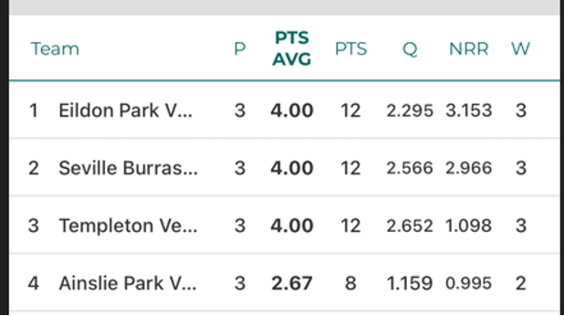

Semi Finals: Seville Burras V’s Templeton, Eildon Park Vets V’s Ainslie Park Vets. Wins to Seville Burras Vets & Eildon Park, both games were close and again high scores well done to the winners.

Grand Final: Eildon Park Vets V’s Seville Burras at Eildon Park home ground. Very hot evening and Eildon Park got off to a flyer and amassed a large score again 2/237 off 20 Overs, Cosstick 58 of 30 balls, Adams 55 off 30 balls & Dowling 71 off 30 balls. It wasn’t the Burras evening they didn’t get off to a great start chasing the large score. Congratulations to Eildon Park on a great win.

Thank you to Eildon Park to hosting the Final, the GF was played with great spirit and enjoyed by most watching the game.

To all teams and players thank you for a wonderful T20 Big Bash season, feedback was very positive and enjoyed by everyone.

A special thank you to all Umpires for attending and officiating all games, and your enjoyment of the competition.

I would also like to thank Timothy Court on his help and support helping with the fixturing and uploading to PlayHQ and support while I was away.

Looking forward to T20 Big Bash Season 7.

Sunday Competition

The Eastern Veterans Competition is an Over 40’s partnership competition between the Ringwood and District Association (RDCA) and the Box Hill Reporter Cricket Association (BHRDCA). The competition was first contested in 2023-24.

In season 2024-25 a total of 17 teams competed across the three divisions with a total of 329 players registered to compete in the season. The seven round season was truncated by effects of weather with a wash out in November followed by a heat out in February. Finals were played over the weekends of February 9 and 23 2025.

The A Division Peter White Perpetual Trophy had a total of 6 teams competing. The final was held between Box Hill North Superkings and Notting Hill Brandon Park with the teams having finished 2nd and 4th respectively. Box Hill North were the eventual premiers chasing down Notting Hill Brandon Park innings of 6/166 with 4 overs to spare.

The B Division Ken Johnston Trophy was contested by 5 teams following a late withdrawal. Heatherdale and Deakin finished 1st and 2nd respectively at the completion of the home and away season and contested the Grand Final. Heatherdale winning the decider making 195 runs from their allotted 36 overs and dismissing Deakin for 129.

The C Division Bill & Marg Stafford Trophy had six teams in the division. The Grand Final was between the teams that finished first and second on the ladder , Kerrimuir United and Mitcham Black. The final was evenly fought with Kerrimuir winning by 11 runs at the compulsory closure of both innings.

The season completed we look forward to season 2025/26 with the hope that a few more clubs will enter an over 40 team.

WOMEN'S COMPETITION REPORT

Chair - Linda Bailey
Season 2024/25 was the 4 th season for the RDCA’s Women’s East Competition. We were
able to offer a 5 grade competition, which ranged from our E Grade T20 only grade to our
elite A Grade. It can be described as one where our players took the opportunities presented, both in our competition matches and in representative matches, to highlight
their skills, abilities and determination for Victoria to see.

We were challenged yet again with adverse weather in the form of teeming rain and
excessive heat. Our players, clubs and umpires took it all in their stride and continued to
play good cricket. It is obvious to all who come along to our women’s matches that the
standard of cricket overall has grown since our first season, and that’s a testament to our
players and coaches.

Congratulations to our premiers:
- A Grade: Mooroolbark
- B Grade: Warranwood
- C Grade: Kilsyth
- D: Grade: Templeton
- E Grade: Knox City

Congratulations too, to the inaugural Radio Eastern 98.1 FM Women’s Player of the Year,
Hailey Ferris from Heatherdale, who also took out our B Grade Champion Player’s Award.

Other Champion Players were:
- A Grade: Sarah Smith (Bayswater Park)
- C Grade: Alyssa Rowe (Blackburn)
- D Grade: Megan Payne (Templeton)
- E Grade: Rajni Sharma (Knox City)

It was Knox City’s first year in our competition, what a way to make your entrance!
We had two opportunities this year to showcase our game beyond our usual home and
away season, with the RDCA Emergency Services Cup and the first RDCA All Stars match
against Ringwood Rams. We unfortunately lost the game against the Rams, and were
treated to a batting masterclass by Ringwood’s Teagan Rule. Kudos to our young bowlers
who kept their heads up and toiled away. Thanks to Caity Parker from Lusatia Park who
took on the role of captain, and Shane Larmour from Bayswater Park who took on the role
of coach.

Our women’s match in the Emergency Services Cup was definitely where the action was at,
with spectators and players alike joining in the spirit of the day, which was to raise funds for the CFA and the SES. Huge thanks to Jo Fairy and Pul Attfield for the work they put in to
make the day a success, and Caity Parker and Jess Walker from Belgrave who captained the teams. Team SES won our women’s match and Team CFA won the men’s match, which
meant that both services had some silverware to take back, as well as some bragging rights.
Not only did our players have fun, but they enjoyed playing with members of both
emergency services and getting to hear a little more about what they do.

Our players are also representing the RDCA with distinction in other competitions eg:
- Junior players who played for the RDCA in the Junior Carnival
- Players selected for the Victorian Metro and Country age squads
- Playing in over 40s tournaments
- Playing for Victoria in the recent Australian Indoor Cricket Championships
- Playing in the Afghanistan Women’s XI vs Cricket Without Borders T20 match at
- Citipower Centre in January

All in all, it was a successful season.

STATISTICAL INFORMATION 2024/2025

LINDSAY TROLLOPE SHIELD

Premiers: Croydon Ranges CC

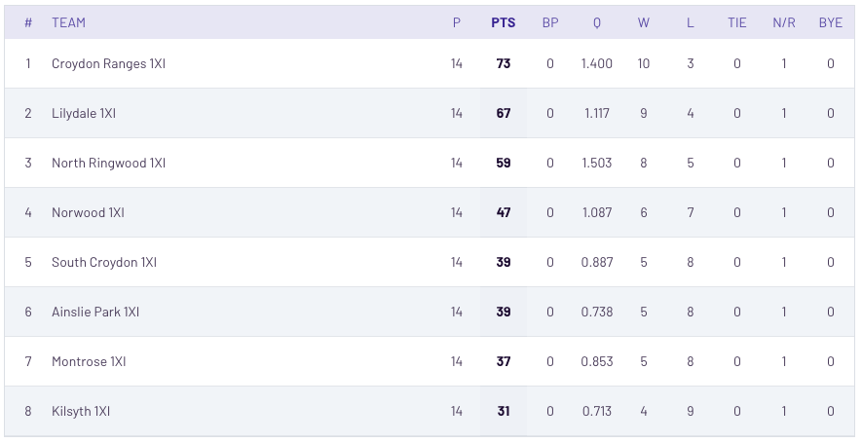

Grand Final

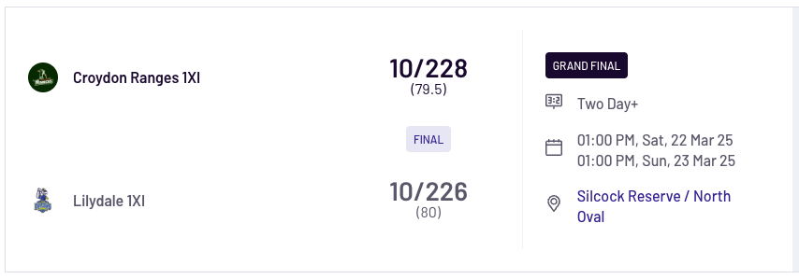

BILL WILKINS CUP
Premiers: St Andrews CC
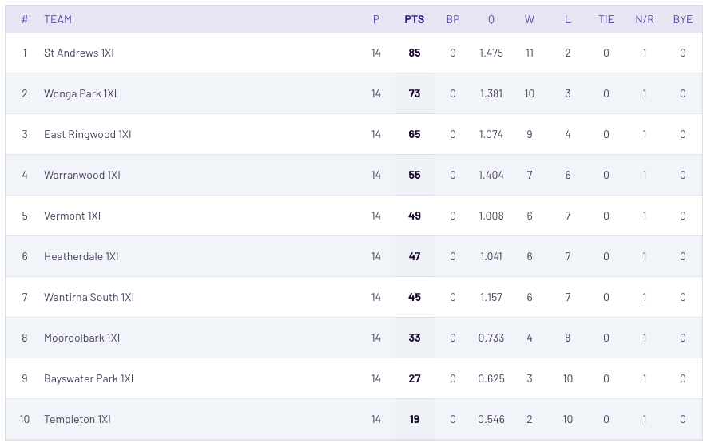

Grand Final

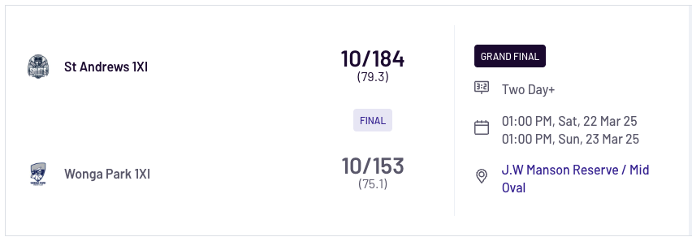

STUART NEWEY PLATE

Premiers: Mt Evelyn CC
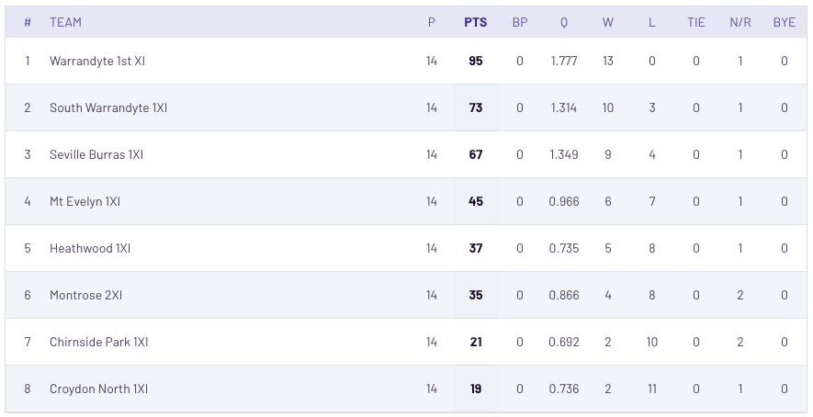

Grand Final

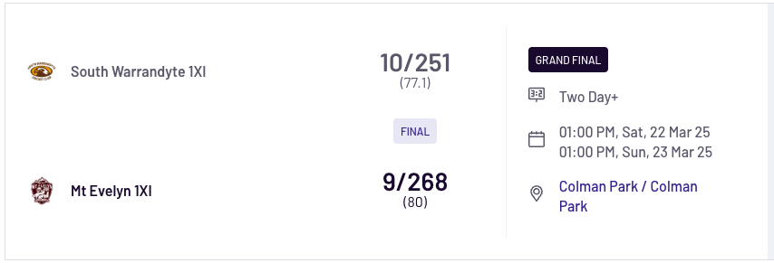

STEVE PASCOE SHIELD

Premiers: Yarra Junction CC
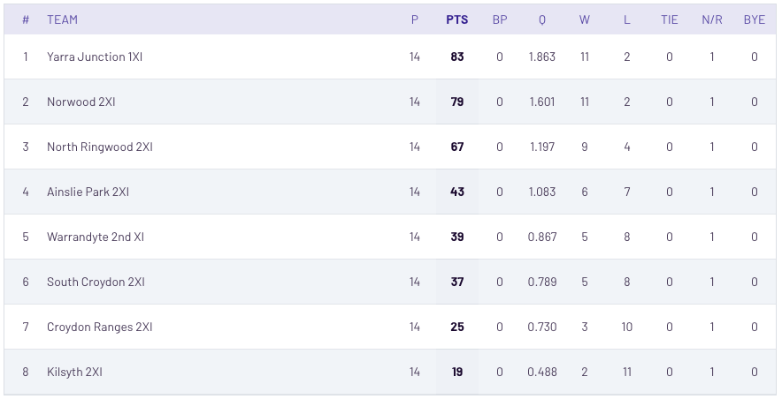

Grand Final

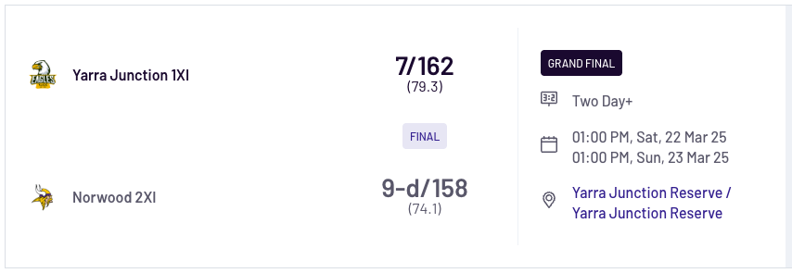

PAT MEEHAN SHIELD

Premiers: East Ringwood CC

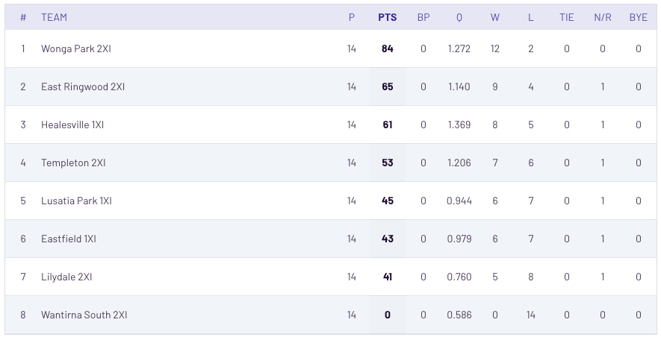

Grand Final

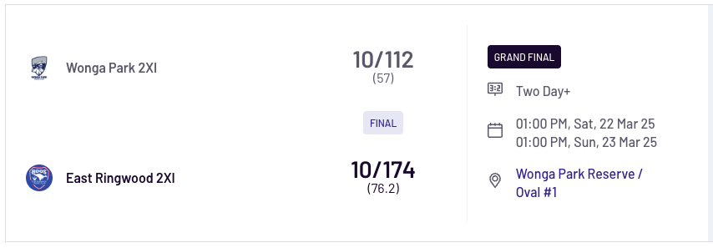

IAN SPENCER SHIELD

Premiers: Warranwood CC
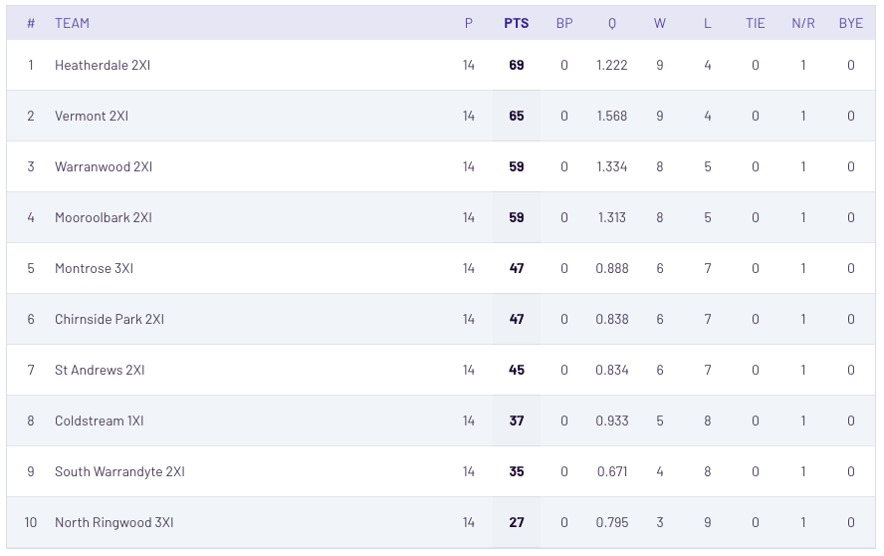

Grand Final
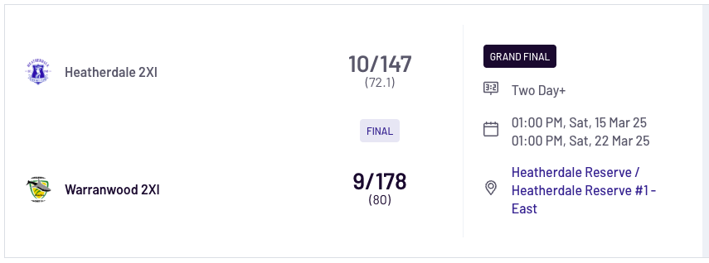

DAVID BEATTY SHIELD
Premiers: Heathwood CC

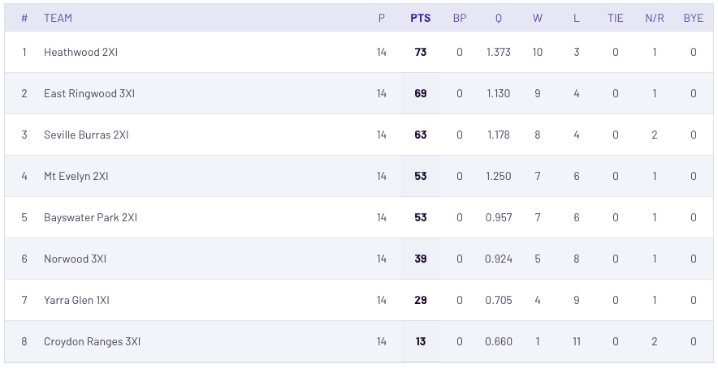

Grand Final
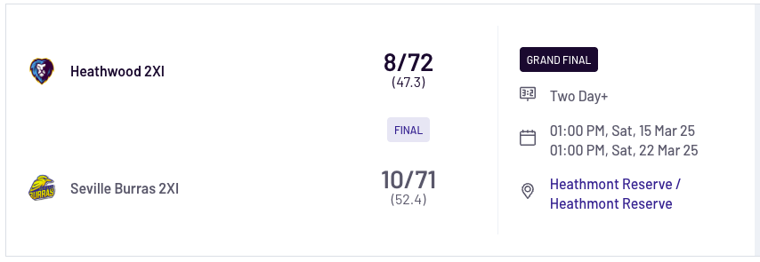

DON SMITH SHIELD
Premiers: Wandin CC
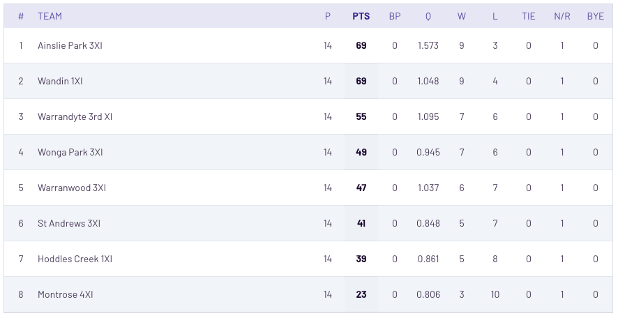

Grand Final
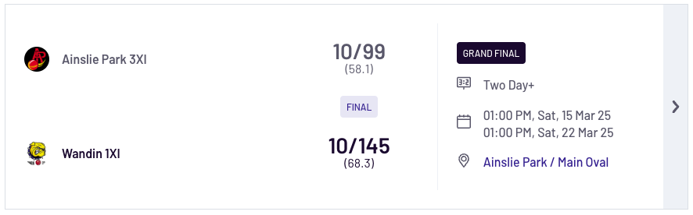

JOHN SPRINGETT SHIELD
Premiers: Kilsyth CC
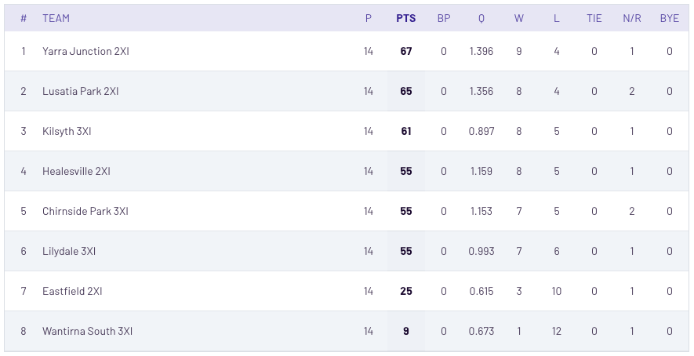

Grand Final
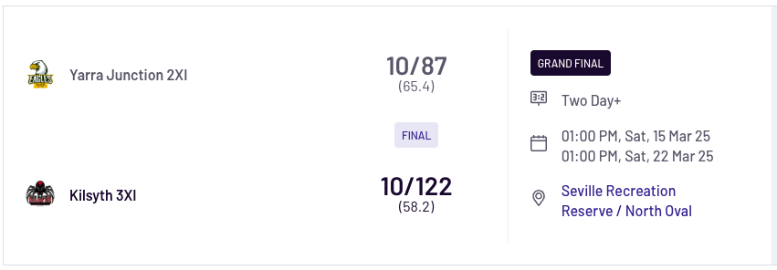

“A” GRADE – NEIL TULL SHIELD
Premiers: Croydon North CC
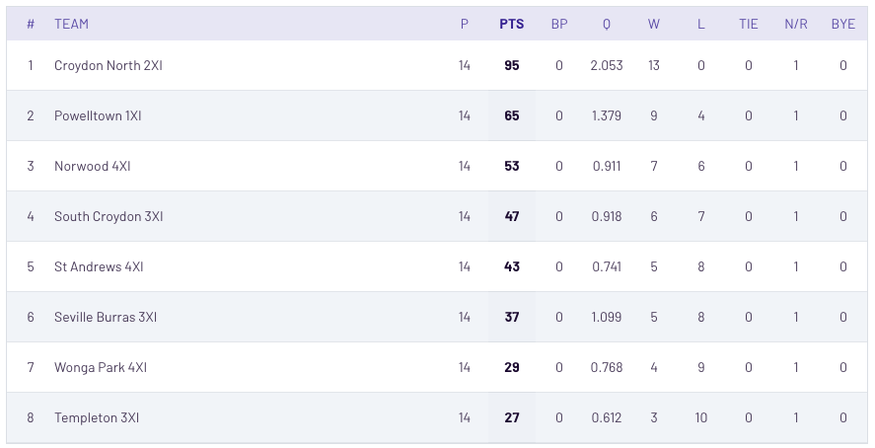

Grand Final
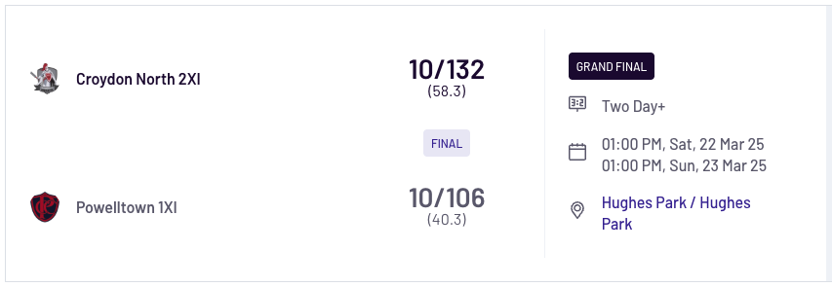

“B” GRADE – ANN PASCOE SHIELD
Premiers: Heatherale CC
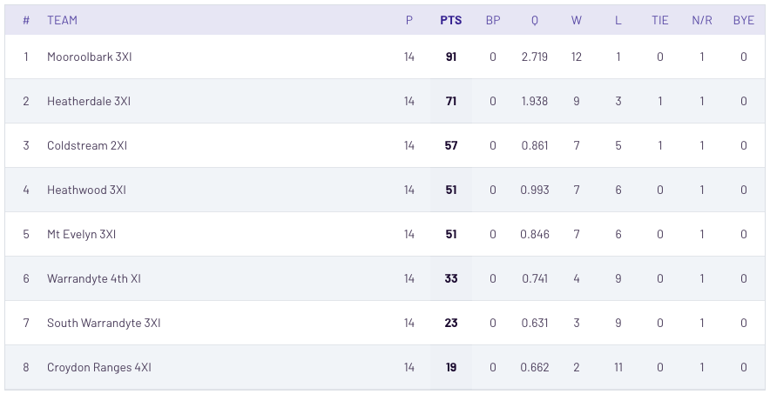

Grand Final
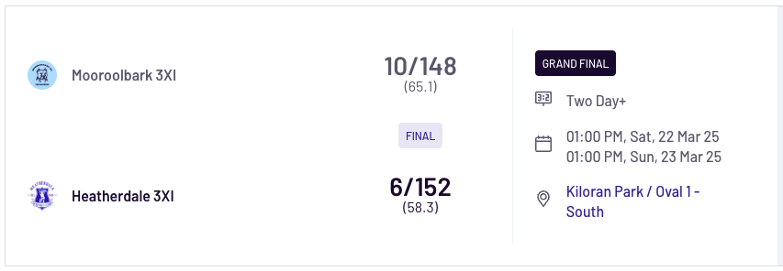

“C” GRADE – DJ STRACHAN SHIELD
Premiers: Kilsyth CC

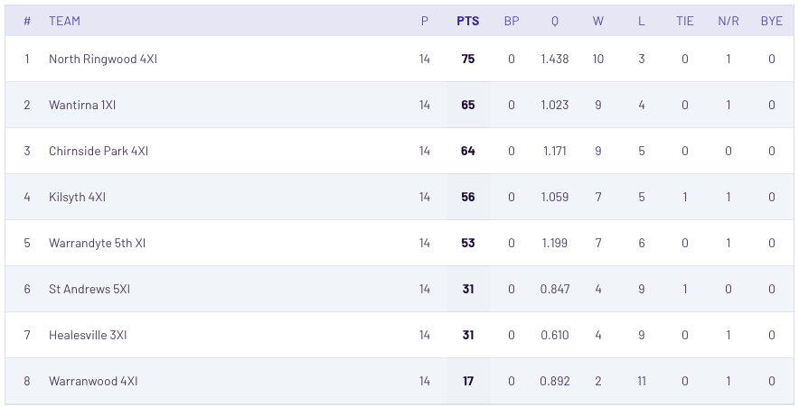

Grand Final
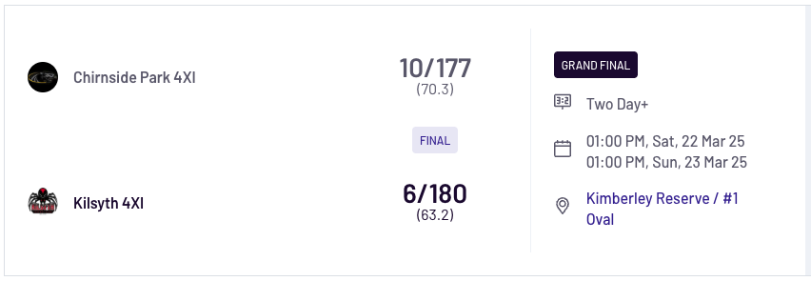

“D” GRADE – ADRIAN HAMMOND
Premiers: East Ringwood CC
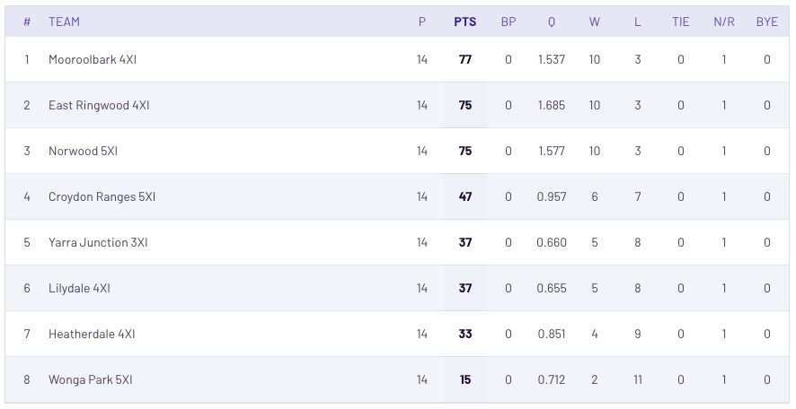

Grand Final
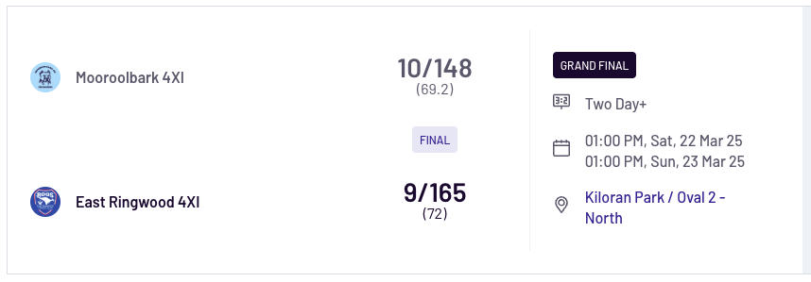

“E” GRADE - Stuart Minetti Shield
Premiers: Wandin CC
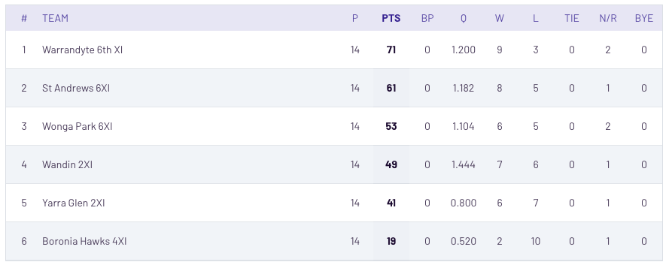

Grand Final
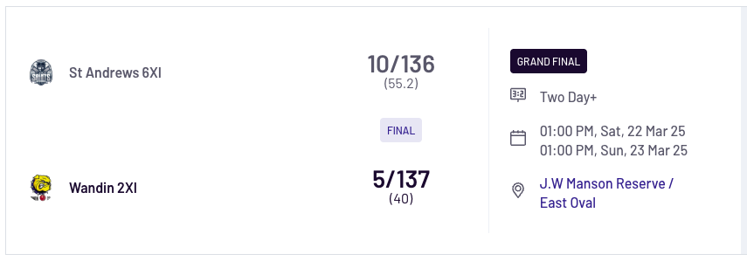

“F” GRADE – IAN DENCH SHIELD
Premiers: Ainslie Park CC
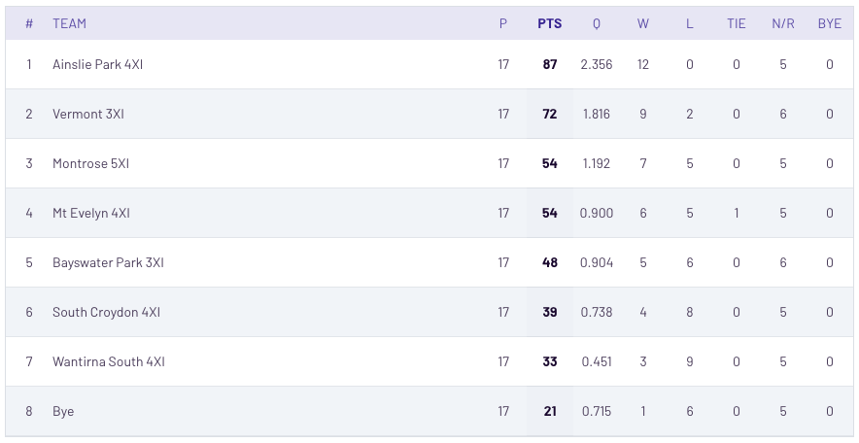

Grand Final
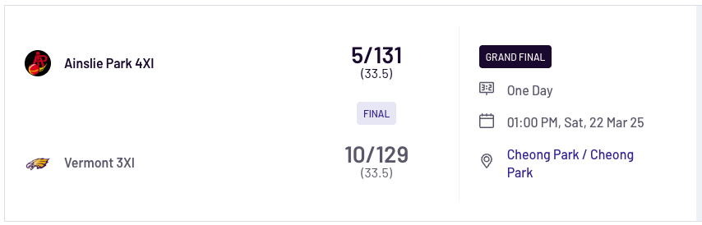

“G” GRADE – JOHN MACMILLAN SHIELD
Premiers: Mt Evelyn CC

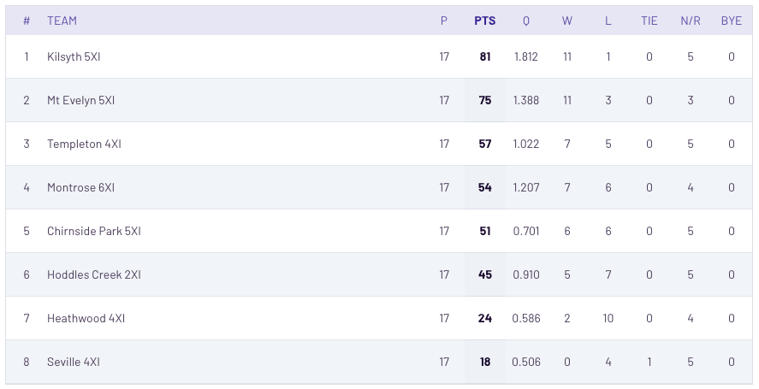

Grand Final
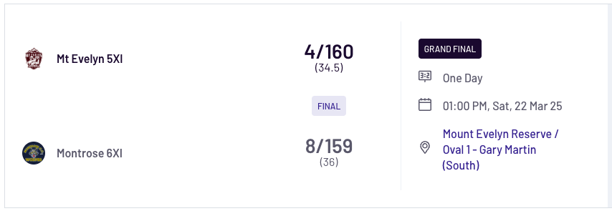

“H” GRADE – TIMOTHY COURT SHIELD
Premiers: Warranwood CC
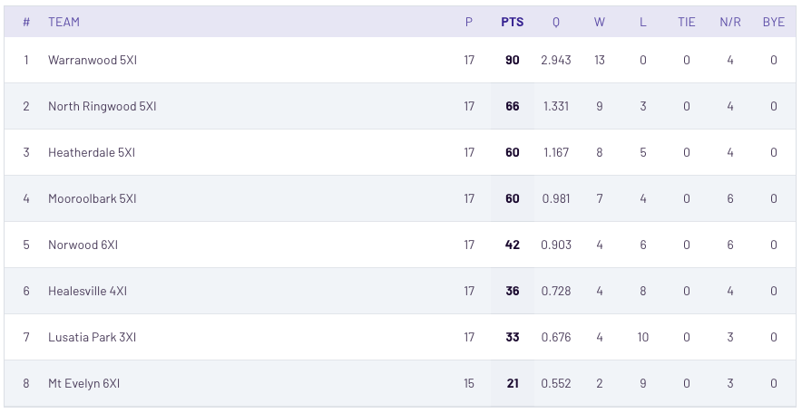

Grand Final
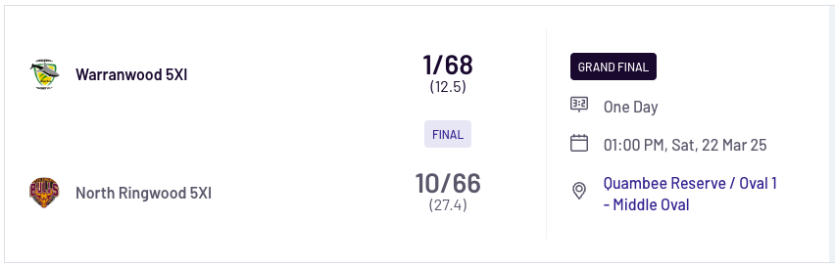

“I” GRADE – TONY GAWNE SHIELD
Premiers: Croydon North CC
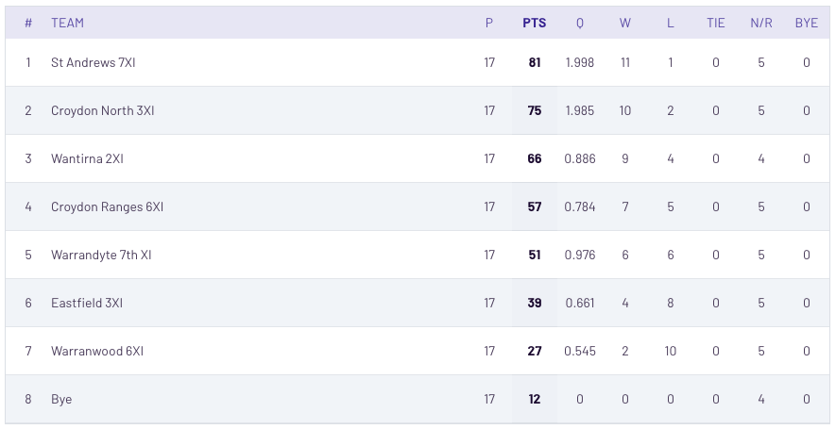

Grand Final
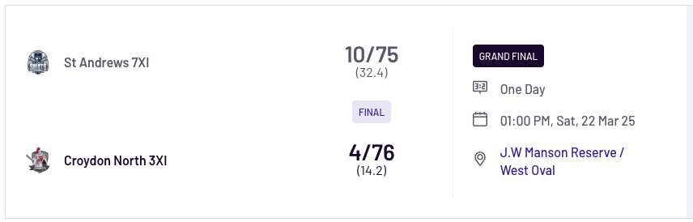

“J” GRADE - GREGOR MASON SHIELD
Premiers: Wonga Park CC

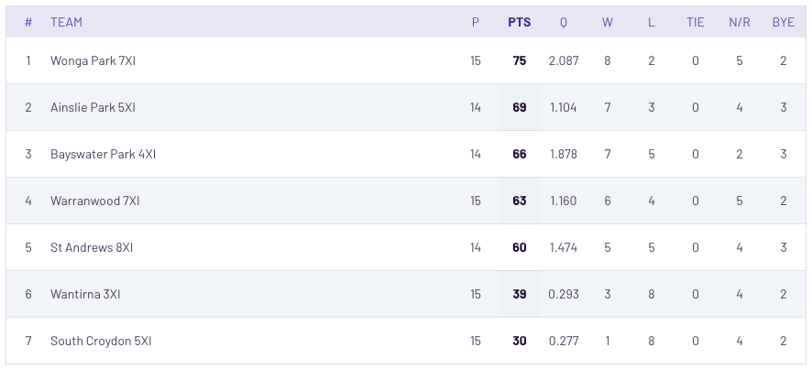

Grand Final
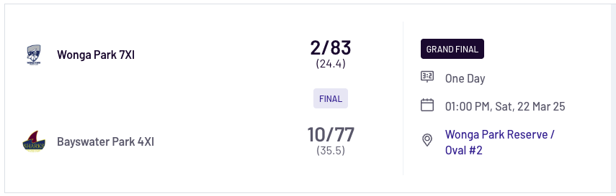

“K” GRADE - GREG MITCHELL SHIELD
Premiers: Croydon North CC
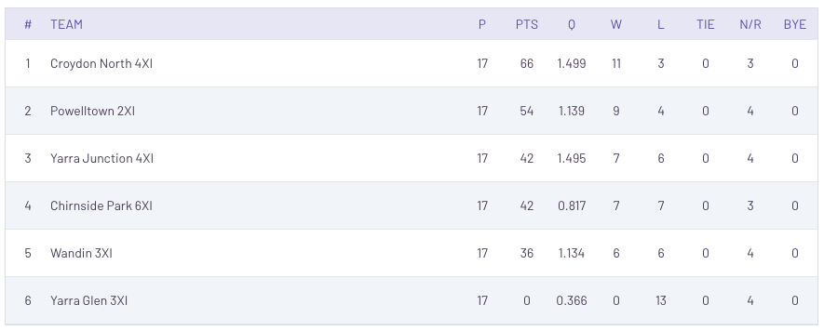

Grand Final
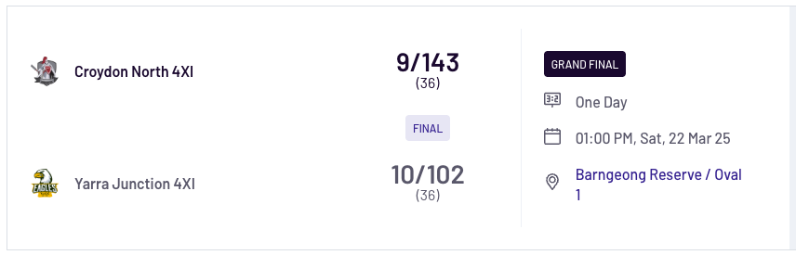

“L” GRADE
Premiers: East Ringwood CC

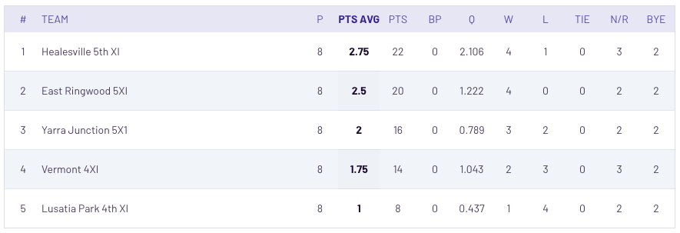

Grand Final
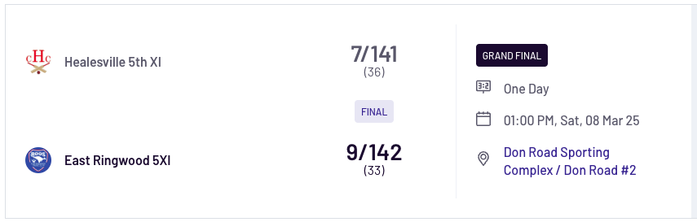

Vets T20 Big Bash

Premiers: Eildon Park CC

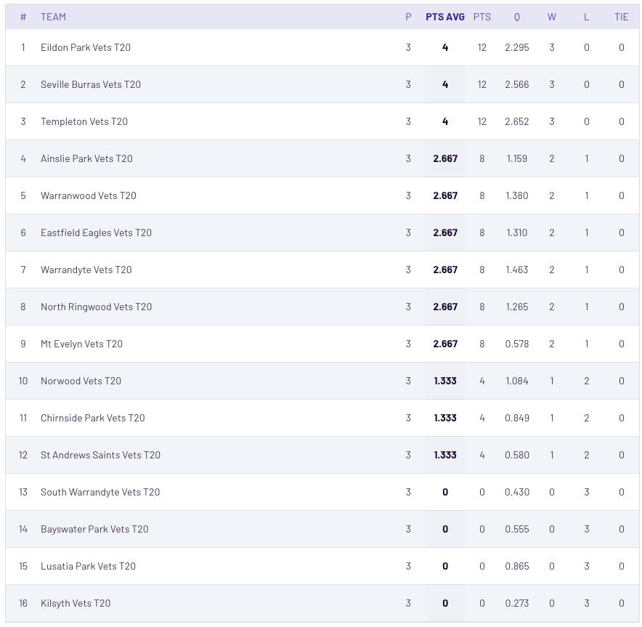
Grand Final

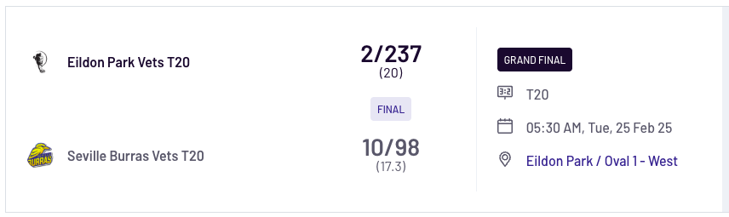

Masters 1 - Peter White Memorial Shield
Premiers: Box Hill Super Kings CC
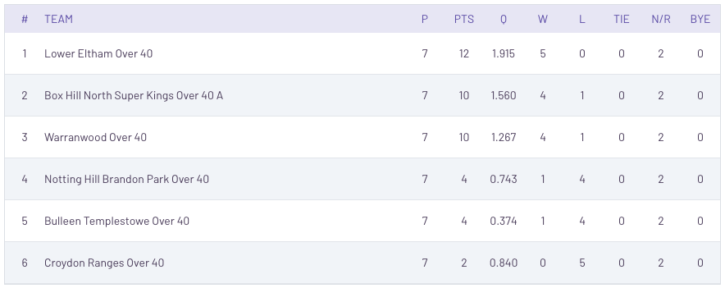

Grand Final
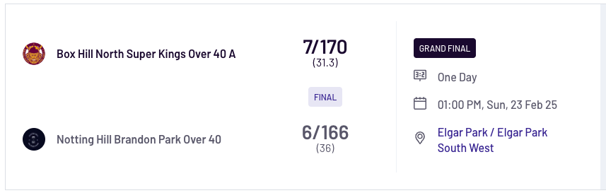

Masters 2 - Ken Johnston Trophy
Premiers: Heatherdale CC
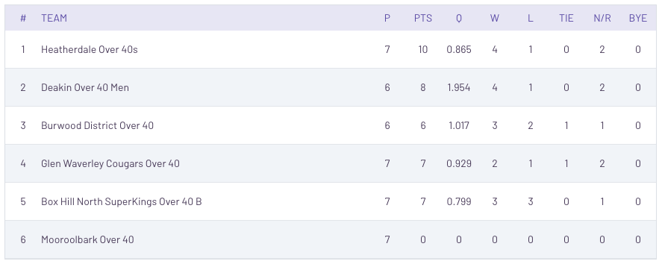

Grand Final
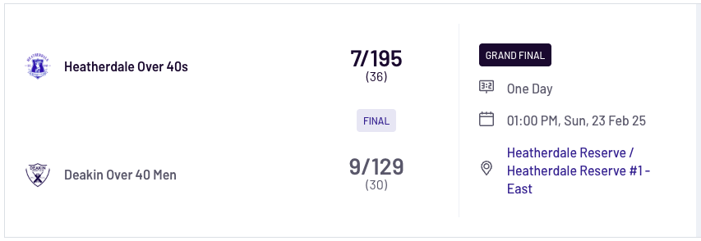

Masters 3 - Bill and Marg Stafford Trophy
Premiers: Kerrimuir United CC

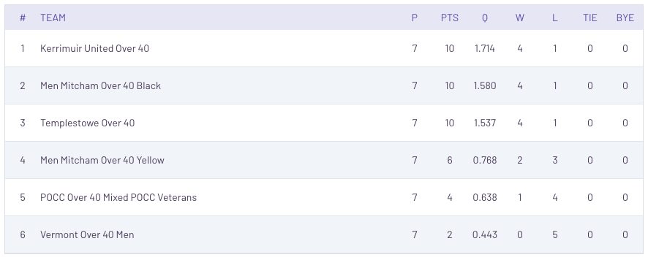

Grand Final

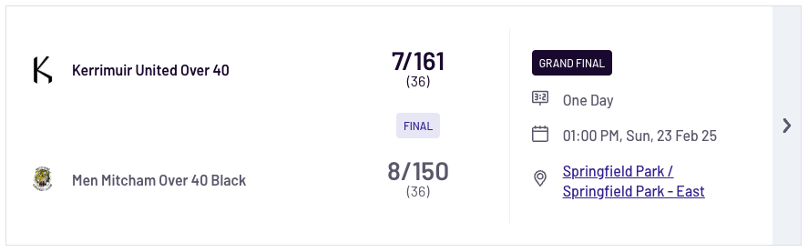

Women's - A Grade
Premiers: Mooroolbark CC

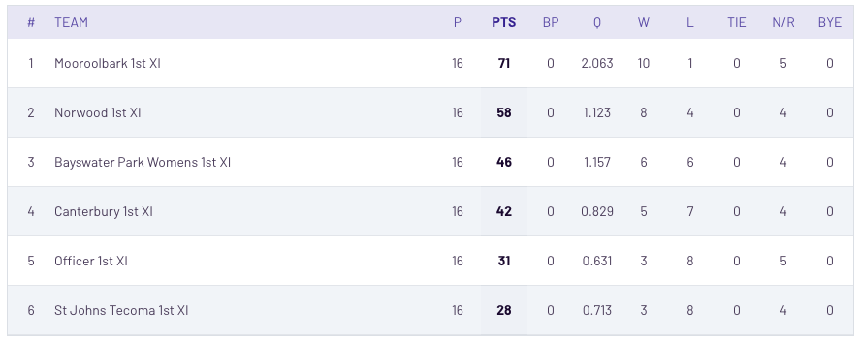

Grand Final

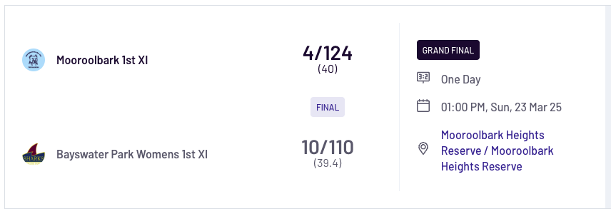

Women's - B Grade
Premiers: Warranwood CC
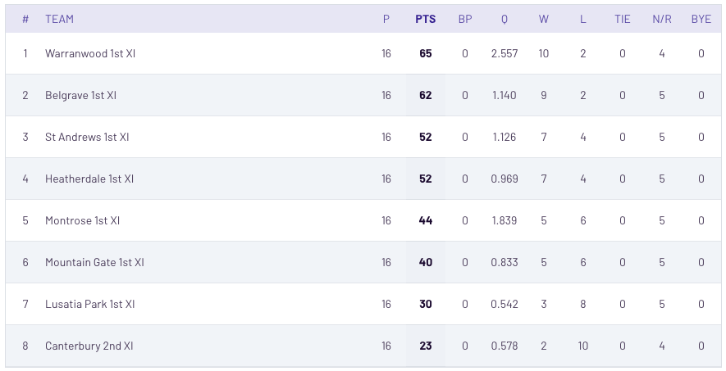

Grand Final

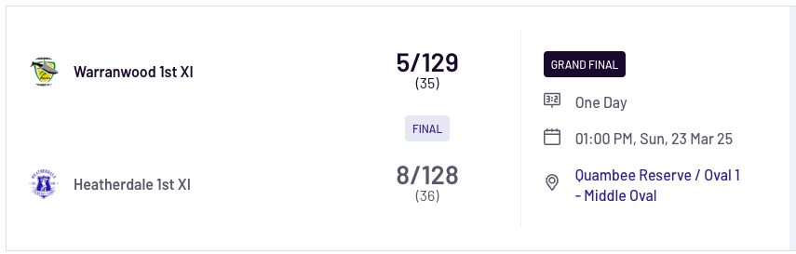

Women's - C Grade
Premiers: Kilsyth CC
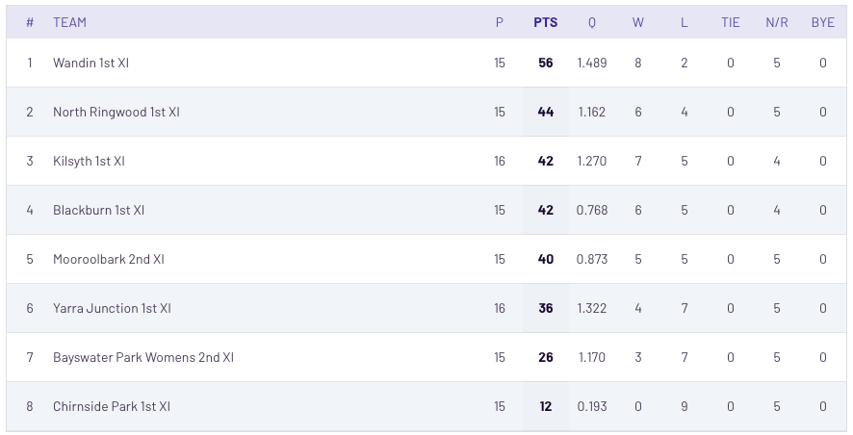

Grand Final
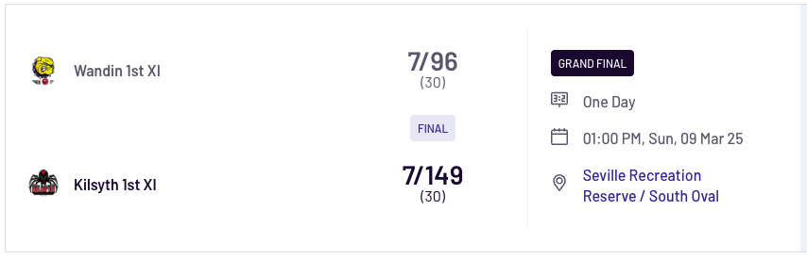

Women's - D Grade
Premiers: Templeton CC
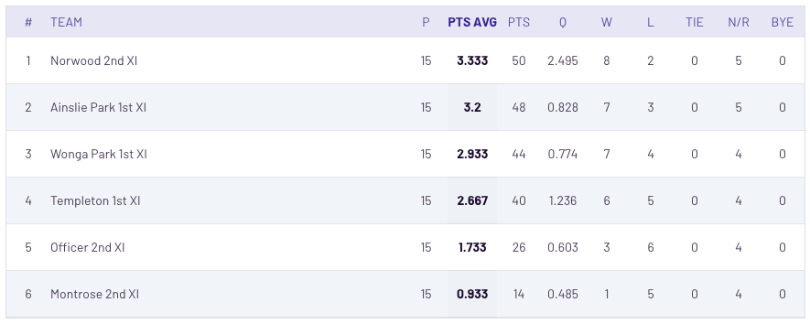

Grand Final
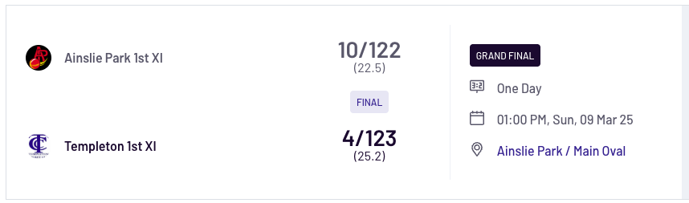

Women's - E Grade
Premiers: Knox City CC
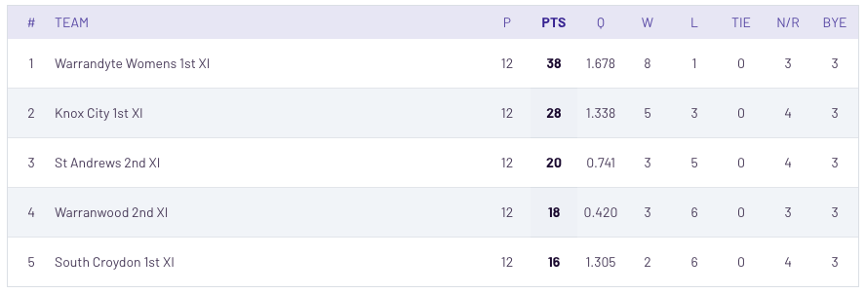

Grand Final
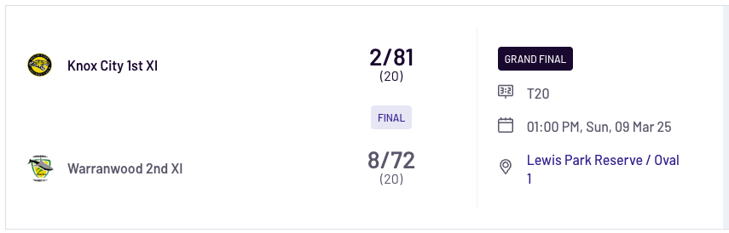

AWARD WINNERS

CLUB CHAMPIONSHIP – Phil McCallum award
Winner Norwood CC

SPIRIT OF CRICKET TROPHY – Ron Ellis award
(Professional Umpires rate teams that compete in the top five grades, in 5 categories, at end of each match)

Winner Croydon Ranges CC

BEST ADMINISTERED CLUB – Bob Bisset award
(Senior Committee introduced this award in season 2010/11 and it selects the winner)

Winner Me Evelyn CC

UMPIRE OF THE YEAR TROPHY – Ken Dunham award
(based on the ratings given by team captains after each round)

Winner Doug Wooles

FRED HODGKINS ALL STAR TEAM OF THE YEAR

Player | Club
Ryan Peter-Budge | North Ringwood
Andy Solomons | Kilsyth
Daniel Thompson | Lilydale
Jack Blyth (C) | Croydon Ranges
Michael Edwards | Montrose
Aaron Leis | North Ringwood
Luke Ridgwell | North Rinwood
Jandu Ishraji | Norwood
Mitchell Crozier | South Croydon
Darcy Carrigan | Croydon Ranges
Joseph Blyth | Croydon Ranges

BEST and FAIREST AWARDS
(Decided on umpires votes)

Bill Dean Medal - Lindsay Trollope Shield
Jack Blyth Croydon Ranges

Bill Wilkins Medal – Bill Wilkins Cup
Troy Gstrein Bayswater Park

Stuart Newey Medal - Stuart Newey Plate
Robert Cranmer Heathwood

Steve Pascoe Medal – Steve Pascoe Shield
David Lever Yarra Junction

Pat Meehan Medal – Pat Meehan Shield
Ash Hamer Healesville

ALLROUNDER TROPHIES
Meehan Shield:
Joshua Handysyde Healsville

Pascoe Shield:
David Lever Yarra Junction

Newey Plate:
Robert Cramner Heathwood

Wilkins Cup:
Cameron Wheeler St Andrews

Trollope Shield:
Andy Solomons Kilsyth

CHAMPION PLAYER
Women's - A Grade:
Sarah Smith Bayswater Park

Women's - B Grade:
Hayley Ferris Heatherdale

Women's - C Grade
Alyssa Rowe Blackburn

Women's - D Grade
Megan Payne Templeton

Women's - E Grade:
Rajni Sharma Knox City

BATTING and BOWLING AVERAGES

GRADE | BATTING | BOWLING
LINDSAY TROLLOPE SHIELD | RYAN PETER-BUDGE  (NORTH RINGWOOD)  629 RUNS AVG: 89.86 | LUKE RIDGWELL  (NORTH RINGWOOD)  29 WICKETS AVG: 13.17
BILL WILKINS CUP | TROY McGOWN  (WANTIRNA SOUTH)  383 RUNS AVG: 47.88 | CAMERON WHEELER  (ST ANDREWS)  33 WICKETS AVG: 10.48
STUART NEWEY PLATE | MORGAN PERRSON-CLARK (SOUTH WARRANDYTE)  586 RUNS AVG: 73.25 | CHAD WITHERDIN  (SEVILLE BURRAS)  27 WICKETS AVG: 12.85
STEVE PASCOE SHIELD | DAVID LEVER  (YARRA JUNCTION)  619 RUNS AVG: 51.58 | DANIEL LEVER  (YARRA JUNCTION)  32 WICKETS AVG: 9.06
PAT MEEHAN SHIELD | DEVESH SINGH  (TEMPLETON)  287 RUNS AVG: 95.67 | MATTHEW BARNARD (EASTFIELD)  24 WICKETS AVG: 14.75
IAN SPENCER SHIELD | TIM HALL  (WARRANWOOD)  341 RUNS AVG: 56.83 | SEAN MILTON  (ST ANDREWS)  25 WICKETS AVG: 16.36
DAVID BEATTY SHIELD | ANTHONY BIDDISCOMBE (YARRA GLEN)  315 RUNS AVG: 39.38 | LEMUEL SURAJ  (EAST RINGWOOD)  20 WICKETS AVG: 11.15
DON SMITH SHIELD | SIMON McLACHLAN  (HODDLES CREEK)  536 RUNS AVG: 59.56 | DANIEL TREMBATH  (WANDIN)  24 WICKETS AVG: 17.33
JOHN SPRINGETT SHIELD | ASHLEY WEBB  (WANTIRNA SOUTH)  667 RUNS AVG: 74.11 | TYLER REED  (YARRA JUNCTION)  34 WICKETS AVG: 9.21
A GRADE - NEIL TULL SHIELD | TARRAN VAN EGMOND  (SOUTH CROYDON)  607 RUNS AVG: 75.88 | DANIEL EASTWOOD (POWELLTOWN)  29 WICKETS AVG: 14.90
B GRADE - ANN PASCOE SHIELD | DARRYN FISK  (MOOROOLBARK)  530 RUNS AVG: 132.50 | HAILEY FERRIS  (HEATHERDALE)  19 WICKETS AVG: 8.89
C GRADE - DJ STRACHAN SHIELD | JASON GREEN  (WANTIRNA)  643 RUNS AVG: 64.30 | MATTHEW O'BRIEN (WANTIRNA)  22 WICKETS AVG: 15.09
D GRADE - ADRIAN HAMMOND SHIELD | SHANE ARCHER (MOOROOLBARK)  204 RUNS AVG: 68.00 | FLYNN TAYLOR  (EAST RINGWOOD)  21 WICKETS AVG: 5.71
E GRADE - STUART MINETTI SHIELD | TIM MORAN  (ST ANDREWS)  820 RUNS AVG: 91.11 | HUNTER GRENFELL  (YARRA GLEN)  18 WICKETS AVG: 11.36
F GRADE - IAN DENCH SHIELD | TROY HARRIS  (AINSLIE PARK)  255 RUNS AVG: 255.00 | HAYDEN LACE  (AINSLIE PARK)  16 WICKETS AVG: 13.69
G GRADE - JOHN MACMILLAN SHIELD | KANE RATTRAY ROBERT (MONTROSE)  375 RUNS AVG: 125.00 | JOHN WILSON  (KILSYTH)  14 WICKETS AVG: 10.79
H GRADE - TIMOTHY COURT SHIELD | JOHN MIDDENWAY  (NORTH RINGWOOD)  373 RUNS AVG: 124.33 | STEPHEN ORR  (NORWOOD)  20 WICKETS AVG: 9.40
I GRADE - TONY GAWNE SHIELD | KAPIL SETHI (ST ANDREWS)  390 RUNS AVG: 78.00 | ANTHONY SMITH  (CROYDON NORTH)  15 WICKETS AVG: 11.60
J GRADE - GREGOR MASON SHIELD | WILLIAM EDMONDS  (WONGA PARK)  309 RUNS AVG: 309.00 | CHRIS KENT  (WONGA PARK)  10 WICKETS AVG: 10.00
K GRADE - GREG MITCHELL SHIELD | GORDON GOSLAND  (WANDIN)  283 RUNS AVG: 94.33 | GLENN LAIDLAW  (CROYDON NORTH)  19 WICKETS AVG: 9.37
L GRADE | LEE CALDICOTT  (HEALESVILLE)  121 RUNS AVG: 121.00 | SUMMER CALDICOTT (HEALESVILLE)  7 WICKETS AVG: 10.14

Women's - A Grade | Batting | Lily Osborn | Mooroolbark | 40.38
 | Bowling | Briony Polkinghorne | Norwood | 9.37
Women's - B Grade | Batting | Hailey Ferris | Heatherdale | 100.5
 | Bowling | Tegan Pitt | Warranwood | 8.17
Women's - C Grade | Batting | Ashleigh Katoa | Kilsyth | 277
 | Bowling | Olivia Edwards | Wandin | 6.07
Women's - D Grade | Batting | Megan Payne | Templeton | 47
 | Bowling | Olivia Payne | Templeton | 10.75
Women's - E Grade | Batting | Yasemin Ziada | Warrandyte | 121
 | Bowling | Rajni Sharma | Knox City | 8.8

SENIOR MENS PREMIERSHIPS WON from 1966/67 to 2024/2025

Club | Premierships | 1st XI |  | Club | Premierships | 1st XI
Wonga Park | 51 | 4 |  | Wantirna | 18 | 6
Ainslie Park | 42 | 5 |  | Chirnside Park | 17 | 5
East Ringwood | 38 | 8 |  | Sth Warrandyte | 15 | 5
Mooroolbark | 36 | 11 |  | South Croydon | 13 | 5
North Ringwood | 35 | 8 |  | Scoresby | 12 | 2
Wantirna South | 35 | 6 |  | Boronia | 11 | 0
Croydon Ranges | 34 | 9 |  | Eastfield | 10 | 3
St Andrews | 34 | 7 |  | Heathwood | 8 | 1
Kilsyth | 31 | 3 |  | Seville | 3 | 0
Montrose | 30 | 6 |  | Yarra Glen | 3 | 0
Croydon North | 29 | 9 |  | Wandin | 3 | 1
Norwood | 28 | 4 |  | Coldstream | 2 | 1
Templeton | 28 | 5 |  | Healesville | 2 | 0
Warrandyte | 27 | 4 |  | Poweltown | 2 | 0
Lilydale | 24 | 5 |  | Yarra Junction | 2 | 1
Bayswater Park | 23 | 3 |  | Hoddles Creek | 1 | 1
Warranwood | 23 | 9 |  | Heatherdale | 1 | 0
Mt Evelyn | 18 | 4

- Croydon Ranges totals include premierships won by Croydon United and Croydon Hockeyers.

- Warranwood totals include premierships won by South Ringwood and Parkwood.

- Scoresby totals include premierships won by Scoresby Ferndale.

- Heathwood totals include premierships won by Heathmont Baptists

SENIOR WOMEN’S PREMIERSHIPS WON from 2021/2022 to 2024/2025

Club | Total | A | B | C | D | E
Mooroolbark | 3 | 2 | 1 | 0 | 0 | 0
Kilsyth | 2 | 0 | 0 | 2 | 0 | 0
Norwood | 2 | 1 | 0 | 1 | 0 | 0
Warranwood | 1 | 0 | 1 | 0 | 0 | 0
Ainslie Park | 1 | 0 | 0 | 0 | 1 | 0
Knox City | 1 | 0 | 0 | 0 | 0 | 1
Officer | 1 | 0 | 1 | 0 | 0 | 0
St Andrews | 1 | 0 | 0 | 1 | 0 | 0
Wonga Park | 1 | 0 | 0 | 0 | 1 | 0
Launching Place | 1 | 1 | 0 | 0 | 0 | 0
Wycliff | 1 | 0 | 1 | 0 | 0 | 0

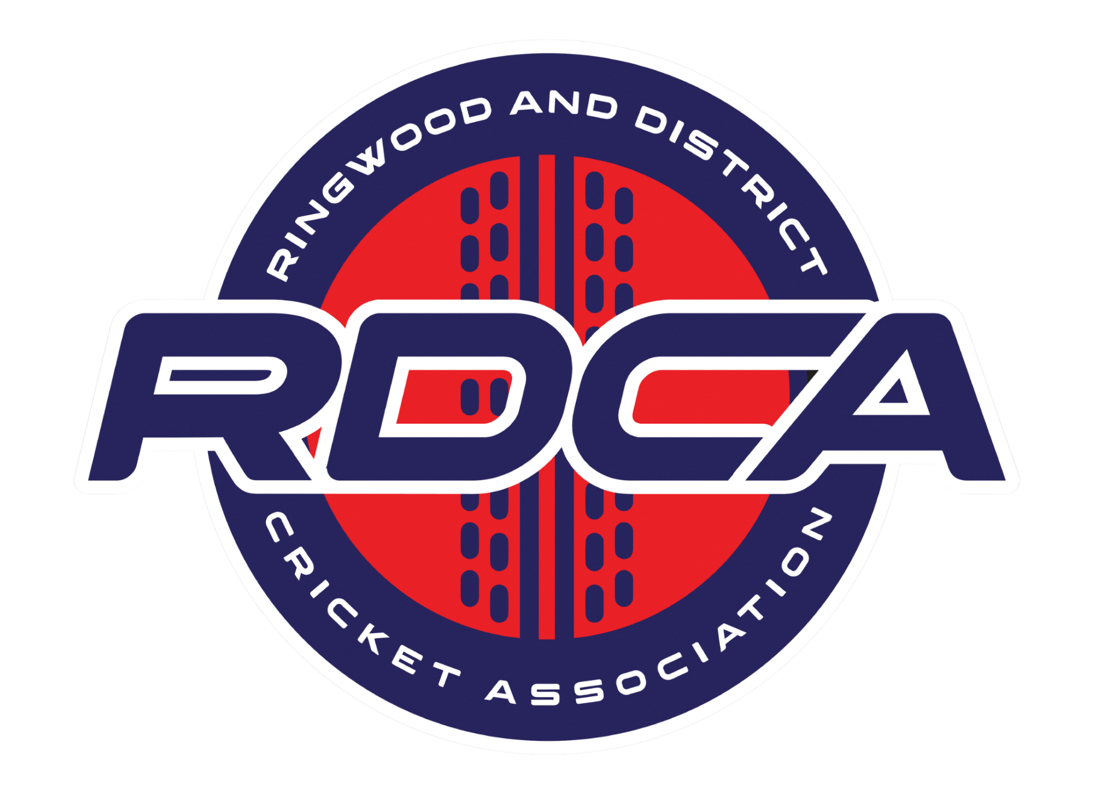

2024/2025 Sponsors

