Modeling Moon Phases and the Earth-Moon System
Project ASTRO Texas

What do they learn?
Students explore how moon phases arise, how they change with the lunar cycle, and why certain phases are visible at certain times. The activity uses simple materials that illustrate how lunar phases arise from illumination by the Sun. This is an opportunity to understand the relative scales and motions of the Earth-Moon system.

What do they do?
Students use inexpensive styrofoam balls to simulate the Moon, which is lit by a single light source in the room that represents the Sun. This hands-on exercise will have them observing how the Moon-ball is lit up as they hold it in various positions. Using a larger ball to represent the Earth, a 3-D model of the Earth and Moon can be appreciated.

Some suggestions

• The lunar phase activity works best in a very dark room, ideally with dark walls. Consider doing it in a room in which the lights can be turned off and the windows shaded. Some teachers have suggested that an auditorium stage, inside a closed dark curtain, works well.

• The activity can be done with an overhead projector or laptop projector as a very bright light source, but only the students in the beam will be able to use it.

• Students should be spread out enough that they don’t shade each other, and are at least an arms length apart. It may well be done best in small groups.

• To address misconceptions, start the activity by asking the students to develop possible explanations for lunar phases that they can be used to test.

• Teacher can start the activity with a demonstration, asking students to start out by reasoning out what the teacher sees as he/she does the activity. “Tell me what I’m seeing here.”

Materials:

• Light bulb on a stand. 60-100W ideal.
• One white styrofoam ball for each student
• One pencil for each student to hold the ball
• Darkenable room with space for students at arms length or more

Procedure for Lunar Phases:

(1) Set up light bulb in front of the room, high enough that nothing is blocking it. Perhaps set it on a chair or a stool that is on a table.
Ideally affix it with some tape, to prevent it from being accidentally pulled down.

(2) Students should stand apart in a semicircle, facing the lamp. Ideally at least one arms length apart.

(3) Explain that the lamp represents the Sun, their head the Earth, and their nose being where they live.

(4) Students should turn slowly to make day and night. Noon is when their nose faces the light, and midnight is when their nose faces away. The students should be reminded that the Earth takes one day (24 hours) to turn all the way around. Really, it should be their head going all the way around, but humans are not built to do that!

(5) If the north pole is at the top of their head, which way is east and which way is west? They should be turning to their left, which is towards their east. (The Earth rotates only in one direction!) What would be different if the Earth rotated the other way? If their nose is Texas, which cheek would California be on? Where would China be? Have a globe handy to illustrate.

(6) Distribute one styrofoam ball to each student. Students should stick their pencil into the ball (ideally, in a hole that’s already in the ball – don’t make lots of holes!), and hold the ball at arms length.

(7) Students should turn around (to the left again!) with the Moon at arms length. This represents the Moon in orbit around the Earth. The students should be reminded that the Moon takes “about a month” (a “moonth”!) to go all the way around the Earth.
First Quarter
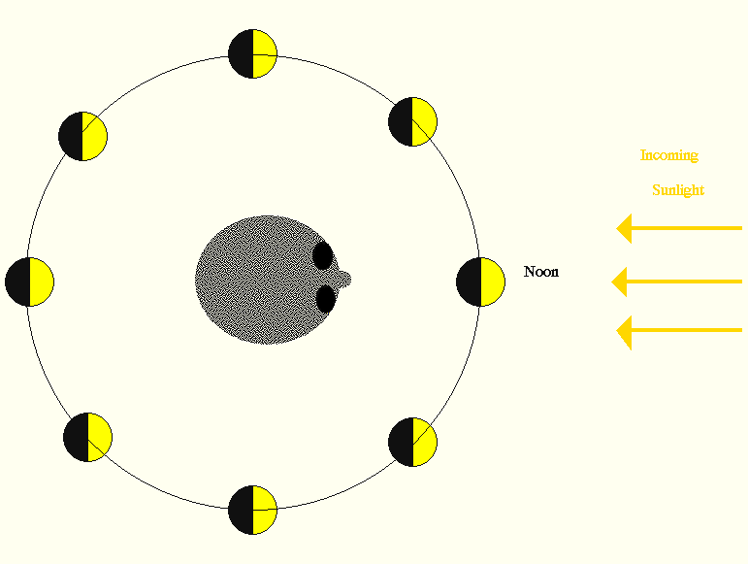
Full Moon
New Moon
Last Quarter

(8) Students should explore how the Moon is lit up by the Sun as the Moon revolves around the Earth. Students should be encouraged to see that the way the Moon is lit up doesn’t depend on the time of day. Would the Moon look the same to people in Texas as it does to people in California? Yes!

(9) Have students identify the phases of the Moon in their model (as shown above).

First quarter Moon
Full Moon
Last quarter Moon
New Moon
Crescent phases

(10) Think about what you’re Earth-head would look like as seen from your Moon. Does the Earth have phases as seen from the Moon? What phase would the Earth have when the Moon is full? (New) What phase would the Earth have when the Moon is new? (Full) What phase would the Earth have then the Moon is a quarter? (A quarter)

(11) This is a good time to discuss the fact that the Moon always keeps the same side facing the Earth. Does the Moon rotate? How long does it take to rotate? (About a month!) Is there a “dark side” of the Moon? Is there a “dark side” of the Earth? (Yes, there is, but it’s not always the same side!)

Procedure for Earth-Moon-Sun Scale:

(12) But is this really an accurate representation of the Earth-Moon system with regard to size and distance? No! Bring out two large balls, one an Earth globe, and the other a ball that will represent the Moon that is 4 times smaller. Hold them up next to each other. Would North America fit on the Moon? (Probably barely.) How big is the Moon as seen from the Earth? How big would the Earth look, as seen from the Moon?
Earth
Moon
Sun

30 Earth diameters!

(13) Students should now consider “scale”. How big would a human being be on this scale? How big would Texas be on this scale? On this scale, how close are the Earth and the Moon? It turns out that the Moon is about 30 Earth diameters away from the Earth. Why don’t our books (and the diagram above) show it that way??

(14) Have the students estimate, looking at the Earth ball, how far away the Moon should be on this scale. Have a student hold the Moon, and walk to that distance (probably most of the way across the room.) How easy would it be to have our little Moon orbit our little Earth on this scale?

(15) The Sun is a hundred times bigger than the Earth. How big would that be? How much bigger is the Sun than the Moon? (4x100=400 times) Then WHY do the Sun and the Moon look about the same size in the sky? Yes, the Sun is 400 times farther away than the Moon. What would we have to do to make an accurate model of the Earth-Moon-Sun system?

Extension:

Now give the students each 3 oreo cookies on a napkin. The students are not allowed to touch the cookies until you tell them they may. Tell them that they are going to make models, or representations, of the phases of the moon with their cookies. They may only eat their cookies if do what you tell them correctly! Tell them that the black cookie represents the darkness we see and the frosting represents what we see of the moon.

Assign each table one phase of the moon. The students may work together but each must create their own model of the moon. Once they are finished, they can show you. If they get it right, that table may eat their cookies! If a table does not get it right, they may go on to their second cookie for their second chance (they cannot eat the cookies yet!). Let them try again, and if they get it right, they may eat their cookies.

