

CSCE2303 – Computer Organization and Assembly Language Programming
Fall 2022
Project 2 report
Memory Hierarchy Simulator
Youssef Magdy: 900192960
Ali Eissa: 900201885

- A brief description of our implementation including any bonus features included.
This project is an implementation of a Memory hierarchy Simulator.
The main system is structured in cache classes, the cache class contains the functions for fetching data from itself, its upper level cache, or the main memory. The class also contains multiple cacheEntries, another class representing each line in the cache, containing the valid bit, tag, index, and data information. Along with functions for reading the input files, the main program just gathers the inputs from the user and fetches the address directly from the first level cache and prints the info for each cache.
The bonus feature that we had implemented in this code is multiple level cache
Multilevel Caches is one of the techniques to improve Cache Performance by reducing the “MISS PENALTY”. Miss Penalty refers to the extra time required to bring the data into cache from the Main memory whenever there is a “miss” in the cache. The second feature is Supporting a read-write cache instead of just a read only cache. In this case, the user will need to specify the writing policy used (both in case of hit and in case of miss). Also, each of the memory addresses in the provided sequence must be labelled as either a read or write access, and cache entries will include a dirty bit to account for the write back method.

What is Memory Hierarchy?
The memory in a computer can be divided into five hierarchies based on the speed as well as use. The processor can move from one level to another based on its requirements. The five hierarchies in the memory are registers, cache, main memory, magnetic discs, and magnetic tapes. The first three hierarchies are volatile memories which mean when there is no power, and then automatically they lose their stored data. Whereas the last two hierarchies are not volatile which means they store the data permanently.
A memory element is the set of storage devices which stores the binary data in the type of bits. In general, the storage of memory can be classified into two categories such as volatile as well as non- volatile.

Memory Hierarchy in Computer Architecture
The memory hierarchy design in a computer system mainly includes different storage devices. Most of the computers were inbuilt with extra storage to run more powerfully beyond the main memory capacity. The following memory hierarchy diagram is a hierarchical pyramid for computer memory. The designing of the memory hierarchy is divided into two types such as primary (Internal) memory and secondary (External) memory.
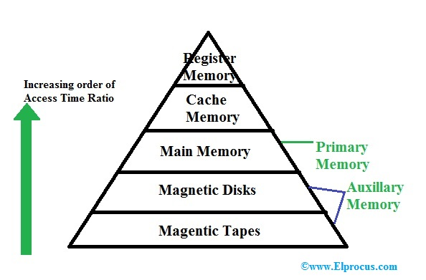Memory Hierarchy
Primary Memory
The primary memory is also known as internal memory, and this is accessible by the processor straightly. This memory includes main, cache, as well as CPU registers.

Design decisions and assumptions

The program was initially designed with multiple cache levels in mind, that;s why we implemented the cache and entries as classes.

Our main assumptions are that the user would input expected values to the prompts (ie. Not entering a character instead of a number, or entering an insanely high number) and that the user writes the input files in the correct format/syntax.

So far there are no bugs or issues with simulating throughout our testing, assuming the inputs were made correctly.
Usage instructions

Prepare the input files, have them in the same directory as the cpp and executable file.
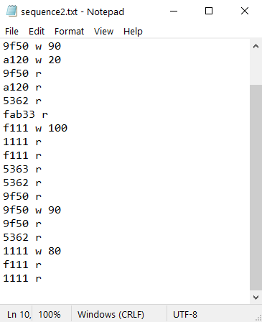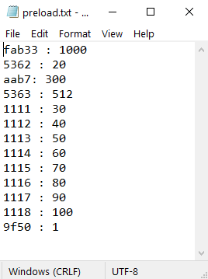

Compile and run the program
Follow the console prompts
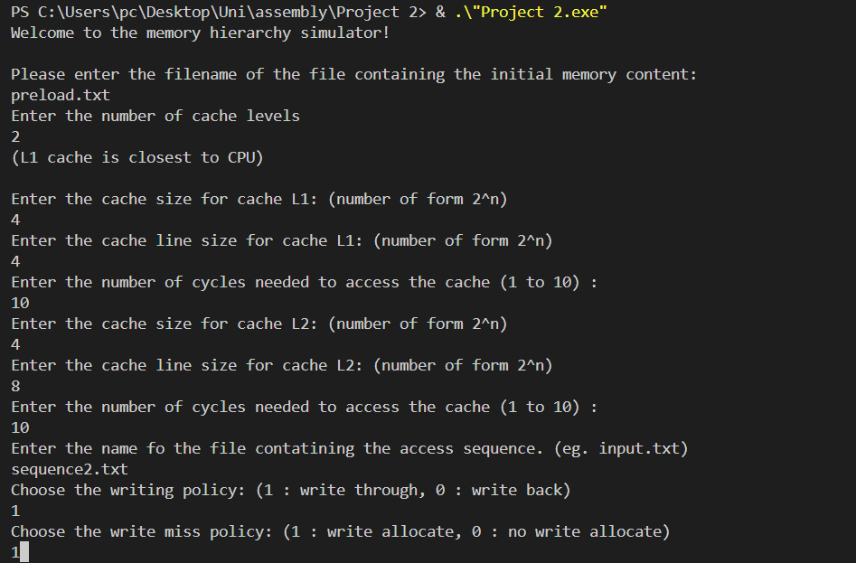

The program will then output the result of each instruction in order all at once.
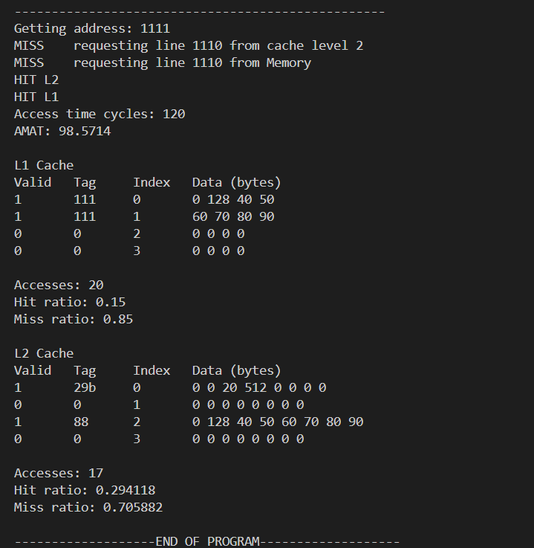

Input files format

Memory preload file format: Address(hex) : value(decimal)
Ex:
fab33 : 1000
5362 : 20
aab7: 300

sequence file format:
Read : Address(hex) r
Write: Address(hex) w value(dec)
Ex:
5362 r
fab33 r
f111 w 100

Tested sequences 1
5363 r
5362 r
fab33 r
f111 w 100
a120 w 20
5363 r
5362 r
1111 r
1112 r
1117 r
9f50 r
9f50 w 90
9f50 r
5362 r
1111 r
fab33 r
fab33 w 20
5363 r
fab33 r
a120 r

Tested sequences 2
1111 r
1112 r
1117 r
9f50 w 90
a120 w 20
9f50 r
a120 r
5362 r
fab33 r
f111 w 100
1111 r
f111 r
5363 r
5362 r
9f50 r
9f50 w 90
9f50 r
5362 r
1111 w 80
f111 r
1111 r

